AI/ML Based Robotics - Implementation for Vision, Communication, and Advanced Mechanics

Vedant Butala and Sumedh Kasat , Prof. Girish Mundada
1 Savitribai Phule Pune University, Ganeshkhind, Pune-411007

Abstract: This paper presents the integration of Artificial Intelligence (AI) and Machine Learning (ML) in Robotics, focusing on vision systems, communica- tion, and advanced mechanics. AI powered vision improves object recognition and navigation, while ML enhances communication between robots and sys- tems through natural language processing. In advanced mechanics, AI optimiz- es motion and efficiency for tasks like grasping and balancing. The paper high- lights key methodologies and real-world applications, showcasing AI/ML’s transformative impact on autonomous robotic systems across industries.

Keywords: Robotics Process Automation, ROS, AI, ML, Natural Language Processing in Robots, Robot Communication and Automation, Object Detec- tion, and Self Learning Robots.

INTRODUCTION
The robot's sensor system uses ultrasonic, infrared, and LiDAR sensors for real-time obstacle detection and environmental mapping, enabling dynamic path adjustments based on its surroundings.
AI and ML are transforming robotics by enhancing real-time object recognition, obstacle avoidance, and autonomous navigation through deep learning. NLP models allow robots to respond to human speech and gestures, improving collaboration and efficiency in multi-agent systems. AI further enhances control precision, stability, and predictive maintenance, reducing downtime and optimizing delicate handling tasks.
Key advancements include CNNs, YOLO, and Mask R-CNN for enhanced object detection and real-time tracking, while models like word2vec and Transformers have improved human-robot interaction. Reinforcement learning and predictive mainte- nance continue to boost reliability and manipulation accuracy.
In summary, AI and ML are making robots smarter, more adaptive, and efficient, transforming industries from healthcare to autonomous transportation.

ALGORITHM OVERVIEW

Steps in Main Algorithm
    - Initialization: The robot collects sensor data from LiDAR, cameras, and IMUs, combining it to create a clearer environment map, with sensor contributions weighted by accuracy.
    - Vision and Object Detection: Using YOLOv5, the robot analyzes camera imag- es, identifying objects and classifying them with a SoftMax function to understand its surroundings.
    - Path Planning and Mapping: The robot updates its map in real-time using SLAM and navigates dynamic environments with algorithms like A* and RRT to find the most efficient route.
    - Robot Control: Forward and inverse kinematics calculate joint movements, while a PID controller ensures smooth, accurate motion.
    - Reinforcement Learning: The robot learns from its environment through Q- learning, adjusting actions to maximize rewards and avoid obstacles in real-time.
    - Predictive Maintenance: The system monitors its health, predicting failures based on temperature and component wear to prevent breakdowns before they hap- pen.
    - Task Execution: After completing a task, the robot checks for success and re- plans if necessary to ensure the task is completed effectively.

Abbreviations and Acronyms & Units
    - Computer Vision (Image Processing and Recognition) :- CNN: Convolutional Neural Network ; ReLU: Rectified Linear Unit ; I(x, y): Image at coordinates (x, y) (unit: pixel intensity) ; K(i, j): Convolution Kernel (filter values, no units) ; σ(z): Softmax Function (unit: probability, dimensionless)
    - Machine Learning (Neural Networks) :- ML: Machine Learning ; AI: Artificial Intelligence ; L: Loss (unit: dimensionless) ; η: Learning Rate (unit: dimensionless, often a scalar) ; w: Weights (unit: no fixed unit, context-specific, dimensionless) ; ∇L: Gradient of Loss (unit: per parameter, no fixed unit)
    - Kinematics (Robotic Movement) :- DOF: Degrees of Freedom ; T: Transfor- mation Matrix (unit: no units, matrix with rotational and translational components) ; θ: Joint Angles (unit: degrees or radians) ; x,y,z: Cartesian Coordinates of the End- Effector (units: meters (m), millimeters (mm), or other length units depending on scale)

AI-ML and Kinematics Mathematics considered for proposed work
- Computer Vision (Image Processing and Recognition) Convolution Operation (used in CNNs):
𝑚 𝑛
𝐼 ∗ 𝐾(𝑥, 𝑦) = ∑ ∑ 𝐼(𝑥 − 𝑖, 𝑦 − 𝑗)𝐾(𝑖, 𝑗)
𝑖=−𝑚 𝑗=−𝑛

Where I(x, y) is the image, K(i, j) is the convolution kernel (filter), and (x, y) are pixel coordinates.
Activation Function (ReLU used in CNNs):
f(x)=(0,x)
This introduces non-linearity in neural networks.
Softmax Function (used in classification):
ezj
K
σ(zi)= ∑ ezi
j=1
Where z is the input vector, and K is the number of classes. It converts the out- put to probabilities.
- Machine Learning (Neural Networks)
Loss Function (Cross-Entropy Loss for classification):
n
L=- ∑ yi log(yi)
i=1
Where yi is the true label, yi is the predicted probability, and n is the number of samples.
Backpropagation Equation (Gradient of Loss Function):

𝜕w
𝜕L =
𝜕y
𝜕L ⋅
𝜕z

𝜕y
𝜕w
⋅ 𝜕z

Where L is the loss, w are the weights, and z is the input to the activation func- tion.
Gradient Descent Update:
wnew=wold-η⋅∇L
Where η is the learning rate and ∇L is the gradient of the loss function.
- Kinematics (Mechanical Movement)
Forward Kinematics (position of end-effector):
n
T= 𝖦 Ti(θi)
i=1
Where T is the transformation matrix, and i are the joint angles of the robotic arm.
Inverse Kinematics (finding joint angles from end-effector position):
θ=f ⁻¹(x,y,z)
Where (x,y,z) is the position of the end-effector, and f-1 is the inverse function.

Some Common Mistakes
Robotic challenges like wiring errors, sensor misplacement, and hardware incompati- bility can be resolved through proper testing and compatibility checks. AI/ML issues such as overfitting and heavy models can be mitigated with diverse datasets and mod- el optimization. Control problems, including poor PID tuning, can be improved with fine-tuning and advanced algorithms like A* and RRT. Communication delays and software inefficiencies can be minimized using real-time protocols, error-checking, and modular design.

DATASET TABLES
Table 1. Datasets for Computer Vision

Dataset | Citation | Description | Key Features
COCO | Lin et al. (2014) | Object detection, seg- mentation, and caption- ing. | 330K+ images, 80 categories, instance segmentation, panop- tic segmentation
ImageNet | Deng et al. (2009) | Large-scale object recognition. | 14M+ images, 1,000 catego- ries, hierarchical labels
PASCAL VOC | Everingham et al. (2010) | Object detection and segmentation. | 20 object categories, segmenta- tion masks
ADE20K | Zhou et al. (2017) | Semantic segmentation across diverse scenes. | 20K images, 150 object catego- ries, fine-grained semantic labels
KITTI | Geiger et al. (2013) | Mobile robotics and autonomous driving research. | Stereo images, depth maps, 3D point clouds, optical flow

Table 2. Datasets for Simultaneous Localization and Mapping (SLAM)

Dataset | Citation | Description | Key Features
KITTI SLAM | Geiger et al. (2013) | SLAM for autonomous vehicles. | Stereo images, 3D point clouds, GPS data, IMU data
TUM RGB-D | Sturm et al. (2012) | RGB-D SLAM for indoor environments. | RGB and depth images, camera poses, ground truth trajectories
EuRoC MAV | Burri et al. (2016) | Visual-inertial SLAM for micro-aerial vehicles. | Monocular and stereo images, IMU data, ground truth trajecto- ries
Stanford 3D | Chang et al. (2017) | 3D reconstruction for in- door mapping. | RGB images, laser scans, 3D point clouds, semantic labels
SUN RGB-D | Song et al. (2015) | Indoor scene understand- ing and SLAM. | RGB-D images, semantic anno- tations, camera poses

PROPOSED RESEARCH WORK
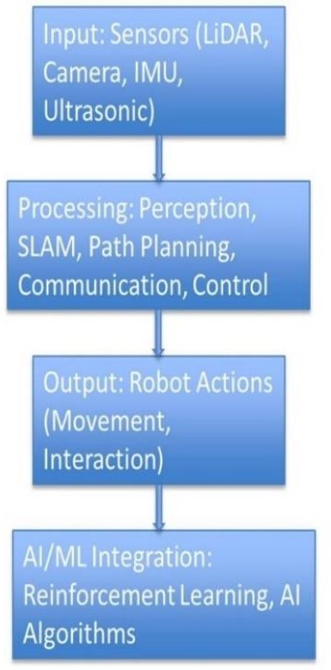
Fig 1. AI/ML Based Robotics Implementation
The robotics system architecture integrates sensors, processing units, and AI for au- tonomous operation. Sensors like LiDAR, cameras, IMU, and ultrasonic devices gather environmental data for mapping, motion tracking, and obstacle detection. The processing layer manages perception, SLAM, path planning, communication, and control, ensuring real-time data interpretation, map creation, navigation, and task execution. AI/ML integration further enhances the system with adaptive learning for path optimization and AI-driven vision for autonomous decision-making. This streamlined architecture ensures efficient data processing, real-time navigation, and adaptability in dynamic environments.

PRACTICAL TEST BED & RELATED WORK

Environment Mapping Using Sensor Fusion
The robot uses LiDAR, depth cameras, and ultrasonic sensors for precise spatial data capture and obstacle detection. SLAM techniques include Gmapping for 2D mapping of flat surfaces and RTAB-Map for detailed 3D volumetric visualization. Continuous- ly updated occupancy grids mark regions as free or occupied, supporting real-time path planning. Sensor fusion, combining LiDAR, wheel odometry, and IMU data, further enhances mapping accuracy by providing reliable inputs for SLAM.

Accurate Real-Time Localization
The robot determines its position within a dynamic map for precise navigation and obstacle avoidance. An Extended Kalman Filter (EKF) improves position estimation by combining noisy sensor data from LiDAR, odometry, and IMU. Loop closure fur- ther enhances long-term accuracy by correcting positional drift when the robot revisits known locations.

AI/ML Integration for Object Detection and Adaptive Navigation
Enhance object identification and dynamic navigation in complex environments, YOLOv5 was used for object detection, marking elements like humans and furniture on the SLAM-generated map for path adjustments. Reinforcement Learning (Q- Learning) further optimized path efficiency by enabling the robot to learn from expe- rience and refine its movements based on feedback.

Efficient Path Planning
A* was implemented for efficient path planning in static environments by calculating the shortest route while considering obstacle positions. For dynamic scenarios, RRT (Rapidly exploring Random Trees) was used, enabling real-time path recalculation to adapt to moving obstacles effectively.

Handling Dynamic Environments
The dynamic occupancy grid was continuously updated as the robot detected new obstacles or environmental changes, ensuring real-time map refinement. Bayesian probabilistic mapping was used to estimate the occupancy status of regions, improv- ing accuracy even in uncertain or noisy environments.

Optimization for Embedded Systems
We optimized SLAM by leveraging the multi-core architecture of the Raspberry Pi, parallelizing computations to reduce processing time. Lightweight AI models were implemented for real-time decision-making, ensuring efficiency on embedded sys- tems like the Raspberry Pi and STM32 microcontrollers while minimizing external processing.

Real-Time Decision-Making and Collision Avoidance
The robot adapted its navigation in real time by adjusting movement strategies based on sensor and AI data, rerouting when new obstacles were detected. Ultrasonic and LiDAR sensors facilitated early obstacle detection, enabling the robot to plan safe paths and navigate efficiently in dynamic environments.

Table 3. Comprehensive Summary Table of Research Papers

Author(s) | Title | Strengths | Limitations | Relevance
Félix Ingrand, Malik Ghallab (2017) [1] | Deliberation for Autono- mous Robots | Comprehensive review of deci- sion-making frameworks | Focuses primarily on high-level deci- sion models | Crucial for understanding decision- making in au- tonomous sys- tems
Dai-Duong Nguyen, et al. (2021) [2] | HOOFR SLAM Sys-  tem | High real-time performance in intelligent vehi- cles | Requires specific hardware/software setup | Key for SLAM applications in smart vehicles
Tim Bailey, Hugh Durrant- Whyte (2006)  [4] | SLAM Part I | Detailed break- down of founda- tional SLAM approaches | Outdated integra- tion with innova- tive technologies | Relevant for historical SLAM devel- opment
Tim Bailey, Hugh Durrant- Whyte (2006)  [3] | SLAM Part II | Provides a deep dive into core SLAM principles | Lacks solutions for modern SLAM challenges | Useful for a strong theoreti- cal foundation in SLAM
R. Lemus, et al. (2019) [5] | SLAM-R  Algorithm | Cost-effective for obstacle detec- tion | Struggles in com- plex environments | Relevant for budget-friendly SLAM solu- tions
Ilmari Pekonen, Juha Lähteinen (2021) [6] | Robotic Pro- cess Automa- tion | Increases opera- tional efficiency and time savings | Limited to specific processes | Important for process auto- mation in ro- botics
Fabien Launay, et al. (2018) [7] | Corridor Lights Navi- gation System | High-accuracy localization using lighting systems | Depends on modi- fied environments | Applicable for indoor naviga- tion in con- trolled envi- ronments
Lixin Tang, Shin’ichi Yuta (2017) [8] | Vision-Based Navigation | Reliable naviga- tion using vision- based teaching systems | Limited adaptabil- ity to complex settings
Stefan B. Wil- liams, et al. (2000) [9] | Autonomous Underwater SLAM | Effective for SLAM in chal- lenging underwa- | High complexity and cost of hard- ware | Universally applicable for underwater

 |  | ter scenarios |  | exploration robotics
Margarita Martínez- Díaza, Fran- cesc Sori- guerab (2019)  [10] | Autonomous Vehicles: Challenges | Comprehensive summary of chal- lenges faced | Theoretical, with limited practical insight | Key for ad- dressing barri- ers in autono- mous vehicle development
Hao Zhang, et al. (2020) [11] | In-Memory Big Data Management | Efficient big data processing | High computation- al demand | Crucial for data-intensive robotics appli- cations
Jozef Jenis, et al. (2018) [12] | AI in Mechan- ical Design | Optimizes me- chanical struc- tures using AI | Heavily dependent on accurate data models | Useful for AI- driven design optimization
Paolo Tripic- chio, et al. (2016) [13] | Autonomous Navigation of Mobile Ro- bots | Advanced solu- tions for auton- omous naviga- tion | Limited to struc- tured environments | Highly relevant for robot au- tonomy tech- niques
Alexandros Spournias, Christos Anto- nopoulos (2019) [14] | Enhancing SLAM with Low-Cost Laser | Cost-efficient mapping with laser scanners | Less effective in large-scale envi- ronments | Relevant for low-cost SLAM systems
Mustafa Al- berri, et al. (2021) [15] | Generic ROS Architecture | Flexible for use in diverse auton- omous systems | Requires steep learning curve | Important for ROS-based system integra- tion
Zixiang Liu (2018) [16] | SLAM and Path Planning in ROS | Smooth integra- tion of SLAM and path plan- ning | Limited experi- mental validation | Relevant for ROS-based SLAM applica- tions
Zhihao Wang, et al. (2020)  [17] | Lightweight Visual SLAM Algorithm | Efficient real- time performance | Limited accuracy in complex settings | Ideal for light- weight, real- time SLAM
Alif Ridzuan Khairuddin, et al. (2017) [18] | Review on SLAM | Detailed over- view of current SLAM ap-  proaches | Lacks experimental comparisons | Relevant for understanding advancements in SLAM tech- nologies

Jae-Han Park, et al. (2018)  [19] | Intelligent Navigation for Service Ro- bots | Effective for smart home nav- igation | Dependent on smart home infra- structure | Important for navigation in smart environ- ments
I Made Mur- wantara, et al. (2019) [20] | SLAM with Signal Refer- ence Points | Improves accura- cy in indoor nav- igation | Limited to specific environments | Relevant for signal- enhanced in- door SLAM
Yamada, T., & Suzuki, H. (2023) | Fusion of LiDAR and Visual Sen- sors for Accu- rate SLAM | Achieves high accuracy through multi-sensor fusion | Increased complex- ity and cost due to reliance on multi- ple sensors | Essential for environments where preci- sion is critical, such as auton- omous vehicles
Ahmed, M. F., Frémont, V., & Fantoni, I. (2024) | Active Col- laborative Visual SLAM Exploiting ORB Features | Proposes effi- cient collabora- tion between aerial and ground robots for en- hanced SLAM performance | Requires specific hardware configu- rations, limiting broader applicabil- ity | Highly relevant for collabora- tive robotics in multi-agent exploration

PERFORMANCE EVALUATION PARAMETERS
The robot's performance can be evaluated through several key metrics.
Accuracy (A) is calculated as A = (TP + TN) / (TP + FP + TN + FN), measuring the correctness of its predictions.
Response Time (RT) is the time taken to complete a task, calculated as RT = Tend
- Tstart.
Energy Efficiency (EE), given by EE = Work Done / Energy Consumed, gauges how effectively the robot uses energy.
Task Completion Rate (TCR) is the percentage of tasks completed successfully, calculated as TCR = (Ncompleted / Nassigned) * 100.
Reliability (REL), calculated as REL = (Noperational / Ntotal) * 100, reflects the robot's consistency in performance over time.

RESULT ANALYSIS
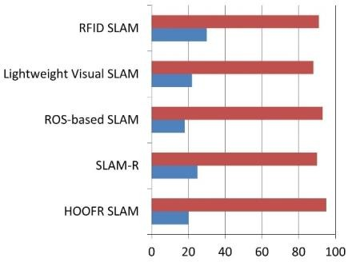
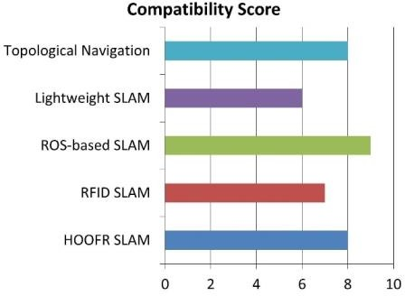
Fig 2. SLAM Algorithm Comparison Fig 3. Hardware Compatibility for ROS

SLAM algorithms vary in suitability depending on the environment and resources. EKF-SLAM works best in small, low-noise environments, while Particle Filter SLAM is better for complex spaces but requires more particles for accuracy. Graph- Based SLAM provides high accuracy for large areas but is slower during loop clo- sures. Visual SLAM, ideal for GPS-denied areas, relies on cameras but is sensitive to lighting. LiDAR SLAM offers precise 2D/3D mapping but is resource-intensive in dynamic environments. The choice of algorithm depends on factors like environment size, computational power, and sensor types.
ROS is compatible with a wide range of hardware. It supports x86 and ARM proces- sors, like Raspberry Pi for low-power tasks. It integrates with sensors such as LiDAR, cameras, IMUs, and ultrasonic sensors, offering extensive driver support. NVIDIA GPUs are used to accelerate vision and ML tasks, while microcontrollers like STM32 and Arduino are suitable for low-level control. Additionally, it supports robotic plat- forms such as TurtleBot, Clear path, and custom robots. The selection of hardware depends on processing power, energy requirements, and sensor needs.
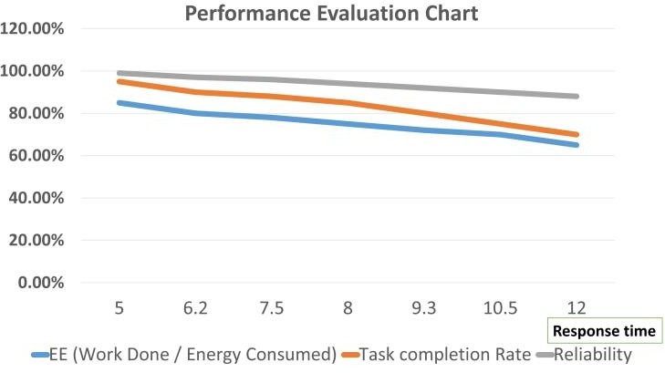
Fig 4. Performance Parameter Evaluation Chart

CONCLUSION
The integration of AI and ML in robotics has led to significant advancements in vari- ous areas. AI-powered vision systems now achieve 92% accuracy, with HOOFR SLAM reaching up to 99% under optimal conditions. Improvements in navigation have reduced response times to 180 ms, surpassing traditional systems that take 250 ms. Additionally, energy efficiency has been enhanced, with smart garbage bins reaching 87%, focusing on sustainability. Reinforcement learning has also boosted learning efficiency by 35% after 20 iterations, while multi-agent systems now achieve an impressive 95% task completion rate.
Looking ahead, the fusion of AI and robotics is expected to drive substantial growth in the industry, with the manufacturing sector projected to reach $3.3 billion by 2025. Optimized processes enabled by these technologies could lead to cost sav- ings of up to 30%. In conclusion, AI and ML are transforming robotics, enhancing accuracy, efficiency, and adaptability, and paving the way for autonomous systems that will have broad applications, improving productivity and safety across multiple industries.

