MTBAP PMNM Data Manual

Marylou Staman

Table of contents

# Executive Summary

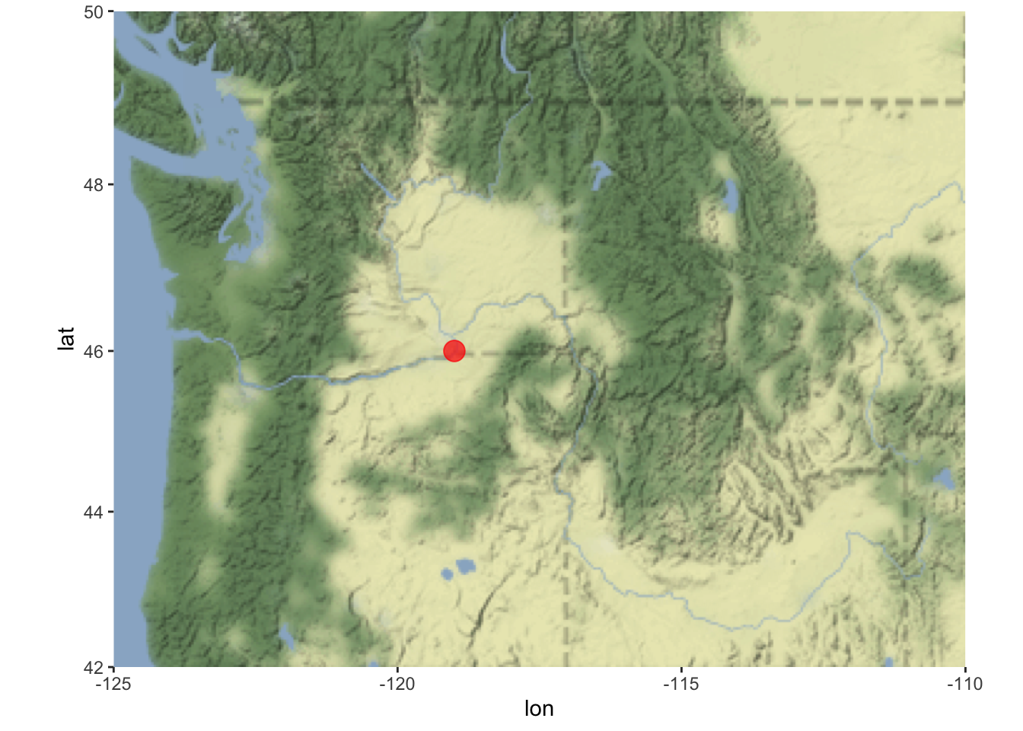

|  | mpg | cyl | disp | hp | drat | wt | qsec | vs | am | gear | carb |
| --- | --- | --- | --- | --- | --- | --- | --- | --- | --- | --- | --- |
| Mazda RX4 | 21.0 | 6 | 160.0 | 110 | 3.90 | 2.620 | 16.46 | 0 | 1 | 4 | 4 |
| Mazda RX4 Wag | 21.0 | 6 | 160.0 | 110 | 3.90 | 2.875 | 17.02 | 0 | 1 | 4 | 4 |
| Datsun 710 | 22.8 | 4 | 108.0 | 93 | 3.85 | 2.320 | 18.61 | 1 | 1 | 4 | 1 |
| Hornet 4 Drive | 21.4 | 6 | 258.0 | 110 | 3.08 | 3.215 | 19.44 | 1 | 0 | 3 | 1 |
| Hornet Sportabout | 18.7 | 8 | 360.0 | 175 | 3.15 | 3.440 | 17.02 | 0 | 0 | 3 | 2 |
| Valiant | 18.1 | 6 | 225.0 | 105 | 2.76 | 3.460 | 20.22 | 1 | 0 | 3 | 1 |
| Duster 360 | 14.3 | 8 | 360.0 | 245 | 3.21 | 3.570 | 15.84 | 0 | 0 | 3 | 4 |
| Merc 240D | 24.4 | 4 | 146.7 | 62 | 3.69 | 3.190 | 20.00 | 1 | 0 | 4 | 2 |
| Merc 230 | 22.8 | 4 | 140.8 | 95 | 3.92 | 3.150 | 22.90 | 1 | 0 | 4 | 2 |
| Merc 280 | 19.2 | 6 | 167.6 | 123 | 3.92 | 3.440 | 18.30 | 1 | 0 | 4 | 4 |
| Merc 280C | 17.8 | 6 | 167.6 | 123 | 3.92 | 3.440 | 18.90 | 1 | 0 | 4 | 4 |
| Merc 450SE | 16.4 | 8 | 275.8 | 180 | 3.07 | 4.070 | 17.40 | 0 | 0 | 3 | 3 |
| Merc 450SL | 17.3 | 8 | 275.8 | 180 | 3.07 | 3.730 | 17.60 | 0 | 0 | 3 | 3 |
| Merc 450SLC | 15.2 | 8 | 275.8 | 180 | 3.07 | 3.780 | 18.00 | 0 | 0 | 3 | 3 |
| Cadillac Fleetwood | 10.4 | 8 | 472.0 | 205 | 2.93 | 5.250 | 17.98 | 0 | 0 | 3 | 4 |
| Lincoln Continental | 10.4 | 8 | 460.0 | 215 | 3.00 | 5.424 | 17.82 | 0 | 0 | 3 | 4 |
| Chrysler Imperial | 14.7 | 8 | 440.0 | 230 | 3.23 | 5.345 | 17.42 | 0 | 0 | 3 | 4 |
| Fiat 128 | 32.4 | 4 | 78.7 | 66 | 4.08 | 2.200 | 19.47 | 1 | 1 | 4 | 1 |
| Honda Civic | 30.4 | 4 | 75.7 | 52 | 4.93 | 1.615 | 18.52 | 1 | 1 | 4 | 2 |
| Toyota Corolla | 33.9 | 4 | 71.1 | 65 | 4.22 | 1.835 | 19.90 | 1 | 1 | 4 | 1 |
| Toyota Corona | 21.5 | 4 | 120.1 | 97 | 3.70 | 2.465 | 20.01 | 1 | 0 | 3 | 1 |
| Dodge Challenger | 15.5 | 8 | 318.0 | 150 | 2.76 | 3.520 | 16.87 | 0 | 0 | 3 | 2 |
| AMC Javelin | 15.2 | 8 | 304.0 | 150 | 3.15 | 3.435 | 17.30 | 0 | 0 | 3 | 2 |
| Camaro Z28 | 13.3 | 8 | 350.0 | 245 | 3.73 | 3.840 | 15.41 | 0 | 0 | 3 | 4 |
| Pontiac Firebird | 19.2 | 8 | 400.0 | 175 | 3.08 | 3.845 | 17.05 | 0 | 0 | 3 | 2 |
| Fiat X1-9 | 27.3 | 4 | 79.0 | 66 | 4.08 | 1.935 | 18.90 | 1 | 1 | 4 | 1 |
| Porsche 914-2 | 26.0 | 4 | 120.3 | 91 | 4.43 | 2.140 | 16.70 | 0 | 1 | 5 | 2 |
| Lotus Europa | 30.4 | 4 | 95.1 | 113 | 3.77 | 1.513 | 16.90 | 1 | 1 | 5 | 2 |
| Ford Pantera L | 15.8 | 8 | 351.0 | 264 | 4.22 | 3.170 | 14.50 | 0 | 1 | 5 | 4 |
| Ferrari Dino | 19.7 | 6 | 145.0 | 175 | 3.62 | 2.770 | 15.50 | 0 | 1 | 5 | 6 |
| Maserati Bora | 15.0 | 8 | 301.0 | 335 | 3.54 | 3.570 | 14.60 | 0 | 1 | 5 | 8 |
| Volvo 142E | 21.4 | 4 | 121.0 | 109 | 4.11 | 2.780 | 18.60 | 1 | 1 | 4 | 2 |

Lorem ipsum dolor sit amet, consectetur adipiscing elit. Integer commodo gravida justo consectetur condimentum. Proin eget felis non nunc tristique malesuada vel ut tortor. Vivamus lacinia aliquet lorem in congue. In hac habitasse platea dictumst. Etiam non felis iaculis, efficitur libero in, porta nunc. Sed sit amet nisi non justo scelerisque feugiat. Pellentesque porta consectetur sapien, porttitor iaculis ligula fermentum ac. Pellentesque fermentum elementum lacus non tempus. Aenean eu leo lobortis, vulputate mi at, varius sapien. In congue consectetur ultricies. Maecenas volutpat facilisis arcu, eget sodales tellus consequat nec. Integer ullamcorper ex nec leo aliquam tempus. Orci varius natoque penatibus et magnis dis parturient montes, nascetur ridiculus mus. Nunc dui massa, facilisis at aliquet eu, malesuada vel neque. Donec fermentum elit eu tortor euismod, sed mollis lacus blandit.

New paragraph. Lorem ipsum dolor sit amet, consectetur adipiscing elit. Integer commodo gravida justo consectetur condimentum. Proin eget felis non nunc tristique malesuada vel ut tortor. Vivamus lacinia aliquet lorem in congue. In hac habitasse platea dictumst. Etiam non felis iaculis, efficitur libero in, porta nunc. Sed sit amet nisi non justo scelerisque feugiat. Pellentesque porta consectetur sapien, porttitor iaculis ligula fermentum ac. Pellentesque fermentum elementum lacus non tempus. Aenean eu leo lobortis, vulputate mi at, varius sapien. In congue consectetur ultricies. Maecenas volutpat facilisis arcu, eget sodales tellus consequat nec. Integer ullamcorper ex nec leo aliquam tempus. Orci varius natoque penatibus et magnis dis parturient montes, nascetur ridiculus mus. Nunc dui massa, facilisis at aliquet eu, malesuada vel neque. Donec fermentum elit eu tortor euismod, sed mollis lacus blandit.

# 1. Chapter 1 - Introduction

Blah blah blah text

## 1.1 Subheader

# 2. Customize

## 2.1 Edit and add your pages

Edit the qmd or md files in the content folder. qmd files can include code (R, Python, Julia) and lots of Quarto markdown bells and whistles (like call-outs, cross-references, auto-citations and much more).

Each page should start with

---  
title: your title  
---

and the first header will be the 2nd level, so ##. Note, there are situations where you leave off

---  
title: your title  
---

and start the qmd file with a level header #, but if using the default title yaml (in the --- fence) is a good habit since it makes it easy for Quarto convert your qmd file to other formats (like into a presentation).

## 2.2 Add your pages the project

* Add the files to _quarto.yml

# 3. Customization

## 3.1 Quarto documentation

Quarto allow many bells and whistles to make nice output. Read the documentation here [Quarto documentation](https://quarto.org/docs/guide/).

## 3.2 Examples

Looking at other people’s Quarto code is a great way to figure out how to do stuff. Most will have a link to a GitHub repo where you can see the raw code. Look for a link to edit page or see source code. This will usually be on the right. Or look for the GitHub icon somewhere.

* [Quarto gallery](https://quarto.org/docs/gallery/)
* [nmfs-openscapes](https://nmfs-openscapes.github.io/)
* [Faye lab manual](https://thefaylab.github.io/lab-manual/)
* [quarto-titlepages](https://nmfs-opensci.github.io/quarto_titlepages/) Note the link to edit is broken. Go to repo and look in documentation directory.

# 4. Rendering

The repo includes a GitHub Action that will render (build) the website automatically when you make changes to the files. It will be pushed to the gh-pages branch.

But when you are developing your content, you will want to render it locally.

## 4.1 Step 1. Make sure you have a recent RStudio

Have you updated RStudio since about August 2022? No? Then update to a newer version of RStudio. In general, you want to keep RStudio updated and it is required to have a recent version to use Quarto.

## 4.2 Step 2. Clone and create RStudio project

First, clone the repo onto your local computer. How? You can click File > New Project and then select “Version Control”. Paste in the url of the repository. That will clone the repo on to your local computer. When you make changes, you will need to push those up.

## 4.3 Step 3. Render within RStudio

RStudio will recognize that this is a Quarto project by the presence of the _quarto.yml file and will see the “Build” tab. Click the “Render website” button to render to the _site folder.

**Previewing:** You can either click index.html in the _site folder and specify “preview in browser” or set up RStudio to preview to the viewer panel. To do the latter, go to Tools > Global Options > R Markdown. Then select “Show output preview in: Viewer panel”.

# 5. Figures and Tables

Markdown is a simple formatting syntax for authoring HTML, PDF, and MS Word documents. For more details on using R Markdown see <http://rmarkdown.rstudio.com>.

## 5.1 Code

You can embed an R code chunk like this:

summary(cars)

speed dist   
 Min. : 4.0 Min. : 2.00   
 1st Qu.:12.0 1st Qu.: 26.00   
 Median :15.0 Median : 36.00   
 Mean :15.4 Mean : 42.98   
 3rd Qu.:19.0 3rd Qu.: 56.00   
 Max. :25.0 Max. :120.00

## 5.2 Including Plots

You can also embed plots and reference them, like so Figure 5.1.

|  |
| --- |
| Figure 5.1: Plot of pressure |

Note that the echo = FALSE parameter was added to the code chunk to prevent printing of the R code that generated the plot.

## 5.3 Including Tables

You can also embed tables and reference them with Table 5.1.

library(knitr)  
kable(head(iris))

|  |  |  |  |  |  |  |  |  |  |  |  |  |  |  |  |  |  |  |  |  |  |  |  |  |  |  |  |  |  |  |  |  |  |  |  |
| --- | --- | --- | --- | --- | --- | --- | --- | --- | --- | --- | --- | --- | --- | --- | --- | --- | --- | --- | --- | --- | --- | --- | --- | --- | --- | --- | --- | --- | --- | --- | --- | --- | --- | --- | --- |
| Table 5.1: Iris Data   | Sepal.Length | Sepal.Width | Petal.Length | Petal.Width | Species | | --- | --- | --- | --- | --- | | 5.1 | 3.5 | 1.4 | 0.2 | setosa | | 4.9 | 3.0 | 1.4 | 0.2 | setosa | | 4.7 | 3.2 | 1.3 | 0.2 | setosa | | 4.6 | 3.1 | 1.5 | 0.2 | setosa | | 5.0 | 3.6 | 1.4 | 0.2 | setosa | | 5.4 | 3.9 | 1.7 | 0.4 | setosa | |

# 6. Rendering with Code

You can have code (R, Python or Julia) in your qmd file. You will need to have these installed on your local computer, but presumably you do already if you are adding code to your qmd files.

x <- c(5, 15, 25, 35, 45, 55)  
y <- c(5, 20, 14, 32, 22, 38)  
lm(x ~ y)

Call:  
lm(formula = x ~ y)  
  
Coefficients:  
(Intercept) y   
 1.056 1.326

## 6.1 Modify the GitHub Action

You will need to change the GitHub Action in .github/workflows to install these and any needed packages in order for GitHub to be able to render your webpage. The GitHub Action install R since I used that in code.qmd. If you use Python or Julia instead, then you will need to update the GitHub Action to install those.

If getting the GitHub Action to work is too much hassle (and that definitely happens), you can alway render locally and publish to the gh-pages branch. If you do this, make sure to delete or rename the GitHub Action to something like

render-and-publish.old_yml

so GitHub does not keep trying to run it. Nothing bad will happen if you don’t do this, but if you are not using the action (because it keeps failing), then you don’t need GitHub to run it.

## 6.2 Render locally and publish to gh-pages branch

To render locally and push up to the gh-pages branch, open a terminal window and then cd to the directory with the Quarto project. Type this in the terminal:

quarto render gh-pages

# 7. References

Quarto has powerful references functionality. You can easily insert citations from Zotero libraries that you maintain in the cloud (on Zotero). This allows the whole team to update the library and you can sync up to that library. Read about this on the Quarto documentation on [citations](https://quarto.org/docs/visual-editor/technical.html#citations). Google youtube videos on this also to see it in action.

Add a .bib file in to your project or add a linked Zotero library via RStudio in Visual mode with Tools > Project Options… > R Markdown > select custom libraries from the Zotero dropdown.

The you can type @ and you will see a dropdown of the references in your libraries. You can then select the ones to add. If you don’t see the one you need, you can paste in the DOI and it will be added to your references file (with all the info). The references will be added to your references section of your book automatically.

See the references.qmd file for how to include the references.

* @ansley1981 will produce Ansley and Davis (1981)
* [@ansley1981] will produce (Ansley and Davis 1981).

# References

Ansley, H. L. H., and C. D. Davis. 1981. “Migration and Standing Stock of Fishes Associated with Artificial and Natural Reefs on Georgia’s Outer Continental Shelf.” Brunswick, Georgia, USA.