Change Point 2022

2023-12-06

# Fishery Productivity Time Series Analyses

## WCNPO Striped Marlin

## 2021 Update of 2019 Assessment

### Summary of Input Data

## year oni mei pdo   
## Min. :1975 Min. :-1.2250 Min. :-1.34000 Min. :-2.0420   
## 1st Qu.:1986 1st Qu.:-0.4695 1st Qu.:-0.46600 1st Qu.:-0.8660   
## Median :1996 Median : 0.0410 Median :-0.02100 Median :-0.1960   
## Mean :1996 Mean : 0.0177 Mean : 0.01377 Mean :-0.1212   
## 3rd Qu.:2006 3rd Qu.: 0.3905 3rd Qu.: 0.40100 3rd Qu.: 0.6310   
## Max. :2017 Max. : 1.4610 Max. : 1.37300 Max. : 1.5340   
## NA's :4   
## rec ssb rssb popbio   
## Min. :0.0770 Min. :0.5780 Min. :0.0990 Min. :11.56   
## 1st Qu.:0.2115 1st Qu.:0.9055 1st Qu.:0.1475 1st Qu.:12.98   
## Median :0.4000 Median :1.2050 Median :0.2110 Median :14.18   
## Mean :0.3943 Mean :1.7765 Mean :0.2513 Mean :14.40   
## 3rd Qu.:0.5085 3rd Qu.:2.7320 3rd Qu.:0.3410 3rd Qu.:15.88   
## Max. :1.0210 Max. :4.0300 Max. :0.6040 Max. :17.75   
##   
## fmort spr catbio fspr   
## Min. :0.530 Min. :0.0610 Min. : 1.808 Min. :0.8030   
## 1st Qu.:0.770 1st Qu.:0.0955 1st Qu.: 3.559 1st Qu.:0.8575   
## Median :1.020 Median :0.1100 Median : 5.675 Median :0.8900   
## Mean :1.057 Mean :0.1196 Mean : 5.633 Mean :0.8804   
## 3rd Qu.:1.350 3rd Qu.:0.1425 3rd Qu.: 7.459 3rd Qu.:0.9045   
## Max. :1.720 Max. :0.1970 Max. :10.862 Max. :0.9390   
##   
## netbio hrate   
## Min. : 1.773 Min. :0.1058   
## 1st Qu.: 6.384 1st Qu.:0.2672   
## Median : 8.816 Median :0.3873   
## Mean : 8.768 Mean :0.3976   
## 3rd Qu.:10.725 3rd Qu.:0.5014   
## Max. :15.474 Max. :0.8597   
##

## Environmental Time Series, 1975-2017

#### Oceanic Nino Index (oni)

#### Multivariate ENSO Index (mei)

#### Pacific Decadal Oscillation, November-March (pdo)

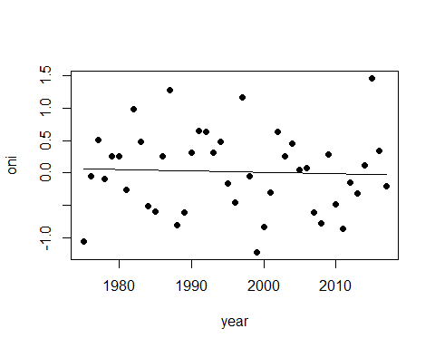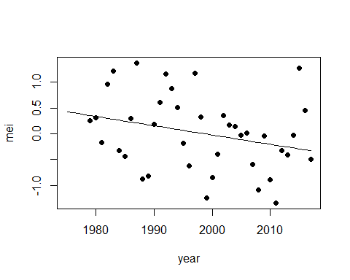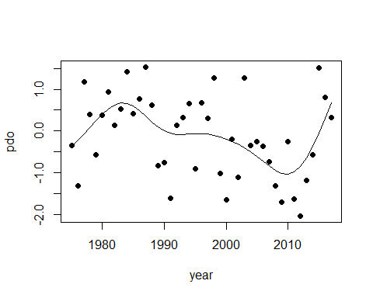

## Fishery System Time Series, 1975-2017

#### Recruitment (rec) and Spawning Stock Biomass (ssb)

#### Recruits per Spawning Biomass (rssb) and Spawning Potential Ratio (spr)

#### Population Biomass (popbio) and Catch Biomass (catbio)

#### Fishing Mortality (fmort) and Fishing Intensity (fspr)

#### Population Minus Catch Biomass (netbio) and Harvest Rate (hrate)

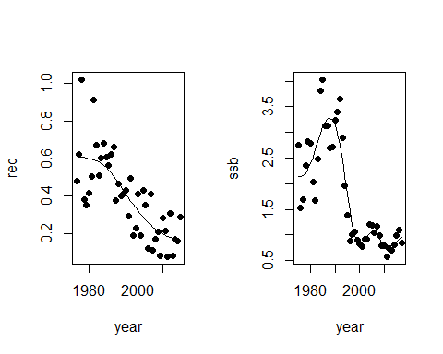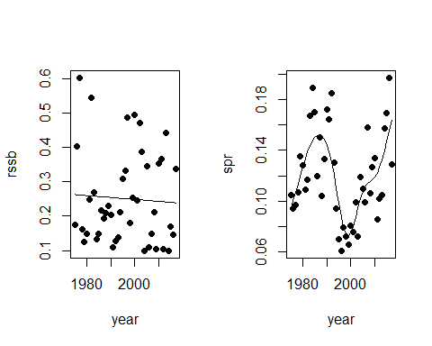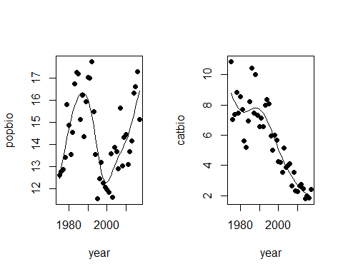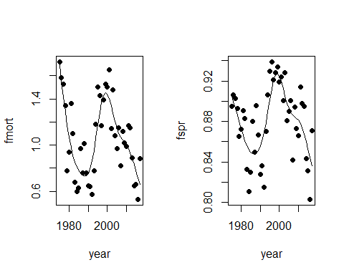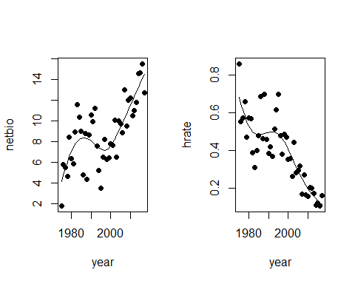

### Spearman Correlations of Environmental Series with Year, 1975-2017

## Call:corr.test(x = mls[c(1:4)], use = "pairwise.complete.obs", method = "spearman",   
## adjust = "fdr", normal = FALSE)  
## Correlation matrix   
## year oni mei pdo  
## year 1.00 -0.08 -0.28 -0.27  
## oni -0.08 1.00 0.95 0.30  
## mei -0.28 0.95 1.00 0.43  
## pdo -0.27 0.30 0.43 1.00  
## Sample Size   
## year oni mei pdo  
## year 43 43 39 43  
## oni 43 43 39 43  
## mei 39 39 39 39  
## pdo 43 43 39 43  
## Probability values (Entries above the diagonal are adjusted for multiple tests.)   
## year oni mei pdo  
## year 0.00 0.60 0.10 0.10  
## oni 0.60 0.00 0.00 0.10  
## mei 0.08 0.00 0.00 0.02  
## pdo 0.08 0.05 0.01 0.00  
##   
## Confidence intervals based upon normal theory. To get bootstrapped values, try cor.ci  
## raw.lower raw.r raw.upper raw.p lower.adj upper.adj  
## year-oni -0.37 -0.08 0.22 0.60 -0.46 0.32  
## year-mei -0.55 -0.28 0.03 0.08 -0.62 0.15  
## year-pdo -0.53 -0.27 0.04 0.08 -0.60 0.14  
## oni-mei 0.90 0.95 0.97 0.00 0.88 0.98  
## oni-pdo 0.00 0.30 0.55 0.05 -0.11 0.62  
## mei-pdo 0.13 0.43 0.65 0.01 0.02 0.71

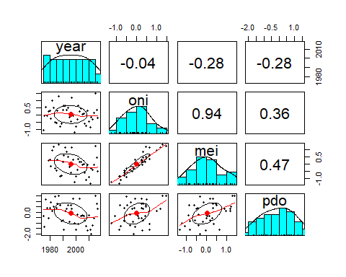

### Spearman Correlations of Fishery Series with Year, 1975-2017

## Call:corr.test(x = mls[c(1, 5:14)], use = "pairwise.complete.obs",   
## method = "spearman", adjust = "fdr", normal = FALSE)  
## Correlation matrix   
## year rec ssb rssb popbio fmort spr catbio fspr netbio hrate  
## year 1.00 -0.78 -0.75 -0.08 -0.02 -0.14 -0.03 -0.87 0.03 0.66 -0.82  
## rec -0.78 1.00 0.66 0.44 0.16 -0.03 0.10 0.67 -0.10 -0.44 0.60  
## ssb -0.75 0.66 1.00 -0.30 0.51 -0.42 0.51 0.76 -0.51 -0.31 0.60  
## rssb -0.08 0.44 -0.30 1.00 -0.48 0.49 -0.52 -0.02 0.52 -0.25 0.10  
## popbio -0.02 0.16 0.51 -0.48 1.00 -0.96 0.95 -0.05 -0.95 0.59 -0.29  
## fmort -0.14 -0.03 -0.42 0.49 -0.96 1.00 -0.91 0.16 0.91 -0.65 0.38  
## spr -0.03 0.10 0.51 -0.52 0.95 -0.91 1.00 -0.08 -1.00 0.60 -0.32  
## catbio -0.87 0.67 0.76 -0.02 -0.05 0.16 -0.08 1.00 0.08 -0.81 0.96  
## fspr 0.03 -0.10 -0.51 0.52 -0.95 0.91 -1.00 0.08 1.00 -0.60 0.32  
## netbio 0.66 -0.44 -0.31 -0.25 0.59 -0.65 0.60 -0.81 -0.60 1.00 -0.93  
## hrate -0.82 0.60 0.60 0.10 -0.29 0.38 -0.32 0.96 0.32 -0.93 1.00  
## Sample Size   
## year rec ssb rssb popbio fmort spr catbio fspr netbio hrate  
## year 43 43 43 43 43 43 43 43 43 43 43  
## rec 43 43 43 43 43 43 43 43 43 43 43  
## ssb 43 43 43 43 43 43 43 43 43 43 43  
## rssb 43 43 43 43 43 43 43 43 43 43 43  
## popbio 43 43 43 43 43 43 43 43 43 43 43  
## fmort 43 43 43 43 43 43 43 43 43 43 43  
## spr 43 43 43 43 43 43 43 43 43 43 43  
## catbio 43 43 43 43 43 43 43 43 43 43 43  
## fspr 43 43 43 43 43 43 43 43 43 43 43  
## netbio 43 43 43 43 43 43 43 43 43 43 43  
## hrate 43 43 43 43 43 43 43 43 43 43 43  
## Probability values (Entries above the diagonal are adjusted for multiple tests.)   
## year rec ssb rssb popbio fmort spr catbio fspr netbio hrate  
## year 0.00 0.00 0.00 0.69 0.88 0.49 0.87 0.00 0.87 0.00 0.00  
## rec 0.00 0.00 0.00 0.01 0.41 0.87 0.63 0.00 0.63 0.01 0.00  
## ssb 0.00 0.00 0.00 0.07 0.00 0.01 0.00 0.00 0.00 0.06 0.00  
## rssb 0.62 0.00 0.05 0.00 0.00 0.00 0.00 0.88 0.00 0.14 0.63  
## popbio 0.88 0.32 0.00 0.00 0.00 0.00 0.00 0.81 0.00 0.00 0.08  
## fmort 0.38 0.83 0.01 0.00 0.00 0.00 0.00 0.41 0.00 0.00 0.02  
## spr 0.84 0.53 0.00 0.00 0.00 0.00 0.00 0.68 0.00 0.00 0.06  
## catbio 0.00 0.00 0.00 0.88 0.74 0.31 0.60 0.00 0.68 0.00 0.00  
## fspr 0.84 0.53 0.00 0.00 0.00 0.00 0.00 0.60 0.00 0.00 0.06  
## netbio 0.00 0.00 0.04 0.10 0.00 0.00 0.00 0.00 0.00 0.00 0.00  
## hrate 0.00 0.00 0.00 0.51 0.06 0.01 0.04 0.00 0.04 0.00 0.00  
##   
## Confidence intervals based upon normal theory. To get bootstrapped values, try cor.ci  
## raw.lower raw.r raw.upper raw.p lower.adj upper.adj  
## year-rec -0.87 -0.78 -0.62 0.00 -0.92 -0.48  
## year-ssb -0.86 -0.75 -0.59 0.00 -0.91 -0.43  
## year-rssb -0.37 -0.08 0.23 0.62 -0.54 0.42  
## year-popbi -0.32 -0.02 0.28 0.88 -0.50 0.46  
## year-fmort -0.42 -0.14 0.17 0.38 -0.58 0.37  
## year-spr -0.33 -0.03 0.27 0.84 -0.51 0.46  
## year-catbi -0.93 -0.87 -0.77 0.00 -0.95 -0.66  
## year-fspr -0.27 0.03 0.33 0.84 -0.46 0.51  
## year-netbi 0.45 0.66 0.80 0.00 0.27 0.87  
## year-hrate -0.90 -0.82 -0.69 0.00 -0.93 -0.56  
## rec-ssb 0.45 0.66 0.80 0.00 0.27 0.87  
## rec-rssb 0.17 0.44 0.66 0.00 -0.05 0.76  
## rec-popbi -0.15 0.16 0.44 0.32 -0.35 0.59  
## rec-fmort -0.33 -0.03 0.27 0.83 -0.51 0.45  
## rec-spr -0.21 0.10 0.39 0.53 -0.40 0.55  
## rec-catbi 0.46 0.67 0.81 0.00 0.28 0.87  
## rec-fspr -0.39 -0.10 0.21 0.53 -0.55 0.40  
## rec-netbi -0.65 -0.44 -0.16 0.00 -0.76 0.05  
## rec-hrate 0.36 0.60 0.76 0.00 0.17 0.84  
## ssb-rssb -0.55 -0.30 0.00 0.05 -0.68 0.21  
## ssb-popbi 0.25 0.51 0.70 0.00 0.04 0.80  
## ssb-fmort -0.64 -0.42 -0.14 0.01 -0.75 0.08  
## ssb-spr 0.24 0.51 0.70 0.00 0.03 0.79  
## ssb-catbi 0.60 0.76 0.87 0.00 0.45 0.91  
## ssb-fspr -0.70 -0.51 -0.24 0.00 -0.79 -0.03  
## ssb-netbi -0.56 -0.31 -0.01 0.04 -0.69 0.20  
## ssb-hrate 0.36 0.60 0.76 0.00 0.16 0.84  
## rssb-popbi -0.68 -0.48 -0.21 0.00 -0.78 0.00  
## rssb-fmort 0.22 0.49 0.69 0.00 0.01 0.78  
## rssb-spr -0.71 -0.52 -0.26 0.00 -0.80 -0.05  
## rssb-catbi -0.32 -0.02 0.28 0.88 -0.50 0.46  
## rssb-fspr 0.26 0.52 0.71 0.00 0.05 0.80  
## rssb-netbi -0.51 -0.25 0.05 0.10 -0.65 0.26  
## rssb-hrate -0.20 0.10 0.39 0.51 -0.40 0.56  
## popbi-fmort -0.98 -0.96 -0.93 0.00 -0.99 -0.90  
## popbi-spr 0.91 0.95 0.97 0.00 0.87 0.98  
## popbi-catbi -0.35 -0.05 0.25 0.74 -0.52 0.44  
## popbi-fspr -0.97 -0.95 -0.91 0.00 -0.98 -0.87  
## popbi-netbi 0.35 0.59 0.76 0.00 0.15 0.83  
## popbi-hrate -0.54 -0.29 0.01 0.06 -0.68 0.22  
## fmort-spr -0.95 -0.91 -0.84 0.00 -0.97 -0.77  
## fmort-catbi -0.15 0.16 0.44 0.31 -0.35 0.59  
## fmort-fspr 0.84 0.91 0.95 0.00 0.77 0.97  
## fmort-netbi -0.80 -0.65 -0.44 0.00 -0.86 -0.25  
## fmort-hrate 0.10 0.38 0.61 0.01 -0.12 0.73  
## spr-catbi -0.37 -0.08 0.22 0.60 -0.54 0.41  
## spr-fspr -1.00 -1.00 -1.00 0.00 -1.00 -1.00  
## spr-netbi 0.36 0.60 0.76 0.00 0.17 0.84  
## spr-hrate -0.57 -0.32 -0.02 0.04 -0.69 0.19  
## catbi-fspr -0.22 0.08 0.37 0.60 -0.41 0.54  
## catbi-netbi -0.90 -0.81 -0.68 0.00 -0.93 -0.55  
## catbi-hrate 0.92 0.96 0.98 0.00 0.88 0.98  
## fspr-netbi -0.76 -0.60 -0.36 0.00 -0.84 -0.17  
## fspr-hrate 0.02 0.32 0.57 0.04 -0.19 0.69  
## netbi-hrate -0.96 -0.93 -0.87 0.00 -0.97 -0.81

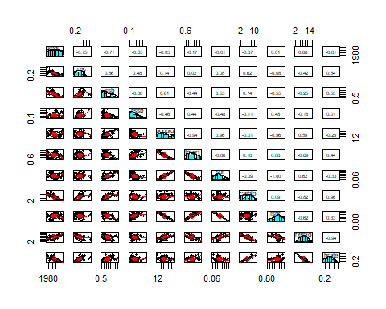

### Spearman Correlations of Fishery Series with ONI, 1975-2017

## Call:corr.test(x = mls[c(2, 5:14)], use = "pairwise.complete.obs",   
## method = "spearman", adjust = "fdr", normal = FALSE)  
## Correlation matrix   
## oni rec ssb rssb popbio fmort spr catbio fspr netbio hrate  
## oni 1.00 0.17 0.26 -0.10 0.36 -0.32 0.29 -0.02 -0.29 0.18 -0.09  
## rec 0.17 1.00 0.66 0.44 0.16 -0.03 0.10 0.67 -0.10 -0.44 0.60  
## ssb 0.26 0.66 1.00 -0.30 0.51 -0.42 0.51 0.76 -0.51 -0.31 0.60  
## rssb -0.10 0.44 -0.30 1.00 -0.48 0.49 -0.52 -0.02 0.52 -0.25 0.10  
## popbio 0.36 0.16 0.51 -0.48 1.00 -0.96 0.95 -0.05 -0.95 0.59 -0.29  
## fmort -0.32 -0.03 -0.42 0.49 -0.96 1.00 -0.91 0.16 0.91 -0.65 0.38  
## spr 0.29 0.10 0.51 -0.52 0.95 -0.91 1.00 -0.08 -1.00 0.60 -0.32  
## catbio -0.02 0.67 0.76 -0.02 -0.05 0.16 -0.08 1.00 0.08 -0.81 0.96  
## fspr -0.29 -0.10 -0.51 0.52 -0.95 0.91 -1.00 0.08 1.00 -0.60 0.32  
## netbio 0.18 -0.44 -0.31 -0.25 0.59 -0.65 0.60 -0.81 -0.60 1.00 -0.93  
## hrate -0.09 0.60 0.60 0.10 -0.29 0.38 -0.32 0.96 0.32 -0.93 1.00  
## Sample Size   
## oni rec ssb rssb popbio fmort spr catbio fspr netbio hrate  
## oni 43 43 43 43 43 43 43 43 43 43 43  
## rec 43 43 43 43 43 43 43 43 43 43 43  
## ssb 43 43 43 43 43 43 43 43 43 43 43  
## rssb 43 43 43 43 43 43 43 43 43 43 43  
## popbio 43 43 43 43 43 43 43 43 43 43 43  
## fmort 43 43 43 43 43 43 43 43 43 43 43  
## spr 43 43 43 43 43 43 43 43 43 43 43  
## catbio 43 43 43 43 43 43 43 43 43 43 43  
## fspr 43 43 43 43 43 43 43 43 43 43 43  
## netbio 43 43 43 43 43 43 43 43 43 43 43  
## hrate 43 43 43 43 43 43 43 43 43 43 43  
## Probability values (Entries above the diagonal are adjusted for multiple tests.)   
## oni rec ssb rssb popbio fmort spr catbio fspr netbio hrate  
## oni 0.00 0.36 0.13 0.60 0.03 0.07 0.08 0.89 0.08 0.35 0.64  
## rec 0.28 0.00 0.00 0.01 0.39 0.86 0.60 0.00 0.60 0.01 0.00  
## ssb 0.09 0.00 0.00 0.08 0.00 0.01 0.00 0.00 0.00 0.07 0.00  
## rssb 0.52 0.00 0.05 0.00 0.00 0.00 0.00 0.89 0.00 0.14 0.60  
## popbio 0.02 0.32 0.00 0.00 0.00 0.00 0.00 0.78 0.00 0.00 0.08  
## fmort 0.04 0.83 0.01 0.00 0.00 0.00 0.00 0.39 0.00 0.00 0.02  
## spr 0.06 0.53 0.00 0.00 0.00 0.00 0.00 0.64 0.00 0.00 0.06  
## catbio 0.89 0.00 0.00 0.88 0.74 0.31 0.60 0.00 0.64 0.00 0.00  
## fspr 0.06 0.53 0.00 0.00 0.00 0.00 0.00 0.60 0.00 0.00 0.06  
## netbio 0.26 0.00 0.04 0.10 0.00 0.00 0.00 0.00 0.00 0.00 0.00  
## hrate 0.58 0.00 0.00 0.51 0.06 0.01 0.04 0.00 0.04 0.00 0.00  
##   
## Confidence intervals based upon normal theory. To get bootstrapped values, try cor.ci  
## raw.lower raw.r raw.upper raw.p lower.adj upper.adj  
## oni-rec -0.14 0.17 0.45 0.28 -0.34 0.60  
## oni-ssb -0.05 0.26 0.52 0.09 -0.25 0.66  
## oni-rssb -0.39 -0.10 0.21 0.52 -0.55 0.40  
## oni-popbi 0.06 0.36 0.59 0.02 -0.15 0.72  
## oni-fmort -0.56 -0.32 -0.02 0.04 -0.69 0.20  
## oni-spr -0.01 0.29 0.54 0.06 -0.22 0.68  
## oni-catbi -0.32 -0.02 0.28 0.89 -0.50 0.46  
## oni-fspr -0.54 -0.29 0.01 0.06 -0.68 0.22  
## oni-netbi -0.13 0.18 0.45 0.26 -0.33 0.61  
## oni-hrate -0.38 -0.09 0.22 0.58 -0.55 0.41  
## rec-ssb 0.45 0.66 0.80 0.00 0.27 0.87  
## rec-rssb 0.17 0.44 0.66 0.00 -0.05 0.76  
## rec-popbi -0.15 0.16 0.44 0.32 -0.35 0.59  
## rec-fmort -0.33 -0.03 0.27 0.83 -0.51 0.45  
## rec-spr -0.21 0.10 0.39 0.53 -0.40 0.55  
## rec-catbi 0.46 0.67 0.81 0.00 0.28 0.87  
## rec-fspr -0.39 -0.10 0.21 0.53 -0.55 0.40  
## rec-netbi -0.65 -0.44 -0.16 0.00 -0.76 0.05  
## rec-hrate 0.36 0.60 0.76 0.00 0.17 0.84  
## ssb-rssb -0.55 -0.30 0.00 0.05 -0.68 0.21  
## ssb-popbi 0.25 0.51 0.70 0.00 0.04 0.80  
## ssb-fmort -0.64 -0.42 -0.14 0.01 -0.75 0.08  
## ssb-spr 0.24 0.51 0.70 0.00 0.03 0.79  
## ssb-catbi 0.60 0.76 0.87 0.00 0.45 0.91  
## ssb-fspr -0.70 -0.51 -0.24 0.00 -0.79 -0.03  
## ssb-netbi -0.56 -0.31 -0.01 0.04 -0.69 0.20  
## ssb-hrate 0.36 0.60 0.76 0.00 0.16 0.84  
## rssb-popbi -0.68 -0.48 -0.21 0.00 -0.78 0.00  
## rssb-fmort 0.22 0.49 0.69 0.00 0.01 0.78  
## rssb-spr -0.71 -0.52 -0.26 0.00 -0.80 -0.05  
## rssb-catbi -0.32 -0.02 0.28 0.88 -0.50 0.46  
## rssb-fspr 0.26 0.52 0.71 0.00 0.05 0.80  
## rssb-netbi -0.51 -0.25 0.05 0.10 -0.65 0.26  
## rssb-hrate -0.20 0.10 0.39 0.51 -0.40 0.56  
## popbi-fmort -0.98 -0.96 -0.93 0.00 -0.99 -0.90  
## popbi-spr 0.91 0.95 0.97 0.00 0.87 0.98  
## popbi-catbi -0.35 -0.05 0.25 0.74 -0.52 0.44  
## popbi-fspr -0.97 -0.95 -0.91 0.00 -0.98 -0.87  
## popbi-netbi 0.35 0.59 0.76 0.00 0.15 0.83  
## popbi-hrate -0.54 -0.29 0.01 0.06 -0.68 0.22  
## fmort-spr -0.95 -0.91 -0.84 0.00 -0.97 -0.77  
## fmort-catbi -0.15 0.16 0.44 0.31 -0.35 0.59  
## fmort-fspr 0.84 0.91 0.95 0.00 0.77 0.97  
## fmort-netbi -0.80 -0.65 -0.44 0.00 -0.86 -0.25  
## fmort-hrate 0.10 0.38 0.61 0.01 -0.12 0.73  
## spr-catbi -0.37 -0.08 0.22 0.60 -0.54 0.41  
## spr-fspr -1.00 -1.00 -1.00 0.00 -1.00 -1.00  
## spr-netbi 0.36 0.60 0.76 0.00 0.17 0.84  
## spr-hrate -0.57 -0.32 -0.02 0.04 -0.69 0.19  
## catbi-fspr -0.22 0.08 0.37 0.60 -0.41 0.54  
## catbi-netbi -0.90 -0.81 -0.68 0.00 -0.93 -0.55  
## catbi-hrate 0.92 0.96 0.98 0.00 0.88 0.98  
## fspr-netbi -0.76 -0.60 -0.36 0.00 -0.84 -0.17  
## fspr-hrate 0.02 0.32 0.57 0.04 -0.19 0.69  
## netbi-hrate -0.96 -0.93 -0.87 0.00 -0.97 -0.81

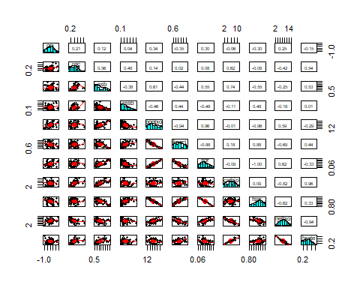

### Spearman Correlations of Fishery Series with MEI, 1979-2017

## Call:corr.test(x = mls[c(3, 5:14)], use = "pairwise.complete.obs",   
## method = "spearman", adjust = "fdr", normal = FALSE)  
## Correlation matrix   
## mei rec ssb rssb popbio fmort spr catbio fspr netbio hrate  
## mei 1.00 0.26 0.44 -0.19 0.37 -0.34 0.32 0.19 -0.32 0.03 0.10  
## rec 0.26 1.00 0.66 0.44 0.16 -0.03 0.10 0.67 -0.10 -0.44 0.60  
## ssb 0.44 0.66 1.00 -0.30 0.51 -0.42 0.51 0.76 -0.51 -0.31 0.60  
## rssb -0.19 0.44 -0.30 1.00 -0.48 0.49 -0.52 -0.02 0.52 -0.25 0.10  
## popbio 0.37 0.16 0.51 -0.48 1.00 -0.96 0.95 -0.05 -0.95 0.59 -0.29  
## fmort -0.34 -0.03 -0.42 0.49 -0.96 1.00 -0.91 0.16 0.91 -0.65 0.38  
## spr 0.32 0.10 0.51 -0.52 0.95 -0.91 1.00 -0.08 -1.00 0.60 -0.32  
## catbio 0.19 0.67 0.76 -0.02 -0.05 0.16 -0.08 1.00 0.08 -0.81 0.96  
## fspr -0.32 -0.10 -0.51 0.52 -0.95 0.91 -1.00 0.08 1.00 -0.60 0.32  
## netbio 0.03 -0.44 -0.31 -0.25 0.59 -0.65 0.60 -0.81 -0.60 1.00 -0.93  
## hrate 0.10 0.60 0.60 0.10 -0.29 0.38 -0.32 0.96 0.32 -0.93 1.00  
## Sample Size   
## mei rec ssb rssb popbio fmort spr catbio fspr netbio hrate  
## mei 39 39 39 39 39 39 39 39 39 39 39  
## rec 39 43 43 43 43 43 43 43 43 43 43  
## ssb 39 43 43 43 43 43 43 43 43 43 43  
## rssb 39 43 43 43 43 43 43 43 43 43 43  
## popbio 39 43 43 43 43 43 43 43 43 43 43  
## fmort 39 43 43 43 43 43 43 43 43 43 43  
## spr 39 43 43 43 43 43 43 43 43 43 43  
## catbio 39 43 43 43 43 43 43 43 43 43 43  
## fspr 39 43 43 43 43 43 43 43 43 43 43  
## netbio 39 43 43 43 43 43 43 43 43 43 43  
## hrate 39 43 43 43 43 43 43 43 43 43 43  
## Probability values (Entries above the diagonal are adjusted for multiple tests.)   
## mei rec ssb rssb popbio fmort spr catbio fspr netbio hrate  
## mei 0.00 0.16 0.01 0.32 0.04 0.06 0.07 0.32 0.07 0.86 0.59  
## rec 0.12 0.00 0.00 0.01 0.39 0.86 0.59 0.00 0.59 0.01 0.00  
## ssb 0.01 0.00 0.00 0.07 0.00 0.01 0.00 0.00 0.00 0.07 0.00  
## rssb 0.25 0.00 0.05 0.00 0.00 0.00 0.00 0.88 0.00 0.14 0.59  
## popbio 0.02 0.32 0.00 0.00 0.00 0.00 0.00 0.78 0.00 0.00 0.08  
## fmort 0.04 0.83 0.01 0.00 0.00 0.00 0.00 0.39 0.00 0.00 0.02  
## spr 0.05 0.53 0.00 0.00 0.00 0.00 0.00 0.64 0.00 0.00 0.06  
## catbio 0.25 0.00 0.00 0.88 0.74 0.31 0.60 0.00 0.64 0.00 0.00  
## fspr 0.05 0.53 0.00 0.00 0.00 0.00 0.00 0.60 0.00 0.00 0.06  
## netbio 0.85 0.00 0.04 0.10 0.00 0.00 0.00 0.00 0.00 0.00 0.00  
## hrate 0.53 0.00 0.00 0.51 0.06 0.01 0.04 0.00 0.04 0.00 0.00  
##   
## Confidence intervals based upon normal theory. To get bootstrapped values, try cor.ci  
## raw.lower raw.r raw.upper raw.p lower.adj upper.adj  
## mei-rec -0.06 0.26 0.53 0.12 -0.28 0.67  
## mei-ssb 0.14 0.44 0.66 0.01 -0.09 0.77  
## mei-rssb -0.48 -0.19 0.13 0.25 -0.63 0.35  
## mei-popbi 0.06 0.37 0.62 0.02 -0.16 0.74  
## mei-fmort -0.59 -0.34 -0.02 0.04 -0.72 0.20  
## mei-spr 0.01 0.32 0.58 0.05 -0.22 0.71  
## mei-catbi -0.14 0.19 0.48 0.25 -0.35 0.63  
## mei-fspr -0.58 -0.32 -0.01 0.05 -0.71 0.22  
## mei-netbi -0.29 0.03 0.34 0.85 -0.48 0.53  
## mei-hrate -0.22 0.10 0.41 0.53 -0.42 0.58  
## rec-ssb 0.45 0.66 0.80 0.00 0.27 0.87  
## rec-rssb 0.17 0.44 0.66 0.00 -0.05 0.76  
## rec-popbi -0.15 0.16 0.44 0.32 -0.35 0.59  
## rec-fmort -0.33 -0.03 0.27 0.83 -0.51 0.45  
## rec-spr -0.21 0.10 0.39 0.53 -0.40 0.55  
## rec-catbi 0.46 0.67 0.81 0.00 0.28 0.87  
## rec-fspr -0.39 -0.10 0.21 0.53 -0.55 0.40  
## rec-netbi -0.65 -0.44 -0.16 0.00 -0.76 0.05  
## rec-hrate 0.36 0.60 0.76 0.00 0.17 0.84  
## ssb-rssb -0.55 -0.30 0.00 0.05 -0.68 0.21  
## ssb-popbi 0.25 0.51 0.70 0.00 0.04 0.80  
## ssb-fmort -0.64 -0.42 -0.14 0.01 -0.75 0.08  
## ssb-spr 0.24 0.51 0.70 0.00 0.03 0.79  
## ssb-catbi 0.60 0.76 0.87 0.00 0.45 0.91  
## ssb-fspr -0.70 -0.51 -0.24 0.00 -0.79 -0.03  
## ssb-netbi -0.56 -0.31 -0.01 0.04 -0.69 0.20  
## ssb-hrate 0.36 0.60 0.76 0.00 0.16 0.84  
## rssb-popbi -0.68 -0.48 -0.21 0.00 -0.78 0.00  
## rssb-fmort 0.22 0.49 0.69 0.00 0.01 0.78  
## rssb-spr -0.71 -0.52 -0.26 0.00 -0.80 -0.05  
## rssb-catbi -0.32 -0.02 0.28 0.88 -0.50 0.46  
## rssb-fspr 0.26 0.52 0.71 0.00 0.05 0.80  
## rssb-netbi -0.51 -0.25 0.05 0.10 -0.65 0.26  
## rssb-hrate -0.20 0.10 0.39 0.51 -0.40 0.56  
## popbi-fmort -0.98 -0.96 -0.93 0.00 -0.99 -0.90  
## popbi-spr 0.91 0.95 0.97 0.00 0.87 0.98  
## popbi-catbi -0.35 -0.05 0.25 0.74 -0.52 0.44  
## popbi-fspr -0.97 -0.95 -0.91 0.00 -0.98 -0.87  
## popbi-netbi 0.35 0.59 0.76 0.00 0.15 0.83  
## popbi-hrate -0.54 -0.29 0.01 0.06 -0.68 0.22  
## fmort-spr -0.95 -0.91 -0.84 0.00 -0.97 -0.77  
## fmort-catbi -0.15 0.16 0.44 0.31 -0.35 0.59  
## fmort-fspr 0.84 0.91 0.95 0.00 0.77 0.97  
## fmort-netbi -0.80 -0.65 -0.44 0.00 -0.86 -0.25  
## fmort-hrate 0.10 0.38 0.61 0.01 -0.12 0.73  
## spr-catbi -0.37 -0.08 0.22 0.60 -0.54 0.41  
## spr-fspr -1.00 -1.00 -1.00 0.00 -1.00 -1.00  
## spr-netbi 0.36 0.60 0.76 0.00 0.17 0.84  
## spr-hrate -0.57 -0.32 -0.02 0.04 -0.69 0.19  
## catbi-fspr -0.22 0.08 0.37 0.60 -0.41 0.54  
## catbi-netbi -0.90 -0.81 -0.68 0.00 -0.93 -0.55  
## catbi-hrate 0.92 0.96 0.98 0.00 0.88 0.98  
## fspr-netbi -0.76 -0.60 -0.36 0.00 -0.84 -0.17  
## fspr-hrate 0.02 0.32 0.57 0.04 -0.19 0.69  
## netbi-hrate -0.96 -0.93 -0.87 0.00 -0.97 -0.81

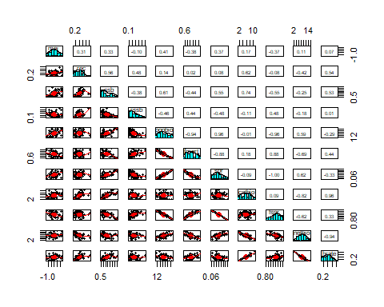

### Spearman Correlations of Fishery Series with PDO, 1975-2017

## Call:corr.test(x = mls[c(4, 5:14)], use = "pairwise.complete.obs",   
## method = "spearman", normal = FALSE)  
## Correlation matrix   
## pdo rec ssb rssb popbio fmort spr catbio fspr netbio hrate  
## pdo 1.00 0.28 0.37 0.01 0.19 -0.15 0.17 0.31 -0.17 -0.21 0.31  
## rec 0.28 1.00 0.66 0.44 0.16 -0.03 0.10 0.67 -0.10 -0.44 0.60  
## ssb 0.37 0.66 1.00 -0.30 0.51 -0.42 0.51 0.76 -0.51 -0.31 0.60  
## rssb 0.01 0.44 -0.30 1.00 -0.48 0.49 -0.52 -0.02 0.52 -0.25 0.10  
## popbio 0.19 0.16 0.51 -0.48 1.00 -0.96 0.95 -0.05 -0.95 0.59 -0.29  
## fmort -0.15 -0.03 -0.42 0.49 -0.96 1.00 -0.91 0.16 0.91 -0.65 0.38  
## spr 0.17 0.10 0.51 -0.52 0.95 -0.91 1.00 -0.08 -1.00 0.60 -0.32  
## catbio 0.31 0.67 0.76 -0.02 -0.05 0.16 -0.08 1.00 0.08 -0.81 0.96  
## fspr -0.17 -0.10 -0.51 0.52 -0.95 0.91 -1.00 0.08 1.00 -0.60 0.32  
## netbio -0.21 -0.44 -0.31 -0.25 0.59 -0.65 0.60 -0.81 -0.60 1.00 -0.93  
## hrate 0.31 0.60 0.60 0.10 -0.29 0.38 -0.32 0.96 0.32 -0.93 1.00  
## Sample Size   
## pdo rec ssb rssb popbio fmort spr catbio fspr netbio hrate  
## pdo 43 43 43 43 43 43 43 43 43 43 43  
## rec 43 43 43 43 43 43 43 43 43 43 43  
## ssb 43 43 43 43 43 43 43 43 43 43 43  
## rssb 43 43 43 43 43 43 43 43 43 43 43  
## popbio 43 43 43 43 43 43 43 43 43 43 43  
## fmort 43 43 43 43 43 43 43 43 43 43 43  
## spr 43 43 43 43 43 43 43 43 43 43 43  
## catbio 43 43 43 43 43 43 43 43 43 43 43  
## fspr 43 43 43 43 43 43 43 43 43 43 43  
## netbio 43 43 43 43 43 43 43 43 43 43 43  
## hrate 43 43 43 43 43 43 43 43 43 43 43  
## Probability values (Entries above the diagonal are adjusted for multiple tests.)   
## pdo rec ssb rssb popbio fmort spr catbio fspr netbio hrate  
## pdo 0.00 1.00 0.39 1.00 1.00 1.00 1.00 0.94 1.00 1.00 0.95  
## rec 0.07 0.00 0.00 0.09 1.00 1.00 1.00 0.00 1.00 0.09 0.00  
## ssb 0.02 0.00 0.00 1.00 0.02 0.14 0.02 0.00 0.02 0.94 0.00  
## rssb 0.94 0.00 0.05 0.00 0.04 0.03 0.01 1.00 0.01 1.00 1.00  
## popbio 0.23 0.32 0.00 0.00 0.00 0.00 0.00 1.00 0.00 0.00 1.00  
## fmort 0.35 0.83 0.01 0.00 0.00 0.00 0.00 1.00 0.00 0.00 0.29  
## spr 0.28 0.53 0.00 0.00 0.00 0.00 0.00 1.00 0.00 0.00 0.90  
## catbio 0.04 0.00 0.00 0.88 0.74 0.31 0.60 0.00 1.00 0.00 0.00  
## fspr 0.28 0.53 0.00 0.00 0.00 0.00 0.00 0.60 0.00 0.00 0.90  
## netbio 0.18 0.00 0.04 0.10 0.00 0.00 0.00 0.00 0.00 0.00 0.00  
## hrate 0.05 0.00 0.00 0.51 0.06 0.01 0.04 0.00 0.04 0.00 0.00  
##   
## Confidence intervals based upon normal theory. To get bootstrapped values, try cor.ci  
## raw.lower raw.r raw.upper raw.p lower.adj upper.adj  
## pdo-rec -0.02 0.28 0.54 0.07 -0.18 0.64  
## pdo-ssb 0.08 0.37 0.60 0.02 -0.10 0.70  
## pdo-rssb -0.29 0.01 0.31 0.94 -0.29 0.31  
## pdo-popbi -0.12 0.19 0.46 0.23 -0.27 0.57  
## pdo-fmort -0.43 -0.15 0.16 0.35 -0.53 0.29  
## pdo-spr -0.14 0.17 0.45 0.28 -0.28 0.56  
## pdo-catbi 0.01 0.31 0.56 0.04 -0.16 0.67  
## pdo-fspr -0.45 -0.17 0.14 0.28 -0.56 0.28  
## pdo-netbi -0.48 -0.21 0.10 0.18 -0.59 0.25  
## pdo-hrate 0.01 0.31 0.56 0.05 -0.16 0.66  
## rec-ssb 0.45 0.66 0.80 0.00 0.28 0.87  
## rec-rssb 0.17 0.44 0.66 0.00 -0.02 0.75  
## rec-popbi -0.15 0.16 0.44 0.32 -0.28 0.54  
## rec-fmort -0.33 -0.03 0.27 0.83 -0.39 0.33  
## rec-spr -0.21 0.10 0.39 0.53 -0.32 0.49  
## rec-catbi 0.46 0.67 0.81 0.00 0.29 0.87  
## rec-fspr -0.39 -0.10 0.21 0.53 -0.48 0.31  
## rec-netbi -0.65 -0.44 -0.16 0.00 -0.75 0.02  
## rec-hrate 0.36 0.60 0.76 0.00 0.18 0.83  
## ssb-rssb -0.55 -0.30 0.00 0.05 -0.66 0.17  
## ssb-popbi 0.25 0.51 0.70 0.00 0.06 0.79  
## ssb-fmort -0.64 -0.42 -0.14 0.01 -0.74 0.05  
## ssb-spr 0.24 0.51 0.70 0.00 0.06 0.79  
## ssb-catbi 0.60 0.76 0.87 0.00 0.45 0.91  
## ssb-fspr -0.70 -0.51 -0.24 0.00 -0.79 -0.06  
## ssb-netbi -0.56 -0.31 -0.01 0.04 -0.67 0.16  
## ssb-hrate 0.36 0.60 0.76 0.00 0.18 0.83  
## rssb-popbi -0.68 -0.48 -0.21 0.00 -0.77 -0.02  
## rssb-fmort 0.22 0.49 0.69 0.00 0.03 0.77  
## rssb-spr -0.71 -0.52 -0.26 0.00 -0.79 -0.07  
## rssb-catbi -0.32 -0.02 0.28 0.88 -0.36 0.32  
## rssb-fspr 0.26 0.52 0.71 0.00 0.07 0.79  
## rssb-netbi -0.51 -0.25 0.05 0.10 -0.62 0.21  
## rssb-hrate -0.20 0.10 0.39 0.51 -0.32 0.50  
## popbi-fmort -0.98 -0.96 -0.93 0.00 -0.99 -0.90  
## popbi-spr 0.91 0.95 0.97 0.00 0.87 0.98  
## popbi-catbi -0.35 -0.05 0.25 0.74 -0.42 0.33  
## popbi-fspr -0.97 -0.95 -0.91 0.00 -0.98 -0.87  
## popbi-netbi 0.35 0.59 0.76 0.00 0.17 0.83  
## popbi-hrate -0.54 -0.29 0.01 0.06 -0.65 0.17  
## fmort-spr -0.95 -0.91 -0.84 0.00 -0.97 -0.77  
## fmort-catbi -0.15 0.16 0.44 0.31 -0.29 0.55  
## fmort-fspr 0.84 0.91 0.95 0.00 0.77 0.97  
## fmort-netbi -0.80 -0.65 -0.44 0.00 -0.86 -0.26  
## fmort-hrate 0.10 0.38 0.61 0.01 -0.09 0.72  
## spr-catbi -0.37 -0.08 0.22 0.60 -0.46 0.32  
## spr-fspr -1.00 -1.00 -1.00 0.00 -1.00 -1.00  
## spr-netbi 0.36 0.60 0.76 0.00 0.18 0.83  
## spr-hrate -0.57 -0.32 -0.02 0.04 -0.67 0.15  
## catbi-fspr -0.22 0.08 0.37 0.60 -0.31 0.45  
## catbi-netbi -0.90 -0.81 -0.68 0.00 -0.93 -0.55  
## catbi-hrate 0.92 0.96 0.98 0.00 0.88 0.98  
## fspr-netbi -0.76 -0.60 -0.36 0.00 -0.83 -0.18  
## fspr-hrate 0.02 0.32 0.57 0.04 -0.16 0.68  
## netbi-hrate -0.96 -0.93 -0.87 0.00 -0.97 -0.81

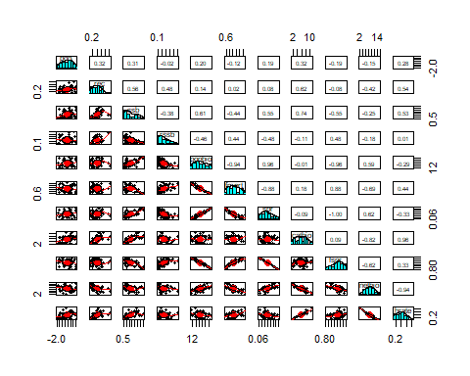

## Change Point Analyses

### Recruitment Change Point Analyses

#### Pruned Exact Linear Time Algorithm

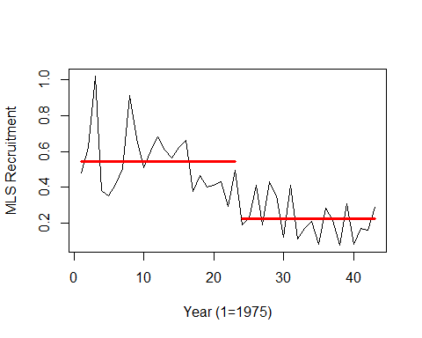

## [1] "Number of change points, Change points, Segment means, Segment standard deviations"

## [1] 1.0000000 23.0000000 0.5423913 0.2240000 0.1703826 0.1097921

### Spawning Biomass Change Point Analyses

#### Pruned Exact Linear Time Algorithm

## Created Using changepoint version 2.2.4   
## Changepoint type : Change in mean and variance   
## Method of analysis : PELT   
## Test Statistic : Normal   
## Type of penalty : MBIC with value, 15.0448   
## Minimum Segment Length : 2   
## Maximum no. of cpts : Inf   
## Changepoint Locations : 21

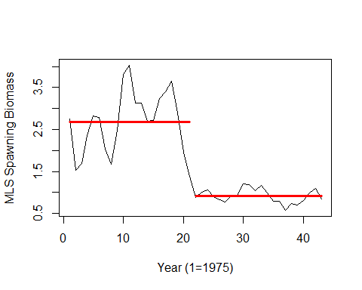

## [1] "Number of change points, Change points, Segment means, Segment standard deviations"

## [1] 1.0000000 21.0000000 2.6754286 0.9185000 0.7374507 0.1621096

### Recruits per Spawning Biomass Change Point Analyses

#### Pruned Exact Linear Time Algorithm

## Created Using changepoint version 2.2.4   
## Changepoint type : Change in mean and variance   
## Method of analysis : PELT   
## Test Statistic : Normal   
## Type of penalty : MBIC with value, 15.0448   
## Minimum Segment Length : 2   
## Maximum no. of cpts : Inf   
## Changepoint Locations :

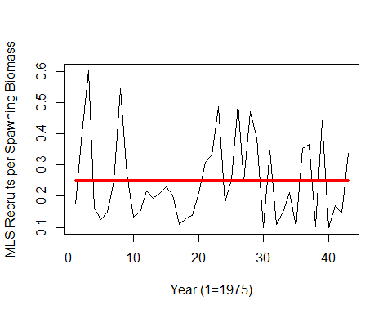

## [1] "Number of change points, Change points, Segment means, Segment standard deviations"

## [1] 0.0000000 0.2513256 0.1340439

### Spawning Potential Ratio Change Point Analyses

#### Pruned Exact Linear Time Algorithm

## Created Using changepoint version 2.2.4   
## Changepoint type : Change in mean and variance   
## Method of analysis : PELT   
## Test Statistic : Normal   
## Type of penalty : MBIC with value, 15.0448   
## Minimum Segment Length : 2   
## Maximum no. of cpts : Inf   
## Changepoint Locations : 4 19 29

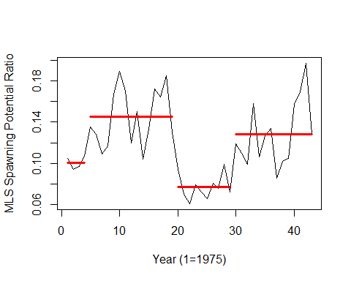

## [1] "Number of change points, Change points, Segment means, Segment standard deviations"

## [1] 3.000000000 4.000000000 19.000000000 29.000000000 0.100750000  
## [6] 0.144866667 0.077000000 0.128428571 0.005402546 0.026961372  
## [11] 0.011269428 0.030375541

### Population Biomass Change Point Analyses

#### Pruned Exact Linear Time Algorithm

## Created Using changepoint version 2.2.4   
## Changepoint type : Change in mean and variance   
## Method of analysis : PELT   
## Test Statistic : Normal   
## Type of penalty : MBIC with value, 15.0448   
## Minimum Segment Length : 2   
## Maximum no. of cpts : Inf   
## Changepoint Locations : 3 19 39

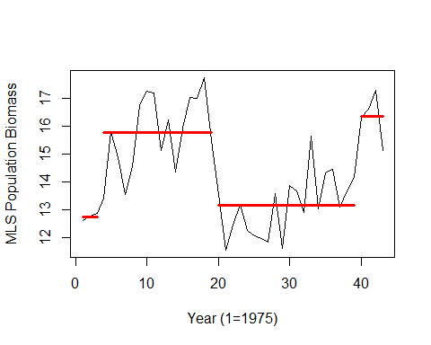

## [1] "Number of change points, Change points, Segment means, Segment standard deviations"

## [1] 3.00000000 3.00000000 19.00000000 39.00000000 12.75800000 15.77812500  
## [7] 13.15550000 16.35050000 0.09625314 1.31566660 1.05551298 0.78975518

### Catch Biomass Change Point Analyses

#### Pruned Exact Linear Time Algorithm

## Created Using changepoint version 2.2.4   
## Changepoint type : Change in mean and variance   
## Method of analysis : PELT   
## Test Statistic : Normal   
## Type of penalty : MBIC with value, 15.0448   
## Minimum Segment Length : 2   
## Maximum no. of cpts : Inf   
## Changepoint Locations : 25 34

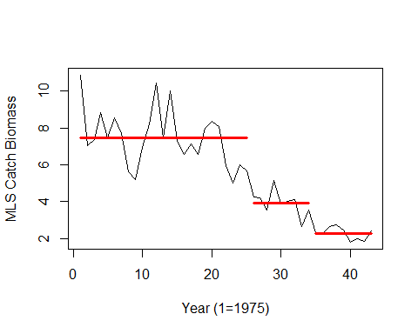

## [1] "Number of change points, Change points, Segment means, Segment standard deviations"

## [1] 2.0000000 25.0000000 34.0000000 7.4512756 3.9336656 2.2792233 1.5008045  
## [8] 0.6348752 0.3193690

### Fishing Mortality Change Point Analyses

#### Pruned Exact Linear Time Algorithm

## Created Using changepoint version 2.2.4   
## Changepoint type : Change in mean and variance   
## Method of analysis : PELT   
## Test Statistic : Normal   
## Type of penalty : MBIC with value, 15.0448   
## Minimum Segment Length : 2   
## Maximum no. of cpts : Inf   
## Changepoint Locations :

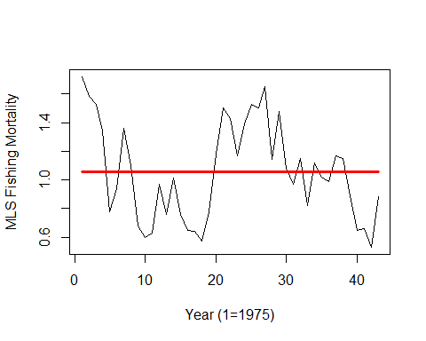

## [1] "Number of change points, Change points, Segment means, Segment standard deviations"

## [1] 0.0000000 1.0569767 0.3330587

### Fishing Intensity Change Point Analyses

#### Pruned Exact Linear Time Algorithm

## Created Using changepoint version 2.2.4   
## Changepoint type : Change in mean and variance   
## Method of analysis : PELT   
## Test Statistic : Normal   
## Type of penalty : MBIC with value, 15.0448   
## Minimum Segment Length : 2   
## Maximum no. of cpts : Inf   
## Changepoint Locations : 4 19 29

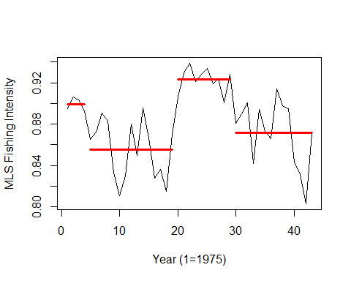

## [1] "Number of change points, Change points, Segment means, Segment standard deviations"

## [1] 3.000000000 4.000000000 19.000000000 29.000000000 0.899250000  
## [6] 0.855133333 0.923000000 0.871571429 0.005402546 0.026961372  
## [11] 0.011269428 0.030375541

### Net Biomass Change Point Analyses

#### Pruned Exact Linear Time Algorithm

## Created Using changepoint version 2.2.4   
## Changepoint type : Change in mean and variance   
## Method of analysis : PELT   
## Test Statistic : Normal   
## Type of penalty : MBIC with value, 15.0448   
## Minimum Segment Length : 2   
## Maximum no. of cpts : Inf   
## Changepoint Locations : 32

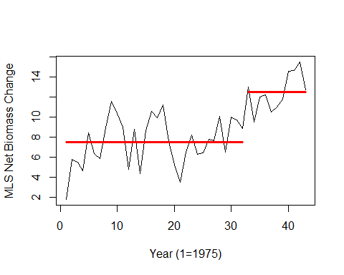

## [1] "Number of change points, Change points, Segment means, Segment standard deviations"

## [1] 1.000000 32.000000 7.496442 12.468362 2.348322 1.767508

### Harvest Rate Change Point Analyses

#### Pruned Exact Linear Time Algorithm

## Created Using changepoint version 2.2.4   
## Changepoint type : Change in mean and variance   
## Method of analysis : PELT   
## Test Statistic : Normal   
## Type of penalty : MBIC with value, 15.0448   
## Minimum Segment Length : 2   
## Maximum no. of cpts : Inf   
## Changepoint Locations : 25 27 34

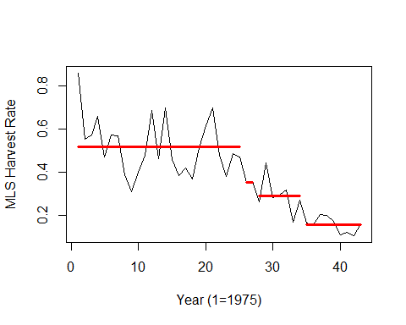

## [1] "Number of change points, Change points, Segment means, Segment standard deviations"

## [1] 3.000000e+00 2.500000e+01 2.700000e+01 3.400000e+01 5.181665e-01  
## [6] 3.545353e-01 2.915231e-01 1.547199e-01 1.277120e-01 4.807614e-04  
## [11] 7.585825e-02 3.399009e-02

### Oceanic Nino Index Change Point Analyses

#### Pruned Exact Linear Time Algorithm

## Created Using changepoint version 2.2.4   
## Changepoint type : Change in mean and variance   
## Method of analysis : PELT   
## Test Statistic : Normal   
## Type of penalty : MBIC with value, 15.0448   
## Minimum Segment Length : 2   
## Maximum no. of cpts : Inf   
## Changepoint Locations :

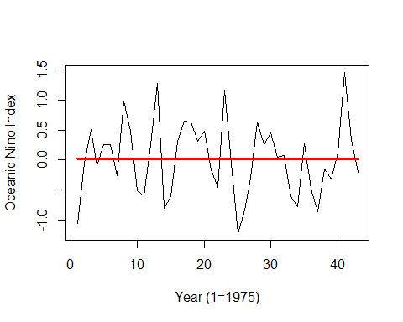

## [1] "Number of change points, Change points, Segment means, Segment standard deviations"

## [1] 0.00000000 0.01769767 0.61728116

### Multivariate ENSO Index Change Point Analyses

#### Pruned Exact Linear Time Algorithm

## Created Using changepoint version 2.2.4   
## Changepoint type : Change in mean and variance   
## Method of analysis : PELT   
## Test Statistic : Normal   
## Type of penalty : MBIC with value, 14.65425   
## Minimum Segment Length : 2   
## Maximum no. of cpts : Inf   
## Changepoint Locations :

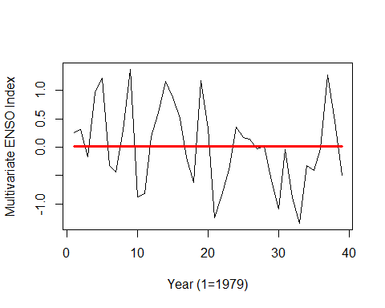

## [1] "Number of change points, Change points, Segment means, Segment standard deviations"

## [1] 0.00000000 0.01376923 0.71691860

### Pacific Decadal Oscillation Change Point Analyses

#### Pruned Exact Linear Time Algorithm

## Created Using changepoint version 2.2.4   
## Changepoint type : Change in mean and variance   
## Method of analysis : PELT   
## Test Statistic : Normal   
## Type of penalty : MBIC with value, 15.0448   
## Minimum Segment Length : 2   
## Maximum no. of cpts : Inf   
## Changepoint Locations :

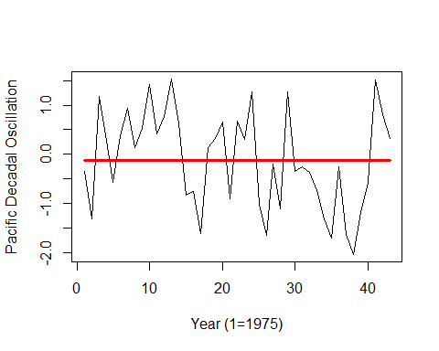

## [1] "Number of change points, Change points, Segment means, Segment standard deviations"

## [1] 0.0000000 -0.1211628 0.9786228

## Autocorrelation Function Analyses

### Recruitment ACF Analysis

## [1] "ACF for rec series"

## [1] "Number of signifcant ACF lags (n):"  
## [1] 8  
## [1] "Significant ACF lags are:"  
## [1] 1 2 3 4 5 6 7 8  
## [1] "Significant ACF values (1:n) are:"  
## [1] 0.5661556 0.4960643 0.4992045 0.3805030 0.6044915 0.4426688 0.3569259  
## [8] 0.3982441

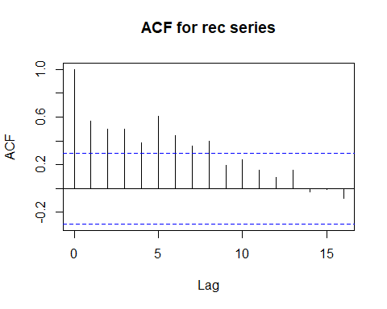

### Spawning Biomass ACF Analysis

## [1] "ACF for ssb series"

## [1] "Number of signifcant ACF lags (n):"  
## [1] 7  
## [1] "Significant ACF lags are:"  
## [1] 1 2 3 4 5 6 7  
## [1] "Significant ACF values (1:n) are:"  
## [1] 0.8784673 0.7269971 0.6248037 0.5851472 0.5737573 0.5119019 0.4060421

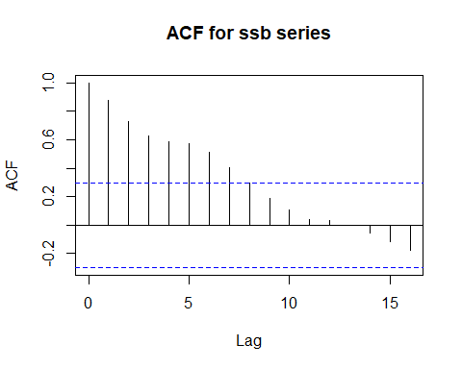

### Recruits Per Spawning Biomass ACF Analysis

## [1] "ACF for rssb series"

## [1] "Number of signifcant ACF lags (n):"  
## [1] 0

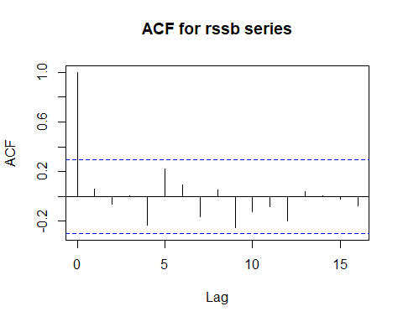

### Spawning Potential Ratio ACF Analysis

## [1] "ACF for spr series"

## [1] "Number of signifcant ACF lags (n):"  
## [1] 6  
## [1] "Significant ACF lags are:"  
## [1] 1 2 11 13 14 16  
## [1] "Significant ACF values (1:n) are:"  
## [1] 0.6363558 0.4172139 -0.3091722 -0.3077636 -0.3110248 -0.3068366

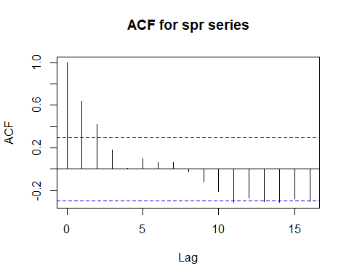

### Population Biomass ACF Analysis

## [1] "ACF for popbio series"

## [1] "Number of signifcant ACF lags (n):"  
## [1] 8  
## [1] "Significant ACF lags are:"  
## [1] 1 2 11 12 13 14 15 16  
## [1] "Significant ACF values (1:n) are:"  
## [1] 0.6803263 0.4900110 -0.3404748 -0.3294414 -0.3272971 -0.3934584 -0.4085137  
## [8] -0.4354253

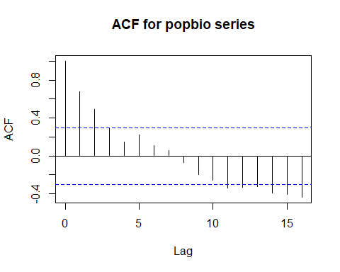

### Catch Biomass ACF Analysis

## [1] "ACF for catbio series"

## [1] "Number of signifcant ACF lags (n):"  
## [1] 10  
## [1] "Significant ACF lags are:"  
## [1] 1 2 3 4 5 6 7 8 9 10  
## [1] "Significant ACF values (1:n) are:"  
## [1] 0.7848537 0.7165045 0.6426775 0.5514167 0.5578185 0.5034447 0.4618754  
## [8] 0.4191359 0.3588900 0.3209526

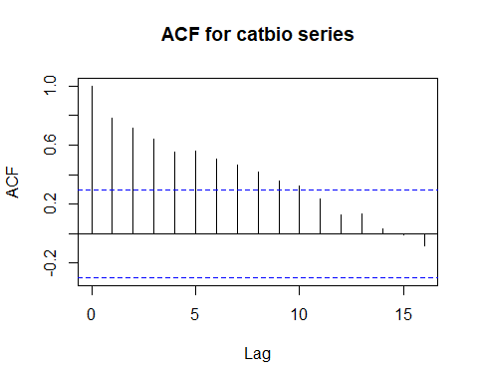

### Fishing Mortality ACF Analysis

## [1] "ACF for fmort series"

## [1] "Number of signifcant ACF lags (n):"  
## [1] 9  
## [1] "Significant ACF lags are:"  
## [1] 1 2 10 11 12 13 14 15 16  
## [1] "Significant ACF values (1:n) are:"  
## [1] 0.6692052 0.4276745 -0.3102456 -0.3420457 -0.3421524 -0.3175042 -0.3834632  
## [8] -0.4269802 -0.4299386

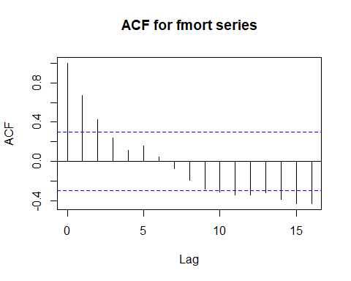

### Fishing Intensity ACF Analysis

## [1] "ACF for fspr series"

## [1] "Number of signifcant ACF lags (n):"  
## [1] 6  
## [1] "Significant ACF lags are:"  
## [1] 1 2 11 13 14 16  
## [1] "Significant ACF values (1:n) are:"  
## [1] 0.6363558 0.4172139 -0.3091722 -0.3077636 -0.3110248 -0.3068366

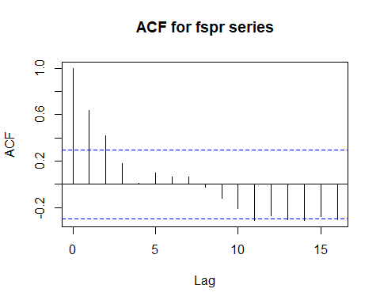

### Net Biomass ACF Analysis

## [1] "ACF for rec series"

## [1] "Number of signifcant ACF lags (n):"  
## [1] 3  
## [1] "Significant ACF lags are:"  
## [1] 1 2 3  
## [1] "Significant ACF values (1:n) are:"  
## [1] 0.6086792 0.4802801 0.3214511

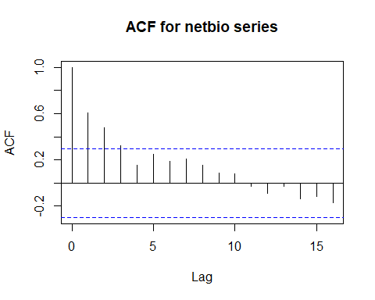

### Harvest Rate ACF Analysis

## [1] "ACF for hrate series"

## [1] "Number of signifcant ACF lags (n):"  
## [1] 8  
## [1] "Significant ACF lags are:"  
## [1] 1 2 3 4 5 6 7 8  
## [1] "Significant ACF values (1:n) are:"  
## [1] 0.6748506 0.5938773 0.5064364 0.3781845 0.4111139 0.3566610 0.3390184  
## [8] 0.3095249

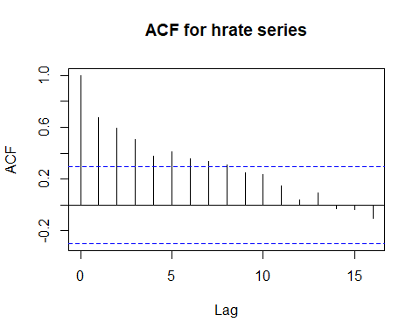

### Oceanic Nino Index ACF Analysis

## [1] "ACF for oni series"

## [1] "Number of signifcant ACF lags (n):"  
## [1] 1  
## [1] "Significant ACF lags are:"  
## [1] 2  
## [1] "Significant ACF values (1:n) are:"  
## [1] -0.3202967

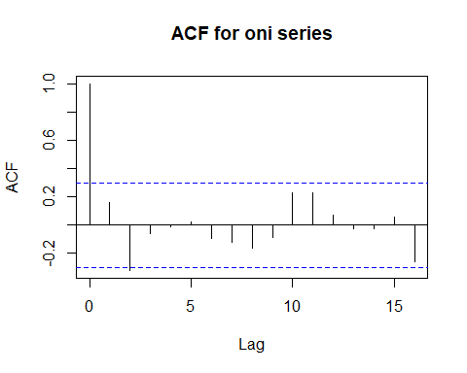

### Multivariate ENSO Index ACF Analysis

## [1] "ACF for mei series"

## [1] "Number of signifcant ACF lags (n):"  
## [1] 0

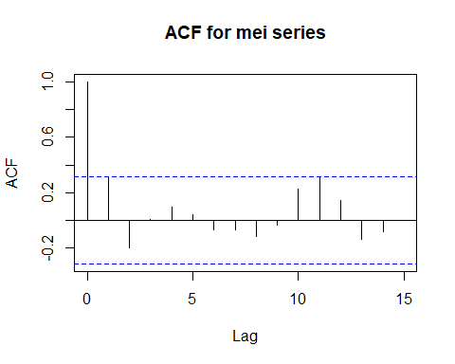

### Pacific Decadal Oscillation ACF Analysis

## [1] "ACF for pdo series"

## [1] "Number of signifcant ACF lags (n):"  
## [1] 1  
## [1] "Significant ACF lags are:"  
## [1] 1  
## [1] "Significant ACF values (1:n) are:"  
## [1] 0.3412628

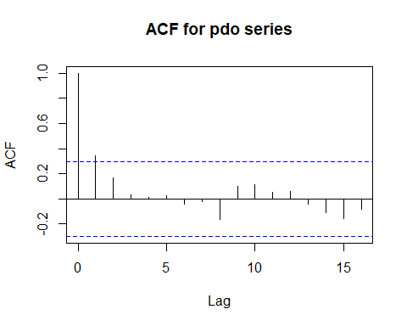

## Partial Autocorrelation Function Analyses

### Recruitment PACF Analysis

## [1] "PACF for rec series"

## [1] "Number of signifcant PACF lags (n):"  
## [1] 2  
## [1] "Significant PACF lags are:"  
## [1] 1 5  
## [1] "Significant PACF values (1:n) are:"  
## [1] 0.5661556 0.4597389

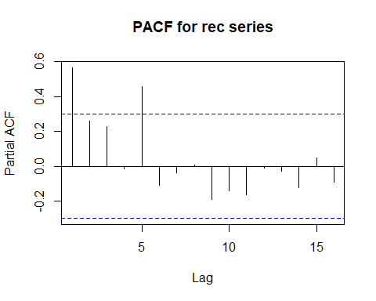

### Spawning Biomass PACF Analysis

## [1] "PACF for ssb series"

## [1] "Number of signifcant PACF lags (n):"  
## [1] 1  
## [1] "Significant PACF lags are:"  
## [1] 1  
## [1] "Significant PACF values (1:n) are:"  
## [1] 0.8784673

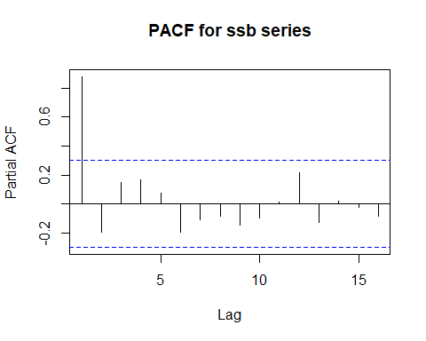

### Recruits Per Spawning Biomass PACF Analysis

## [1] "PACF for rssb series"

## [1] "Number of signifcant PACF lags (n):"  
## [1] 0

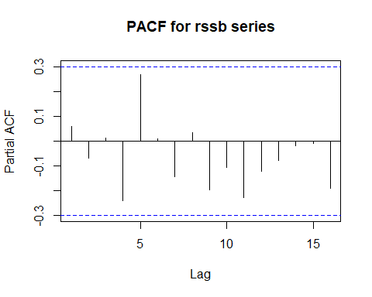

### Spawning Potential Ratio PACF Analysis

## [1] "PACF for spr series"

## [1] "Number of signifcant PACF lags (n):"  
## [1] 1  
## [1] "Significant PACF lags are:"  
## [1] 1  
## [1] "Significant PACF values (1:n) are:"  
## [1] 0.6363558

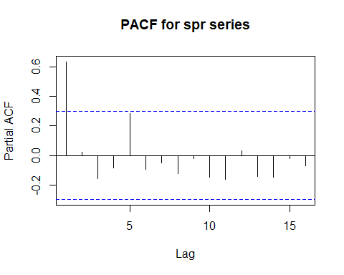 ### Population Biomass PACF Analysis

## [1] "PACF for popbio series"

## [1] "Number of signifcant PACF lags (n):"  
## [1] 2  
## [1] "Significant PACF lags are:"  
## [1] 1 5  
## [1] "Significant PACF values (1:n) are:"  
## [1] 0.6803263 0.3058824

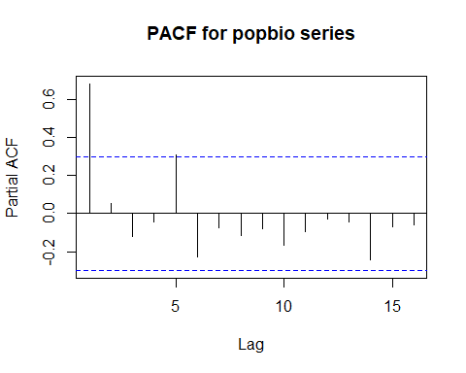

### Catch Biomass PACF Analysis

## [1] "PACF for catbio series"

## [1] "Number of signifcant PACF lags (n):"  
## [1] 1  
## [1] "Significant PACF lags are:"  
## [1] 1  
## [1] "Significant PACF values (1:n) are:"  
## [1] 0.7848537

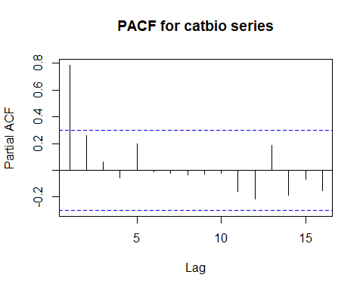

### Fishing Mortality PACF Analysis

## [1] "PACF for fmort series"

## [1] "Number of signifcant PACF lags (n):"  
## [1] 1  
## [1] "Significant PACF lags are:"  
## [1] 1  
## [1] "Significant PACF values (1:n) are:"  
## [1] 0.6692052

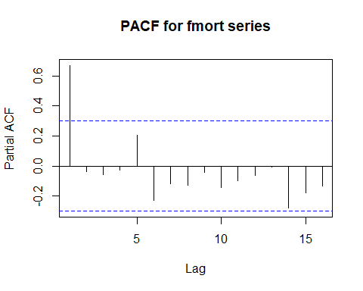

### Fishing Intensity PACF Analysis

## [1] "PACF for fspr series"

## [1] "Number of signifcant PACF lags (n):"  
## [1] 1  
## [1] "Significant PACF lags are:"  
## [1] 1  
## [1] "Significant PACF values (1:n) are:"  
## [1] 0.6363558

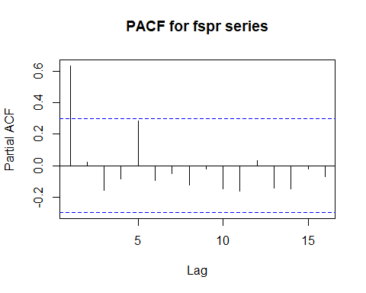

### Net Biomass PACF Analysis

## [1] "PACF for rec series"

## [1] "Number of signifcant PACF lags (n):"  
## [1] 1  
## [1] "Significant PACF lags are:"  
## [1] 1  
## [1] "Significant PACF values (1:n) are:"  
## [1] 0.6086792

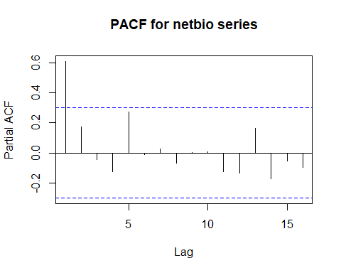

### Harvest Rate PACF Analysis

## [1] "PACF for hrate series"

## [1] "Number of signifcant PACF lags (n):"  
## [1] 1  
## [1] "Significant PACF lags are:"  
## [1] 1  
## [1] "Significant PACF values (1:n) are:"  
## [1] 0.6748506

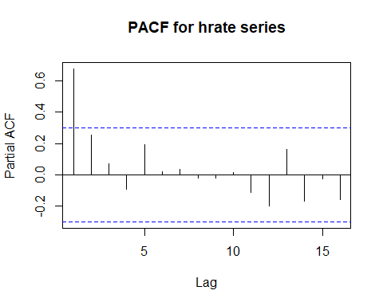

### Oceanic Nino Index PACF Analysis

## [1] "PACF for oni series"

## [1] "Number of signifcant PACF lags (n):"  
## [1] 2  
## [1] "Significant PACF lags are:"  
## [1] 2 16  
## [1] "Significant PACF values (1:n) are:"  
## [1] -0.3554028 -0.3685027

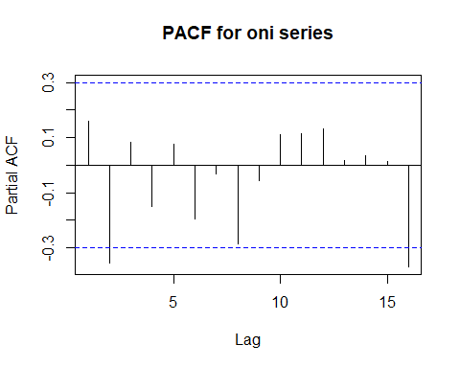

### Multivariate ENSO Index PACF Analysis

## [1] "PACF for mei series"

## [1] "Number of signifcant PACF lags (n):"  
## [1] 0

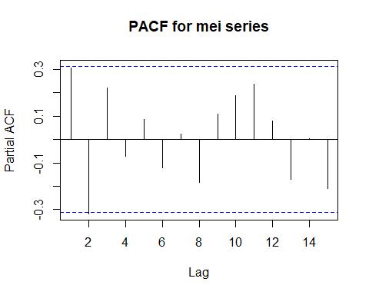

### Pacific Decadal Oscillation PACF Analysis

## [1] "PACF for pdo series"

## [1] "Number of signifcant PACF lags (n):"  
## [1] 1  
## [1] "Significant PACF lags are:"  
## [1] 1  
## [1] "Significant PACF values (1:n) are:"  
## [1] 0.3412628

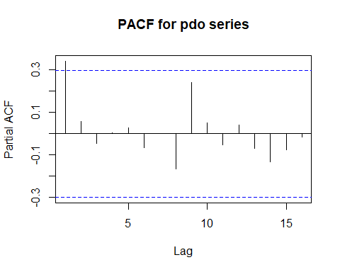

## Cross Correlation Function Analyses

### Recruitment CCF Analyses

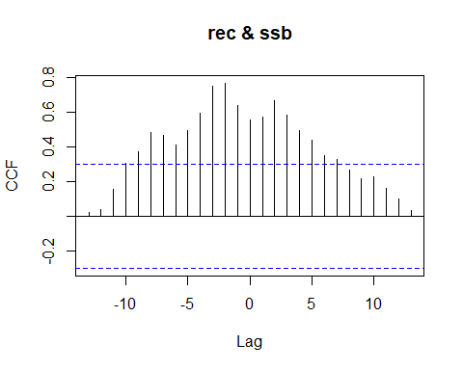

## [1] "CCF for (rec,ssb) series"

##   
## Autocorrelations of series 'X', by lag  
##   
## -13 -12 -11 -10 -9 -8 -7 -6 -5 -4 -3 -2 -1   
## 0.020 0.041 0.157 0.304 0.371 0.482 0.469 0.414 0.497 0.595 0.748 0.768 0.642   
## 0 1 2 3 4 5 6 7 8 9 10 11 12   
## 0.557 0.573 0.667 0.586 0.497 0.442 0.349 0.331 0.269 0.220 0.227 0.163 0.099   
## 13   
## 0.036

## [1] "Significant cross correlations exist at lags:"  
## [1] -9 -8 -7 -6 -5 -4 -3 -2 -1 0 1 2 3 4 5 6 7  
## [1] 0.3712827 0.4820644 0.4692197 0.4136374 0.4973953 0.5954666 0.7482190  
## [8] 0.7681021 0.6421907 0.5571129 0.5728840 0.6666402 0.5860238 0.4968480  
## [15] 0.4421284 0.3488871 0.3310362

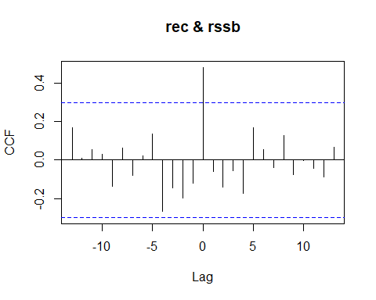

## [1] "CCF for (rec,rssb) series"

##   
## Autocorrelations of series 'X', by lag  
##   
## -13 -12 -11 -10 -9 -8 -7 -6 -5 -4 -3   
## 0.167 0.009 0.054 0.032 -0.136 0.064 -0.078 0.023 0.134 -0.266 -0.143   
## -2 -1 0 1 2 3 4 5 6 7 8   
## -0.197 -0.122 0.482 -0.059 -0.140 -0.054 -0.174 0.170 0.055 -0.038 0.129   
## 9 10 11 12 13   
## -0.076 -0.003 -0.042 -0.088 0.067

## [1] "Significant cross correlations exist at lags:"  
## [1] 0  
## [1] 0.4824619

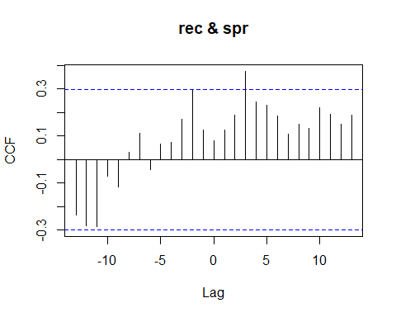

## [1] "CCF for (rec,spr) series"

##   
## Autocorrelations of series 'X', by lag  
##   
## -13 -12 -11 -10 -9 -8 -7 -6 -5 -4 -3   
## -0.236 -0.283 -0.285 -0.070 -0.118 0.029 0.110 -0.044 0.064 0.072 0.170   
## -2 -1 0 1 2 3 4 5 6 7 8   
## 0.298 0.124 0.080 0.126 0.188 0.375 0.243 0.231 0.186 0.106 0.151   
## 9 10 11 12 13   
## 0.131 0.219 0.193 0.149 0.189

## [1] 3  
## [1] 0.3747786

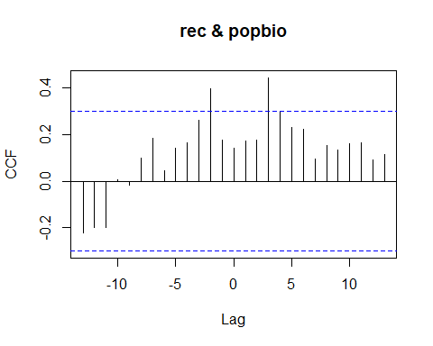

## [1] "CCF for (rec,popbio) series"

##   
## Autocorrelations of series 'X', by lag  
##   
## -13 -12 -11 -10 -9 -8 -7 -6 -5 -4 -3   
## -0.223 -0.197 -0.200 0.007 -0.019 0.100 0.182 0.046 0.139 0.166 0.262   
## -2 -1 0 1 2 3 4 5 6 7 8   
## 0.397 0.175 0.143 0.171 0.177 0.443 0.296 0.232 0.223 0.094 0.152   
## 9 10 11 12 13   
## 0.133 0.161 0.163 0.089 0.114

## [1] "Significant cross correlations exist at lags:"  
## [1] -2 3  
## [1] 0.3965209 0.4427425

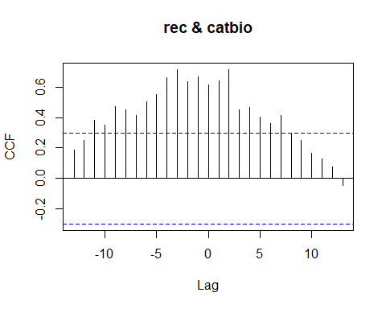

## [1] "CCF for (rec,catbio) series"

##   
## Autocorrelations of series 'X', by lag  
##   
## -13 -12 -11 -10 -9 -8 -7 -6 -5 -4 -3   
## 0.189 0.251 0.381 0.350 0.472 0.450 0.411 0.505 0.552 0.661 0.714   
## -2 -1 0 1 2 3 4 5 6 7 8   
## 0.637 0.667 0.616 0.641 0.715 0.449 0.467 0.400 0.363 0.415 0.294   
## 9 10 11 12 13   
## 0.250 0.163 0.130 0.075 -0.047

## [1] "Significant cross correlations exist at lags:"  
## [1] -11 -10 -9 -8 -7 -6 -5 -4 -3 -2 -1 0 1 2 3 4 5 6 7  
## [1] 0.3806898 0.3495327 0.4723859 0.4504537 0.4114885 0.5051257 0.5519832  
## [8] 0.6614680 0.7140378 0.6373385 0.6673304 0.6158381 0.6407831 0.7151221  
## [15] 0.4487084 0.4670657 0.4004767 0.3628487 0.4154748

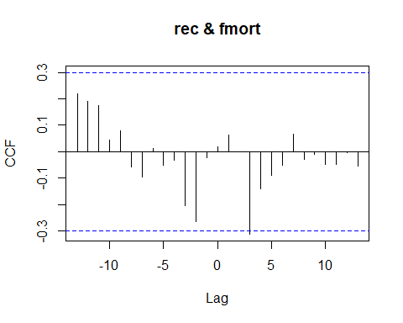

## [1] "CCF for (rec,fmort) series"

##   
## Autocorrelations of series 'X', by lag  
##   
## -13 -12 -11 -10 -9 -8 -7 -6 -5 -4 -3   
## 0.218 0.191 0.174 0.045 0.080 -0.057 -0.096 0.014 -0.050 -0.033 -0.204   
## -2 -1 0 1 2 3 4 5 6 7 8   
## -0.266 -0.022 0.018 0.063 0.001 -0.312 -0.141 -0.089 -0.051 0.067 -0.029   
## 9 10 11 12 13   
## -0.010 -0.047 -0.049 -0.003 -0.054

## [1] "Significant cross correlations exist at lags:"  
## [1] 3  
## [1] -0.3123799

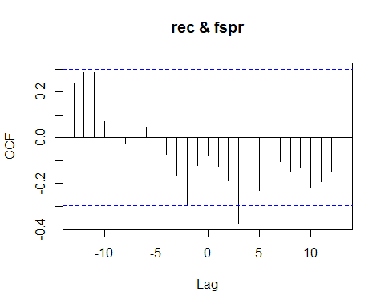

## [1] "CCF for (rec,fspr) series"

##   
## Autocorrelations of series 'X', by lag  
##   
## -13 -12 -11 -10 -9 -8 -7 -6 -5 -4 -3   
## 0.236 0.283 0.285 0.070 0.118 -0.029 -0.110 0.044 -0.064 -0.072 -0.170   
## -2 -1 0 1 2 3 4 5 6 7 8   
## -0.298 -0.124 -0.080 -0.126 -0.188 -0.375 -0.243 -0.231 -0.186 -0.106 -0.151   
## 9 10 11 12 13   
## -0.131 -0.219 -0.193 -0.149 -0.189

## [1] "Significant cross correlations exist at lags:"  
## [1] 3  
## [1] -0.3747786

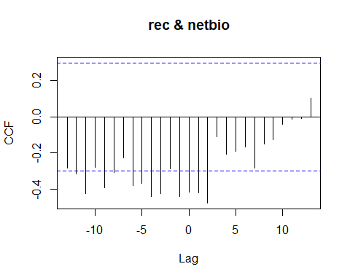

## [1] "CCF for (rec,netbio) series"

##   
## Autocorrelations of series 'X', by lag  
##   
## -13 -12 -11 -10 -9 -8 -7 -6 -5 -4 -3   
## -0.282 -0.317 -0.423 -0.279 -0.393 -0.307 -0.228 -0.382 -0.367 -0.440 -0.427   
## -2 -1 0 1 2 3 4 5 6 7 8   
## -0.287 -0.439 -0.416 -0.420 -0.477 -0.108 -0.207 -0.191 -0.165 -0.282 -0.150   
## 9 10 11 12 13   
## -0.126 -0.039 -0.011 -0.010 0.103

## [1] "Significant cross correlations exist at lags:"  
## [1] -12 -11 -9 -8 -6 -5 -4 -3 -1 0 1 2  
## [1] -0.3170296 -0.4231798 -0.3931958 -0.3070726 -0.3821539 -0.3665561  
## [7] -0.4396849 -0.4269116 -0.4394073 -0.4163187 -0.4200684 -0.4770262

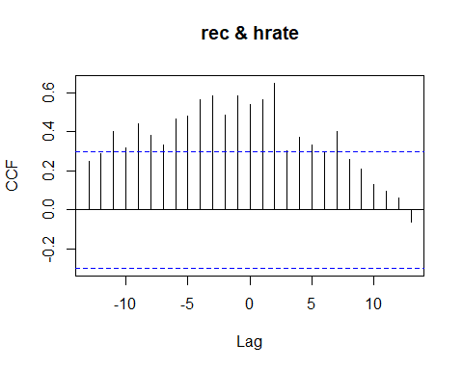

## [1] "CCF for (rec,hrate) series"

##   
## Autocorrelations of series 'X', by lag  
##   
## -13 -12 -11 -10 -9 -8 -7 -6 -5 -4 -3   
## 0.249 0.288 0.402 0.317 0.439 0.384 0.330 0.464 0.480 0.565 0.583   
## -2 -1 0 1 2 3 4 5 6 7 8   
## 0.483 0.582 0.540 0.563 0.649 0.304 0.370 0.333 0.300 0.400 0.258   
## 9 10 11 12 13   
## 0.210 0.130 0.093 0.063 -0.062

## [1] "Significant cross correlations exist at lags:"  
## [1] -11 -10 -9 -8 -7 -6 -5 -4 -3 -2 -1 0 1 2 4 5 7  
## [1] 0.4021037 0.3174116 0.4393529 0.3835070 0.3302019 0.4637512 0.4798625  
## [8] 0.5654654 0.5834129 0.4831221 0.5822749 0.5395544 0.5628284 0.6488225  
## [15] 0.3703713 0.3331723 0.3996573

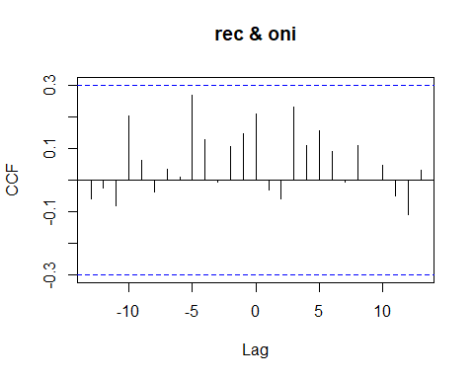

## [1] "CCF for (rec,oni) series"

##   
## Autocorrelations of series 'X', by lag  
##   
## -13 -12 -11 -10 -9 -8 -7 -6 -5 -4 -3   
## -0.059 -0.026 -0.081 0.201 0.061 -0.036 0.034 0.010 0.267 0.128 -0.007   
## -2 -1 0 1 2 3 4 5 6 7 8   
## 0.106 0.148 0.208 -0.030 -0.058 0.230 0.109 0.155 0.089 -0.006 0.108   
## 9 10 11 12 13   
## 0.001 0.047 -0.051 -0.109 0.031

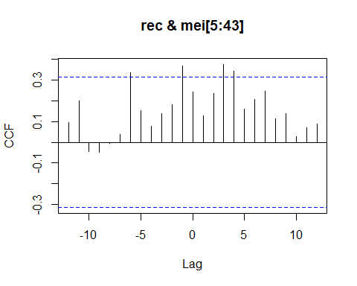

## [1] "CCF for (rec,mei) series"

##   
## Autocorrelations of series 'X', by lag  
##   
## -12 -11 -10 -9 -8 -7 -6 -5 -4 -3 -2   
## 0.095 0.200 -0.043 -0.046 -0.005 0.038 0.336 0.155 0.079 0.140 0.181   
## -1 0 1 2 3 4 5 6 7 8 9   
## 0.371 0.243 0.129 0.236 0.377 0.345 0.162 0.209 0.247 0.114 0.139   
## 10 11 12   
## 0.028 0.070 0.090

## [1] "Significant cross correlations exist at lags:"  
## [1] -6 -1 3 4  
## [1] 0.3356568 0.3706614 0.3768825 0.3451732

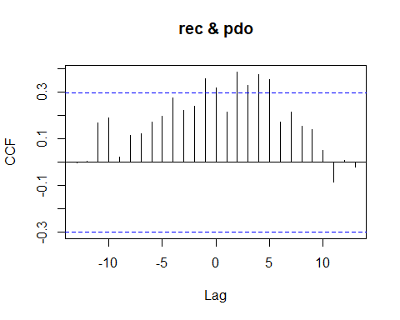

## [1] "CCF for (rec,pdo) series"

##   
## Autocorrelations of series 'X', by lag  
##   
## -13 -12 -11 -10 -9 -8 -7 -6 -5 -4 -3   
## -0.001 0.005 0.170 0.190 0.021 0.117 0.122 0.171 0.199 0.278 0.224   
## -2 -1 0 1 2 3 4 5 6 7 8   
## 0.239 0.359 0.321 0.214 0.388 0.329 0.377 0.356 0.174 0.214 0.155   
## 9 10 11 12 13   
## 0.140 0.052 -0.084 0.009 -0.020

## [1] "Significant cross correlations exist at lags:"  
## [1] -1 0 2 3 4 5  
## [1] 0.3589804 0.3208549 0.3876240 0.3290520 0.3772789 0.3555947

### Spawning Biomass CCF Analyses

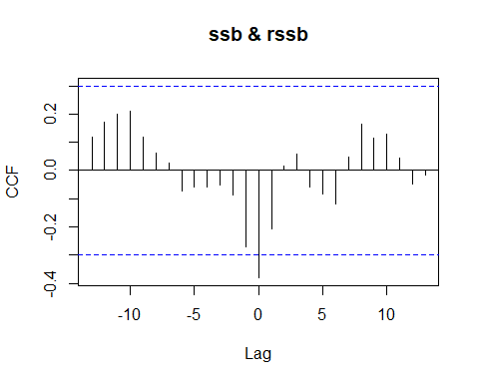

## [1] "CCF for (ssb,rssb) series"

##   
## Autocorrelations of series 'X', by lag  
##   
## -13 -12 -11 -10 -9 -8 -7 -6 -5 -4 -3   
## 0.117 0.170 0.200 0.210 0.118 0.061 0.026 -0.072 -0.059 -0.059 -0.051   
## -2 -1 0 1 2 3 4 5 6 7 8   
## -0.086 -0.270 -0.380 -0.205 0.014 0.058 -0.060 -0.085 -0.119 0.049 0.164   
## 9 10 11 12 13   
## 0.114 0.128 0.045 -0.048 -0.015

## [1] "Significant cross correlations exist at lags:"  
## [1] 0  
## [1] -0.3796974

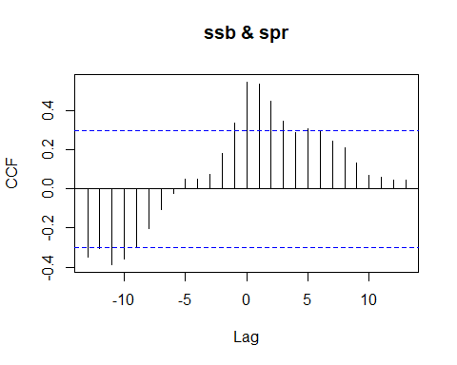

## [1] "CCF for (ssb,spr) series"

##   
## Autocorrelations of series 'X', by lag  
##   
## -13 -12 -11 -10 -9 -8 -7 -6 -5 -4 -3   
## -0.349 -0.307 -0.387 -0.356 -0.294 -0.205 -0.108 -0.021 0.051 0.050 0.075   
## -2 -1 0 1 2 3 4 5 6 7 8   
## 0.179 0.337 0.545 0.536 0.448 0.345 0.289 0.305 0.291 0.245 0.211   
## 9 10 11 12 13   
## 0.131 0.068 0.059 0.047 0.045

## [1] "Significant cross correlations exist at lags:"  
## [1] -13 -12 -11 -10 -1 0 1 2 3  
## [1] -0.3491442 -0.3069062 -0.3869144 -0.3561643 0.3372313 0.5452508 0.5361952  
## [8] 0.4478758 0.3451873

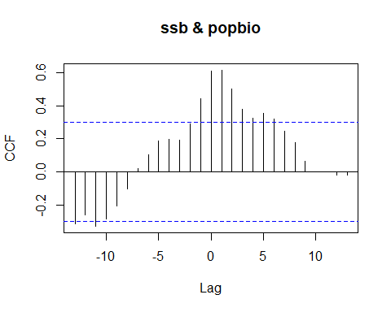

## [1] "CCF for (ssb,popbio) series"

##   
## Autocorrelations of series 'X', by lag  
##   
## -13 -12 -11 -10 -9 -8 -7 -6 -5 -4 -3   
## -0.315 -0.259 -0.329 -0.284 -0.207 -0.102 0.018 0.103 0.187 0.197 0.190   
## -2 -1 0 1 2 3 4 5 6 7 8   
## 0.290 0.440 0.607 0.614 0.503 0.380 0.326 0.352 0.321 0.247 0.176   
## 9 10 11 12 13   
## 0.065 -0.001 0.001 -0.020 -0.020

## [1] "Significant cross correlations exist at lags:"  
## [1] -13 -11 -1 0 1 2 3 4 5 6  
## [1] -0.3151062 -0.3287764 0.4397100 0.6072043 0.6142959 0.5028431  
## [7] 0.3797326 0.3262597 0.3524756 0.3214818

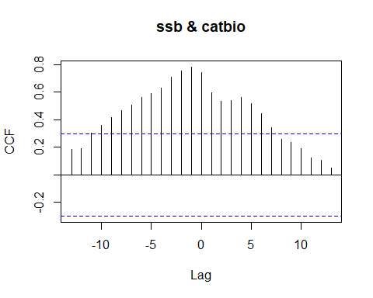

## [1] "CCF for (ssb,catbio) series"

##   
## Autocorrelations of series 'X', by lag  
##   
## -13 -12 -11 -10 -9 -8 -7 -6 -5 -4 -3 -2 -1   
## 0.185 0.189 0.303 0.359 0.416 0.467 0.507 0.564 0.591 0.633 0.712 0.757 0.784   
## 0 1 2 3 4 5 6 7 8 9 10 11 12   
## 0.744 0.594 0.535 0.542 0.566 0.519 0.444 0.346 0.259 0.239 0.188 0.121 0.108   
## 13   
## 0.048

## [1] "Significant cross correlations exist at lags:"  
## [1] -10 -9 -8 -7 -6 -5 -4 -3 -2 -1 0 1 2 3 4 5 6 7  
## [1] 0.3585137 0.4157595 0.4667478 0.5066633 0.5641220 0.5906615 0.6327503  
## [8] 0.7117007 0.7566703 0.7837099 0.7442694 0.5944459 0.5347713 0.5417649  
## [15] 0.5658488 0.5191458 0.4436738 0.3458190

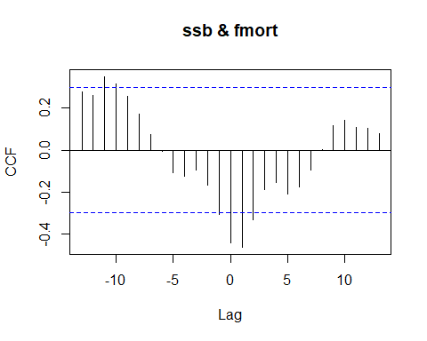

## [1] "CCF for (ssb,fmort) series"

##   
## Autocorrelations of series 'X', by lag  
##   
## -13 -12 -11 -10 -9 -8 -7 -6 -5 -4 -3   
## 0.276 0.262 0.350 0.314 0.257 0.171 0.076 -0.006 -0.109 -0.124 -0.096   
## -2 -1 0 1 2 3 4 5 6 7 8   
## -0.168 -0.306 -0.444 -0.462 -0.332 -0.187 -0.154 -0.210 -0.177 -0.096 0.001   
## 9 10 11 12 13   
## 0.119 0.142 0.107 0.102 0.078

## [1] "Significant cross correlations exist at lags:"  
## [1] -11 -10 -1 0 1 2  
## [1] 0.3499336 0.3143294 -0.3061804 -0.4435074 -0.4623187 -0.3324015

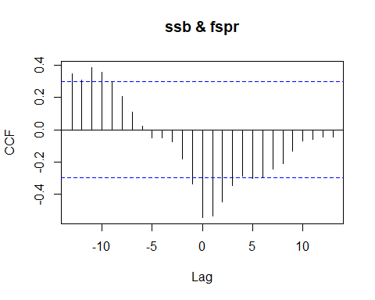

## [1] "CCF for (ssb,fspr) series"

##   
## Autocorrelations of series 'X', by lag  
##   
## -13 -12 -11 -10 -9 -8 -7 -6 -5 -4 -3   
## 0.349 0.307 0.387 0.356 0.294 0.205 0.108 0.021 -0.051 -0.050 -0.075   
## -2 -1 0 1 2 3 4 5 6 7 8   
## -0.179 -0.337 -0.545 -0.536 -0.448 -0.345 -0.289 -0.305 -0.291 -0.245 -0.211   
## 9 10 11 12 13   
## -0.131 -0.068 -0.059 -0.047 -0.045

## [1] "Significant cross correlations exist at lags:"  
## [1] -13 -12 -11 -10 -1 0 1 2 3  
## [1] 0.3491442 0.3069062 0.3869144 0.3561643 -0.3372313 -0.5452508 -0.5361952  
## [8] -0.4478758 -0.3451873

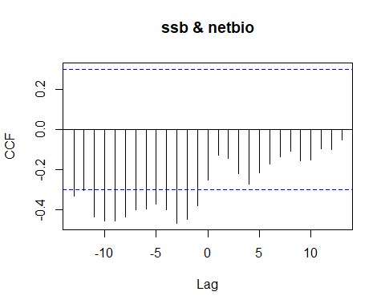

## [1] "CCF for (ssb,netbio) series"

##   
## Autocorrelations of series 'X', by lag  
##   
## -13 -12 -11 -10 -9 -8 -7 -6 -5 -4 -3   
## -0.332 -0.302 -0.434 -0.454 -0.456 -0.437 -0.400 -0.397 -0.371 -0.399 -0.467   
## -2 -1 0 1 2 3 4 5 6 7 8   
## -0.445 -0.381 -0.253 -0.127 -0.143 -0.220 -0.270 -0.217 -0.174 -0.138 -0.108   
## 9 10 11 12 13   
## -0.156 -0.153 -0.098 -0.099 -0.051

## [1] "Significant cross correlations exist at lags:"  
## [1] -13 -11 -10 -9 -8 -7 -6 -5 -4 -3 -2 -1  
## [1] -0.3315859 -0.4344377 -0.4539347 -0.4557023 -0.4366330 -0.3999083  
## [7] -0.3970223 -0.3706101 -0.3985331 -0.4667916 -0.4453740 -0.3810268

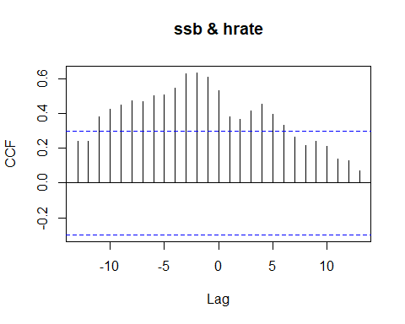

## [1] "CCF for (ssb,hrate) series"

##   
## Autocorrelations of series 'X', by lag  
##   
## -13 -12 -11 -10 -9 -8 -7 -6 -5 -4 -3 -2 -1   
## 0.241 0.239 0.378 0.421 0.450 0.470 0.469 0.501 0.506 0.546 0.627 0.632 0.607   
## 0 1 2 3 4 5 6 7 8 9 10 11 12   
## 0.530 0.381 0.366 0.414 0.452 0.396 0.332 0.264 0.213 0.240 0.207 0.137 0.129   
## 13   
## 0.068

## [1] "Significant cross correlations exist at lags:"  
## [1] -11 -10 -9 -8 -7 -6 -5 -4 -3 -2 -1 0 1 2 3 4 5 6  
## [1] 0.3781176 0.4209517 0.4498340 0.4695527 0.4692248 0.5012733 0.5064091  
## [8] 0.5459878 0.6267866 0.6321915 0.6072037 0.5297787 0.3806803 0.3657319  
## [15] 0.4135874 0.4522162 0.3963232 0.3321907

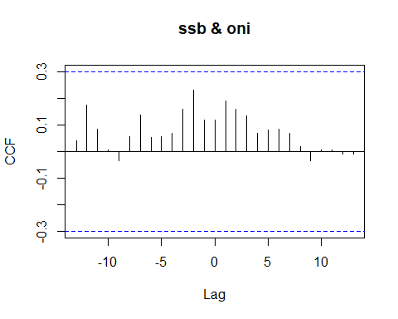

## [1] "CCF for (ssb,oni) series"

##   
## Autocorrelations of series 'X', by lag  
##   
## -13 -12 -11 -10 -9 -8 -7 -6 -5 -4 -3   
## 0.041 0.173 0.085 0.007 -0.033 0.055 0.137 0.052 0.056 0.067 0.158   
## -2 -1 0 1 2 3 4 5 6 7 8   
## 0.230 0.119 0.117 0.190 0.159 0.134 0.069 0.081 0.084 0.069 0.018   
## 9 10 11 12 13   
## -0.034 0.005 0.007 -0.009 -0.009

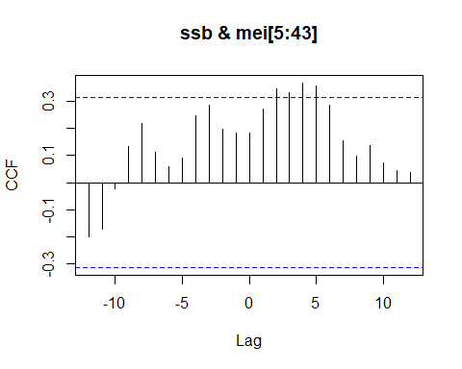

## [1] "CCF for (ssb,mei) series"

##   
## Autocorrelations of series 'X', by lag  
##   
## -12 -11 -10 -9 -8 -7 -6 -5 -4 -3 -2   
## -0.200 -0.172 -0.024 0.132 0.219 0.113 0.061 0.090 0.249 0.288 0.199   
## -1 0 1 2 3 4 5 6 7 8 9   
## 0.185 0.184 0.272 0.346 0.332 0.369 0.359 0.286 0.157 0.099 0.138   
## 10 11 12   
## 0.073 0.045 0.038

## [1] "Significant cross correlations exist at lags:"  
## [1] 2 3 4 5  
## [1] 0.3461088 0.3317449 0.3686285 0.3585069

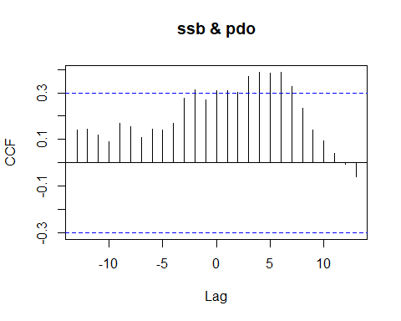

## [1] "CCF for (ssb,pdo) series"

##   
## Autocorrelations of series 'X', by lag  
##   
## -13 -12 -11 -10 -9 -8 -7 -6 -5 -4 -3   
## 0.141 0.145 0.118 0.089 0.170 0.155 0.109 0.145 0.142 0.169 0.278   
## -2 -1 0 1 2 3 4 5 6 7 8   
## 0.314 0.270 0.308 0.308 0.301 0.370 0.388 0.383 0.386 0.327 0.233   
## 9 10 11 12 13   
## 0.141 0.095 0.040 -0.006 -0.058

## [1] "Significant cross correlations exist at lags:"  
## [1] -2 0 1 3 4 5 6 7  
## [1] 0.3143667 0.3080461 0.3081070 0.3695577 0.3881883 0.3834307 0.3863904  
## [8] 0.3272414

### Recruits Per Spawning Biomass CCF Analysis

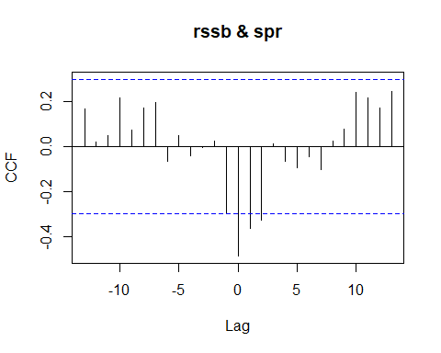

## [1] "CCF for (rssb,spr) series"

##   
## Autocorrelations of series 'X', by lag  
##   
## -13 -12 -11 -10 -9 -8 -7 -6 -5 -4 -3   
## 0.169 0.021 0.048 0.216 0.072 0.170 0.198 -0.063 0.050 -0.040 -0.002   
## -2 -1 0 1 2 3 4 5 6 7 8   
## 0.024 -0.295 -0.484 -0.364 -0.325 0.011 -0.065 -0.092 -0.044 -0.103 0.025   
## 9 10 11 12 13   
## 0.076 0.240 0.219 0.173 0.246

## [1] "Significant cross correlations exist at lags:"  
## [1] 0 1 2  
## [1] -0.4844109 -0.3636512 -0.3246377

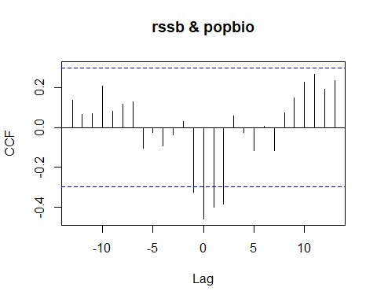

## [1] "CCF for (rssb,popbio) series"

##   
## Autocorrelations of series 'X', by lag  
##   
## -13 -12 -11 -10 -9 -8 -7 -6 -5 -4 -3   
## 0.135 0.065 0.070 0.208 0.082 0.118 0.131 -0.105 -0.025 -0.093 -0.035   
## -2 -1 0 1 2 3 4 5 6 7 8   
## 0.031 -0.324 -0.459 -0.401 -0.384 0.057 -0.026 -0.114 0.008 -0.117 0.072   
## 9 10 11 12 13   
## 0.150 0.228 0.269 0.191 0.233

## [1] "Significant cross correlations exist at lags:"  
## [1] -1 0 1 2  
## [1] -0.3240423 -0.4587965 -0.4005268 -0.3842041

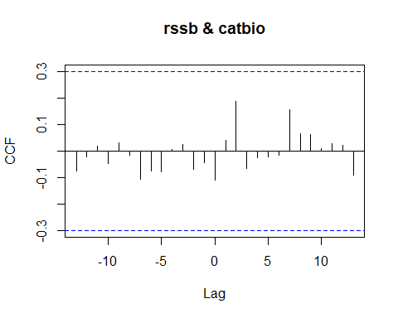

## [1] "CCF for (rssb,catbio) series"

##   
## Autocorrelations of series 'X', by lag  
##   
## -13 -12 -11 -10 -9 -8 -7 -6 -5 -4 -3   
## -0.076 -0.023 0.020 -0.047 0.032 -0.017 -0.105 -0.074 -0.077 0.005 0.024   
## -2 -1 0 1 2 3 4 5 6 7 8   
## -0.068 -0.044 -0.109 0.039 0.186 -0.064 -0.026 -0.022 -0.016 0.156 0.064   
## 9 10 11 12 13   
## 0.063 0.009 0.029 0.021 -0.090

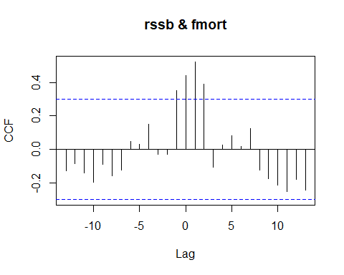

## [1] "CCF for (rssb,fmort) series"

##   
## Autocorrelations of series 'X', by lag  
##   
## -13 -12 -11 -10 -9 -8 -7 -6 -5 -4 -3   
## -0.128 -0.084 -0.142 -0.196 -0.090 -0.159 -0.125 0.049 0.032 0.149 -0.030   
## -2 -1 0 1 2 3 4 5 6 7 8   
## -0.030 0.352 0.443 0.523 0.391 -0.105 0.027 0.081 0.018 0.123 -0.125   
## 9 10 11 12 13   
## -0.174 -0.213 -0.254 -0.179 -0.244

## [1] "Significant cross correlations exist at lags:"  
## [1] -1 0 1 2  
## [1] 0.3517602 0.4432396 0.5231657 0.3914318

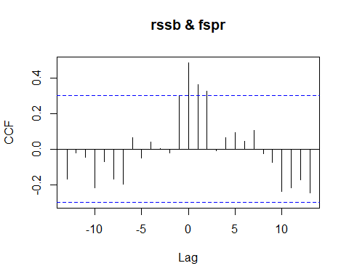

## [1] "CCF for (rssb,fspr) series"

##   
## Autocorrelations of series 'X', by lag  
##   
## -13 -12 -11 -10 -9 -8 -7 -6 -5 -4 -3   
## -0.169 -0.021 -0.048 -0.216 -0.072 -0.170 -0.198 0.063 -0.050 0.040 0.002   
## -2 -1 0 1 2 3 4 5 6 7 8   
## -0.024 0.295 0.484 0.364 0.325 -0.011 0.065 0.092 0.044 0.103 -0.025   
## 9 10 11 12 13   
## -0.076 -0.240 -0.219 -0.173 -0.246

## [1] "Significant cross correlations exist at lags:"  
## [1] 0 1 2  
## [1] 0.4844109 0.3636512 0.3246377

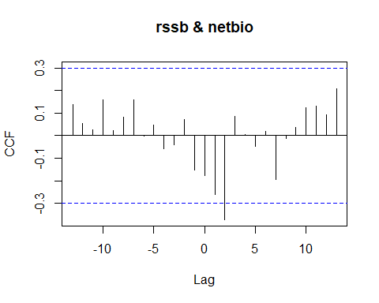

## [1] "CCF for (rssb,netbio) series"

##   
## Autocorrelations of series 'X', by lag  
##   
## -13 -12 -11 -10 -9 -8 -7 -6 -5 -4 -3   
## 0.140 0.056 0.025 0.158 0.021 0.082 0.160 0.000 0.048 -0.057 -0.040   
## -2 -1 0 1 2 3 4 5 6 7 8   
## 0.073 -0.151 -0.177 -0.262 -0.372 0.085 0.006 -0.048 0.018 -0.194 -0.011   
## 9 10 11 12 13   
## 0.035 0.124 0.131 0.093 0.208

## [1] "Significant cross correlations exist at lags:"  
## [1] 2  
## [1] -0.3719504

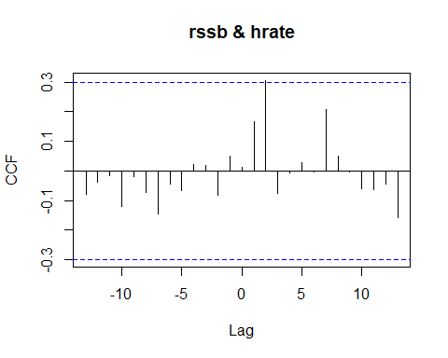

## [1] "CCF for (rssb,hrate) series"

##   
## Autocorrelations of series 'X', by lag  
##   
## -13 -12 -11 -10 -9 -8 -7 -6 -5 -4 -3   
## -0.080 -0.036 -0.015 -0.119 -0.018 -0.073 -0.143 -0.044 -0.067 0.021 0.017   
## -2 -1 0 1 2 3 4 5 6 7 8   
## -0.081 0.051 0.014 0.166 0.306 -0.076 -0.007 0.027 -0.002 0.209 0.049   
## 9 10 11 12 13   
## -0.003 -0.060 -0.064 -0.044 -0.158

## [1] "Significant cross correlations exist at lags:"  
## [1] 2  
## [1] 0.3057116

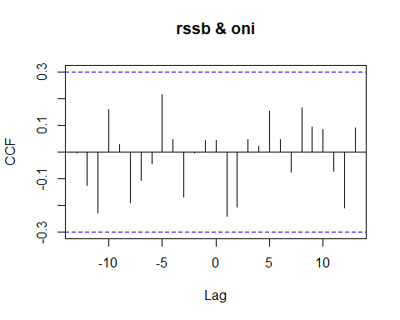

## [1] "CCF for (rssb,oni) series"

##   
## Autocorrelations of series 'X', by lag  
##   
## -13 -12 -11 -10 -9 -8 -7 -6 -5 -4 -3   
## -0.003 -0.123 -0.227 0.157 0.026 -0.189 -0.106 -0.045 0.215 0.045 -0.170   
## -2 -1 0 1 2 3 4 5 6 7 8   
## -0.004 0.042 0.044 -0.240 -0.205 0.046 0.021 0.153 0.045 -0.076 0.164   
## 9 10 11 12 13   
## 0.092 0.084 -0.072 -0.208 0.089

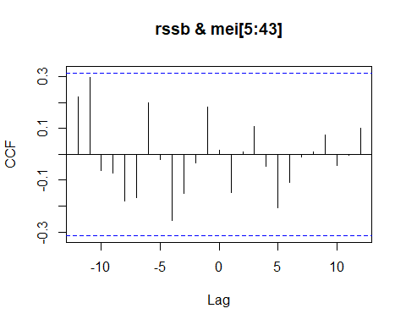

## [1] "CCF for (rssb,mei) series"

##   
## Autocorrelations of series 'X', by lag  
##   
## -12 -11 -10 -9 -8 -7 -6 -5 -4 -3 -2   
## 0.223 0.296 -0.061 -0.071 -0.179 -0.168 0.199 -0.020 -0.254 -0.151 -0.034   
## -1 0 1 2 3 4 5 6 7 8 9   
## 0.181 0.017 -0.148 0.009 0.109 -0.045 -0.206 -0.107 -0.012 0.009 0.075   
## 10 11 12   
## -0.042 -0.004 0.101

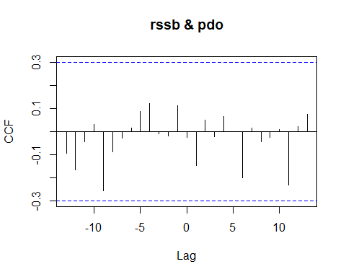

## [1] "CCF for (rssb,pdo) series"

##   
## Autocorrelations of series 'X', by lag  
##   
## -13 -12 -11 -10 -9 -8 -7 -6 -5 -4 -3   
## -0.094 -0.166 -0.042 0.030 -0.257 -0.089 -0.029 0.014 0.088 0.121 -0.008   
## -2 -1 0 1 2 3 4 5 6 7 8   
## -0.020 0.111 -0.024 -0.148 0.050 -0.021 0.066 0.001 -0.199 0.014 -0.043   
## 9 10 11 12 13   
## -0.026 0.008 -0.230 0.022 0.073

### Spawning Potential Ratio CCF Analysis

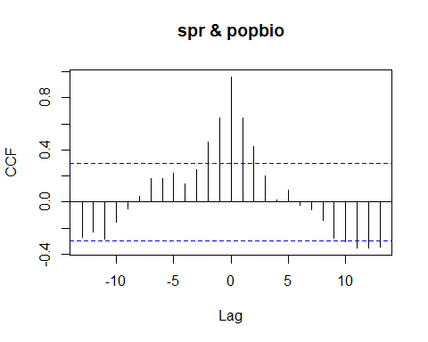

## [1] "CCF for (spr,popbio) series"

##   
## Autocorrelations of series 'X', by lag  
##   
## -13 -12 -11 -10 -9 -8 -7 -6 -5 -4 -3   
## -0.268 -0.230 -0.284 -0.152 -0.054 0.041 0.180 0.181 0.219 0.138 0.246   
## -2 -1 0 1 2 3 4 5 6 7 8   
## 0.463 0.643 0.959 0.645 0.427 0.197 0.019 0.093 -0.026 -0.059 -0.144   
## 9 10 11 12 13   
## -0.274 -0.307 -0.352 -0.351 -0.344

## [1] "Significant cross correlations exist at lags:"  
## [1] -2 -1 0 1 2 10 11 12 13  
## [1] 0.4629605 0.6428195 0.9592282 0.6450884 0.4271160 -0.3070947 -0.3515399  
## [8] -0.3507386 -0.3440458

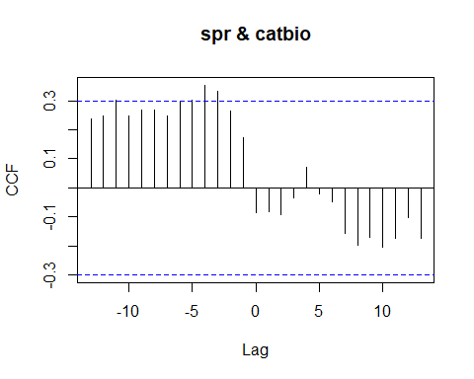

## [1] "CCF for (spr,catbio) series"

##   
## Autocorrelations of series 'X', by lag  
##   
## -13 -12 -11 -10 -9 -8 -7 -6 -5 -4 -3   
## 0.239 0.248 0.303 0.247 0.268 0.268 0.246 0.299 0.303 0.353 0.331   
## -2 -1 0 1 2 3 4 5 6 7 8   
## 0.263 0.172 -0.087 -0.082 -0.092 -0.034 0.072 -0.019 -0.049 -0.155 -0.196   
## 9 10 11 12 13   
## -0.168 -0.206 -0.175 -0.102 -0.174

## [1] "Significant cross correlations exist at lags:"  
## [1] -4 -3  
## [1] 0.3533277 0.3314615

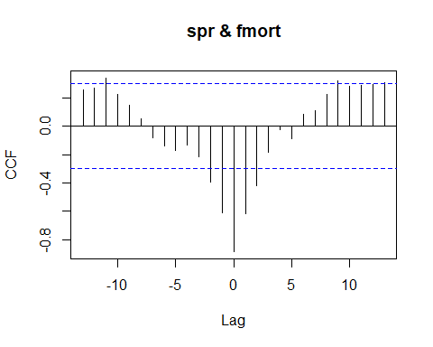

## [1] "CCF for (spr,fmort) series"

##   
## Autocorrelations of series 'X', by lag  
##   
## -13 -12 -11 -10 -9 -8 -7 -6 -5 -4 -3   
## 0.256 0.270 0.339 0.222 0.150 0.050 -0.082 -0.141 -0.173 -0.133 -0.218   
## -2 -1 0 1 2 3 4 5 6 7 8   
## -0.395 -0.609 -0.883 -0.615 -0.419 -0.184 -0.026 -0.090 0.081 0.106 0.221   
## 9 10 11 12 13   
## 0.321 0.278 0.288 0.295 0.304

## [1] "Significant cross correlations exist at lags:"  
## [1] -11 -2 -1 0 1 2 9  
## [1] 0.3387443 -0.3945278 -0.6086659 -0.8828778 -0.6152091 -0.4193067 0.3207725

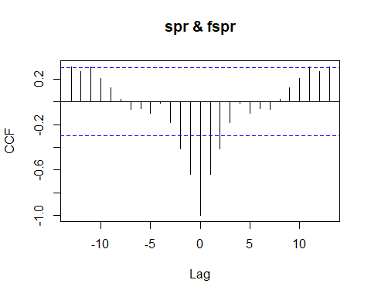

## [1] "CCF for (spr,fspr) series"

##   
## Autocorrelations of series 'X', by lag  
##   
## -13 -12 -11 -10 -9 -8 -7 -6 -5 -4 -3   
## 0.308 0.270 0.309 0.206 0.121 0.024 -0.067 -0.063 -0.097 -0.012 -0.180   
## -2 -1 0 1 2 3 4 5 6 7 8   
## -0.417 -0.636 -1.000 -0.636 -0.417 -0.180 -0.012 -0.097 -0.063 -0.067 0.024   
## 9 10 11 12 13   
## 0.121 0.206 0.309 0.270 0.308

## [1] "Significant cross correlations exist at lags:"  
## [1] -13 -11 -2 -1 0 1 2 11 13  
## [1] 0.3077636 0.3091722 -0.4172139 -0.6363558 -1.0000000 -0.6363558 -0.4172139  
## [8] 0.3091722 0.3077636

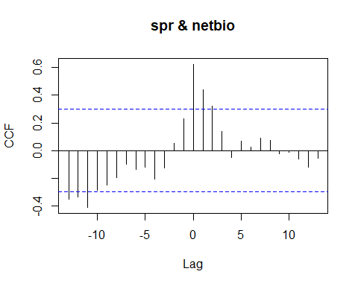

## [1] "CCF for (spr,netbio) series"

##   
## Autocorrelations of series 'X', by lag  
##   
## -13 -12 -11 -10 -9 -8 -7 -6 -5 -4 -3   
## -0.347 -0.333 -0.409 -0.288 -0.248 -0.193 -0.096 -0.137 -0.119 -0.206 -0.127   
## -2 -1 0 1 2 3 4 5 6 7 8   
## 0.054 0.231 0.623 0.438 0.321 0.141 -0.048 0.069 0.025 0.092 0.075   
## 9 10 11 12 13   
## -0.022 -0.010 -0.061 -0.120 -0.057

## [1] "Significant cross correlations exist at lags:"  
## [1] -13 -12 -11 0 1 2  
## [1] -0.3474361 -0.3330793 -0.4085023 0.6228792 0.4378884 0.3206306

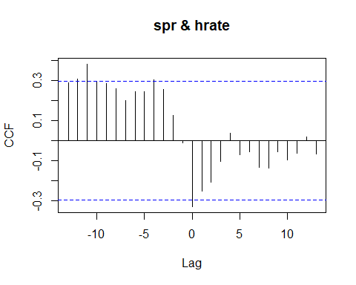

## [1] "CCF for (spr,hrate) series"

##   
## Autocorrelations of series 'X', by lag  
##   
## -13 -12 -11 -10 -9 -8 -7 -6 -5 -4 -3   
## 0.292 0.309 0.383 0.292 0.285 0.260 0.199 0.247 0.247 0.304 0.257   
## -2 -1 0 1 2 3 4 5 6 7 8   
## 0.126 -0.013 -0.331 -0.255 -0.208 -0.106 0.038 -0.071 -0.054 -0.132 -0.138   
## 9 10 11 12 13   
## -0.055 -0.097 -0.064 0.019 -0.068

## [1] "Significant cross correlations exist at lags:"  
## [1] -12 -11 0  
## [1] 0.3094427 0.3831161 -0.3309788

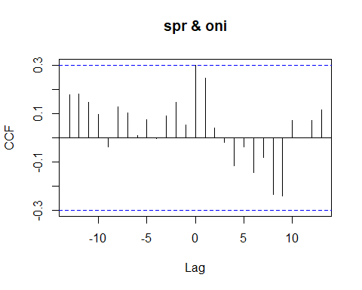

## [1] "CCF for (spr,oni) series"

##   
## Autocorrelations of series 'X', by lag  
##   
## -13 -12 -11 -10 -9 -8 -7 -6 -5 -4 -3   
## 0.179 0.180 0.146 0.096 -0.037 0.128 0.101 0.008 0.075 -0.005 0.089   
## -2 -1 0 1 2 3 4 5 6 7 8   
## 0.147 0.051 0.299 0.245 0.042 -0.018 -0.114 -0.037 -0.142 -0.080 -0.234   
## 9 10 11 12 13   
## -0.240 0.071 0.001 0.071 0.114

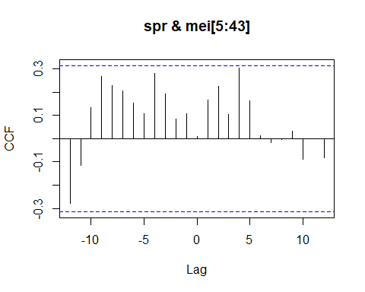

## [1] "CCF for (spr,mei) series"

##   
## Autocorrelations of series 'X', by lag  
##   
## -12 -11 -10 -9 -8 -7 -6 -5 -4 -3 -2   
## -0.278 -0.114 0.133 0.268 0.229 0.204 0.155 0.106 0.282 0.192 0.086   
## -1 0 1 2 3 4 5 6 7 8 9   
## 0.109 0.011 0.165 0.226 0.105 0.304 0.162 0.013 -0.017 -0.004 0.032   
## 10 11 12   
## -0.089 -0.002 -0.082

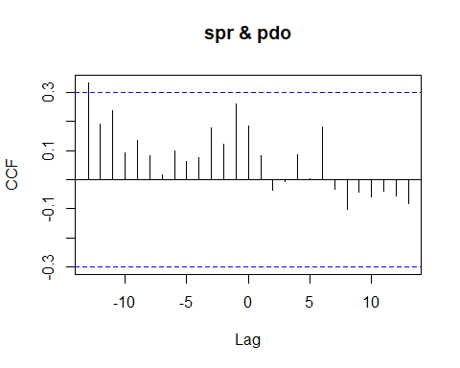

## [1] "CCF for (spr,pdo) series"

##   
## Autocorrelations of series 'X', by lag  
##   
## -13 -12 -11 -10 -9 -8 -7 -6 -5 -4 -3   
## 0.332 0.191 0.237 0.093 0.136 0.083 0.016 0.098 0.064 0.074 0.178   
## -2 -1 0 1 2 3 4 5 6 7 8   
## 0.121 0.260 0.185 0.082 -0.037 -0.006 0.086 0.003 0.179 -0.034 -0.101   
## 9 10 11 12 13   
## -0.043 -0.060 -0.040 -0.055 -0.082

## [1] "Significant cross correlations exist at lags:"  
## [1] -13  
## [1] 0.3322702

### Population Biomass CCF Analysis

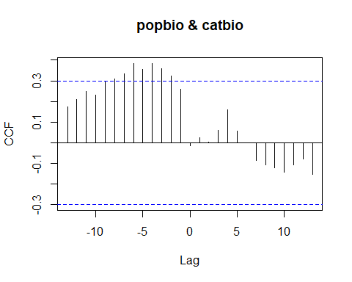

## [1] "CCF for (popbio,catbio) series"

##   
## Autocorrelations of series 'X', by lag  
##   
## -13 -12 -11 -10 -9 -8 -7 -6 -5 -4 -3   
## 0.173 0.210 0.247 0.232 0.300 0.311 0.336 0.383 0.354 0.384 0.358   
## -2 -1 0 1 2 3 4 5 6 7 8   
## 0.323 0.259 -0.014 0.023 0.003 0.060 0.160 0.057 0.000 -0.087 -0.107   
## 9 10 11 12 13   
## -0.121 -0.143 -0.107 -0.077 -0.153

## [1] "Significant cross correlations exist at lags:"  
## [1] -8 -7 -6 -5 -4 -3 -2  
## [1] 0.3109754 0.3355825 0.3827112 0.3539347 0.3843055 0.3577232 0.3229192

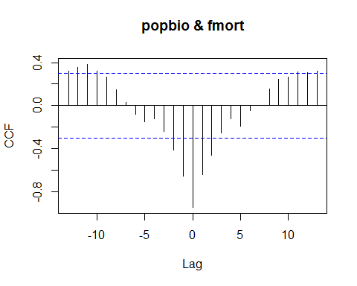

## [1] "CCF for (popbio,fmort) series"

##   
## Autocorrelations of series 'X', by lag  
##   
## -13 -12 -11 -10 -9 -8 -7 -6 -5 -4 -3   
## 0.319 0.353 0.384 0.323 0.268 0.148 0.034 -0.081 -0.151 -0.121 -0.240   
## -2 -1 0 1 2 3 4 5 6 7 8   
## -0.408 -0.650 -0.943 -0.641 -0.463 -0.254 -0.119 -0.193 -0.044 0.005 0.153   
## 9 10 11 12 13   
## 0.245 0.266 0.314 0.310 0.320

## [1] "Significant cross correlations exist at lags:"  
## [1] -13 -12 -11 -10 -2 -1 0 1 2 11 12 13  
## [1] 0.3189088 0.3533712 0.3835525 0.3232646 -0.4083942 -0.6501887  
## [7] -0.9430462 -0.6410054 -0.4628315 0.3136846 0.3102241 0.3195438

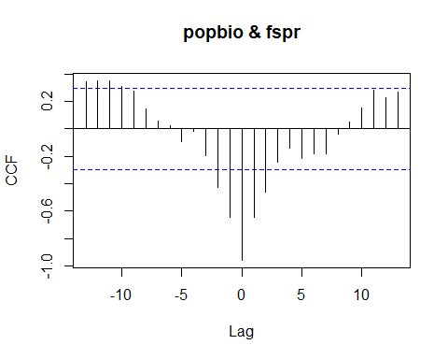

## [1] "CCF for (popbio,fspr) series"

##   
## Autocorrelations of series 'X', by lag  
##   
## -13 -12 -11 -10 -9 -8 -7 -6 -5 -4 -3   
## 0.344 0.351 0.352 0.307 0.274 0.144 0.059 0.026 -0.093 -0.019 -0.197   
## -2 -1 0 1 2 3 4 5 6 7 8   
## -0.427 -0.645 -0.959 -0.643 -0.463 -0.246 -0.138 -0.219 -0.181 -0.180 -0.041   
## 9 10 11 12 13   
## 0.054 0.152 0.284 0.230 0.268

## [1] "Significant cross correlations exist at lags:"  
## [1] -13 -12 -11 -10 -2 -1 0 1 2  
## [1] 0.3440458 0.3507386 0.3515399 0.3070947 -0.4271160 -0.6450884 -0.9592282  
## [8] -0.6428195 -0.4629605

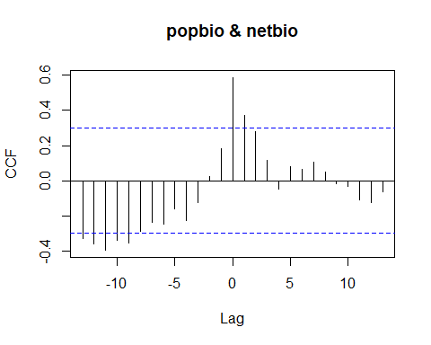

## [1] "CCF for (popbio,netbio) series"

##   
## Autocorrelations of series 'X', by lag  
##   
## -13 -12 -11 -10 -9 -8 -7 -6 -5 -4 -3   
## -0.328 -0.360 -0.396 -0.338 -0.357 -0.291 -0.238 -0.246 -0.161 -0.228 -0.124   
## -2 -1 0 1 2 3 4 5 6 7 8   
## 0.021 0.182 0.587 0.374 0.280 0.117 -0.046 0.080 0.064 0.104 0.047   
## 9 10 11 12 13   
## -0.016 -0.034 -0.109 -0.128 -0.064

## [1] "Significant cross correlations exist at lags:"  
## [1] -13 -12 -11 -10 -9 0 1  
## [1] -0.3283458 -0.3595134 -0.3960764 -0.3378020 -0.3572234 0.5872899 0.3735126

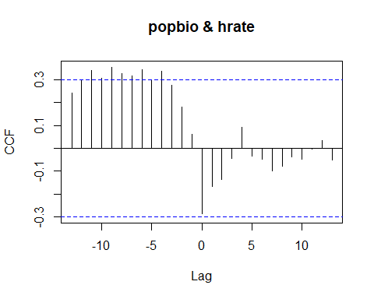

## [1] "CCF for (popbio,hrate) series"

##   
## Autocorrelations of series 'X', by lag  
##   
## -13 -12 -11 -10 -9 -8 -7 -6 -5 -4 -3   
## 0.242 0.295 0.341 0.307 0.353 0.326 0.315 0.343 0.297 0.335 0.275   
## -2 -1 0 1 2 3 4 5 6 7 8   
## 0.181 0.062 -0.285 -0.167 -0.135 -0.043 0.092 -0.033 -0.048 -0.100 -0.077   
## 9 10 11 12 13   
## -0.038 -0.049 -0.004 0.034 -0.052

## [1] "Significant cross correlations exist at lags:"  
## [1] -11 -10 -9 -8 -7 -6 -4  
## [1] 0.3409517 0.3067361 0.3534917 0.3256651 0.3146448 0.3432167 0.3351088

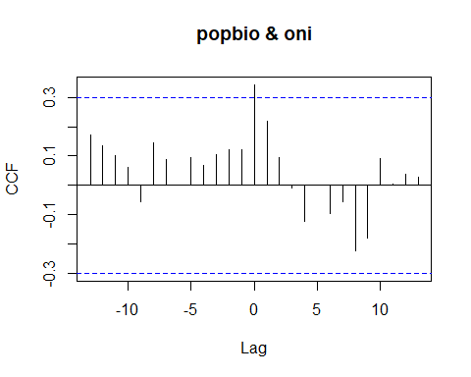

## [1] "CCF for (popbio,oni) series"

##   
## Autocorrelations of series 'X', by lag  
##   
## -13 -12 -11 -10 -9 -8 -7 -6 -5 -4 -3   
## 0.172 0.135 0.101 0.063 -0.057 0.145 0.088 0.003 0.095 0.067 0.104   
## -2 -1 0 1 2 3 4 5 6 7 8   
## 0.121 0.120 0.342 0.219 0.094 -0.007 -0.122 0.002 -0.094 -0.055 -0.222   
## 9 10 11 12 13   
## -0.179 0.092 0.005 0.037 0.028

## [1] "Significant cross correlations exist at lags:"  
## [1] 0  
## [1] 0.3423802

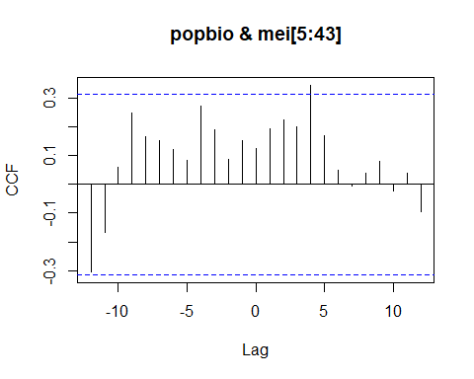

## [1] "CCF for (popbio,mei) series"

##   
## Autocorrelations of series 'X', by lag  
##   
## -12 -11 -10 -9 -8 -7 -6 -5 -4 -3 -2   
## -0.306 -0.168 0.058 0.249 0.167 0.151 0.121 0.082 0.273 0.190 0.086   
## -1 0 1 2 3 4 5 6 7 8 9   
## 0.150 0.122 0.191 0.224 0.199 0.344 0.168 0.050 -0.005 0.038 0.079   
## 10 11 12   
## -0.024 0.037 -0.095

## [1] "Significant cross correlations exist at lags:"  
## [1] 4  
## [1] 0.3435665

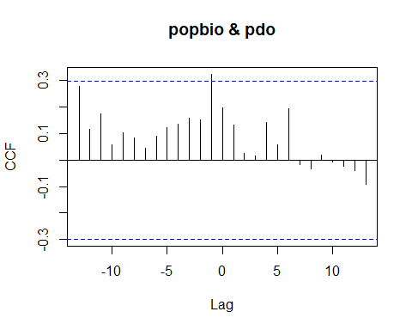

## [1] "CCF for (popbio,pdo) series"

##   
## Autocorrelations of series 'X', by lag  
##   
## -13 -12 -11 -10 -9 -8 -7 -6 -5 -4 -3   
## 0.278 0.116 0.174 0.057 0.102 0.083 0.046 0.091 0.123 0.135 0.158   
## -2 -1 0 1 2 3 4 5 6 7 8   
## 0.153 0.324 0.196 0.131 0.027 0.014 0.141 0.058 0.193 -0.017 -0.032   
## 9 10 11 12 13   
## 0.019 -0.008 -0.023 -0.041 -0.091

## [1] "Significant cross correlations exist at lags:"  
## [1] -1  
## [1] 0.323741

### Catch Biomass CCF Analysis

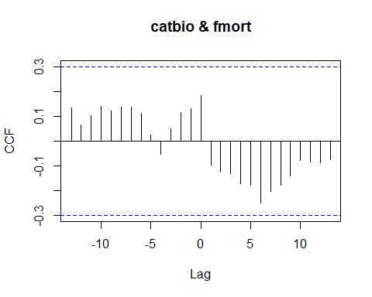

## [1] "CCF for (catbio,fmort) series"

##   
## Autocorrelations of series 'X', by lag  
##   
## -13 -12 -11 -10 -9 -8 -7 -6 -5 -4 -3   
## 0.135 0.066 0.101 0.138 0.122 0.137 0.136 0.113 0.025 -0.052 0.051   
## -2 -1 0 1 2 3 4 5 6 7 8   
## 0.114 0.129 0.183 -0.097 -0.124 -0.130 -0.172 -0.177 -0.248 -0.202 -0.178   
## 9 10 11 12 13   
## -0.141 -0.078 -0.084 -0.088 -0.074

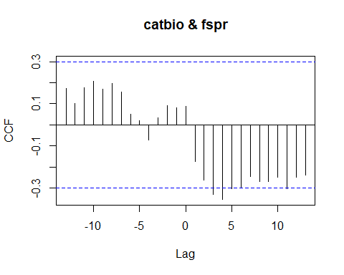

## [1] "CCF for (catbio,fspr) series"

##   
## Autocorrelations of series 'X', by lag  
##   
## -13 -12 -11 -10 -9 -8 -7 -6 -5 -4 -3   
## 0.174 0.102 0.175 0.206 0.168 0.196 0.155 0.049 0.019 -0.072 0.034   
## -2 -1 0 1 2 3 4 5 6 7 8   
## 0.092 0.082 0.087 -0.172 -0.263 -0.331 -0.353 -0.303 -0.299 -0.246 -0.268   
## 9 10 11 12 13   
## -0.268 -0.247 -0.303 -0.248 -0.239

## [1] "Significant cross correlations exist at lags:"  
## [1] 3 4  
## [1] -0.3314615 -0.3533277

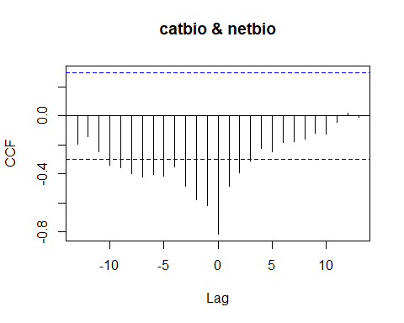

## [1] "CCF for (catbio,netbio) series"

##   
## Autocorrelations of series 'X', by lag  
##   
## -13 -12 -11 -10 -9 -8 -7 -6 -5 -4 -3   
## -0.199 -0.144 -0.250 -0.342 -0.360 -0.401 -0.424 -0.407 -0.419 -0.354 -0.486   
## -2 -1 0 1 2 3 4 5 6 7 8   
## -0.578 -0.622 -0.817 -0.486 -0.394 -0.314 -0.225 -0.248 -0.187 -0.181 -0.160   
## 9 10 11 12 13   
## -0.118 -0.126 -0.046 0.021 -0.011

## [1] "Significant cross correlations exist at lags:"  
## [1] -10 -9 -8 -7 -6 -5 -4 -3 -2 -1 0 1 2 3  
## [1] -0.3420287 -0.3603827 -0.4010911 -0.4241222 -0.4072818 -0.4188918  
## [7] -0.3543317 -0.4857223 -0.5784311 -0.6221525 -0.8173653 -0.4860948  
## [13] -0.3939191 -0.3141064

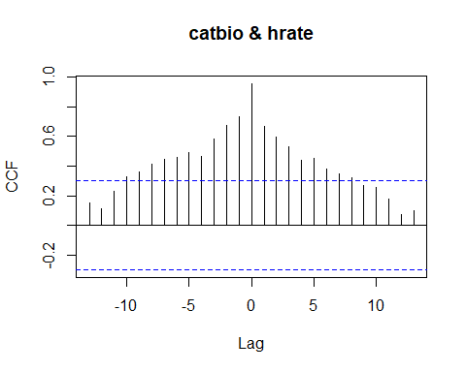

## [1] "CCF for (catbio,hrate) series"

##   
## Autocorrelations of series 'X', by lag  
##   
## -13 -12 -11 -10 -9 -8 -7 -6 -5 -4 -3 -2 -1   
## 0.150 0.116 0.232 0.330 0.363 0.414 0.445 0.461 0.491 0.468 0.585 0.673 0.732   
## 0 1 2 3 4 5 6 7 8 9 10 11 12   
## 0.956 0.666 0.594 0.534 0.440 0.454 0.383 0.350 0.321 0.269 0.258 0.180 0.073   
## 13   
## 0.100

## [1] "Significant cross correlations exist at lags:"  
## [1] -10 -9 -8 -7 -6 -5 -4 -3 -2 -1 0 1 2 3 4 5 6 7 8  
## [1] 0.3295191 0.3634284 0.4137310 0.4447670 0.4611043 0.4911287 0.4678957  
## [8] 0.5848863 0.6731923 0.7319130 0.9564454 0.6658232 0.5938772 0.5336367  
## [15] 0.4404871 0.4538646 0.3825955 0.3499393 0.3212690

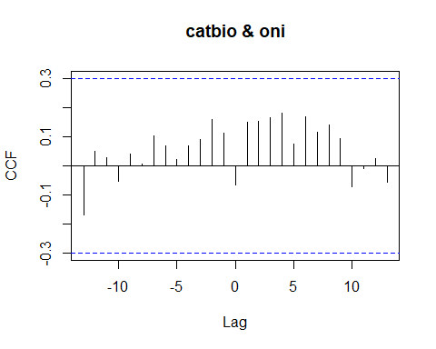

## [1] "CCF for (catbio,oni) series"

##   
## Autocorrelations of series 'X', by lag  
##   
## -13 -12 -11 -10 -9 -8 -7 -6 -5 -4 -3   
## -0.167 0.050 0.028 -0.054 0.041 0.007 0.102 0.069 0.022 0.068 0.090   
## -2 -1 0 1 2 3 4 5 6 7 8   
## 0.157 0.112 -0.065 0.148 0.154 0.166 0.181 0.075 0.168 0.113 0.141   
## 9 10 11 12 13   
## 0.094 -0.071 -0.008 0.025 -0.058

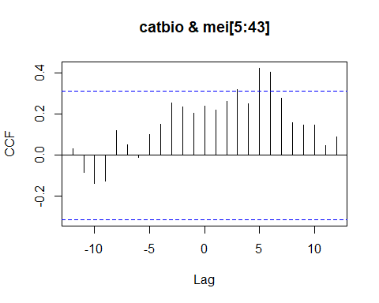

## [1] "CCF for (catbio,mei) series"

##   
## Autocorrelations of series 'X', by lag  
##   
## -12 -11 -10 -9 -8 -7 -6 -5 -4 -3 -2   
## 0.031 -0.085 -0.137 -0.126 0.121 0.051 -0.012 0.099 0.149 0.253 0.236   
## -1 0 1 2 3 4 5 6 7 8 9   
## 0.203 0.240 0.219 0.262 0.319 0.252 0.424 0.403 0.279 0.160 0.147   
## 10 11 12   
## 0.149 0.048 0.089

## [1] "Significant cross correlations exist at lags:"  
## [1] 5 6  
## [1] 0.4238208 0.4025912

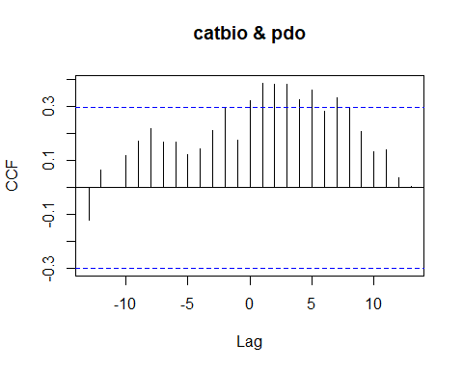

## [1] "CCF for (catbio,pdo) series"

##   
## Autocorrelations of series 'X', by lag  
##   
## -13 -12 -11 -10 -9 -8 -7 -6 -5 -4 -3   
## -0.122 0.066 0.002 0.121 0.174 0.218 0.167 0.170 0.124 0.142 0.212   
## -2 -1 0 1 2 3 4 5 6 7 8   
## 0.299 0.176 0.324 0.387 0.384 0.382 0.325 0.361 0.283 0.332 0.295   
## 9 10 11 12 13   
## 0.207 0.135 0.142 0.036 0.005

## [1] "Significant cross correlations exist at lags:"  
## [1] 0 1 2 3 4 5 7  
## [1] 0.3243258 0.3874047 0.3844252 0.3820021 0.3249937 0.3607264 0.3323993

### Fishing Mortality CCF Analysis

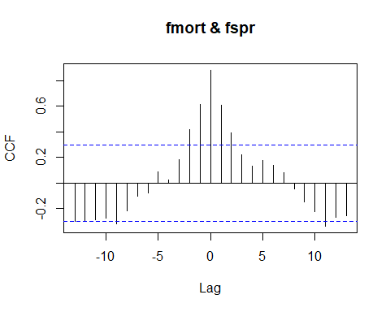

## [1] "CCF for (fmort,fspr) series"

##   
## Autocorrelations of series 'X', by lag  
##   
## -13 -12 -11 -10 -9 -8 -7 -6 -5 -4 -3   
## -0.304 -0.295 -0.288 -0.278 -0.321 -0.221 -0.106 -0.081 0.090 0.026 0.184   
## -2 -1 0 1 2 3 4 5 6 7 8   
## 0.419 0.615 0.883 0.609 0.395 0.218 0.133 0.173 0.141 0.082 -0.050   
## 9 10 11 12 13   
## -0.150 -0.222 -0.339 -0.270 -0.256

## [1] "Significant cross correlations exist at lags:"  
## [1] -9 -2 -1 0 1 2 11  
## [1] -0.3207725 0.4193067 0.6152091 0.8828778 0.6086659 0.3945278 -0.3387443

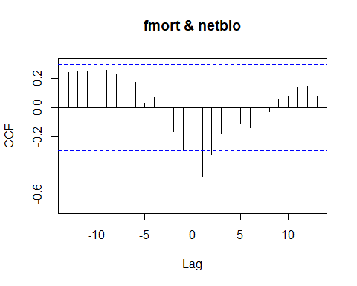

## [1] "CCF for (fmort,netbio) series"

##   
## Autocorrelations of series 'X', by lag  
##   
## -13 -12 -11 -10 -9 -8 -7 -6 -5 -4 -3   
## 0.244 0.250 0.249 0.216 0.256 0.232 0.166 0.175 0.032 0.070 -0.041   
## -2 -1 0 1 2 3 4 5 6 7 8   
## -0.166 -0.291 -0.692 -0.479 -0.327 -0.179 -0.028 -0.107 -0.138 -0.090 -0.026   
## 9 10 11 12 13   
## 0.056 0.074 0.139 0.151 0.075

## [1] "Significant cross correlations exist at lags:"  
## [1] 0 1 2  
## [1] -0.6917998 -0.4791540 -0.3272750

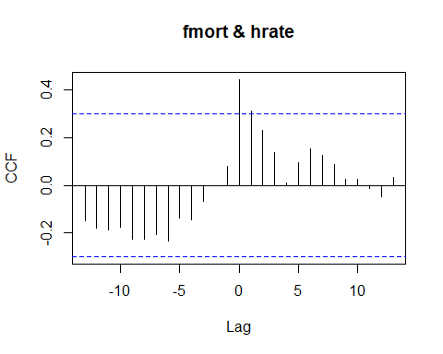

## [1] "CCF for (fmort,hrate) series"

##   
## Autocorrelations of series 'X', by lag  
##   
## -13 -12 -11 -10 -9 -8 -7 -6 -5 -4 -3   
## -0.147 -0.181 -0.188 -0.175 -0.224 -0.227 -0.207 -0.234 -0.137 -0.143 -0.068   
## -2 -1 0 1 2 3 4 5 6 7 8   
## -0.002 0.080 0.443 0.311 0.230 0.139 0.009 0.096 0.154 0.124 0.088   
## 9 10 11 12 13   
## 0.026 0.025 -0.014 -0.049 0.035

## [1] "Significant cross correlations exist at lags:"  
## [1] 0 1  
## [1] 0.4433992 0.3106255

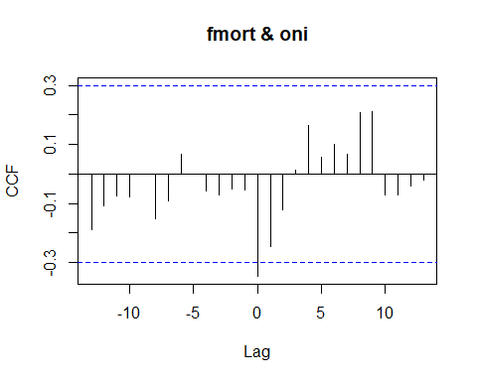

## [1] "CCF for (fmort,oni) series"

##   
## Autocorrelations of series 'X', by lag  
##   
## -13 -12 -11 -10 -9 -8 -7 -6 -5 -4 -3   
## -0.187 -0.108 -0.074 -0.078 -0.001 -0.152 -0.091 0.067 0.001 -0.056 -0.069   
## -2 -1 0 1 2 3 4 5 6 7 8   
## -0.051 -0.053 -0.346 -0.246 -0.122 0.013 0.164 0.057 0.099 0.068 0.209   
## 9 10 11 12 13   
## 0.210 -0.072 -0.071 -0.040 -0.021

## [1] "Significant cross correlations exist at lags:"  
## [1] 0  
## [1] -0.3457827

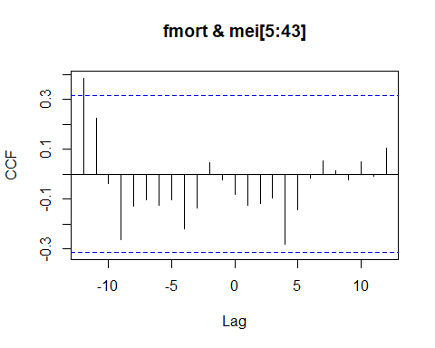

## [1] "CCF for (fmort,mei) series"

##   
## Autocorrelations of series 'X', by lag  
##   
## -12 -11 -10 -9 -8 -7 -6 -5 -4 -3 -2   
## 0.384 0.224 -0.037 -0.264 -0.130 -0.102 -0.125 -0.103 -0.220 -0.137 0.045   
## -1 0 1 2 3 4 5 6 7 8 9   
## -0.022 -0.083 -0.127 -0.116 -0.095 -0.282 -0.144 -0.017 0.053 0.012 -0.023   
## 10 11 12   
## 0.048 -0.007 0.104

## [1] "Significant cross correlations exist at lags:"  
## [1] -12  
## [1] 0.3840518

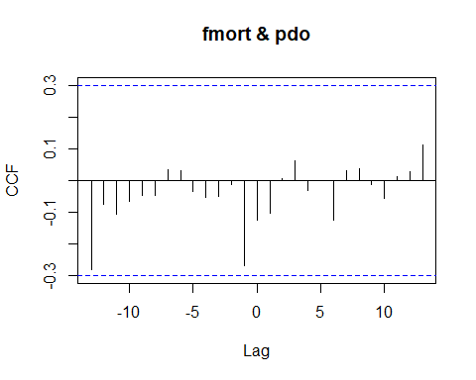

## [1] "CCF for (fmort,pdo) series"

##   
## Autocorrelations of series 'X', by lag  
##   
## -13 -12 -11 -10 -9 -8 -7 -6 -5 -4 -3   
## -0.281 -0.075 -0.108 -0.066 -0.045 -0.046 0.035 0.032 -0.035 -0.055 -0.050   
## -2 -1 0 1 2 3 4 5 6 7 8   
## -0.013 -0.267 -0.123 -0.103 0.007 0.062 -0.030 0.001 -0.126 0.030 0.036   
## 9 10 11 12 13   
## -0.014 -0.056 0.011 0.027 0.111

### Fishing Intensity CCF Analysis

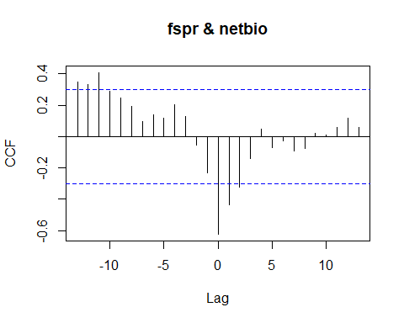

## [1] "CCF for (fspr,netbio) series"

##   
## Autocorrelations of series 'X', by lag  
##   
## -13 -12 -11 -10 -9 -8 -7 -6 -5 -4 -3   
## 0.347 0.333 0.409 0.288 0.248 0.193 0.096 0.137 0.119 0.206 0.127   
## -2 -1 0 1 2 3 4 5 6 7 8   
## -0.054 -0.231 -0.623 -0.438 -0.321 -0.141 0.048 -0.069 -0.025 -0.092 -0.075   
## 9 10 11 12 13   
## 0.022 0.010 0.061 0.120 0.057

## [1] "Significant cross correlations exist at lags:"  
## [1] -13 -12 -11 0 1 2  
## [1] 0.3474361 0.3330793 0.4085023 -0.6228792 -0.4378884 -0.3206306

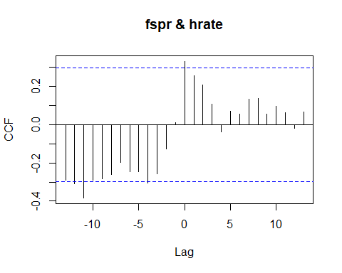

## [1] "CCF for (fspr,hrate) series"

##   
## Autocorrelations of series 'X', by lag  
##   
## -13 -12 -11 -10 -9 -8 -7 -6 -5 -4 -3   
## -0.292 -0.309 -0.383 -0.292 -0.285 -0.260 -0.199 -0.247 -0.247 -0.304 -0.257   
## -2 -1 0 1 2 3 4 5 6 7 8   
## -0.126 0.013 0.331 0.255 0.208 0.106 -0.038 0.071 0.054 0.132 0.138   
## 9 10 11 12 13   
## 0.055 0.097 0.064 -0.019 0.068

## [1] "Significant cross correlations exist at lags:"  
## [1] -12 -11 0  
## [1] -0.3094427 -0.3831161 0.3309788

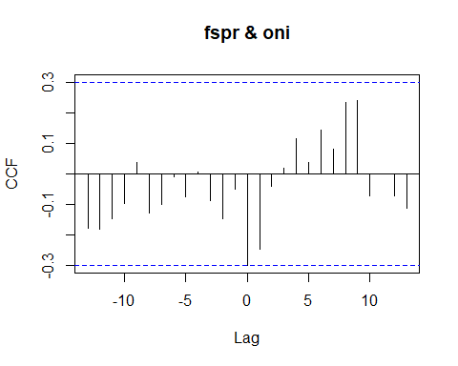

## [1] "CCF for (fspr,oni) series"

##   
## Autocorrelations of series 'X', by lag  
##   
## -13 -12 -11 -10 -9 -8 -7 -6 -5 -4 -3   
## -0.179 -0.180 -0.146 -0.096 0.037 -0.128 -0.101 -0.008 -0.075 0.005 -0.089   
## -2 -1 0 1 2 3 4 5 6 7 8   
## -0.147 -0.051 -0.299 -0.245 -0.042 0.018 0.114 0.037 0.142 0.080 0.234   
## 9 10 11 12 13   
## 0.240 -0.071 -0.001 -0.071 -0.114

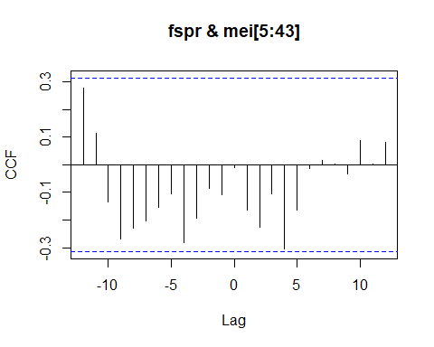

## [1] "CCF for (fspr,mei) series"

##   
## Autocorrelations of series 'X', by lag  
##   
## -12 -11 -10 -9 -8 -7 -6 -5 -4 -3 -2   
## 0.278 0.114 -0.133 -0.268 -0.229 -0.204 -0.155 -0.106 -0.282 -0.192 -0.086   
## -1 0 1 2 3 4 5 6 7 8 9   
## -0.109 -0.011 -0.165 -0.226 -0.105 -0.304 -0.162 -0.013 0.017 0.004 -0.032   
## 10 11 12   
## 0.089 0.002 0.082

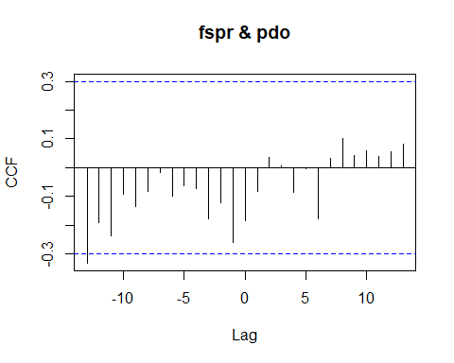

## [1] "CCF for (fspr,pdo) series"

##   
## Autocorrelations of series 'X', by lag  
##   
## -13 -12 -11 -10 -9 -8 -7 -6 -5 -4 -3   
## -0.332 -0.191 -0.237 -0.093 -0.136 -0.083 -0.016 -0.098 -0.064 -0.074 -0.178   
## -2 -1 0 1 2 3 4 5 6 7 8   
## -0.121 -0.260 -0.185 -0.082 0.037 0.006 -0.086 -0.003 -0.179 0.034 0.101   
## 9 10 11 12 13   
## 0.043 0.060 0.040 0.055 0.082

## [1] "Significant cross correlations exist at lags:"  
## [1] -13  
## [1] -0.3322702

### Net Biomass CCF Analysis

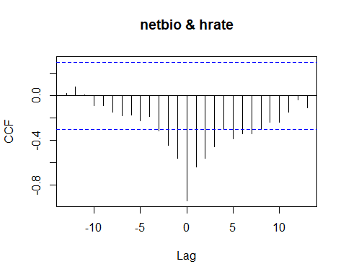

## [1] "CCF for (netbio,hrate) series"

##   
## Autocorrelations of series 'X', by lag  
##   
## -13 -12 -11 -10 -9 -8 -7 -6 -5 -4 -3   
## 0.018 0.076 0.009 -0.090 -0.091 -0.147 -0.179 -0.175 -0.226 -0.186 -0.315   
## -2 -1 0 1 2 3 4 5 6 7 8   
## -0.440 -0.557 -0.939 -0.635 -0.559 -0.457 -0.304 -0.387 -0.337 -0.341 -0.304   
## 9 10 11 12 13   
## -0.239 -0.237 -0.147 -0.040 -0.111

## [1] "Significant cross correlations exist at lags:"  
## [1] -3 -2 -1 0 1 2 3 5 6 7  
## [1] -0.3151814 -0.4404788 -0.5566184 -0.9386263 -0.6352319 -0.5585943  
## [7] -0.4565597 -0.3866364 -0.3373617 -0.3407556

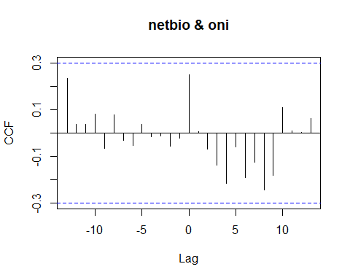

## [1] "CCF for (netbio,oni) series"

##   
## Autocorrelations of series 'X', by lag  
##   
## -13 -12 -11 -10 -9 -8 -7 -6 -5 -4 -3   
## 0.234 0.037 0.036 0.080 -0.066 0.078 -0.032 -0.054 0.037 -0.016 -0.013   
## -2 -1 0 1 2 3 4 5 6 7 8   
## -0.057 -0.021 0.249 0.007 -0.070 -0.139 -0.217 -0.059 -0.190 -0.124 -0.242   
## 9 10 11 12 13   
## -0.179 0.110 0.010 0.001 0.063

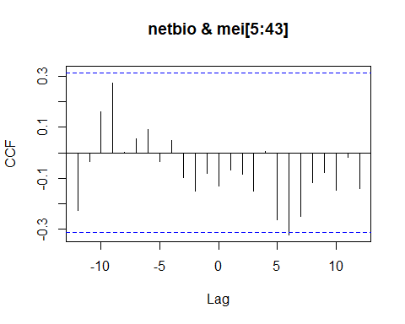

## [1] "CCF for (netbio,mei) series"

##   
## Autocorrelations of series 'X', by lag  
##   
## -12 -11 -10 -9 -8 -7 -6 -5 -4 -3 -2   
## -0.229 -0.036 0.159 0.275 0.003 0.054 0.091 -0.034 0.048 -0.098 -0.152   
## -1 0 1 2 3 4 5 6 7 8 9   
## -0.080 -0.132 -0.068 -0.084 -0.151 0.004 -0.264 -0.323 -0.250 -0.116 -0.078   
## 10 11 12   
## -0.147 -0.018 -0.141

## [1] "Significant cross correlations exist at lags:"  
## [1] 6  
## [1] -0.3228764

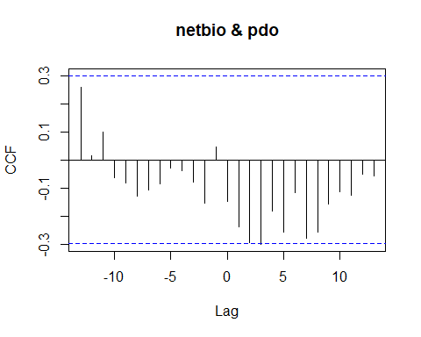

## [1] "CCF for (netbio,pdo) series"

##   
## Autocorrelations of series 'X', by lag  
##   
## -13 -12 -11 -10 -9 -8 -7 -6 -5 -4 -3   
## 0.259 0.013 0.098 -0.065 -0.082 -0.129 -0.109 -0.086 -0.029 -0.038 -0.081   
## -2 -1 0 1 2 3 4 5 6 7 8   
## -0.154 0.044 -0.150 -0.238 -0.296 -0.301 -0.182 -0.258 -0.118 -0.279 -0.257   
## 9 10 11 12 13   
## -0.156 -0.114 -0.128 -0.052 -0.056

### Harvest Rate CCF Analysis

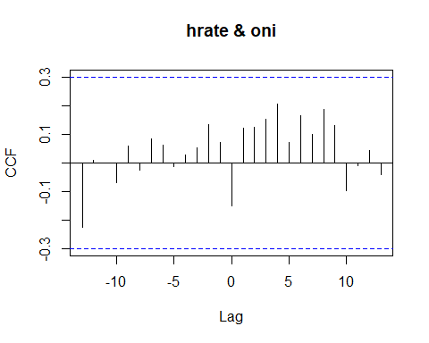

## [1] "CCF for (hrate,oni) series"

##   
## Autocorrelations of series 'X', by lag  
##   
## -13 -12 -11 -10 -9 -8 -7 -6 -5 -4 -3   
## -0.225 0.010 0.000 -0.069 0.059 -0.024 0.083 0.063 -0.013 0.027 0.052   
## -2 -1 0 1 2 3 4 5 6 7 8   
## 0.134 0.071 -0.150 0.121 0.125 0.152 0.204 0.072 0.166 0.100 0.185   
## 9 10 11 12 13   
## 0.129 -0.096 -0.010 0.044 -0.041

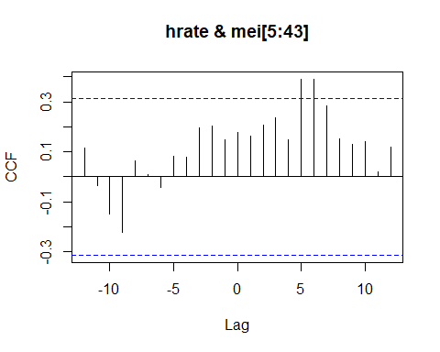

## [1] "CCF for (hrate,mei) series"

##   
## Autocorrelations of series 'X', by lag  
##   
## -12 -11 -10 -9 -8 -7 -6 -5 -4 -3 -2   
## 0.117 -0.035 -0.151 -0.221 0.065 0.010 -0.044 0.081 0.080 0.196 0.203   
## -1 0 1 2 3 4 5 6 7 8 9   
## 0.146 0.179 0.162 0.206 0.236 0.149 0.391 0.390 0.283 0.151 0.130   
## 10 11 12   
## 0.139 0.020 0.119

## [1] "Significant cross correlations exist at lags:"  
## [1] 5 6  
## [1] 0.3908623 0.3897741

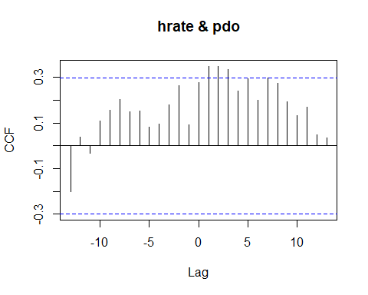

## [1] "CCF for (hrate,pdo) series"

##   
## Autocorrelations of series 'X', by lag  
##   
## -13 -12 -11 -10 -9 -8 -7 -6 -5 -4 -3   
## -0.200 0.039 -0.031 0.107 0.157 0.204 0.148 0.151 0.080 0.097 0.180   
## -2 -1 0 1 2 3 4 5 6 7 8   
## 0.264 0.093 0.279 0.346 0.348 0.334 0.242 0.295 0.198 0.296 0.272   
## 9 10 11 12 13   
## 0.193 0.132 0.168 0.050 0.035

## [1] "Significant cross correlations exist at lags:"  
## [1] 1 2 3  
## [1] 0.3464286 0.3483422 0.3337863

### Oceanic Nino Index CCF Analysis

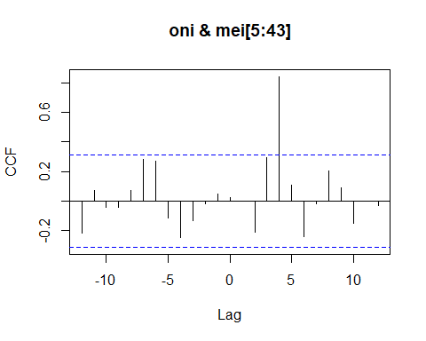

## [1] "CCF for (oni,mei) series"

##   
## Autocorrelations of series 'X', by lag  
##   
## -12 -11 -10 -9 -8 -7 -6 -5 -4 -3 -2   
## -0.220 0.073 -0.042 -0.046 0.071 0.281 0.270 -0.116 -0.248 -0.132 -0.017   
## -1 0 1 2 3 4 5 6 7 8 9   
## 0.047 0.021 0.001 -0.213 0.296 0.843 0.109 -0.244 -0.018 0.205 0.088   
## 10 11 12   
## -0.152 0.002 -0.033

## [1] "Significant cross correlations exist at lags:"  
## [1] 4  
## [1] 0.8433219

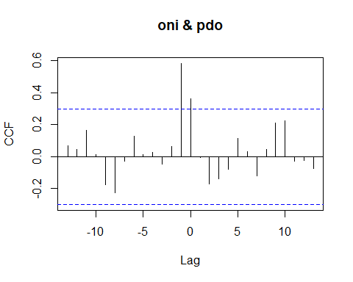

## [1] "CCF for (oni,pdo) series"

##   
## Autocorrelations of series 'X', by lag  
##   
## -13 -12 -11 -10 -9 -8 -7 -6 -5 -4 -3   
## 0.067 0.048 0.165 0.014 -0.175 -0.225 -0.026 0.130 0.015 0.025 -0.045   
## -2 -1 0 1 2 3 4 5 6 7 8   
## 0.066 0.584 0.361 -0.006 -0.171 -0.137 -0.076 0.114 0.034 -0.122 0.045   
## 9 10 11 12 13   
## 0.210 0.224 -0.026 -0.024 -0.074

## [1] "Significant cross correlations exist at lags:"  
## [1] -1 0  
## [1] 0.5842851 0.3608859

### Multivariate ENSO Index CCF Analysis

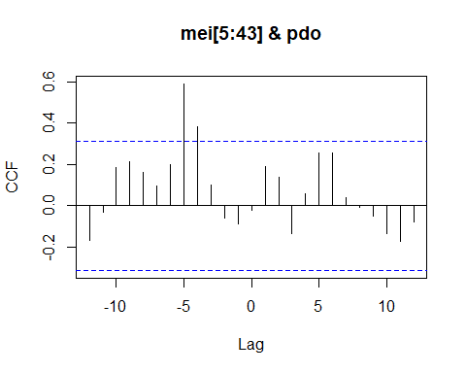

## [1] "CCF for (mei,pdo) series"

##   
## Autocorrelations of series 'X', by lag  
##   
## -12 -11 -10 -9 -8 -7 -6 -5 -4 -3 -2   
## -0.170 -0.032 0.182 0.214 0.162 0.097 0.200 0.590 0.385 0.099 -0.058   
## -1 0 1 2 3 4 5 6 7 8 9   
## -0.090 -0.023 0.190 0.138 -0.133 0.058 0.258 0.256 0.038 -0.010 -0.052   
## 10 11 12   
## -0.136 -0.175 -0.080

## [1] "Significant cross correlations exist at lags:"  
## [1] -5 -4  
## [1] 0.5901160 0.3847564