Change Point 2023

2023-12-06

# Fishery Productivity Time Series Analyses

## WCNPO Striped Marlin

## 2023 Benchmark Assessment

### Summary of Input Data

## year oni mei pdo   
## Min. :1977 Min. :-1.22500 Min. :-1.3400000 Min. :-2.0420   
## 1st Qu.:1988 1st Qu.:-0.38425 1st Qu.:-0.4825000 1st Qu.:-0.8460   
## Median :1998 Median : 0.05650 Median :-0.0225000 Median :-0.1980   
## Mean :1998 Mean : 0.04543 Mean : 0.0001667 Mean :-0.1185   
## 3rd Qu.:2009 3rd Qu.: 0.45400 3rd Qu.: 0.3477500 3rd Qu.: 0.6215   
## Max. :2020 Max. : 1.46100 Max. : 1.3730000 Max. : 1.5340   
## NA's :2   
## rec ssb rssb popbio   
## Min. :0.0900 Min. :1.081 Min. :0.0530 Min. : 9.711   
## 1st Qu.:0.2205 1st Qu.:1.246 1st Qu.:0.1143 1st Qu.:11.090   
## Median :0.3420 Median :1.657 Median :0.1760 Median :12.284   
## Mean :0.3662 Mean :2.266 Mean :0.1741 Mean :12.217   
## 3rd Qu.:0.4888 3rd Qu.:3.065 3rd Qu.:0.2215 3rd Qu.:13.163   
## Max. :0.7110 Max. :5.118 Max. :0.3330 Max. :15.283   
##   
## fmort spr catbio fspr   
## Min. :0.5340 Min. :0.0600 Min. : 2.177 Min. :0.7690   
## 1st Qu.:0.7522 1st Qu.:0.1065 1st Qu.: 3.202 1st Qu.:0.8490   
## Median :0.8750 Median :0.1225 Median : 5.014 Median :0.8775   
## Mean :0.8889 Mean :0.1268 Mean : 5.419 Mean :0.8732   
## 3rd Qu.:1.0052 3rd Qu.:0.1510 3rd Qu.: 7.109 3rd Qu.:0.8935   
## Max. :1.4220 Max. :0.2310 Max. :10.912 Max. :0.9400   
##   
## netbio hrate   
## Min. :-0.184 Min. :0.1577   
## 1st Qu.: 4.848 1st Qu.:0.2546   
## Median : 6.952 Median :0.4088   
## Mean : 6.797 Mean :0.4585   
## 3rd Qu.: 9.303 3rd Qu.:0.6086   
## Max. :12.871 Max. :1.0172   
##

## Environmental Time Series, 1977-2020

#### Oceanic Nino Index (oni)

#### Multivariate ENSO Index (mei)

#### Pacific Decadal Oscillation, November-March (pdo)

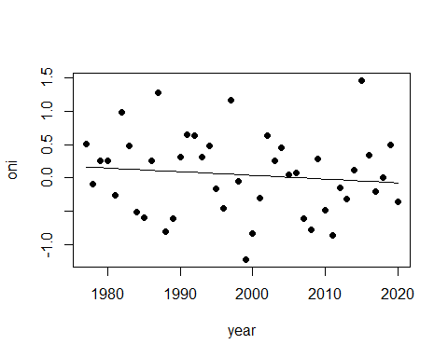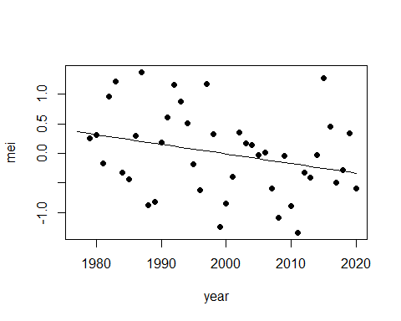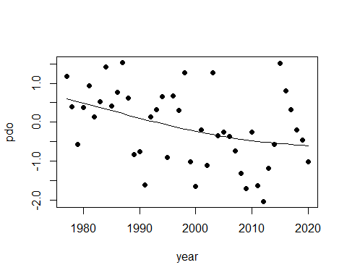

## Fishery System Time Series, 1977-2020

#### Recruitment (rec) and Spawning Stock Biomass (ssb)

#### Recruits per Spawning Biomass (rssb) and Spawning Potential Ratio (spr)

#### Population Biomass (popbio) and Catch Biomass (catbio)

#### Fishing Mortality (fmort) and Fishing Intensity (fspr)

#### Population Minus Catch Biomass (netbio) and Harvest Rate (hrate)

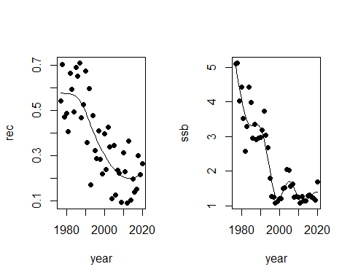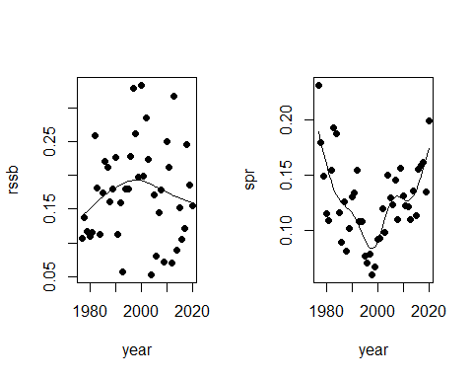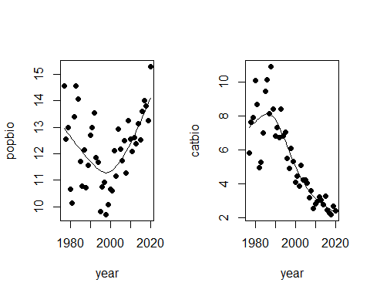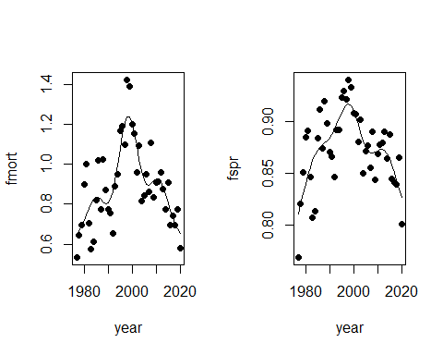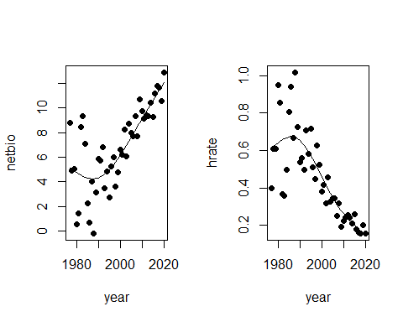

### Spearman Correlations of Environmental Series with Year, 1977-2020

## Call:corr.test(x = mls[c(1:4)], use = "pairwise.complete.obs", method = "spearman",   
## adjust = "fdr", normal = FALSE)  
## Correlation matrix   
## year oni mei pdo  
## year 1.00 -0.15 -0.27 -0.39  
## oni -0.15 1.00 0.95 0.29  
## mei -0.27 0.95 1.00 0.42  
## pdo -0.39 0.29 0.42 1.00  
## Sample Size   
## year oni mei pdo  
## year 44 44 42 44  
## oni 44 44 42 44  
## mei 42 42 42 42  
## pdo 44 44 42 44  
## Probability values (Entries above the diagonal are adjusted for multiple tests.)   
## year oni mei pdo  
## year 0.00 0.35 0.10 0.02  
## oni 0.35 0.00 0.00 0.08  
## mei 0.09 0.00 0.00 0.02  
## pdo 0.01 0.05 0.01 0.00  
##   
## Confidence intervals based upon normal theory. To get bootstrapped values, try cor.ci  
## raw.lower raw.r raw.upper raw.p lower.adj upper.adj  
## year-oni -0.42 -0.15 0.16 0.35 -0.51 0.26  
## year-mei -0.53 -0.27 0.04 0.09 -0.60 0.15  
## year-pdo -0.61 -0.39 -0.10 0.01 -0.68 0.00  
## oni-mei 0.91 0.95 0.97 0.00 0.89 0.98  
## oni-pdo 0.00 0.29 0.54 0.05 -0.11 0.61  
## mei-pdo 0.14 0.42 0.65 0.01 0.03 0.70

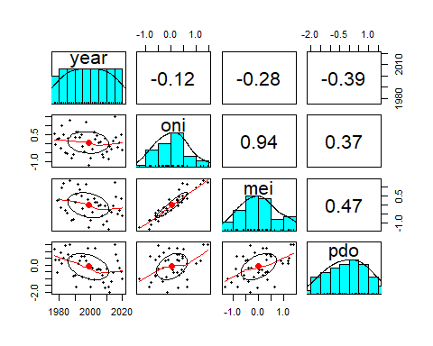

### Spearman Correlations of Fishery Series with Year, 1977-2020

## Call:corr.test(x = mls[c(1, 5:14)], use = "pairwise.complete.obs",   
## method = "spearman", adjust = "fdr", normal = FALSE)  
## Correlation matrix   
## year rec ssb rssb popbio fmort spr catbio fspr netbio hrate  
## year 1.00 -0.78 -0.79 0.03 0.20 0.10 0.08 -0.89 -0.08 0.74 -0.83  
## rec -0.78 1.00 0.67 0.37 -0.04 -0.24 0.03 0.67 -0.03 -0.52 0.61  
## ssb -0.79 0.67 1.00 -0.39 0.19 -0.48 0.32 0.71 -0.32 -0.46 0.59  
## rssb 0.03 0.37 -0.39 1.00 -0.34 0.38 -0.42 -0.05 0.42 -0.10 0.03  
## popbio 0.20 -0.04 0.19 -0.34 1.00 -0.90 0.93 -0.45 -0.93 0.72 -0.59  
## fmort 0.10 -0.24 -0.48 0.38 -0.90 1.00 -0.92 0.13 0.92 -0.44 0.29  
## spr 0.08 0.03 0.32 -0.42 0.93 -0.92 1.00 -0.37 -1.00 0.64 -0.51  
## catbio -0.89 0.67 0.71 -0.05 -0.45 0.13 -0.37 1.00 0.37 -0.93 0.98  
## fspr -0.08 -0.03 -0.32 0.42 -0.93 0.92 -1.00 0.37 1.00 -0.64 0.51  
## netbio 0.74 -0.52 -0.46 -0.10 0.72 -0.44 0.64 -0.93 -0.64 1.00 -0.98  
## hrate -0.83 0.61 0.59 0.03 -0.59 0.29 -0.51 0.98 0.51 -0.98 1.00  
## Sample Size   
## year rec ssb rssb popbio fmort spr catbio fspr netbio hrate  
## year 44 44 44 44 44 44 44 44 44 44 44  
## rec 44 44 44 44 44 44 44 44 44 44 44  
## ssb 44 44 44 44 44 44 44 44 44 44 44  
## rssb 44 44 44 44 44 44 44 44 44 44 44  
## popbio 44 44 44 44 44 44 44 44 44 44 44  
## fmort 44 44 44 44 44 44 44 44 44 44 44  
## spr 44 44 44 44 44 44 44 44 44 44 44  
## catbio 44 44 44 44 44 44 44 44 44 44 44  
## fspr 44 44 44 44 44 44 44 44 44 44 44  
## netbio 44 44 44 44 44 44 44 44 44 44 44  
## hrate 44 44 44 44 44 44 44 44 44 44 44  
## Probability values (Entries above the diagonal are adjusted for multiple tests.)   
## year rec ssb rssb popbio fmort spr catbio fspr netbio hrate  
## year 0.00 0.00 0.00 0.85 0.24 0.62 0.70 0.00 0.70 0.00 0.00  
## rec 0.00 0.00 0.00 0.02 0.85 0.16 0.85 0.00 0.85 0.00 0.00  
## ssb 0.00 0.00 0.00 0.01 0.27 0.00 0.05 0.00 0.05 0.00 0.00  
## rssb 0.84 0.01 0.01 0.00 0.04 0.02 0.01 0.84 0.01 0.61 0.85  
## popbio 0.19 0.80 0.21 0.03 0.00 0.00 0.00 0.00 0.00 0.00 0.00  
## fmort 0.53 0.12 0.00 0.01 0.00 0.00 0.00 0.47 0.00 0.01 0.08  
## spr 0.62 0.84 0.04 0.00 0.00 0.00 0.00 0.02 0.00 0.00 0.00  
## catbio 0.00 0.00 0.00 0.76 0.00 0.38 0.01 0.00 0.02 0.00 0.00  
## fspr 0.62 0.84 0.04 0.00 0.00 0.00 0.00 0.01 0.00 0.00 0.00  
## netbio 0.00 0.00 0.00 0.51 0.00 0.00 0.00 0.00 0.00 0.00 0.00  
## hrate 0.00 0.00 0.00 0.85 0.00 0.06 0.00 0.00 0.00 0.00 0.00  
##   
## Confidence intervals based upon normal theory. To get bootstrapped values, try cor.ci  
## raw.lower raw.r raw.upper raw.p lower.adj upper.adj  
## year-rec -0.88 -0.78 -0.63 0.00 -0.92 -0.49  
## year-ssb -0.88 -0.79 -0.64 0.00 -0.92 -0.50  
## year-rssb -0.27 0.03 0.33 0.84 -0.45 0.50  
## year-popbi -0.10 0.20 0.47 0.19 -0.30 0.62  
## year-fmort -0.21 0.10 0.38 0.53 -0.40 0.55  
## year-spr -0.23 0.08 0.36 0.62 -0.42 0.53  
## year-catbi -0.94 -0.89 -0.80 0.00 -0.96 -0.71  
## year-fspr -0.36 -0.08 0.23 0.62 -0.53 0.42  
## year-netbi 0.56 0.74 0.85 0.00 0.40 0.90  
## year-hrate -0.90 -0.83 -0.70 0.00 -0.94 -0.58  
## rec-ssb 0.46 0.67 0.80 0.00 0.28 0.87  
## rec-rssb 0.08 0.37 0.60 0.01 -0.13 0.72  
## rec-popbi -0.33 -0.04 0.26 0.80 -0.51 0.45  
## rec-fmort -0.50 -0.24 0.06 0.12 -0.64 0.27  
## rec-spr -0.27 0.03 0.32 0.84 -0.45 0.50  
## rec-catbi 0.46 0.67 0.80 0.00 0.28 0.87  
## rec-fspr -0.32 -0.03 0.27 0.84 -0.50 0.45  
## rec-netbi -0.71 -0.52 -0.27 0.00 -0.80 -0.06  
## rec-hrate 0.38 0.61 0.76 0.00 0.18 0.84  
## ssb-rssb -0.62 -0.39 -0.11 0.01 -0.73 0.11  
## ssb-popbi -0.11 0.19 0.46 0.21 -0.31 0.61  
## ssb-fmort -0.68 -0.48 -0.21 0.00 -0.78 0.00  
## ssb-spr 0.02 0.32 0.56 0.04 -0.19 0.69  
## ssb-catbi 0.52 0.71 0.83 0.00 0.35 0.89  
## ssb-fspr -0.56 -0.32 -0.02 0.04 -0.69 0.19  
## ssb-netbi -0.66 -0.46 -0.18 0.00 -0.77 0.03  
## ssb-hrate 0.35 0.59 0.75 0.00 0.16 0.83  
## rssb-popbi -0.58 -0.34 -0.04 0.03 -0.70 0.17  
## rssb-fmort 0.10 0.38 0.61 0.01 -0.11 0.73  
## rssb-spr -0.64 -0.42 -0.14 0.00 -0.75 0.07  
## rssb-catbi -0.34 -0.05 0.25 0.76 -0.51 0.44  
## rssb-fspr 0.14 0.42 0.64 0.00 -0.07 0.75  
## rssb-netbi -0.39 -0.10 0.20 0.51 -0.55 0.39  
## rssb-hrate -0.27 0.03 0.32 0.85 -0.45 0.50  
## popbi-fmort -0.95 -0.90 -0.83 0.00 -0.96 -0.75  
## popbi-spr 0.88 0.93 0.96 0.00 0.82 0.98  
## popbi-catbi -0.66 -0.45 -0.17 0.00 -0.76 0.04  
## popbi-fspr -0.96 -0.93 -0.88 0.00 -0.98 -0.82  
## popbi-netbi 0.54 0.72 0.84 0.00 0.38 0.89  
## popbi-hrate -0.76 -0.59 -0.36 0.00 -0.83 -0.16  
## fmort-spr -0.96 -0.92 -0.86 0.00 -0.97 -0.80  
## fmort-catbi -0.17 0.13 0.42 0.38 -0.36 0.57  
## fmort-fspr 0.86 0.92 0.96 0.00 0.80 0.97  
## fmort-netbi -0.65 -0.44 -0.16 0.00 -0.76 0.05  
## fmort-hrate -0.01 0.29 0.54 0.06 -0.22 0.67  
## spr-catbi -0.60 -0.37 -0.08 0.01 -0.72 0.13  
## spr-fspr -1.00 -1.00 -1.00 0.00 -1.00 -1.00  
## spr-netbi 0.42 0.64 0.79 0.00 0.23 0.85  
## spr-hrate -0.70 -0.51 -0.26 0.00 -0.80 -0.05  
## catbi-fspr 0.08 0.37 0.60 0.01 -0.13 0.72  
## catbi-netbi -0.96 -0.93 -0.88 0.00 -0.97 -0.82  
## catbi-hrate 0.97 0.98 0.99 0.00 0.95 0.99  
## fspr-netbi -0.79 -0.64 -0.42 0.00 -0.85 -0.23  
## fspr-hrate 0.26 0.51 0.70 0.00 0.05 0.80  
## netbi-hrate -0.99 -0.98 -0.96 0.00 -0.99 -0.94

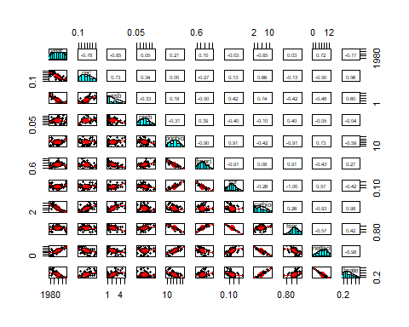

### Spearman Correlations of Fishery Series with ONI, 1977-2020

## Call:corr.test(x = mls[c(2, 5:14)], use = "pairwise.complete.obs",   
## method = "spearman", adjust = "fdr", normal = FALSE)  
## Correlation matrix   
## oni rec ssb rssb popbio fmort spr catbio fspr netbio hrate  
## oni 1.00 0.17 0.30 -0.10 0.36 -0.36 0.27 0.05 -0.27 0.09 -0.01  
## rec 0.17 1.00 0.67 0.37 -0.04 -0.24 0.03 0.67 -0.03 -0.52 0.61  
## ssb 0.30 0.67 1.00 -0.39 0.19 -0.48 0.32 0.71 -0.32 -0.46 0.59  
## rssb -0.10 0.37 -0.39 1.00 -0.34 0.38 -0.42 -0.05 0.42 -0.10 0.03  
## popbio 0.36 -0.04 0.19 -0.34 1.00 -0.90 0.93 -0.45 -0.93 0.72 -0.59  
## fmort -0.36 -0.24 -0.48 0.38 -0.90 1.00 -0.92 0.13 0.92 -0.44 0.29  
## spr 0.27 0.03 0.32 -0.42 0.93 -0.92 1.00 -0.37 -1.00 0.64 -0.51  
## catbio 0.05 0.67 0.71 -0.05 -0.45 0.13 -0.37 1.00 0.37 -0.93 0.98  
## fspr -0.27 -0.03 -0.32 0.42 -0.93 0.92 -1.00 0.37 1.00 -0.64 0.51  
## netbio 0.09 -0.52 -0.46 -0.10 0.72 -0.44 0.64 -0.93 -0.64 1.00 -0.98  
## hrate -0.01 0.61 0.59 0.03 -0.59 0.29 -0.51 0.98 0.51 -0.98 1.00  
## Sample Size   
## oni rec ssb rssb popbio fmort spr catbio fspr netbio hrate  
## oni 44 44 44 44 44 44 44 44 44 44 44  
## rec 44 44 44 44 44 44 44 44 44 44 44  
## ssb 44 44 44 44 44 44 44 44 44 44 44  
## rssb 44 44 44 44 44 44 44 44 44 44 44  
## popbio 44 44 44 44 44 44 44 44 44 44 44  
## fmort 44 44 44 44 44 44 44 44 44 44 44  
## spr 44 44 44 44 44 44 44 44 44 44 44  
## catbio 44 44 44 44 44 44 44 44 44 44 44  
## fspr 44 44 44 44 44 44 44 44 44 44 44  
## netbio 44 44 44 44 44 44 44 44 44 44 44  
## hrate 44 44 44 44 44 44 44 44 44 44 44  
## Probability values (Entries above the diagonal are adjusted for multiple tests.)   
## oni rec ssb rssb popbio fmort spr catbio fspr netbio hrate  
## oni 0.00 0.34 0.07 0.62 0.03 0.03 0.10 0.84 0.10 0.62 0.93  
## rec 0.27 0.00 0.00 0.02 0.86 0.16 0.86 0.00 0.86 0.00 0.00  
## ssb 0.05 0.00 0.00 0.02 0.27 0.00 0.05 0.00 0.05 0.00 0.00  
## rssb 0.53 0.01 0.01 0.00 0.04 0.02 0.01 0.84 0.01 0.61 0.86  
## popbio 0.02 0.80 0.21 0.03 0.00 0.00 0.00 0.01 0.00 0.00 0.00  
## fmort 0.02 0.12 0.00 0.01 0.00 0.00 0.00 0.47 0.00 0.01 0.08  
## spr 0.07 0.84 0.04 0.00 0.00 0.00 0.00 0.02 0.00 0.00 0.00  
## catbio 0.76 0.00 0.00 0.76 0.00 0.38 0.01 0.00 0.02 0.00 0.00  
## fspr 0.07 0.84 0.04 0.00 0.00 0.00 0.00 0.01 0.00 0.00 0.00  
## netbio 0.54 0.00 0.00 0.51 0.00 0.00 0.00 0.00 0.00 0.00 0.00  
## hrate 0.93 0.00 0.00 0.85 0.00 0.06 0.00 0.00 0.00 0.00 0.00  
##   
## Confidence intervals based upon normal theory. To get bootstrapped values, try cor.ci  
## raw.lower raw.r raw.upper raw.p lower.adj upper.adj  
## oni-rec -0.13 0.17 0.44 0.27 -0.33 0.60  
## oni-ssb 0.00 0.30 0.55 0.05 -0.21 0.68  
## oni-rssb -0.38 -0.10 0.21 0.53 -0.55 0.40  
## oni-popbi 0.07 0.36 0.59 0.02 -0.14 0.71  
## oni-fmort -0.59 -0.36 -0.07 0.02 -0.71 0.14  
## oni-spr -0.03 0.27 0.53 0.07 -0.23 0.66  
## oni-catbi -0.25 0.05 0.34 0.76 -0.44 0.51  
## oni-fspr -0.53 -0.27 0.03 0.07 -0.66 0.23  
## oni-netbi -0.21 0.09 0.38 0.54 -0.40 0.55  
## oni-hrate -0.31 -0.01 0.28 0.93 -0.49 0.46  
## rec-ssb 0.46 0.67 0.80 0.00 0.28 0.87  
## rec-rssb 0.08 0.37 0.60 0.01 -0.13 0.72  
## rec-popbi -0.33 -0.04 0.26 0.80 -0.51 0.45  
## rec-fmort -0.50 -0.24 0.06 0.12 -0.64 0.27  
## rec-spr -0.27 0.03 0.32 0.84 -0.45 0.50  
## rec-catbi 0.46 0.67 0.80 0.00 0.28 0.87  
## rec-fspr -0.32 -0.03 0.27 0.84 -0.50 0.45  
## rec-netbi -0.71 -0.52 -0.27 0.00 -0.80 -0.06  
## rec-hrate 0.38 0.61 0.76 0.00 0.18 0.84  
## ssb-rssb -0.62 -0.39 -0.11 0.01 -0.73 0.11  
## ssb-popbi -0.11 0.19 0.46 0.21 -0.31 0.61  
## ssb-fmort -0.68 -0.48 -0.21 0.00 -0.78 0.00  
## ssb-spr 0.02 0.32 0.56 0.04 -0.19 0.69  
## ssb-catbi 0.52 0.71 0.83 0.00 0.35 0.89  
## ssb-fspr -0.56 -0.32 -0.02 0.04 -0.69 0.19  
## ssb-netbi -0.66 -0.46 -0.18 0.00 -0.77 0.03  
## ssb-hrate 0.35 0.59 0.75 0.00 0.16 0.83  
## rssb-popbi -0.58 -0.34 -0.04 0.03 -0.70 0.17  
## rssb-fmort 0.10 0.38 0.61 0.01 -0.11 0.73  
## rssb-spr -0.64 -0.42 -0.14 0.00 -0.75 0.07  
## rssb-catbi -0.34 -0.05 0.25 0.76 -0.51 0.44  
## rssb-fspr 0.14 0.42 0.64 0.00 -0.07 0.75  
## rssb-netbi -0.39 -0.10 0.20 0.51 -0.55 0.39  
## rssb-hrate -0.27 0.03 0.32 0.85 -0.45 0.50  
## popbi-fmort -0.95 -0.90 -0.83 0.00 -0.96 -0.75  
## popbi-spr 0.88 0.93 0.96 0.00 0.82 0.98  
## popbi-catbi -0.66 -0.45 -0.17 0.00 -0.76 0.04  
## popbi-fspr -0.96 -0.93 -0.88 0.00 -0.98 -0.82  
## popbi-netbi 0.54 0.72 0.84 0.00 0.38 0.89  
## popbi-hrate -0.76 -0.59 -0.36 0.00 -0.83 -0.16  
## fmort-spr -0.96 -0.92 -0.86 0.00 -0.97 -0.80  
## fmort-catbi -0.17 0.13 0.42 0.38 -0.36 0.57  
## fmort-fspr 0.86 0.92 0.96 0.00 0.80 0.97  
## fmort-netbi -0.65 -0.44 -0.16 0.00 -0.76 0.05  
## fmort-hrate -0.01 0.29 0.54 0.06 -0.22 0.67  
## spr-catbi -0.60 -0.37 -0.08 0.01 -0.72 0.13  
## spr-fspr -1.00 -1.00 -1.00 0.00 -1.00 -1.00  
## spr-netbi 0.42 0.64 0.79 0.00 0.23 0.85  
## spr-hrate -0.70 -0.51 -0.26 0.00 -0.80 -0.05  
## catbi-fspr 0.08 0.37 0.60 0.01 -0.13 0.72  
## catbi-netbi -0.96 -0.93 -0.88 0.00 -0.97 -0.82  
## catbi-hrate 0.97 0.98 0.99 0.00 0.95 0.99  
## fspr-netbi -0.79 -0.64 -0.42 0.00 -0.85 -0.23  
## fspr-hrate 0.26 0.51 0.70 0.00 0.05 0.80  
## netbi-hrate -0.99 -0.98 -0.96 0.00 -0.99 -0.94

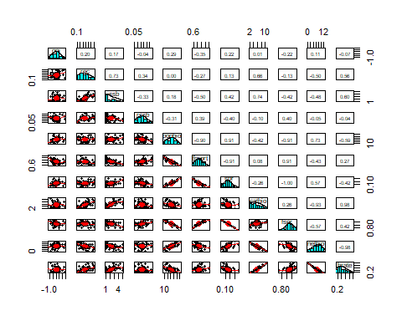

### Spearman Correlations of Fishery Series with MEI, 1979-2020

## Call:corr.test(x = mls[c(3, 5:14)], use = "pairwise.complete.obs",   
## method = "spearman", adjust = "fdr", normal = FALSE)  
## Correlation matrix   
## mei rec ssb rssb popbio fmort spr catbio fspr netbio hrate  
## mei 1.00 0.25 0.38 -0.07 0.23 -0.32 0.17 0.20 -0.17 -0.08 0.16  
## rec 0.25 1.00 0.67 0.37 -0.04 -0.24 0.03 0.67 -0.03 -0.52 0.61  
## ssb 0.38 0.67 1.00 -0.39 0.19 -0.48 0.32 0.71 -0.32 -0.46 0.59  
## rssb -0.07 0.37 -0.39 1.00 -0.34 0.38 -0.42 -0.05 0.42 -0.10 0.03  
## popbio 0.23 -0.04 0.19 -0.34 1.00 -0.90 0.93 -0.45 -0.93 0.72 -0.59  
## fmort -0.32 -0.24 -0.48 0.38 -0.90 1.00 -0.92 0.13 0.92 -0.44 0.29  
## spr 0.17 0.03 0.32 -0.42 0.93 -0.92 1.00 -0.37 -1.00 0.64 -0.51  
## catbio 0.20 0.67 0.71 -0.05 -0.45 0.13 -0.37 1.00 0.37 -0.93 0.98  
## fspr -0.17 -0.03 -0.32 0.42 -0.93 0.92 -1.00 0.37 1.00 -0.64 0.51  
## netbio -0.08 -0.52 -0.46 -0.10 0.72 -0.44 0.64 -0.93 -0.64 1.00 -0.98  
## hrate 0.16 0.61 0.59 0.03 -0.59 0.29 -0.51 0.98 0.51 -0.98 1.00  
## Sample Size   
## mei rec ssb rssb popbio fmort spr catbio fspr netbio hrate  
## mei 42 42 42 42 42 42 42 42 42 42 42  
## rec 42 44 44 44 44 44 44 44 44 44 44  
## ssb 42 44 44 44 44 44 44 44 44 44 44  
## rssb 42 44 44 44 44 44 44 44 44 44 44  
## popbio 42 44 44 44 44 44 44 44 44 44 44  
## fmort 42 44 44 44 44 44 44 44 44 44 44  
## spr 42 44 44 44 44 44 44 44 44 44 44  
## catbio 42 44 44 44 44 44 44 44 44 44 44  
## fspr 42 44 44 44 44 44 44 44 44 44 44  
## netbio 42 44 44 44 44 44 44 44 44 44 44  
## hrate 42 44 44 44 44 44 44 44 44 44 44  
## Probability values (Entries above the diagonal are adjusted for multiple tests.)   
## mei rec ssb rssb popbio fmort spr catbio fspr netbio hrate  
## mei 0.00 0.16 0.02 0.72 0.18 0.06 0.34 0.25 0.34 0.71 0.38  
## rec 0.12 0.00 0.00 0.02 0.85 0.17 0.85 0.00 0.85 0.00 0.00  
## ssb 0.01 0.00 0.00 0.02 0.27 0.00 0.06 0.00 0.06 0.00 0.00  
## rssb 0.66 0.01 0.01 0.00 0.04 0.02 0.01 0.82 0.01 0.59 0.85  
## popbio 0.13 0.80 0.21 0.03 0.00 0.00 0.00 0.01 0.00 0.00 0.00  
## fmort 0.04 0.12 0.00 0.01 0.00 0.00 0.00 0.45 0.00 0.01 0.08  
## spr 0.28 0.84 0.04 0.00 0.00 0.00 0.00 0.02 0.00 0.00 0.00  
## catbio 0.19 0.00 0.00 0.76 0.00 0.38 0.01 0.00 0.02 0.00 0.00  
## fspr 0.28 0.84 0.04 0.00 0.00 0.00 0.00 0.01 0.00 0.00 0.00  
## netbio 0.63 0.00 0.00 0.51 0.00 0.00 0.00 0.00 0.00 0.00 0.00  
## hrate 0.32 0.00 0.00 0.85 0.00 0.06 0.00 0.00 0.00 0.00 0.00  
##   
## Confidence intervals based upon normal theory. To get bootstrapped values, try cor.ci  
## raw.lower raw.r raw.upper raw.p lower.adj upper.adj  
## mei-rec -0.06 0.25 0.51 0.12 -0.27 0.65  
## mei-ssb 0.09 0.38 0.62 0.01 -0.13 0.73  
## mei-rssb -0.37 -0.07 0.24 0.66 -0.54 0.43  
## mei-popbi -0.07 0.23 0.50 0.13 -0.28 0.65  
## mei-fmort -0.57 -0.32 -0.02 0.04 -0.70 0.20  
## mei-spr -0.14 0.17 0.45 0.28 -0.34 0.61  
## mei-catbi -0.11 0.20 0.48 0.19 -0.31 0.63  
## mei-fspr -0.45 -0.17 0.14 0.28 -0.61 0.34  
## mei-netbi -0.37 -0.08 0.23 0.63 -0.54 0.43  
## mei-hrate -0.15 0.16 0.44 0.32 -0.36 0.60  
## rec-ssb 0.46 0.67 0.80 0.00 0.28 0.87  
## rec-rssb 0.08 0.37 0.60 0.01 -0.13 0.72  
## rec-popbi -0.33 -0.04 0.26 0.80 -0.51 0.45  
## rec-fmort -0.50 -0.24 0.06 0.12 -0.64 0.27  
## rec-spr -0.27 0.03 0.32 0.84 -0.45 0.50  
## rec-catbi 0.46 0.67 0.80 0.00 0.28 0.87  
## rec-fspr -0.32 -0.03 0.27 0.84 -0.50 0.45  
## rec-netbi -0.71 -0.52 -0.27 0.00 -0.80 -0.06  
## rec-hrate 0.38 0.61 0.76 0.00 0.18 0.84  
## ssb-rssb -0.62 -0.39 -0.11 0.01 -0.73 0.11  
## ssb-popbi -0.11 0.19 0.46 0.21 -0.31 0.61  
## ssb-fmort -0.68 -0.48 -0.21 0.00 -0.78 0.00  
## ssb-spr 0.02 0.32 0.56 0.04 -0.19 0.69  
## ssb-catbi 0.52 0.71 0.83 0.00 0.35 0.89  
## ssb-fspr -0.56 -0.32 -0.02 0.04 -0.69 0.19  
## ssb-netbi -0.66 -0.46 -0.18 0.00 -0.77 0.03  
## ssb-hrate 0.35 0.59 0.75 0.00 0.16 0.83  
## rssb-popbi -0.58 -0.34 -0.04 0.03 -0.70 0.17  
## rssb-fmort 0.10 0.38 0.61 0.01 -0.11 0.73  
## rssb-spr -0.64 -0.42 -0.14 0.00 -0.75 0.07  
## rssb-catbi -0.34 -0.05 0.25 0.76 -0.51 0.44  
## rssb-fspr 0.14 0.42 0.64 0.00 -0.07 0.75  
## rssb-netbi -0.39 -0.10 0.20 0.51 -0.55 0.39  
## rssb-hrate -0.27 0.03 0.32 0.85 -0.45 0.50  
## popbi-fmort -0.95 -0.90 -0.83 0.00 -0.96 -0.75  
## popbi-spr 0.88 0.93 0.96 0.00 0.82 0.98  
## popbi-catbi -0.66 -0.45 -0.17 0.00 -0.76 0.04  
## popbi-fspr -0.96 -0.93 -0.88 0.00 -0.98 -0.82  
## popbi-netbi 0.54 0.72 0.84 0.00 0.38 0.89  
## popbi-hrate -0.76 -0.59 -0.36 0.00 -0.83 -0.16  
## fmort-spr -0.96 -0.92 -0.86 0.00 -0.97 -0.80  
## fmort-catbi -0.17 0.13 0.42 0.38 -0.36 0.57  
## fmort-fspr 0.86 0.92 0.96 0.00 0.80 0.97  
## fmort-netbi -0.65 -0.44 -0.16 0.00 -0.76 0.05  
## fmort-hrate -0.01 0.29 0.54 0.06 -0.22 0.67  
## spr-catbi -0.60 -0.37 -0.08 0.01 -0.72 0.13  
## spr-fspr -1.00 -1.00 -1.00 0.00 -1.00 -1.00  
## spr-netbi 0.42 0.64 0.79 0.00 0.23 0.85  
## spr-hrate -0.70 -0.51 -0.26 0.00 -0.80 -0.05  
## catbi-fspr 0.08 0.37 0.60 0.01 -0.13 0.72  
## catbi-netbi -0.96 -0.93 -0.88 0.00 -0.97 -0.82  
## catbi-hrate 0.97 0.98 0.99 0.00 0.95 0.99  
## fspr-netbi -0.79 -0.64 -0.42 0.00 -0.85 -0.23  
## fspr-hrate 0.26 0.51 0.70 0.00 0.05 0.80  
## netbi-hrate -0.99 -0.98 -0.96 0.00 -0.99 -0.94

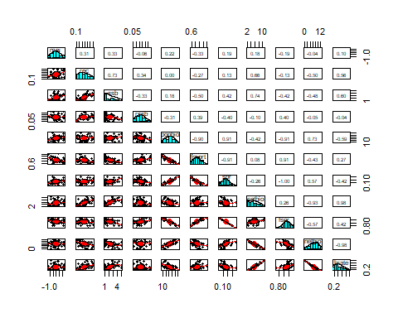

### Spearman Correlations of Fishery Series with PDO, 1975-2020

## Call:corr.test(x = mls[c(4, 5:14)], use = "pairwise.complete.obs",   
## method = "spearman", normal = FALSE)  
## Correlation matrix   
## pdo rec ssb rssb popbio fmort spr catbio fspr netbio hrate  
## pdo 1.00 0.35 0.40 -0.02 -0.05 -0.11 -0.03 0.40 0.03 -0.31 0.38  
## rec 0.35 1.00 0.67 0.37 -0.04 -0.24 0.03 0.67 -0.03 -0.52 0.61  
## ssb 0.40 0.67 1.00 -0.39 0.19 -0.48 0.32 0.71 -0.32 -0.46 0.59  
## rssb -0.02 0.37 -0.39 1.00 -0.34 0.38 -0.42 -0.05 0.42 -0.10 0.03  
## popbio -0.05 -0.04 0.19 -0.34 1.00 -0.90 0.93 -0.45 -0.93 0.72 -0.59  
## fmort -0.11 -0.24 -0.48 0.38 -0.90 1.00 -0.92 0.13 0.92 -0.44 0.29  
## spr -0.03 0.03 0.32 -0.42 0.93 -0.92 1.00 -0.37 -1.00 0.64 -0.51  
## catbio 0.40 0.67 0.71 -0.05 -0.45 0.13 -0.37 1.00 0.37 -0.93 0.98  
## fspr 0.03 -0.03 -0.32 0.42 -0.93 0.92 -1.00 0.37 1.00 -0.64 0.51  
## netbio -0.31 -0.52 -0.46 -0.10 0.72 -0.44 0.64 -0.93 -0.64 1.00 -0.98  
## hrate 0.38 0.61 0.59 0.03 -0.59 0.29 -0.51 0.98 0.51 -0.98 1.00  
## Sample Size   
## pdo rec ssb rssb popbio fmort spr catbio fspr netbio hrate  
## pdo 44 44 44 44 44 44 44 44 44 44 44  
## rec 44 44 44 44 44 44 44 44 44 44 44  
## ssb 44 44 44 44 44 44 44 44 44 44 44  
## rssb 44 44 44 44 44 44 44 44 44 44 44  
## popbio 44 44 44 44 44 44 44 44 44 44 44  
## fmort 44 44 44 44 44 44 44 44 44 44 44  
## spr 44 44 44 44 44 44 44 44 44 44 44  
## catbio 44 44 44 44 44 44 44 44 44 44 44  
## fspr 44 44 44 44 44 44 44 44 44 44 44  
## netbio 44 44 44 44 44 44 44 44 44 44 44  
## hrate 44 44 44 44 44 44 44 44 44 44 44  
## Probability values (Entries above the diagonal are adjusted for multiple tests.)   
## pdo rec ssb rssb popbio fmort spr catbio fspr netbio hrate  
## pdo 0.00 0.42 0.21 1.00 1.00 1.00 1.00 0.21 1.00 0.66 0.28  
## rec 0.02 0.00 0.00 0.30 1.00 1.00 1.00 0.00 1.00 0.01 0.00  
## ssb 0.01 0.00 0.00 0.23 1.00 0.04 0.66 0.00 0.66 0.06 0.00  
## rssb 0.90 0.01 0.01 0.00 0.48 0.26 0.13 1.00 0.13 1.00 1.00  
## popbio 0.75 0.80 0.21 0.03 0.00 0.00 0.00 0.07 0.00 0.00 0.00  
## fmort 0.48 0.12 0.00 0.01 0.00 0.00 0.00 1.00 0.00 0.09 0.85  
## spr 0.85 0.84 0.04 0.00 0.00 0.00 0.00 0.30 0.00 0.00 0.01  
## catbio 0.01 0.00 0.00 0.76 0.00 0.38 0.01 0.00 0.30 0.00 0.00  
## fspr 0.85 0.84 0.04 0.00 0.00 0.00 0.00 0.01 0.00 0.00 0.01  
## netbio 0.04 0.00 0.00 0.51 0.00 0.00 0.00 0.00 0.00 0.00 0.00  
## hrate 0.01 0.00 0.00 0.85 0.00 0.06 0.00 0.00 0.00 0.00 0.00  
##   
## Confidence intervals based upon normal theory. To get bootstrapped values, try cor.ci  
## raw.lower raw.r raw.upper raw.p lower.adj upper.adj  
## pdo-rec 0.06 0.35 0.58 0.02 -0.11 0.68  
## pdo-ssb 0.11 0.40 0.62 0.01 -0.07 0.72  
## pdo-rssb -0.32 -0.02 0.28 0.90 -0.32 0.28  
## pdo-popbi -0.34 -0.05 0.25 0.75 -0.45 0.37  
## pdo-fmort -0.39 -0.11 0.19 0.48 -0.50 0.32  
## pdo-spr -0.32 -0.03 0.27 0.85 -0.38 0.33  
## pdo-catbi 0.11 0.40 0.62 0.01 -0.07 0.72  
## pdo-fspr -0.27 0.03 0.32 0.85 -0.35 0.40  
## pdo-netbi -0.56 -0.31 -0.02 0.04 -0.65 0.14  
## pdo-hrate 0.09 0.38 0.61 0.01 -0.08 0.71  
## rec-ssb 0.46 0.67 0.80 0.00 0.29 0.86  
## rec-rssb 0.08 0.37 0.60 0.01 -0.09 0.70  
## rec-popbi -0.33 -0.04 0.26 0.80 -0.43 0.36  
## rec-fmort -0.50 -0.24 0.06 0.12 -0.60 0.21  
## rec-spr -0.27 0.03 0.32 0.84 -0.36 0.41  
## rec-catbi 0.46 0.67 0.80 0.00 0.29 0.87  
## rec-fspr -0.32 -0.03 0.27 0.84 -0.42 0.36  
## rec-netbi -0.71 -0.52 -0.27 0.00 -0.79 -0.08  
## rec-hrate 0.38 0.61 0.76 0.00 0.20 0.84  
## ssb-rssb -0.62 -0.39 -0.11 0.01 -0.71 0.07  
## ssb-popbi -0.11 0.19 0.46 0.21 -0.25 0.57  
## ssb-fmort -0.68 -0.48 -0.21 0.00 -0.77 -0.02  
## ssb-spr 0.02 0.32 0.56 0.04 -0.14 0.66  
## ssb-catbi 0.52 0.71 0.83 0.00 0.36 0.88  
## ssb-fspr -0.56 -0.32 -0.02 0.04 -0.66 0.14  
## ssb-netbi -0.66 -0.46 -0.18 0.00 -0.76 0.00  
## ssb-hrate 0.35 0.59 0.75 0.00 0.17 0.83  
## rssb-popbi -0.58 -0.34 -0.04 0.03 -0.68 0.12  
## rssb-fmort 0.10 0.38 0.61 0.01 -0.08 0.71  
## rssb-spr -0.64 -0.42 -0.14 0.00 -0.73 0.04  
## rssb-catbi -0.34 -0.05 0.25 0.76 -0.44 0.36  
## rssb-fspr 0.14 0.42 0.64 0.00 -0.04 0.74  
## rssb-netbi -0.39 -0.10 0.20 0.51 -0.49 0.32  
## rssb-hrate -0.27 0.03 0.32 0.85 -0.31 0.36  
## popbi-fmort -0.95 -0.90 -0.83 0.00 -0.96 -0.75  
## popbi-spr 0.88 0.93 0.96 0.00 0.82 0.97  
## popbi-catbi -0.66 -0.45 -0.17 0.00 -0.75 0.01  
## popbi-fspr -0.96 -0.93 -0.88 0.00 -0.97 -0.82  
## popbi-netbi 0.54 0.72 0.84 0.00 0.38 0.89  
## popbi-hrate -0.76 -0.59 -0.36 0.00 -0.83 -0.18  
## fmort-spr -0.96 -0.92 -0.86 0.00 -0.97 -0.80  
## fmort-catbi -0.17 0.13 0.42 0.38 -0.30 0.52  
## fmort-fspr 0.86 0.92 0.96 0.00 0.80 0.97  
## fmort-netbi -0.65 -0.44 -0.16 0.00 -0.75 0.02  
## fmort-hrate -0.01 0.29 0.54 0.06 -0.16 0.64  
## spr-catbi -0.60 -0.37 -0.08 0.01 -0.70 0.09  
## spr-fspr -1.00 -1.00 -1.00 0.00 -1.00 -1.00  
## spr-netbi 0.42 0.64 0.79 0.00 0.25 0.85  
## spr-hrate -0.70 -0.51 -0.26 0.00 -0.79 -0.07  
## catbi-fspr 0.08 0.37 0.60 0.01 -0.09 0.70  
## catbi-netbi -0.96 -0.93 -0.88 0.00 -0.97 -0.82  
## catbi-hrate 0.97 0.98 0.99 0.00 0.95 0.99  
## fspr-netbi -0.79 -0.64 -0.42 0.00 -0.85 -0.24  
## fspr-hrate 0.26 0.51 0.70 0.00 0.07 0.79  
## netbi-hrate -0.99 -0.98 -0.96 0.00 -0.99 -0.94

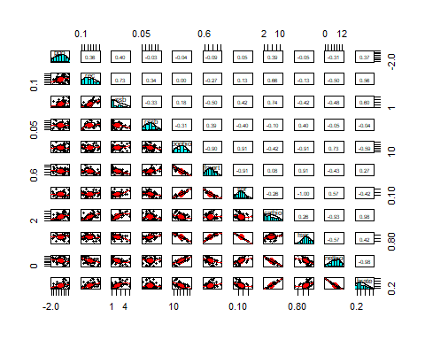

## Change Point Analyses

### Recruitment Change Point Analyses

#### Pruned Exact Linear Time Algorithm

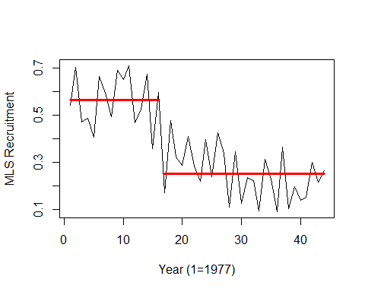

## [1] "Number of change points, Change points, Segment means, Segment standard deviations"

## [1] 1.0000000 16.0000000 0.5652500 0.2524643 0.1082546 0.1066803

### Spawning Biomass Change Point Analyses

#### Pruned Exact Linear Time Algorithm

## Created Using changepoint version 2.2.4   
## Changepoint type : Change in mean and variance   
## Method of analysis : PELT   
## Test Statistic : Normal   
## Type of penalty : MBIC with value, 15.13676   
## Minimum Segment Length : 2   
## Maximum no. of cpts : Inf   
## Changepoint Locations : 2 18

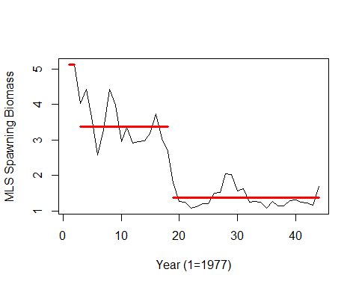

## [1] "Number of change points, Change points, Segment means, Segment standard deviations"

## [1] 2.0000000 2.0000000 18.0000000 5.1070000 3.3740000 1.3657308 0.0110000  
## [8] 0.5714122 0.2695276

### Recruits per Spawning Biomass Change Point Analyses

#### Pruned Exact Linear Time Algorithm

## Created Using changepoint version 2.2.4   
## Changepoint type : Change in mean and variance   
## Method of analysis : PELT   
## Test Statistic : Normal   
## Type of penalty : MBIC with value, 15.13676   
## Minimum Segment Length : 2   
## Maximum no. of cpts : Inf   
## Changepoint Locations : 5

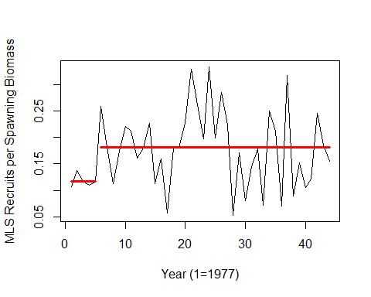

## [1] "Number of change points, Change points, Segment means, Segment standard deviations"

## [1] 1.00000000 5.00000000 0.11740000 0.18133333 0.01089220 0.07211932

### Spawning Potential Ratio Change Point Analyses

#### Pruned Exact Linear Time Algorithm

## Created Using changepoint version 2.2.4   
## Changepoint type : Change in mean and variance   
## Method of analysis : PELT   
## Test Statistic : Normal   
## Type of penalty : MBIC with value, 15.13676   
## Minimum Segment Length : 2   
## Maximum no. of cpts : Inf   
## Changepoint Locations : 16 18 23 25

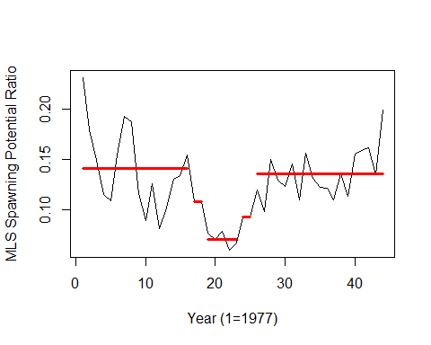

## [1] "Number of change points, Change points, Segment means, Segment standard deviations"

## [1] 4.00000000 16.00000000 18.00000000 23.00000000 25.00000000 0.14056250  
## [7] 0.10800000 0.07080000 0.09250000 0.13542105 0.03977117 0.00000000  
## [13] 0.00688186 0.00050000 0.02339662

### Population Biomass Change Point Analyses

#### Pruned Exact Linear Time Algorithm

## Created Using changepoint version 2.2.4   
## Changepoint type : Change in mean and variance   
## Method of analysis : PELT   
## Test Statistic : Normal   
## Type of penalty : MBIC with value, 15.13676   
## Minimum Segment Length : 2   
## Maximum no. of cpts : Inf   
## Changepoint Locations :

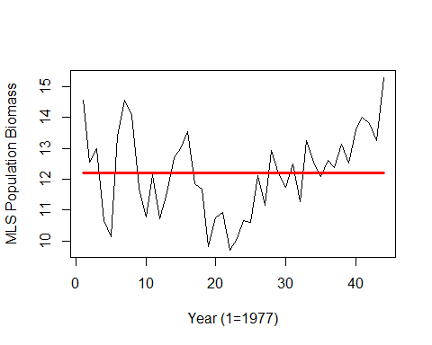

## [1] "Number of change points, Change points, Segment means, Segment standard deviations"

## [1] 0.000000 12.216886 1.347488

### Catch Biomass Change Point Analyses

#### Pruned Exact Linear Time Algorithm

## Created Using changepoint version 2.2.4   
## Changepoint type : Change in mean and variance   
## Method of analysis : PELT   
## Test Statistic : Normal   
## Type of penalty : MBIC with value, 15.13676   
## Minimum Segment Length : 2   
## Maximum no. of cpts : Inf   
## Changepoint Locations : 19 27 29

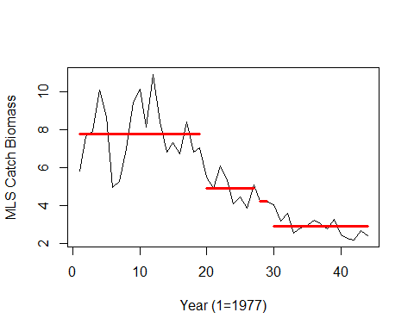

## [1] "Number of change points, Change points, Segment means, Segment standard deviations"

## [1] 3.0000000 19.0000000 27.0000000 29.0000000 7.7579474 4.9095000  
## [7] 4.2180000 2.8894667 1.5881001 0.7084843 0.0030000 0.4928609

### Fishing Mortality Change Point Analyses

#### Pruned Exact Linear Time Algorithm

## Created Using changepoint version 2.2.4   
## Changepoint type : Change in mean and variance   
## Method of analysis : PELT   
## Test Statistic : Normal   
## Type of penalty : MBIC with value, 15.13676   
## Minimum Segment Length : 2   
## Maximum no. of cpts : Inf   
## Changepoint Locations : 18 25

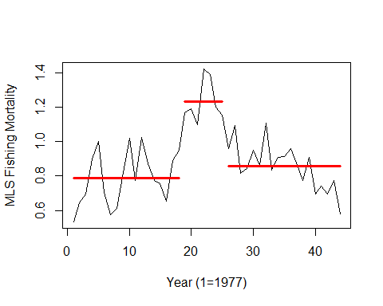

## [1] "Number of change points, Change points, Segment means, Segment standard deviations"

## [1] 2.0000000 18.0000000 25.0000000 0.7890556 1.2317143 0.8571053 0.1507892  
## [8] 0.1142750 0.1283338

### Fishing Intensity Change Point Analyses

#### Pruned Exact Linear Time Algorithm

## Created Using changepoint version 2.2.4   
## Changepoint type : Change in mean and variance   
## Method of analysis : PELT   
## Test Statistic : Normal   
## Type of penalty : MBIC with value, 15.13676   
## Minimum Segment Length : 2   
## Maximum no. of cpts : Inf   
## Changepoint Locations : 16 18 23 25

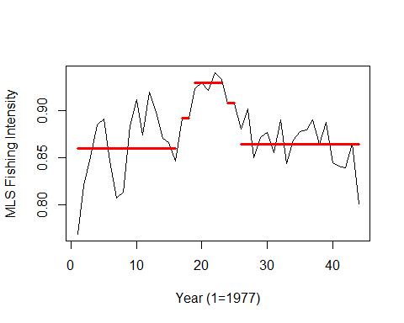

## [1] "Number of change points, Change points, Segment means, Segment standard deviations"

## [1] 4.00000000 16.00000000 18.00000000 23.00000000 25.00000000 0.85943750  
## [7] 0.89200000 0.92920000 0.90750000 0.86457895 0.03977117 0.00000000  
## [13] 0.00688186 0.00050000 0.02339662

### Net Biomass Change Point Analyses

#### Pruned Exact Linear Time Algorithm

## Created Using changepoint version 2.2.4   
## Changepoint type : Change in mean and variance   
## Method of analysis : PELT   
## Test Statistic : Normal   
## Type of penalty : MBIC with value, 15.13676   
## Minimum Segment Length : 2   
## Maximum no. of cpts : Inf   
## Changepoint Locations : 27 39

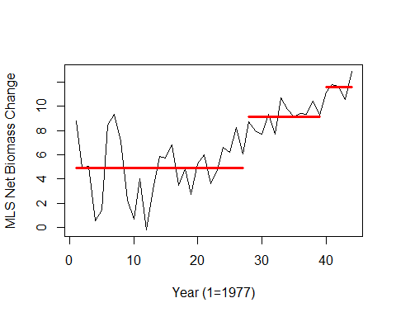

## [1] "Number of change points, Change points, Segment means, Segment standard deviations"

## [1] 2.0000000 27.0000000 39.0000000 4.8798519 9.1147500 11.5910000 2.5008416  
## [8] 0.9174187 0.7686448

### Harvest Rate Change Point Analyses

#### Pruned Exact Linear Time Algorithm

## Created Using changepoint version 2.2.4   
## Changepoint type : Change in mean and variance   
## Method of analysis : PELT   
## Test Statistic : Normal   
## Type of penalty : MBIC with value, 15.13676   
## Minimum Segment Length : 2   
## Maximum no. of cpts : Inf   
## Changepoint Locations : 23 32

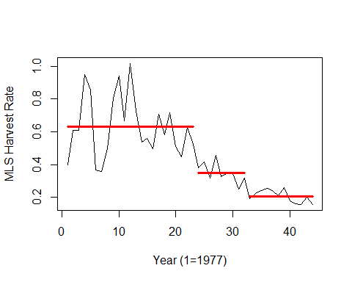

## [1] "Number of change points, Change points, Segment means, Segment standard deviations"

## [1] 2.00000000 23.00000000 32.00000000 0.63138868 0.35139755 0.20756130  
## [7] 0.18133272 0.05722634 0.03665908

### Oceanic Nino Index Change Point Analyses

#### Pruned Exact Linear Time Algorithm

## Created Using changepoint version 2.2.4   
## Changepoint type : Change in mean and variance   
## Method of analysis : PELT   
## Test Statistic : Normal   
## Type of penalty : MBIC with value, 15.13676   
## Minimum Segment Length : 2   
## Maximum no. of cpts : Inf   
## Changepoint Locations :

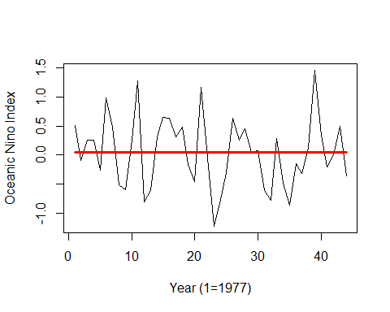

## [1] "Number of change points, Change points, Segment means, Segment standard deviations"

## [1] 0.00000000 0.04543182 0.59473185

### Multivariate ENSO Index Change Point Analyses

#### Pruned Exact Linear Time Algorithm

## Created Using changepoint version 2.2.4   
## Changepoint type : Change in mean and variance   
## Method of analysis : PELT   
## Test Statistic : Normal   
## Type of penalty : MBIC with value, 14.95068   
## Minimum Segment Length : 2   
## Maximum no. of cpts : Inf   
## Changepoint Locations :

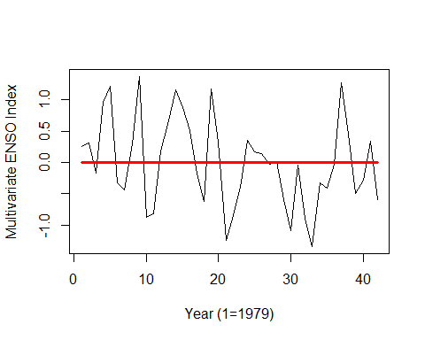

## [1] "Number of change points, Change points, Segment means, Segment standard deviations"

## [1] 0.0000000000 0.0001666667 0.7002888491

### Pacific Decadal Oscillation Change Point Analyses

#### Pruned Exact Linear Time Algorithm

## Created Using changepoint version 2.2.4   
## Changepoint type : Change in mean and variance   
## Method of analysis : PELT   
## Test Statistic : Normal   
## Type of penalty : MBIC with value, 15.13676   
## Minimum Segment Length : 2   
## Maximum no. of cpts : Inf   
## Changepoint Locations :

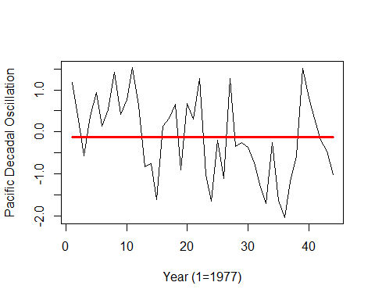

## [1] "Number of change points, Change points, Segment means, Segment standard deviations"

## [1] 0.0000000 -0.1185455 0.9608032

## Autocorrelation Function Analyses

### Recruitment ACF Analysis

## [1] "ACF for rec series"

## [1] "Number of signifcant ACF lags (n):"  
## [1] 8  
## [1] "Significant ACF lags are:"  
## [1] 1 2 3 4 5 6 7 8  
## [1] "Significant ACF values (1:n) are:"  
## [1] 0.5393349 0.6699954 0.6287761 0.4834321 0.6397907 0.3642774 0.3831900  
## [8] 0.4580318

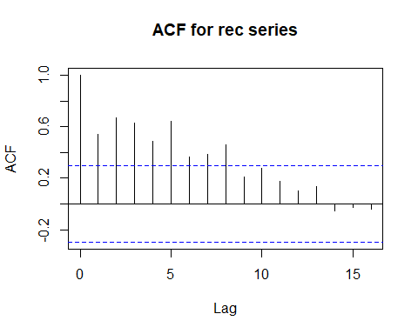

### Spawning Biomass ACF Analysis

## [1] "ACF for ssb series"

## [1] "Number of signifcant ACF lags (n):"  
## [1] 8  
## [1] "Significant ACF lags are:"  
## [1] 1 2 3 4 5 6 7 8  
## [1] "Significant ACF values (1:n) are:"  
## [1] 0.8586420 0.7092171 0.6352218 0.5346870 0.4798706 0.4791778 0.4643694  
## [8] 0.3661701

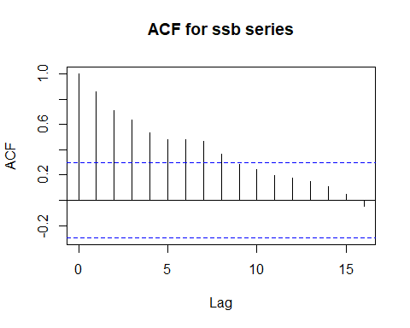

### Recruits Per Spawning Biomass ACF Analysis

## [1] "ACF for rssb series"

## [1] "Number of signifcant ACF lags (n):"  
## [1] 1  
## [1] "Significant ACF lags are:"  
## [1] 9  
## [1] "Significant ACF values (1:n) are:"  
## [1] -0.3594955

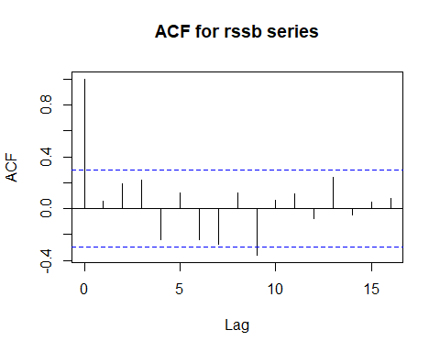

### Spawning Potential Ratio ACF Analysis

## [1] "ACF for spr series"

## [1] "Number of signifcant ACF lags (n):"  
## [1] 2  
## [1] "Significant ACF lags are:"  
## [1] 1 2  
## [1] "Significant ACF values (1:n) are:"  
## [1] 0.5239828 0.3328887

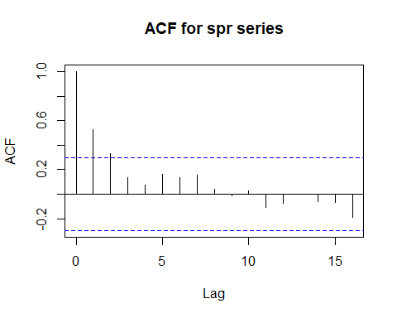

### Population Biomass ACF Analysis

## [1] "ACF for popbio series"

## [1] "Number of signifcant ACF lags (n):"  
## [1] 1  
## [1] "Significant ACF lags are:"  
## [1] 1  
## [1] "Significant ACF values (1:n) are:"  
## [1] 0.5018

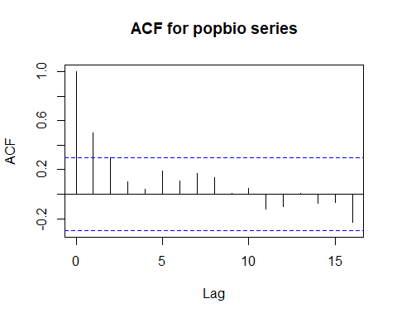

### Catch Biomass ACF Analysis

## [1] "ACF for catbio series"

## [1] "Number of signifcant ACF lags (n):"  
## [1] 10  
## [1] "Significant ACF lags are:"  
## [1] 1 2 3 4 5 6 7 8 9 10  
## [1] "Significant ACF values (1:n) are:"  
## [1] 0.8416476 0.7244384 0.6328611 0.5787808 0.5994579 0.5523669 0.5557551  
## [8] 0.5020865 0.3868355 0.3141033

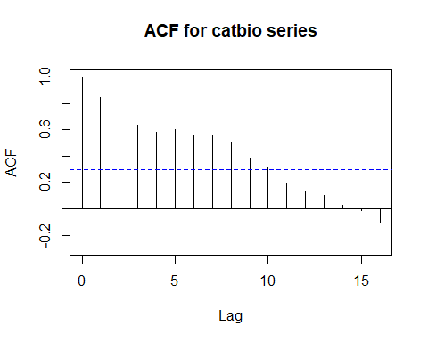

### Fishing Mortality ACF Analysis

## [1] "ACF for fmort series"

## [1] "Number of signifcant ACF lags (n):"  
## [1] 4  
## [1] "Significant ACF lags are:"  
## [1] 1 2 3 16  
## [1] "Significant ACF values (1:n) are:"  
## [1] 0.6398360 0.4985415 0.3079522 -0.3370574

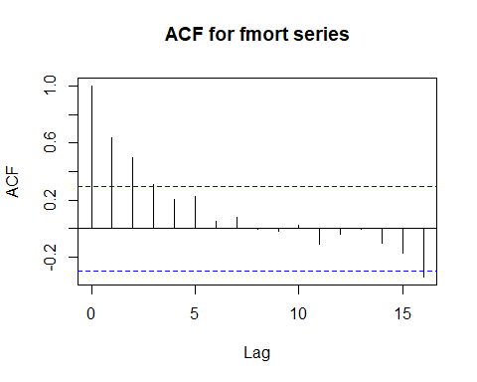

### Fishing Intensity ACF Analysis

## [1] "ACF for fspr series"

## [1] "Number of signifcant ACF lags (n):"  
## [1] 2  
## [1] "Significant ACF lags are:"  
## [1] 1 2  
## [1] "Significant ACF values (1:n) are:"  
## [1] 0.5239828 0.3328887

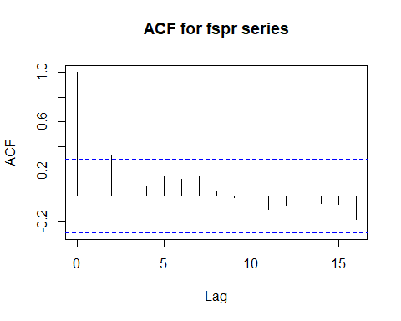

### Net Biomass ACF Analysis

## [1] "ACF for rec series"

## [1] "Number of signifcant ACF lags (n):"  
## [1] 8  
## [1] "Significant ACF lags are:"  
## [1] 1 2 3 4 5 6 7 8  
## [1] "Significant ACF values (1:n) are:"  
## [1] 0.6887634 0.5298919 0.3993013 0.3515403 0.4461329 0.3973171 0.4577387  
## [8] 0.4185416

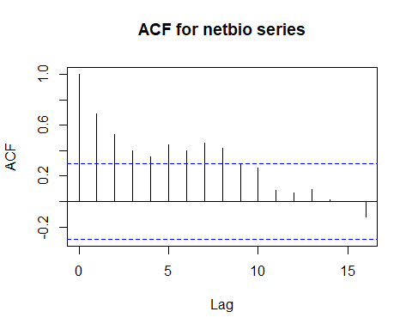

### Harvest Rate ACF Analysis

## [1] "ACF for hrate series"

## [1] "Number of signifcant ACF lags (n):"  
## [1] 9  
## [1] "Significant ACF lags are:"  
## [1] 1 2 3 4 5 6 7 8 9  
## [1] "Significant ACF values (1:n) are:"  
## [1] 0.7374697 0.5876050 0.4823613 0.4326714 0.5192516 0.4641848 0.5146096  
## [8] 0.4704561 0.3338890

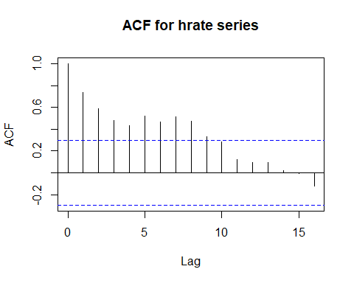

### Oceanic Nino Index ACF Analysis

## [1] "ACF for oni series"

## [1] "Number of signifcant ACF lags (n):"  
## [1] 1  
## [1] "Significant ACF lags are:"  
## [1] 2  
## [1] "Significant ACF values (1:n) are:"  
## [1] -0.3117824

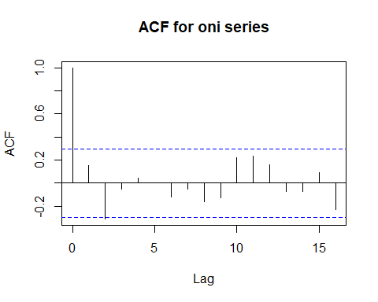

### Multivariate ENSO Index ACF Analysis

## [1] "ACF for mei series"

## [1] "Number of signifcant ACF lags (n):"  
## [1] 0

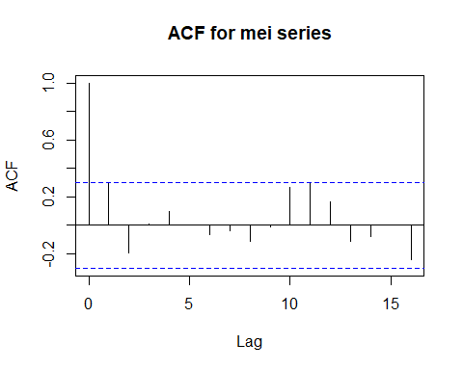

### Pacific Decadal Oscillation ACF Analysis

## [1] "ACF for pdo series"

## [1] "Number of signifcant ACF lags (n):"  
## [1] 1  
## [1] "Significant ACF lags are:"  
## [1] 1  
## [1] "Significant ACF values (1:n) are:"  
## [1] 0.384948

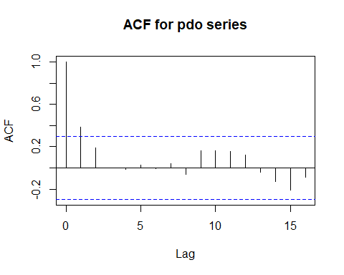

## Partial Autocorrelation Function Analyses

### Recruitment PACF Analysis

## [1] "PACF for rec series"

## [1] "Number of signifcant PACF lags (n):"  
## [1] 3  
## [1] "Significant PACF lags are:"  
## [1] 1 2 3  
## [1] "Significant PACF values (1:n) are:"  
## [1] 0.5393349 0.5346266 0.3401623

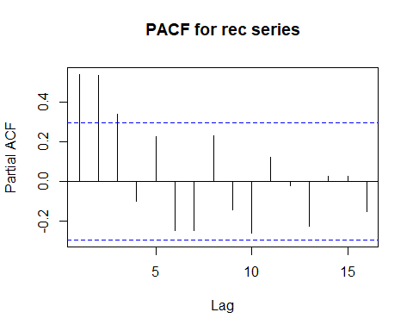

### Spawning Biomass PACF Analysis

## [1] "PACF for ssb series"

## [1] "Number of signifcant PACF lags (n):"  
## [1] 2  
## [1] "Significant PACF lags are:"  
## [1] 1 8  
## [1] "Significant PACF values (1:n) are:"  
## [1] 0.8586420 -0.3309918

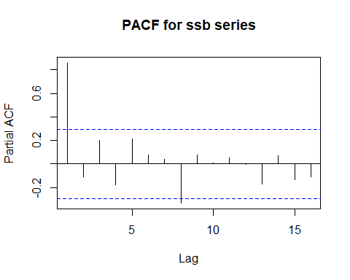

### Recruits Per Spawning Biomass PACF Analysis

## [1] "PACF for rssb series"

## [1] "Number of signifcant PACF lags (n):"  
## [1] 1  
## [1] "Significant PACF lags are:"  
## [1] 4  
## [1] "Significant PACF values (1:n) are:"  
## [1] -0.314675

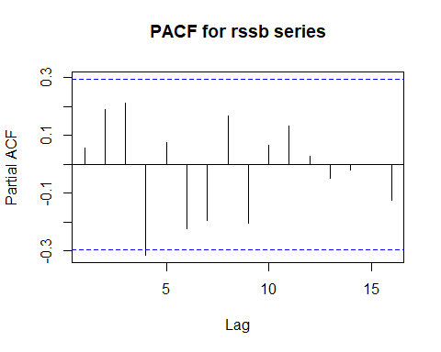

### Spawning Potential Ratio PACF Analysis

## [1] "PACF for spr series"

## [1] "Number of signifcant PACF lags (n):"  
## [1] 1  
## [1] "Significant PACF lags are:"  
## [1] 1  
## [1] "Significant PACF values (1:n) are:"  
## [1] 0.5239828

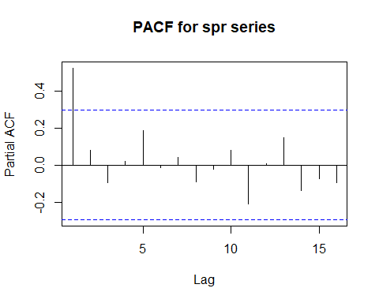 ### Population Biomass PACF Analysis

## [1] "PACF for popbio series"

## [1] "Number of signifcant PACF lags (n):"  
## [1] 1  
## [1] "Significant PACF lags are:"  
## [1] 1  
## [1] "Significant PACF values (1:n) are:"  
## [1] 0.5018

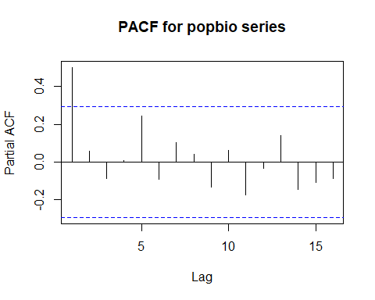

### Catch Biomass PACF Analysis

## [1] "PACF for catbio series"

## [1] "Number of signifcant PACF lags (n):"  
## [1] 1  
## [1] "Significant PACF lags are:"  
## [1] 1  
## [1] "Significant PACF values (1:n) are:"  
## [1] 0.8416476

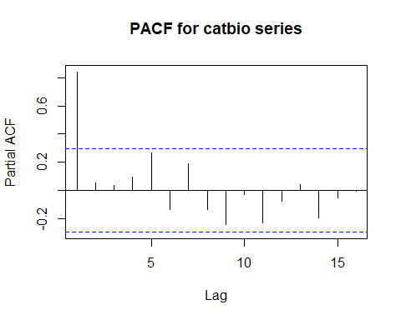

### Fishing Mortality PACF Analysis

## [1] "PACF for fmort series"

## [1] "Number of signifcant PACF lags (n):"  
## [1] 2  
## [1] "Significant PACF lags are:"  
## [1] 1 14  
## [1] "Significant PACF values (1:n) are:"  
## [1] 0.6398360 -0.3703579

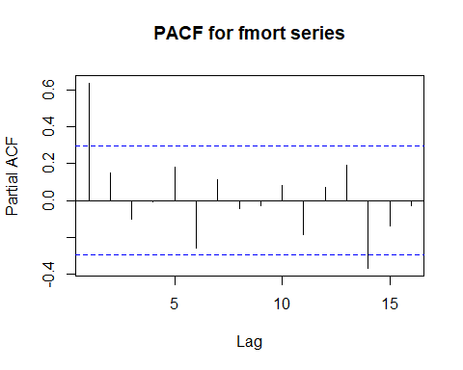

### Fishing Intensity PACF Analysis

## [1] "PACF for fspr series"

## [1] "Number of signifcant PACF lags (n):"  
## [1] 1  
## [1] "Significant PACF lags are:"  
## [1] 1  
## [1] "Significant PACF values (1:n) are:"  
## [1] 0.5239828

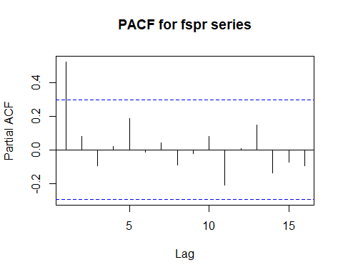

### Net Biomass PACF Analysis

## [1] "PACF for rec series"

## [1] "Number of signifcant PACF lags (n):"  
## [1] 2  
## [1] "Significant PACF lags are:"  
## [1] 1 5  
## [1] "Significant PACF values (1:n) are:"  
## [1] 0.6887634 0.3045266

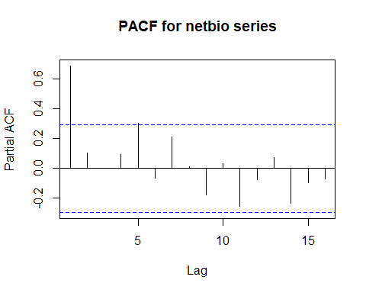

### Harvest Rate PACF Analysis

## [1] "PACF for hrate series"

## [1] "Number of signifcant PACF lags (n):"  
## [1] 2  
## [1] "Significant PACF lags are:"  
## [1] 1 5  
## [1] "Significant PACF values (1:n) are:"  
## [1] 0.7374697 0.3293201

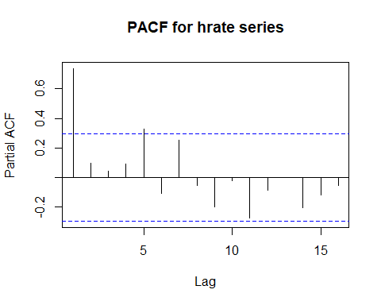

### Oceanic Nino Index PACF Analysis

## [1] "PACF for oni series"

## [1] "Number of signifcant PACF lags (n):"  
## [1] 2  
## [1] "Significant PACF lags are:"  
## [1] 2 16  
## [1] "Significant PACF values (1:n) are:"  
## [1] -0.3433919 -0.3441829

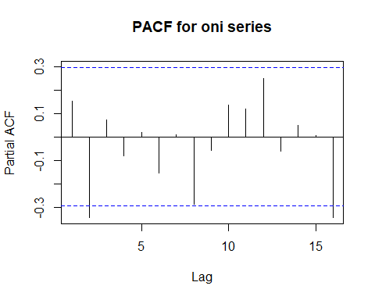

### Multivariate ENSO Index PACF Analysis

## [1] "PACF for mei series"

## [1] "Number of signifcant PACF lags (n):"  
## [1] 0

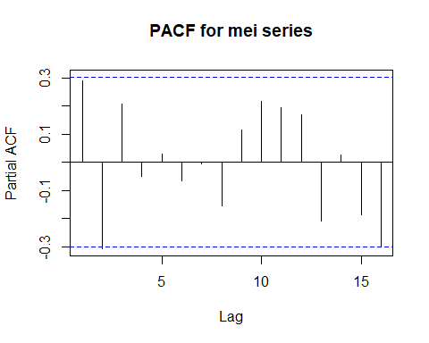

### Pacific Decadal Oscillation PACF Analysis

## [1] "PACF for pdo series"

## [1] "Number of signifcant PACF lags (n):"  
## [1] 1  
## [1] "Significant PACF lags are:"  
## [1] 1  
## [1] "Significant PACF values (1:n) are:"  
## [1] 0.384948

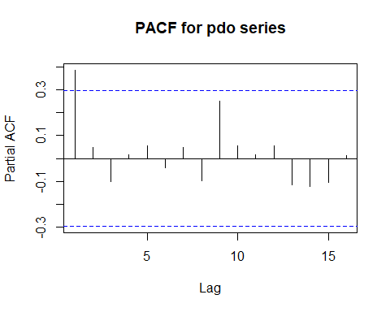

## Cross Correlation Function Analyses

### Recruitment CCF Analyses

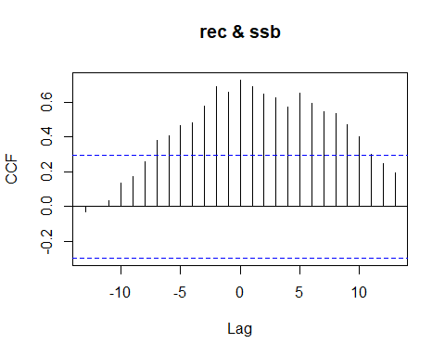

## [1] "CCF for (rec,ssb) series"

##   
## Autocorrelations of series 'X', by lag  
##   
## -13 -12 -11 -10 -9 -8 -7 -6 -5 -4 -3   
## -0.032 0.003 0.034 0.133 0.173 0.258 0.382 0.410 0.466 0.481 0.577   
## -2 -1 0 1 2 3 4 5 6 7 8   
## 0.691 0.657 0.727 0.691 0.644 0.625 0.570 0.650 0.593 0.547 0.537   
## 9 10 11 12 13   
## 0.469 0.404 0.299 0.245 0.194

## [1] "Significant cross correlations exist at lags:"  
## [1] -7 -6 -5 -4 -3 -2 -1 0 1 2 3 4 5 6 7 8 9 10  
## [1] 0.3822632 0.4095603 0.4657436 0.4813653 0.5765440 0.6914632 0.6567686  
## [8] 0.7271501 0.6905956 0.6444830 0.6246943 0.5701204 0.6504461 0.5926585  
## [15] 0.5470105 0.5373612 0.4690693 0.4039038

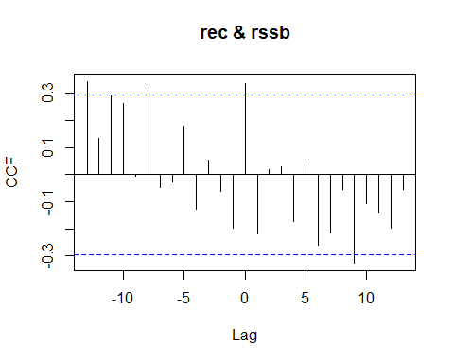

## [1] "CCF for (rec,rssb) series"

##   
## Autocorrelations of series 'X', by lag  
##   
## -13 -12 -11 -10 -9 -8 -7 -6 -5 -4 -3   
## 0.344 0.132 0.291 0.265 -0.004 0.333 -0.049 -0.028 0.181 -0.126 0.054   
## -2 -1 0 1 2 3 4 5 6 7 8   
## -0.063 -0.199 0.336 -0.217 0.020 0.029 -0.172 0.035 -0.262 -0.215 -0.054   
## 9 10 11 12 13   
## -0.326 -0.108 -0.139 -0.197 -0.055

## [1] "Significant cross correlations exist at lags:"  
## [1] -13 -8 0 9  
## [1] 0.3439017 0.3333971 0.3356078 -0.3263217

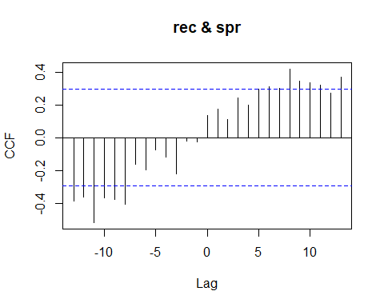

## [1] "CCF for (rec,spr) series"

##   
## Autocorrelations of series 'X', by lag  
##   
## -13 -12 -11 -10 -9 -8 -7 -6 -5 -4 -3   
## -0.388 -0.363 -0.518 -0.369 -0.378 -0.405 -0.163 -0.196 -0.075 -0.117 -0.221   
## -2 -1 0 1 2 3 4 5 6 7 8   
## -0.021 -0.024 0.133 0.173 0.109 0.243 0.199 0.296 0.311 0.303 0.418   
## 9 10 11 12 13   
## 0.344 0.336 0.319 0.270 0.368

## [1] -13 -12 -11 -10 -9 -8 6 7 8 9 10 11 13  
## [1] -0.3883334 -0.3628576 -0.5175046 -0.3692896 -0.3777197 -0.4047221  
## [7] 0.3114514 0.3026074 0.4182042 0.3441719 0.3363626 0.3187463  
## [13] 0.3676248

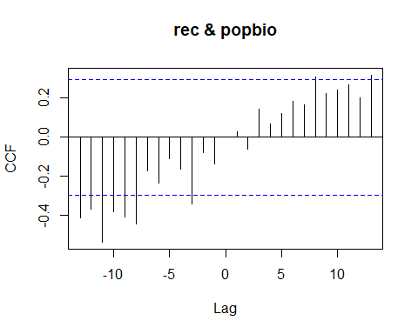

## [1] "CCF for (rec,popbio) series"

##   
## Autocorrelations of series 'X', by lag  
##   
## -13 -12 -11 -10 -9 -8 -7 -6 -5 -4 -3   
## -0.411 -0.368 -0.536 -0.380 -0.408 -0.442 -0.175 -0.235 -0.111 -0.164 -0.343   
## -2 -1 0 1 2 3 4 5 6 7 8   
## -0.080 -0.139 0.000 0.029 -0.063 0.143 0.065 0.122 0.184 0.164 0.305   
## 9 10 11 12 13   
## 0.224 0.239 0.269 0.203 0.316

## [1] "Significant cross correlations exist at lags:"  
## [1] -13 -12 -11 -10 -9 -8 -3 8 13  
## [1] -0.4114142 -0.3681179 -0.5362959 -0.3798337 -0.4084315 -0.4422344 -0.3428970  
## [8] 0.3048511 0.3162848

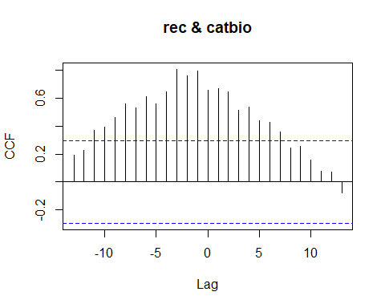

## [1] "CCF for (rec,catbio) series"

##   
## Autocorrelations of series 'X', by lag  
##   
## -13 -12 -11 -10 -9 -8 -7 -6 -5 -4 -3   
## 0.190 0.228 0.372 0.392 0.464 0.560 0.532 0.609 0.558 0.645 0.807   
## -2 -1 0 1 2 3 4 5 6 7 8   
## 0.762 0.796 0.659 0.670 0.647 0.511 0.536 0.440 0.426 0.360 0.242   
## 9 10 11 12 13   
## 0.256 0.158 0.074 0.070 -0.080

## [1] "Significant cross correlations exist at lags:"  
## [1] -11 -10 -9 -8 -7 -6 -5 -4 -3 -2 -1 0 1 2 3 4 5 6 7  
## [1] 0.3724157 0.3921386 0.4640906 0.5604526 0.5320453 0.6085617 0.5580727  
## [8] 0.6453083 0.8072119 0.7619336 0.7957651 0.6586349 0.6699133 0.6466798  
## [15] 0.5110884 0.5359119 0.4401531 0.4259724 0.3600600

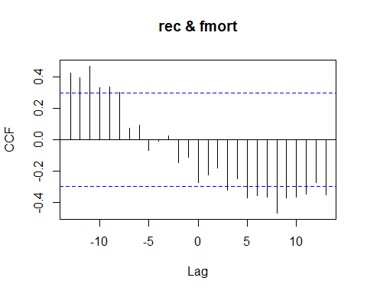

## [1] "CCF for (rec,fmort) series"

##   
## Autocorrelations of series 'X', by lag  
##   
## -13 -12 -11 -10 -9 -8 -7 -6 -5 -4 -3   
## 0.424 0.395 0.469 0.330 0.336 0.303 0.072 0.091 -0.068 -0.010 0.024   
## -2 -1 0 1 2 3 4 5 6 7 8   
## -0.147 -0.113 -0.273 -0.226 -0.179 -0.320 -0.249 -0.369 -0.358 -0.368 -0.468   
## 9 10 11 12 13   
## -0.372 -0.366 -0.348 -0.273 -0.352

## [1] "Significant cross correlations exist at lags:"  
## [1] -13 -12 -11 -10 -9 -8 3 5 6 7 8 9 10 11 13  
## [1] 0.4242631 0.3945820 0.4690965 0.3302286 0.3360248 0.3033111  
## [7] -0.3201211 -0.3691471 -0.3575324 -0.3681013 -0.4681309 -0.3722014  
## [13] -0.3661477 -0.3483215 -0.3523487

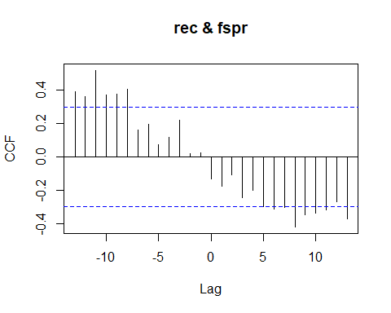

## [1] "CCF for (rec,fspr) series"

##   
## Autocorrelations of series 'X', by lag  
##   
## -13 -12 -11 -10 -9 -8 -7 -6 -5 -4 -3   
## 0.388 0.363 0.518 0.369 0.378 0.405 0.163 0.196 0.075 0.117 0.221   
## -2 -1 0 1 2 3 4 5 6 7 8   
## 0.021 0.024 -0.133 -0.173 -0.109 -0.243 -0.199 -0.296 -0.311 -0.303 -0.418   
## 9 10 11 12 13   
## -0.344 -0.336 -0.319 -0.270 -0.368

## [1] "Significant cross correlations exist at lags:"  
## [1] -13 -12 -11 -10 -9 -8 6 7 8 9 10 11 13  
## [1] 0.3883334 0.3628576 0.5175046 0.3692896 0.3777197 0.4047221  
## [7] -0.3114514 -0.3026074 -0.4182042 -0.3441719 -0.3363626 -0.3187463  
## [13] -0.3676248

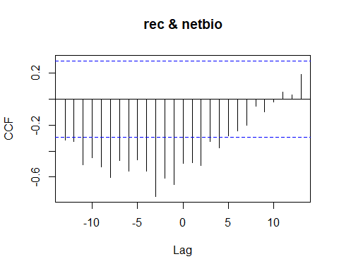

## [1] "CCF for (rec,netbio) series"

##   
## Autocorrelations of series 'X', by lag  
##   
## -13 -12 -11 -10 -9 -8 -7 -6 -5 -4 -3   
## -0.314 -0.325 -0.503 -0.453 -0.519 -0.606 -0.473 -0.556 -0.466 -0.554 -0.750   
## -2 -1 0 1 2 3 4 5 6 7 8   
## -0.606 -0.656 -0.496 -0.492 -0.513 -0.325 -0.376 -0.280 -0.244 -0.202 -0.055   
## 9 10 11 12 13   
## -0.099 -0.020 0.056 0.032 0.192

## [1] "Significant cross correlations exist at lags:"  
## [1] -13 -12 -11 -10 -9 -8 -7 -6 -5 -4 -3 -2 -1 0 1 2 3 4  
## [1] -0.3144336 -0.3247273 -0.5034431 -0.4531079 -0.5191301 -0.6056774  
## [7] -0.4729391 -0.5555120 -0.4661203 -0.5535901 -0.7498760 -0.6064337  
## [13] -0.6563812 -0.4955202 -0.4917837 -0.5125195 -0.3246910 -0.3759386

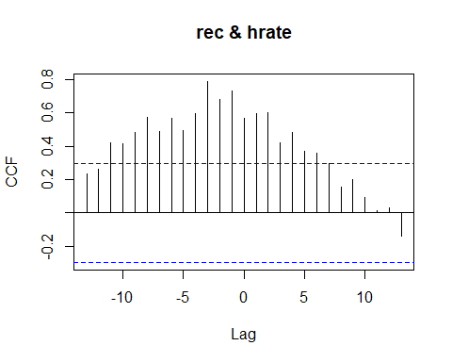

## [1] "CCF for (rec,hrate) series"

##   
## Autocorrelations of series 'X', by lag  
##   
## -13 -12 -11 -10 -9 -8 -7 -6 -5 -4 -3   
## 0.235 0.260 0.420 0.415 0.483 0.574 0.490 0.568 0.494 0.593 0.787   
## -2 -1 0 1 2 3 4 5 6 7 8   
## 0.678 0.728 0.564 0.592 0.600 0.422 0.485 0.370 0.360 0.293 0.154   
## 9 10 11 12 13   
## 0.198 0.095 0.014 0.030 -0.139

## [1] "Significant cross correlations exist at lags:"  
## [1] -11 -10 -9 -8 -7 -6 -5 -4 -3 -2 -1 0 1 2 3 4 5 6  
## [1] 0.4197967 0.4146167 0.4826705 0.5735761 0.4904018 0.5681787 0.4941007  
## [8] 0.5928761 0.7870905 0.6783543 0.7275054 0.5639353 0.5923898 0.5995304  
## [15] 0.4216413 0.4847711 0.3700285 0.3597213

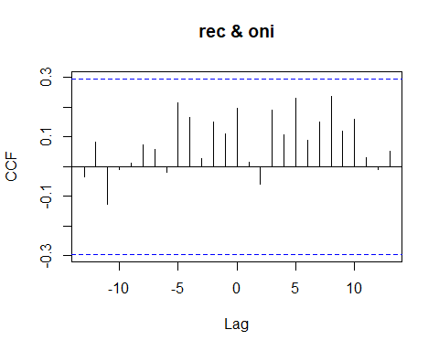

## [1] "CCF for (rec,oni) series"

##   
## Autocorrelations of series 'X', by lag  
##   
## -13 -12 -11 -10 -9 -8 -7 -6 -5 -4 -3   
## -0.034 0.081 -0.126 -0.009 0.013 0.073 0.058 -0.018 0.216 0.167 0.028   
## -2 -1 0 1 2 3 4 5 6 7 8   
## 0.151 0.110 0.197 0.015 -0.059 0.191 0.108 0.231 0.090 0.151 0.236   
## 9 10 11 12 13   
## 0.120 0.161 0.032 -0.010 0.052

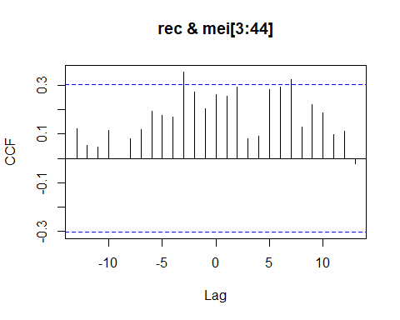

## [1] "CCF for (rec,mei) series"

##   
## Autocorrelations of series 'X', by lag  
##   
## -13 -12 -11 -10 -9 -8 -7 -6 -5 -4 -3   
## 0.123 0.054 0.047 0.115 -0.003 0.082 0.120 0.193 0.176 0.170 0.356   
## -2 -1 0 1 2 3 4 5 6 7 8   
## 0.273 0.203 0.264 0.255 0.295 0.081 0.090 0.282 0.293 0.324 0.129   
## 9 10 11 12 13   
## 0.223 0.187 0.099 0.113 -0.021

## [1] "Significant cross correlations exist at lags:"  
## [1] -3 7  
## [1] 0.3555183 0.3238839

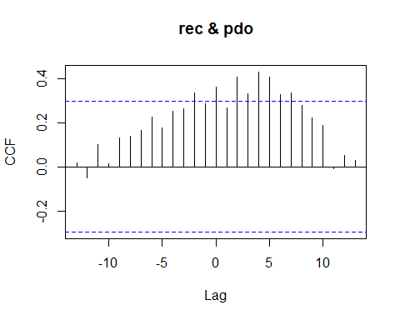

## [1] "CCF for (rec,pdo) series"

##   
## Autocorrelations of series 'X', by lag  
##   
## -13 -12 -11 -10 -9 -8 -7 -6 -5 -4 -3   
## 0.016 -0.049 0.099 0.012 0.131 0.138 0.166 0.226 0.176 0.253 0.264   
## -2 -1 0 1 2 3 4 5 6 7 8   
## 0.333 0.286 0.361 0.265 0.406 0.331 0.429 0.404 0.327 0.333 0.276   
## 9 10 11 12 13   
## 0.221 0.188 -0.010 0.053 0.029

## [1] "Significant cross correlations exist at lags:"  
## [1] -2 0 2 3 4 5 6 7  
## [1] 0.3333137 0.3610074 0.4063780 0.3312050 0.4290603 0.4042376 0.3271702  
## [8] 0.3326289

### Spawning Biomass CCF Analyses

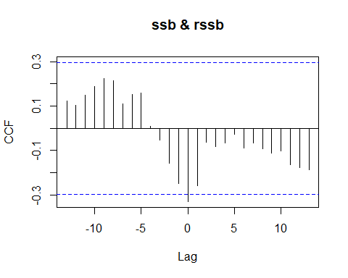

## [1] "CCF for (ssb,rssb) series"

##   
## Autocorrelations of series 'X', by lag  
##   
## -13 -12 -11 -10 -9 -8 -7 -6 -5 -4 -3   
## 0.122 0.103 0.148 0.187 0.225 0.215 0.110 0.152 0.158 0.007 -0.054   
## -2 -1 0 1 2 3 4 5 6 7 8   
## -0.157 -0.249 -0.329 -0.259 -0.061 -0.081 -0.066 -0.028 -0.089 -0.066 -0.090   
## 9 10 11 12 13   
## -0.112 -0.101 -0.162 -0.177 -0.187

## [1] "Significant cross correlations exist at lags:"  
## [1] 0  
## [1] -0.3289774

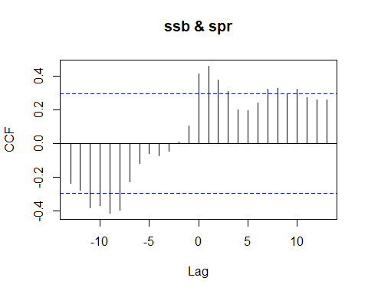

## [1] "CCF for (ssb,spr) series"

##   
## Autocorrelations of series 'X', by lag  
##   
## -13 -12 -11 -10 -9 -8 -7 -6 -5 -4 -3   
## -0.234 -0.275 -0.382 -0.368 -0.412 -0.392 -0.226 -0.116 -0.058 -0.070 -0.045   
## -2 -1 0 1 2 3 4 5 6 7 8   
## 0.009 0.104 0.416 0.460 0.378 0.311 0.200 0.194 0.242 0.321 0.327   
## 9 10 11 12 13   
## 0.296 0.322 0.273 0.259 0.262

## [1] "Significant cross correlations exist at lags:"  
## [1] -11 -10 -9 -8 0 1 2 3 7 8 10  
## [1] -0.3821349 -0.3679388 -0.4115967 -0.3921725 0.4161896 0.4602098  
## [7] 0.3780028 0.3113305 0.3214272 0.3265583 0.3216124

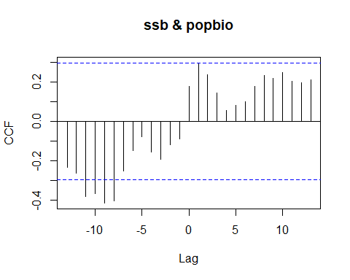

## [1] "CCF for (ssb,popbio) series"

##   
## Autocorrelations of series 'X', by lag  
##   
## -13 -12 -11 -10 -9 -8 -7 -6 -5 -4 -3   
## -0.232 -0.261 -0.379 -0.366 -0.413 -0.402 -0.251 -0.149 -0.076 -0.154 -0.192   
## -2 -1 0 1 2 3 4 5 6 7 8   
## -0.119 -0.088 0.177 0.292 0.236 0.144 0.055 0.081 0.101 0.177 0.233   
## 9 10 11 12 13   
## 0.217 0.248 0.205 0.195 0.211

## [1] "Significant cross correlations exist at lags:"  
## [1] -11 -10 -9 -8  
## [1] -0.3790738 -0.3661048 -0.4125617 -0.4023771

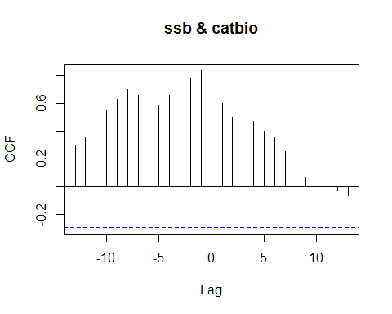

## [1] "CCF for (ssb,catbio) series"

##   
## Autocorrelations of series 'X', by lag  
##   
## -13 -12 -11 -10 -9 -8 -7 -6 -5 -4 -3   
## 0.299 0.362 0.502 0.550 0.632 0.702 0.662 0.618 0.589 0.662 0.746   
## -2 -1 0 1 2 3 4 5 6 7 8   
## 0.785 0.838 0.740 0.602 0.499 0.476 0.471 0.401 0.352 0.251 0.140   
## 9 10 11 12 13   
## 0.070 -0.002 -0.014 -0.029 -0.066

## [1] "Significant cross correlations exist at lags:"  
## [1] -12 -11 -10 -9 -8 -7 -6 -5 -4 -3 -2 -1 0 1 2 3 4 5 6  
## [1] 0.3618517 0.5024203 0.5500011 0.6320081 0.7019225 0.6616716 0.6180064  
## [8] 0.5893040 0.6624088 0.7464604 0.7846643 0.8377099 0.7397226 0.6018241  
## [15] 0.4993017 0.4763639 0.4705748 0.4013867 0.3519766

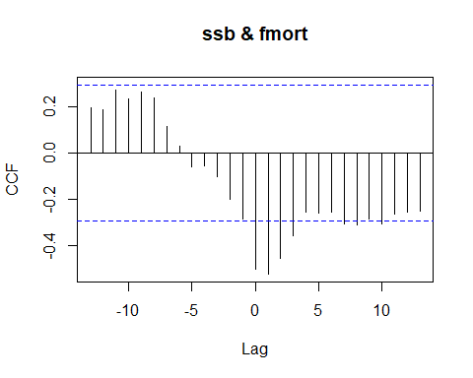

## [1] "CCF for (ssb,fmort) series"

##   
## Autocorrelations of series 'X', by lag  
##   
## -13 -12 -11 -10 -9 -8 -7 -6 -5 -4 -3   
## 0.195 0.187 0.275 0.235 0.263 0.240 0.116 0.030 -0.061 -0.055 -0.102   
## -2 -1 0 1 2 3 4 5 6 7 8   
## -0.200 -0.284 -0.502 -0.524 -0.458 -0.359 -0.254 -0.258 -0.255 -0.309 -0.310   
## 9 10 11 12 13   
## -0.286 -0.307 -0.266 -0.257 -0.253

## [1] "Significant cross correlations exist at lags:"  
## [1] 0 1 2 3 7 8 10  
## [1] -0.5021821 -0.5237944 -0.4578632 -0.3589748 -0.3086439 -0.3104507 -0.3074516

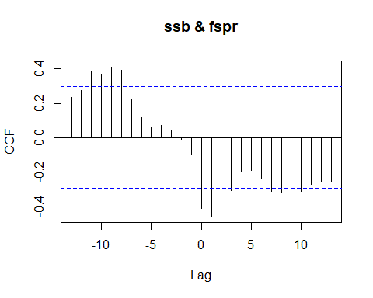

## [1] "CCF for (ssb,fspr) series"

##   
## Autocorrelations of series 'X', by lag  
##   
## -13 -12 -11 -10 -9 -8 -7 -6 -5 -4 -3   
## 0.234 0.275 0.382 0.368 0.412 0.392 0.226 0.116 0.058 0.070 0.045   
## -2 -1 0 1 2 3 4 5 6 7 8   
## -0.009 -0.104 -0.416 -0.460 -0.378 -0.311 -0.200 -0.194 -0.242 -0.321 -0.327   
## 9 10 11 12 13   
## -0.296 -0.322 -0.273 -0.259 -0.262

## [1] "Significant cross correlations exist at lags:"  
## [1] -11 -10 -9 -8 0 1 2 3 7 8 10  
## [1] 0.3821349 0.3679388 0.4115967 0.3921725 -0.4161896 -0.4602098  
## [7] -0.3780028 -0.3113305 -0.3214272 -0.3265583 -0.3216124

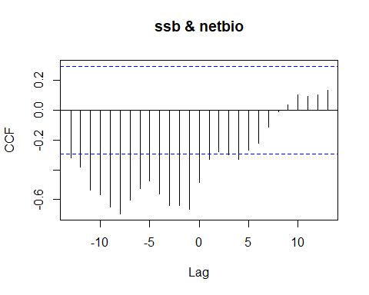

## [1] "CCF for (ssb,netbio) series"

##   
## Autocorrelations of series 'X', by lag  
##   
## -13 -12 -11 -10 -9 -8 -7 -6 -5 -4 -3   
## -0.322 -0.381 -0.536 -0.566 -0.647 -0.695 -0.602 -0.527 -0.475 -0.562 -0.641   
## -2 -1 0 1 2 3 4 5 6 7 8   
## -0.639 -0.667 -0.482 -0.331 -0.277 -0.298 -0.331 -0.268 -0.223 -0.115 -0.008   
## 9 10 11 12 13   
## 0.038 0.104 0.095 0.103 0.137

## [1] "Significant cross correlations exist at lags:"  
## [1] -13 -12 -11 -10 -9 -8 -7 -6 -5 -4 -3 -2 -1 0 1 4  
## [1] -0.3217209 -0.3809708 -0.5357279 -0.5661090 -0.6471312 -0.6954679  
## [7] -0.6022595 -0.5266386 -0.4746803 -0.5622586 -0.6414173 -0.6394803  
## [13] -0.6668190 -0.4824777 -0.3307744 -0.3311743

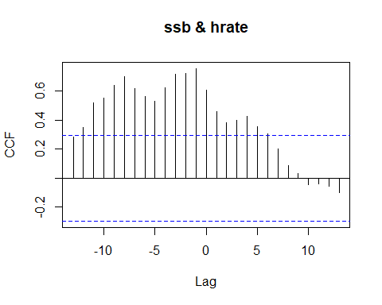

## [1] "CCF for (ssb,hrate) series"

##   
## Autocorrelations of series 'X', by lag  
##   
## -13 -12 -11 -10 -9 -8 -7 -6 -5 -4 -3   
## 0.285 0.349 0.516 0.552 0.635 0.699 0.618 0.561 0.526 0.621 0.715   
## -2 -1 0 1 2 3 4 5 6 7 8   
## 0.722 0.753 0.602 0.456 0.383 0.400 0.426 0.352 0.306 0.199 0.085   
## 9 10 11 12 13   
## 0.029 -0.043 -0.040 -0.053 -0.097

## [1] "Significant cross correlations exist at lags:"  
## [1] -12 -11 -10 -9 -8 -7 -6 -5 -4 -3 -2 -1 0 1 2 3 4 5 6  
## [1] 0.3494775 0.5164804 0.5516661 0.6351980 0.6986459 0.6181420 0.5606094  
## [8] 0.5261930 0.6209790 0.7147879 0.7217050 0.7527693 0.6022948 0.4561739  
## [15] 0.3831824 0.4000593 0.4262262 0.3519975 0.3058391

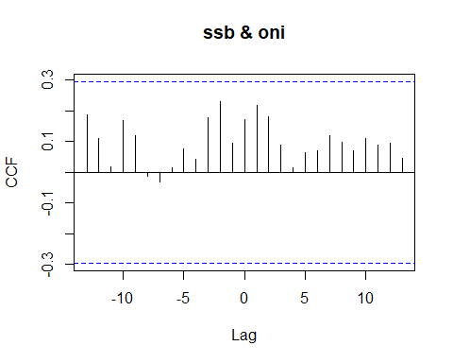

## [1] "CCF for (ssb,oni) series"

##   
## Autocorrelations of series 'X', by lag  
##   
## -13 -12 -11 -10 -9 -8 -7 -6 -5 -4 -3   
## 0.188 0.111 0.018 0.170 0.119 -0.012 -0.031 0.016 0.078 0.042 0.177   
## -2 -1 0 1 2 3 4 5 6 7 8   
## 0.230 0.095 0.172 0.218 0.182 0.088 0.015 0.065 0.070 0.121 0.099   
## 9 10 11 12 13   
## 0.069 0.110 0.089 0.095 0.045

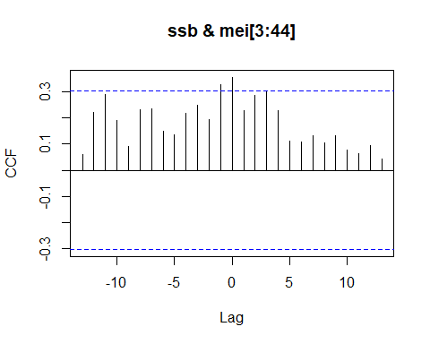

## [1] "CCF for (ssb,mei) series"

##   
## Autocorrelations of series 'X', by lag  
##   
## -13 -12 -11 -10 -9 -8 -7 -6 -5 -4 -3 -2 -1   
## 0.061 0.220 0.290 0.189 0.090 0.232 0.234 0.150 0.134 0.217 0.247 0.195 0.328   
## 0 1 2 3 4 5 6 7 8 9 10 11 12   
## 0.354 0.229 0.286 0.301 0.227 0.113 0.107 0.133 0.105 0.133 0.076 0.063 0.093   
## 13   
## 0.044

## [1] "Significant cross correlations exist at lags:"  
## [1] -1 0  
## [1] 0.3280627 0.3544694

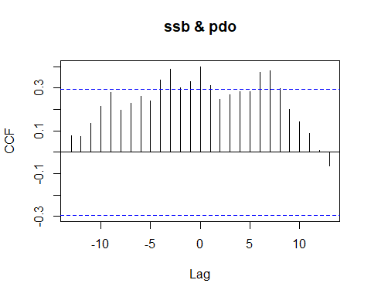

## [1] "CCF for (ssb,pdo) series"

##   
## Autocorrelations of series 'X', by lag  
##   
## -13 -12 -11 -10 -9 -8 -7 -6 -5 -4 -3   
## 0.078 0.073 0.134 0.216 0.278 0.196 0.231 0.263 0.241 0.338 0.387   
## -2 -1 0 1 2 3 4 5 6 7 8   
## 0.302 0.329 0.400 0.314 0.245 0.267 0.282 0.283 0.373 0.380 0.298   
## 9 10 11 12 13   
## 0.201 0.142 0.089 0.007 -0.063

## [1] "Significant cross correlations exist at lags:"  
## [1] -4 -3 -2 -1 0 1 6 7  
## [1] 0.3376460 0.3870840 0.3023385 0.3292628 0.3996832 0.3137775 0.3732869  
## [8] 0.3803445

### Recruits Per Spawning Biomass CCF Analysis

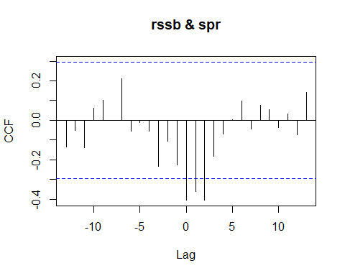

## [1] "CCF for (rssb,spr) series"

##   
## Autocorrelations of series 'X', by lag  
##   
## -13 -12 -11 -10 -9 -8 -7 -6 -5 -4 -3   
## -0.135 -0.052 -0.139 0.060 0.103 -0.001 0.211 -0.054 -0.011 -0.055 -0.234   
## -2 -1 0 1 2 3 4 5 6 7 8   
## -0.106 -0.228 -0.404 -0.360 -0.405 -0.182 -0.069 0.004 0.097 -0.045 0.077   
## 9 10 11 12 13   
## 0.056 -0.035 0.032 -0.073 0.140

## [1] "Significant cross correlations exist at lags:"  
## [1] 0 1 2  
## [1] -0.4042016 -0.3597244 -0.4049597

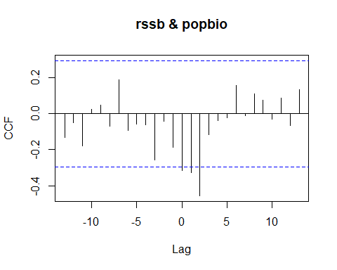

## [1] "CCF for (rssb,popbio) series"

##   
## Autocorrelations of series 'X', by lag  
##   
## -13 -12 -11 -10 -9 -8 -7 -6 -5 -4 -3   
## -0.133 -0.050 -0.179 0.027 0.047 -0.068 0.189 -0.092 -0.059 -0.059 -0.255   
## -2 -1 0 1 2 3 4 5 6 7 8   
## -0.040 -0.185 -0.314 -0.329 -0.456 -0.115 -0.036 -0.022 0.160 -0.009 0.111   
## 9 10 11 12 13   
## 0.077 -0.029 0.090 -0.067 0.136

## [1] "Significant cross correlations exist at lags:"  
## [1] 0 1 2  
## [1] -0.3142071 -0.3287794 -0.4561236

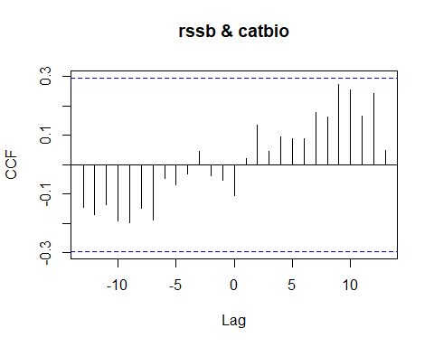

## [1] "CCF for (rssb,catbio) series"

##   
## Autocorrelations of series 'X', by lag  
##   
## -13 -12 -11 -10 -9 -8 -7 -6 -5 -4 -3   
## -0.144 -0.168 -0.135 -0.190 -0.197 -0.147 -0.187 -0.048 -0.068 -0.032 0.047   
## -2 -1 0 1 2 3 4 5 6 7 8   
## -0.038 -0.052 -0.104 0.022 0.135 0.045 0.095 0.088 0.090 0.178 0.164   
## 9 10 11 12 13   
## 0.273 0.255 0.166 0.242 0.048

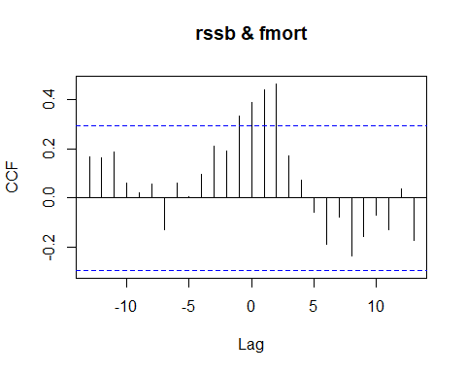

## [1] "CCF for (rssb,fmort) series"

##   
## Autocorrelations of series 'X', by lag  
##   
## -13 -12 -11 -10 -9 -8 -7 -6 -5 -4 -3   
## 0.166 0.163 0.188 0.061 0.023 0.055 -0.128 0.060 0.006 0.097 0.213   
## -2 -1 0 1 2 3 4 5 6 7 8   
## 0.190 0.333 0.390 0.440 0.465 0.171 0.072 -0.060 -0.188 -0.080 -0.238   
## 9 10 11 12 13   
## -0.159 -0.070 -0.130 0.036 -0.172

## [1] "Significant cross correlations exist at lags:"  
## [1] -1 0 1 2  
## [1] 0.3332281 0.3895027 0.4400866 0.4645943

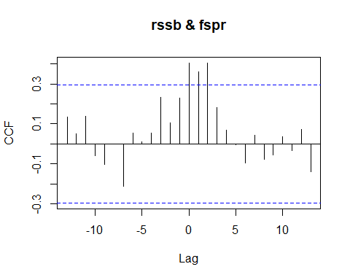

## [1] "CCF for (rssb,fspr) series"

##   
## Autocorrelations of series 'X', by lag  
##   
## -13 -12 -11 -10 -9 -8 -7 -6 -5 -4 -3   
## 0.135 0.052 0.139 -0.060 -0.103 0.001 -0.211 0.054 0.011 0.055 0.234   
## -2 -1 0 1 2 3 4 5 6 7 8   
## 0.106 0.228 0.404 0.360 0.405 0.182 0.069 -0.004 -0.097 0.045 -0.077   
## 9 10 11 12 13   
## -0.056 0.035 -0.032 0.073 -0.140

## [1] "Significant cross correlations exist at lags:"  
## [1] 0 1 2  
## [1] 0.4042016 0.3597244 0.4049597

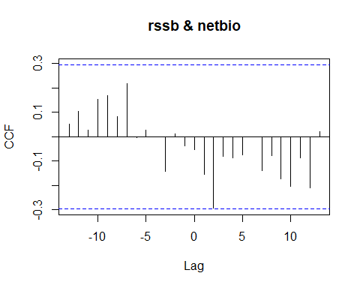

## [1] "CCF for (rssb,netbio) series"

##   
## Autocorrelations of series 'X', by lag  
##   
## -13 -12 -11 -10 -9 -8 -7 -6 -5 -4 -3   
## 0.053 0.106 0.027 0.154 0.168 0.082 0.219 -0.002 0.027 -0.001 -0.142   
## -2 -1 0 1 2 3 4 5 6 7 8   
## 0.012 -0.038 -0.052 -0.154 -0.291 -0.081 -0.087 -0.075 -0.001 -0.138 -0.077   
## 9 10 11 12 13   
## -0.173 -0.204 -0.087 -0.210 0.020

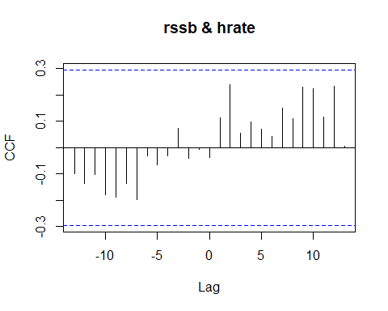

## [1] "CCF for (rssb,hrate) series"

##   
## Autocorrelations of series 'X', by lag  
##   
## -13 -12 -11 -10 -9 -8 -7 -6 -5 -4 -3   
## -0.097 -0.135 -0.103 -0.178 -0.187 -0.134 -0.197 -0.031 -0.066 -0.032 0.074   
## -2 -1 0 1 2 3 4 5 6 7 8   
## -0.041 -0.007 -0.036 0.112 0.241 0.057 0.099 0.072 0.044 0.151 0.112   
## 9 10 11 12 13   
## 0.231 0.224 0.116 0.234 0.005

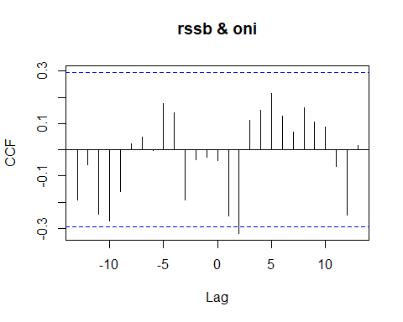

## [1] "CCF for (rssb,oni) series"

##   
## Autocorrelations of series 'X', by lag  
##   
## -13 -12 -11 -10 -9 -8 -7 -6 -5 -4 -3   
## -0.191 -0.056 -0.247 -0.272 -0.159 0.024 0.050 -0.002 0.175 0.141 -0.192   
## -2 -1 0 1 2 3 4 5 6 7 8   
## -0.037 -0.029 -0.041 -0.251 -0.319 0.113 0.151 0.214 0.127 0.069 0.160   
## 9 10 11 12 13   
## 0.106 0.088 -0.062 -0.250 0.017

## [1] "Significant cross correlations exist at lags:"  
## [1] 2  
## [1] -0.3193714

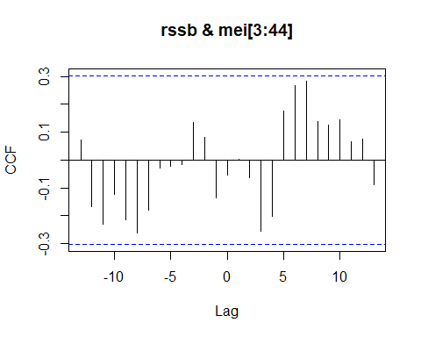

## [1] "CCF for (rssb,mei) series"

##   
## Autocorrelations of series 'X', by lag  
##   
## -13 -12 -11 -10 -9 -8 -7 -6 -5 -4 -3   
## 0.074 -0.166 -0.231 -0.123 -0.213 -0.261 -0.180 -0.028 -0.024 -0.017 0.135   
## -2 -1 0 1 2 3 4 5 6 7 8   
## 0.080 -0.136 -0.054 0.001 -0.063 -0.256 -0.203 0.177 0.266 0.284 0.138   
## 9 10 11 12 13   
## 0.126 0.143 0.066 0.074 -0.089

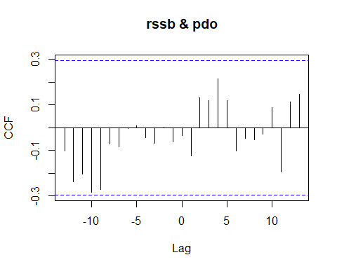

## [1] "CCF for (rssb,pdo) series"

##   
## Autocorrelations of series 'X', by lag  
##   
## -13 -12 -11 -10 -9 -8 -7 -6 -5 -4 -3   
## -0.103 -0.236 -0.204 -0.283 -0.270 -0.071 -0.083 -0.005 0.008 -0.043 -0.069   
## -2 -1 0 1 2 3 4 5 6 7 8   
## 0.004 -0.062 -0.034 -0.124 0.131 0.121 0.215 0.121 -0.102 -0.046 -0.054   
## 9 10 11 12 13   
## -0.029 0.090 -0.193 0.114 0.146

### Spawning Potential Ratio CCF Analysis

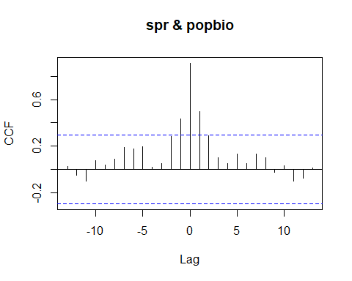

## [1] "CCF for (spr,popbio) series"

##   
## Autocorrelations of series 'X', by lag  
##   
## -13 -12 -11 -10 -9 -8 -7 -6 -5 -4 -3   
## 0.028 -0.053 -0.098 0.077 0.040 0.088 0.187 0.175 0.198 0.019 0.050   
## -2 -1 0 1 2 3 4 5 6 7 8   
## 0.281 0.433 0.914 0.501 0.290 0.101 0.050 0.135 0.049 0.133 0.101   
## 9 10 11 12 13   
## -0.022 0.031 -0.100 -0.075 0.015

## [1] "Significant cross correlations exist at lags:"  
## [1] -1 0 1  
## [1] 0.4326244 0.9138619 0.5005578

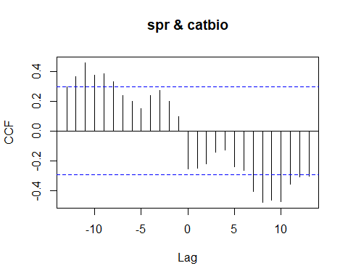

## [1] "CCF for (spr,catbio) series"

##   
## Autocorrelations of series 'X', by lag  
##   
## -13 -12 -11 -10 -9 -8 -7 -6 -5 -4 -3   
## 0.296 0.364 0.459 0.375 0.386 0.329 0.240 0.201 0.148 0.238 0.273   
## -2 -1 0 1 2 3 4 5 6 7 8   
## 0.200 0.096 -0.256 -0.248 -0.220 -0.141 -0.130 -0.239 -0.264 -0.406 -0.480   
## 9 10 11 12 13   
## -0.464 -0.475 -0.356 -0.310 -0.304

## [1] "Significant cross correlations exist at lags:"  
## [1] -12 -11 -10 -9 -8 7 8 9 10 11 12 13  
## [1] 0.3643394 0.4587739 0.3750849 0.3862644 0.3288481 -0.4063939  
## [7] -0.4797435 -0.4639830 -0.4746609 -0.3558469 -0.3104389 -0.3036051

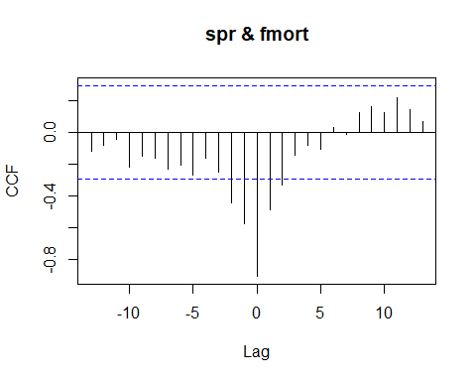

## [1] "CCF for (spr,fmort) series"

##   
## Autocorrelations of series 'X', by lag  
##   
## -13 -12 -11 -10 -9 -8 -7 -6 -5 -4 -3   
## -0.119 -0.082 -0.045 -0.218 -0.150 -0.165 -0.232 -0.206 -0.269 -0.164 -0.250   
## -2 -1 0 1 2 3 4 5 6 7 8   
## -0.442 -0.574 -0.908 -0.491 -0.329 -0.142 -0.084 -0.109 0.034 -0.009 0.126   
## 9 10 11 12 13   
## 0.162 0.129 0.219 0.143 0.069

## [1] "Significant cross correlations exist at lags:"  
## [1] -2 -1 0 1 2  
## [1] -0.4420467 -0.5743685 -0.9083266 -0.4910903 -0.3291444

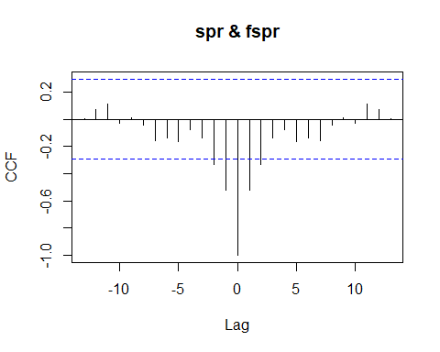

## [1] "CCF for (spr,fspr) series"

##   
## Autocorrelations of series 'X', by lag  
##   
## -13 -12 -11 -10 -9 -8 -7 -6 -5 -4 -3   
## 0.003 0.071 0.110 -0.029 0.009 -0.042 -0.155 -0.137 -0.161 -0.074 -0.135   
## -2 -1 0 1 2 3 4 5 6 7 8   
## -0.333 -0.524 -1.000 -0.524 -0.333 -0.135 -0.074 -0.161 -0.137 -0.155 -0.042   
## 9 10 11 12 13   
## 0.009 -0.029 0.110 0.071 0.003

## [1] "Significant cross correlations exist at lags:"  
## [1] -2 -1 0 1 2  
## [1] -0.3328887 -0.5239828 -1.0000000 -0.5239828 -0.3328887

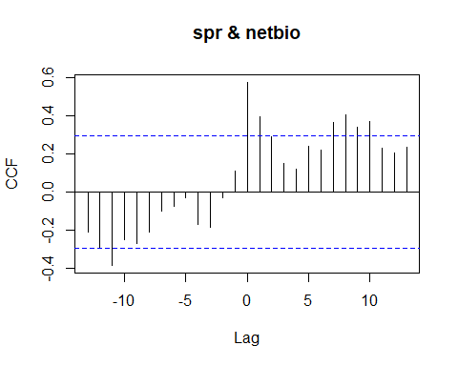

## [1] "CCF for (spr,netbio) series"

##   
## Autocorrelations of series 'X', by lag  
##   
## -13 -12 -11 -10 -9 -8 -7 -6 -5 -4 -3   
## -0.211 -0.296 -0.386 -0.250 -0.274 -0.211 -0.103 -0.079 -0.029 -0.171 -0.185   
## -2 -1 0 1 2 3 4 5 6 7 8   
## -0.033 0.108 0.573 0.395 0.286 0.148 0.119 0.236 0.219 0.361 0.403   
## 9 10 11 12 13   
## 0.340 0.370 0.226 0.202 0.234

## [1] "Significant cross correlations exist at lags:"  
## [1] -11 0 1 7 8 9 10  
## [1] -0.3857873 0.5733571 0.3953597 0.3609698 0.4030404 0.3395683 0.3700808

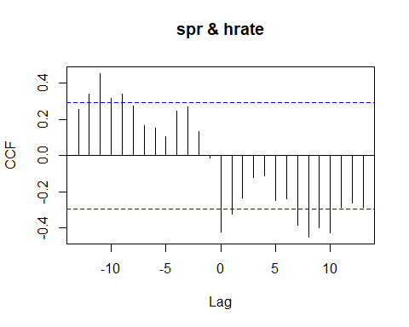

## [1] "CCF for (spr,hrate) series"

##   
## Autocorrelations of series 'X', by lag  
##   
## -13 -12 -11 -10 -9 -8 -7 -6 -5 -4 -3   
## 0.255 0.341 0.454 0.319 0.341 0.275 0.166 0.149 0.106 0.246 0.271   
## -2 -1 0 1 2 3 4 5 6 7 8   
## 0.132 -0.012 -0.424 -0.322 -0.233 -0.123 -0.110 -0.248 -0.238 -0.386 -0.451   
## 9 10 11 12 13   
## -0.399 -0.427 -0.284 -0.263 -0.287

## [1] "Significant cross correlations exist at lags:"  
## [1] -12 -11 -10 -9 0 1 7 8 9 10  
## [1] 0.3405214 0.4538497 0.3189757 0.3413080 -0.4239348 -0.3224852  
## [7] -0.3861265 -0.4509252 -0.3992787 -0.4265986

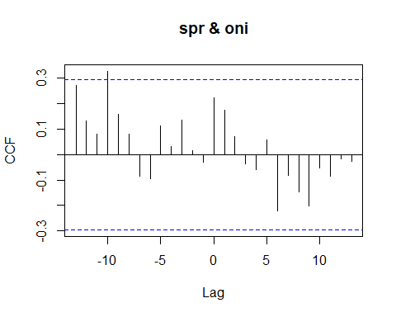

## [1] "CCF for (spr,oni) series"

##   
## Autocorrelations of series 'X', by lag  
##   
## -13 -12 -11 -10 -9 -8 -7 -6 -5 -4 -3   
## 0.271 0.133 0.079 0.327 0.159 0.080 -0.084 -0.096 0.112 0.031 0.135   
## -2 -1 0 1 2 3 4 5 6 7 8   
## 0.015 -0.030 0.223 0.175 0.071 -0.036 -0.059 0.057 -0.221 -0.083 -0.145   
## 9 10 11 12 13   
## -0.202 -0.051 -0.086 -0.016 -0.026

## [1] "Significant cross correlations exist at lags:"  
## [1] -10  
## [1] 0.3268193

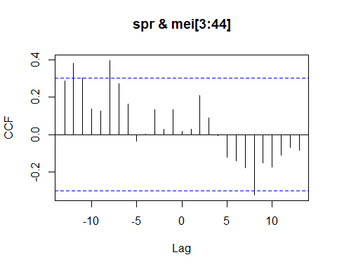

## [1] "CCF for (spr,mei) series"

##   
## Autocorrelations of series 'X', by lag  
##   
## -13 -12 -11 -10 -9 -8 -7 -6 -5 -4 -3   
## 0.289 0.383 0.305 0.139 0.125 0.398 0.275 0.165 -0.035 0.002 0.133   
## -2 -1 0 1 2 3 4 5 6 7 8   
## 0.027 0.136 0.016 0.027 0.211 0.088 -0.005 -0.123 -0.140 -0.180 -0.326   
## 9 10 11 12 13   
## -0.151 -0.177 -0.111 -0.070 -0.085

## [1] "Significant cross correlations exist at lags:"  
## [1] -12 -8 8  
## [1] 0.3828964 0.3981413 -0.3256550

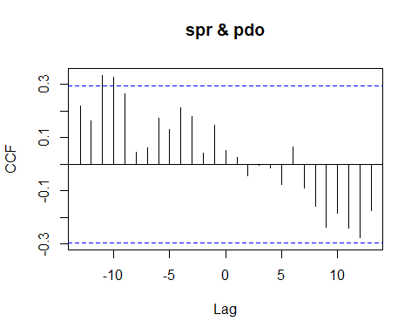

## [1] "CCF for (spr,pdo) series"

##   
## Autocorrelations of series 'X', by lag  
##   
## -13 -12 -11 -10 -9 -8 -7 -6 -5 -4 -3   
## 0.220 0.163 0.334 0.326 0.265 0.045 0.062 0.174 0.131 0.213 0.178   
## -2 -1 0 1 2 3 4 5 6 7 8   
## 0.043 0.146 0.052 0.025 -0.043 -0.003 -0.013 -0.078 0.064 -0.089 -0.158   
## 9 10 11 12 13   
## -0.236 -0.184 -0.239 -0.278 -0.175

## [1] "Significant cross correlations exist at lags:"  
## [1] -11 -10  
## [1] 0.3335244 0.3260014

### Population Biomass CCF Analysis

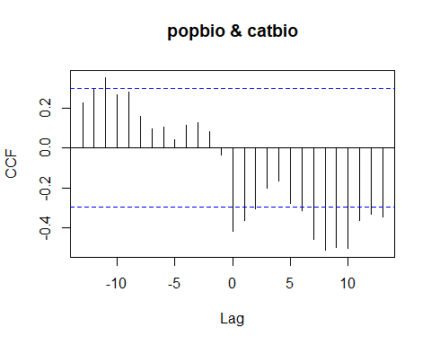

## [1] "CCF for (popbio,catbio) series"

##   
## Autocorrelations of series 'X', by lag  
##   
## -13 -12 -11 -10 -9 -8 -7 -6 -5 -4 -3   
## 0.226 0.290 0.351 0.265 0.278 0.157 0.096 0.104 0.039 0.112 0.125   
## -2 -1 0 1 2 3 4 5 6 7 8   
## 0.083 -0.038 -0.417 -0.363 -0.303 -0.200 -0.167 -0.276 -0.315 -0.460 -0.512   
## 9 10 11 12 13   
## -0.498 -0.504 -0.363 -0.333 -0.345

## [1] "Significant cross correlations exist at lags:"  
## [1] -11 0 1 2 6 7 8 9 10 11 12 13  
## [1] 0.3510222 -0.4165546 -0.3633677 -0.3031560 -0.3154207 -0.4599309  
## [7] -0.5116149 -0.4980607 -0.5035201 -0.3634305 -0.3331040 -0.3447029

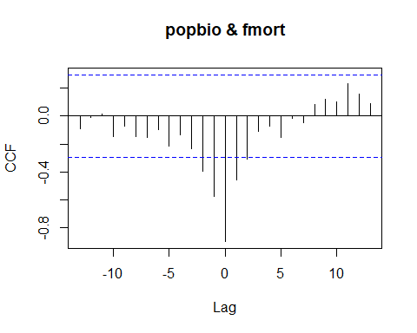

## [1] "CCF for (popbio,fmort) series"

##   
## Autocorrelations of series 'X', by lag  
##   
## -13 -12 -11 -10 -9 -8 -7 -6 -5 -4 -3   
## -0.088 -0.012 0.014 -0.144 -0.070 -0.145 -0.150 -0.099 -0.214 -0.133 -0.235   
## -2 -1 0 1 2 3 4 5 6 7 8   
## -0.393 -0.572 -0.897 -0.455 -0.307 -0.109 -0.071 -0.151 -0.013 -0.047 0.082   
## 9 10 11 12 13   
## 0.121 0.102 0.232 0.160 0.092

## [1] "Significant cross correlations exist at lags:"  
## [1] -2 -1 0 1 2  
## [1] -0.3932586 -0.5716330 -0.8969238 -0.4552560 -0.3071532

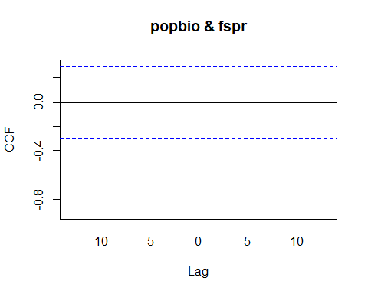

## [1] "CCF for (popbio,fspr) series"

##   
## Autocorrelations of series 'X', by lag  
##   
## -13 -12 -11 -10 -9 -8 -7 -6 -5 -4 -3   
## -0.015 0.075 0.100 -0.031 0.022 -0.101 -0.133 -0.049 -0.135 -0.050 -0.101   
## -2 -1 0 1 2 3 4 5 6 7 8   
## -0.290 -0.501 -0.914 -0.433 -0.281 -0.050 -0.019 -0.198 -0.175 -0.187 -0.088   
## 9 10 11 12 13   
## -0.040 -0.077 0.098 0.053 -0.028

## [1] "Significant cross correlations exist at lags:"  
## [1] -1 0 1  
## [1] -0.5005578 -0.9138619 -0.4326244

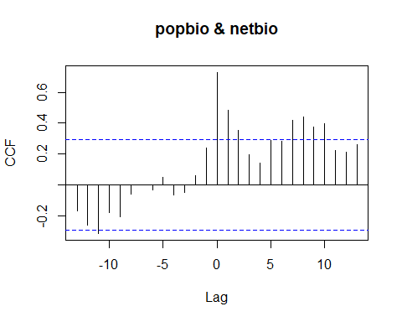

## [1] "CCF for (popbio,netbio) series"

##   
## Autocorrelations of series 'X', by lag  
##   
## -13 -12 -11 -10 -9 -8 -7 -6 -5 -4 -3   
## -0.168 -0.259 -0.315 -0.179 -0.207 -0.062 -0.002 -0.033 0.049 -0.068 -0.051   
## -2 -1 0 1 2 3 4 5 6 7 8   
## 0.061 0.238 0.730 0.482 0.351 0.193 0.143 0.286 0.282 0.416 0.441   
## 9 10 11 12 13   
## 0.377 0.398 0.222 0.210 0.261

## [1] "Significant cross correlations exist at lags:"  
## [1] -11 0 1 2 7 8 9 10  
## [1] -0.3152464 0.7297733 0.4822708 0.3511008 0.4163236 0.4411079 0.3767678  
## [8] 0.3983510

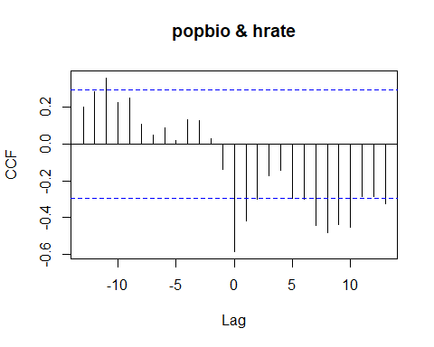

## [1] "CCF for (popbio,hrate) series"

##   
## Autocorrelations of series 'X', by lag  
##   
## -13 -12 -11 -10 -9 -8 -7 -6 -5 -4 -3   
## 0.203 0.286 0.359 0.226 0.250 0.110 0.050 0.087 0.017 0.134 0.127   
## -2 -1 0 1 2 3 4 5 6 7 8   
## 0.031 -0.136 -0.586 -0.419 -0.300 -0.172 -0.141 -0.294 -0.299 -0.445 -0.485   
## 9 10 11 12 13   
## -0.439 -0.455 -0.287 -0.286 -0.327

## [1] "Significant cross correlations exist at lags:"  
## [1] -11 0 1 7 8 9 10 13  
## [1] 0.3594426 -0.5858093 -0.4194521 -0.4453899 -0.4849369 -0.4388605 -0.4554653  
## [8] -0.3268175

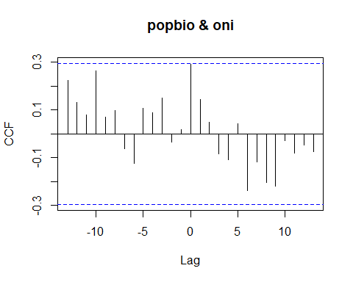

## [1] "CCF for (popbio,oni) series"

##   
## Autocorrelations of series 'X', by lag  
##   
## -13 -12 -11 -10 -9 -8 -7 -6 -5 -4 -3   
## 0.226 0.131 0.079 0.265 0.069 0.099 -0.062 -0.124 0.108 0.089 0.152   
## -2 -1 0 1 2 3 4 5 6 7 8   
## -0.035 0.017 0.292 0.144 0.048 -0.085 -0.109 0.043 -0.238 -0.116 -0.203   
## 9 10 11 12 13   
## -0.218 -0.029 -0.081 -0.047 -0.074

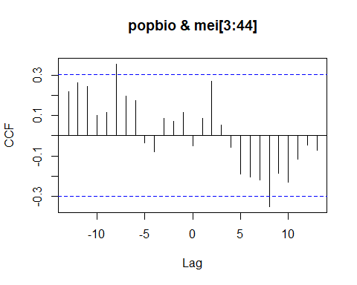

## [1] "CCF for (popbio,mei) series"

##   
## Autocorrelations of series 'X', by lag  
##   
## -13 -12 -11 -10 -9 -8 -7 -6 -5 -4 -3   
## 0.220 0.263 0.244 0.103 0.116 0.356 0.198 0.173 -0.037 -0.078 0.085   
## -2 -1 0 1 2 3 4 5 6 7 8   
## 0.070 0.117 -0.051 0.085 0.271 0.053 -0.058 -0.191 -0.206 -0.220 -0.352   
## 9 10 11 12 13   
## -0.187 -0.230 -0.115 -0.048 -0.073

## [1] "Significant cross correlations exist at lags:"  
## [1] -8 8  
## [1] 0.3561912 -0.3523252

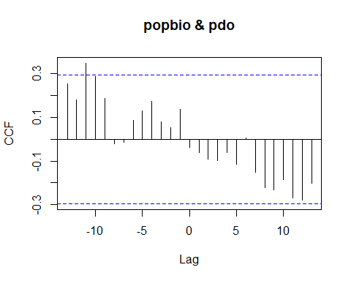

## [1] "CCF for (popbio,pdo) series"

##   
## Autocorrelations of series 'X', by lag  
##   
## -13 -12 -11 -10 -9 -8 -7 -6 -5 -4 -3   
## 0.254 0.181 0.348 0.288 0.188 -0.021 -0.014 0.087 0.129 0.173 0.080   
## -2 -1 0 1 2 3 4 5 6 7 8   
## 0.052 0.136 -0.038 -0.063 -0.091 -0.100 -0.062 -0.115 0.005 -0.152 -0.222   
## 9 10 11 12 13   
## -0.232 -0.186 -0.270 -0.279 -0.204

## [1] "Significant cross correlations exist at lags:"  
## [1] -11  
## [1] 0.3478511

### Catch Biomass CCF Analysis

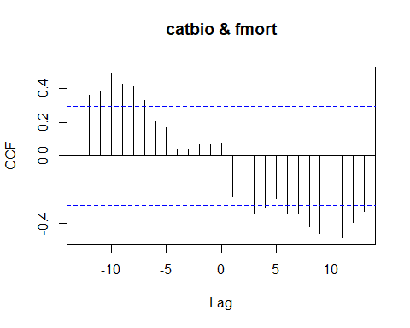

## [1] "CCF for (catbio,fmort) series"

##   
## Autocorrelations of series 'X', by lag  
##   
## -13 -12 -11 -10 -9 -8 -7 -6 -5 -4 -3   
## 0.386 0.359 0.385 0.488 0.425 0.412 0.333 0.202 0.167 0.034 0.039   
## -2 -1 0 1 2 3 4 5 6 7 8   
## 0.066 0.067 0.079 -0.242 -0.308 -0.341 -0.305 -0.251 -0.339 -0.340 -0.420   
## 9 10 11 12 13   
## -0.459 -0.445 -0.486 -0.393 -0.327

## [1] "Significant cross correlations exist at lags:"  
## [1] -13 -12 -11 -10 -9 -8 -7 2 3 4 6 7 8 9 10 11 12 13  
## [1] 0.3859491 0.3588860 0.3851681 0.4880280 0.4249467 0.4121276  
## [7] 0.3325669 -0.3076133 -0.3414605 -0.3053361 -0.3392760 -0.3404716  
## [13] -0.4197786 -0.4592436 -0.4450940 -0.4860768 -0.3928886 -0.3268040

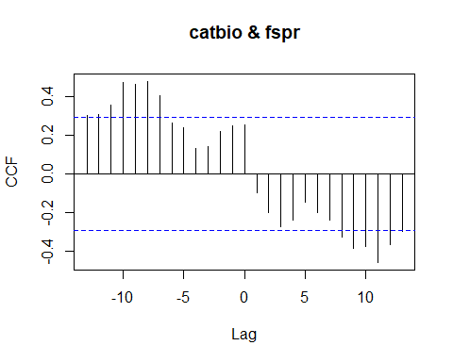

## [1] "CCF for (catbio,fspr) series"

##   
## Autocorrelations of series 'X', by lag  
##   
## -13 -12 -11 -10 -9 -8 -7 -6 -5 -4 -3   
## 0.304 0.310 0.356 0.475 0.464 0.480 0.406 0.264 0.239 0.130 0.141   
## -2 -1 0 1 2 3 4 5 6 7 8   
## 0.220 0.248 0.256 -0.096 -0.200 -0.273 -0.238 -0.148 -0.201 -0.240 -0.329   
## 9 10 11 12 13   
## -0.386 -0.375 -0.459 -0.364 -0.296

## [1] "Significant cross correlations exist at lags:"  
## [1] -13 -12 -11 -10 -9 -8 -7 8 9 10 11 12  
## [1] 0.3036051 0.3104389 0.3558469 0.4746609 0.4639830 0.4797435  
## [7] 0.4063939 -0.3288481 -0.3862644 -0.3750849 -0.4587739 -0.3643394

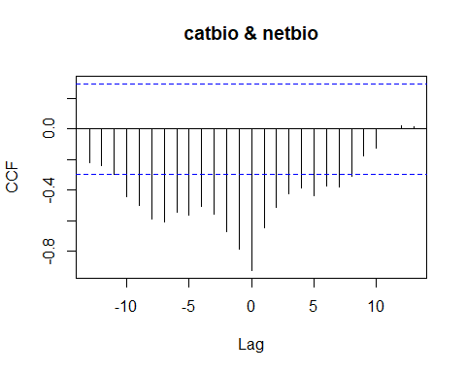

## [1] "CCF for (catbio,netbio) series"

##   
## Autocorrelations of series 'X', by lag  
##   
## -13 -12 -11 -10 -9 -8 -7 -6 -5 -4 -3   
## -0.221 -0.238 -0.295 -0.446 -0.498 -0.591 -0.610 -0.547 -0.566 -0.505 -0.559   
## -2 -1 0 1 2 3 4 5 6 7 8   
## -0.671 -0.784 -0.926 -0.649 -0.510 -0.424 -0.389 -0.435 -0.372 -0.378 -0.312   
## 9 10 11 12 13   
## -0.175 -0.126 0.003 0.021 0.016

## [1] "Significant cross correlations exist at lags:"  
## [1] -10 -9 -8 -7 -6 -5 -4 -3 -2 -1 0 1 2 3 4 5 6 7 8  
## [1] -0.4459384 -0.4983621 -0.5906811 -0.6095154 -0.5467779 -0.5658975  
## [7] -0.5049078 -0.5593066 -0.6710745 -0.7842993 -0.9255396 -0.6487596  
## [13] -0.5101526 -0.4238115 -0.3885045 -0.4347396 -0.3720034 -0.3780869  
## [19] -0.3122394

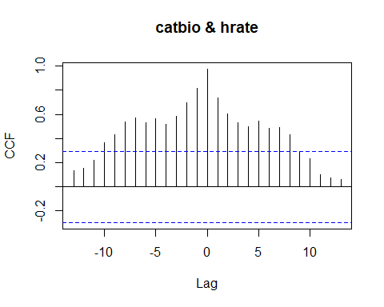

## [1] "CCF for (catbio,hrate) series"

##   
## Autocorrelations of series 'X', by lag  
##   
## -13 -12 -11 -10 -9 -8 -7 -6 -5 -4 -3 -2 -1   
## 0.135 0.157 0.218 0.368 0.431 0.539 0.573 0.531 0.563 0.518 0.584 0.698 0.818   
## 0 1 2 3 4 5 6 7 8 9 10 11 12   
## 0.975 0.736 0.604 0.531 0.497 0.548 0.482 0.490 0.429 0.291 0.232 0.103 0.072   
## 13   
## 0.060

## [1] "Significant cross correlations exist at lags:"  
## [1] -10 -9 -8 -7 -6 -5 -4 -3 -2 -1 0 1 2 3 4 5 6 7 8  
## [1] 0.3677473 0.4308402 0.5389513 0.5728048 0.5305578 0.5630391 0.5177227  
## [8] 0.5838582 0.6975084 0.8176118 0.9754379 0.7361000 0.6040917 0.5310801  
## [15] 0.4966117 0.5475304 0.4818224 0.4903961 0.4290067

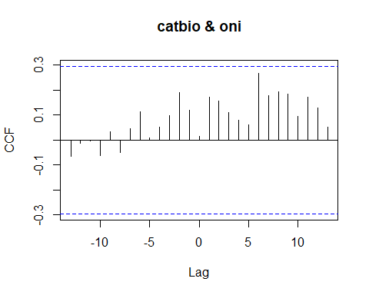

## [1] "CCF for (catbio,oni) series"

##   
## Autocorrelations of series 'X', by lag  
##   
## -13 -12 -11 -10 -9 -8 -7 -6 -5 -4 -3   
## -0.066 -0.012 -0.002 -0.062 0.033 -0.048 0.047 0.114 0.010 0.053 0.097   
## -2 -1 0 1 2 3 4 5 6 7 8   
## 0.192 0.121 0.014 0.171 0.158 0.110 0.078 0.061 0.268 0.177 0.192   
## 9 10 11 12 13   
## 0.184 0.095 0.173 0.128 0.053

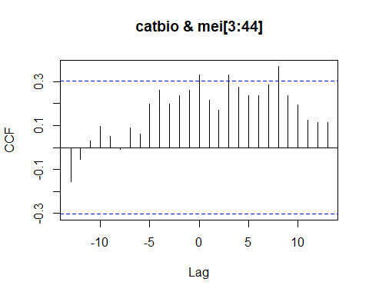

## [1] "CCF for (catbio,mei) series"

##   
## Autocorrelations of series 'X', by lag  
##   
## -13 -12 -11 -10 -9 -8 -7 -6 -5 -4 -3   
## -0.157 -0.053 0.030 0.096 0.051 -0.009 0.089 0.063 0.200 0.263 0.197   
## -2 -1 0 1 2 3 4 5 6 7 8   
## 0.237 0.262 0.331 0.216 0.172 0.330 0.276 0.237 0.237 0.287 0.370   
## 9 10 11 12 13   
## 0.238 0.195 0.123 0.113 0.116

## [1] "Significant cross correlations exist at lags:"  
## [1] 0 3 8  
## [1] 0.3312817 0.3297038 0.3701105

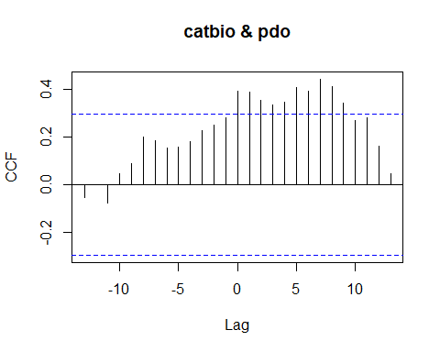

## [1] "CCF for (catbio,pdo) series"

##   
## Autocorrelations of series 'X', by lag  
##   
## -13 -12 -11 -10 -9 -8 -7 -6 -5 -4 -3   
## -0.055 0.000 -0.075 0.046 0.089 0.200 0.184 0.155 0.159 0.179 0.228   
## -2 -1 0 1 2 3 4 5 6 7 8   
## 0.249 0.281 0.392 0.388 0.352 0.335 0.346 0.406 0.394 0.442 0.413   
## 9 10 11 12 13   
## 0.344 0.270 0.281 0.163 0.048

## [1] "Significant cross correlations exist at lags:"  
## [1] 0 1 2 3 4 5 6 7 8 9  
## [1] 0.3924570 0.3883896 0.3521493 0.3348579 0.3456353 0.4062389 0.3937075  
## [8] 0.4424334 0.4127058 0.3437381

### Fishing Mortality CCF Analysis

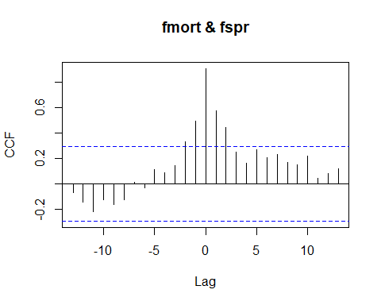

## [1] "CCF for (fmort,fspr) series"

##   
## Autocorrelations of series 'X', by lag  
##   
## -13 -12 -11 -10 -9 -8 -7 -6 -5 -4 -3   
## -0.069 -0.143 -0.219 -0.129 -0.162 -0.126 0.009 -0.034 0.109 0.084 0.142   
## -2 -1 0 1 2 3 4 5 6 7 8   
## 0.329 0.491 0.908 0.574 0.442 0.250 0.164 0.269 0.206 0.232 0.165   
## 9 10 11 12 13   
## 0.150 0.218 0.045 0.082 0.119

## [1] "Significant cross correlations exist at lags:"  
## [1] -2 -1 0 1 2  
## [1] 0.3291444 0.4910903 0.9083266 0.5743685 0.4420467

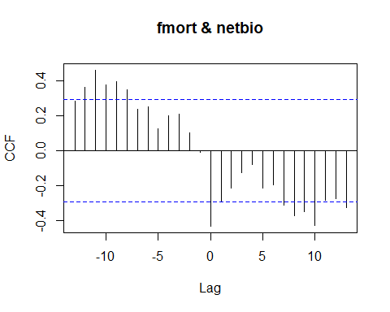

## [1] "CCF for (fmort,netbio) series"

##   
## Autocorrelations of series 'X', by lag  
##   
## -13 -12 -11 -10 -9 -8 -7 -6 -5 -4 -3   
## 0.284 0.362 0.462 0.377 0.396 0.350 0.236 0.250 0.126 0.200 0.211   
## -2 -1 0 1 2 3 4 5 6 7 8   
## 0.103 -0.008 -0.433 -0.289 -0.214 -0.127 -0.081 -0.215 -0.193 -0.313 -0.370   
## 9 10 11 12 13   
## -0.349 -0.427 -0.284 -0.275 -0.327

## [1] "Significant cross correlations exist at lags:"  
## [1] -12 -11 -10 -9 -8 0 7 8 9 10 13  
## [1] 0.3620916 0.4621901 0.3773339 0.3956053 0.3497541 -0.4326490  
## [7] -0.3126502 -0.3704743 -0.3488776 -0.4268428 -0.3267450

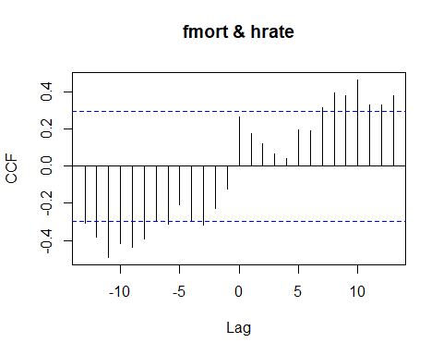

## [1] "CCF for (fmort,hrate) series"

##   
## Autocorrelations of series 'X', by lag  
##   
## -13 -12 -11 -10 -9 -8 -7 -6 -5 -4 -3   
## -0.305 -0.380 -0.491 -0.415 -0.435 -0.390 -0.292 -0.310 -0.207 -0.291 -0.317   
## -2 -1 0 1 2 3 4 5 6 7 8   
## -0.229 -0.126 0.265 0.177 0.119 0.068 0.042 0.195 0.188 0.316 0.394   
## 9 10 11 12 13   
## 0.379 0.463 0.330 0.326 0.380

## [1] "Significant cross correlations exist at lags:"  
## [1] -13 -12 -11 -10 -9 -8 -6 -3 7 8 9 10 11 12 13  
## [1] -0.3047522 -0.3796658 -0.4905575 -0.4149853 -0.4347498 -0.3896776  
## [7] -0.3103933 -0.3172448 0.3161065 0.3937933 0.3786895 0.4634388  
## [13] 0.3303489 0.3264738 0.3800847

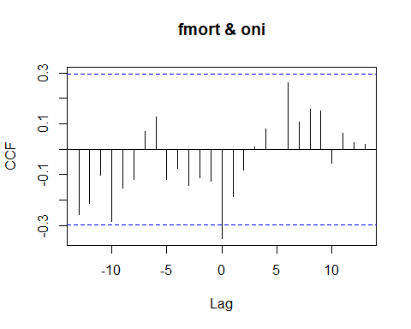

## [1] "CCF for (fmort,oni) series"

##   
## Autocorrelations of series 'X', by lag  
##   
## -13 -12 -11 -10 -9 -8 -7 -6 -5 -4 -3   
## -0.258 -0.212 -0.103 -0.284 -0.152 -0.119 0.070 0.128 -0.118 -0.076 -0.143   
## -2 -1 0 1 2 3 4 5 6 7 8   
## -0.110 -0.124 -0.350 -0.185 -0.080 0.009 0.079 -0.001 0.261 0.107 0.156   
## 9 10 11 12 13   
## 0.150 -0.055 0.063 0.025 0.019

## [1] "Significant cross correlations exist at lags:"  
## [1] 0  
## [1] -0.3502295

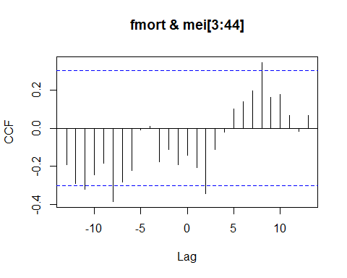

## [1] "CCF for (fmort,mei) series"

##   
## Autocorrelations of series 'X', by lag  
##   
## -13 -12 -11 -10 -9 -8 -7 -6 -5 -4 -3   
## -0.193 -0.291 -0.320 -0.246 -0.185 -0.385 -0.283 -0.223 -0.007 0.012 -0.178   
## -2 -1 0 1 2 3 4 5 6 7 8   
## -0.113 -0.189 -0.141 -0.207 -0.344 -0.112 -0.022 0.101 0.139 0.199 0.346   
## 9 10 11 12 13   
## 0.164 0.176 0.067 -0.017 0.067

## [1] "Significant cross correlations exist at lags:"  
## [1] -11 -8 2 8  
## [1] -0.3197685 -0.3849467 -0.3440111 0.3460453

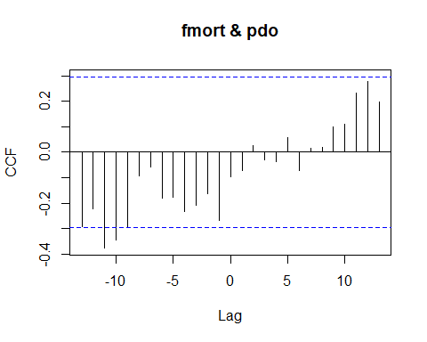

## [1] "CCF for (fmort,pdo) series"

##   
## Autocorrelations of series 'X', by lag  
##   
## -13 -12 -11 -10 -9 -8 -7 -6 -5 -4 -3   
## -0.293 -0.222 -0.375 -0.344 -0.294 -0.093 -0.059 -0.180 -0.177 -0.231 -0.206   
## -2 -1 0 1 2 3 4 5 6 7 8   
## -0.161 -0.266 -0.095 -0.073 0.028 -0.030 -0.038 0.059 -0.070 0.015 0.020   
## 9 10 11 12 13   
## 0.098 0.110 0.231 0.277 0.196

## [1] "Significant cross correlations exist at lags:"  
## [1] -11 -10  
## [1] -0.3752772 -0.3444616

### Fishing Intensity CCF Analysis

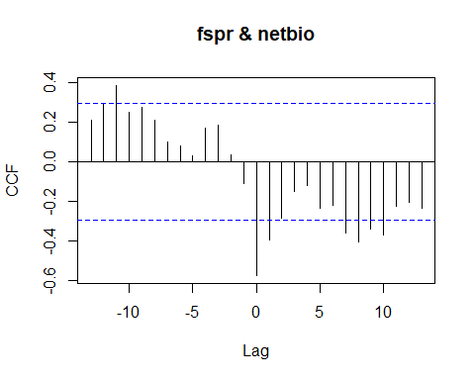

## [1] "CCF for (fspr,netbio) series"

##   
## Autocorrelations of series 'X', by lag  
##   
## -13 -12 -11 -10 -9 -8 -7 -6 -5 -4 -3   
## 0.211 0.296 0.386 0.250 0.274 0.211 0.103 0.079 0.029 0.171 0.185   
## -2 -1 0 1 2 3 4 5 6 7 8   
## 0.033 -0.108 -0.573 -0.395 -0.286 -0.148 -0.119 -0.236 -0.219 -0.361 -0.403   
## 9 10 11 12 13   
## -0.340 -0.370 -0.226 -0.202 -0.234

## [1] "Significant cross correlations exist at lags:"  
## [1] -11 0 1 7 8 9 10  
## [1] 0.3857873 -0.5733571 -0.3953597 -0.3609698 -0.4030404 -0.3395683 -0.3700808

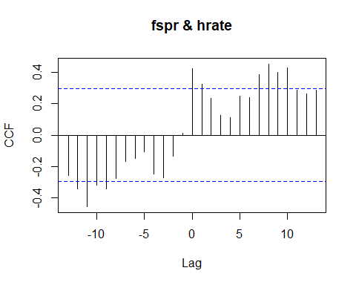

## [1] "CCF for (fspr,hrate) series"

##   
## Autocorrelations of series 'X', by lag  
##   
## -13 -12 -11 -10 -9 -8 -7 -6 -5 -4 -3   
## -0.255 -0.341 -0.454 -0.319 -0.341 -0.275 -0.166 -0.149 -0.106 -0.246 -0.271   
## -2 -1 0 1 2 3 4 5 6 7 8   
## -0.132 0.012 0.424 0.322 0.233 0.123 0.110 0.248 0.238 0.386 0.451   
## 9 10 11 12 13   
## 0.399 0.427 0.284 0.263 0.287

## [1] "Significant cross correlations exist at lags:"  
## [1] -12 -11 -10 -9 0 1 7 8 9 10  
## [1] -0.3405214 -0.4538497 -0.3189757 -0.3413080 0.4239348 0.3224852  
## [7] 0.3861265 0.4509252 0.3992787 0.4265986

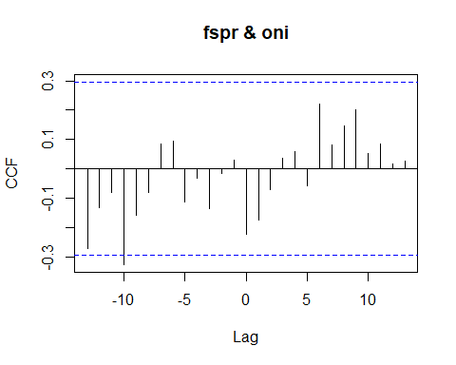

## [1] "CCF for (fspr,oni) series"

##   
## Autocorrelations of series 'X', by lag  
##   
## -13 -12 -11 -10 -9 -8 -7 -6 -5 -4 -3   
## -0.271 -0.133 -0.079 -0.327 -0.159 -0.080 0.084 0.096 -0.112 -0.031 -0.135   
## -2 -1 0 1 2 3 4 5 6 7 8   
## -0.015 0.030 -0.223 -0.175 -0.071 0.036 0.059 -0.057 0.221 0.083 0.145   
## 9 10 11 12 13   
## 0.202 0.051 0.086 0.016 0.026

## [1] "Significant cross correlations exist at lags:"  
## [1] -10  
## [1] -0.3268193

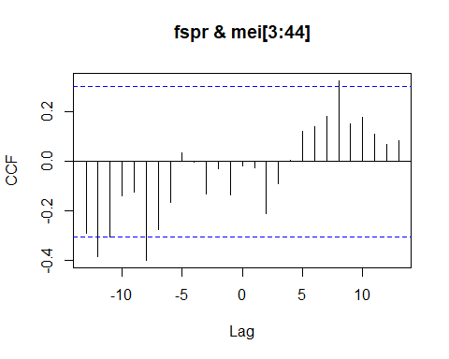

## [1] "CCF for (fspr,mei) series"

##   
## Autocorrelations of series 'X', by lag  
##   
## -13 -12 -11 -10 -9 -8 -7 -6 -5 -4 -3   
## -0.289 -0.383 -0.305 -0.139 -0.125 -0.398 -0.275 -0.165 0.035 -0.002 -0.133   
## -2 -1 0 1 2 3 4 5 6 7 8   
## -0.027 -0.136 -0.016 -0.027 -0.211 -0.088 0.005 0.123 0.140 0.180 0.326   
## 9 10 11 12 13   
## 0.151 0.177 0.111 0.070 0.085

## [1] "Significant cross correlations exist at lags:"  
## [1] -12 -8 8  
## [1] -0.3828964 -0.3981413 0.3256550

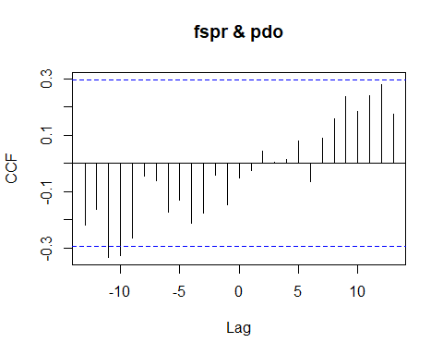

## [1] "CCF for (fspr,pdo) series"

##   
## Autocorrelations of series 'X', by lag  
##   
## -13 -12 -11 -10 -9 -8 -7 -6 -5 -4 -3   
## -0.220 -0.163 -0.334 -0.326 -0.265 -0.045 -0.062 -0.174 -0.131 -0.213 -0.178   
## -2 -1 0 1 2 3 4 5 6 7 8   
## -0.043 -0.146 -0.052 -0.025 0.043 0.003 0.013 0.078 -0.064 0.089 0.158   
## 9 10 11 12 13   
## 0.236 0.184 0.239 0.278 0.175

## [1] "Significant cross correlations exist at lags:"  
## [1] -11 -10  
## [1] -0.3335244 -0.3260014

### Net Biomass CCF Analysis

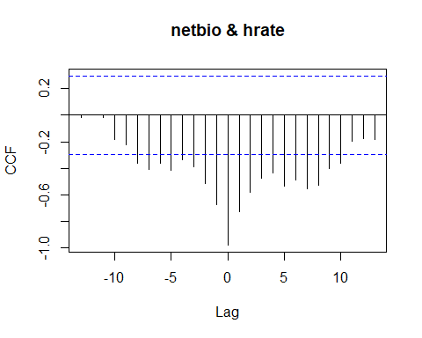

## [1] "CCF for (netbio,hrate) series"

##   
## Autocorrelations of series 'X', by lag  
##   
## -13 -12 -11 -10 -9 -8 -7 -6 -5 -4 -3   
## -0.017 0.001 -0.014 -0.182 -0.220 -0.359 -0.410 -0.363 -0.416 -0.334 -0.386   
## -2 -1 0 1 2 3 4 5 6 7 8   
## -0.512 -0.672 -0.978 -0.728 -0.579 -0.471 -0.432 -0.534 -0.487 -0.554 -0.525   
## 9 10 11 12 13   
## -0.402 -0.364 -0.197 -0.173 -0.181

## [1] "Significant cross correlations exist at lags:"  
## [1] -8 -7 -6 -5 -4 -3 -2 -1 0 1 2 3 4 5 6 7 8 9 10  
## [1] -0.3594807 -0.4099313 -0.3629112 -0.4163268 -0.3335595 -0.3861838  
## [7] -0.5117205 -0.6715987 -0.9775636 -0.7282826 -0.5790657 -0.4711099  
## [13] -0.4323323 -0.5340156 -0.4869116 -0.5543063 -0.5246105 -0.4017753  
## [19] -0.3644407

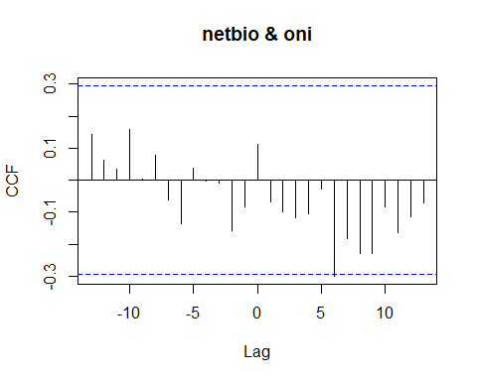

## [1] "CCF for (netbio,oni) series"

##   
## Autocorrelations of series 'X', by lag  
##   
## -13 -12 -11 -10 -9 -8 -7 -6 -5 -4 -3   
## 0.143 0.064 0.035 0.157 0.004 0.078 -0.061 -0.137 0.037 -0.003 -0.009   
## -2 -1 0 1 2 3 4 5 6 7 8   
## -0.159 -0.084 0.111 -0.069 -0.099 -0.118 -0.104 -0.028 -0.300 -0.182 -0.229   
## 9 10 11 12 13   
## -0.229 -0.084 -0.164 -0.116 -0.071

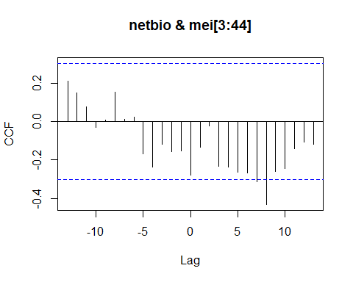

## [1] "CCF for (netbio,mei) series"

##   
## Autocorrelations of series 'X', by lag  
##   
## -13 -12 -11 -10 -9 -8 -7 -6 -5 -4 -3   
## 0.212 0.149 0.077 -0.032 0.008 0.154 0.013 0.023 -0.170 -0.235 -0.117   
## -2 -1 0 1 2 3 4 5 6 7 8   
## -0.155 -0.154 -0.277 -0.132 -0.021 -0.233 -0.237 -0.261 -0.268 -0.312 -0.431   
## 9 10 11 12 13   
## -0.261 -0.245 -0.142 -0.107 -0.119

## [1] "Significant cross correlations exist at lags:"  
## [1] 7 8  
## [1] -0.3124650 -0.4310654

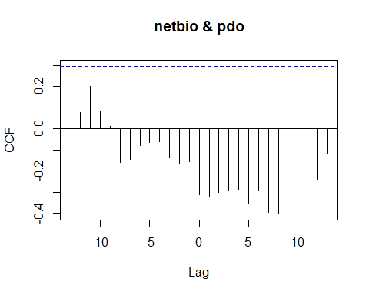

## [1] "CCF for (netbio,pdo) series"

##   
## Autocorrelations of series 'X', by lag  
##   
## -13 -12 -11 -10 -9 -8 -7 -6 -5 -4 -3   
## 0.147 0.075 0.201 0.086 0.011 -0.159 -0.144 -0.080 -0.066 -0.063 -0.138   
## -2 -1 0 1 2 3 4 5 6 7 8   
## -0.166 -0.155 -0.311 -0.318 -0.303 -0.293 -0.286 -0.353 -0.294 -0.396 -0.403   
## 9 10 11 12 13   
## -0.355 -0.281 -0.323 -0.239 -0.121

## [1] "Significant cross correlations exist at lags:"  
## [1] 0 1 2 5 7 8 9 11  
## [1] -0.3109154 -0.3182082 -0.3027900 -0.3533018 -0.3962380 -0.4029588 -0.3550353  
## [8] -0.3233743

### Harvest Rate CCF Analysis

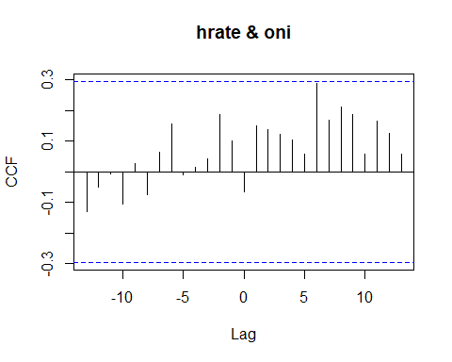

## [1] "CCF for (hrate,oni) series"

##   
## Autocorrelations of series 'X', by lag  
##   
## -13 -12 -11 -10 -9 -8 -7 -6 -5 -4 -3   
## -0.130 -0.048 -0.007 -0.105 0.026 -0.073 0.064 0.156 -0.009 0.015 0.043   
## -2 -1 0 1 2 3 4 5 6 7 8   
## 0.187 0.101 -0.065 0.149 0.137 0.123 0.103 0.057 0.289 0.168 0.212   
## 9 10 11 12 13   
## 0.189 0.057 0.166 0.126 0.058

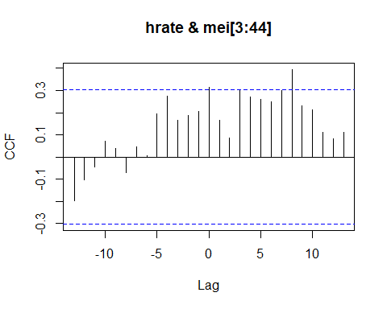

## [1] "CCF for (hrate,mei) series"

##   
## Autocorrelations of series 'X', by lag  
##   
## -13 -12 -11 -10 -9 -8 -7 -6 -5 -4 -3   
## -0.196 -0.105 -0.044 0.069 0.039 -0.070 0.048 0.007 0.196 0.275 0.165   
## -2 -1 0 1 2 3 4 5 6 7 8   
## 0.188 0.205 0.313 0.164 0.085 0.303 0.271 0.261 0.250 0.298 0.395   
## 9 10 11 12 13   
## 0.232 0.212 0.113 0.081 0.110

## [1] "Significant cross correlations exist at lags:"  
## [1] 0 8  
## [1] 0.3129625 0.3947427

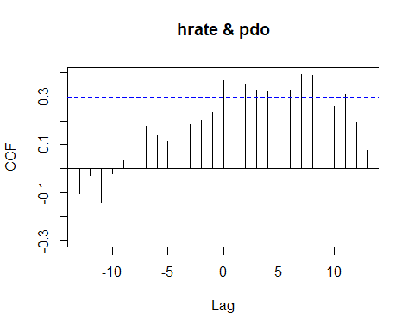

## [1] "CCF for (hrate,pdo) series"

##   
## Autocorrelations of series 'X', by lag  
##   
## -13 -12 -11 -10 -9 -8 -7 -6 -5 -4 -3   
## -0.102 -0.027 -0.142 -0.019 0.032 0.198 0.175 0.138 0.116 0.123 0.182   
## -2 -1 0 1 2 3 4 5 6 7 8   
## 0.201 0.232 0.366 0.378 0.349 0.326 0.319 0.375 0.327 0.392 0.388   
## 9 10 11 12 13   
## 0.326 0.261 0.309 0.191 0.076

## [1] "Significant cross correlations exist at lags:"  
## [1] 0 1 2 3 4 5 6 7 8 9 11  
## [1] 0.3660175 0.3782316 0.3492365 0.3264068 0.3185367 0.3751718 0.3273121  
## [8] 0.3919434 0.3880639 0.3259166 0.3085689

### Oceanic Nino Index CCF Analysis

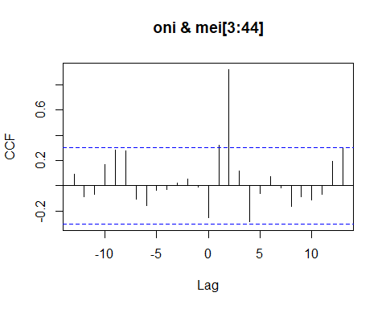

## [1] "CCF for (oni,mei) series"

##   
## Autocorrelations of series 'X', by lag  
##   
## -13 -12 -11 -10 -9 -8 -7 -6 -5 -4 -3   
## 0.095 -0.087 -0.066 0.170 0.286 0.275 -0.107 -0.159 -0.035 -0.027 0.022   
## -2 -1 0 1 2 3 4 5 6 7 8   
## 0.052 -0.013 -0.250 0.321 0.921 0.117 -0.285 -0.062 0.075 -0.015 -0.160   
## 9 10 11 12 13   
## -0.089 -0.111 -0.065 0.191 0.296

## [1] "Significant cross correlations exist at lags:"  
## [1] 1 2  
## [1] 0.3210004 0.9206468

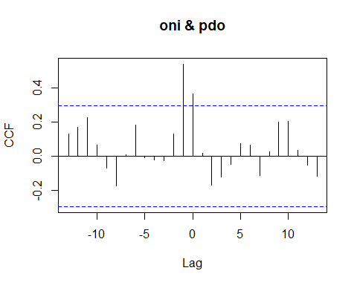

## [1] "CCF for (oni,pdo) series"

##   
## Autocorrelations of series 'X', by lag  
##   
## -13 -12 -11 -10 -9 -8 -7 -6 -5 -4 -3   
## 0.130 0.169 0.225 0.064 -0.070 -0.175 0.008 0.184 -0.009 -0.021 -0.025   
## -2 -1 0 1 2 3 4 5 6 7 8   
## 0.129 0.541 0.367 0.019 -0.170 -0.123 -0.050 0.074 0.068 -0.113 0.027   
## 9 10 11 12 13   
## 0.201 0.207 0.033 -0.052 -0.116

## [1] "Significant cross correlations exist at lags:"  
## [1] -1 0  
## [1] 0.5410553 0.3669013

### Multivariate ENSO Index CCF Analysis

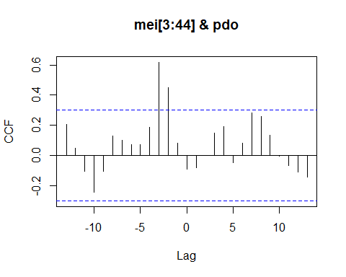

## [1] "CCF for (mei,pdo) series"

##   
## Autocorrelations of series 'X', by lag  
##   
## -13 -12 -11 -10 -9 -8 -7 -6 -5 -4 -3   
## 0.204 0.045 -0.108 -0.244 -0.107 0.130 0.101 0.069 0.073 0.188 0.618   
## -2 -1 0 1 2 3 4 5 6 7 8   
## 0.449 0.079 -0.094 -0.083 -0.003 0.149 0.189 -0.049 0.081 0.280 0.258   
## 9 10 11 12 13   
## 0.132 -0.005 -0.068 -0.113 -0.144

## [1] "Significant cross correlations exist at lags:"  
## [1] -3 -2  
## [1] 0.6178303 0.4492731