### 6/18/19 BILLWG



**Annex 11**

*19th Meeting of the International Scientific Committee for Tuna*

*and Tuna-Like Species in the North Pacific Ocean Taiwan, Chinese-Taipei*

*July 11-15, 2019*

**STOCK ASSESSMENT REPORT FOR STRIPED MARLIN (KAJIKIA AUDAX) IN THE WESTERN AND CENTRAL NORTH PACIFIC OCEAN THROUGH 2017**

July 2019

Left Blank for Printing

**TABLE OF CONTENTS**

ABSTRACT 1

EXECUTIVE SUMMARY: WESTERN AND CENTRAL NORTH PACIFIC OCEAN STRIPED MARLIN STOCK ASSESSMENT 2

Stock Identification and Distribution 2

Catches 2

Data and Assessment 2

Status of Stock 2

Biological Reference Points 3

Projections 3

Conservation Advice 4

Special Comments 4

1. INTRODUCTION 14
2. MATERIALS AND METHODS 14
   1. Spatial and Temporal Stratification 14
   2. Definition of Fisheries 14
   3. Catch 15
   4. Abundance Indices 15
   5. Size Composition Data 16
   6. Model Description 17
   7. Data Observation Models 17
   8. Estimation of Fishery Selectivity 18
   9. Data Weighting 18
   10. Model Diagnostics 18

Retrospective analysis 18

R0 likelihood profile 19

Age-structured production model 19

Goodness-of-Fit Indices of Abundance 19

Goodness-of-Fit Size Composition Data 20

* 1. Stock Projections 20

1. RESULTS 22
   1. Base Case Model 22
   2. Model Convergence 22
   3. Model Diagnostics 22

Goodness-of-Fit Indices of Abundance 23

Residuals Analysis of Size Composition Data 23

Retrospective Analysis 23

Age-structured production model 24

* 1. Stock Assessment Results 24
  2. Biological Reference Points 24
  3. Stock Status 25
  4. Sensitivity Analyses 25
  5. Stock Projections 26
  6. Assessment Challenges 27

Stock structure 27

Driftnet catch 28

Life History Parameters 28

Initial equilibrium catch 28

R0 Profile 29

ASPM diagnostic 29

* 1. Special Comments 29
  2. Conservation Advice 30

1. ACKNOWLEDGMENTS 30
2. REFERENCES 30
3. TABLES 34
4. FIGURES 61

# ABSTRACT

We present the benchmark stock assessment for the Western and Central North Pacific Ocean striped marlin (*Kajikia audax*) stock conducted in 2019 by the ISC Billfish Working Group (BILLWG). The 2019 assessment consisted of applying a Stock Synthesis model with the best- available catch, abundance index, and length composition data for 1975-2017. The results indicated that biomass (age 1 and older) for the Western and Central North Pacific striped marlin stock decreased from 17,000 metric tons in 1975 to 6,000 metric tons in 2017. Estimated fishing mortality averaged F=0.97 during 1975-1994 with a range of 0.60 to 1.59, peaked at F=1.71 year-1 in 2001, and declined sharply to F=0.64 year-1 in the most recent years (2015-2017).

Fishing mortality has fluctuated around FMSY since 2013. Compared to MSY-based reference points, the current spawning biomass (average for 2015-2017) was 76% below SSBMSY and the current fishing mortality (average for ages 3 – 12 in 2015-2017) was 7% above FMSY. The base case model indicated that under current conditions the Western and Central North Pacific striped marlin stock was overfished and was subject to overfishing relative to MSY-based reference points.

1

# EXECUTIVE SUMMARY: WESTERN AND CENTRAL NORTH PACIFIC OCEAN STRIPED MARLIN STOCK ASSESSMENT

## Stock Identification and Distribution

The Western and Central North Pacific Ocean (WCNPO) striped marlin (*Kajikia audax*) stock area consisted of waters of the North Pacific Ocean contained in the Western and Central Pacific Fisheries Commission management area bounded by the equator and 150°W. All available fishery data from this area were used for the stock assessment. For the purpose of modeling observations of CPUE and size composition data, it was assumed that there was an instantaneous mixing of fish throughout the stock area on a quarterly basis.

## Catches

North Pacific striped marlin catches were high from the 1970’s to the 1990’s, and has decreased to the present. The catch by Japanese fleets has decreased and catch from the US and Chinese Taipei has varied without trend, while the catch by other Western and Central Pacific Fisheries Commission (WCPFC) countries has increased (Figure S1). Overall, longline gear has accounted for the vast majority of Western and Central North Pacific striped marlin catches since the 1990’s and the driftnet catch dominated from 1975 to 1993.

## Data and Assessment

Catch and size composition data were collected from ISC countries (Japan, Chinese Taipei, and USA) and the WCPFC. Standardized catch-per-unit effort data used to measure trends in relative abundance were provided by Japan, USA, and Chinese Taipei. The Western and Central North Pacific striped marlin stock was assessed using an age- and length-structured assessment Stock Synthesis model fit to time series of standardized CPUE and size composition data. The value for stock-recruitment steepness used for the base case model was *h* = 0.87. The assessment model was fit to relative abundance indices and size composition data in a likelihood-based statistical framework. Maximum likelihood estimates of model parameters, derived outputs, and their variances were used to characterize stock status and to develop stock projections. Several sensitivity analyses were conducted to evaluate the effects of changes in model parameters, including the natural mortality rate, the stock-recruitment steepness, the growth curve parameters, and the female age at 50% maturity, as well as uncertainty in the input data and model structure.

## Status of Stock

Estimates of population biomass of the WCNPO striped marlin stock (*Kajikia audax*) fluctuated without trend between 1975 and 1993. The population deceased substantially in 1994 and fluctuated without trend until the present year. Population biomass (age-1 and older) averaged roughly 17,969 t, or 54% below unfished biomass during 1975-1993 and declined to 4,508 t, or 89% below unfished biomass in 2008. The minimum spawning stock biomass is estimated to be 618 t in 2011 (76% below *SSB*MSY, the spawning stock biomass to produce MSY, Figure S2a). In 2017, SSB = 981 mt and SSB/SSBMSY = 0.38. Fishing mortality on the stock (average *F* on ages 3-12) is currently around FMSY (Figure S2b). It averaged roughly *F* = 0.64 during 2015-2017, or 7% above *F*MSY and in 2017, F=0.80 with a relative fishing mortality of F/FMSY = 1.33. Fishing mortality has been above FMSY in every year except 1984, 1992, and 2016. The predicted value of the spawning potential ratio (SPR, the predicted spawning output at current *F* as a fraction of

unfished spawning output) is currently *SPR2015-2017* = 17% and is approximately equal to the SPR required to produce MSY. Recruitment averaged about 263,000 age-0 recruits during 1994-2016, which was 34% below the 1975-2016 average. No target or limit reference points have been established for the WCNPO striped marlin stock under the auspices of the WCPFC. Despite the relative large L50/Linf ratio for WCNPO striped marlin, the stock is expected to be highly productive due to its rapid growth and high resilience to reductions in spawning potential. Recent recruitments have been lower than expected and have been below the long-term trend since 2005. Although fishing mortality has decreased since 2000, due to the prolonged low recruitment and landings of juvenile fish, the biomass of the stock has remained below MSY. When the status of striped marlin is evaluated relative to MSY-based reference points, the 2017 spawning stock biomass of 981 mt is 62% below *SSB*MSY (2,604 t) and the 2015-2017 fishing mortality exceeds *F*MSY by 7%. Therefore, relative to MSY-based reference points, overfishing is occurring and the WCNPO striped marlin stock is overfished (Figure S3).

**Table S1.** Reported catch (mt) used in the stock assessment along with annual estimates of population biomass (age-1 and older, mt), female spawning biomass (mt), relative female spawning biomass (*SSB/SSBMSY*), recruitment (thousands of age-0 fish), fishing mortality (average F, ages-3 – 12), relative fishing mortality (*F/FMSY*), and spawning potential ratio of Western and Central North Pacific striped marlin.

|  |  |  |  |  |  |  |  |  |  |  |
| --- | --- | --- | --- | --- | --- | --- | --- | --- | --- | --- |
| **Year** | **2011** | **2012** | **2013** | **2014** | **2015** | **2016** | **2017** | **Mean1** | **Min1** | **Max1** |
| Reported Catch | 2,690 | 2,757 | 2,534 | 1,879 | 2,072 | 1,892 | 2,487 | 5,643 | 1,879 | 10,862 |
| Population Biomass | 5,874 | 6,057 | 4,937 | 6,241 | 5,745 | 5,832 | 6,196 | 12,153 | 4,509 | 22,303 |
| Spawning Biomass | 618 | 809 | 743 | 864 | 1,073 | 1,185 | 981 | 1,765 | 618 | 3,999 |
| Relative Spawning Biomass | 0.24 | 0.31 | 0.29 | 0.33 | 0.41 | 0.46 | 0.38 | 0.68 | 0.24 | 1.54 |
| Recruitment (age 0) | 196,590 | 87,956 | 330,550 | 77,274 | 185,438 | 195,069 | 354,391 | 396,218 | 77,274 | 1,049,460 |
| Fishing Mortality | 1.11 | 1.06 | 0.86 | 0.63 | 0.62 | 0.51 | 0.80 | 1.06 | 0.51 | 1.71 |
| Relative Fishing Mortality | 1.85 | 1.76 | 1.42 | 1.05 | 1.03 | 0.85 | 1.33 | 1.76 | 0.85 | 2.85 |
| Spawning Potential Ratio | 9% | 11% | 11% | 16% | 17% | 20% | 14% | 12% | 20% | 6% |

1 During 1975-2017

## Biological Reference Points

Biological reference points were computed for the base case model with Stock Synthesis (Table S2). The point estimate of maximum sustainable yield was MSY = 4,947 mt. The point estimate of the spawning biomass to produce MSY (adult female biomass) was SSBMSY = 2,604 mt. The point estimate of FMSY, the fishing mortality rate to produce MSY (average fishing mortality on ages 3 – 12) was FMSY = 0.60 and the corresponding equilibrium value of spawning potential ratio at MSY was SPRMSY = 18%.

## Projections

Stock projections for WCNPO striped marlin were conducted using the age-structured projection model software AGEPRO. Stochastic projections were conducted using results from the base case model to evaluate the probable impacts of alternative fishing intensities or constant catch quotas on future spawning stock biomass and yield for striped marlin in the Western and Central North Pacific Ocean. For fishing mortality projections, a standard set of F-based projections were conducted. For catch quota projections, the set of rebuilding projection analyses requested by the 14th Regular Session of the WCPFC Northern Committee were conducted. Two future

recruitment scenarios were evaluated: (1) a short-term recruitment scenario based on resampling the empirical cumulative distribution function of recruitment observed during 2012-2016 and (2) a long-term recruitment scenario based on resampling the empirical cumulative distribution function of recruitment observed during 1975-2016. The short-term recruitment scenario had an average recruitment of 134,020 age-1 fish and the long-term recruitment mean was 306,989 age- 1 fish. The stochastic projections employed model estimates of the multi-fleet, multi-season, size- and age-selectivity, and structural complexity in the assessment model to produce consistent results. Fishing mortality-based projections started in 2018 and continued through 2037 under 5 levels of fishing mortality and the two recruitment scenarios. The five fishing mortality stock projection scenarios were: (1) F status quo (average F during 2015-2017), (2)

FMSY, (3) F at 0.2·SSB(F=0), (4) FHigh at the highest 3-year average during 1975-2017, and (5) FLow at F0.30%. For the F-based scenarios, fishing mortality in 2018-2019 was set to be F status quo (0.64) and fishing mortality during 2020-2037 was set to the projected level of F. Catch-based projections also ran from 2018 to 2037 and included 7 levels of constant catch for the long-term recruitment scenario and 10 levels of catch for the short-term recruitment scenario. For the catch- based scenarios, catch biomass in 2018-2019 was set to be the status quo catch during 2015-2017 (2150.6 mt) and annual catches during 2020-2037 were set to the projected catch quota. The ten constant catch stock projection scenarios were: (1) Quota based upon CMM10-01, (2) 90% of the quota, (3) 80% of the quota, (4) 70% of the quota, (5) 60% of the quota, (6) 50% of the

quota, (7) 40% of the quota, (8) 30% of the quota, (9) 20% of the quota, and (10) 10% of the quota. Results show the projected female spawning stock biomasses and the catch biomasses under each of the scenarios (Table S3 and Figure S4).

## Conservation Advice

The WCNPO striped marlin stock has produced annual yields of around 2,173 mt per year since 2012, or about 40% of the MSY catch amount. Striped marlin stock status shows evidence of substantial depletion of spawning potential (SSBCurrent is 62% below SSBMSY), however fishing mortality has fluctuated around FMSY in the last 4 years. It was also noted that retrospective analyses show that the assessment model appears to underestimate spawning potential in recent years.

## Special Comments

WG achieved a base-case model using best available data and biological information. However, the WG recognized has uncertainty in input catch data including drift gillnet and initial catch amounts, life history parameters including maturation and growth, and stock structure. The WG considered an extensive suite of model formulations and associated diagnostics for developing the base-case assessment model. Overall, we found issues with the base case model diagnostics and sensitivity runs that indicated some data conflicts exist (see Assessment Challenges and Sensitivity Analyses). To improve the stock assessment, the WG also recommends continuing model development work to reduce data conflicts and modeling uncertainties, and reevaluating and improving input assessment data. When developing a CMM to rebuild the resource, the WG recommends that these issues be recognized and carefully considered.

**Table S2.** Estimates of biological reference points along with estimates of fishing mortality (F), spawning stock biomass (SSB), recent average yield (C), and spawning potential ratio (SPR) of Western and Central North Pacific striped marlin, derived from the base case model assessment model, where “MSY” indicates reference points based on maximum sustainable yield.

|  |  |
| --- | --- |
| **Reference Point** | **Estimate** |
| FMSY (age 3-12) | 0.60 |
| F2017 (age 3-12) | 0.80 |
| F20%SSB(F=0) | 0.47 |
| SSBMSY | 2,604 mt |
| SSB2017 | 981 mt |
| SSB20%(F=0) | 3,610 mt |
| MSY | 4,946 mt |
| C2015-2017 | 2,151 mt |
| SPRMSY | 18% |
| SPR2017 | 14% |
| SPR20%SSB(F=0) | 23% |

**Table S3.** Projected median values of Western and Central North Pacific striped marlin spawning stock biomass (SSB, mt), catch (mt), and probability of reaching 20%SSBF=0 under five constant fishing mortality rate (F) and ten constant catch scenarios during 2018-2037. For scenarios which have a 60% probability of reaching the target of 20%SSBF=0, the year in which this occurs is provided; NA indicates projections that did not meet this criterion. Note that 20%SSBF=0 is 3610 mt and SSBMSY is 2604 mt.

|  |  |  |  |  |  |  |  |  |
| --- | --- | --- | --- | --- | --- | --- | --- | --- |
| **Year** | **2018** | **2019** | **2020** | **2021** | **2022** | **2027** | **2037** | **Year when target achieved with 60% probability** |
| **Scenario 1: Fstatus quo; Long-Term Recruitment** | | | | | | | | |
| SSB | 1931.3 | 2605.3 | 3591 | 4288.3 | 4639.4 | 4893.4 | 4884.4 |  |
| Catch | 2229.8 | 3089.8 | 3911.6 | 4412.8 | 4644.9 | 4797.2 | 4790.9 |  |
| Probability of reaching 20% SSB | 0% | 4% | 44% | 70% | 79% | 84% | 84% | 2021 |
| **Scenario 2: Fstatus quo; Short-Term Recruitment** | | | | | | | | |
| SSB | 1932.4 | 2556.5 | 3080 | 2786.9 | 2422.3 | 2071.4 | 2072.1 |  |
| Catch | 2224.6 | 2827 | 2871.7 | 2535.9 | 2260.7 | 2029.6 | 2030.4 |  |
| Probability of reaching 20% SSB | 0% | 4% | 21% | 9% | 2% | <0.5% | <0.5% | NA |
| **Scenario 3: FMSY; Long-Term Recruitment** | | | | | | | | |
| SSB | 1935.1 | 2611.8 | 3650.5 | 4444 | 4860.6 | 5158.9 | 5203.5 |  |
| Catch | 2228.1 | 3092.7 | 3705.2 | 4241.6 | 4498.9 | 4666.4 | 4711.5 |  |
| Probability of reaching 20% SSB | 0% | 4% | 47% | 75% | 83% | 89% | 89% | 2021 |
| **Scenario 4: FMSY; Short-Term Recruitment** | | | | | | | | |
| SSB | 1932.9 | 2557.7 | 3126.3 | 2895.5 | 2552.2 | 2207 | 2197 |  |
| Catch | 2230.8 | 2829.6 | 2724.6 | 2450.7 | 2209.9 | 1994.1 | 1984.9 |  |
| Probability of reaching 20% SSB | 0% | 4% | 23% | 12% | 4% | <0.5% | <0.5% | NA |
| **Scenario 5: F 20%SSBF=0; Long-Term Recruitment** | | | | | | | | |
| SSB | 1933.7 | 2611.9 | 3813.4 | 4943.7 | 5631 | 6358.1 | 6348.5 |  |
| Catch | 2227.6 | 3091.3 | 2996.4 | 3588.7 | 3933.2 | 4271.7 | 4266.7 |  |
| Probability of reaching 20% SSB | 0% | 4% | 55% | 85% | 93% | 97% | 98% | 2021 |
| **Scenario 6: F 20%SSBF=0; Short-Term Recruitment** | | | | | | | | |
| SSB | 1934 | 2560.5 | 3276.3 | 3274.8 | 3030.2 | 2697 | 2690.2 |  |
| Catch | 2224.9 | 2828.8 | 2211.6 | 2115.4 | 1969.7 | 1809.1 | 1804.7 |  |
| Probability of reaching 20% SSB | 0% | 4% | 29% | 28% | 17% | 6% | 7% | NA |
| **Scenario 7: Highest F (Average F 1975-1977); Long-Term Recruitment** | | | | | | | | |
| SSB | 1932.8 | 2611.8 | 2739.8 | 2299.1 | 2102 | 2028.4 | 2036.2 |  |
| Catch | 2226.4 | 3088.5 | 7520.7 | 6557.5 | 6184.4 | 6058 | 6084.1 |  |
| Probability of reaching 20% SSB | 0% | 4% | 9% | 4% | 2% | 1% | 1% | NA |
| **Scenario 8: Highest F (Average F 1975-1977); Short-Term Recruitment** | | | | | |  |  |  |
| SSB | 1933.5 | 2559.4 | 2289.2 | 1330.7 | 968.3 | 858.7 | 859.2 |  |
| Catch | 2225.9 | 2827.6 | 5362.9 | 3399.3 | 2751.6 | 2564.6 | 2570.9 |  |

|  |  |  |  |  |  |  |  |  |
| --- | --- | --- | --- | --- | --- | --- | --- | --- |
| **Year** | **2018** | **2019** | **2020** | **2021** | **2022** | **2027** | **2037** | **Year when target achieved with 60% probability** |
| Probability of reaching  20% SSB | 0% | 3% | 2% | <0.5% | 0% | 0% | 0% | NA |
| **Scenario 9: Low F (F30%); Long-Term Recruitment** | | | | | | | | |
| SSB | 1933.6 | 2612.5 | 4009.5 | 5603.2 | 6742.4 | 8287.5 | 8353 |  |
| Catch | 2228.6 | 3093.5 | 2117.6 | 2693.6 | 3075 | 3558.2 | 3577.8 |  |
| Probability of reaching 20% SSB | 0% | 4% | 63% | 93% | 98% | >99.5% | >99.5% | 2020 |
| **Scenario 10: Low F (F30%); Short-Term Recruitment** | | | | | | | | |
| SSB | 1932.5 | 2555.6 | 3453.8 | 3788.4 | 3747.4 | 3537.4 | 3525.3 |  |
| Catch | 2228.4 | 2832 | 1572.9 | 1623.8 | 1589 | 1515.8 | 1511.6 |  |
| Probability of reaching 20% SSB | 0% | 4% | 37% | 54% | 54% | 44% | 42% | NA |
| **Scenario 11: Quota; Long-Term Recruitment** | | | | | | | | |
| SSB | 1946.7 | 2823 | 4141.1 | 5220.9 | 6074.7 | 8147.5 | 8715.3 |  |
| Catch | 2150.6 | 2150.6 | 3396.8 | 3396.7 | 3396.3 | 3396.1 | 3396.8 |  |
| Probability of reaching 20% SSB | <0.5% | 17% | 61% | 76% | 83% | 93% | 95% | 2020 |
| **Scenario 12: Quota; Short-Term Recruitment** | | | | | | | | |
| SSB | 1948.8 | 2737.1 | 3279.8 | 2592.9 | 1781.9 | 524.2 | 436.7 |  |
| Catch | 2150.6 | 2150.6 | 3393.7 | 3377.1 | 3319.7 | 2954.7 | 2903 |  |
| Probability of reaching 20% SSB | <0.5% | 15% | 36% | 20% | 7% | <0.5% | <0.5% | NA |
| **Scenario 13: 10% Reduction; Long-Term Recruitment** | | | | | | | | |
| SSB | 1947.9 | 2826.1 | 4225.3 | 5467.3 | 6492.5 | 9096.5 | 9798.7 |  |
| Catch | 2150.6 | 2150.6 | 3057.1 | 3057.1 | 3056.8 | 3057.1 | 3057.1 |  |
| Probability of reaching 20% SSB | <0.5% | 17% | 63% | 81% | 87% | 96% | 97% | 2020 |
| **Scenario 14: 10% Reduction; Short-Term Recruitment** | | | | | | | | |
| SSB | 1948.6 | 2738 | 3390.9 | 2886.8 | 2162.9 | 763 | 587 |  |
| Catch | 2150.6 | 2150.6 | 3054.6 | 3052.8 | 3032.5 | 2846.7 | 2780.1 |  |
| Probability of reaching 20% SSB | <0.5% | 15% | 40% | 26% | 12% | <0.5% | <0.5% | NA |
| **Scenario 15: 20% Reduction; Long-Term Recruitment** | | | | | | | | |
| SSB | 1949.9 | 2829.1 | 4317.7 | 5750.4 | 6954.1 | 9928.4 | 10806.2 |  |
| Catch | 2150.6 | 2150.6 | 2717.4 | 2717.4 | 2717.4 | 2717.4 | 2717.4 |  |
| Probability of reaching 20% SSB | <0.5% | 18% | 65% | 84% | 90% | 98% | 99% | 2020 |
| **Scenario 16: 20% Reduction; Short-Term Recruitment** | | | | | | | | |
| SSB | 1949.3 | 2739.2 | 3495.1 | 3176.4 | 2570.8 | 1175.5 | 883.3 |  |
| Catch | 2150.6 | 2150.6 | 2716.8 | 2714.3 | 2710.8 | 2648.8 | 2610.7 |  |
| Probability of reaching 20% SSB | <0.5% | 15% | 43% | 34% | 19% | 1% | <0.5% | NA |
| **Scenario 17: 30% Reduction; Long-Term Recruitment** | | | |  |  |  |  |  |
| SSB | 1947.6 | 2824.5 | 4381.5 | 5981.7 | 7356.2 | 10856.  1 | 11783.5 |  |
| Catch | 2150.6 | 2150.6 | 2377.8 | 2377.8 | 2377.8 | 2377.8 | 2377.8 |  |

|  |  |  |  |  |  |  |  |  |
| --- | --- | --- | --- | --- | --- | --- | --- | --- |
| **Year** | **2018** | **2019** | **2020** | **2021** | **2022** | **2027** | **2037** | **Year when target achieved with 60% probability** |
| Probability of reaching  20% SSB | <0.5% | 17% | 67% | 87% | 94% | 99% | >99.5% | 2020 |
| **Scenario 18: 30% Reduction; Short-Term Recruitment** | | | | | | | | |
| SSB | 1947.4 | 2733.8 | 3594 | 3479.2 | 3018.1 | 1736.6 | 1383.5 |  |
| Catch | 2150.6 | 2150.6 | 2377.8 | 2377.1 | 2377.1 | 2365.6 | 2355.3 |  |
| Probability of reaching 20% SSB | <0.5% | 15% | 45% | 42% | 29% | 5% | 2% | NA |
| **Scenario 19: 40% Reduction; Long-Term Recruitment** | | | | | | | | |
| SSB | 1949.2 | 2831.8 | 4486.8 | 6295.8 | 7868.9 | 11749.  2 | 12851.3 |  |
| Catch | 2150.6 | 2150.6 | 2038.1 | 2038.1 | 2038.1 | 2038.1 | 2038.1 |  |
| Probability of reaching 20% SSB | <0.5% | 18% | 70% | 90% | 95% | >99.5% | >99.5% | 2020 |
| **Scenario 20: 40% Reduction; Short-Term Recruitment** | | | | | | | | |
| SSB | 1949.9 | 2737.3 | 3689.5 | 3756 | 3445.9 | 2444.2 | 2124.2 |  |
| Catch | 2150.6 | 2150.6 | 2038.1 | 2038.1 | 2037.9 | 2037.6 | 2036.4 |  |
| Probability of reaching 20% SSB | <0.5% | 15% | 48% | 49% | 41% | 16% | 10% | NA |
| **Scenario 21: 50% Reduction; Long-Term Recruitment** | | | | | | | | |
| SSB | 1950.4 | 2829.7 | 4548.9 | 6512.1 | 8259.1 | 12654 | 13799.3 |  |
| Catch | 2150.6 | 2150.6 | 1698.4 | 1698.4 | 1698.4 | 1698.4 | 1698.4 |  |
| Probability of reaching 20% SSB | <0.5% | 17% | 71% | 92% | 97% | >99.5% | >99.5% | 2020 |
| **Scenario 22: 50% Reduction; Short-Term Recruitment** | | | | | | | | |
| SSB | 1949.1 | 2737.4 | 3791.4 | 4065.7 | 3916.3 | 3214.4 | 3021.3 |  |
| Catch | 2150.6 | 2150.6 | 1698.4 | 1698.4 | 1698.4 | 1698.4 | 1698.4 |  |
| Probability of reaching 20% SSB | <0.5% | 15% | 51% | 57% | 53% | 35% | 29% | NA |
| **Scenario 23: 60% Reduction; Long-Term Recruitment** | | | | | | | | |
| SSB | 1949.9 | 2829.1 | 4631.3 | 6798.1 | 8741.1 | 13605.  2 | 14857.1 |  |
| Catch | 2150.6 | 2150.6 | 1358.7 | 1358.7 | 1358.7 | 1358.7 | 1358.7 |  |
| Probability of reaching 20% SSB | <0.5% | 18% | 73% | 94% | 98% | >99.5% | >99.5% | 2020 |
| **Scenario 24: 60% Reduction; Short-Term Recruitment** | | | | | | | | |
| SSB | 1948.6 | 2737.7 | 3888.1 | 4364.3 | 4396.6 | 4110.1 | 3970.5 |  |
| Catch | 2150.6 | 2150.6 | 1358.7 | 1358.7 | 1358.7 | 1358.7 | 1358.7 |  |
| Probability of reaching 20% SSB | <0.5% | 15% | 53% | 65% | 67% | 63% | 59% | 2021* |
| **Scenario 25: 70% Reduction; Short-Term Recruitment** | | | | | | | | |
| SSB | 1948.7 | 2736.4 | 3979.8 | 4667.7 | 4886 | 4960.9 | 4977 |  |
| Catch | 2150.6 | 2150.6 | 1019 | 1019 | 1019 | 1019 | 1019 |  |
| Probability of reaching 20% SSB | <0.5% | 15% | 56% | 72% | 78% | 85% | 86% | 2021 |
| **Scenario 26: 80% Reduction; Short-Term Recruitment** | | | |  |  |  |  |  |
| SSB | 1948.7 | 2736.2 | 4071.1 | 4971.3 | 5380.3 | 5909.1 | 5977.5 |  |
| Catch | 2150.6 | 2150.6 | 679.4 | 679.4 | 679.4 | 679.4 | 679.4 |  |

|  |  |  |  |  |  |  |  |  |
| --- | --- | --- | --- | --- | --- | --- | --- | --- |
| **Year** | **2018** | **2019** | **2020** | **2021** | **2022** | **2027** | **2037** | **Year when target achieved with 60% probability** |
| Probability of reaching  20% SSB | <0.5% | 15% | 58% | 79% | 88% | 97% | 97% | 2021 |
| **Scenario 27: 90% Reduction; Short-Term Recruitment** | | | | | | | | |
| SSB | 1950.6 | 2740.5 | 4170.3 | 5284.1 | 5881.7 | 6836.7 | 7009.4 |  |
| Catch | 2150.6 | 2150.6 | 339.7 | 339.7 | 339.7 | 339.7 | 339.7 |  |
| Probability of reaching 20% SSB | <0.5% | 15% | 61% | 85% | 94% | >99.5% | >99.5% | 2020 |

* This scenario has a 60% probability of being at or above 20%SSBF=0 in 2020 but drops slightly below 60% starting in 2035.

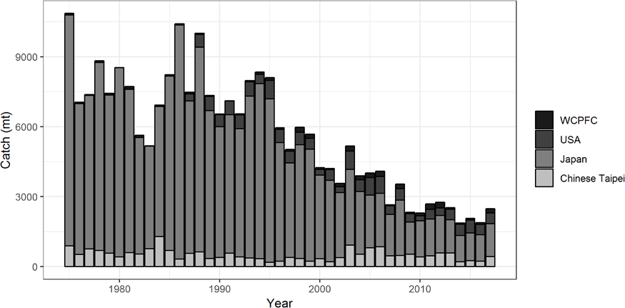

**Figure S1.** Annual catch biomass (mt) of Western and Central North Pacific striped marlin (*Kajikia audax*) by country for Japan, Chinese Taipei, the U.S.A., and all other countries during 1975-2017.

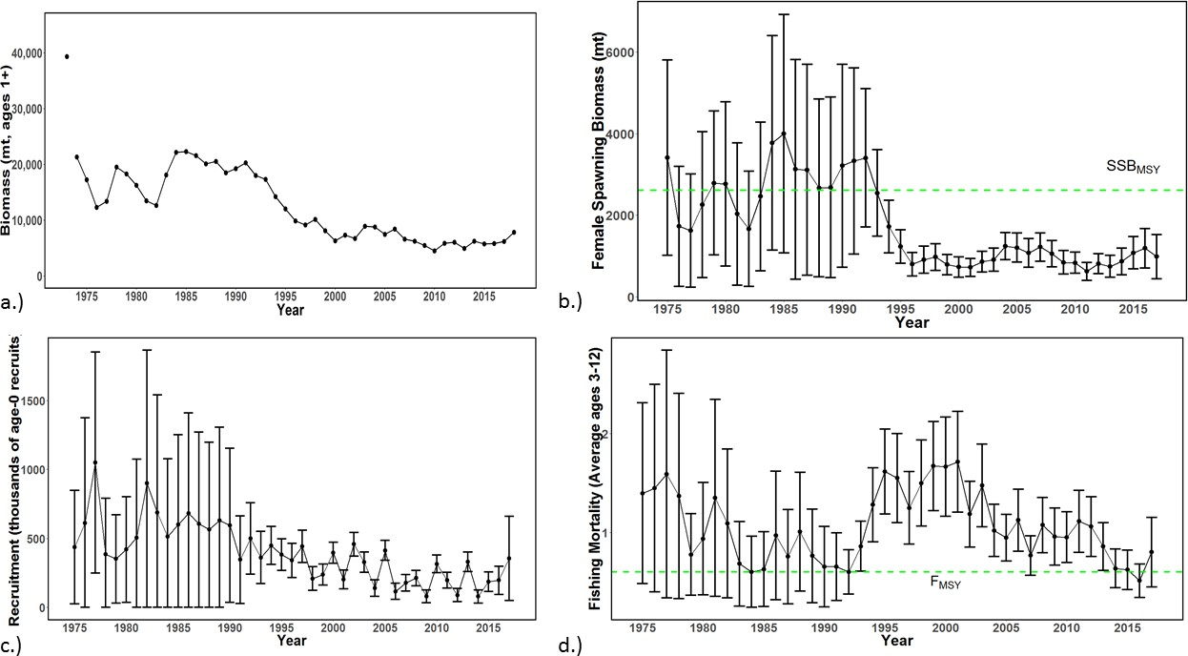

**Figure S2.** Time series of estimates of (a) population biomass (age 1+), (b) spawning biomass,

(c) recruitment (age-0 fish), and (d) instantaneous fishing mortality (average for age 3-12, year-1) for Western and Central North Pacific striped marlin (*Kajikia audax*) derived from the 2019 stock assessment. The circles represent the maximum likelihood estimates by year for each quantity and the error bars represent the uncertainty of the estimates (95% confidence intervals), green dashed lines indicate SSBMSY and FMSY.

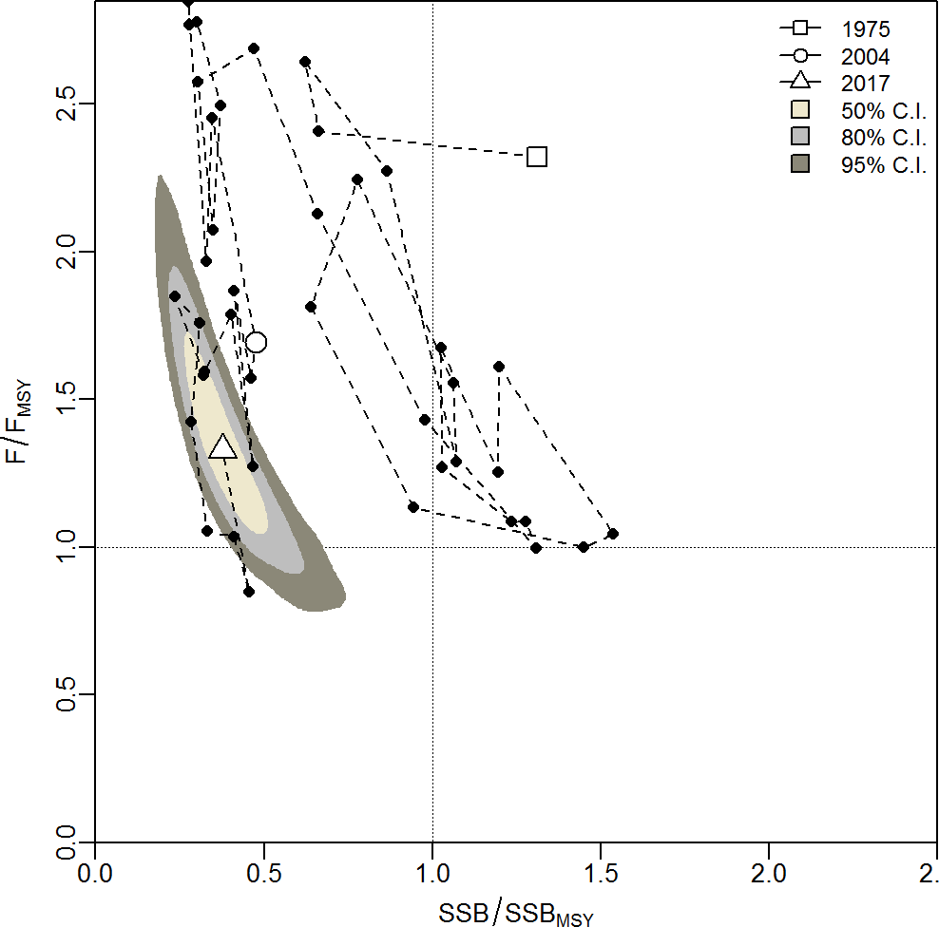

**Figure S3.** Kobe plot of the time series of estimates of relative fishing mortality (average of age 3-12) and relative spawning stock biomass of Western and Central North Pacific striped marlin (*Kajikia audax*) during 1975-2017. The white square denotes the first (1975) year of the assessment, the white circle denotes 2004, and the white triangle denotes the last (2017) year of the assessment.

a.)

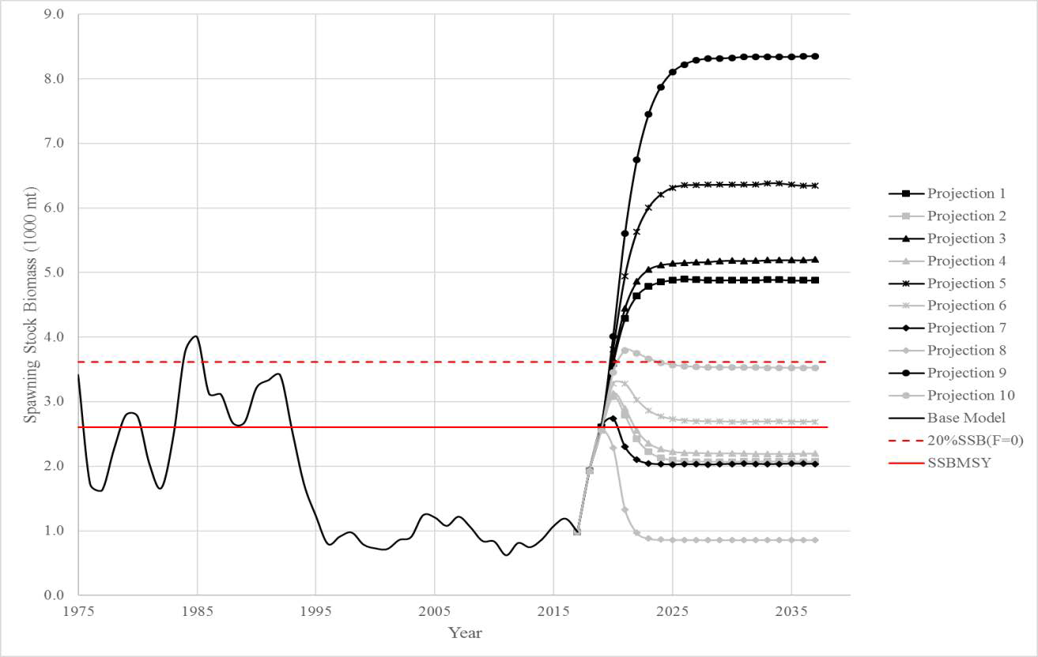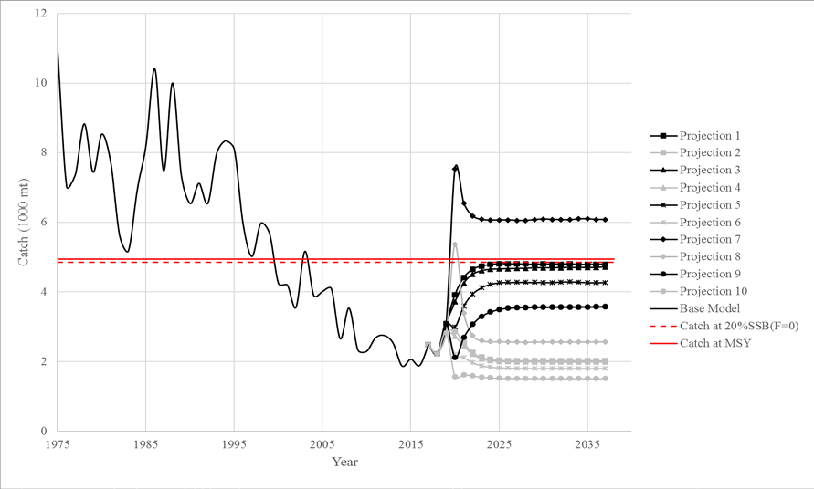

b.)

**Figure S4.** Historical and projected trajectories of spawning biomass and total catch from the Western and Central North Pacific striped marlin base case model based upon F and constant catch scenarios: (a) F scenarios projected spawning biomass; (b) F scenarios projected catch; (c) constant catch scenarios projected spawning biomass; and (d) constant catch scenarios projected catch. Black lines indicate the long-term recruitment scenarios; grey lines indicate the short-term recruitment scenarios. Red dashed line indicates the catch or spawning stock biomass at 20%SSBF=0. Red solid line indicates the catch or spawning stock biomass at SSBMSY. The list of projection scenarios can be found in Table S3.

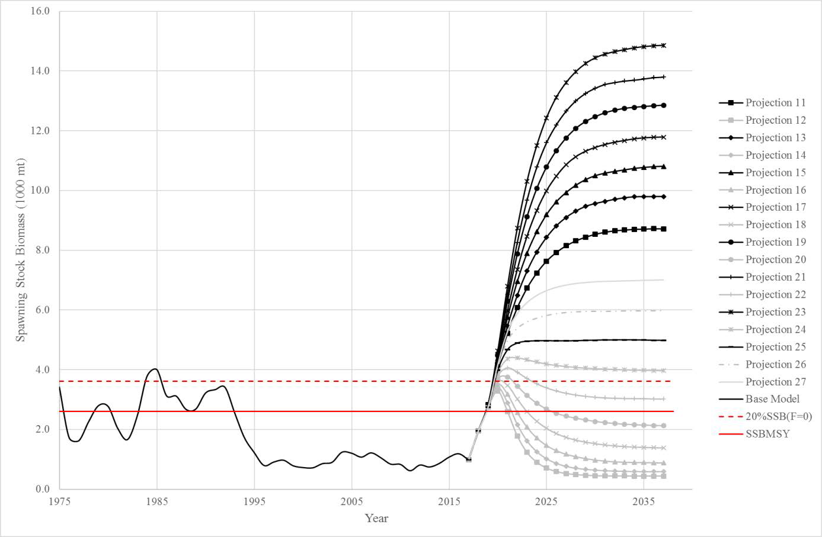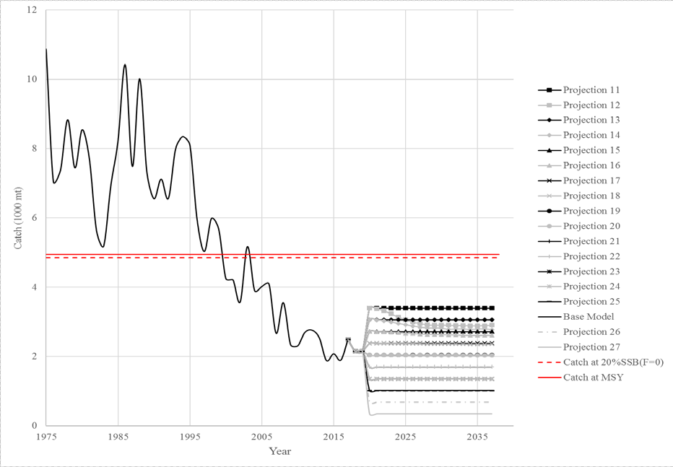

c.)

d.)

**Figure S4.** Continued.

# INTRODUCTION

The Billfish Working Group (BILLWG) of the International Scientific Committee for Tuna and Tuna-like Species in the North Pacific Ocean (ISC) completed a benchmark stock assessment for striped marlin (*Kajikia audax*) in the Western and Central Pacific Ocean (WCNPO) in 2011 (ISC, 2012) and updated the assessment in 2015 (ISC, 2015). The ISC BILLWG proposed to run a benchmark assessment on western and central North Pacific (WCNPO) striped marlin in 2019. The status of the WCNPO striped marlin stock was overfished and overfishing was occurring relative to MSY-based reference points in the 2015 updated assessment using a Stock Synthesis (SS) assessment model. The ISC BILLWG data preparatory meeting was held in January 2019 to evaluate new stock structure, life history, catch, length composition, and CPUE data and strategize for the assessment (ISC, 2019).

This report describes the 2019 stock assessment for the WCNPO striped marlin stock. The best available scientific information including the up-to-date catch, catch-per-unit-effort (CPUE), and composition data from 1975-2017 were provided by individual ISC countries, the Western and Central Pacific Fisheries Commission (WCPFC), and the Inter-American Tropical Tuna Commission (IATTC). The 2019 assessment was an integrated age-structured assessment model with a quarterly time step using the modeling platform Stock Synthesis (SS) version 3.30.08 (Methot and Wetzel 2013).

# MATERIALS AND METHODS

## Spatial and Temporal Stratification

The geographic area encompassed in the assessment for striped marlin was the Western and Central North Pacific Ocean bounded by the equator and the Western and Central Pacific Fisheries Commission management boundary at 150°W. The eastern stock boundary was changed from 140°W used in the 2015 assessment after review of the available information on striped marlin stock structure. Lacking conclusive evidence of a clearly defined stock boundary, the management unit with an eastern boundary of 150°W longitude was used as the definition of the stock for this assessment. Over 90% of the catch was accounted for using the 150°W boundary compared to the 140°W boundary. Three types of data were used: fishery-specific catches, relative abundance indices, and length measurements. The fishery data were compiled for 1975-2017, noting that the catch data and length composition data were compiled and modeled on a quarterly basis. Several CPUE indices were also modeled as a quarterly index from the Japanese longline fleet. Available data, sources of data, and temporal coverage of the datasets used in the updated stock assessment are summarized in Figure 1. Further details are presented below.

## Definition of Fisheries

A total of 23 fisheries that caught striped marlin were defined on the basis of country, gear type, location, and time period, where each fishery was assumed to target a distinct component of the stock. These fisheries included fourteen longline fisheries from Japan. Thirteen of these fleets are the results of the flexmix model applied to the Japanese offshore and distant-water longline data,

which divided the data into areas and quarters based upon mean weight and CPUE. Nine quarter- area combinations were identified and two of these, Japan quarter 1 area 1 and quarter 3 area 1 were divided into the early and late periods. An additional longline fleet (JPNLL_Others) accounted for any other striped marlin longline catches. Three additional fleets from Japan included the driftnet catches in two fleets divided by quarter: quarters one and four and quarters two and three (JPNDF_Q14 and JPNDF_Q23) and a fleet to encompass all other Japanese striped marlin catches (JPN_Others). There were also three fleets from Chinese Taipei: one for

their distant water longline fleet (TWN_DWLL), one for their small-scale tuna longline fleet (TWN_STLL) and one other fleet for any additional catches (TWN_Others). There were two fleets from the United States: a single fleet for the Hawaii-based longline fleet (US_LL) and one other fleet (US_Others) which included handline and troll catches. Finally, there was one fleet for the various flags contained in the WCPFC management region not otherwise accounted for (WCPFC_Others). Descriptions and data sources to characterize the twenty-three fisheries that catch WCNPO striped marlin are also summarized in Table 1.

## Catch

Catch was input into the model on a quarterly basis (i.e., by calendar year and quarter) from 1975 to 2017 for the 23 individual fisheries. Catch was reported in terms of catch biomass (mt) for all fisheries, with the exception of the Japanese offshore and distant water longline fleets (JPNLL F1-13) for which catch was reported as numbers of fish caught.

Three countries (i.e., Japan, Chinese Taipei, and the USA) provided national catch data (Hirotaka Ijima, NRIFSF, personal communication; Yi-Jay Chang, NTU, personal communication; Ito 2019). Striped marlin catches for all other fishing countries were collected from WCPFC category I and II data (Peter Williams, SPC, personal communication).

The resulting best available data on striped marlin catches by fishery from 1975-2017 were tabulated and are shown in Figure 2 and Table 2. The historical maximum and minimum annual striped marlin catches were 10,862 metric tons in 1976 and 1,879 metric tons in 2014, respectively. From 1975 to 1993, the Japanese driftnet fishery harvested approximately half of the total annual catch. However, it is possible that these catches have large uncertainty and sensitivity runs to evaluate how future adjustments to these reported catches were explored in this assessment. Overall, annual catches of WCNPO striped marlin have generally declined since 1975. The annual catch of striped marlin in the WCNPO averaged about 2,151 metric tons in the period since the last assessment (2015-2017).

## Abundance Indices

Relative abundance indices for WCNPO striped marlin based on standardized CPUE were prepared for this assessment and are shown in Figure 3 and Tables 3 and 4. A finite mixture model analysis was used to identify nine different area-quarter combinations based upon the weight and CPUE of striped marlin caught in the Japanese offshore and distant water longline fleets. Japanese CPUE data were standardized in two area-quarters (area one quarter one and area one quarter 3) as well as pre- and post-1993 when Japanese logbook reporting requirements were changed (Ijima and Kanaiwa, 2019a; Ijima and Kanaiwa, 2019b).

Operational fishing data collected in the Hawaiian longline fishery by fishery observers in 1995- 2017 were used for CPUE standardization of US longline fleets (Sculley, 2019). The fishery operates in two sectors; a shallow-set sector targeting swordfish and a deep-set sector targeting

tunas. Striped marlin is caught as bycatch in both sectors. These data were standardized into a single CPUE time series including factors that accounted for much of the variability between sectors.

Two CPUE standardizations were put forward from Taiwanese fisheries. The distant-water longline fleet was standardized from 1995-2017 (Chang *et al.,* 2019). A new index was presented by Chinese Taipei from the small-scale tuna fishery from 2008-2017 (Chang *et al.,* 2019).

Visual inspection of all indices showed an overall decreasing trend with the last 5-10 years showing a relatively flat trend. Both of the early Japanese LL indices are increasing through 1993 and the Chinese Taipei small-scale tuna index has a peak around 2012 (Figure 3).

Correlations among CPUE indices were analyzed in the 2019 assessment using the diags component of the FLCore package (Version 2.6.6, Kell *et al.* 2007) in R (version 3.4.0, R Core Team, 2018). These packages provide a standardized method to plot and summarize CPUE data so that modelers can better evaluate their input data into assessment models. Each CPUE index was fit using a Loess smoother with only year as an explanatory variable using the default phase and number of nodes in the R package gam (Hastie, 2018), and the residuals from that smoother were examined graphically. Patterns in correlations among CPUE indices for the assessment were generally positive. Based on the graphical inspection of relative CPUEs and the correlation analysis, the data supported the use of all the CPUE indices in the base case model. However, S1 (JPNLL Q1A1 Late), S5 (TWN STLL) and S6 (JPNLL Q1A1 Early) were ultimately excluded from the model likelihood due to conflicts in the indices identified when profiling the likelihood based upon R0.

## Size Composition Data

Quarterly fish length composition data from 1975–2016 for seventeen fisheries were available for the assessment; nine were ultimately used, and are summarized in Table 3. Length composition data for the Japanese fleets F3 and F7-F11 were not included because it accounted for <0.5% of the total catch in the fishery. Length composition data for fleet F1, F6, and F12 were not included in the likelihood because they had a conflicting trend in the profile of log(R0) compared to the other length composition data and CPUE indices or the data were determined to be too sparse to be informative.

Length frequency data were compiled using 5-cm length bins from 50 to 230 cm. The lower boundary of each bin was used to define each bin for all composition data, and each observation consisted of the actual number of striped marlin measured. The new composition data were agreed upon at the BILLWG data workshop as the best available scientific information for the 2019 stock assessment.

Figure 4 shows the quarterly length compositions. Most of the fisheries caught small (<150cm) individuals. The longline fleets caught fish with a mean of 150 cm EFL while the driftnet fleets caught slightly larger fish, mean 157 cm EFL. The US longline fleet (US_LL) caught smaller fish on average than any of the other fleets (mean size 136cm EFL).

The aggregate length composition distributions were relatively consistent between fleets, with the exception of the US Longline fleet (Figure 5). Most longline size distributions had a single mode around 150-160cm. The US longline fleet was bimodal with peaks around 110cm and 140cm EFL.

## Model Description

The assessment was conducted with Stock Synthesis (SS) version 3.30.08.03-SAFE released 09/29/2017 using Otter Research ADMB 11.6 (Methot and Wetzel 2013). The WCNPO model was set up as a single area model with a single sex and four seasons (quarters). Spawning was assumed to occur in quarter two while recruitment was assumed to occur in July (month 7). Age at recruitment was calculated based upon the model estimated average selectivity at age based upon the quarterly selectivity at length. The maximum age of striped marlin was set to 15 years. Age-specific natural mortality was used (Table 5) as agreed upon in the BILLWG data preparatory meeting (ISC, 2019). In addition, the CV of the growth curve was set to 0.3, and the sex ratio at birth was assumed to be 1:1. The model used a Beverton-Holt spawner-recruit relationship with steepness (h) fixed at 0.87 and sigmaR (σr) fixed at 0.6.

## Data Observation Models

The assessment model fit three data components: 1) total catch; 2) relative abundance indices; and 3) composition data. The observed total catches were assumed to be unbiased and relatively precise, and were fitted assuming a lognormal error distribution with standard error (SE) of 0.05. The relative abundance indices were assumed to have log-normally distributed errors with SE in log-space (log(SE)) which was log(SE)=sqrt(log(1+CV2)), where CV is the standard error of the observation divided by the mean value of the observation and sqrt is the square root function.

Annual CPUEs (S3-5) were assigned to quarter one. Japanese longline fleets (S1, S2, S6 and S7) were quarterly indices representing quarters one and three. Of these, fleets S1, S5, and S6 were excluded from the base-case model. These three CPUE indices were excluded from the base-case model because they were shown to be in conflict with the other input data based upon the R0 likelihood profile. The CPUE indices were assumed to be linearly proportional to biomass where catchability (*q*) was assumed to be constant and occur in the first month of the quarter assigned.

The CVs for each CPUE index were assumed to be equal to their respective calculated SEs on the log scale (Table 6). The minimum CV was scaled to a minimum of 0.2 and then reweighted based upon the Francis method using the root-mean-square error (RMSE, i.e., square root of the residual variance, Francis 2011).

The composition data were assumed to have multinomial error distributions with the error variances determined by the effective sample sizes. Measurements of fish are usually not random

samples from the entire population. Rather, they tend to be highly correlated within a set or trip (Pennington *et al*., 2002). The effective sample size is usually substantially lower than the actual number of fish measured because the variance within each set or trip is substantially lower than the variance within a population. The effective sample size for Japanese DWLL fleets were given effective sample sizes calculated by Japan. All other fleets had effective sample sizes equal to 1/10 of the total number of samples in each quarter, in alignment with previous assessments (ISC 2015). In addition, quarters with fewer than 15 total samples were removed from the time series due to limited sample size and the maximum number of samples was set to 50, as agreed upon by the modeling sub-group.

## Estimation of Fishery Selectivity

Selectivity was estimated as a double-normal curve for all fleets, except for F13 and F14, the Japan drift gillnet fisheries, and were assumed as asymptotic lognormal (Figure 6). All other fleets were mirrored to the fleet that was believed to have the most similar selectivity pattern (Table 7).

## Data Weighting

Index data were prioritized in this assessment based on the principles that relative abundance indices should be fitted well because abundance indices are a direct measure of population trends and scale, and that other data components such as composition data should not induce poor fits to the abundance indices (Francis, 2011).

It is common practice to re-weight some or all data sets in two stages (Francis, 2011). However, because the model was sensitive to reweighting of the length composition and CPUE data, input sample sizes were not iteratively re-weighted in stage 2.

## Model Diagnostics

Several diagnostics have been evaluated for their utility to identify data conflicts and model misspecification within integrated stock assessment models (Carvalho *et al.* 2017). However, Carvalho *et al.* (2017) determined that there was no single diagnostic that worked well in all of the cases they evaluated. Instead, they recommend the use of a carefully selected range of diagnostics that proved to increase the ability to detect model misspecification.

Key stock assessments diagnostics identified by Carvalho *et al*. (2017) were implemented to evaluate the base case model.

*Retrospective analysis*

Retrospective analysis is a way to detect bias and model misspecification (Hurtado-Ferro et al. 2014). A retrospective analysis was applied to the base-case model results. The diagnostic was implemented here by sequentially eliminating the five most recent years of data from the full stock assessment base case model (a 5 year “peel”) and then re-estimating all stock assessment model parameters from each peel and from the full model.

*R0 likelihood profile*

An R0 likelihood component profile (Lee *et al.* 2014) was applied to the base-case model results.

The diagnostic was implemented here by sequentially fixing the equilibrium recruitment parameter, R0, on the natural log scale, log(R0), to a range of values. The relative change in negative log-likelihood units over the range of fixed values for log(R0) (the R0 profile) was compared among the Stock Synthesis model likelihood components for CPUE, length- composition, and recruitment deviations using two diagnostic tests. First, a relatively large change in negative log-likelihood units along the R0 profile was diagnostic of a relatively informative data source for that particular model. Second, a difference in the location of the minimum negative log-likelihood along the R0 profile among data sources was diagnostic of either conflict in the data or model misspecification (or both).

*Age-structured production model*

An age-structured production model (ASPM; Maunder and Piner 2015; Carvalho *et al*. 2017) was applied to the base-case model results.

The diagnostic was implemented here by fixing selectivity to its estimated values in the fully integrated stock assessment model, fixing recruitment equal to the stock recruitment curve obtained from the fully integrated stock assessment model, and then estimating the remaining parameters of the stock assessment model. Trends in relative spawning stock size were compared from the fully integrated stock assessment model and the ASPM.

Carvalho *et al.* (2017) suggest that if the ASPM is able to fit well to the indices of abundance that have good contrast (i.e. those that have declining and/or increasing trends), then this is evidence of the existence of a production function, and the indices will likely provide information about absolute abundance. On the other hand, Carvalho *et al*. (2017) suggest that if there is not a good fit to the indices, then the catch data alone cannot explain the trajectories depicted in the indices of relative abundance. This can have several causes: (i) the stock is recruitment-driven; (ii) the stock has not yet declined to the point at which catch is a major factor influencing abundance; (iii) the base-case model is incorrect; or (iv) the indices of relative abundance are not proportional to abundance.

*Goodness-of-Fit Indices of Abundance*

Residuals are examined for patterns to evaluate whether the model assumptions have been met. Many statistics exist to evaluate the residuals for desirable properties. One way is to calculate, for each abundance index, the root-mean-square-error (RSME) was used as a goodness-of-fit diagnostic, with relatively low RMSE values (i.e., RMSE < 0.3) being indicative of a good fit.

*Goodness-of-Fit Size Composition Data*

Comparisons between the observed and expected mean values of composition data from Francis (2011) were used for model diagnostics. Pearson residuals for size composition data fits were also used as a model diagnostic.

## Stock Projections

Stock projections for WCNPO striped marlin were conducted using the age-structured projection model software AGEPRO (Brodziak et al. 1998). Stochastic projections were conducted using results from the base-case model to evaluate the probable impacts of alternative fishing intensities or constant catch quotas on future spawning stock biomass and yield for striped marlin in the Western and Central North Pacific Ocean. For fishing mortality projections, a standard set of F-based were conducted (c.f., ISC BILLWG 2018). For catch quota projections, the set of rebuilding projection analyses requested by the 14th Regular Session of the WCPFC Northern Committee was conducted (NC14 2018). Technical descriptions of the F-based and catch-based projection analyses are provided below (Table 8).

Initial conditions for the stochastic projections were based on the estimated initial population size at age in year 2018 from the base case model. A total of 100 bootstrap replicates of the 2018 striped marlin population size at age were calculated in SS3 to characterize the uncertainty in the initial population size. In each projection, 100 total simulations were run for each bootstrap replicate to characterize the effects of process errors in future recruitment, life history and fishery parameters. This gave 10,000 total simulated trajectories to evaluate the central tendency and variability of population and fishery quantities of interest, such as spawning biomass and catch, in each projection.

Recruitment for the stochastic projections was based on two hypotheses about future recruitment. The first hypothesis was that future recruitment would be similar to recent short-term recruitment. This hypothesis was based on the observation that recruitment estimates had remained relatively low in recent years and one may not expect this to change in the future. In particular, the short-term recruitment scenario was based on resampling the empirical cumulative distribution function of recruitment observed during 2012-2016 (AGEPRO, recruitment sub- model 14). Under the short-term recruitment scenario, the average recruitment was 134,020 age- 1 fish with a CV of 58%. The second hypothesis was that future recruitment would be similar to the long-term recruitment pattern. This hypothesis was based on the observation that the average of the bootstrap distribution of recruitment in 2018 (294,574 age-1 fish with a CV of 44%) was more than two-fold higher than the recent 5-year average, suggesting that achieving higher recruitment was a possibility. In particular, the long-term recruitment scenario was based on resampling the empirical cumulative distribution function of recruitment observed during 1975- 2017 (AGEPRO, recruitment sub-model 14). Under the long-term recruitment scenario, the average recruitment was 360,989 age-1 fish with a CV of 54%. Thus, the long-term recruitment scenario would be expected to produce over twice as many recruits as the short-term scenario on average although both scenarios had similar levels of observed recruitment variability.

Fishery selectivity for the stochastic projections was based on the estimated selectivities in the base case model. It was noted that all of the longline and other fleet-specific estimates of fishery selectivity as a function of age were dome-shaped in the base case model, with the exception of the Japanese drift gillnet fleet, which had a flat-topped selectivity at age. To characterize the fishery selectivity of both the dome-shaped and flat-topped selectivity fleets, an aggregate fishery selectivity was calculated as a weighted average of the two fleet types. In this case, the catch biomass percentages in 2017 by dome-shaped (95%) and flat-topped (5%) were used to weight the representative dome-shaped fleet (Japanese longline fleet in area 1 in quarter 3) and the representative flat-topped fleet (Japanese gillnet fleet in quarters 2 and 3) fishery selectivities to produce the fishery selectivity at age. Here it was noted that the differences in comparable projection results using the two representative fleets versus using the single fleet were negligible. As a result, projections were conducted using the single fishery aggregate fleet selectivity for parsimony and tractability, and also noting that projections with two fleets requires annual assumptions about the magnitude of the relative catch by each fleet going into the future. For stochastic projections, fishery selectivity at age were sampled with a multiplicative lognormal process error with a mean of unity and a CV of 10% to represent uncertainty about future selectivity.

Life history parameters for the projections were based on the exact same values as were used in the base case model. This included natural mortality at age, maturity at age, and mean spawning weights at age. Mean fishery catch weights at age were calculated as a weighted average of the catch weights at age for the representative dome-shaped (95%) and flat-topped (5%) selectivity fleets. For stochastic projections, life history parameters at age were sampled with a multiplicative lognormal process error with a mean of unity and a CV of 10% to represent uncertainty about future values, with the exception of maturity at age, which was sampled with a CV of 1%.

The stochastic projections employed model estimates of the multi-fleet, multi-season, size- and age-selectivity, and structural complexity in the assessment model to produce consistent results. Fishing mortality-based projections started in 2018 and continued through 2037 under 5 levels of fishing mortality and two recruitment scenarios (Table 8). The five fishing mortality stock projection scenarios were: (1) F status quo (average F during 2015-2017), (2) FMSY, (3) F at 0.2·SSB(F=0), (4) FHigh at the highest 3-year average during 1975-2016, and (5) FLow at F0.30%. For the F-based scenarios, fishing mortality in 2018-2019 was set to be F status quo (0.64) and fishing mortality during 2020-2037 was set to the projected level of F. Catch-based projections also ran from 2018 to 2037 and included 7 levels of constant catch for the long-term recruitment scenario and 10 levels of catch for the short-term recruitment scenario. For the catch-based scenarios, catch biomass in 2018-2019 was set to be the status quo catch during 2015-2017 (2150.6 mt) and annual catches during 2020-2037 were set to the projected catch quota. The ten constant catch stock projection scenarios were: (1) Quota based upon CMM10-01, (2) 90% of the quota, (3) 80% of the quota, (4) 70% of the quota, (5) 60% of the quota, (6) 50% of the

quota, (7) 40% of the quota, (8) 30% of the quota, (9) 20% of the quota, and (10) 10% of the quota. The alternative constant catch projections were requested by the WCPFC Northern Committee (NC) in order to provide information for the development of a rebuilding plan for WCNPO striped marlin (NC14, 2018). This request was to provide the probability of rebuilding

to 20%SSBF=0 within 20 years and continue reducing catches by 10% until the probability of achieving the rebuilding target of 3610.4 mt of spawning biomass was at least 60%.

# RESULTS

## Base Case Model

Results for the base case model provided estimates of biological reference points for WCNPO striped marlin and included trends in estimates of total stock biomass, spawning stock biomass, recruitment, and fishing mortality, along with a Kobe plot indicating stock status over time.

## Model Convergence

All estimated parameters in the base case model were within the set bounds, and the final gradient of the model was approximately 0.0001 and the hessian matrix for the parameter estimates was positive definite, which indicated that the model had converged to a local or global minimum. Results from 100 model runs with different random initial starting values for estimated parameters using the internal “jitter” routine in SS supported the result that a global minimum was obtained (i.e., there was no evidence of a lack of convergence to a global minimum, Figure 7).

## Model Diagnostics

Figure 8 presents the results of the likelihood profiling on the logarithm of the unfished recruitment parameter R0, i.e. log(R0), for each data component. Detailed information on changes in negative log-likelihoods among the various fishery data sources are shown in Tables 9 and 10 and Figure 9 and 10.

Changes in the likelihood of each data component indicated how informative that data component was to the overall estimated model fit. Ideally, relative abundance indices should be the primary sources of information on the population scale in a model (Francis, 2011).

There was a relatively large change in the R0 profile for estimated recruitment deviations (Recruitment) relative to the data likelihood components for survey (CPUE) and length composition data (Figure 8). This result indicated that the estimation of the recruitment deviations was relatively informative within the likelihood. The changes in negative log- likelihood of abundance indices was relatively flat and the local minimum value (5.7) was lower to that of total likelihood log(𝑅𝑅0) = 6.22. Index S7 (max 6.25) showed the largest changes in negative log-likelihood values across values of R0 among abundance indices, followed by S3 (max 0.75), S2 (max 0.37), and S4 (max 0.19; Table 9, Figure 9).

Similar to the abundance indices data, the changes in the negative log-likelihoods from the nine length composition data included were small, with a local minimum at 6.0 (Figure 8). The U.S. longline fleet (F16) showed the largest changes in negative log-likelihood values (max 2.69) across values of R0 among the nine size composition data (Table 10, Figure 10).

Another large component of the change in R0 was driven by the initial equilibrium catch. There were also differences in the location of the minimum negative log-likelihood along the R0 profile observed among data likelihood components for the base case model. The two-stage Francis approach seemed to have reduced the conflict, but did not eliminate it.

*Goodness-of-Fit Indices of Abundance*

Goodness-of-fit diagnostics were presented in Table 6, and plots of predicted and observed CPUE by fishery for the base case model were shown in Figure 11.

The fit to the CPUE indices were summarized into two groups: (1) those in which indices contributed to the total likelihood (S2, S3, S4, S7), and those in which indices did not contribute to the total likelihood (S1, S5, and S6). Results showed that the Japan early abundance index (S1) had RMSE < 0.3, which indicates that the model fit this CPUE index well. However, all the other indices included in the total likelihood had values for RMSE > 0.3.

*Residuals Analysis of Size Composition Data*

Comparisons between the observed and expected mean values of composition data from Francis (2011) were used for model diagnostics. Figure 12 shows the 95% credible intervals for mean value for the nine length composition data sets. The model fit passed through almost all of the credible intervals.

Fits to the annual length compositions by fleet could be improved (Figure 13), with few obvious systematic patterns observed in the residuals (e.g., patterns of positive or negative residuals) making it difficult to objectively determine how to improve the fits. This is an important area for future model development. For example, more flexible selectivity curves (or time blocks) in combination with alternative binning of length composition data could be examined in the future to account for the jagged distributions observed in seasonal length compositions. Alternatively, different area stratification of fleets could be explored in the future to either increase sample size or smooth the length-frequency distributions.

Assuming standardized residuals were normally distributed, 95% of the measurements would fall within 2 standard deviations of the mean. The majority of Pearson residuals did not meet this criteria (Figure 13), in particular F16 U.S. longline and F18 Chinese Taipei distant water longline showed stronger residual patterns when compared to the other fleets**.**

Overall, the model fit the length modes in composition data aggregated by fishery fairly well using the input effective sample sizes (Figure 14). However, F16 showed some misfit.

*Retrospective Analysis*

A retrospective analysis of the base case Western and Central North Pacific striped marlin stock assessment model was conducted for the last 5 years of the assessment time horizon to evaluate whether there were any strong changes in parameter estimates through time. This retrospective analysis was conducted during the May 2019 BILLWG workshop. The results of the

retrospective analysis are shown in Figure 15. The trajectories of estimated spawning stock biomass and the index of fishing intensity (i.e., one minus the spawning potential ratio, or 1- SPR) showed there was a tendency for the base case model to underestimate spawning biomass in recent years and overestimate fishing intensity.

*Age-structured production model*

ASPM results are provided in Figure 16. The models showed different trends in SSB during the first 20 years of modeled timeframe. However, after 1995 the ASPM showed a similar stabilized trend than the fully integrated stock assessment model. After 2013, the ASPM showed a steep increase in SSB, while the fully integrated stock assessment model continued to show stabilization. The asymptotic 95% confidence interval from the fully integrated stock assessment did not overlap with the SSB trend from the ASPM for most of the modeled years.

## Stock Assessment Results

Estimates of population biomass (estimated biomass of age 1 and older fish at the beginning of the year) declined from a high of 22,303 mt in 1985 to 4,509 mt in 2010, and increased to around 5,904 metric tons during the final three years of the 2019 stock assessment time horizon (2015−2017, Table 11 and Figure 17). Overall, population biomass declined from an average of roughly 22 thousand metric tons in the mid-1980s to an average of roughly 5 thousand metric tons in the 2010s (Figure 17).

Spawning stock biomass (SSB) estimates exhibited an initial oscillation around 2 thousand metric tons in the late 1970s. SSB reached its highest level of 3,999 metric tons in 1985, and declined to 794 metric tons in 1996 (Table 11 and Figure 18). The time-series of SSB during the past decade averaged 5,710 metric tons, or 31% of unfished SSB. Overall, SSB exhibited a strong decline during the early 1990s and has stabilized since. However, SSB showed signs of increase in recent years going from 743 metric tons in 2013 to 981 metric tons in 2017.

Recruitment (age-0 fish) estimates indicated a long-term fluctuation around a mean of approximately 764,000 (Table 11 and Figures 19). The model estimated a strong year class (> 1000 thousand recruits) recruited to the fisheries in 1977 and weak year classes in 2009 and 2014. While the overall pattern of recruitment from 1975-2017 was variable, there was an apparent declining trend in recruitment strength over time (Table 11 and Figure 19).

Over the course of the assessment time horizon, estimated fishing mortality (arithmetic average of F for ages 3 – 12) decreased from 1.4 year-1 in 1975s to 0.6 year-1 in 1992, increased to 1.71 year-1 in 2001, and afterward declined to an all-time low of 0.51 year-1 in 2016 (Table 11 and Figure 20).

## Biological Reference Points

Biological reference points were computed from the Stock Synthesis base case model. Since most life history parameters for Western and Central North Pacific striped marlin, including steepness, were considered reasonably well defined, MSY-based biological reference points were

used to assess relative stock status (Table 12). The point estimate of maximum sustainable yield was MSY = 4,946 metric tons. The point estimate of the spawning stock biomass to produce MSY was SSBMSY = 2,604 metric tons. The point estimate of FMSY, the fishing mortality rate to produce MSY on ages 3-12 fish was FMSY = 0.6 and the corresponding equilibrium value of spawning potential ratio at MSY was SPRMSY = 18%.

## Stock Status

Compared to MSY-based reference points, the current spawning biomass (average of 2015-2017) was 62% below SSBMSY and the current fishing mortality (average for ages 3-12 in 2015-2017) was 7% above FMSY. The Kobe plot indicates that the Western and Central North Pacific striped marlin stock is currently overfished and is subject to overfishing relative to MSY-based

reference points (Figure 14).

## Sensitivity Analyses

In the May 2019 BILLWG workshop, it was agreed that at least five life history parameters would be evaluated in sensitivity analyses in the 2019 assessment (Table 13) in order to examine the effects of plausible alternative model assumptions and data input. These analyses were:

* + 1. **Sensitivity analysis on growth**: The WG agreed to conduct two sensitivity analyses for growth. These were an alternative growth curve with LAmax set to the mean from Fitchett (2019, 184 cm EFL) and an alternative growth curve with a 10% larger maximum size (225 cm EFL).
    2. **Sensitivity analysis on natural mortality**: The WG agreed to conduct two sensitivity analyses for natural mortality at age. These were a low natural mortality scenario where M at age was 10% lower than the base case for each age group and a high natural mortality scenario where M at age was 10% higher than the base case for each age.
    3. **Sensitivity analysis on recruitment variability**: The WG agreed to run a sensitivity run on recruitment variability by assuming a larger σR (0.9).
    4. **Sensitivity analysis on steepness**: The WG agreed to run three additional sensitivity runs on steepness. Steepness was fixed at h=0.95, h=0.79, and h=0.70.
    5. **Sensitivity analysis on maturity**: The group agreed to run three sensitivity analyses for the maturity ogive. These were an alternative maturity ogives with L50 = 171 cm, Alternative maturity ogives with L50=177 cm (used in the 2015 assessment), and an alternative maturity ogives with converted L50 = 181cm from Chang et al. (2019).
    6. **Sensitivity analysis on initial equilibrium catch**: The group agreed to run four sensitivity analyses for the initial equilibrium catch. These were assuming alternative values for the initial equilibrium catch; the values were 1000 mt, 25000 mt, 75000 mt, and 10000 mt.
    7. **Sensitivity analysis on uncertainty in the Japanese drift gillnet catch**: The group agreed to run four sensitivity analyses on uncertainty in the Japanese drift gillnet catch. These were assuming that the catches for these fisheries were 90%, 50%, 30%, and 10% lower than the catches used in the base case model. In addition, a fifth sensitivity analysis were conducted assuming a CV of 10% around the Japanese drift gillnet catch, which is higher than the 5% assumed in the base case.
    8. **Sensitivity analysis on assessment model time frame**: The group agreed to run a sensitivity analyses on the stock assessment time frame. This was assuming the same parametrization of the base case model, however excluding all the data prior 1994. This particular sensitivity analysis was conducted to explore the impact of removing historical data on the stock assessment results.

During the May 2019 BILLWG workshop, all 22 sensitivity analyses were completed and the results were presented and reviewed.

For each sensitivity run, comparisons of spawning stock biomass and fishing intensity (1-SPR) trajectories were completed (Figure 22). Additionally, the WG produced a Kobe plot, that showed the patterns of the base case and terminal year estimates for the key sensitivity runs (Figure 23).

For one of the 22 sensitivity runs, the stock status was estimated to be in the yellow section of the Kobe plot indicating that the stock was overfished but not experiencing overfishing (Figure 23). This was Run 7 (steepness = 0.95). For Run 2 (LAmax set to 184 cm EFL), the stock was estimated to be in the green section of the Kobe plot, indicating stock was not overfished and not experiencing overfishing (Figure 23).

Overall, the results of the sensitivity analyses confirmed the robustness of the base case model, and it was concluded that other sensitivity runs were not necessary for this stock assessment.

## Stock Projections

Projection results showed the average spawning stock biomass the average catch, and the probability of achieving the spawning stock biomass target in 2018-2022, 2027, and 2037 for each of the twenty-seven scenarios (Table 14 and Figures 24 and 25). For the constant F scenarios, the recruitment scenario substantially influenced the probability of rebuilding the stock to 20%SSBF=0. Under the long-term recruitment scenario, which had a higher mean recruitment of 307 thousand age-1 fish, it was predicted that all of the constant F projections (scenarios 1, 3, 5, and 9) would recover the stock by 2021 with the exception of the high F scenario 7. Under the short-term recruitment scenario, none of the constant F projections were expected to rebuild the stock with 60% probability although the low F scenario 10 would be expected to achieve the rebuilding target with a 54% probability in 2021. Thus, for the constant F scenarios, the projections indicated that stock rebuilding was unlikely to occur unless recruitment increased from recent low levels.

All of the projections show an increasing trend in spawning stock biomass during 2018-2020, with the exception of the high F scenario 8 under short-term recruitment. This increasing trend in SSB is due to the 2018 recruitment which averaged about 295 thousand age-1 fish, or more than twice as large as the average recruitment under the short-term recruitment scenario (134 thousand age-1 fish). Thus, the initial population size for the projections includes a large year class that improves the chances for rebuilding in the early years of the projection time horizon.

For the constant catch projection scenarios, it was notable that all of the projections under the long-recruitment scenario (scenarios 11, 13, 15, 17, 19, 21, and 23) would be expected to achieve the spawning biomass target by 2020 with probabilities ranging from 61% to 73% and catch quotas ranging from 1359 to 3397 mt. In contrast, under the short-term recruitment scenario, the projection scenarios that rebuilt the stock with at least 60% probability (scenarios 24, 25, 26, and 27) required substantial catch reductions to achieve the target. The smallest quota reduction that would be expected to rebuild the stock was scenario 24 with a 60% reduction in the CM2011-11 quota to 1359 mt with a rebuilding probability of 65% in 2021. This corresponds to a reduction of roughly 37% from the recent average yield of 2151 mt. Quota reductions of 70% to 90% from the CM2011-11 level (scenarios 25, 26, and 27) would produce higher rebuilding probabilities ranging from 72% to 85%. Overall, the catch-based projections show that reducing total catch biomass by 60% from the CM2011-11 levels would be required to rebuild the stock if future recruitment follows the short-term recruitment scenario.

## Assessment Challenges

The WG identified several challenges in developing the base-case stock assessment model that contributed to uncertainty in the assessment results. The six major sources of uncertainty were detailed by the WG and should be carefully evaluated in the future.

*Stock structure*

The WG noted that there is considerable uncertainty in the stock structure for Pacific striped marlin. Several genetic studies suggest there are at least three genetically distinct populations, one including Japan, Hawaii, and California, one including Equator and Peru, and one including Australia and New Zealand (Graves and McDowell 1994, Sipple *et al.* 2007, McDowell and Graves 2008, Purcell and Edmands 2011, Sipple *et al.* 2011). Evidence from Purcell and Edmands (2011) and more recently Mamoozadeh et al. (2018) also suggested a fourth genetically distinct group, which separates adults in Hawaii into a distinct group indicating that adults caught around Hawaii may not be from the same genetic stock as juveniles caught around Hawaii. Lam *et al.* (WP1 from this meeting) also indicated there is mixing between the NP, Eastern Pacific, and SW Pacific Ocean based upon conventional, PSAT, and data archival storage tagging. There also appears to be differences in life history parameters between striped marlin in the eastern and western Pacific Ocean (see below, Chang *et al.,* 2018; Humphreys and Brodziak, 2019). In addition, previous analyses of patterns of longline CPUE data suggested alternative eastern stock boundaries (ISC 2019). The flexmix analysis provided by Japan also suggested seasonal spatio-temporal patterns of fisheries CPUE and catch size composition (Ijima and Kanaiwa, 2019b). Overall, noting that there was ambiguity in the evidence to support the eastern stock boundary at 140ºW, the WG elected to assess the WCNPO striped marlin stock

management unit based upon the boundaries of the convention area of the RFMO in this stock assessment; however, the WG noted that tag-recovery data indicated that there was some mixing of striped marlin stock between the WCPFC and IATTC convention areas. Population dynamics may be more complex than can be modeled in this stock assessment (e.g., a meta-population model could be considered in the future).

*Driftnet catch*

The WG noted that the Japanese driftnet catch before the moratorium on gillnets in the high seas (i.e., before 1993) might be smaller than reported for this assessment. The catch provided by Japan in January was used in this assessment since alternative catch data were not available for the group to consider. Additional time will be required to update and correct the driftnet catch data. The driftnet fishery comprises the majority of the catch until 1993, and the WG expressed concern about how this uncertainty would influence the stock assessment results. The WG ran a series of sensitivity analyses to evaluate the consequences of any potential changes in driftnet catch. The results show that the spawning biomass and fishing mortality trends are consistent with the base-case model for all of the alternative driftnet catch time-series from 1994 to 2017 and overall stock status is the same (Figure 22g). The different levels of driftnet catch changed the estimate of virgin biomass and the trend of spawning stock biomass and fishing mortality at the beginning of the assessment (1975-1993).

*Life History Parameters*

The WG noted that there were substantially different estimates for length at 50% maturity (L50) for individuals caught by the Chinese Taipei (L50 =181 cm EFL, Chang *et al.,* 2018) and US longline fleets (L50=161 cm EFL, Humphreys and Brodziak, 2019). The WG agreed that it should use peer-reviewed results from Chang *et al.* (2018). However, model convergence was not achieved when L50=181 cm EFL was used in the assessment model. Therefore, the WG elected to use the lower value of the 50% maturity at length (L50=161 cm EFL). The WG noted that the value of L50/Linf is 0.85 for L50=181 cm EFL and is 0.75 for L50 =161 cm EFL. These values are relatively higher than other Pacific billfish species (about 0.6). Furthermore, Fitchett (2019) presented in the striped marlin data preparatory meeting provided some additional estimates of Linf between 170 and 190 cm EFL based upon tagging data around Hawaii, which would be biologically inconsistent with an L50 of 181 cm EFL. The WG noted that changing the length at Amax changed the trajectories of spawning biomass and fishing mortality, but changing the L50 has less of an impact (Figure 22a, e). However, the models with different L50 parameters did not always converge with a positive definite Hessian. Additional work would be necessary to obtain a converged model and evaluate the impact of the different life history parameters.

*Initial equilibrium catch*

Initial conditions for this assessment are another major source of uncertainty. Initial equilibrium catch was fixed in the base-case model in order to estimate initial F. The WG pointed out that there was striped marlin landings before 1975, but these are highly uncertain (due to double counting between oceans, etc.). Historical catches range from 4,000 to 18,000 mt. The WG agreed to use 5,000 mt in the base case to be consistent with the previous assessment. It was

noted that while the WG was able to estimate initial equilibrium catch in model runs starting in 1994, the 2015 stock assessment also fit to the initial equilibrium catch. The WG agreed that there was not sufficient evidence to change the initial equilibrium catch from the 2015 level.

Sensitivity analyses fitted to different levels of initial equilibrium catch showed slightly different levels of estimated fishing intensity and female SSB compared to the base-case model (Figure 22f).

*R0 Profile*

The WG discussed the information provided to estimate the equilibrium recruitment parameter, R0, on the natural log scale, log(R0), in this stock assessment. The WG observed that there was a much larger change in the R0 profile for estimated recruitment deviations (recruitment, Figure 8) relative to the likelihood components for CPUE and length composition. The WG also noted that a large portion of the change in R0 was determined by the initial equilibrium catch. Differences in the location of the minimum value along the R0 profile were observed among likelihood components for estimated recruitment deviations and the likelihood components for CPUE and length composition. A two-stage Francis approach was applied aiming to reduce this conflict.

After one iteration of CPUE reweighting, the conflict between individual CPUE time-series was reduced, but the conflict between CPUE and length composition data increased. The information provided by the initial equilibrium catch and the recruitment deviation remained dominant. The WG elected not to reweight the CPUE indices in order to reduce the conflict between the CPUE and length composition data, noting that reweighting the CPUE indices did not change the overall assessment results or the estimated value of R0. It is important to note that it is desirable that the information provided to estimate R0 come from data sources such as the CPUE indices and length composition.

*ASPM diagnostic*

Overall, the ASPM for the base case model does not follows the trend from the fully integrated stock assessment during the early part of the time series (1975-1995), and during the most recent years (2014-2017). However, for the period around 1995-2014, it seems that the changes in the abundance indices can be explained by the catches alone. These results indicate that during about 50% of the modeled time frame the abundance information, both absolute and relative, contained in the CPUE indices cannot be interpreted without accounting for the fluctuations in recruitment.

## Special Comments

WG achieved a base-case model using best available data and biological information. However, the WG recognized that there is considerable uncertainty in input catch data including drift gillnet and initial catch amounts, life history parameters including maturation and growth, and stock structure. The WG considered an extensive suite of model formulations and associated diagnostics for developing the base-case assessment model. Overall, we found issues with the base case model diagnostics and sensitivity runs that indicated some data conflicts exist (see sections Assessment Challenges and Sensitivity Analyses). To improve the stock assessment, the WG also recommends continuing model development work, to reduce data conflicts and modeling uncertainties , and reevaluating and improving input assessment data. When

developing a CMM to rebuild the resource, the WG recommends that these issues be recognized and carefully considered.

## Conservation Advice

The WCNPO striped marlin stock has produced annual yields of around 2,173 mt per year since 2012, or about 40% of the MSY catch amount; however the majority of the catch are immature fish. Striped marlin stock status shows evidence of substantial depletion of spawning potential (SSBCurrent is 62% below SSBMSY), however fishing mortality has fluctuated around FMSY in the last 4 years. It was also noted that retrospective analyses show that the assessment model appears to underestimate spawning potential in recent years.

# ACKNOWLEDGMENTS

We thank the fishery stakeholders, data providers, and participants in the ISC Billfish Working Group meetings for their help in preparing and providing information for this assessment of Western and Central North Pacific striped marlin.

# REFERENCES

Brodziak, J. and Mangel, M. (2011). Probable values of stock-recruitment steepness for north Pacific striped marlin. ISC/11/BILLWG-2/11. Available at: <http://isc.fra.go.jp/pdf/BILL/ISC11_BILL_2/ISC11BILLWG2_WP11.pdf>

Brodziak, J., Mangel, M., and Sun, C.-L. (2015). Stock-recruitment resilience of North Pacific striped marlin based on reproductive ecology. Fisheries Research, 166:140-150. Available at: <http://dx.doi.org/10.1016/j.fishres.2014.08.008>

Brodziak, J., Rago, P. and Conser. R. (1998). A general approach for making short-term stochastic projections from an age-structured fisheries assessment model. In F. Funk, T. Quinn II, J. Heifetz, J. Ianelli, J. Powers, J. Schweigert, P. Sullivan, and C.-I. Zhang (eds), Proceedings of the International Symposium on Fishery Stock Assessment Models for the 21st Century.

Alaska Sea Grant College Program, Univ. of Alaska, Fairbanks. Available at: [https://www.researchgate.net/publication/267682539_A_General_Approach_for_Making_Short-](https://www.researchgate.net/publication/267682539_A_General_Approach_for_Making_Short-Term_Stochastic_Projections_from_an_Age-Structured_Fisheries_Assessment_Model) [Term_Stochastic_Projections_from_an_Age-Structured_Fisheries_Assessment_Model](https://www.researchgate.net/publication/267682539_A_General_Approach_for_Making_Short-Term_Stochastic_Projections_from_an_Age-Structured_Fisheries_Assessment_Model)

Carvalho, F., Punt, A. E., Chang, Y.-J., Maunder, M. N., and Piner, K. R. (2017). Can diagnostic tests help identify model misspecification in integrated stock assessments? Fisheries Research, 192: 28-40.

Chang, Y., Yeh, S., Hsu, J., and Sun, C. (2019). Catch rate standardization of striped marlin in the Western and Central North Pacific Ocean by the Taiwanese tuna longline fisheries during 1989-2017. ISC/19/BILLWG-1/8.

Chang, H.-Y., Sun, C.-L., Yeh, S.-Z., Chang, Y.-J., Su, N.-J., and DiNardo, G. (2018).

Reproductive biology of female striped marlin *Kajikia audax* in the western Pacific Ocean. Journal of Fish Biology, 92:105–130.

Francis, R.I.C.C. (2011). Data weighting in statistical fisheries stock assessment models. Canadian Journal of Fisheries and Aquatic Sciences, 68:1124-1138.

Graves, J.E., and McDowell, J.R. (1994). Genetic analysis of striped marlin (*Tetrapturus audax*) population structure in the Pacific Ocean. Canadian Journal of Fisheries and Aquatic Sciences, 51:1762-1968.

Hastie, T. (2018) gam: Generalized Additive Models, Version 1.15. Available at: [https://CRAN.R-project.org/package=gam](https://cran.r-project.org/package%3Dgam)

Humphreys, R. and Brodziak, J. (2019). Reproductive maturity of striped marlin, (*Kajikia audax*), in the central North Pacific off Hawaii. ISC/19/BILLWG-2/2.

Hurtado-Ferro, F., Szuwalski, C. S., Valero, J. L., Anderson, S. C., Cunningham, C. J., Johnson,

K. F., Licandeo, R., McGilliard, C.R., Monnahan, C.C., Muradian, M.L., Ono, K., Vert-Pre,

K.A. Whitten, A.R., and Punt, A.E. (2015). Looking in the rear-view mirror: bias and retrospective patterns in integrated, age-structured stock assessment models. ICES Journal of Marine Science, 72: 99-110.

Ijima, H., and Kanaiwa, M. (2019a). Japanese longline CPUE of striped marlin (*Kajika audax*) in the WCNPO. ISC/19/BILLWG-1/7.

Ijima, H., and Kanaiwa, M. (2019b). Size-dependent distribution of Pacific striped marlin (*Kajikia audax*): The analysis of Japanese longline fishery data using the finite mixture model. ISC/19/BILLWG-1/9.

International Scientific Committee for Tuna and Tuna-Like Species in the North Pacific [ISC]. (2012). Stock assessment of striped marlin in the Western and Central North Pacific Ocean in 2011, Report of the Billfish Working Group Stock Assessment Workshop. July, Sapporo, Japan. ISC/SAR/MLS/2012. Available at: [http://isc.ac.affrc.go.jp/pdf/Stock_assessment/ISC-](http://isc.ac.affrc.go.jp/pdf/Stock_assessment/ISC-BILLWG%202011%20Stock%20Assess%20ment%20of%20Striped%20Marlin.pdf) [BILLWG%202011%20Stock%20Assess ment%20of%20Striped%20Marlin.pdf](http://isc.ac.affrc.go.jp/pdf/Stock_assessment/ISC-BILLWG%202011%20Stock%20Assess%20ment%20of%20Striped%20Marlin.pdf)

International Scientific Committee for Tuna and Tuna-Like Species in the North Pacific [ISC Billfish WG]. (2015). Annex 11: Report of the Billfish Working Group Workshop, Stock assessment update for striped marlin (*Kajikia audax*) in the Western and Central North Pacific Ocean through 2013, 15-20 July 2015. Kona, HI, USA. ISC/15/Annex11. Available at: <http://isc.fra.go.jp/pdf/ISC15/Annex11_WCNPO_STM_ASSESSMENT_REPORT_2015.pdf>

International Scientific Committee for Tuna and Tuna-Like Species in the North Pacific [ISC Billfish WG]. (2018). Annex 16: Stock assessment for swordfish (*Xiphias gladius*) in the Western and Central North Pacific Ocean through 2016, 11-16 July 2018. Yeosu, Korea.

ISC/18/Annex16. Available at: [http://isc.fra.go.jp/pdf/ISC18/ISC_18_ANNEX_16_Stock_Assessment_of_WCNPO_Swordfish_](http://isc.fra.go.jp/pdf/ISC18/ISC_18_ANNEX_16_Stock_Assessment_of_WCNPO_Swordfish_through_2016_FINAL.pdf) [through_2016_FINAL.pdf](http://isc.fra.go.jp/pdf/ISC18/ISC_18_ANNEX_16_Stock_Assessment_of_WCNPO_Swordfish_through_2016_FINAL.pdf)

International Scientific Committee for Tuna and Tuna-Like Species in the North Pacific [ISC Billfish WG]. (2019). Report of the Billfish Working Group Workshop, 14-21 January 2019. Honolulu, HI, USA. ISC/19/BILLWG-01/REPORT.

Ito, R. (2019). U.S. commercial fisheries for marlins in the North Pacific Ocean. ISC/19/BILLWG-1/01.

Kell, L. T., Mosqueira, I., Grosjean, P., Fromentin, J-M., Garcia, D., Hillary, R., Jardim, E., Mardle, S., Pastoors, M.A., Poos, J.J., Scott, F., and Scott, R.D. (2007). FLR: an open-source framework for the evaluation and development of management strategies. ICES Journal of Marine Science, 64 (4): 640-646. Doi: [10.1093/icesjms/fsm012](https://doi.org/10.1093/icesjms/fsm012)

Lee, H.-H., Piner, K. R., Methot Jr., R. D., and Maunder, M. N. (2014). Use of likelihood profiling over a global scaling parameter to structure the population dynamics model: An example using blue marlin in the Pacific Ocean. Fisheries Research 158: 138-146.

Mamoozadeh, N., McDowell, J., and Graves, J. 2018. Genetic population structure of striped marlin (*Kajikia audax*) in the Indian Ocean, with relationship to Pacific Ocean populations. Indian Ocean Tuna Commission, 16th Working Party on Billfish, IOTC-2018-WPB16-20, 23 p.

McDowell, J.R., and Graves, J.E. (2008). Population structure of striped marlin (*Kajikia audax*) in the Pacific Ocean based on analysis of microsatellite and mitochondrial DNA. Canadian Journal of Fisheries and Aquatic Sciences, 65:1307–1320.

Maunder, M. N., and Piner, K. R. (2015). Contemporary fisheries stock assessment: many issues still remain. ICES Journal of Marine Science, 72: 7-18.

Methot, R.D. and Wetzel, C.R. (2013). Stock Synthesis: a biological and statistical framework for fish stock assessment and fishery management. Fisheries Research, 142, 86–99.

Northern Committee Fourteenth Regular Session [NC14]. (2018). NC14 Summary Report, revision 1. Western and Central Pacific Fisheries Commission, Northern Committee Fourteenth Regular Session, Fukuoka, Japan 4 – 7 September 2018. Available at: <https://www.wcpfc.int/meeting-folders/northern-committee> .

Pennington, M., Burmeister, L. M., and Hjellvik, V. (2002). Assessing the precision of frequency distributions estimated from trawl-survey samples. Fishery Bulletin, US, 100: 74–81.

Piner, K.R. and Lee, H.H. 2011. Correction to meta-analysis of striped marlin natural mortality. ISC/11/BILLWG-2/08. Available at: <http://isc.ac.affrc.go.jp/pdf/BILL/ISC11_BILL_2/ISC11BILLWG2_WP08.pdf>

Purcell, C.M., and Edmands, S. (2011). Resolving the genetic structure of striped marlin, *Kajikia audax*, in the Pacific Ocean through spatial and temporal sampling of adult and immature fish.

Canadian Journal of Fisheries and Aquatic Sciences, 68:1861–1875.

R Core Team (2018). R: A language and environment for statistical computing. R Foundation for Statistical Computing, Vienna, Austria. URL [https://www.R-project.org/](https://www.r-project.org/).

Sculley, M. (2019). Standardization of the striped marlin *Kajikia audax c*atch per unit effort data caught by the Hawaii-based longline fishery from 1994-2017 using generalized linear models.

### ISC/19/BILLWG-01/06.

Sippel, T.J., Davie, P.S., Holdsworth, J.C., and Block, B.A. (2007). Striped marlin (*Tetrapturus audax*) movements and habitat utilization during a summer and autumn in the Southwest Pacific Ocean. Fisheries Oceanography, 16:459–472.

Sippel, T., Holdsworth, J., Dennis, T., and Montgomery, J. (2011). Investigating behavior and population dynamics of striped marlin (*Kajikia audax*) from the southwest Pacific Ocean with satellite tags. PLoS One 6, e21087.

Sun, C.L., Hsu, W.S., Chang, Y.J., Yeh, S.Z., Chiang, W.C., and Su, N.J. (2011a). Age and growth of striped marlin (*Kajikia audax*) in waters off Taiwan: A revision. Working paper submitted to the ISC Billfish Working Group Meeting, 24 May-1 June 2011, Taipei, Taiwan. ISC/11/BILLWG-2/07: 12p. Available at: <http://isc.ac.affrc.go.jp/pdf/BILL/ISC11_BILL_2/ISC11BILLWG2_WP07.pdf>

Sun, C.L., Hsu, W.S., Chang, Y.J., Yeh, S.Z., Chiang, W.C., and Su, N.J. (2011b). Reproductive biology of male striped marlin, Kajikia audax, in the waters off Taiwan. Working paper submitted to the ISC Billfish Working Group Meeting, 24 May-1 June 2011, Taipei, Taiwan.

### ISC/11/BILLWG-2/09.

# TABLES

Table 1. Descriptions of fisheries catch and abundance indices included in the base case model for the stock assessment including fishing countries, time-period, and reference sources for CPUE standardizations.

|  |  |  |  |  |
| --- | --- | --- | --- | --- |
| **Catch Index** | **Abundance Index** | **Fleet Name** | **Time Period** | **Source** |
| F1 | S1 | JPNLL_Q1A1_Late | 1994-2017 | Ijima and Kanaiwa (2019) |
| F2 | - | JPNLL_Q1A2 | 1975-2017 |  |
| F3 | - | JPNLL_Q1A3 | 1975-2017 |  |
| F4 | - | JPNLL_Q2A1 | 1975-2017 |  |
| F5 | S2 | JPNLL_Q3A1_Late | 1994-2017 | Ijima and Kanaiwa (2019) |
| F6 | - | JPNLL_Q4A1 | 1975-2017 |  |
| F7 | - | JPNLL_Q1A4 | 1975-2017 |  |
| F8 | - | JPNLL_Q2A2 | 1975-2017 |  |
| F9 | - | JPNLL_Q3A2 | 1975-2017 |  |
| F10 | - | JPNLL_Q4A2 | 1975-2017 |  |
| F11 | - | JPNLL_Q4A3 | 1975-2017 |  |
| F12 | - | JPNLL_Others | 1975-2017 |  |
| F13 | - | JPNDF_Q14 | 1975-2017 |  |
| F14 | - | JPNDF_Q23 | 1975-2017 |  |
| F15 | - | JPN_Others | 1975-2017 |  |
| F16 | S3 | US_LL | 1987-2017 | Sculley (2019) |
| F17 | - | US_Others | 1987-2017 | Chang *et al.* (2019) |
| F18 | S4 | TWN_DWLL | 1967-2017 |  |
| F19 | S5 | TWN_STLL | 1958-2017 |  |
| F20 | - | TWN_Others | 1958-2017 |  |
| F21 | - | WCPFC_Others | 1975-2017 |  |
| F22 | S6 | JPNLL_Q1A1_Early | 1975-1993 | Ijima and Kanaiwa (2019) |
| F23 | S7 | JPNLL_Q3A1_Early | 1975-1993 | Ijima and Kanaiwa (2019) |

Table 2. Time series of catch by fleet submitted for the 2018 North Pacific striped marlin stock assessment Fleets 1-11 and 22-23 are in numbers of fish, fleets 12-21 are in metric tons. See Table 1 for and explanation of fleet numbers

|  |  |  |  |  |  |  |  |  |  |  |  |  |  |
| --- | --- | --- | --- | --- | --- | --- | --- | --- | --- | --- | --- | --- | --- |
|  |  |  |  |  |  |  |  |  |  | **Fleet** |  |  |  |
| **Year** | **Quarter** | **1** | **2** | **3** | **4** | **5** | **6** | **7** | **8** | **9** | **10** | **11** | **12** |
| 1975 | 1 | - | 8100 | 8628 | - | - | - | 195 | - | - | - | - | 81 |
| 1975 | 2 | - | - | - | 12285 | - | - | - | 439 | - | - | - | 81 |
| 1975 | 3 | - | - | - | - | - | - | - | - | 297 | - | - | 81 |
| 1975 | 4 | - | - | - | - | - | 11013 | - | - | - | 675 | 264 | 81 |
| 1976 | 1 | - | 10524 | 6635 | - | - | - | 260 | - | - | - | - | 69.5 |
| 1976 | 2 | - | - | - | 11119 | - | - | - | 987 | - | - | - | 69.5 |
| 1976 | 3 | - | - | - | - | - | - | - | - | 374 | - | - | 69.5 |
| 1976 | 4 | - | - | - | - | - | 12176 | - | - | - | 1942 | 347 | 69.5 |
| 1977 | 1 | - | 8005 | 4006 | - | - | - | 58 | - | - | - | - | 67.75 |
| 1977 | 2 | - | - | - | 8691 | - | - | - | 569 | - | - | - | 67.75 |
| 1977 | 3 | - | - | - | - | - | - | - | - | 124 | - | - | 67.75 |
| 1977 | 4 | - | - | - | - | - | 7456 | - | - | - | 2095 | 168 | 67.75 |
| 1978 | 1 | - | 6689 | 3309 | - | - | - | 81 | - | - | - | - | 67.5 |
| 1978 | 2 | - | - | - | 13233 | - | - | - | 1096 | - | - | - | 67.5 |
| 1978 | 3 | - | - | - | - | - | - | - | - | 191 | - | - | 67.5 |
| 1978 | 4 | - | - | - | - | - | 11592 | - | - | - | 3925 | 156 | 67.5 |
| 1979 | 1 | - | 11708 | 11827 | - | - | - | 360 | - | - | - | - | 96.75 |
| 1979 | 2 | - | - | - | 32730 | - | - | - | 1115 | - | - | - | 96.75 |
| 1979 | 3 | - | - | - | - | - | - | - | - | 378 | - | - | 96.75 |
| 1979 | 4 | - | - | - | - | - | 13646 | - | - | - | 3257 | 265 | 96.75 |
| 1980 | 1 | - | 14348 | 21479 | - | - | - | 594 | - | - | - | - | 153 |
| 1980 | 2 | - | - | - | 22548 | - | - | - | 692 | - | - | - | 153 |
| 1980 | 3 | - | - | - | - | - | - | - | - | 149 | - | - | 153 |
| 1980 | 4 | - | - | - | - | - | 12889 | - | - | - | 622 | 164 | 153 |
| 1981 | 1 | - | 10297 | 10837 | - | - | - | 171 | - | - | - | - | 67.75 |
| 1981 | 2 | - | - | - | 14692 | - | - | - | 476 | - | - | - | 67.75 |
| 1981 | 3 | - | - | - | - | - | - | - | - | 418 | - | - | 67.75 |
| 1981 | 4 | - | - | - | - | - | 11809 | - | - | - | 245 | 95 | 67.75 |
| 1982 | 1 | - | 8491 | 10546 | - | - | - | 147 | - | - | - | - | 70.75 |
| 1982 | 2 | - | - | - | 12399 | - | - | - | 484 | - | - | - | 70.75 |
| 1982 | 3 | - | - | - | - | - | - | - | - | 117 | - | - | 70.75 |
| 1982 | 4 | - | - | - | - | - | 5461 | - | - | - | 168 | 89 | 70.75 |
| 1983 | 1 | - | 5726 | 4747 | - | - | - | 254 | - | - | - | - | 82.5 |
| 1983 | 2 | - | - | - | 11098 | - | - | - | 327 | - | - | - | 82.5 |
| 1983 | 3 | - | - | - | - | - | - | - | - | 194 | - | - | 82.5 |
| 1983 | 4 | - | - | - | - | - | 8888 | - | - | - | 86 | 65 | 82.5 |
| 1984 | 1 | - | 8796 | 4280 | - | - | - | 164 | - | - | - | - | 98.75 |
| 1984 | 2 | - | - | - | 13655 | - | - | - | 254 | - | - | - | 98.75 |
| 1984 | 3 | - | - | - | - | - | - | - | - | 274 | - | - | 98.75 |

|  |  |  |  |  |  |  |  |  |  |  |  |  |  |
| --- | --- | --- | --- | --- | --- | --- | --- | --- | --- | --- | --- | --- | --- |
|  |  |  |  |  |  |  |  |  |  | **Fleet** |  |  |  |
| **Year** | **Quarter** | **1** | **2** | **3** | **4** | **5** | **6** | **7** | **8** | **9** | **10** | **11** | **12** |
| 1984 | 4 | - | - | - | - | - | 17912 | - | - | - | 211 | 172 | 98.75 |
| 1985 | 1 | - | 9227 | 8269 | - | - | - | 234 | - | - | - | - | 183.75 |
| 1985 | 2 | - | - | - | 35272 | - | - | - | 708 | - | - | - | 183.75 |
| 1985 | 3 | - | - | - | - | - | - | - | - | 122 | - | - | 183.75 |
| 1985 | 4 | - | - | - | - | - | 10070 | - | - | - | 549 | 173 | 183.75 |
| 1986 | 1 | - | 17703 | 16378 | - | - | - | 488 | - | - | - | - | 233.5 |
| 1986 | 2 | - | - | - | 47991 | - | - | - | 458 | - | - | - | 233.5 |
| 1986 | 3 | - | - | - | - | - | - | - | - | 93 | - | - | 233.5 |
| 1986 | 4 | - | - | - | - | - | 15907 | - | - | - | 607 | 126 | 233.5 |
| 1987 | 1 | - | 8607 | 7807 | - | - | - | 172 | - | - | - | - | 298.25 |
| 1987 | 2 | - | - | - | 25529 | - | - | - | 626 | - | - | - | 298.25 |
| 1987 | 3 | - | - | - | - | - | - | - | - | 247 | - | - | 298.25 |
| 1987 | 4 | - | - | - | - | - | 15723 | - | - | - | 1308 | 113 | 298.25 |
| 1988 | 1 | - | 9421 | 26842 | - | - | - | 135 | - | - | - | - | 189.75 |
| 1988 | 2 | - | - | - | 43422 | - | - | - | 329 | - | - | - | 189.75 |
| 1988 | 3 | - | - | - | - | - | - | - | - | 135 | - | - | 189.75 |
| 1988 | 4 | - | - | - | - | - | 22434 | - | - | - | 3539 | 42 | 189.75 |
| 1989 | 1 | - | 7813 | 14446 | - | - | - | 139 | - | - | - | - | 273.5 |
| 1989 | 2 | - | - | - | 29436 | - | - | - | 320 | - | - | - | 273.5 |
| 1989 | 3 | - | - | - | - | - | - | - | - | 98 | - | - | 273.5 |
| 1989 | 4 | - | - | - | - | - | 11305 | - | - | - | 2363 | 98 | 273.5 |
| 1990 | 1 | - | 4774 | 9562 | - | - | - | 38 | - | - | - | - | 282 |
| 1990 | 2 | - | - | - | 16998 | - | - | - | 179 | - | - | - | 282 |
| 1990 | 3 | - | - | - | - | - | - | - | - | 240 | - | - | 282 |
| 1990 | 4 | - | - | - | - | - | 6787 | - | - | - | 1395 | 139 | 282 |
| 1991 | 1 | - | 6825 | 14061 | - | - | - | 118 | - | - | - | - | 300 |
| 1991 | 2 | - | - | - | 24026 | - | - | - | 216 | - | - | - | 300 |
| 1991 | 3 | - | - | - | - | - | - | - | - | 501 | - | - | 300 |
| 1991 | 4 | - | - | - | - | - | 11545 | - | - | - | 1093 | 48 | 300 |
| 1992 | 1 | - | 4309 | 11271 | - | - | - | 213 | - | - | - | - | 314.25 |
| 1992 | 2 | - | - | - | 23584 | - | - | - | 432 | - | - | - | 314.25 |
| 1992 | 3 | - | - | - | - | - | - | - | - | 732 | - | - | 314.25 |
| 1992 | 4 | - | - | - | - | - | 8842 | - | - | - | 1527 | 137 | 314.25 |
| 1993 | 1 | - | 7723 | 16814 | - | - | - | 81 | - | - | - | - | 431 |
| 1993 | 2 | - | - | - | 28776 | - | - | - | 328 | - | - | - | 431 |
| 1993 | 3 | - | - | - | - | - | - | - | - | 153 | - | - | 431 |
| 1993 | 4 | - | - | - | - | - | 19100 | - | - | - | 2369 | 129 | 431 |
| 1994 | 1 | 2268 | 10394 | 23330 | - | - | - | 390 | - | - | - | - | 91.9 |
| 1994 | 2 | - | - | - | 37664 | - | - | - | 464 | - | - | - | 91.9 |
| 1994 | 3 | - | - | - | - | 12086 | - | - | - | 732 | - | - | 91.9 |
| 1994 | 4 | - | - | - | - | - | 32594 | - | - | - | 2352 | 248 | 91.9 |
| 1995 | 1 | 2604 | 8838 | 18128 | - | - | - | 142 | - | - | - | - | 64.5 |

|  |  |  |  |  |  |  |  |  |  |  |  |  |  |
| --- | --- | --- | --- | --- | --- | --- | --- | --- | --- | --- | --- | --- | --- |
|  |  |  |  |  |  |  |  |  |  | **Fleet** |  |  |  |
| **Year** | **Quarter** | **1** | **2** | **3** | **4** | **5** | **6** | **7** | **8** | **9** | **10** | **11** | **12** |
| 1995 | 2 | - | - | - | 33438 | - | - | - | 276 | - | - | - | 64.5 |
| 1995 | 3 | - | - | - | - | 22252 | - | - | - | 178 | - | - | 64.5 |
| 1995 | 4 | - | - | - | - | - | 41026 | - | - | - | 6272 | 138 | 64.5 |
| 1996 | 1 | 2066 | 6112 | 14918 | - | - | - | 320 | - | - | - | - | 173.7 |
| 1996 | 2 | - | - | - | 36874 | - | - | - | 602 | - | - | - | 173.7 |
| 1996 | 3 | - | - | - | - | 8978 | - | - | - | 1228 | - | - | 173.7 |
| 1996 | 4 | - | - | - | - | - | 15502 | - | - | - | 1178 | 378 | 173.7 |
| 1997 | 1 | 1370 | 4432 | 12460 | - | - | - | 186 | - | - | - | - | 61.3 |
| 1997 | 2 | - | - | - | 24946 | - | - | - | 324 | - | - | - | 61.3 |
| 1997 | 3 | - | - | - | - | 10346 | - | - | - | 336 | - | - | 61.3 |
| 1997 | 4 | - | - | - | - | - | 15206 | - | - | - | 604 | 84 | 61.3 |
| 1998 | 1 | 950 | 3484 | 8012 | - | - | - | 252 | - | - | - | - | 78.1 |
| 1998 | 2 | - | - | - | 29796 | - | - | - | 544 | - | - | - | 78.1 |
| 1998 | 3 | - | - | - | - | 18038 | - | - | - | 652 | - | - | 78.1 |
| 1998 | 4 | - | - | - | - | - | 15084 | - | - | - | 1628 | 548 | 78.1 |
| 1999 | 1 | 1874 | 5824 | 13622 | - | - | - | 476 | - | - | - | - | 138.7 |
| 1999 | 2 | - | - | - | 24776 | - | - | - | 632 | - | - | - | 138.7 |
| 1999 | 3 | - | - | - | - | 11240 | - | - | - | 306 | - | - | 138.7 |
| 1999 | 4 | - | - | - | - | - | 11124 | - | - | - | 1988 | 240 | 138.7 |
| 2000 | 1 | 442 | 4658 | 9348 | - | - | - | 142 | - | - | - | - | 85.8 |
| 2000 | 2 | - | - | - | 7240 | - | - | - | 392 | - | - | - | 85.8 |
| 2000 | 3 | - | - | - | - | 12534 | - | - | - | 148 | - | - | 85.8 |
| 2000 | 4 | - | - | - | - | - | 10064 | - | - | - | 1550 | 116 | 85.8 |
| 2001 | 1 | 616 | 5004 | 9950 | - | - | - | 158 | - | - | - | - | 88.9 |
| 2001 | 2 | - | - | - | 7154 | - | - | - | 506 | - | - | - | 88.9 |
| 2001 | 3 | - | - | - | - | 12840 | - | - | - | 282 | - | - | 88.9 |
| 2001 | 4 | - | - | - | - | - | 9878 | - | - | - | 1566 | 226 | 88.9 |
| 2002 | 1 | 386 | 4770 | 6610 | - | - | - | 114 | - | - | - | - | 3.0 |
| 2002 | 2 | - | - | - | 8062 | - | - | - | 500 | - | - | - | 3.0 |
| 2002 | 3 | - | - | - | - | 4596 | - | - | - | 202 | - | - | 3.0 |
| 2002 | 4 | - | - | - | - | - | 4962 | - | - | - | 586 | 194 | 3.0 |
| 2003 | 1 | 430 | 5600 | 12152 | - | - | - | 160 | - | - | - | - | 49.2 |
| 2003 | 2 | - | - | - | 7010 | - | - | - | 128 | - | - | - | 49.2 |
| 2003 | 3 | - | - | - | - | 10510 | - | - | - | 578 | - | - | 49.2 |
| 2003 | 4 | - | - | - | - | - | 7756 | - | - | - | 1400 | 132 | 49.2 |
| 2004 | 1 | 974 | 3952 | 7252 | - | - | - | 96 | - | - | - | - | 31.1 |
| 2004 | 2 | - | - | - | 3084 | - | - | - | 138 | - | - | - | 31.1 |
| 2004 | 3 | - | - | - | - | 5406 | - | - | - | 196 | - | - | 31.1 |
| 2004 | 4 | - | - | - | - | - | 6842 | - | - | - | 1044 | 122 | 31.1 |
| 2005 | 1 | 424 | 1844 | 4170 | - | - | - | 44 | - | - | - | - | 27.6 |
| 2005 | 2 | - | - | - | 3882 | - | - | - | 166 | - | - | - | 27.6 |
| 2005 | 3 | - | - | - | - | 3318 | - | - | - | 110 | - | - | 27.6 |

|  |  |  |  |  |  |  |  |  |  |  |  |  |  |
| --- | --- | --- | --- | --- | --- | --- | --- | --- | --- | --- | --- | --- | --- |
|  |  |  |  |  |  |  |  |  |  | **Fleet** |  |  |  |
| **Year** | **Quarter** | **1** | **2** | **3** | **4** | **5** | **6** | **7** | **8** | **9** | **10** | **11** | **12** |
| 2005 | 4 | - | - | - | - | - | 4548 | - | - | - | 1378 | 56 | 27.6 |
| 2006 | 1 | 250 | 1848 | 3810 | - | - | - | 20 | - | - | - | - | 19.9 |
| 2006 | 2 | - | - | - | 6210 | - | - | - | 80 | - | - | - | 19.9 |
| 2006 | 3 | - | - | - | - | 4592 | - | - | - | 58 | - | - | 19.9 |
| 2006 | 4 | - | - | - | - | - | 3850 | - | - | - | 1100 | 50 | 19.9 |
| 2007 | 1 | 680 | 1672 | 2370 | - | - | - | 12 | - | - | - | - | 30.9 |
| 2007 | 2 | - | - | - | 2168 | - | - | - | 68 | - | - | - | 30.9 |
| 2007 | 3 | - | - | - | - | 2070 | - | - | - | 114 | - | - | 30.9 |
| 2007 | 4 | - | - | - | - | - | 4560 | - | - | - | 872 | 6 | 30.9 |
| 2008 | 1 | 556 | 2328 | 2676 | - | - | - | 6 | - | - | - | - | 38.6 |
| 2008 | 2 | - | - | - | 2432 | - | - | - | 130 | - | - | - | 38.6 |
| 2008 | 3 | - | - | - | - | 2008 | - | - | - | 60 | - | - | 38.6 |
| 2008 | 4 | - | - | - | - | - | 7658 | - | - | - | 1240 | 208 | 38.6 |
| 2009 | 1 | 180 | 712 | 2516 | - | - | - | 4 | - | - | - | - | 44.2 |
| 2009 | 2 | - | - | - | 666 | - | - | - | 30 | - | - | - | 44.2 |
| 2009 | 3 | - | - | - | - | 1020 | - | - | - | 20 | - | - | 44.2 |
| 2009 | 4 | - | - | - | - | - | 1612 | - | - | - | 182 | 28 | 44.2 |
| 2010 | 1 | 210 | 830 | 1274 | - | - | - | 22 | - | - | - | - | 53.8 |
| 2010 | 2 | - | - | - | 1326 | - | - | - | 574 | - | - | - | 53.8 |
| 2010 | 3 | - | - | - | - | 1420 | - | - | - | 406 | - | - | 53.8 |
| 2010 | 4 | - | - | - | - | - | 1482 | - | - | - | 80 | 312 | 53.8 |
| 2011 | 1 | 200 | 10632 | 3660 | - | - | - | 130 | - | - | - | - | 63.4 |
| 2011 | 2 | - | - | - | 1594 | - | - | - | 520 | - | - | - | 63.4 |
| 2011 | 3 | - | - | - | - | 1686 | - | - | - | 46 | - | - | 63.4 |
| 2011 | 4 | - | - | - | - | - | 2950 | - | - | - | 432 | 422 | 63.4 |
| 2012 | 1 | 600 | 3392 | 5296 | - | - | - | 50 | - | - | - | - | 53.4 |
| 2012 | 2 | - | - | - | 2594 | - | - | - | 66 | - | - | - | 53.4 |
| 2012 | 3 | - | - | - | - | 1940 | - | - | - | 26 | - | - | 53.4 |
| 2012 | 4 | - | - | - | - | - | 3016 | - | - | - | 272 | 22 | 53.4 |
| 2013 | 1 | 420 | 2306 | 3332 | - | - | - | 32 | - | - | - | - | 65.2 |
| 2013 | 2 | - | - | - | 6200 | - | - | - | 376 | - | - | - | 65.2 |
| 2013 | 3 | - | - | - | - | 1418 | - | - | - | 24 | - | - | 65.2 |
| 2013 | 4 | - | - | - | - | - | 2182 | - | - | - | 684 | 34 | 65.2 |
| 2014 | 1 | 362 | 1468 | 6740 | - | - | - | 20 | - | - | - | - | 58.6 |
| 2014 | 2 | - | - | - | 2886 | - | - | - | 112 | - | - | - | 58.6 |
| 2014 | 3 | - | - | - | - | 1516 | - | - | - | 104 | - | - | 58.6 |
| 2014 | 4 | - | - | - | - | - | 2614 | - | - | - | 120 | 98 | 58.6 |
| 2015 | 1 | 318 | 2272 | 3802 | - | - | - | 28 | - | - | - | - | 67.3 |
| 2015 | 2 | - | - | - | 3064 | - | - | - | 64 | - | - | - | 67.3 |
| 2015 | 3 | - | - | - | - | 1282 | - | - | - | 172 | - | - | 67.3 |
| 2015 | 4 | - | - | - | - | - | 1396 | - | - | - | 50 | 46 | 67.3 |
| 2016 | 1 | 822 | 838 | 1518 | - | - | - | 12 | - | - | - | - | 54.3 |

|  |  |  |  |  |  |  |  |  |  |  |  |  |  |
| --- | --- | --- | --- | --- | --- | --- | --- | --- | --- | --- | --- | --- | --- |
|  |  |  |  |  |  |  |  |  |  | **Fleet** |  |  |  |
| **Year** | **Quarter** | **1** | **2** | **3** | **4** | **5** | **6** | **7** | **8** | **9** | **10** | **11** | **12** |
| 2016 | 2 | - | - | - | 2510 | - | - | - | 58 | - | - | - | 54.3 |
| 2016 | 3 | - | - | - | - | 3076 | - | - | - | 162 | - | - | 54.3 |
| 2016 | 4 | - | - | - | - | - | 2026 | - | - | - | 32 | 44 | 54.3 |
| 2017 | 1 | 3877 | 2280 | 2353 | - | - | - | 7 | - | - | - | - | 53.3 |
| 2017 | 2 | - | - | - | 4757 | - | - | - | 25 | - | - | - | 53.3 |
| 2017 | 3 | - | - | - | - | 1475 | - | - | - | 87 | - | - | 53.3 |
| 2017 | 4 | - | - | - | - | - | 2301 | - | - | - | 38 | 53 | 53.3 |

|  |  |  |  |  |  |  |  |  |  |  |  |  |
| --- | --- | --- | --- | --- | --- | --- | --- | --- | --- | --- | --- | --- |
| **Fleet** | | | | | | | | | | | | |
| **Year** | **Quarter** | **13** | **14** | **15** | **16** | **17** | **18** | **19** | **20** | **21** | **22** | **23** |
| 1975 | 1 | 1058 | - | 171.5 | 24.2 | 0 | 16 | 183 | 24 | 5.2 | 854 | - |
| 1975 | 2 | - | 446 | 171.5 | 11.0 | 0 | 16 | 183 | 24 | 36.7 | - | - |
| 1975 | 3 | - | 3549 | 171.5 | 42.8 | 0 | 16 | 183 | 24 | 15.7 | - | 7954 |
| 1975 | 4 | 1482 | - | 171.5 | 15.3 | 0 | 16 | 183 | 24 | 19.6 | - | - |
| 1976 | 1 | 577 | - | 146.25 | 15.8 | 0 | 8 | 86.75 | 35 | 10.2 | 1778 | - |
| 1976 | 2 | - | 243 | 146.25 | 23.2 | 0 | 8 | 86.75 | 35 | 6.4 | - | - |
| 1976 | 3 | - | 1934 | 146.25 | 43.3 | 0 | 8 | 86.75 | 35 | 9.1 | - | 3261 |
| 1976 | 4 | 807 | - | 146.25 | 27.2 | 0 | 8 | 86.75 | 35 | 27.6 | - | - |
| 1977 | 1 | 716 | - | 136.75 | 7.6 | 0 | 4.25 | 131 | 54.75 | 11.5 | 1319 | - |
| 1977 | 2 | - | 302 | 136.75 | 16.0 | 0 | 4.25 | 131 | 54.75 | 9.7 | - | - |
| 1977 | 3 | - | 2403 | 136.75 | 4.7 | 0 | 4.25 | 131 | 54.75 | 5.9 | - | 2289 |
| 1977 | 4 | 1003 | - | 136.75 | 18.4 | 0 | 4.25 | 131 | 54.75 | 2.9 | - | - |
| 1978 | 1 | 906 | - | 136.5 | 22.0 | 0 | 0 | 154.5 | 19.5 | 21.9 | 625 | - |
| 1978 | 2 | - | 381 | 136.5 | 22.0 | 0 | 0 | 154.5 | 19.5 | 9.9 | - | - |
| 1978 | 3 | - | 3038 | 136.5 | 7.3 | 0 | 0 | 154.5 | 19.5 | 16.9 | - | 2838 |
| 1978 | 4 | 1268 | - | 136.5 | 22.0 | 0 | 0 | 154.5 | 19.5 | 33.1 | - | - |
| 1979 | 1 | 410 | - | 131.5 | 29.6 | 0 | 6.5 | 108 | 30.5 | 28.3 | 961 | - |
| 1979 | 2 | - | 173 | 131.5 | 29.6 | 0 | 6.5 | 108 | 30.5 | 14.7 | - | - |
| 1979 | 3 | - | 1375 | 131.5 | 9.9 | 0 | 6.5 | 108 | 30.5 | 11.5 | - | 5720 |
| 1979 | 4 | 574 | - | 131.5 | 29.6 | 0 | 6.5 | 108 | 30.5 | 23.8 | - | - |
| 1980 | 1 | 561 | - | 134 | 39.5 | 0 | 15.25 | 55.75 | 32.875 | 5.7 | 891 | - |
| 1980 | 2 | - | 236 | 134 | 39.5 | 0 | 15.25 | 55.75 | 32.875 | 2.9 | - | - |
| 1980 | 3 | - | 1883 | 134 | 13.2 | 0 | 15.25 | 55.75 | 32.875 | 0 | - | 5943 |
| 1980 | 4 | 786 | - | 134 | 39.5 | 0 | 15.25 | 55.75 | 32.875 | 1.8 | - | - |
| 1981 | 1 | 626 | - | 135.5 | 47.2 | 0 | 4 | 122.75 | 23.75 | 52.0 | 1333 | - |
| 1981 | 2 | - | 264 | 135.5 | 47.2 | 0 | 4 | 122.75 | 23.75 | 24.2 | - | - |
| 1981 | 3 | - | 2100 | 135.5 | 15.7 | 0 | 4 | 122.75 | 23.75 | 16.6 | - | 3462 |
| 1981 | 4 | 877 | - | 135.5 | 47.2 | 0 | 4 | 122.75 | 23.75 | 32.5 | - | - |
| 1982 | 1 | 381 | - | 164 | 55.8 | 0 | 1.75 | 99.25 | 34.5 | 43.6 | 791 | - |
| 1982 | 2 | - | 160 | 164 | 55.8 | 0 | 1.75 | 99.25 | 34.5 | 23.5 | - | - |

|  |  |  |  |  |  |  |  |  |  |  |  |  |
| --- | --- | --- | --- | --- | --- | --- | --- | --- | --- | --- | --- | --- |
| **Fleet** | | | | | | | | | | | | |
| **Year** | **Quarter** | **13** | **14** | **15** | **16** | **17** | **18** | **19** | **20** | **21** | **22** | **23** |
| 1982 | 3 | - | 1277 | 164 | 18.6 | 0 | 1.75 | 99.25 | 34.5 | 21.0 | - | 3240 |
| 1982 | 4 | 533 | - | 164 | 55.8 | 0 | 1.75 | 99.25 | 34.5 | 13.8 | - | - |
| 1983 | 1 | 298 | - | 212.25 | 65.0 | 0 | 0 | 138.75 | 53.5 | 12.9 | 874 | - |
| 1983 | 2 | - | 126 | 212.25 | 65.0 | 0 | 0 | 138.75 | 53.5 | 0.7 | - | - |
| 1983 | 3 | - | 1000 | 212.25 | 21.7 | 0 | 0 | 138.75 | 53.5 | 1.3 | - | 2725 |
| 1983 | 4 | 418 | - | 212.25 | 65.0 | 0 | 0 | 138.75 | 53.5 | 2.5 | - | - |
| 1984 | 1 | 358 | - | 198.75 | 74.2 | 0 | 0 | 241.25 | 82.5 | 35.3 | 1540 | - |
| 1984 | 2 | - | 151 | 198.75 | 74.2 | 0 | 0 | 241.25 | 82.5 | 4.8 | - | - |
| 1984 | 3 | - | 1200 | 198.75 | 24.8 | 0 | 0 | 241.25 | 82.5 | 6.3 | - | 5502 |
| 1984 | 4 | 501 | - | 198.75 | 74.2 | 0 | 0 | 241.25 | 82.5 | 26.0 | - | - |
| 1985 | 1 | 374 | - | 193.25 | 82.2 | 0 | 0 | 128.25 | 45.25 | 13.1 | 1666 | - |
| 1985 | 2 | - | 157 | 193.25 | 82.2 | 0 | 0 | 128.25 | 45.25 | 5.5 | - | - |
| 1985 | 3 | - | 1253 | 193.25 | 27.4 | 0 | 0 | 128.25 | 45.25 | 24.1 | - | 15561 |
| 1985 | 4 | 523 | - | 193.25 | 82.2 | 0 | 0 | 128.25 | 45.25 | 13.8 | - | - |
| 1986 | 1 | 568 | - | 156.25 | 91.1 | 0 | 0 | 44.75 | 37 | 11.7 | 1280 | - |
| 1986 | 2 | - | 239 | 156.25 | 91.1 | 0 | 0 | 44.75 | 37 | 3.8 | - | - |
| 1986 | 3 | - | 1906 | 156.25 | 30.4 | 0 | 0 | 44.75 | 37 | 6.9 | - | 9714 |
| 1986 | 4 | 796 | - | 156.25 | 91.1 | 0 | 0 | 44.75 | 37 | 38.9 | - | - |
| 1987 | 1 | 300 | - | 136.25 | 35.6 | 7.75 | 7.75 | 95.75 | 37.75 | 26.4 | 1357 | - |
| 1987 | 2 | - | 126 | 136.25 | 85.8 | 7.75 | 7.75 | 95.75 | 37.75 | 20.3 | - | - |
| 1987 | 3 | - | 1007 | 136.25 | 15.2 | 7.75 | 7.75 | 95.75 | 37.75 | 11.9 | - | 6846 |
| 1987 | 4 | 420 | - | 136.25 | 140.0 | 7.75 | 7.75 | 95.75 | 37.75 | 15.0 | - | - |
| 1988 | 1 | 334 | - | 180.5 | 130.3 | 13.75 | 1.75 | 114.25 | 42.25 | 45.0 | 2544 | - |
| 1988 | 2 | - | 141 | 180.5 | 177.2 | 13.75 | 1.75 | 114.25 | 42.25 | 1.7 | - | - |
| 1988 | 3 | - | 1119 | 180.5 | 8.5 | 13.75 | 1.75 | 114.25 | 42.25 | 6.3 | - | 13879 |
| 1988 | 4 | 467 | - | 180.5 | 166.6 | 13.75 | 1.75 | 114.25 | 42.25 | 7.3 | - | - |
| 1989 | 1 | 217 | - | 159.75 | 174.7 | 6 | 1.5 | 46 | 39.25 | 18.4 | 1382 | - |
| 1989 | 2 | - | 92 | 159.75 | 257.3 | 6 | 1.5 | 46 | 39.25 | 3.4 | - | - |
| 1989 | 3 | - | 729 | 159.75 | 17.5 | 6 | 1.5 | 46 | 39.25 | 7.0 | - | 8640 |
| 1989 | 4 | 305 | - | 159.75 | 137.4 | 6 | 1.5 | 46 | 39.25 | 11.9 | - | - |
| 1990 | 1 | 300 | - | 141 | 114.5 | 6.75 | 0.5 | 34.25 | 64 | 16.4 | 1460 | - |
| 1990 | 2 | - | 126 | 141 | 205.8 | 6.75 | 0.5 | 34.25 | 64 | 5.3 | - | - |
| 1990 | 3 | - | 1005 | 141 | 35.4 | 6.75 | 0.5 | 34.25 | 64 | 2.0 | - | 6174 |
| 1990 | 4 | 419 | - | 141 | 128.0 | 6.75 | 0.5 | 34.25 | 64 | 5.7 | - | - |
| 1991 | 1 | 211 | - | 133.5 | 103.1 | 10 | 9 | 63.5 | 71.5 | 8.1 | 667 | - |
| 1991 | 2 | - | 89 | 133.5 | 239.6 | 10 | 9 | 63.5 | 71.5 | 0.6 | - | - |
| 1991 | 3 | - | 707 | 133.5 | 61.9 | 10 | 9 | 63.5 | 71.5 | 0.2 | - | 7676 |
| 1991 | 4 | 295 | - | 133.5 | 145.2 | 10 | 9 | 63.5 | 71.5 | 3.1 | - | - |
| 1992 | 1 | 189 | - | 84.5 | 134.3 | 9.75 | 0.25 | 54.75 | 49.25 | 19.4 | 769 | - |
| 1992 | 2 | - | 80 | 84.5 | 181.5 | 9.75 | 0.25 | 54.75 | 49.25 | 16.0 | - | - |
| 1992 | 3 | - | 635 | 84.5 | 69.8 | 9.75 | 0.25 | 54.75 | 49.25 | 5.9 | - | 8629 |
| 1992 | 4 | 265 | - | 84.5 | 159.9 | 9.75 | 0.25 | 54.75 | 49.25 | 8.0 | - | - |

|  |  |  |  |  |  |  |  |  |  |  |  |  |
| --- | --- | --- | --- | --- | --- | --- | --- | --- | --- | --- | --- | --- |
| **Fleet** | | | | | | | | | | | | |
| **Year** | **Quarter** | **13** | **14** | **15** | **16** | **17** | **18** | **19** | **20** | **21** | **22** | **23** |
| 1993 | 1 | 134 | - | 177 | 104.7 | 17.25 | 1.25 | 55.25 | 35.5 | 35.4 | 917 | - |
| 1993 | 2 | - | 56 | 177 | 202.8 | 17.25 | 1.25 | 55.25 | 35.5 | 16.6 | - | - |
| 1993 | 3 | - | 450 | 177 | 55.3 | 17.25 | 1.25 | 55.25 | 35.5 | 4.0 | - | 9876 |
| 1993 | 4 | 188 | - | 177 | 169.8 | 17.25 | 1.25 | 55.25 | 35.5 | 6.9 | - | - |
| 1994 | 1 | 234 | - | 95.75 | 108.6 | 8.5 | 0.25 | 34.25 | 49 | 40.6 | - | - |
| 1994 | 2 | - | 98 | 95.75 | 142.4 | 8.5 | 0.25 | 34.25 | 49 | 15.4 | - | - |
| 1994 | 3 | - | 784 | 95.75 | 32.4 | 8.5 | 0.25 | 34.25 | 49 | 21.6 | - | - |
| 1994 | 4 | 327 | - | 95.75 | 79.9 | 8.5 | 0.25 | 34.25 | 49 | 23.7 | - | - |
| 1995 | 1 | 157 | - | 70.75 | 105.3 | 13 | 6.75 | 20.75 | 20.5 | 46.8 | - | - |
| 1995 | 2 | - | 66 | 70.75 | 201.1 | 13 | 6.75 | 20.75 | 20.5 | 27.2 | - | - |
| 1995 | 3 | - | 527 | 70.75 | 96.5 | 13 | 6.75 | 20.75 | 20.5 | 12.0 | - | - |
| 1995 | 4 | 220 | - | 70.75 | 335.3 | 13 | 6.75 | 20.75 | 20.5 | 24.0 | - | - |
| 1996 | 1 | 114 | - | 38 | 156.4 | 13.75 | 6.5 | 40.5 | 11.75 | 18.4 | - | - |
| 1996 | 2 | - | 48 | 38 | 167.4 | 13.75 | 6.5 | 40.5 | 11.75 | 6.7 | - | - |
| 1996 | 3 | - | 382 | 38 | 63.7 | 13.75 | 6.5 | 40.5 | 11.75 | 8.1 | - | - |
| 1996 | 4 | 159 | - | 38 | 127.7 | 13.75 | 6.5 | 40.5 | 11.75 | 30.7 | - | - |
| 1997 | 1 | 132 | - | 40.75 | 95.8 | 9.75 | 14.75 | 72.5 | 11.75 | 12.9 | - | - |
| 1997 | 2 | - | 55 | 40.75 | 246.6 | 9.75 | 14.75 | 72.5 | 11.75 | 5.5 | - | - |
| 1997 | 3 | - | 442 | 40.75 | 32.1 | 9.75 | 14.75 | 72.5 | 11.75 | 9.7 | - | - |
| 1997 | 4 | 184 | - | 40.75 | 93.5 | 9.75 | 14.75 | 72.5 | 11.75 | 36.5 | - | - |
| 1998 | 1 | 177 | - | 76 | 79.3 | 6.5 | 22.5 | 51.25 | 12.5 | 38.4 | - | - |
| 1998 | 2 | - | 74 | 76 | 116.1 | 6.5 | 22.5 | 51.25 | 12.5 | 22.0 | - | - |
| 1998 | 3 | - | 593 | 76 | 64.3 | 6.5 | 22.5 | 51.25 | 12.5 | 48.1 | - | - |
| 1998 | 4 | 248 | - | 76 | 239.3 | 6.5 | 22.5 | 51.25 | 12.5 | 112.5 | - | - |
| 1999 | 1 | 182 | - | 46 | 118.5 | 7.25 | 16.5 | 32 | 10.5 | 63.9 | - | - |
| 1999 | 2 | - | 77 | 46 | 133.9 | 7.25 | 16.5 | 32 | 10.5 | 43.2 | - | - |
| 1999 | 3 | - | 612 | 46 | 69.7 | 7.25 | 16.5 | 32 | 10.5 | 26.9 | - | - |
| 1999 | 4 | 255 | - | 46 | 129.0 | 7.25 | 16.5 | 32 | 10.5 | 31.3 | - | - |
| 2000 | 1 | 172 | - | 74.25 | 69.8 | 3.75 | 22.5 | 40.25 | 13.75 | 18.5 | - | - |
| 2000 | 2 | - | 72 | 74.25 | 90.6 | 3.75 | 22.5 | 40.25 | 13.75 | 11.2 | - | - |
| 2000 | 3 | - | 577 | 74.25 | 21.5 | 3.75 | 22.5 | 40.25 | 13.75 | 26.9 | - | - |
| 2000 | 4 | 241 | - | 74.25 | 51.3 | 3.75 | 22.5 | 40.25 | 13.75 | 18.8 | - | - |
| 2001 | 1 | 174 | - | 59.25 | 71.9 | 11 | 5.25 | 32.25 | 12.75 | 5.0 | - | - |
| 2001 | 2 | - | 73 | 59.25 | 95.4 | 11 | 5.25 | 32.25 | 12.75 | 14.2 | - | - |
| 2001 | 3 | - | 585 | 59.25 | 31.1 | 11 | 5.25 | 32.25 | 12.75 | 8.9 | - | - |
| 2001 | 4 | 244 | - | 59.25 | 217.0 | 11 | 5.25 | 32.25 | 12.75 | 7.7 | - | - |
| 2002 | 1 | 205 | - | 72.5 | 72.5 | 7.5 | 12.75 | 56.5 | 7.25 | 35.3 | - | - |
| 2002 | 2 | - | 86 | 72.5 | 56.4 | 7.5 | 12.75 | 56.5 | 7.25 | 56.0 | - | - |
| 2002 | 3 | - | 686 | 72.5 | 13.9 | 7.5 | 12.75 | 56.5 | 7.25 | 19.5 | - | - |
| 2002 | 4 | 287 | - | 72.5 | 89.3 | 7.5 | 12.75 | 56.5 | 7.25 | 28.8 | - | - |
| 2003 | 1 | 172 | - | 50.75 | 288.2 | 7.5 | 43 | 170.25 | 10.75 | 105.9 | - | - |
| 2003 | 2 | - | 73 | 50.75 | 113.0 | 7.5 | 43 | 170.25 | 10.75 | 34.2 | - | - |

|  |  |  |  |  |  |  |  |  |  |  |  |  |
| --- | --- | --- | --- | --- | --- | --- | --- | --- | --- | --- | --- | --- |
| **Fleet** | | | | | | | | | | | | |
| **Year** | **Quarter** | **13** | **14** | **15** | **16** | **17** | **18** | **19** | **20** | **21** | **22** | **23** |
| 2003 | 3 | - | 578 | 50.75 | 55.8 | 7.5 | 43 | 170.25 | 10.75 | 13.3 | - | - |
| 2003 | 4 | 241 | - | 50.75 | 302.2 | 7.5 | 43 | 170.25 | 10.75 | 58.4 | - | - |
| 2004 | 1 | 217 | - | 22.5 | 185.2 | 8.75 | 57 | 65.25 | 6 | 65.8 | - | - |
| 2004 | 2 | - | 91 | 22.5 | 89.2 | 8.75 | 57 | 65.25 | 6 | 13.2 | - | - |
| 2004 | 3 | - | 727 | 22.5 | 48.0 | 8.75 | 57 | 65.25 | 6 | 23.7 | - | - |
| 2004 | 4 | 304 | - | 22.5 | 137.6 | 8.75 | 57 | 65.25 | 6 | 76.2 | - | - |
| 2005 | 1 | 197 | - | 24.5 | 317.7 | 5 | 44 | 146 | 8 | 122.7 | - | - |
| 2005 | 2 | - | 83 | 24.5 | 240.2 | 5 | 44 | 146 | 8 | 10.1 | - | - |
| 2005 | 3 | - | 659 | 24.5 | 68.2 | 5 | 44 | 146 | 8 | 15.5 | - | - |
| 2005 | 4 | 275 | - | 24.5 | 107.0 | 5 | 44 | 146 | 8 | 44.7 | - | - |
| 2006 | 1 | 193 | - | 23.75 | 154.9 | 5.25 | 33.5 | 134.25 | 36.75 | 57.4 | - | - |
| 2006 | 2 | - | 81 | 23.75 | 164.0 | 5.25 | 33.5 | 134.25 | 36.75 | 28.7 | - | - |
| 2006 | 3 | - | 646 | 23.75 | 138.3 | 5.25 | 33.5 | 134.25 | 36.75 | 52.1 | - | - |
| 2006 | 4 | 270 | - | 23.75 | 247.4 | 5.25 | 33.5 | 134.25 | 36.75 | 90.8 | - | - |
| 2007 | 1 | 157 | - | 19.75 | 139.9 | 3.25 | 22.25 | 49.75 | 42.5 | 28.6 | - | - |
| 2007 | 2 | - | 66 | 19.75 | 110.0 | 3.25 | 22.25 | 49.75 | 42.5 | 4.1 | - | - |
| 2007 | 3 | - | 527 | 19.75 | 53.8 | 3.25 | 22.25 | 49.75 | 42.5 | 1.9 | - | - |
| 2007 | 4 | 220 | - | 19.75 | 44.6 | 3.25 | 22.25 | 49.75 | 42.5 | 18.6 | - | - |
| 2008 | 1 | 211 | - | 24.25 | 83.5 | 3.5 | 18 | 48 | 53.25 | 87.4 | - | - |
| 2008 | 2 | - | 89 | 24.25 | 212.0 | 3.5 | 18 | 48 | 53.25 | 34.1 | - | - |
| 2008 | 3 | - | 707 | 24.25 | 58.8 | 3.5 | 18 | 48 | 53.25 | 25.3 | - | - |
| 2008 | 4 | 295 | - | 24.25 | 122.5 | 3.5 | 18 | 48 | 53.25 | 57.0 | - | - |
| 2009 | 1 | 133 | - | 22.5 | 92.1 | 2.5 | 7.5 | 56.25 | 34.5 | 26.5 | - | - |
| 2009 | 2 | - | 56 | 22.5 | 114.3 | 2.5 | 7.5 | 56.25 | 34.5 | 21.2 | - | - |
| 2009 | 3 | - | 446 | 22.5 | 66.5 | 2.5 | 7.5 | 56.25 | 34.5 | 7.3 | - | - |
| 2009 | 4 | 186 | - | 22.5 | 79.2 | 2.5 | 7.5 | 56.25 | 34.5 | 14.5 | - | - |
| 2010 | 1 | 148 | - | 20.5 | 45.9 | 4.75 | 8 | 50 | 44 | 13.1 | - | - |
| 2010 | 2 | - | 62 | 20.5 | 45.9 | 4.75 | 8 | 50 | 44 | 12.8 | - | - |
| 2010 | 3 | - | 496 | 20.5 | 45.9 | 4.75 | 8 | 50 | 44 | 52.4 | - | - |
| 2010 | 4 | 207 | - | 20.5 | 45.9 | 4.75 | 8 | 50 | 44 | 48.7 | - | - |
| 2011 | 1 | 56 | - | 22 | 100.38 | 4 | 13.25 | 67.25 | 31.75 | 79.5 | - | - |
| 2011 | 2 | - | 24 | 22 | 100.38 | 4 | 13.25 | 67.25 | 31.75 | 99.3 | - | - |
| 2011 | 3 | - | 188 | 22 | 100.38 | 4 | 13.25 | 67.25 | 31.75 | 29.6 | - | - |
| 2011 | 4 | 79 | - | 22 | 100.38 | 4 | 13.25 | 67.25 | 31.75 | 24.9 | - | - |
| 2012 | 1 | 97 | - | 29.75 | 77.55 | 2.75 | 18.25 | 88 | 37.5 | 112.6 | - | - |
| 2012 | 2 | - | 41 | 29.75 | 77.55 | 2.75 | 18.25 | 88 | 37.5 | 55.0 | - | - |
| 2012 | 3 | - | 324 | 29.75 | 77.55 | 2.75 | 18.25 | 88 | 37.5 | 36.5 | - | - |
| 2012 | 4 | 135 | - | 29.75 | 77.55 | 2.75 | 18.25 | 88 | 37.5 | 31.1 | - | - |
| 2013 | 1 | 54 | - | 23 | 109.73 | 2 | 16.75 | 71.25 | 55 | 39.6 | - | - |
| 2013 | 2 | - | 23 | 23 | 109.73 | 2 | 16.75 | 71.25 | 55 | 18.8 | - | - |
| 2013 | 3 | - | 182 | 23 | 109.73 | 2 | 16.75 | 71.25 | 55 | 8.1 | - | - |
| 2013 | 4 | 76 | - | 23 | 109.73 | 2 | 16.75 | 71.25 | 55 | 8.9 | - | - |

|  |  |  |  |  |  |  |  |  |  |  |  |  |
| --- | --- | --- | --- | --- | --- | --- | --- | --- | --- | --- | --- | --- |
| **Fleet** | | | | | | | | | | | | |
| **Year** | **Quarter** | **13** | **14** | **15** | **16** | **17** | **18** | **19** | **20** | **21** | **22** | **23** |
| 2014 | 1 | 28 | - | 14.25 | 117.15 | 3 | 4.2 | 28.75 | 17.45 | 22.9 | - | - |
| 2014 | 2 | - | 12 | 14.25 | 117.15 | 3 | 4.2 | 28.75 | 17.45 | 15.6 | - | - |
| 2014 | 3 | - | 94 | 14.25 | 117.15 | 3 | 4.2 | 28.75 | 17.45 | 14.8 | - | - |
| 2014 | 4 | 39 | - | 14.25 | 117.15 | 3 | 4.2 | 28.75 | 17.45 | 10.3 | - | - |
| 2015 | 1 | 46 | - | 25.25 | 134.75 | 2.75 | 8.325 | 45.25 | 8.23 | 32.5 | - | - |
| 2015 | 2 | - | 20 | 25.25 | 134.75 | 2.75 | 8.325 | 45.25 | 8.23 | 14.1 | - | - |
| 2015 | 3 | - | 156 | 25.25 | 134.75 | 2.75 | 8.325 | 45.25 | 8.23 | 5.2 | - | - |
| 2015 | 4 | 65 | - | 25.25 | 134.75 | 2.75 | 8.325 | 45.25 | 8.23 | 28.4 | - | - |
| 2016 | 1 | 50 | - | 24.5 | 106.15 | 3 | 14.5 | 33.75 | 6.08 | 37.5 | - | - |
| 2016 | 2 | - | 21 | 24.5 | 106.15 | 3 | 14.5 | 33.75 | 6.08 | 20.7 | - | - |
| 2016 | 3 | - | 167 | 24.5 | 106.15 | 3 | 14.5 | 33.75 | 6.08 | 9.2 | - | - |
| 2016 | 4 | 70 | - | 24.5 | 106.15 | 3 | 14.5 | 33.75 | 6.08 | 17.6 | - | - |
| 2017 | 1 | 50 | - | 24.5 | 113.03 | 1.5 | 18 | 72.75 | 12.08 | 85.0 | - | - |
| 2017 | 2 | - | 21 | 24.5 | 113.03 | 1.5 | 18 | 72.75 | 12.08 | 21.2 | - | - |
| 2017 | 3 | - | 167 | 24.5 | 113.03 | 1.5 | 18 | 72.75 | 12.08 | 16.7 | - | - |
| 2017 | 4 | 70 | - | 24.5 | 113.03 | 1.5 | 18 | 72.75 | 12.08 | 68.5 | - | - |

### 6/18/19 BILLWG

Table 3. List of fleets with catch used in the base-case assessment model along with CPUE indices provided for the 2019 Western Central North Pacific Ocean striped marlin stock assessment, their source and whether the indices were used in the base-case assessment model.

|  |  |  |  |  |
| --- | --- | --- | --- | --- |
| **Length Comp – Used?** | **Relative Abundance Index – Used?** | **Fleet Name** | **Time Series** | **Source** |
| F1 – Y | S1 – N | JPNLL_Q1A1_Late | 1994-2017 | Ijima and Kanaiwa (2019) |
| F2 - Y | - | JPNLL_Q1A2 | 1975-2017 | Hirotaka Ijima, pers. comm. |
| F3 - N | - | JPNLL_Q1A3 | 1975-2017 | Hirotaka Ijima, pers. comm. |
| F4 – Y | - | JPNLL_Q2A1 | 1975-2017 | Hirotaka Ijima, pers. comm. |
| F5 – Y | S2 – Y | JPNLL_Q3A1_Late | 1994-2017 | Ijima and Kanaiwa (2019) |
| F6 – Y | - | JPNLL_Q4A1 | 1975-2017 | Hirotaka Ijima, pers. comm. |
| F7 – N | - | JPNLL_Q1A4 | 1975-2017 | Hirotaka Ijima, pers. comm. |
| F8 – N | - | JPNLL_Q2A2 | 1975-2017 | Hirotaka Ijima, pers. comm. |
| F9 – N | - | JPNLL_Q3A2 | 1975-2017 | Hirotaka Ijima, pers. comm. |
| F10 – N | - | JPNLL_Q4A2 | 1975-2017 | Hirotaka Ijima, pers. comm. |
| F11 – N | - | JPNLL_Q4A3 | 1975-2017 | Hirotaka Ijima, pers. comm. |
| F12 – N | - | JPNLL_Others | 1975-2017 | Hirotaka Ijima, pers. comm. |
| F13 – Y | - | JPNDF_Q14 | 1975-2017 | Hirotaka Ijima, pers. comm. |
| F14 – Y | - | JPNDF_Q23 | 1975-2017 | Hirotaka Ijima, pers. comm. |
| F15 | - | JPN_Others | 1975-2017 | Hirotaka Ijima, pers. comm. |
| F16 – Y | S3 - Y | US_LL | 1987-2017 | Sculley (2019) |
| F17 | - | US_Others | 1987-2017 | Ito (2019) |
| F18-Y | S4 – Y | TWN_DWLL | 1967-2017 | Chang *et al.* (2019) |
| F19 | S5 – N | TWN_STLL | 1958-2017 | Yi-Jay Chang, pers. comm. |
| F20 | - | TWN_Others | 1958-2017 | Yi-Jay Chang, pers. comm. |
| F21 | - | WCPFC_Others | 1975-2017 | Peter Williams, pers. comm. |
| F22 – N | S6 – N | JPNLL_Q1A1_Early | 1975-1993 | Ijima and Kanaiwa (2019) |
| F23 – N | S7 – Y | JPNLL_Q3A1_Early | 1975-1993 | Ijima and Kanaiwa (2019) |

Table 4. Standardized catch-per-unit-effort (CPUE; in number per 1000 hooks) indices and input standard error (SE) in log-scale (i.e., log(SE)) of lognormal error of CPUE for the striped marlin from the Western and Central North Pacific Ocean used in the stock assessment. Index descriptions can be found in Table 3.

|  |  |  |  |  |  |  |  |  |  |  |  |  |  |  |
| --- | --- | --- | --- | --- | --- | --- | --- | --- | --- | --- | --- | --- | --- | --- |
| **Fleet** | **S1** |  | **S2** |  | **S3** |  | **S4** |  | **S5** |  | **S6** |  | **S7** |  |
| **Year** | **CPUE** | **CV** | **CPUE** | **CV** | **CPUE** | **CV** | **CPUE** | **CV** | **CPUE** | **CV** | **CPUE** | **CV** | **CPUE** | **CV** |
| 1976 | - | - | - | - | - | - | - | - | - | - | 0.67 | 0.46 | 0.87 | 0.34 |
| 1977 | - | - | - | - | - | - | - | - | - | - | 0.74 | 0.47 | 0.74 | 0.35 |
| 1978 | - | - | - | - | - | - | - | - | - | - | 0.34 | 0.51 | 0.78 | 0.38 |
| 1979 | - | - | - | - | - | - | - | - | - | - | 0.6 | 0.47 | 2.01 | 0.32 |
| 1980 | - | - | - | - | - | - | - | - | - | - | 0.96 | 0.50 | 2.41 | 0.32 |
| 1981 | - | - | - | - | - | - | - | - | - | - | 0.7 | 0.47 | 1.07 | 0.32 |
| 1982 | - | - | - | - | - | - | - | - | - | - | 0.42 | 0.46 | 0.85 | 0.32 |
| 1983 | - | - | - | - | - | - | - | - | - | - | 0.64 | 0.47 | 0.97 | 0.32 |
| 1984 | - | - | - | - | - | - | - | - | - | - | 0.82 | 0.46 | 1.56 | 0.32 |
| 1985 | - | - | - | - | - | - | - | - | - | - | 0.33 | 0.45 | 3.25 | 0.31 |
| 1986 | - | - | - | - | - | - | - | - | - | - | 0.45 | 0.46 | 2.12 | 0.31 |
| 1987 | - | - | - | - | - | - | - | - | - | - | 0.61 | 0.46 | 1.5 | 0.32 |
| 1988 | - | - | - | - | - | - | - | - | - | - | 0.5 | 0.45 | 1.98 | 0.31 |
| 1989 | - | - | - | - | - | - | - | - | - | - | 0.61 | 0.46 | 1.64 | 0.31 |
| 1990 | - | - | - | - | - | - | - | - | - | - | 0.49 | 0.45 | 1.67 | 0.32 |
| 1991 | - | - | - | - | - | - | - | - | - | - | 0.38 | 0.49 | 1.83 | 0.31 |
| 1992 | - | - | - | - | - | - | - | - | - | - | 0.65 | 0.48 | 1.72 | 0.31 |
| 1993 | - | - | - | - | - | - | - | - | - | - | 0.62 | 0.49 | 2.14 | 0.31 |
| 1994 | 0.51 | 0.37 | 1.84 | 0.43 | - | - | - | - | - | - | - | - | - | - |
| 1995 | 0.62 | 0.36 | 3.96 | 0.43 | 1.19 | 0.86 | 0.22 | 0.27 | - | - | - | - | - | - |
| 1996 | 1.22 | 0.36 | 1.72 | 0.43 | 0.98 | 0.74 | 0.13 | 0.35 | - | - | - | - | - | - |
| 1997 | 0.63 | 0.38 | 2.70 | 0.43 | 0.74 | 0.58 | 0.13 | 0.43 | - | - | - | - | - | - |
| 1998 | 0.74 | 0.39 | 3.54 | 0.43 | 0.83 | 0.64 | 0.05 | 0.58 | - | - | - | - | - | - |
| 1999 | 0.68 | 0.37 | 2.06 | 0.43 | 0.70 | 0.55 | 0.18 | 0.36 | - | - | - | - | - | - |
| 2000 | 0.29 | 0.46 | 2.37 | 0.43 | 0.55 | 0.43 | 0.10 | 0.39 | - | - | - | - | - | - |
| 2001 | 0.73 | 0.44 | 2.10 | 0.43 | 0.72 | 0.57 | 0.08 | 0.43 | - | - | - | - | - | - |
| 2002 | 0.43 | 0.49 | 1.71 | 0.43 | 0.42 | 0.32 | 0.16 | 0.32 | - | - | - | - | - | - |
| 2003 | 0.86 | 0.44 | 2.53 | 0.43 | 0.90 | 0.69 | 0.16 | 0.36 | - | - | - | - | - | - |
| 2004 | 0.48 | 0.42 | 1.23 | 0.44 | 0.55 | 0.43 | 0.22 | 0.32 | - | - | - | - | - | - |
| 2005 | 0.46 | 0.42 | 1.45 | 0.44 | 0.53 | 0.42 | 0.25 | 0.30 | - | - | - | - | - | - |
| 2006 | 0.47 | 0.53 | 1.14 | 0.44 | 0.54 | 0.43 | 0.14 | 0.34 | - | - | - | - | - | - |
| 2007 | 0.52 | 0.43 | 0.77 | 0.45 | 0.30 | 0.21 | 0.11 | 0.37 | - | - | - | - | - | - |
| 2008 | 0.30 | 0.41 | 1.04 | 0.45 | 0.39 | 0.30 | 0.10 | 0.38 | 0.05 | 0.35 | - | - | - | - |
| 2009 | 0.25 | 0.51 | 0.78 | 0.49 | 0.25 | 0.17 | 0.08 | 0.41 | 0.08 | 0.30 | - | - | - | - |
| 2010 | 0.35 | 0.48 | 0.49 | 0.52 | 0.18 | 0.12 | 0.11 | 0.41 | 0.07 | 0.30 | - | - | - | - |
| 2011 | 0.17 | 0.49 | 1.27 | 0.46 | 0.33 | 0.24 | 0.10 | 0.38 | 0.07 | 0.30 | - | - | - | - |
| 2012 | 0.74 | 0.40 | 0.57 | 0.49 | 0.28 | 0.19 | 0.15 | 0.31 | 0.13 | 0.26 | - | - | - | - |

|  |  |  |  |  |  |  |  |  |  |  |  |  |  |  |
| --- | --- | --- | --- | --- | --- | --- | --- | --- | --- | --- | --- | --- | --- | --- |
| **Fleet** | **S1** |  | **S2** |  | **S3** |  | **S4** |  | **S5** |  | **S6** |  | **S7** |  |
| **Year** | **CPUE** | **CV** | **CPUE** | **CV** | **CPUE** | **CV** | **CPUE** | **CV** | **CPUE** | **CV** | **CPUE** | **CV** | **CPUE** | **CV** |
| 2013 | 0.46 | 0.45 | 0.97 | 0.47 | 0.25 | 0.17 | 0.15 | 0.34 | 0.07 | 0.30 | - | - | - | - |
| 2014 | 0.28 | 0.45 | 1.17 | 0.45 | 0.35 | 0.26 | 0.07 | 0.48 | 0.06 | 0.31 | - | - | - | - |
| 2015 | 0.22 | 0.44 | 1.67 | 0.45 | 0.31 | 0.22 | 0.09 | 0.42 | 0.07 | 0.31 | - | - | - | - |
| 2016 | 0.27 | 0.40 | 1.35 | 0.45 | 0.30 | 0.21 | 0.10 | 0.42 | 0.05 | 0.32 | - | - | - | - |
| 2017 | 0.46 | 0.39 | 0.67 | 0.48 | 0.26 | 0.18 | 0.1 | 0.44 | 0.06 | 0.3 | - | - | - | - |

Table 5. Key life history parameters and model structures for Western and Central North Pacific striped marlin used in the stock assessment. The column labeled “Estimated ?” identifies if the parameters are expected to be estimated within the assessment model (Estimated), fixed at a specific value, i.e., not estimated (Fixed) from Table 9.0 in the BILLWG Data Preparatory report (ISC 2019).

|  |  |  |  |
| --- | --- | --- | --- |
| **Parameter** | **Value** | **Comments** | **Source** |
| Gender | 1 | Structure |  |
| Natural mortality | 0.54 (age 0)  0.47 (age 1)  0.43 (age 2)  0.40 (age 3)  0.38 (ages 4-15) | Fixed | Piner and Lee (2011) |
| Reference age ( *A*min ) | 0.3 | Structure | ISC (2012) |
| Maximum age ( *A*max ) | 15 | Structure | ISC (2012) |
| Length at *A*min (cm, EFL) | 104 | Fixed | Refit from Sun et al. (2011a);  ISC (2012) |
| Length at *A*max (cm, EFL) | 214 | Fixed | Refit from Sun et al. (2011a);  ISC (2012) |
| Growth rate (k) | 0.24 | Fixed | Refit from Sun et al. (2011a);  ISC (2012) |
| CV of Length at *A*min | 0.14 | Fixed | ISC (2012) |
| CV of Length at *A*max | 0.08 | Fixed | ISC (2012) |
| Weight-at-length | W=4.68e-006×L3.16 | Fixed | Sun et al. (2011a) |
| Size-at-50% Maturity | 161 | Fixed | Humphries and Brodziak (2019) |
| Slope of maturity ogive | -0.082 | Fixed | Chang et al. (2018) |
| Fecundity | Proportional to spawning biomass | Structure |  |
| Spawning season (quarter) | 2 | Structure | Sun et al. (2011b) |
| Spawner-recruit relationship | Beverton-Holt | Structure | I |
| Spawner-recruit steepness (*h*) | 0.87 | Fixed | Brodziak et al. (2011); Brodziak et al. (2015) |
| Logarithm of Recruitment at virgin biomass log(R0) | - | Estimated |  |
| Recruitment variability (σR) | 0.6 | Fixed |  |
| Initial age structure (5 yr) | - | Estimated |  |
| Recruitment deviations 1975-2017 | - | Estimated |  |

Table 6. Mean input standard error (SE) in log-space (i.e., log(SE)) of lognormal error and root- mean-square-errors (RMSE) for the relative abundance indices for Western and Central North Pacific striped marlin used in the base-case model. S1 (JPNLL_Q1A1_late), S5 (TWN_STLL) and S6 (JPNLL_Q1A1_Early) were not included in the total likelihood.

|  |  |  |  |  |
| --- | --- | --- | --- | --- |
| **Fleet** | ***N*** | **Input log(SE)** | **RMSE** |  |
| **S1_JPNLL_Q1A1_Late** | 24 | 0.43 | 0.44 |  |
| **S2_JPNJPNLL_Q3A1_Late** | 24 | 0.45 | 0.32 |  |
| **S3_US_LL** | 23 | 0.39 | 0.40 |  |
| **S4_TWN_DWLL** | 23 | 0.38 | 0.37 |  |
| **S5_TWN_STLL** | 10 | 0.31 | 0.30 |  |
| **S6_JPNLL_Q1A1_Early** | 18 | 0.47 | 0.45 |  |
| **S7_JPNLL_Q3A1_Early** | 18 | 0.32 | 0.18 |  |

Table 7. Fishery-specific selectivity assumptions for the Western and Central North Pacific striped marlin stock assessment. The selectivity curves for fisheries lacking length composition data were assumed to be the same as (i.e., mirror gear) closely related fisheries or fisheries operating in the same area.

|  |  |
| --- | --- |
| **Fleet** | **Selectivity Function** |
| F1 | Double-normal |
| F2 | Double-normal |
| F3 | Mirror F2 |
| F4 | Double-normal |
| F5 | Double-normal |
| F6 | Double-normal |
| F7 | Mirror F2 |
| F8 | Mirror F4 |
| F9 | Mirror F5 |
| F10 | Mirror F6 |
| F11 | Mirror F6 |
| F12 | Mirror F4 |
| F13 | Asymptotic lognormal |
| F14 | Asymptotic lognormal |
| F15 | Mirror F4 |
| F16 | Double-normal |
| F17 | Mirror F16 |
| F18 | Double-normal |
| F19 | Mirror F18 |
| F20 | Mirror F14 |
| F21 | Mirror F12 |
| F22 | Mirror F1 |
| F23 | Mirror F5 |
| S1 | Mirror F1 |
| S2 | Mirror F5 |
| S3 | Mirror F16 |
| S4 | Mirror F18 |
| S5 | Mirror F18 |
| S6 | Mirror F1 |
| S7 | Mirror F5 |

### 6/18/19 BILLWG

Table 8. Stochastic projections conducted for the 2019 WCNPO striped marlin stock assessment.

|  |  |  |  |  |  |  |
| --- | --- | --- | --- | --- | --- | --- |
| **Projection** | **Scenario** |  | **Value** | **Target** | **Years** | **Recruitment Scenario** |
| 1 | **F-Based** | Fstatus quo (Average F 2015-2017) | 0.64 | 20% SSB | 20 | Long term |
| 2 |  | Fstatus quo (Average F 2015-2017) | 0.64 | 20% SSB | 20 | Short term |
| 3 |  | FMSY | 0.60 | 20% SSB | 20 | Long term |
| 4 |  | FMSY | 0.60 | 20% SSB | 20 | Short term |
| 5 |  | F20%SSB(F=0) | 0.47 | 20% SSB | 20 | Long term |
| 6 |  | F20%SSB(F=0) | 0.47 | 20% SSB | 20 | Short term |
| 7 |  | Highest F (Average F 1975-1977) | 1.48 | 20% SSB | 20 | Long term |
| 8 |  | Highest F (Average F 1975-1977) | 1.48 | 20% SSB | 20 | Short term |
| 9 |  | Low F (F30%) | 0.32 | 20% SSB | 20 | Long term |
| 10 |  | Low F (F30%) | 0.32 | 20% SSB | 20 | Short term |
| 11 | **Catch-Based** | Quota | 3396.8 | 20% SSB | 20 | Long term |
| 12 |  | Quota | 3396.8 | 20% SSB | 20 | Short term |
| 13 |  | 10% Reduction | 3057.1 | 20% SSB | 20 | Long term |
| 14 |  | 10% Reduction | 3057.1 | 20% SSB | 20 | Short term |
| 15 |  | 20% Reduction | 2717.4 | 20% SSB | 20 | Long term |
| 16 |  | 20% Reduction | 2717.4 | 20% SSB | 20 | Short term |
| 17 |  | 30% Reduction | 2377.8 | 20% SSB | 20 | Long term |
| 18 |  | 30% Reduction | 2377.8 | 20% SSB | 20 | Short term |
| 19 |  | 40% Reduction | 2038.1 | 20% SSB | 20 | Long term |
| 20 |  | 40% Reduction | 2038.1 | 20% SSB | 20 | Short term |
| 21 |  | 50% Reduction | 1698.4 | 20% SSB | 20 | Long term |
| 22 |  | 50% Reduction | 1698.4 | 20% SSB | 20 | Short term |
| 23 |  | 60% Reduction | 1358.7 | 20% SSB | 20 | Long term |
| 24 |  | 60% Reduction | 1358.7 | 20% SSB | 20 | Short term |
| 25 |  | 70% Reduction | 1019.0 | 20% SSB | 20 | Short term |
| 26 |  | 80% Reduction | 679.4 | 20% SSB | 20 | Short term |
| 27 |  | 90% Reduction | 339.7 | 20% SSB | 20 | Short term |

Table 9. Relative negative log-likelihoods of abundance index data components in the base case model over a range of fixed levels of virgin recruitment in log-scale (log(R0)). Likelihoods are relative to the minimum negative log-likelihood (best-fit) for each respective data component. Colors indicate relative likelihood (green: low negative log-likelihood, better-fit; red: high negative log-likelihood, poorer-fit). Maximum likelihood estimate of log(R0) was 6.22. See Table 3 for a description of the abundance indices. S1, S5, and S6 were not included in the total likelihood.

|  |  |  |  |  |
| --- | --- | --- | --- | --- |
| **log(R0)** | **S2** | **S3** | **S4** | **S7** |
| 5.1 | 0.35 | 0.30 | 0.00 | 0.29 |
| 5.2 | 0.11 | 0.00 | 0.16 | 0.13 |
| 5.3 | 0.07 | 0.03 | 0.15 | 0.85 |
| 5.4 | 0.28 | 0.34 | 0.04 | 0.13 |
| 5.5 | 0.03 | 0.06 | 0.18 | 0.13 |
| 5.6 | 0.03 | 0.08 | 0.21 | 0.06 |
| 5.7 | 0.01 | 0.14 | 0.21 | 0.00 |
| 5.8 | 0.02 | 0.18 | 0.24 | 0.20 |
| 5.9 | 0.02 | 0.27 | 0.24 | 0.12 |
| 6 | 0.00 | 0.37 | 0.23 | 0.03 |
| 6.1 | 0.03 | 0.43 | 0.25 | 0.44 |
| 6.2 | 0.03 | 0.49 | 0.27 | 0.48 |
| 6.22 | 0.04 | 0.50 | 0.27 | 0.55 |
| 6.3 | 0.08 | 0.55 | 0.29 | 0.89 |
| 6.4 | 0.09 | 0.59 | 0.30 | 1.38 |
| 6.5 | 0.13 | 0.64 | 0.32 | 1.94 |

Table 10. Relative negative log-likelihoods of length composition data components in the base case model over a range of fixed levels of virgin recruitment in log-scale (log(R0)). Likelihoods are relative to the minimum negative log-likelihood (best-fit) for each respective data component. Colors indicate relative likelihood (green: low negative log-likelihood, better-fit; red: high negative log-likelihood, poorer-fit). Maximum likelihood estimate of log(R0) was 6.22. See Table 3 for a description of the composition data.

|  |  |  |  |  |  |  |  |  |  |
| --- | --- | --- | --- | --- | --- | --- | --- | --- | --- |
| ln(R0) | F01 | F02 | F04 | F05 | F06 | F13 | F14 | F16 | F18 |
| 5.1 | 0.00 | 0.10 | 0.11 | 0.32 | 0.05 | 4.73 | 0.05 | 1.45 | 0.09 |
| 5.2 | 0.36 | 0.04 | 0.23 | 0.19 | 0.04 | 4.61 | 0.33 | 0.00 | 0.08 |
| 5.3 | 0.48 | 0.03 | 0.25 | 0.17 | 0.04 | 4.21 | 0.16 | 0.00 | 0.07 |
| 5.4 | 0.07 | 0.04 | 0.00 | 0.08 | 0.04 | 3.39 | 0.11 | 1.75 | 0.05 |
| 5.5 | 0.40 | 0.04 | 0.43 | 0.24 | 0.04 | 3.21 | 0.14 | 0.09 | 0.05 |
| 5.6 | 0.43 | 0.04 | 0.42 | 0.17 | 0.03 | 2.49 | 0.31 | 0.28 | 0.04 |
| 5.7 | 0.47 | 0.03 | 0.44 | 0.20 | 0.03 | 1.94 | 0.11 | 0.31 | 0.03 |
| 5.8 | 0.45 | 0.03 | 0.43 | 0.15 | 0.03 | 1.15 | 0.29 | 0.45 | 0.02 |
| 5.9 | 0.51 | 0.02 | 0.36 | 0.14 | 0.03 | 0.54 | 0.08 | 0.51 | 0.02 |
| 6 | 0.60 | 0.02 | 0.49 | 0.20 | 0.03 | 0.03 | 0.09 | 0.36 | 0.01 |
| 6.1 | 0.72 | 0.01 | 0.30 | 0.00 | 0.03 | 0.07 | 0.07 | 0.81 | 0.00 |
| 6.2 | 0.46 | 0.01 | 0.50 | 0.17 | 0.02 | 0.01 | 0.05 | 0.67 | 0.00 |
| 6.22 | 0.44 | 0.01 | 0.50 | 0.17 | 0.02 | 0.01 | 0.05 | 0.71 | 0.00 |
| 6.3 | 0.37 | 0.00 | 0.36 | 0.08 | 0.01 | 0.00 | 0.02 | 1.03 | 0.00 |
| 6.4 | 0.23 | 0.00 | 0.49 | 0.13 | 0.01 | 0.01 | 0.02 | 1.14 | 0.00 |
| 6.5 | 0.13 | 0.00 | 0.49 | 0.12 | 0.00 | 0.00 | 0.00 | 1.40 | 0.00 |

Table 11. Time series of total biomass (age 1 and older, metric ton), spawning biomass (metric ton), age-0 recruitment (thousands of fish), instantaneous fishing mortality (year-1), and fishing intensity (1- spawning potential ratio) for Western and Central North Pacific striped marlin estimated in the base-case model. SE = standard error.

|  |  |  |  |  |  |  |  |  |  |
| --- | --- | --- | --- | --- | --- | --- | --- | --- | --- |
| **Year** | **Age 1+ biomass (mt)** | **Spawning biomass (mt)** | | **Recruitment (1000 age-0 fish)** | | **Instantaneous fishing mortality** | | **1-spawning potential ratio** | |
|  | **Mean** | **Mean** | **SE** | **Mean** | **SE** | **Mean** | **SE** | **Mean** | **SE** |
| 1975 | 17263 | 3412 | 1226 | 436 | 210 | 1.40 | 0.47 | 0.88 | 0.03 |
| 1976 | 12304 | 1723 | 751 | 611 | 390 | 1.45 | 0.54 | 0.90 | 0.03 |
| 1977 | 13389 | 1623 | 710 | 1049 | 409 | 1.59 | 0.64 | 0.91 | 0.03 |
| 1978 | 19520 | 2255 | 915 | 383 | 208 | 1.37 | 0.53 | 0.90 | 0.04 |
| 1979 | 18305 | 2789 | 900 | 351 | 164 | 0.77 | 0.21 | 0.87 | 0.04 |
| 1980 | 16266 | 2768 | 1028 | 419 | 195 | 0.94 | 0.29 | 0.87 | 0.04 |
| 1981 | 13483 | 2028 | 892 | 505 | 290 | 1.35 | 0.51 | 0.89 | 0.04 |
| 1982 | 12654 | 1662 | 721 | 899 | 493 | 1.09 | 0.38 | 0.88 | 0.04 |
| 1983 | 18108 | 2459 | 932 | 686 | 437 | 0.68 | 0.22 | 0.83 | 0.05 |
| 1984 | 22166 | 3776 | 1343 | 512 | 288 | 0.60 | 0.18 | 0.81 | 0.05 |
| 1985 | 22303 | 3999 | 1493 | 599 | 333 | 0.63 | 0.19 | 0.83 | 0.05 |
| 1986 | 21593 | 3123 | 1377 | 681 | 372 | 0.97 | 0.33 | 0.88 | 0.04 |
| 1987 | 20113 | 3112 | 1321 | 604 | 340 | 0.75 | 0.24 | 0.85 | 0.05 |
| 1988 | 20541 | 2669 | 1115 | 565 | 322 | 1.01 | 0.31 | 0.90 | 0.03 |
| 1989 | 18504 | 2680 | 1132 | 631 | 345 | 0.76 | 0.24 | 0.87 | 0.04 |
| 1990 | 19259 | 3214 | 1271 | 594 | 285 | 0.65 | 0.21 | 0.83 | 0.05 |
| 1991 | 20289 | 3329 | 1168 | 345 | 162 | 0.65 | 0.17 | 0.84 | 0.04 |
| 1992 | 18028 | 3404 | 866 | 499 | 132 | 0.60 | 0.11 | 0.82 | 0.03 |
| 1993 | 17318 | 2545 | 543 | 360 | 97 | 0.86 | 0.13 | 0.88 | 0.02 |
| 1994 | 14215 | 1718 | 330 | 447 | 70 | 1.28 | 0.19 | 0.92 | 0.01 |
| 1995 | 12019 | 1224 | 210 | 382 | 58 | 1.62 | 0.22 | 0.94 | 0.01 |
| 1996 | 9867 | 794 | 146 | 339 | 63 | 1.55 | 0.23 | 0.94 | 0.01 |
| 1997 | 9161 | 908 | 169 | 441 | 60 | 1.25 | 0.19 | 0.93 | 0.01 |
| 1998 | 10148 | 971 | 169 | 208 | 44 | 1.50 | 0.22 | 0.93 | 0.01 |
| 1999 | 8114 | 783 | 127 | 237 | 39 | 1.67 | 0.23 | 0.94 | 0.01 |
| 2000 | 6304 | 725 | 126 | 395 | 39 | 1.66 | 0.26 | 0.93 | 0.01 |
| 2001 | 7320 | 716 | 113 | 201 | 35 | 1.71 | 0.26 | 0.93 | 0.01 |
| 2002 | 6719 | 856 | 131 | 457 | 44 | 1.18 | 0.17 | 0.91 | 0.01 |
| 2003 | 8934 | 902 | 145 | 327 | 38 | 1.48 | 0.21 | 0.93 | 0.01 |
| 2004 | 8783 | 1238 | 168 | 138 | 30 | 1.02 | 0.14 | 0.88 | 0.01 |
| 2005 | 7462 | 1203 | 180 | 412 | 37 | 0.94 | 0.12 | 0.89 | 0.01 |
| 2006 | 8418 | 1074 | 179 | 114 | 30 | 1.12 | 0.16 | 0.90 | 0.01 |
| 2007 | 6606 | 1217 | 177 | 176 | 31 | 0.76 | 0.10 | 0.84 | 0.02 |
| 2008 | 6231 | 1051 | 166 | 211 | 28 | 1.07 | 0.14 | 0.89 | 0.01 |
| 2009 | 5480 | 840 | 147 | 80 | 24 | 0.96 | 0.15 | 0.87 | 0.02 |

|  |  |  |  |  |  |  |  |  |  |
| --- | --- | --- | --- | --- | --- | --- | --- | --- | --- |
| **Year** | **Age 1+ biomass (mt)** | **Spawning biomass (mt)** | | **Recruitment (1000 age-0 fish)** | | **Instantaneous fishing mortality** | | **1-spawning potential ratio** | |
|  | **Mean** | **Mean** | **SE** | **Mean** | **SE** | **Mean** | **SE** | **Mean** | **SE** |
| 2010 | 4509 | 831 | 131 | 313 | 33 | 0.95 | 0.13 | 0.86 | 0.02 |
| 2011 | 5874 | 618 | 111 | 197 | 29 | 1.11 | 0.16 | 0.91 | 0.01 |
| 2012 | 6057 | 809 | 125 | 88 | 24 | 1.06 | 0.15 | 0.89 | 0.01 |
| 2013 | 4937 | 743 | 136 | 331 | 36 | 0.86 | 0.12 | 0.89 | 0.02 |
| 2014 | 6241 | 864 | 168 | 77 | 24 | 0.63 | 0.10 | 0.84 | 0.03 |
| 2015 | 5745 | 1073 | 202 | 185 | 36 | 0.62 | 0.10 | 0.83 | 0.03 |
| 2016 | 5832 | 1185 | 246 | 195 | 52 | 0.51 | 0.09 | 0.80 | 0.03 |
| 2017 | 6196 | 981 | 278 | 354 | 155 | 0.80 | 0.18 | 0.86 | 0.03 |

Table 12. Estimated biological reference points derived from the Stock Synthesis base case model for Western and Central North Pacific striped marlin where F is the instantaneous annual fishing mortality rate, SPR is the annual spawning potential ratio, SSB is spawning stock biomass, and MSY indicates maximum sustainable yield.

|  |  |
| --- | --- |
| **Reference Point** | **Estimate** |
| FMSY (age 3-12) | 0.60 |
| F2017 (age 3-12) | 0.80 |
| F20%SSB(F=0) | 0.47 |
| SSBMSY | 2,604 mt |
| SSB2017 | 981 mt |
| SSB20%(F=0) | 3,610 mt |
| MSY | 4,946 mt |
| C2015-2017 | 2,151 mt |
| SPRMSY | 18% |
| SPR2017 | 14% |
| SPR20%SSB(F=0) | 23% |

Table 13. Complete list of sensitivity runs conducted for the 2019 stock assessment of Western and Central North Pacific striped marlin.

|  |  |  |
| --- | --- | --- |
| RUN | NAME | DESCRIPTION |
| Alternative Life History Parameters: Growth | | |
| 2 | base_case_large_Amax | Alternative growth curve with LAmax set to the mean from Fitchett 2019 (184 cm EFL). |
| 3 | base_case_large_Amax | Alternative growth curve with a 10% larger maximum size (225 cm EFL). |
| Alternative Life History Parameters: Natural Mortality | | |
| 4 | base_case_highM | Alternative natural mortality rates are 10% higher than in the base case |
| 5 | base_case_lowM | Alternative natural mortality rates are 10% lower than in the base case |
| Alternative Life History Parameters: Recruitment Variability (σR) | | |
| 6 | base_case_large_SigR | Alternative growth curve with a larger σR (0.9). |
| Alternative Life History Parameters: Stock-Recruitment Steepness | | |
| 7 | base_case_h095 | Alternative higher steepness with h=0.95 |
| 8 | base_case_h079 | Alternative lower steepness with h=0.79 |
| 9 | base_case_h070 | Alternative lower steepness with h=0.70 |
| Alternative Life History Parameters: Maturity Ogive | | |
| 10 | base_case_L50_171 | Alternative maturity ogives with L50 set to 171 cm |
| 11 | base_case_L50_177 | Alternative maturity ogives with L50 177 cm (Used in the 2015 assessment) |
| 12 | base_case_L50_181 | Alternative maturity ogives with converted L50 from Chang *et al*. (2019) |
| Alternative Model Configuration: Initial Equilibrium Catch | | |
| 13 | base_case_EC1000 | Alternative model with Initial Equilibrium Catch set to 1000mt |
| 14 | base_case_EC2500 | Alternative model with Initial Equilibrium Catch set to 2500mt |
| 15 | base_case_EC7500 | Alternative model with Initial Equilibrium Catch set to 7500mt |
| 16 | base_case_EC10000 | Alternative model with Initial Equilibrium Catch set to 10000mt |
| Alternative Data Inputs: Uncertainty in Japanese Drift Gillnet Catch | | |
| 17 | base_case_F13_90 | Input catch for F13 is 90% lower than base case |
| 18 | base_case_F13_50 | Input catch for F13 is 50% lower than base case |
| 19 | base_case_F13_30 | Input catch for F13 is 30% lower than base case |
| 20 | base_case_F13_10 | Input catch for F13 is 10% lower than base case |
| 21 | base_case_F13_cv10 | Input catch CV for F13 is 10% |
| Alternative Model Configuration: Start in 1994 | | |
| 22 | Base_case_S1994 | Start the assessment model in 1994 instead of 1975 |

Table 14. Projected median values of Western and Central North Pacific striped marlin spawning stock biomass (SSB, mt), catch (mt), and probability of reaching 20%SSBF=0 under five constant fishing mortality rate (F) and ten constant catch scenarios during 2018- 2037. For scenarios which have a 60% probability of reaching the target of 20%SSBF=0, the year in which this occurs is provided; NA indicates projections that did not meet this criterion. Note that 20%SSBF=0 is 3610 mt and SSBMSY is 2604 mt.

|  |  |  |  |  |  |  |  |  |
| --- | --- | --- | --- | --- | --- | --- | --- | --- |
| **Year** | **2018** | **2019** | **2020** | **2021** | **2022** | **2027** | **2037** | **Year when target achieved with 60% probability** |
| **Scenario 1: Fstatus quo; Long-Term Recruitment** | | | | | | | | |
| SSB | 1931.3 | 2605.3 | 3591 | 4288.3 | 4639.4 | 4893.4 | 4884.4 |  |
| Catch | 2229.8 | 3089.8 | 3911.6 | 4412.8 | 4644.9 | 4797.2 | 4790.9 |  |
| Probability of reaching 20% SSB | 0% | 4% | 44% | 70% | 79% | 84% | 84% | 2021 |
| **Scenario 2: Fstatus quo; Short-Term Recruitment** | | | | | | | | |
| SSB | 1932.4 | 2556.5 | 3080 | 2786.9 | 2422.3 | 2071.4 | 2072.1 |  |
| Catch | 2224.6 | 2827 | 2871.7 | 2535.9 | 2260.7 | 2029.6 | 2030.4 |  |
| Probability of reaching 20% SSB | 0% | 4% | 21% | 9% | 2% | <0.5% | <0.5% | NA |
| **Scenario 3: FMSY; Long-Term Recruitment** | | | | | | | | |
| SSB | 1935.1 | 2611.8 | 3650.5 | 4444 | 4860.6 | 5158.9 | 5203.5 |  |
| Catch | 2228.1 | 3092.7 | 3705.2 | 4241.6 | 4498.9 | 4666.4 | 4711.5 |  |
| Probability of reaching 20% SSB | 0% | 4% | 47% | 75% | 83% | 89% | 89% | 2021 |
| **Scenario 4: FMSY; Short-Term Recruitment** | | | | | | | | |
| SSB | 1932.9 | 2557.7 | 3126.3 | 2895.5 | 2552.2 | 2207 | 2197 |  |
| Catch | 2230.8 | 2829.6 | 2724.6 | 2450.7 | 2209.9 | 1994.1 | 1984.9 |  |
| Probability of reaching 20% SSB | 0% | 4% | 23% | 12% | 4% | <0.5% | <0.5% | NA |
| **Scenario 5: F 20%SSBF=0; Long-Term Recruitment** | | | | | | | | |
| SSB | 1933.7 | 2611.9 | 3813.4 | 4943.7 | 5631 | 6358.1 | 6348.5 |  |
| Catch | 2227.6 | 3091.3 | 2996.4 | 3588.7 | 3933.2 | 4271.7 | 4266.7 |  |
| Probability of reaching 20% SSB | 0% | 4% | 55% | 85% | 93% | 97% | 98% | 2021 |
| **Scenario 6: F 20%SSBF=0; Short-Term Recruitment** | | | | | | | | |
| SSB | 1934 | 2560.5 | 3276.3 | 3274.8 | 3030.2 | 2697 | 2690.2 |  |
| Catch | 2224.9 | 2828.8 | 2211.6 | 2115.4 | 1969.7 | 1809.1 | 1804.7 |  |
| Probability of reaching 20% SSB | 0% | 4% | 29% | 28% | 17% | 6% | 7% | NA |
| **Scenario 7: Highest F (Average F 1975-1977); Long-Term Recruitment** | | | |  |  |  |  |  |

|  |  |  |  |  |  |  |  |  |
| --- | --- | --- | --- | --- | --- | --- | --- | --- |
| **Year** | **2018** | **2019** | **2020** | **2021** | **2022** | **2027** | **2037** | **Year when target achieved with 60% probability** |
| SSB | 1932.8 | 2611.8 | 2739.8 | 2299.1 | 2102 | 2028.4 | 2036.2 |  |
| Catch | 2226.4 | 3088.5 | 7520.7 | 6557.5 | 6184.4 | 6058 | 6084.1 |  |
| Probability of reaching 20% SSB | 0% | 4% | 9% | 4% | 2% | 1% | 1% | NA |
| **Scenario 8: Highest F (Average F 1975-1977); Short-Term Recruitment** | | | | | | | | |
| SSB | 1933.5 | 2559.4 | 2289.2 | 1330.7 | 968.3 | 858.7 | 859.2 |  |
| Catch | 2225.9 | 2827.6 | 5362.9 | 3399.3 | 2751.6 | 2564.6 | 2570.9 |  |
| Probability of reaching 20% SSB | 0% | 3% | 2% | <0.5% | 0% | 0% | 0% | NA |
| **Scenario 9: Low F (F30%); Long-Term Recruitment** | | | | | | | | |
| SSB | 1933.6 | 2612.5 | 4009.5 | 5603.2 | 6742.4 | 8287.5 | 8353 |  |
| Catch | 2228.6 | 3093.5 | 2117.6 | 2693.6 | 3075 | 3558.2 | 3577.8 |  |
| Probability of reaching 20% SSB | 0% | 4% | 63% | 93% | 98% | >99.5% | >99.5% | 2020 |
| **Scenario 10: Low F (F30%); Short-Term Recruitment** | | | | | | | | |
| SSB | 1932.5 | 2555.6 | 3453.8 | 3788.4 | 3747.4 | 3537.4 | 3525.3 |  |
| Catch | 2228.4 | 2832 | 1572.9 | 1623.8 | 1589 | 1515.8 | 1511.6 |  |
| Probability of reaching 20% SSB | 0% | 4% | 37% | 54% | 54% | 44% | 42% | NA |
| **Scenario 11: Quota; Long-Term Recruitment** | | | | | | | | |
| SSB | 1946.7 | 2823 | 4141.1 | 5220.9 | 6074.7 | 8147.5 | 8715.3 |  |
| Catch | 2150.6 | 2150.6 | 3396.8 | 3396.7 | 3396.3 | 3396.1 | 3396.8 |  |
| Probability of reaching 20% SSB | <0.5% | 17% | 61% | 76% | 83% | 93% | 95% | 2020 |
| **Scenario 12: Quota; Short-Term Recruitment** | | | | | | | | |
| SSB | 1948.8 | 2737.1 | 3279.8 | 2592.9 | 1781.9 | 524.2 | 436.7 |  |
| Catch | 2150.6 | 2150.6 | 3393.7 | 3377.1 | 3319.7 | 2954.7 | 2903 |  |
| Probability of reaching 20% SSB | <0.5% | 15% | 36% | 20% | 7% | <0.5% | <0.5% | NA |
| **Scenario 13: 10% Reduction; Long-Term Recruitment** | | | | | | | | |
| SSB | 1947.9 | 2826.1 | 4225.3 | 5467.3 | 6492.5 | 9096.5 | 9798.7 |  |
| Catch | 2150.6 | 2150.6 | 3057.1 | 3057.1 | 3056.8 | 3057.1 | 3057.1 |  |
| Probability of reaching 20% SSB | <0.5% | 17% | 63% | 81% | 87% | 96% | 97% | 2020 |
| **Scenario 14: 10% Reduction; Short-Term Recruitment** | | |  |  |  |  |  |  |

|  |  |  |  |  |  |  |  |  |
| --- | --- | --- | --- | --- | --- | --- | --- | --- |
| **Year** | **2018** | **2019** | **2020** | **2021** | **2022** | **2027** | **2037** | **Year when target achieved with 60% probability** |
| SSB | 1948.6 | 2738 | 3390.9 | 2886.8 | 2162.9 | 763 | 587 |  |
| Catch | 2150.6 | 2150.6 | 3054.6 | 3052.8 | 3032.5 | 2846.7 | 2780.1 |  |
| Probability of reaching 20% SSB | <0.5% | 15% | 40% | 26% | 12% | <0.5% | <0.5% | NA |
| **Scenario 15: 20% Reduction; Long-Term Recruitment** | | | | | | | | |
| SSB | 1949.9 | 2829.1 | 4317.7 | 5750.4 | 6954.1 | 9928.4 | 10806.2 |  |
| Catch | 2150.6 | 2150.6 | 2717.4 | 2717.4 | 2717.4 | 2717.4 | 2717.4 |  |
| Probability of reaching 20% SSB | <0.5% | 18% | 65% | 84% | 90% | 98% | 99% | 2020 |
| **Scenario 16: 20% Reduction; Short-Term Recruitment** | | | | | | | | |
| SSB | 1949.3 | 2739.2 | 3495.1 | 3176.4 | 2570.8 | 1175.5 | 883.3 |  |
| Catch | 2150.6 | 2150.6 | 2716.8 | 2714.3 | 2710.8 | 2648.8 | 2610.7 |  |
| Probability of reaching 20% SSB | <0.5% | 15% | 43% | 34% | 19% | 1% | <0.5% | NA |
| **Scenario 17: 30% Reduction; Long-Term Recruitment** | | | | | | | | |
| SSB | 1947.6 | 2824.5 | 4381.5 | 5981.7 | 7356.2 | 10856.1 | 11783.5 |  |
| Catch | 2150.6 | 2150.6 | 2377.8 | 2377.8 | 2377.8 | 2377.8 | 2377.8 |  |
| Probability of reaching 20% SSB | <0.5% | 17% | 67% | 87% | 94% | 99% | >99.5% | 2020 |
| **Scenario 18: 30% Reduction; Short-Term Recruitment** | | | | | | | | |
| SSB | 1947.4 | 2733.8 | 3594 | 3479.2 | 3018.1 | 1736.6 | 1383.5 |  |
| Catch | 2150.6 | 2150.6 | 2377.8 | 2377.1 | 2377.1 | 2365.6 | 2355.3 |  |
| Probability of reaching 20% SSB | <0.5% | 15% | 45% | 42% | 29% | 5% | 2% | NA |
| **Scenario 19: 40% Reduction; Long-Term Recruitment** | | | | | | | | |
| SSB | 1949.2 | 2831.8 | 4486.8 | 6295.8 | 7868.9 | 11749.2 | 12851.3 |  |
| Catch | 2150.6 | 2150.6 | 2038.1 | 2038.1 | 2038.1 | 2038.1 | 2038.1 |  |
| Probability of reaching 20% SSB | <0.5% | 18% | 70% | 90% | 95% | >99.5% | >99.5% | 2020 |
| **Scenario 20: 40% Reduction; Short-Term Recruitment** | | | | | | | | |
| SSB | 1949.9 | 2737.3 | 3689.5 | 3756 | 3445.9 | 2444.2 | 2124.2 |  |
| Catch | 2150.6 | 2150.6 | 2038.1 | 2038.1 | 2037.9 | 2037.6 | 2036.4 |  |
| Probability of reaching 20% SSB | <0.5% | 15% | 48% | 49% | 41% | 16% | 10% | NA |
| **Scenario 21: 50% Reduction; Long-Term Recruitment** | | |  |  |  |  |  |  |

|  |  |  |  |  |  |  |  |  |
| --- | --- | --- | --- | --- | --- | --- | --- | --- |
| **Year** | **2018** | **2019** | **2020** | **2021** | **2022** | **2027** | **2037** | **Year when target achieved with 60% probability** |
| SSB | 1950.4 | 2829.7 | 4548.9 | 6512.1 | 8259.1 | 12654 | 13799.3 |  |
| Catch | 2150.6 | 2150.6 | 1698.4 | 1698.4 | 1698.4 | 1698.4 | 1698.4 |  |
| Probability of reaching 20% SSB | <0.5% | 17% | 71% | 92% | 97% | >99.5% | >99.5% | 2020 |
| **Scenario 22: 50% Reduction; Short-Term Recruitment** | | | | | | | | |
| SSB | 1949.1 | 2737.4 | 3791.4 | 4065.7 | 3916.3 | 3214.4 | 3021.3 |  |
| Catch | 2150.6 | 2150.6 | 1698.4 | 1698.4 | 1698.4 | 1698.4 | 1698.4 |  |
| Probability of reaching 20% SSB | <0.5% | 15% | 51% | 57% | 53% | 35% | 29% | NA |
| **Scenario 23: 60% Reduction; Long-Term Recruitment** | | | | | | | | |
| SSB | 1949.9 | 2829.1 | 4631.3 | 6798.1 | 8741.1 | 13605.2 | 14857.1 |  |
| Catch | 2150.6 | 2150.6 | 1358.7 | 1358.7 | 1358.7 | 1358.7 | 1358.7 |  |
| Probability of reaching 20% SSB | <0.5% | 18% | 73% | 94% | 98% | >99.5% | >99.5% | 2020 |
| **Scenario 24: 60% Reduction; Short-Term Recruitment** | | | | | | | | |
| SSB | 1948.6 | 2737.7 | 3888.1 | 4364.3 | 4396.6 | 4110.1 | 3970.5 |  |
| Catch | 2150.6 | 2150.6 | 1358.7 | 1358.7 | 1358.7 | 1358.7 | 1358.7 |  |
| Probability of reaching 20% SSB | <0.5% | 15% | 53% | 65% | 67% | 63% | 59% | 2021* |
| **Scenario 25: 70% Reduction; Short-Term Recruitment** | | | | | | | | |
| SSB | 1948.7 | 2736.4 | 3979.8 | 4667.7 | 4886 | 4960.9 | 4977 |  |
| Catch | 2150.6 | 2150.6 | 1019 | 1019 | 1019 | 1019 | 1019 |  |
| Probability of reaching 20% SSB | <0.5% | 15% | 56% | 72% | 78% | 85% | 86% | 2021 |
| **Scenario 26: 80% Reduction; Short-Term Recruitment** | | | | | | | | |
| SSB | 1948.7 | 2736.2 | 4071.1 | 4971.3 | 5380.3 | 5909.1 | 5977.5 |  |
| Catch | 2150.6 | 2150.6 | 679.4 | 679.4 | 679.4 | 679.4 | 679.4 |  |
| Probability of reaching 20% SSB | <0.5% | 15% | 58% | 79% | 88% | 97% | 97% | 2021 |
| **Scenario 27: 90% Reduction; Short-Term Recruitment** | | | | | | | | |
| SSB | 1950.6 | 2740.5 | 4170.3 | 5284.1 | 5881.7 | 6836.7 | 7009.4 |  |
| Catch | 2150.6 | 2150.6 | 339.7 | 339.7 | 339.7 | 339.7 | 339.7 |  |
| Probability of reaching 20% SSB | <0.5% | 15% | 61% | 85% | 94% | >99.5% | >99.5% | 2020 |

* This scenario has a 60% probability of being at or above 20%SSBF=0 in 2020 but drops slightly below 60% starting in 2035.

# FIGURES

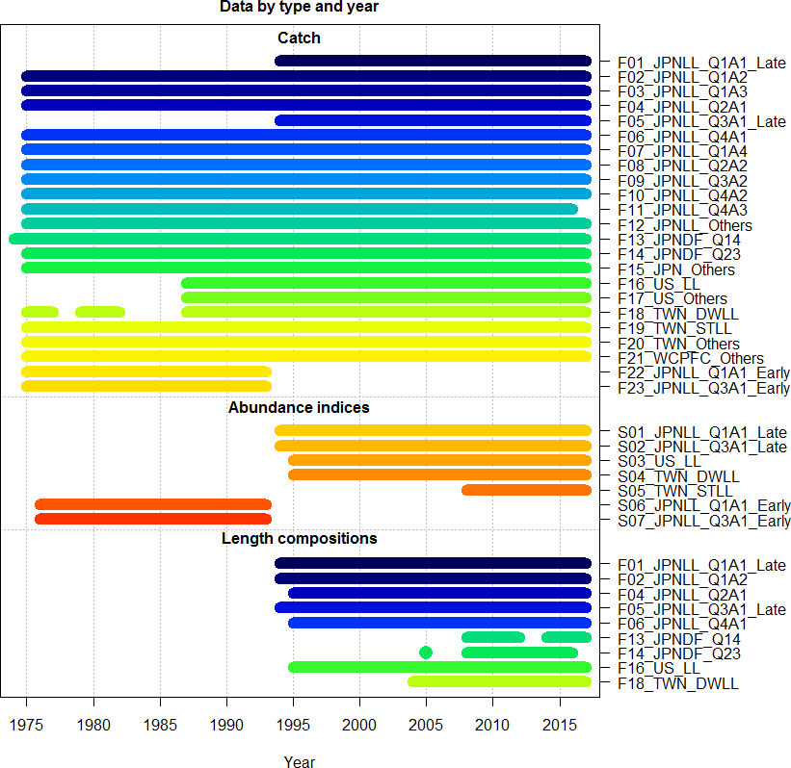

Figure 1. Available temporal coverage and sources of catch, CPUE (abundance indices), and length and size composition for the 2019 stock assessment of the Western and Central North Pacific striped marlin.

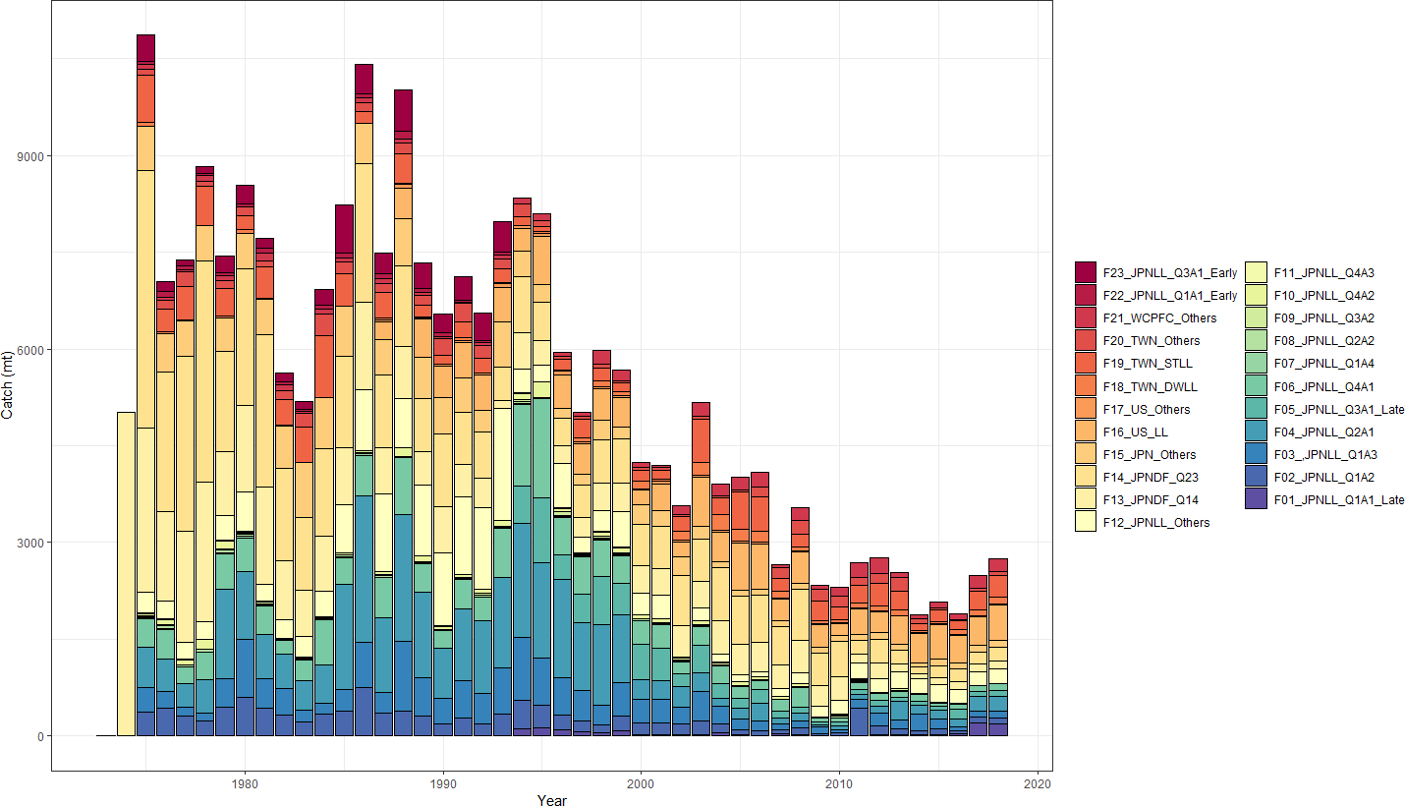

Figure 2. Total annual catch of the Western and Central North Pacific striped marlin by all fisheries harvesting the stock during 1975-2017. See Table 1 for the reference code for each fishery.

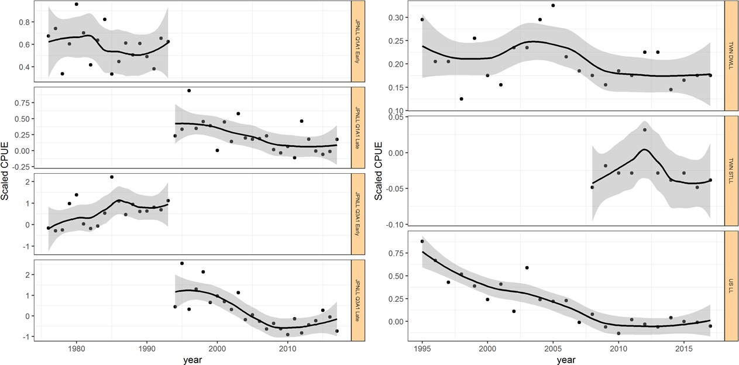

Figure 3. Time series of annual standardized indices of catch-per-unit-effort (CPUE) for the for each fleet in the base-case assessment model for the Western and Central North Pacific striped marlin as described in Table 3. Index values were rescaled by the mean of each index for comparison purposes. A loess curve was fit to the data to show the general trend with shaded area representing 95% confidence intervals.

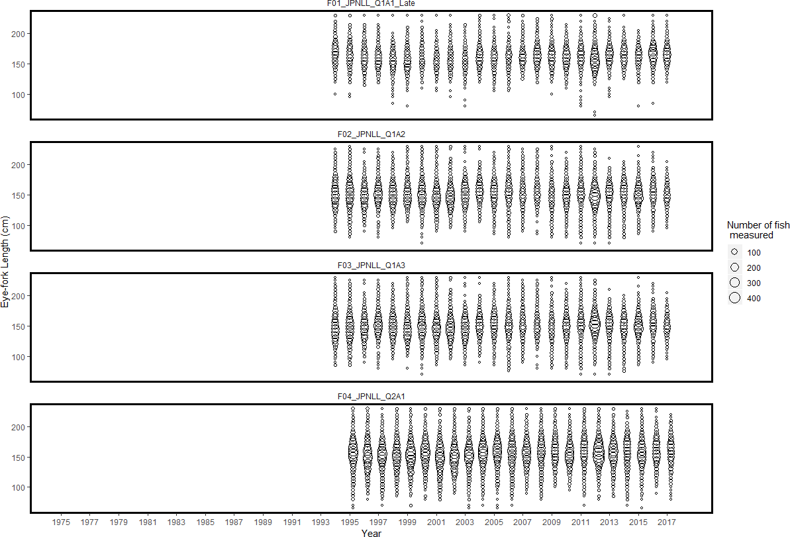

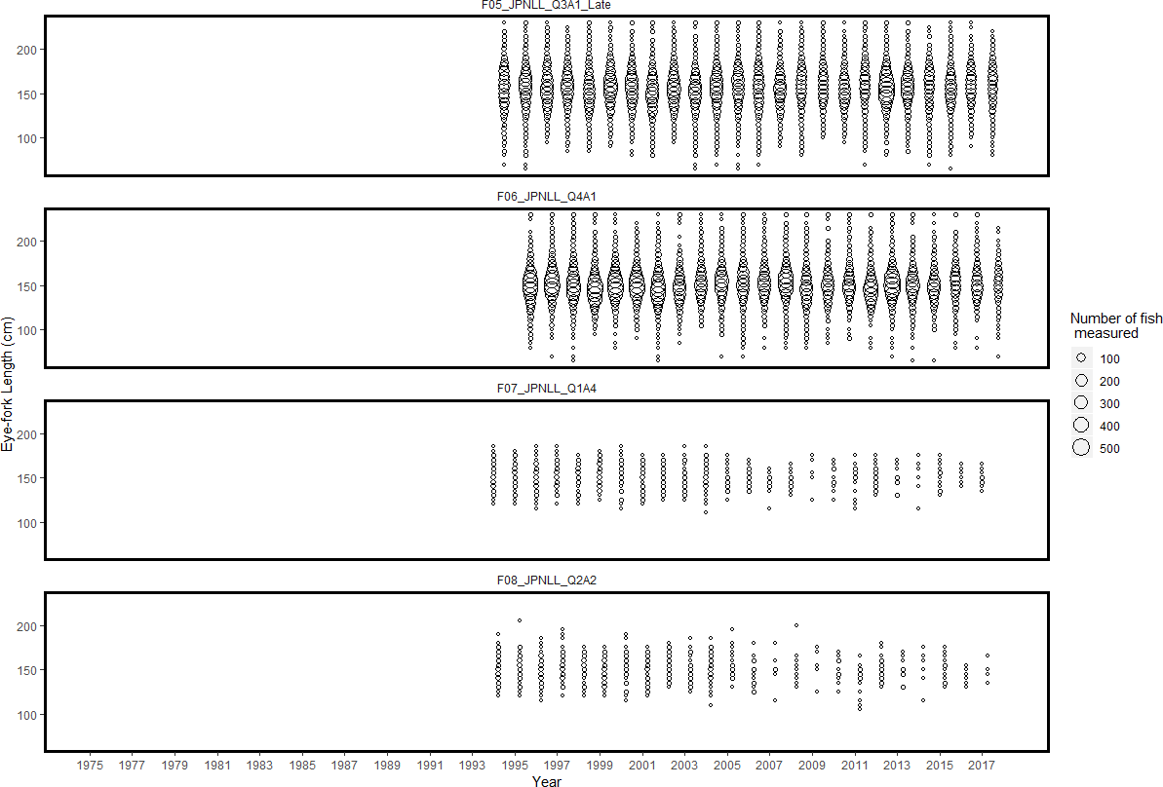

Figure 4. Quarterly length and size composition data by fishery used in the stock assessment (see Table 3). The sizes of the circles are proportional to the number of observations. All measurements were eye- fork lengths (EFL, cm).

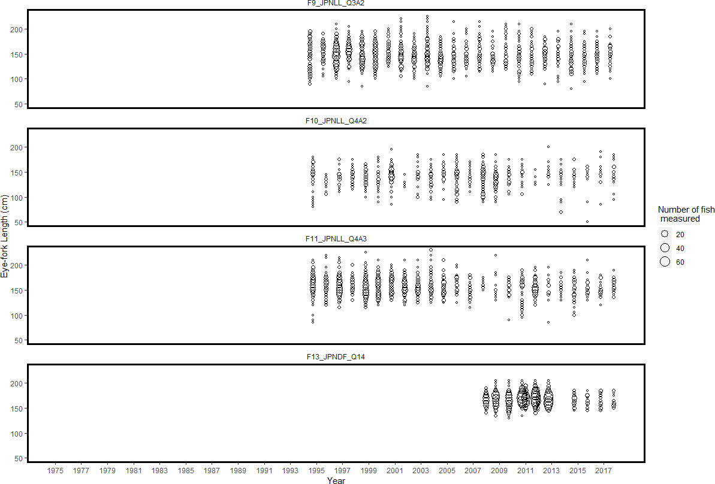

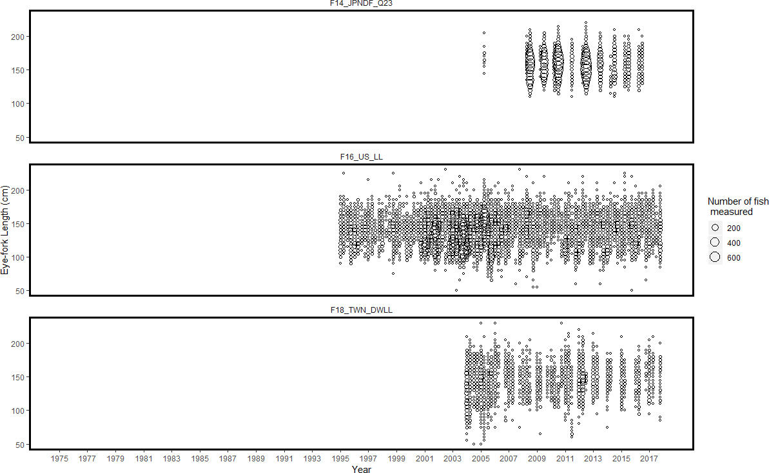

Figure 4. Continued

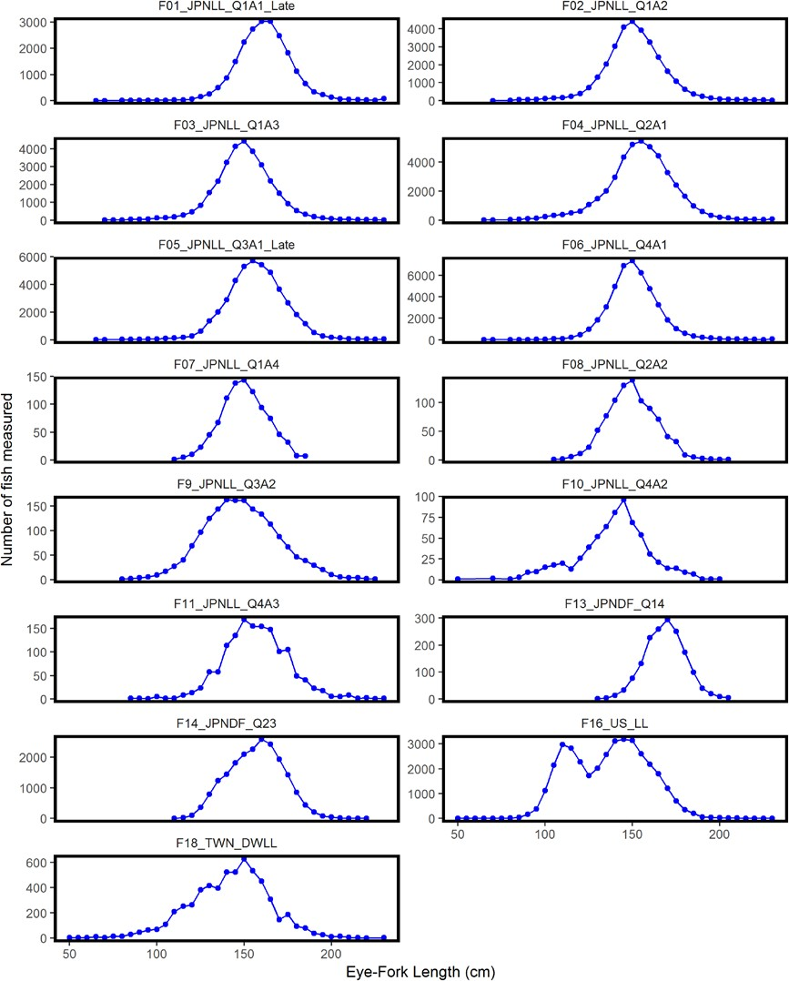

Figure 5. Aggregated length and size compositions used in the stock assessment (see Table 3 for descriptions of the composition data). All measurements were eye-fork lengths (EFL, cm).

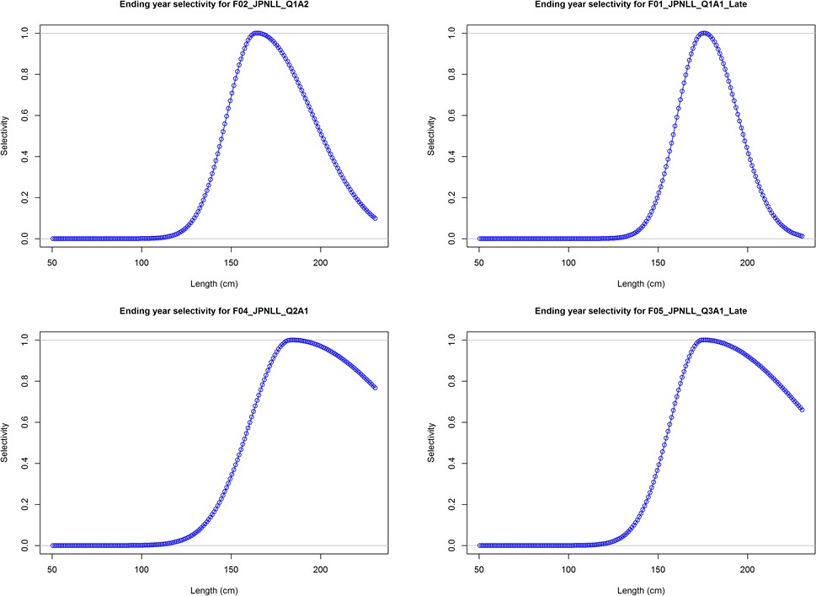

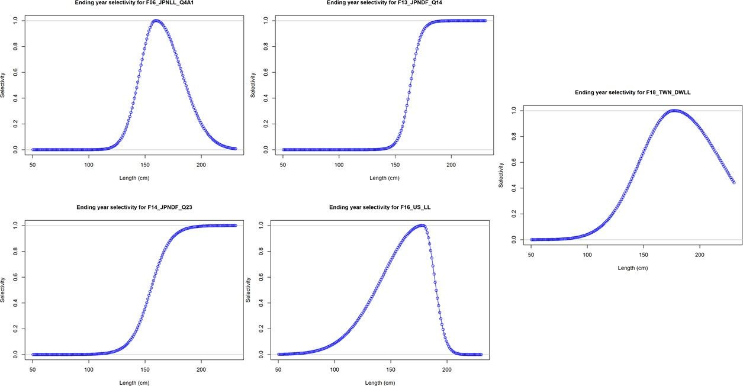

Figure 6. Length-based selectivity of fisheries for Western and Central North Pacific striped marlin estimated for the 2019 assessment.

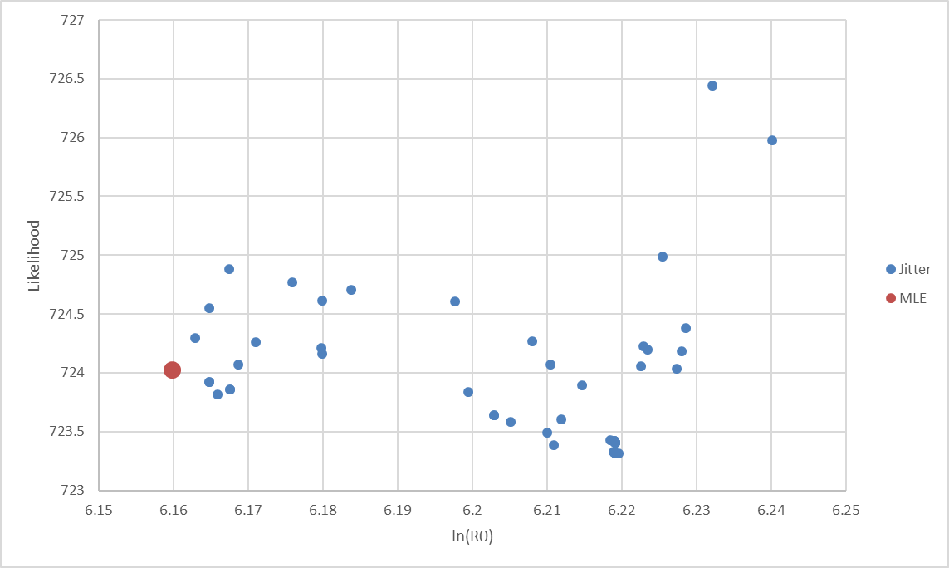

Figure 7. Results of a randomized initial parameter value diagnostic for the base case model where 100 randomized initial conditions were used with a CV of 10% assigned to each parameter. Results are shown for the base case model (MLE, solid red circle) and for the base case model with randomized initial parameter values (Jitter runs, solid blue circle).

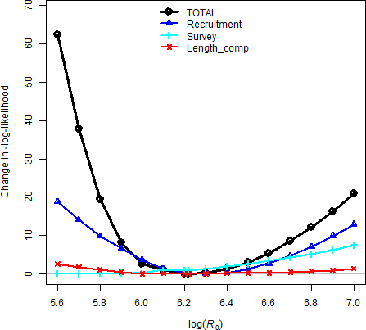

Figure 8. Profiles of the negative log-likelihoods relative to the minimum value of each component for the different likelihood components affecting the unfished recruitment parameter R0 in log-scale (i.e., the x-axis is log(R0)) ranging from 5.6 to 7.0 for the base case model, where recruitment represents the likelihood component based on the deviations from the stock- recruitment curve and length data represents the joint likelihood component for combined fleets based on the fish length composition data.

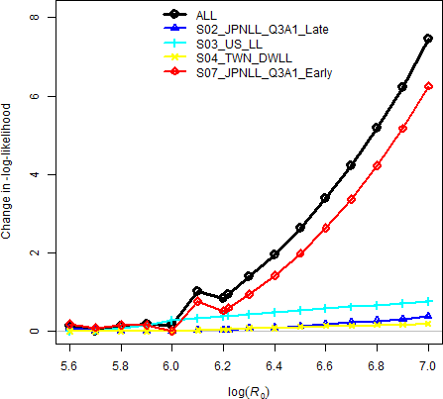

Figure 9. Profiles of the relative negative log-likelihoods by fleet-specific index likelihood components for the virgin recruitment in log-scale (log(R0)) ranged from 5.6 to 7.0 of the base case scenario. See Table 3 for descriptions of the index data. S1, S5, and S6 were not included in the total likelihood.

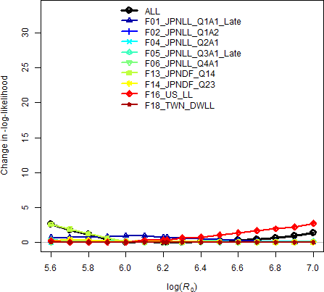

Figure 10. Profiles of the relative negative log-likelihoods by fleet-specific length composition likelihood components for the virgin recruitment in log-scale (log(R0)) ranged from 5.6 to 7.0 of the base case scenario. See Table 3 for descriptions of the length composition data.

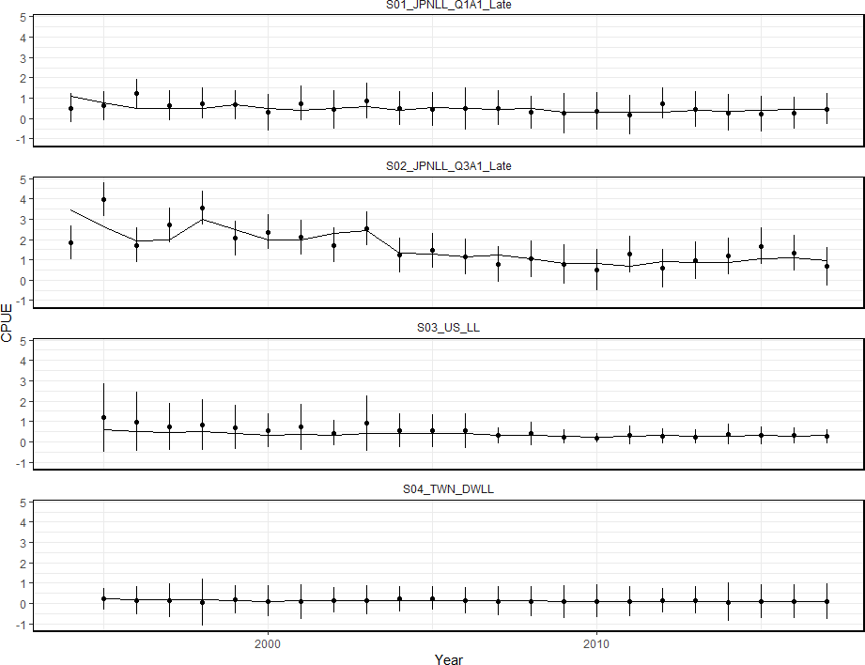

Figure 11. Model fits to the standardized catch-per-unit-effort (CPUE) data sets from different fisheries for the base case scenario. The line is the model predicted value and the points are observed (data) values. The vertical lines represent the estimated confidence intervals (± 1.96 standard deviations) around the CPUE values. S1, S5, and S6 were not included in the total likelihood.

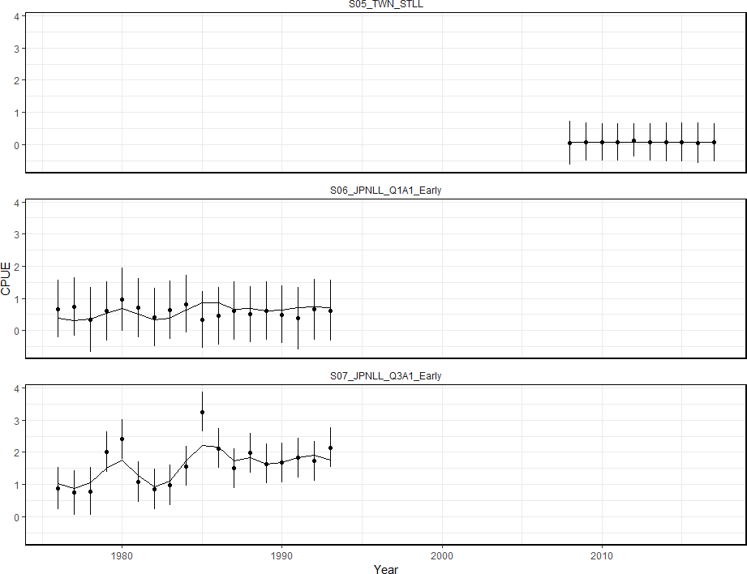

Figure 11. Continued

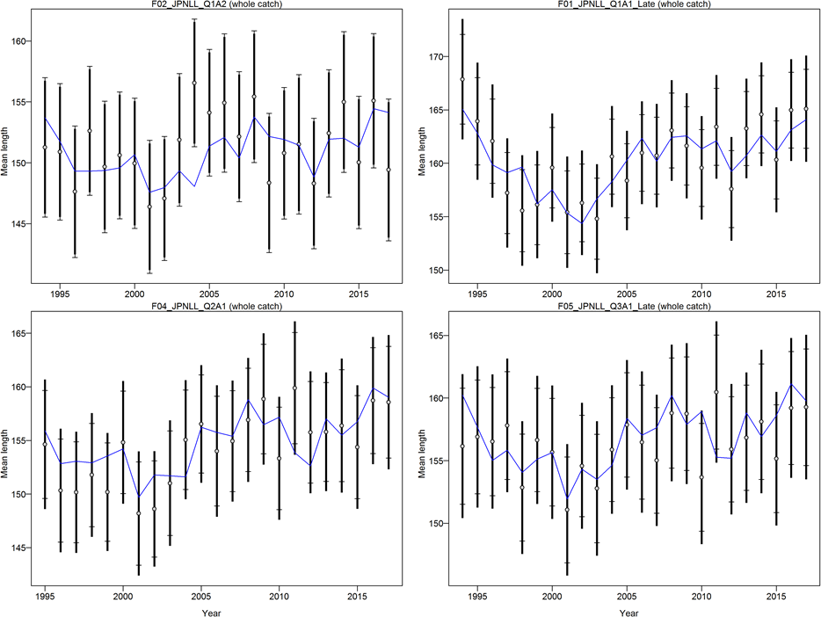

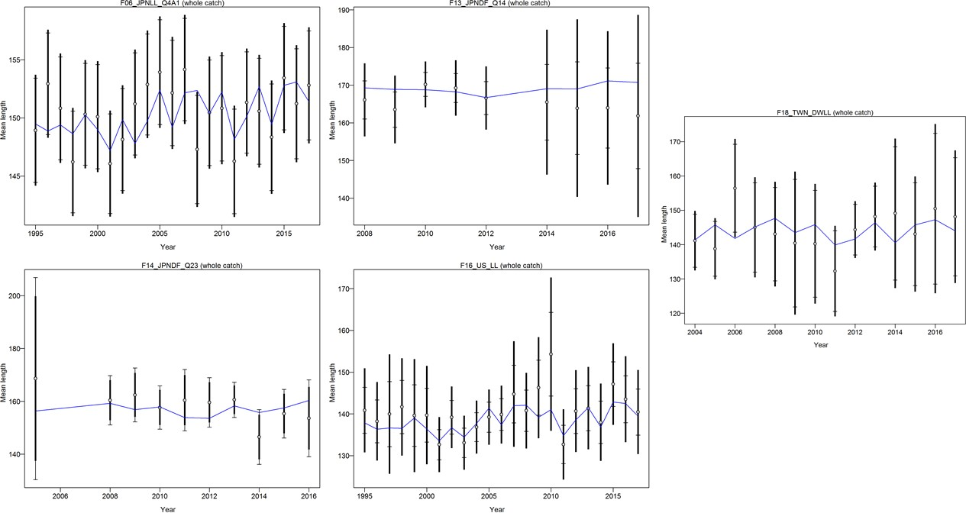

Figure 12. Model fit (lines) to mean length of the composition data (points, showing the observed mean age and 95% credible limits around mean age (vertical lines)). See Table 3 for descriptions of the data. All measurements were eye-fork lengths (EFL, cm).

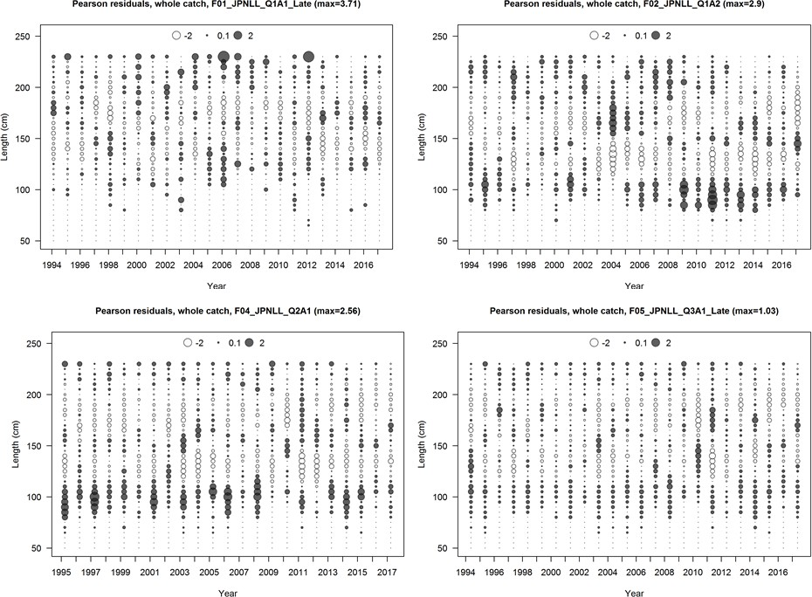

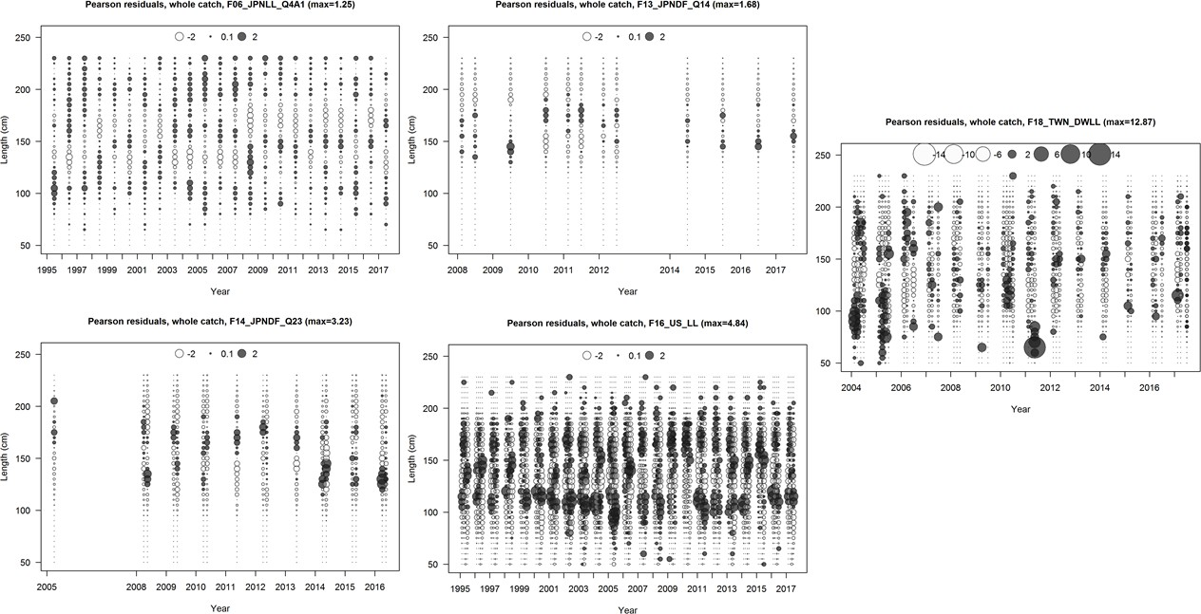

Figure 13. Pearson residual plots of model fits to the various length-composition data for the Western and Central North Pacific striped marlin fisheries used in the assessment model.

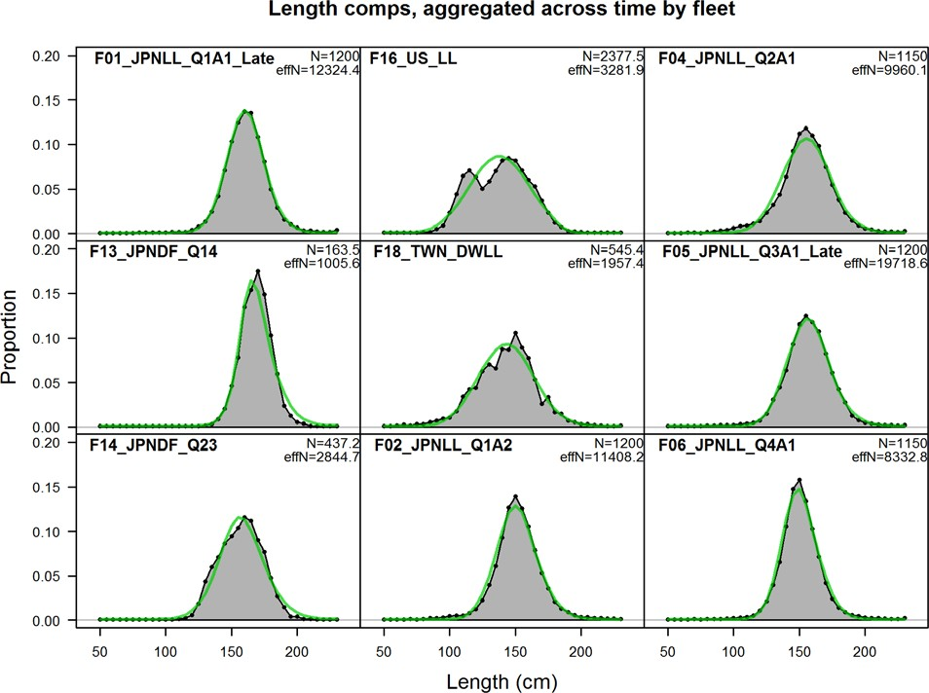

Figure 14. Comparison of observed (gray shaded area and blue dots) and model predicted (blue solid line) length compositions for fisheries used in the stock assessment for the Western and Central North Pacific striped marlin. Observed (black circles) and predicted (green line) length compositions. All measurements were eye-to-fork lengths (EFL, cm).

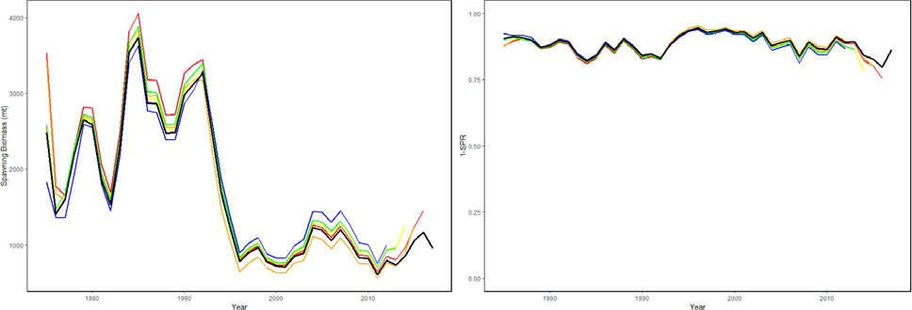

Figure 15. Retrospective analysis of spawning biomass (left) and fishing intensity (1-SPR, one minus the spawning potential ratio, right) consisting of 5 reruns of the base case model each fitted with one more year of data removed from the base case model (black line, 1975-2017).

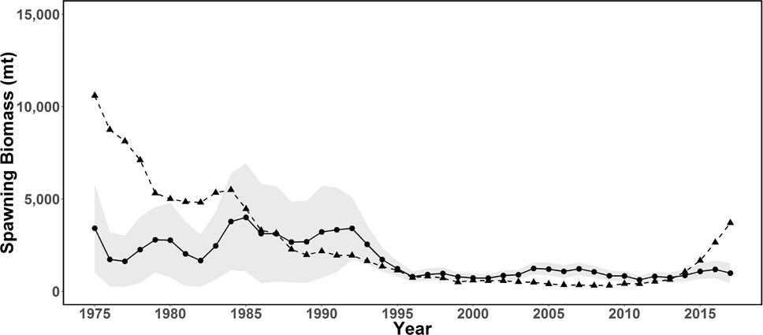

Figure 16. Age structured production model diagnostic for Stock Synthesis base case model. Spawning stock biomass estimates from the base-case model (black circles, solid line; grey shading indicates 95% confidence interval) and ASPM model diagnostic (black triangles, dashed line).

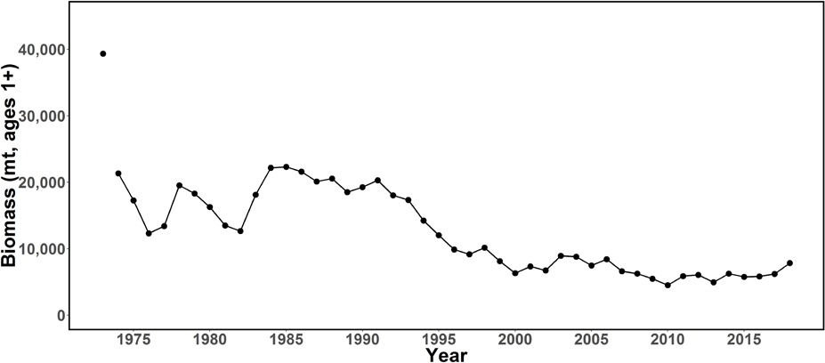

Figure 17. Time series of total biomass (age 1 and older, metric ton) for the Western and Central North Pacific striped marlin estimated in the base-case model. The first year indicates virgin biomass levels.

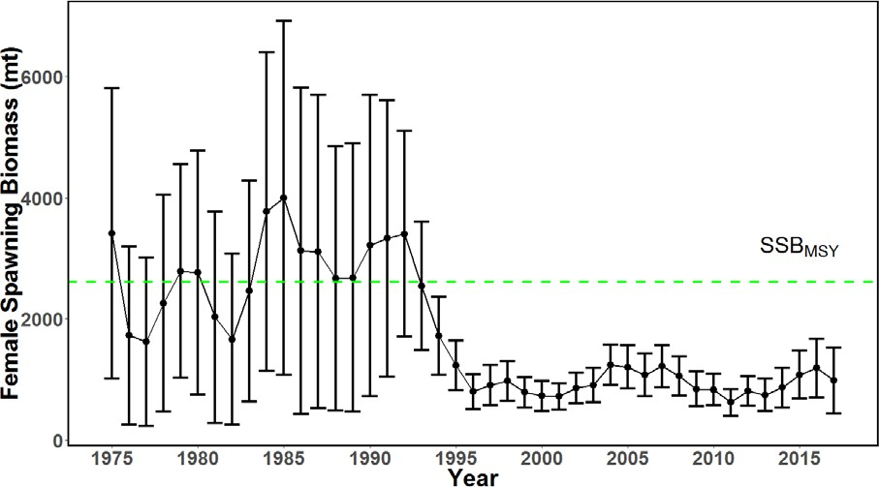

Figure 18. Time series of spawning biomass (metric ton) for the Western and Central North Pacific striped marlin estimated in the base-case model. The solid line with circles represents the maximum likelihood estimates and the error bars represent the uncertainty of the estimates (95% confidence intervals). The dashed horizontal line shows the spawning biomass to produce MSY reference point.

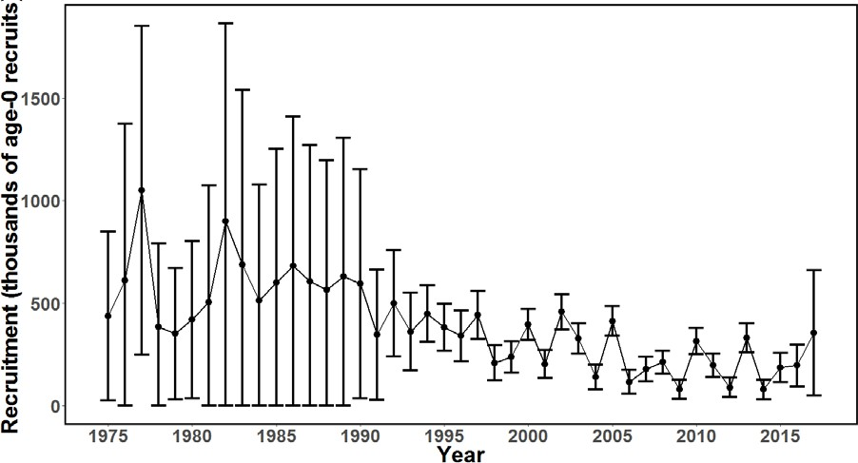

Figure 19. Time series of recruitment (thousands of age-0 fish) for Western and Central North Pacific striped marlin estimated in the base-case model. The solid line with circles represents the maximum likelihood estimates and the error bars represent the uncertainty of the estimates (95% confidence intervals).

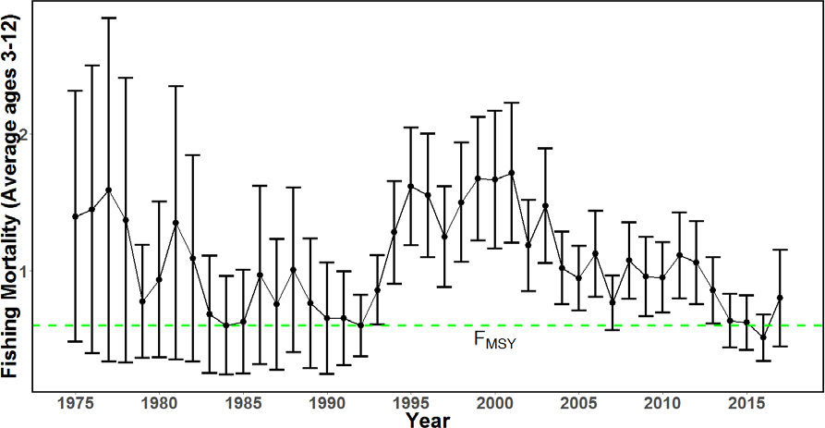

Figure 20. Time series of instantaneous fishing mortality (average for age 3-12) for the Western and Central North Pacific striped marlin estimated in the base-case model. The solid line with circles represents the maximum likelihood estimates and the error bars represent the uncertainty of the estimates (95% confidence interval). The dashed horizontal line shows the fishing mortality to produce MSY reference point.



Figure 21. Kobe plot of the trends in estimates of relative fishing mortality (average of age 3-12) and spawning stock biomass of Western and Central North Pacific striped marlin (*Kajikia audax)* during 1975-2017.

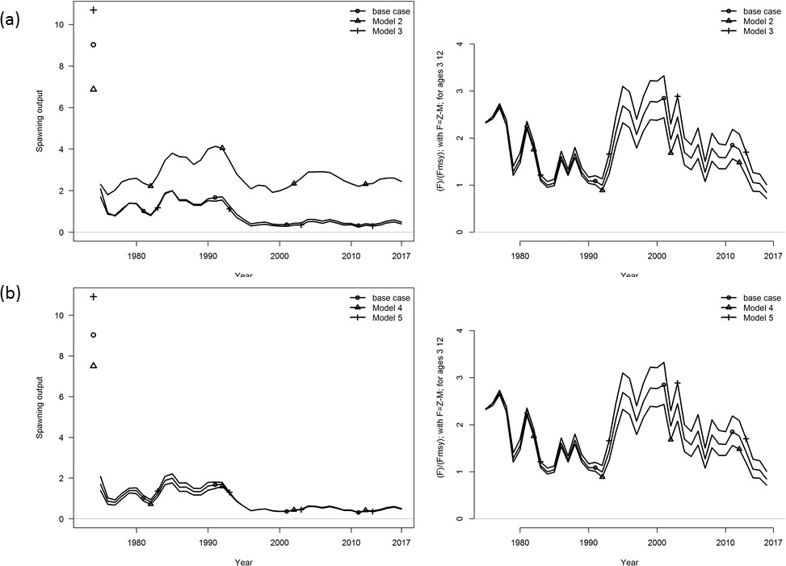

Figure 22. Trajectories of spawning stock biomass and fishing mortality as F/FMSY from 21 sensitivity analyses listed in Table 13, compared to the base case model: (a) Runs 2 and 3 use alternative growth curve parameters; (b) Runs 3, and 4 use alternative natural mortality; (c) Run 6 uses alternative recruitment variability; (d) Runs 7, 8, and 9 use alternative steepness parameters; (e) Runs 10, 11, and 12 use alternative maturity ogives; (f) runs 13, 14, 15, and 16

use alternative initial equilibrium catches; (g) Runs 17, 18, 19, 20, and 21 use alternative Japanese drift gillnet catches; (h) Run 22 starts in 1994 rather than 1975.

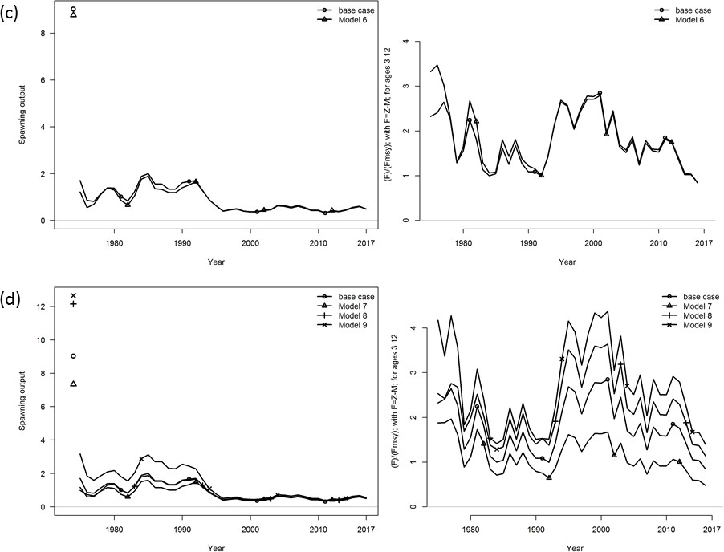

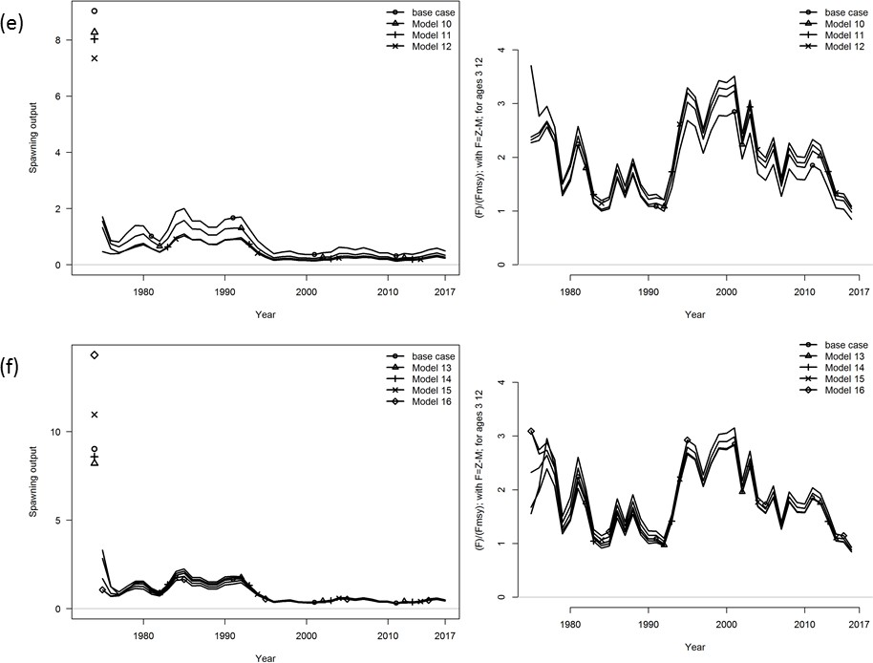

Figure 22. Continued

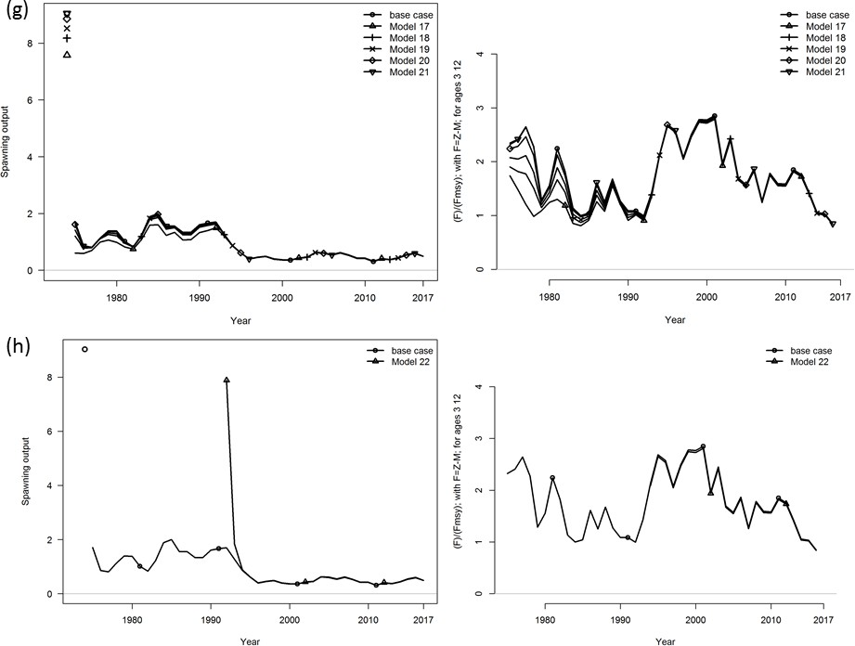

Figure 22. Continued

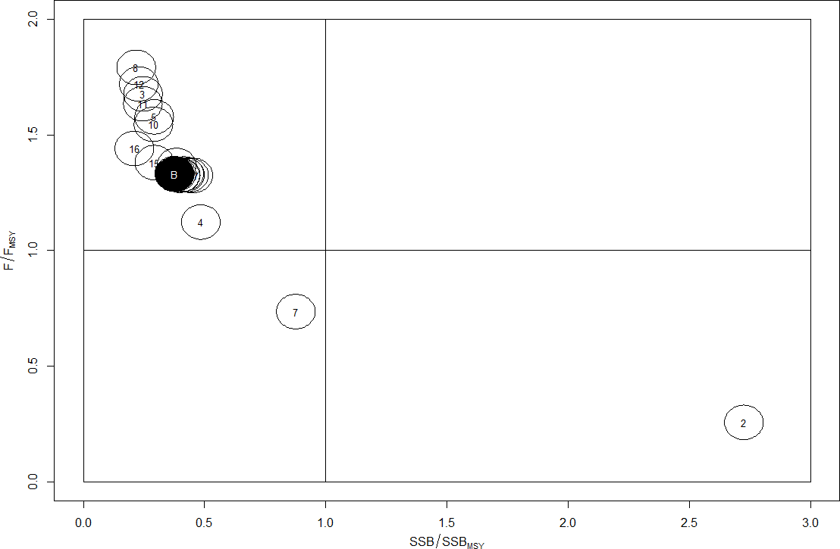

Figure 23. Kobe plot showing the terminal-year stock status for the base case model (B) and the sensitivity analyses as indicated by the run numbers. For the list of sensitivity runs, please see Table 13.

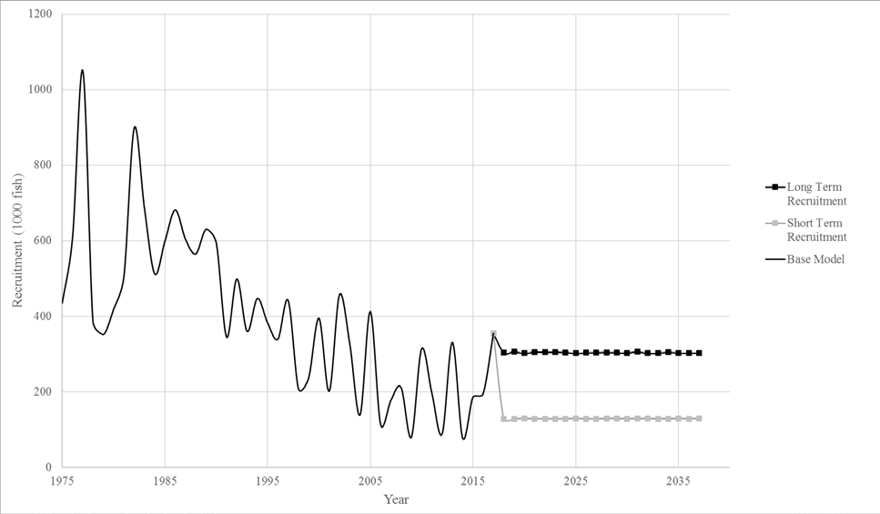

Figure 24. Recruitment trajectories used in the projections: Average short-term recruitment estimates (grey squares); average long-term recruitment estimates (black squares); and base-case model estimated recruitment (black solid line)

a.)

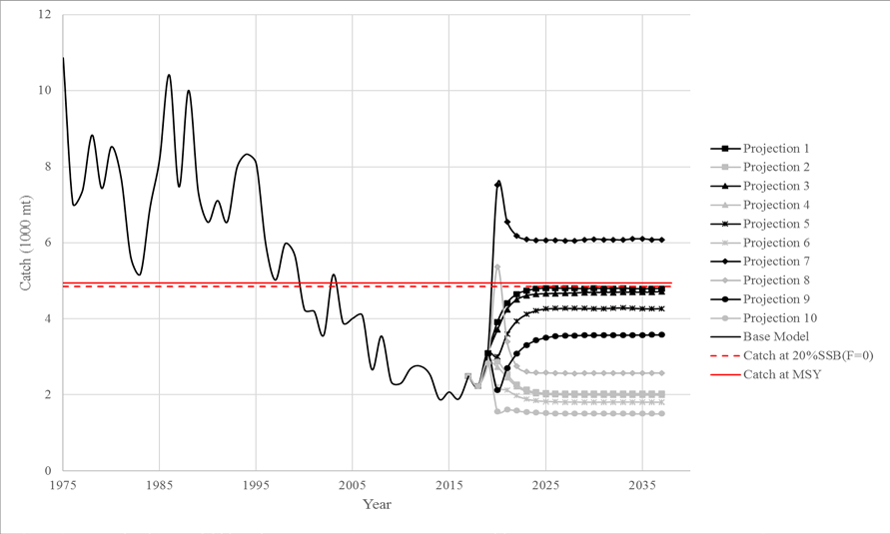

b.)

Figure 25. Historical and projected trajectories of spawning biomass and total catch from the Western and Central North Pacific striped marlin base case model based upon F and constant catch scenarios: (a) F scenarios projected spawning biomass; (b) F scenarios projected catch; (c) Constant catch scenarios projected spawning biomass; and (d) constant catch scenarios projected catch. Black lines indicate the long-term recruitment scenarios; grey lines indicate the short-term recruitment scenarios. Red dashed line indicates the catch or spawning stock biomass at 20%SSBF=0. Red solid line indicates the catch or spawning stock biomass at MSY. The list of projection scenarios can be found in Table 8.

c.)

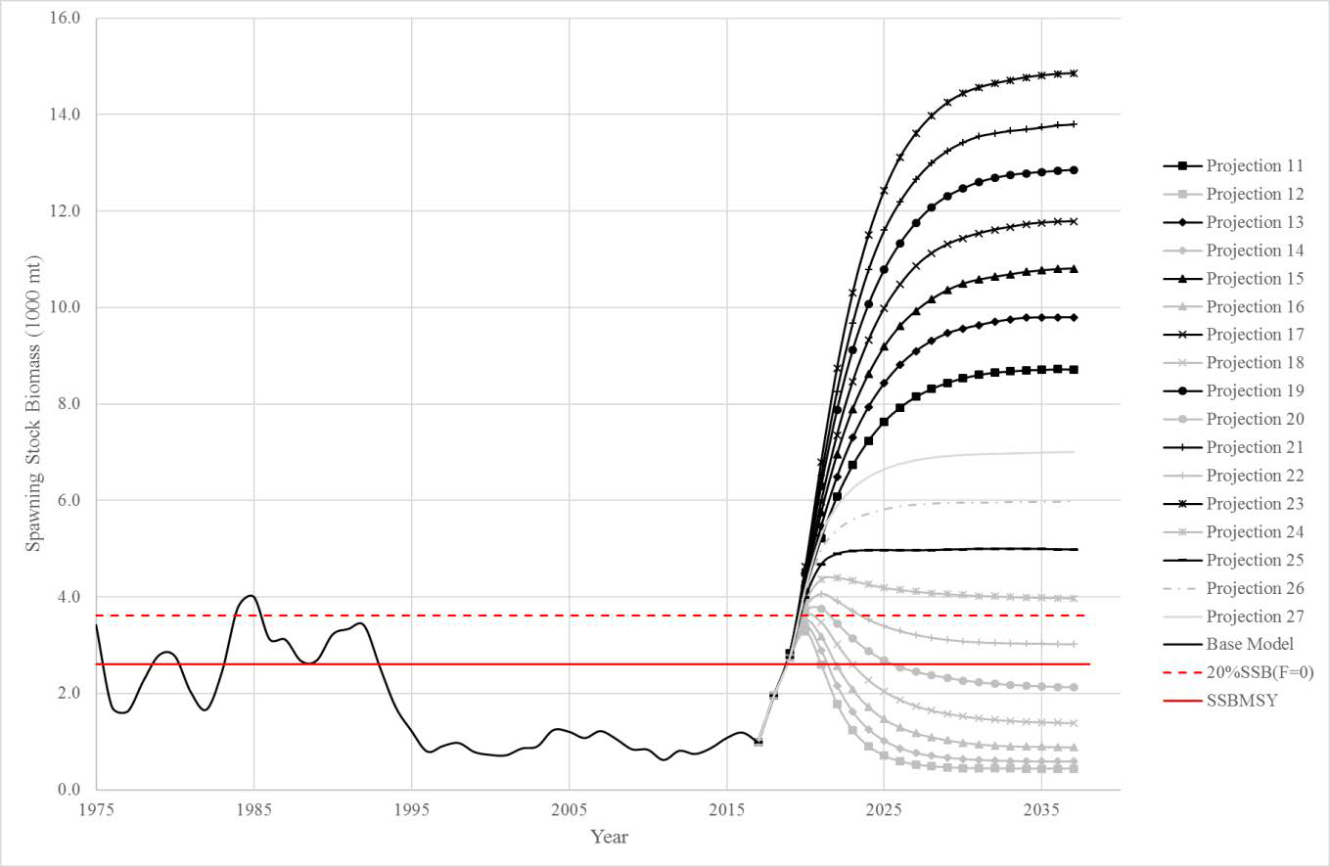

d.)

Figure 25. Continued