ISC/20/BILLWG-01/07

# Which recruitment scenario is most likely for conducting future stock projections of Western and Central North Pacific Ocean striped marlin?

Jon Brodziak and Michelle Sculley

Pacific Islands Fisheries Science Center National Marine Fisheries Service

1845 Wasp Boulevard Honolulu, HI 96818 USA

Email: [Jon.Brodziak@NOAA.GOV](mailto:Jon.Brodziak@NOAA.GOV), [Michelle.Sculley@NOAA.GOV](mailto:Michelle.Sculley@NOAA.GOV)

Working paper submitted to the Billfish Working Group, International Scientific Committee for Tuna and Tuna-like Species in the North Pacific Ocean, Jan 30−Feb 4, 2020, Taipei, Taiwan. Working paper is not to be cited without author’s permission.

PIFSC Working Paper, WP-20-002 https://doi.org/10.25923/7ak7-yz80

# Abstract

Several analyses were conducted to address the request of the Northern Committee of the Western and Central North Pacific Fisheries Commission for the ISC Billfish Working Group to provide advice on which recruitment scenario was most likely for the 2019 Western and Central North Pacific Ocean striped marlin stock assessment projections. Linear regression analyses were used to evaluate the time trend of the recruitment estimates from the stock assessment. The results showed a significant long-term decline in age-0 recruits indicating that using a long-term recruitment trend for future projections was not consistent with the observed recent recruitment values. The long-term decline in recruitment, combined with the better out-of-sample predictive accuracy of the short-term recruitment scenario and the observation that recruitment for billfishes are generally positively auto-correlated, led us to conclude that the short-term recruitment scenario was the most likely recruitment scenario for conducting future stock projections for Western and Central North Pacific Ocean striped marlin.

# Introduction

The ISC Billfish working group presented the Western and Central North Pacific Ocean striped marlin (WCNPO MLS) stock assessment to the Western and Central Pacific Fisheries Commission Scientific and Northern Committees (WCPFC SC and NC) in 2019 (ISC 2019). This benchmark assessment included the results of projections requested by the NC to help inform a rebuilding plan for MLS. The WG included two potential recruitment scenarios, which the group agreed were plausible, for the NC to consider. The NC then requested the ISC BILLWG to provide additional information on which recruitment scenario was more likely given the observed assessment data. This document provides some additional analyses on the relative likelihood of each future recruitment scenario for conducting stock projections.

# Results and Discussion

The short-term recruitment scenario is based on random resampling of the empirical cumulative distribution function of estimated age-1 recruits during 2012–2016 (n = 5 years). The long-term recruitment scenario is based on random resampling of the empirical cumulative distribution function of estimated age-1 recruits during 1976–2016 (n = 41 years). Both the

short- and long-term scenarios are nonparametric models to predict future recruitment. Recruitment averages 134,020 fish under the short-term scenario with a coefficient of variation of 58%, while recruitment averages 306,989 fish under the long-term scenario, or 2-fold greater than under the short-term scenario, with a coefficient of variation of 54%.

The time series of recruitment estimates for the WCNPO striped marlin stock shows a significant long-term decline (Figure 1). To examine trends in striped marlin recruitment, we fitted a linear regression of recruitment as a function of year over the entire time series of recruitment estimates (age-1, 1976–2018). The regression results showed a significant negative time trend (P < 0.001, adjusted R2 = 0.52). The fitted regression conformed to model assumptions and satisfied tests for constant variance (P = 0.07) and normally-distributed errors (P=0.36). We also checked whether the fitted regression results were robust using M-estimates of regression model coefficients (Huber 1981) in the R package “rlm.” This analysis showed that the robust regression coefficients were not significantly different from the linear regression

coefficients1 and further verified that the linear regression results were robust to model assumptions.

The significant declining trend in observed recruitment implied that using the long-term recruitment scenario for MLS projections was not consistent with the observed recent recruitment values (Figure 2). There was no time trend in the recruitment estimates used in the short-term recruitment scenario (linear regression, P=0.94, non-significant). We also evaluated out-of-sample forecasts of the relative prediction errors for the 2017 and 2018 year classes under the short-term and long-term recruitment scenarios using cross validation (e.g., Wood 2006). The out-of-sample forecasts indicated that the weighted error variance (i.e., Bates and Granger 1969) for the predicted 2017–2018 recruitments under the short-term scenario was roughly one-tenth of the weighted error variance under the long-term recruitment scenario. This result indicated that the short-term scenario provided 10-fold better out-of-sample predictive accuracy than the long- term scenario for the two most recent recruitments (Table 1). In comparison, if the more variable 2018 recruitment estimate (CV = 44%) was excluded and only the prediction error for the 2017 recruitment estimate (CV = 27%) was used to measure the predictive accuracy of the two recruitment model scenarios, then the short-term scenario produced a more than 100-fold better predictive accuracy for the 2017 recruitment than the long-term scenario.

In general, using the long-term recruitment scenario for future stock projections requires the assumption that there is no time trend in the observed long-term recruitment time series. This assumption has been shown to have little or no empirical statistical support. Hence it is necessary to either reject or severely down weight the long-term recruitment scenario as an accurate predictor of future recruitment strength in comparison to the short-term recruitment scenario.

While this post-hoc analysis was conducted after the Billfish Working Group completed the stock assessment estimations and projections for the peer-reviewed and accepted 2019 stock assessment of WCNPO striped marlin (ISC 2019), it does not affect the validity of the analyses.

We also want to comment that one of the primary sources of information for recruitment in a Stock Synthesis model is the size composition data. In the 2019 striped marlin stock assessment, length frequency data were the primary input for fish size composition information. In periods with poor quality information or no data to inform recruitment, estimated recruitments can exhibit high variability, indicating that estimates of individual annual recruitment values have low precision (Methot and Wetzel 2013). Simulation work has suggested that periods without size information decrease the accuracy of recruitment estimates making them less reliable than periods with size data. Stock Synthesis can identify the number of small fish in a population, which provides an estimate of recruitment (Ono et al. 2014). For the 2019 striped marlin assessment, the time series of high−quality length composition data were only available starting in 1993, but the age-0 model-based estimates of recruitment started in 1975. Thus, the individual estimates of recruitments in the early part of the model time horizon (circa 1975–1992) are highly uncertain (Figure 1). However, while individual recruitment estimates are uncertain, the overall pattern of the stock producing much higher recruitment, on average, in the early part of

1 Similar regression analyses conducted on the log-scale recruitment residuals also confirmed the existence of a

long-term declining trend in recruitment even after accounting for the maternal effect of declining spawning stock in the stock-recruitment relationship.

the time series is robust because larger recruitments were what was minimally needed to explain the observed catches in the fishery. Nonetheless, the most important point to note is that the overall pattern of recruitment for WCNPO striped marlin shows a clear significant decline over time. This decreasing trend is not consistent with using the long-term recruitment scenario, which treats all of the observed recruitments during 1976–2016 as being equally likely to model the distribution of future recruitment.

In addition, because recruitment for billfish has been shown to be autocorrelated, it is reasonable to assume that future recruitment is more likely to continue following the most recent trend (Thorson et al. 2014). In particular, the autocorrelation function (ACF) for the time series of standardized recruitment residuals during 1976–2018 indicates that significant positive autocorrelations exist at time lags of 1, 5, and 6 years (Figure 3). Thus, there is empirical support for the existence of some autocorrelation in the striped marlin recruitment time series after correcting for maternal effects in the estimated stock-recruitment curve. Here the observed autocorrelations likely represent the combined effects of environmental drivers on recruitment strength and provide empirical support for the short-term recruitment scenario as the most likely recruitment scenario.

# Literature Cited

Bates J, Granger C. 1969. The combination of forecasts. Operational Research Quarterly, 20:451-468.

Huber P. 1981. Robust statistics. Wiley & Sons, New York, 308 p.

International Scientific Committee for Tuna and Tuna-Like Species in the North Pacific Ocean. [ISC]. 2019. Stock Assessment for Striped Marlin (*Kajikia audax*) in the Western

and Central North Pacific Ocean through 2017. Annex 11, ISC/19/ANNEX/11, 91 p.

Methot RD, Wetzel C. 2013. Stock synthesis: A biological and statistical framework for fish stock assessment and fishery management. Fisheries Research, 142:86-99.

Ono K, Licandeo R, Muradian M, Cunningham C, Anderson S, Hurtado-Ferro F, Johnson K, McGilliard C, Monnahan C, Szuwalski C, Valero J, Vert-Pre K, Whitten A, Punt A. 2014. The importance of length and age composition data in statistical age-structured models for marine species. ICES Journal of Marine Science, 72:31-43.

Thorson J, Jensen O, Zipkin E. 2014. How variable is recruitment for exploited marine fishes? A hierarchical model for testing life history theory. Canadian Journal of Fisheries and Aquatic Sciences, 71:973-983.

Wood S. 2006. Generalized additive models. Chapman & Hall, New York, 392 p.

Table 1. Squared recruitment prediction errors in 2017 and 2018 based on the short-term and long-term recruitment models along with combined 2017–2018 weighted recruitment prediction errors, associated model weights, and relative odds ratios by model based on predictive accuracy.

|  |  |  |  |  |  |  |  |  |
| --- | --- | --- | --- | --- | --- | --- | --- | --- |
| **Combined Forecast Weight for 2017 and 2018 Recruitment by Point Prediction** | **Squared Recruitment Prediction Error in 2017** | **Squared Recruitment Prediction Error in 2018** | **Variance of Recruitment Estimate by Year (Top 2017,**  **Bottom 2018)** | **Inverse Variance Weight for Recruitment Estimate by Year (Top 2017,**  **Bottom 2018)** | **Combined 2017-2018**  **Weighted Recruitment Prediction**  **Error** | **Inverse Variance of Combined Prediction Error (1/MSE)**  **by Model** | **Inverse Variance Model Weight Based on Predictive**  **Accuracy** | **Relative Odds by Model Based on Predictive Accuracy** |
| **Short-term R Model** | 221.8 | 18636.3 | 1576.8 | 6.34E-04 | 2077.0 | 0.000481 | 0.916 | 10.9 |
| **Long-term R Model** | 24988.3 | 1328.9 | 14073.4 | 7.11E-05 | 22604.6 | 0.000044 | 0.084 | 0.1 |
| **Total** |  |  | 15650.2 | 7.05E-04 | 24681.6 | 0.000526 | 1.000 |  |

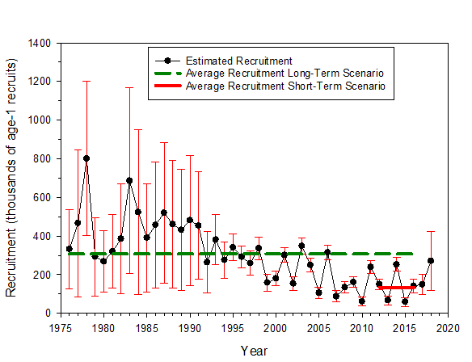

Figure 1. Estimated recruitment from the 2019 Western and Central North Pacific Ocean striped marlin stock assessment with 80% confidence intervals (solid black line and circles) along with the average recruitment expected under the long-term (dashed green line) and short−term (solid red line) recruitment scenarios.

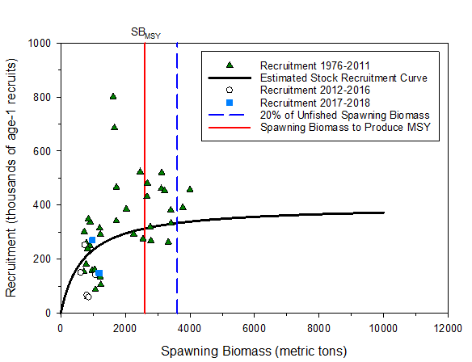

Figure 2. Estimated stock recruitment curve from the 2019 Western and Central North Pacific Ocean striped marlin stock assessment (black solid line) along with the annual recruitment estimates during 1976 to 2011 (green triangles), 2012−2016 (open circles), and 2017−2018 (blue squares). Vertical lines show the estimates of 20% of unfished spawning biomass (dashed blue line) and of spawning biomass to produce maximum sustainable yield (solid red line).

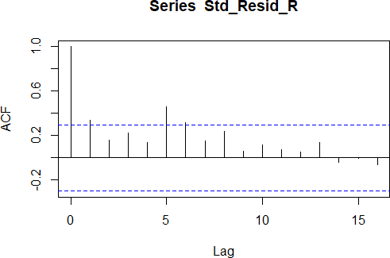

Figure 3. Estimated autocorrelation function (ACF) for the time series of standardized recruitment residuals (Std_Resid_R) during 1975−2017. The results indicate significant autocorrelations at lags of 1, 5, and 6 years (dashed lines indicate ± 2 standard errors for the estimated ACF values).