#### Some Rebuilding Analyses for the Western and Central North Pacific Ocean Striped Marlin Stock

Jon Brodziak*

* Pacific Islands Fisheries Science Center National Marine Fisheries Service

1845 Wasp Boulevard Honolulu, HI 96818 USA

Email: [Jon.Brodziak@NOAA.GOV](mailto:Jon.Brodziak@NOAA.GOV)

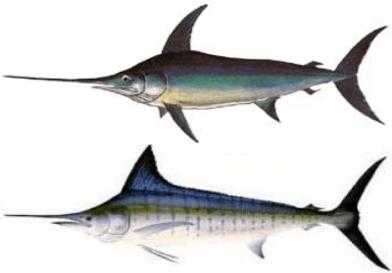

This working paper was submitted to the ISC Billfish Working Group Workshop, 9-11 March 2021 held by webinar.

PIFSC Working Paper, WP-21-003 Issued 6 May 2021 https://doi.org/10.25923/3jfy-7r42

#### Abstract

In this working paper, we describe analyses and stochastic stock projections to develop an interim rebuilding plan for the Western and Central North Pacific Ocean (WCNPO) striped marlin stock. This stock is currently estimated to be depleted and experiencing excess fishing mortality relative to maximum sustainable yield-based reference points. The projection analyses described in this working paper are based on a January 2021 revision of the benchmark 2019 stock assessment of WCNPO striped marlin. The revised 2021 stock assessment was conducted to incorporate minor corrections to the catch time series for the USA longline fleet during 2010–2017 with all other assessment data inputs being the same as those used in the 2019 benchmark assessment. The interim rebuilding plan has the goals of rebuilding the spawning biomass of the stock to 20% of the unfished level, or 20%SBF=0 = 3,493 mt, within a rebuilding time horizon of up to 15 years (2020–2034) and with a probability of rebuilding success of least 60%. There are three management strategy scenarios developed for these rebuilding analyses: a phased scenario, a constant fishing mortality scenario, and a constant quota scenario. The phased rebuilding scenario was designed to gradually reduce harvest quotas for the aggregate international longline fleet in order to rebuild the stock by 2034 and provide some periods of stable annual catch quotas for reducing fishing mortality on striped marlin. The constant F scenario was designed to determine the constant fishing mortality rate and associated fishing effort to be applied during 2022–2034 to rebuild the stock with at least 60% probability by 2034. Similarly, the constant quota scenario was designed to determine the constant catch biomass quota to be applied during 2022–2034 to rebuild the stock with at least 60% probability by 2034. Given the projected catch quotas and spawning biomasses to meet the rebuilding goals, the probabilities of rebuilding the stock were calculated for each of the rebuilding scenarios. The results of the rebuilding analyses showed that, under the phased scenario, the rebuilding probabilities increased from P=0.05 in 2022 to P=0.60 in 2034. In comparison, the rebuilding probabilities under the constant F scenario increased from about P=0.07 in 2022 to P=0.60 in 2032. Similarly, under the constant quota scenario, the rebuilding probabilities increased from P=0.07 in 2022 to P=0.60 in 2034. Last, we discuss some of the key characteristics and uncertainties of the three harvest scenarios to rebuild the WCNPO striped marlin stock.

#### Introduction

This working paper describes analyses and stock projections to develop a rebuilding plan for the Western and Central North Pacific Ocean (WCNPO) striped marlin stock based on the best scientific information available. In this context, the projection analyses described in this working paper are based on a January 2021 revision of the benchmark 2019 stock assessment of WCNPO striped marlin (Sculley 2021). The revised 2021 stock assessment was conducted to incorporate minor corrections to the catch time series for the USA longline fleet during 2010–2017, with all other assessment data inputs being the same as those used in the 2019 benchmark assessment. The WCNPO striped marlin (*Kajikia audax*) stock area

consists of waters in the Western and Central Pacific Fisheries Commission (WCPFC) management area bounded on the south by the equator and in the east by 150°W. For background, annual WCNPO striped marlin catches averaged 7,451 mt, or about 55% above the maximum sustainable yield (MSY) catch of 4,820 mt during 1975–1999. Annual catch has had a decreasing trend since 1993 and has averaged 2,279 mt during 2009–2017, or about 53% below MSY (Figure 1). Overall, international longline fishing fleets have accounted for the vast majority of Western and Central North Pacific striped marlin catches since 1994 (91%).

Stock Status

A January 2021 revision of the benchmark 2019 stock assessment of WCNPO striped marlin indicated the striped marlin stock is currently estimated to be depleted and experiencing overfishing relative to MSY-based reference points (Table 1 and Table 2). The revised 2021 stock assessment incorporated minor corrections to the catch time series for the USA longline fleet during 2010–2017 with all other assessment data inputs being the same as those used in the 2019 benchmark assessment (ISC Billfish WG 2019, Sculley 2021). The stock status results from the 2021 revision and 2019 benchmark assessments were similar to the results from the previous assessment conducted in 2015 (ISC Billfish WG 2015, ISC Billfish WG 2019, Sculley 2021). Estimates of spawning biomass fluctuated around 2,775 mt between 1975 and 1992, or about 16% of the unfished spawning biomass of 17,465 mt (Figure 2). Spawning biomass decreased substantially from 1993 through the late 1990s and fluctuated without a trend from then until the present. The lowest observed spawning stock biomass was 578 t in 2011, or about 77% below SBMSY, the spawning stock biomass to produce MSY, and about 97% below the unfished spawning biomass (Figure 2). In 2017, spawning biomass had increased to 849 mt, or about 66% below SBMSY. Fishing mortality on the stock (average F on ages 3–12) has fluctuated above FMSY with a decreasing trend in recent years (Figure 3) and averaged roughly F = 0.69 during 2015–2017, or 14% above FMSY. In 2017, fishing mortality was F=0.88, or about 45% above FMSY = 0.61. It is notable that fishing mortality has been above FMSY in every year since 1975 except 1984, 1992, and 2016. Overall, the WCNPO striped marlin stock is overfished and experiencing overfishing relative to MSY-based biological reference points (Figures 2 and 3), although we note that no target or limit reference points have been established for the stock under the auspices of the WCPFC.

Rebuilding Goals

In 2018, the WCPFC Northern Committee requested that stock projection analyses be conducted to provide information for the development of a rebuilding plan for WCNPO striped marlin (NC14 2018). In particular, the Northern Committee made the following requests to the ISC:

“*70. NC14 agreed to request ISC to conduct projections examining rebuilding scenarios for North Pacific striped marlin that cover a range of rebuilding targets (20%SSBF=0, FMSY, and 0% to 50% reductions in increments of 10% from current catch limits), timelines (10, 15 and 20 years) and probabilities of each scenario to reach each target within different timelines. ISC should produce additional scenarios of catch reduction if the probability of reaching the*

*rebuilding target in 10, 15, and 20 years is not at least 60%.*

*71. NC14 expressed concern over the status of NP striped marlin and urged the Commission to develop a rebuilding plan for the stock as a matter of priority. NC members are encouraged to submit a draft CMM, if possible.”*

The NC14 request for stock projections was fully addressed in the benchmark stock assessment of WCNPO striped marlin (ISC Billfish WG 2019). This assessment was reviewed at the NC15 meeting in 2019. The United States circulated a consultative draft rebuilding plan that proposed that the rebuilding target for spawning biomass be established as 20% of unfished spawning biomass (20%SBF=0)—equivalent to a calculated spawning biomass of 20%SBF=0 = 3,493 mt based on the revised 2021 stock assessment.

Based on the benchmark stock assessment and the stock projections reviewed at SC15 and NC15, WCPFC16 adopted a rebuilding plan for WCNPO striped marlin where the rebuilding target was 20%SBF=0, and the rebuilding time frame was set at 15 years (2020–2034) with a required probability of rebuilding success of least 60%. Overall, the goals for the WCNPO striped marlin rebuilding plan are:

* Rebuilding target is SBTarget = 20%SBF=0 = 3,493 mt of spawning biomass based on revised 2021 stock assessment.
* Rebuilding time frame is 2020–2034.
* Striped marlin conservation measures are implemented in 2022–2034.
* Required target probability for rebuilding success is PSuccess=0.60.

In this paper, we describe the stochastic stock projections to calculate the fleet-wide reductions in catch biomass required to rebuild the WCNPO striped marlin stock to meet these goals. This includes descriptions of the initial conditions, recruitment dynamics, projection model, rebuilding scenarios, and results. The projection analyses begin in 2018, the first year following the stock assessment time period of 1975–2017, and the catch reductions or other conservation measures to rebuild the stock are expected to be initially implemented in 2022. Last, we also calculated the projection results to rebuild the WCNPO striped marlin stock to the target spawning biomass with a required probability for rebuilding success of PSuccess=0.66 and briefly summarize these results.

Initial Conditions

The stock projections were designed to account for uncertainty in the estimates of the initial striped marlin population numbers at age in 2018 and the catch biomasses harvested in 2018–2021. Uncertainty in the initial population size was an important feature to take into account. noting that there is always some uncertainty in the terminal estimates of stock size based on an age-structured stock assessment (Brodziak et al. 1998). In particular, uncertainty in the initial population size in 2018, the first year of the projections, was characterized by calculating 66 bootstrap replicates of the population size at age using the bootstrapping option for the modeling platform Stock Synthesis (SS) version 3.30.08 (Methot and Wetzel 2013). This corresponded to a sampling intensity of about 78 bootstraps per 1,000 mt of spawning biomass and produced a distribution of initial population sizes at age that were used for projections under each of the three rebuilding scenarios

(Figure 4).

Uncertainty in the distribution of annual catch biomasses during 2018–2021 was characterized using Monte Carlo simulation based on the bootstrap replicates of the initial population size for each projection. In this case, it was assumed that the best estimates of striped marlin harvesting intensity prior to the implementation of rebuilding measures in 2022 were based on the recent average fishing mortality from the revised 2021 stock assessment. In particular, the recent average fishing mortality from the revised 2021 stock assessment was set to be the average annual F on age classes 3 to 12 during 2015–2017, which was FInitial=0.69. This was an increase in FInitial of about 8% from the 2019 assessment (ISC Billfish WG 2019). FInitial=0.69 was applied to the simulated population sizes at age during 2018–2021 to produce the distribution of expected population sizes and catches. The resulting median catch biomasses in 2018, 2019, 2020, and 2021 were approximately 1,900, 2,390, 2,500 and 2,330 mt under each rebuilding scenario. This treatment of the initial catch biomasses for stock projections differed from that used in the 2019 assessment report (ISC Billfish WG 2019) in two ways. First, the additional initial year of 2021 was included to account for the change from 2021 to 2022 as the first year for implementing catch reductions under each rebuilding scenario. Second, the initial expected catches were based on the assumption that longline fishing effort and the associated bycatch fishing mortality of WCNPO striped marlin would be relatively constant during 2018–2021. Here the assumption of a constant initial F during 2018–2021 was consistent with the fact that the striped marlin is primarily a bycatch species in the international longline fisheries in the North Pacific. In this case, one would expect the bycatch of striped marlin to reflect the short-term pattern of relatively stable fishing effort in the aggregate longline fleet. Given that the size of the 2017-year class 1 appears to be above average relative to recent recruitment strengths, it was also important to account for expected increases in catches during 2018–2021 when this year class would be expected to be recruited to the fishery. In comparison, the treatment of initial catch biomasses used in the 2019 assessment projections differed by rebuilding scenario (ISC Billfish WG 2019).

Recruitment Dynamics

Recruitment dynamics for the stochastic rebuilding projections explicitly included uncertainty about future recruitment strength (Brodziak et al. 1998) based on the empirical patterns observed in the revised 2021 stock assessment (Figure 5). Recruitment for the stochastic projections was based on two alternative hypotheses about future recruitment. The first hypothesis was that future recruitment would be similar to recent short-term recruitment (Figure 6). This hypothesis was built on the observation that recruitment estimates had remained relatively low in recent years, and one may not expect this to change in the future. In particular, the short-term recruitment scenario was based on resampling the empirical cumulative distribution function of recruitment observed during 2012–2016 (Figure 7). Under the short-term recruitment scenario, the 5-year average recruitment was 128,982

1 Here we use “year class” to refer to the abundance of age-0 or young-of-the-year fish in contrast to

“recruitment” which refers to the abundance of age-1 fish used in the projection model.

age-1 fish with a CV of 57%. The second hypothesis was that future recruitment would be similar to the long-term recruitment pattern (Figure 6). This hypothesis was based on the observation that the average of the bootstrap distribution of recruitment in 2018 (232,197 age-1 fish with a CV of 27%) was 80% higher than the short-term average, suggesting that achieving higher recruitment in future years was a possibility. In particular, the long-term recruitment scenario was based on resampling the empirical cumulative distribution function of age-1 recruitment values that were observed during 1976–2016 (Figure 7). Under the long-term recruitment scenario, the 41-year average recruitment was 307,430 age-1 fish with a CV of 54%. Thus, the long-term recruitment scenario would be expected to produce over twice as many recruits as the short-term scenario on average, although both scenarios had similar levels of variability in observed recruitment.

In 2019, after the ISC Billfish working group presented the WCNPO striped marlin stock assessment to the WCPFC Scientific and Northern Committees for review, the Northern Committee then requested the ISC Billfish working group provide additional information on which recruitment scenario was more likely given the observed assessment data. This request was made because there were substantial differences in the probable rebuilding trajectories under the short- and long-term recruitment scenarios. In particular, the Northern Committee requested that (NC15 2019):

“*48. Recognizing the need for additional scientific advice to refine a rebuilding strategy, NC15 requested that the ISC Billfish Working Group provide advice on which future recruitment scenario is the most likely one over the near term.*”.

This request was made after the IWSC Billfish Working Group had completed the 2019 benchmark stock assessment.

Subsequently, Brodziak and Sculley (2020) provided additional analyses to address the request of the Northern Committee of the WCPFC to provide advice on which recruitment scenario was most likely for the 2019 WCNPO striped marlin stock assessment projections. First, they applied linear regression analyses to evaluate the time trend of the recruitment estimates from the stock assessment. The regression results showed a significant long-term decline in age-0 recruits, which indicated that using a long-term recruitment trend for the future projections, was not consistent with the observed recent recruitment values. Second, they evaluated out-of-sample forecasts of the relative prediction errors for the observed 2017 and 2018 recruitments under the short-term and long-term recruitment scenarios using cross-validation (e.g., Wood 2006). This analysis indicated that the weighted error variance for recruitment predictions under the short-term scenario was roughly one-tenth of the error variance under the long-term recruitment scenario. This, in turn, indicated that the short-term scenario provided 10-fold better predictive accuracy than the long-term scenario for near-term recruitment. Third, they analyzed the autocorrelation function for the time series of standardized recruitment residuals during 1976–2018 and found that significant positive autocorrelations existed at time lags of 1, 5, and 6 years. This analysis provided empirical support for the existence of some autocorrelation in the striped marlin recruitment time series after correcting for maternal effects in the estimated stock-

recruitment curve. Here it was noted that the observed autocorrelations likely represent the combined effects of environmental drivers on recruitment strength and provide empirical support for the short-term recruitment scenario as the most likely recruitment scenario. Overall, the long-term decline in recruitment, combined with the better predictive accuracy of the short-term recruitment scenario and the observation that recruitment was positively auto-correlated, led to the conclusion that the short-term recruitment scenario was the most likely recruitment scenario for conducting future stock projections for WCNPO striped marlin (ISC Billfish WG 2020). Given this conclusion, it was also noted that there was some chance that the long-term recruitment scenario could be the best approximation of future recruitment dynamics relative to the short-term scenario. To account for this possibility, future recruitment dynamics were modeled as a mixture distribution of the short-term and long-term recruitment scenarios. The mixing probabilities were based on the out-of-sample forecast accuracies for recruitment values in 2017– 2018, as described in Brodziak and Sculley (2020). This led to annual mixing probabilities of 0.92 and 0.08 for the short-term and long-term scenarios, respectively, resulting from the 2019 assessment. When this analysis was redone using the revised 2021 assessment results, the annual mixing probabilities for the short-term and long-term scenarios were 0.97 and 0.03, respectively. As a result, it was about 30-fold more likely that future recruitment dynamics would follow the short-term scenario versus the long-term scenario based on the revised 2021 assessment results.

Projection Model

Rebuilding projections for WCNPO striped marlin were conducted using an age-structured projection model (Brodziak et al. 1998). This stochastic projection model can account for future variability in recruitment, initial population size, and process error in life history and fishery selectivity parameters (AGEPRO software available at: <https://nmfs-fish-tools.github.io/AGEPRO/> ). In the application to rebuilding projections for WCNPO striped marlin, variability in initial conditions and recruitment were modeled as described in the sections above. In each projection, 2,000 simulations were run for each bootstrap replicate to characterize the effects of process errors in future recruitment, life history, and fishery parameters. This gave 132,000 total simulated trajectories to evaluate the central tendency and variability of population and fishery quantities of interest, such as spawning biomass and catch biomass, in each projection. The stochastic projections employed model estimates of the multi-fleet, multi-season, size- and age-selectivity, and structural complexity in the assessment model to produce consistent results. Life history parameters for the projections were based on the exact same values as were used in the 2019 assessment (ISC Billfish WG 2019). This included natural mortality at age, maturity at age, and mean spawning weights at age. Mean fishery catch weights at age were calculated as a weighted average of the catch weights at age for the representative dome-shaped (95%) and flat-topped (5%) selectivity fleets based on the revised 2021 assessment results. In each stochastic projection, life history parameters at age were randomly sampled with a multiplicative lognormal process error with a mean of unity and a CV of 10% to represent uncertainty about future values, with the exception of maturity at age, which was

sampled with a CV of 1%. Similarly, fishery selectivity at age parameters was sampled with a multiplicative lognormal process error with a mean of unity and a CV of 10% to represent uncertainty about future selectivity.

Rebuilding Scenarios

Three alternative harvest scenarios were developed to rebuild the striped marlin stock and satisfy the rebuilding goals. These were:

* a phased rebuilding scenario
* a constant F rebuilding scenario, or constant fishing mortality rate scenario
* a constant quota rebuilding scenario, or constant catch biomass scenario

The phased rebuilding scenario was designed to gradually reduce harvest quotas for the aggregate international fleet in order to rebuild the stock and to provide some periods of temporal stability for bycatch for the aggregate longline fleet. The phased rebuilding scenario consisted of setting fixed catch biomass quotas during four time periods: 2022–2024, 2025–2028, 2029–2032, and 2033–2034. The magnitudes of the quotas were iteratively determined to rebuild the stock to the target spawning biomass with at least 60% probability in 2034 using roughly equal catch reductions in each phase. The constant F scenario was designed to determine the constant fishing mortality rate and associated fishing effort to be applied during 2022–2034 to rebuild the stock with at least 60% probability in 2034. This constant level of fishing mortality was iteratively calculated to meet the rebuilding goals. Similarly, the constant quota scenario was designed to determine the constant catch biomass quota to be applied during 2022–2034 to rebuild the stock with at least 60% probability in 2034. This constant level of catch quota was iteratively calculated to meet the rebuilding goals.

#### Results

The probable distributions of projected catch biomasses were calculated for each of the rebuilding scenarios. The central tendencies, or medians, of annual catch biomasses were roughly 1,900, 2,390, 2,500, and 2,330 mt during 2018–2021 under each scenario. Under the phased scenario, the median catch biomasses to rebuild the stock decreased from 1,810 mt to 1,200 mt in four phases during 2022–2034 (Table 3 and Figure 8). In contrast, the median catch biomasses under the constant F scenario increased from 1,047 in 2022 to 1,415 mt in 2028 and then increased slightly during 2029–2034 (Table 4 and Figure 9). Under the constant quota scenario, the median catch biomass quota to rebuild the stock was about 1,372 mt during 2022–2034 (Table 5 and Figure 10). The percent reductions in catch biomass in 2022 from the average of the median catch biomasses during 2018-2021 under the phased, constant F, and constant quota scenarios were ˗20%, ˗54%, and ˗40%, respectively (Table 6a and Figure 11). Comparing the sums of the median catch biomasses through 2022–2034 indicated that the phased rebuilding scenario produced the highest total catch of about 19,646 mt (Table 6a and Figure 11). In contrast, the constant F and constant quota rebuilding scenarios produced lower total catches of about 17,613 and 17,836 mt, respectively, or about 90% and 91% of

the total catch under the phased scenario. Last, when the target probability of rebuilding success was increased to 66%, the results for projected catch biomasses were similar but showed a lower overall magnitude of annual catch biomass under each of the rebuilding scenarios (Table 6b).

Similarly, we calculated the probable distributions of projected spawning biomasses for each of the rebuilding scenarios. The central tendencies of annual spawning biomasses during 2018–2021 were roughly 1,600, 2,100, 2,500, and 2,360 mt for each scenario. Under the phased scenario, the median spawning biomasses to rebuild the stock increased from 2,265 mt to 3,845 mt during 2022–2034 (Table 7 and Figure 12). Under the constant F scenario, the median spawning biomasses increased from 2,491 mt in 2022 to about 3,660 mt in 2028 and then increased slightly during 2029–2034 (Table 8 and Figure 13). In comparison, the median spawning biomasses under the constant quota scenario increased from 2,394 mt in 2022 to about 3,716 mt in 2030 and then increased slightly during 2031–2034 (Table 9 and Figure 14). The percent changes in median catch biomass from 2021 to 2022 under the phased, constant F, and constant quota scenarios were ˗4%, +5%, and +1%, respectively (Tables 10a, 10b, and Figure 15). Comparing the average of the median spawning biomasses through 2022–2034 indicated that the constant F and constant quota rebuilding scenarios produced similar averages of about 3,464 and 3,397 mt, respectively (Tables 10a and 10bnd Figure 15) while the phased rebuilding scenarios produced a lower average of about 2,973 mt of spawning biomass, or about 14% below the constant F scenario. Last, when the target probability of rebuilding success was increased to 66%, the results for projected spawning biomasses were similar but showed a higher overall magnitude of spawning biomass under each rebuilding scenario (Table 10b).

The probable distributions of projected fishing mortality rates were also calculated for each rebuilding scenario. In the absence of more recent striped marlin catch information, it was assumed that the annual fishing mortality rate during 2018–2021 was equal to FRecent=0.69 as estimated in the 2021 revised stock assessment for each scenario. Under the phased scenario, the median fishing mortality to rebuild the stock decreased from F=0.56 in 2022 to F=0.24 in 2034, for a decline of about ˗56% (Table 11 and Figure 16). Under the constant F scenario, the median fishing mortality remained constant at F=0.30 during 2022–2034 by design (Table 12 and Figure 17). In comparison, the median fishing mortality under the constant quota scenario decreased from F=0.41 in 2022 to F=0.30 in 2027 and then decreased slightly to F=0.28 in 2034 for an overall decline of about -31% (Table 3 and Figure 18). The percent decreases in fishing mortality from 2021 to 2022 under the phased, constant F, and constant quota scenarios were ˗19%, ˗57%, and ˗41%, respectively (Table 14a and Figure 19). Comparing the average of the median fishing mortality rates through 2022–2034 indicated that the constant F and constant quota rebuilding scenarios produced similar averages of F=0.30 and F=0.31, respectively (Table 14a and Figure 19). In contrast, the phased rebuilding scenarios produced a higher average fishing mortality of about F=0.39, or about 30% and 25% above the constant F and constant quota scenarios, respectively, but was ˗35% below FMSY. Last, the results for projected fishing mortality rates were similar when the target probability of rebuilding success was increased to 66%, but the results showed a

lower overall magnitude of fishing mortality was required to rebuild the stock under each scenario (Table 14b).

Given the projected catch quotas required to meet the rebuilding goals, the time series of probabilities of rebuilding the stock were calculated under each of the rebuilding scenarios. The results showed that, under the phased rebuilding scenario, the rebuilding probabilities increased from P=0.05 in 2022 to P=0.60 in 2034 (Table 15a and Figure 20). In comparison, the rebuilding probabilities under the constant F scenario increased from about P=0.07 in 2022 to P=0.60 in 2032- 2034 (Table 15 and Figure 21). Similarly, under the constant quota scenario, the rebuilding probabilities increased from P=0.07 in 2022 to P=0.60 in 2034 (Table 15a and Figure 22). Comparing the rebuilding probabilities through 2022–2034 across scenarios showed that the first year in which the rebuilding goal was achieved was 2034, 2032, and 2034 for the phased, constant F, and constant quota scenarios, respectively (Table 15a). Overall, the time series of rebuilding probabilities were similar for the constant F and constant quota scenarios, which both exhibited a concave increase through time (Table 15a and Figure 23), while the time series of rebuilding probabilities for the phased scenario showed an approximate linear increase during 2022–2034. Last, when the target probability of rebuilding success was increased to 66%, the results showed a higher annual probability of rebuilding the stock under each scenario (Table 15b).

Similarly, we calculated the time series of annual probabilities that the stock was experiencing overfishing relative to FMSY under each of the rebuilding scenarios. Under the phased rebuilding scenario, the overfishing probabilities decreased from about P=0.38 in 2022–2024 and then steadily decreased to P=0.01 in 2034 (Table 16a and Figure 24). In contrast, the overfishing probabilities under the constant F scenario were P=0 during 2022–2034 by design (Table 16a and Figure 25). In comparison, the overfishing probabilities under the constant quota scenario slowly decreased from about P=0.07 in 2022 to P=0.02 in 2034 (Table 16a and Figure 26). Comparing the overfishing probabilities through 2022–2034 showed that the first year in which overfishing was not occurring with less than or equal to 50% probability was 2022 under each scenario (Table 16a and Figure 27). Overall, the annual overfishing probabilities were highest for the phased scenario and lowest for the constant F scenario (Table 16a and Figure 27), while the annual overfishing probabilities under the constant quota scenario were low (<10%) throughout the time series. Last, when the target probability of rebuilding success was increased to 66%, the results showed a lower annual probability of overfishing the stock relative to FMSY under each scenario (Table 16b), with the exception of the constant F scenario, which remained the same.

#### Discussion

In this section, we discuss some of the key characteristics and uncertainties of the three harvest scenarios to rebuild the WCNPO striped marlin stock.

First, it is important to keep in mind that the estimated size of the 2017-year class is relatively large compared to the short-term recruitment pattern but is also more uncertain (Figure 6). If it is true that the 2017-year class is near the long-term average recruitment strength (Figure 6), then one can expect that stock rebuilding

may occur more rapidly than if based on the recent pattern of recruitment of WCNPO striped marlin.

Second, it is important to note that each of the rebuilding scenarios reduces fishing mortality to below the potential overfishing reference point of FMSY during 2022–2034. This implies that each of the rebuilding scenarios meets the requirements of the USA Magnuson Stevens Act to accomplish this goal as soon as practicable.

Third, while each of the rebuilding scenarios requires near-term reductions in catch biomass and fishing mortality, the near-term reductions under the phased rebuilding scenario are much smaller than under the constant F or constant quota scenarios (Figures 11 and 19). This implies that the impacts of achieving near-term conservation goals are likely to be lower under the phased rebuilding scenario. This is a desirable outcome given that it may be difficult to make substantial changes in fishing practices by the aggregate international fleet that harvests WCNPO in the short-term due to management inertia and the general non-malleability of resource extraction capital. In this context, the phased rebuilding scenario requires about a - 20% reduction in the catch in 2022 relative to the 2018-2021 average catch. In comparison, the constant F and constant quota scenarios require catch reductions that are at least 2-fold larger. It is also useful to note that the potential size of the 2017-year class leads to differences between the relative reductions in catch and fishing mortality needed at the start of the rebuilding period. Reducing the catch quotas for WCNPO striped marlin under a phased rebuilding scenario will likely promote greater short-term stability in the longline fisheries that incidentally harvest this bycatch species.

Fourth, it is important to note that the phased rebuilding approach is likely to produce the largest yields from the WCNPO striped marlin stock over the rebuilding time horizon. The increase in fishery yield under the phased versus the constant F or quota scenarios is about 10% in terms of total catch biomass over the rebuilding time period. This increase in fishery yield would likely be larger if translated into a discounted revenue stream, although that is beyond the scope of these analyses.

Fifth, the constant F and quota scenarios produce more rapid rebuilding of the WCNPO striped marlin stock than the phased rebuilding scenario—perhaps by the late-2020s (Figures 15 and 23). This may be an important feature to consider in relation to the long-term trends in catch, spawning biomass, and fishing mortality for this stock (Figures 1, 2, and 3).

Sixth, given that there are several international fleets that harvest WCNPO striped marlin as bycatch, predominantly with longline fishing gear, multiyear quotas which address issues of overage or underage of annual catch quotas by individual nations are a logical option. In this context, it may be useful to consider carryover or multiyear quotas provisions (i.e., Holland et al. 2020) in a 2022–2034 rebuilding plan that may be developed for application in the WCPFC fishery management system. This approach may be useful for each of the rebuilding scenarios described here.

Seventh, while uncertainty about fishery system dynamics have been included in each of the rebuilding scenarios for WCNPO striped marlin in a

comparable manner, the fishery system may produce unexpected results due to unforeseen changes. In this context, adapting to changes in life-history parameters, recruitment patterns, trophic interactions, or environmental factors may be important for implementing a successful rebuilding plan. Here it would be useful to develop an interim rebuilding goal or a “waypoint” to measure the progress achieved in a striped marlin rebuilding plan (i.e., Brodziak et al. 2008). The timing of this “waypoint” could be directly linked to the future assessment schedule for WCNPO striped marlin, which includes a plan to conduct a benchmark stock assessment in 2024 (ISC Billfish WG 2020) and likely every five years after that.

Last, it is important to note that the rebuilding scenarios developed herein do not explicitly account for implementation uncertainty in the conservation measures (e.g., Link et al. 2012) designed to rebuild the WCNPO striped marlin stock. In this context, it may be appropriate to consider increasing the target probability for rebuilding success to be greater than 60% (e.g., 66%) to provide a precautionary buffer that accounts for uncertainty in the effectiveness of conservation measures for WCNPO striped marlin.

#### References

Brodziak J, Rago P, Conser R. 1998. A general approach for making short-term stochastic projections from an age-structured fisheries assessment model. In F. Funk, T. Quinn II, J. Heifetz, J. Ianelli, J. Powers, J. Schweigert, P. Sullivan, and C.-I. Zhang (Eds), Proceedings of the International Symposium on Fishery Stock Assessment Models for the 21st Century. Alaska Sea Grant College Program, Univ. of Alaska, Fairbanks. Available at: [https://www.researchgate.net/publication/267682539_A_General_Approach_for_](https://www.researchgate.net/publication/267682539_A_General_Approach_for_Making_Short-Term_Stochastic_Projections_from_an_Age-Structured_Fisheries_Assessment_Model) [Making_Short-Term_Stochastic_Projections_from_an_Age-](https://www.researchgate.net/publication/267682539_A_General_Approach_for_Making_Short-Term_Stochastic_Projections_from_an_Age-Structured_Fisheries_Assessment_Model) [Structured_Fisheries_Assessment_Model](https://www.researchgate.net/publication/267682539_A_General_Approach_for_Making_Short-Term_Stochastic_Projections_from_an_Age-Structured_Fisheries_Assessment_Model)

Brodziak J, Cadrin SX, Legault CM, Murawski SA. 2008. Goals and strategies for rebuilding New England groundfish stocks. Fish. Res. 94:355-366.

Brodziak J, Sculley M. 2020. Which recruitment scenario is most likely for conducting future stock projections of Western and Central North Pacific Ocean striped marlin? PIFSC Working Paper, WP-20-002, [https://doi.org/10.25923/7ak7-](https://doi.org/10.25923/7ak7-yz80) [yz80,](https://doi.org/10.25923/7ak7-yz80) 9 p. Available at: <http://isc.fra.go.jp/pdf/BILL/ISC20_BILL_1/ISC_20_BILLWG-01_07.pdf>

Holland D, Lambert D, Schnettler E, Methot R, Karp M, Brewster-Geisz K, Brodziak J, Crosson S, Farmer N, Frens K, Gasper J, Hastie J, Lynch P, Matson S, Thunberg E. 2020. National Standard 1 Technical Guidance for Designing, Evaluating, and Implementing Carry-over and Phase-in Provisions. NOAA Technical Memorandum NMFS-F/SPO-203. Available at:

[https://spo.nmfs.noaa.gov/content/tech-memo/national-standard-1-technical-](https://spo.nmfs.noaa.gov/content/tech-memo/national-standard-1-technical-guidance-designing-evaluating-and-implementing-carry) [guidance-designing-evaluating-and-implementing-carry](https://spo.nmfs.noaa.gov/content/tech-memo/national-standard-1-technical-guidance-designing-evaluating-and-implementing-carry)

International Scientific Committee for Tuna and Tuna-Like Species in the North Pacific [ISC Billfish WG]. 2015. Annex 11: Report of the Billfish Working Group Workshop, Stock assessment update for striped marlin (*Kajikia audax*) in the Western and Central North Pacific Ocean through 2013, 15-20 July 2015. Kona, HI, USA. ISC/15/Annex11. Available at: [http://isc.fra.go.jp/pdf/ISC15/Annex11_WCNPO_STM_ASSESSMENT_REPORT_201](http://isc.fra.go.jp/pdf/ISC15/Annex11_WCNPO_STM_ASSESSMENT_REPORT_2015.pdf) [5.pdf](http://isc.fra.go.jp/pdf/ISC15/Annex11_WCNPO_STM_ASSESSMENT_REPORT_2015.pdf)

ISC Billfish WG. 2019. Annex 11: Stock Assessment Report for Striped Marlin (*Kajikia audax*) in the Western and Central North Pacific Ocean through 2018, 11- 15 July 2019. Taipei, Taiwan. ISC/19/Annex11. Available at: [http://isc.fra.go.jp/pdf/ISC19/ISC19_ANNEX11_Stock_Assessment_Report_for_Stri](http://isc.fra.go.jp/pdf/ISC19/ISC19_ANNEX11_Stock_Assessment_Report_for_Striped_Marlin.pdf) [ped_Marlin.pdf](http://isc.fra.go.jp/pdf/ISC19/ISC19_ANNEX11_Stock_Assessment_Report_for_Striped_Marlin.pdf)

ISC Billfish WG. 2020. Annex 7: Report of the Billfish Working Group Workshop, 30 January – 3 February 2020. National Taiwan University, Taipei, Taiwan. ISC/20/ANNEX/7, 28 p. Available at: [http://isc.fra.go.jp/pdf/ISC20/ISC20_ANNEX07_SUMMARY_REPORT_BILLFISH_W](http://isc.fra.go.jp/pdf/ISC20/ISC20_ANNEX07_SUMMARY_REPORT_BILLFISH_Working_Group_Workshop.pdf) [orking_Group_Workshop.pdf](http://isc.fra.go.jp/pdf/ISC20/ISC20_ANNEX07_SUMMARY_REPORT_BILLFISH_Working_Group_Workshop.pdf)

Link J, Idhe T, Harvey C, Gaichas S, Field J, Brodziak J, Townsend H, Peterman R. 2012. Dealing with uncertainty in ecosystem models: the paradox of use for living marine resource management. Prog. in Oceanogr., <http://dx.doi.org/10.1016/j.pocean.2012.03.008>

Methot RD, Wetzel CR 2013. Stock Synthesis: a biological and statistical framework for fish stock assessment and fishery management. Fish. Res., 142, 86–99.

Northern Committee Fourteenth Regular Session [NC14]. 2018. NC14 Summary Report, revision 1. Western and Central Pacific Fisheries Commission, Northern Committee Fourteenth Regular Session, Fukuoka, Japan 4 – 7 September 2018. Available at: <https://www.wcpfc.int/meeting-folders/northern-committee>

Northern Committee Fourteenth Regular Session [NC15]. 2019. NC15 Summary Report. Western and Central Pacific Fisheries Commission, Northern Committee Fifteenth Regular Session, Portland, Oregon 3 – 6 September 2019. Available at: <https://www.wcpfc.int/meeting-folders/northern-committee>

Sculley M. 2021. Update to the 2019 Western and Central North Pacific Ocean Striped Marlin stock assessment. PIFSC Working Paper, WP-21-01-02, 24 p.

Wood S. 2006. Generalized additive models. Chapman & Hall, New York, 392 p.

Table 1. Summaries of the reported catch (mt) used in the revised 2021 stock assessment along with annual estimates of population biomass (age-1 and older, mt), spawning biomass (mt), relative spawning biomass (SB/SBMSY), recruitment (thousands of age-0 fish), fishing mortality (average F, ages-3 to 12), relative fishing mortality (F/FMSY), and spawning potential ratio of Western and Central North Pacific Ocean striped marlin.

|  |  |  |  |  |  |  |  |  |  |  |
| --- | --- | --- | --- | --- | --- | --- | --- | --- | --- | --- |
| **Year** | **2011** | **2012** | **2013** | **2014** | **2015** | **2016** | **2017** | **Mean1** | **Min1** | **Max1** |
| Reported Catch | 2,658 | 2,741 | 2,463 | 1,808 | 1,989 | 1,831 | 2,409 | 5,633 | 1,808 | 10,862 |
| Spawning Biomass | 578 | 738 | 694 | 806 | 991 | 1,091 | 849 | 1,777 | 578 | 4,030 |
| Relative Spawning Biomass2 | 0.23 | 0.29 | 0.27 | 0.32 | 0.39 | 0.43 | 0.34 | 0.70 | 0.23 | 1.59 |
| Recruitment (000s, age 0) | 212.5 | 77.2 | 307.4 | 80.0 | 167.5 | 160.4 | 286.2 | 394.4 | 77.2 | 1,021.3 |
| Fishing Mortality | 1.17 | 1.15 | 0.89 | 0.65 | 0.66 | 0.53 | 0.88 | 1.06 | 0.53 | 1.72 |
| Relative Fishing Mortality2 | 1.92 | 1.89 | 1.47 | 1.07 | 1.08 | 0.88 | 1.45 | 1.74 | 0.88 | 2.82 |
| Spawning Potential Ratio | 9% | 10% | 11% | 16% | 17% | 20% | 13% | 12% | 6% | 20% |

1 During 1975–2017

2 Relative to MSY-based reference points

Table 2. Estimates of biological reference points along with estimates of fishing mortality (F), spawning biomass (SB), ˗recent average yield (C), and spawning potential ratio (SPR) of Western and Central North Pacific striped marlin, derived from the base case model assessment model, where “MSY” indicates reference points based on maximum sustainable yield.

|  |  |
| --- | --- |
| **Reference Point** | **Estimate** |
| FMSY (age 3–12) | 0.61 |
| F2017 (age 3–12) | 0.88 |
| F20%SB(F=0) | 0.47 |
| SBMSY | 2,534 mt |
| SB2017 | 849 mt |
| SB20%(F=0) | 3,493 mt |
| MSY | 4,820 mt |
| C2015-2017 | 2,076 mt |
| SPRMSY | 18% |
| SPR2017 | 13% |
| SPR20%SB(F=0) | 23% |

Table 3. The median projected catch biomass time series (thousand mt) under the phased rebuilding scenario along with the 10th (P10) and 90th (P90) percentiles of the catch biomass distributions.

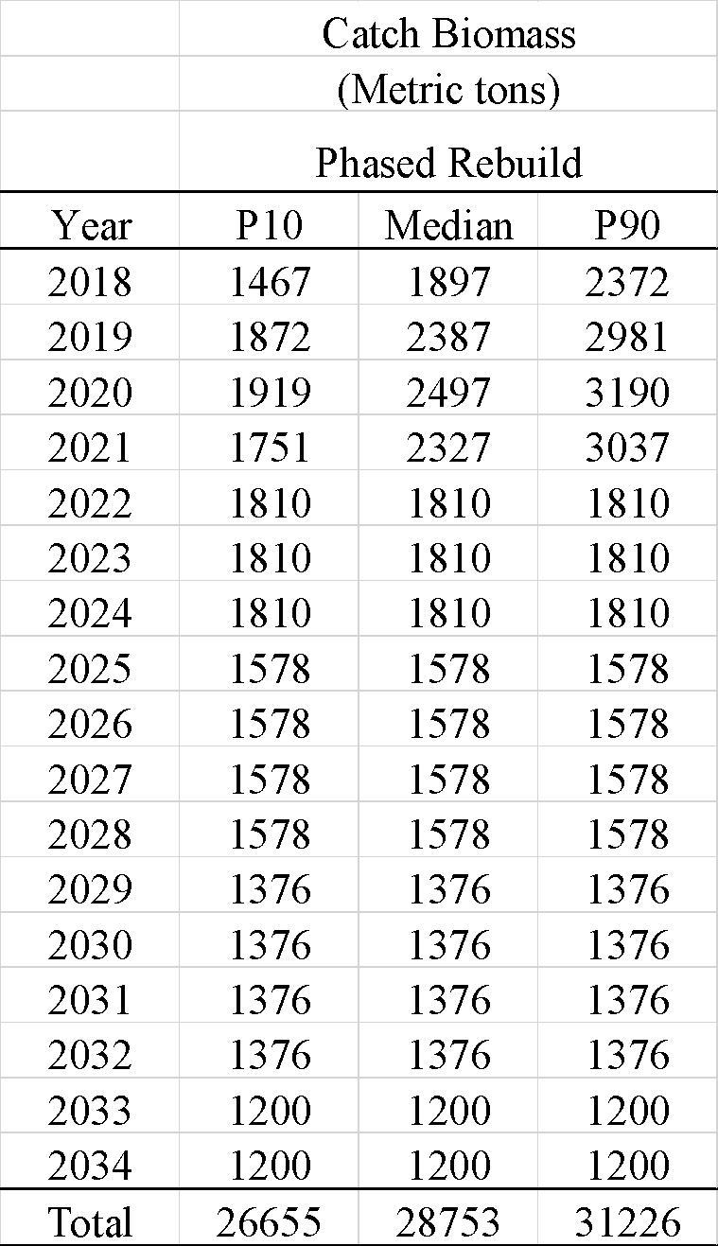

Table 4. The median projected catch biomass time series (thousand mt) under the constant F rebuilding scenario along with the 10th (P10) and 90th (P90) percentiles of the catch biomass distributions.

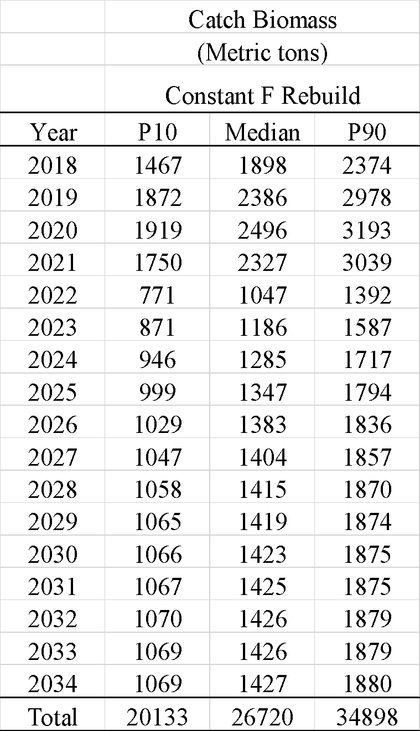

Table 5. The median projected catch biomass time series (thousand mt) under the constant quota rebuilding scenario along with the 10th (P10) and 90th (P90) percentiles of the catch biomass distributions.

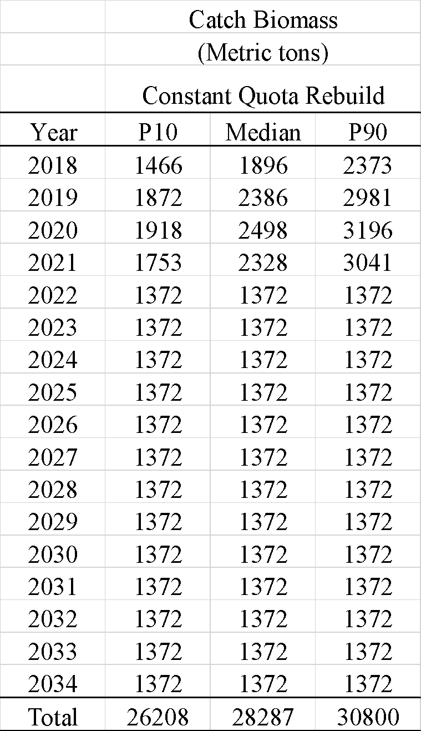

Table 6a. Comparison of the central tendencies of the projected catch biomass time series (median catch, thousand mt) under the phased, constant F, and constant quota rebuilding scenarios along with the average of the median catch, total of the median catch, and percent of the maximum total catch during 2022–2034.

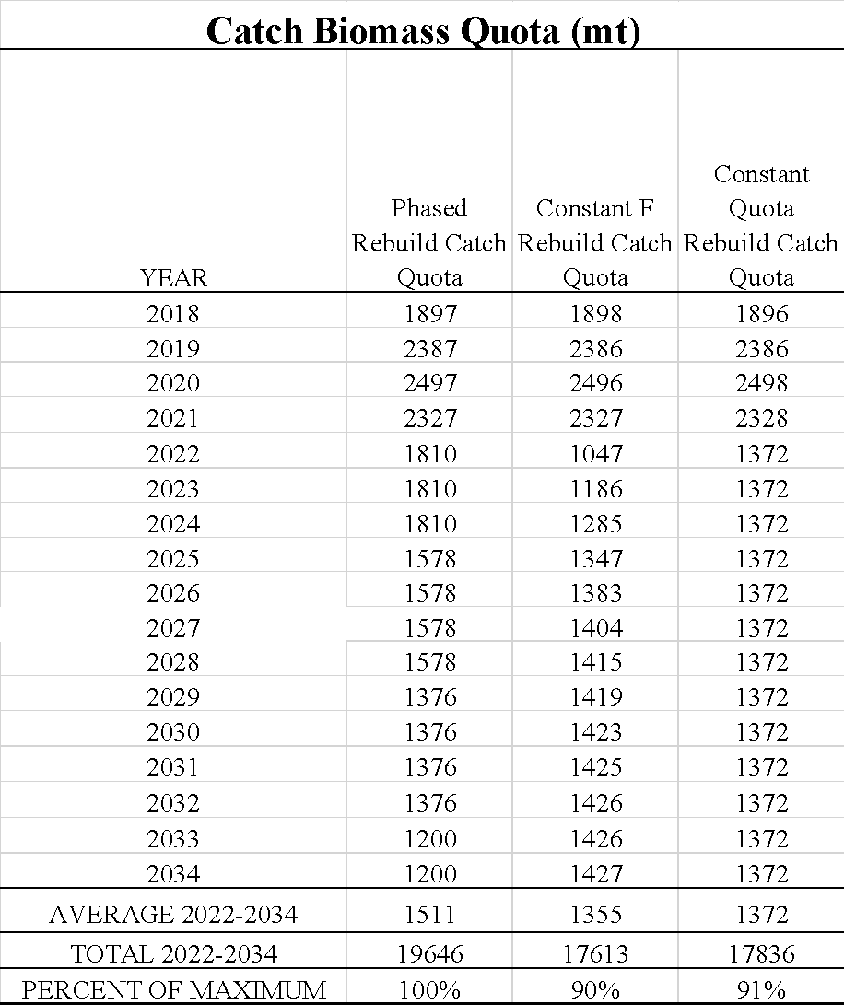

Table 6b. Comparison of the central tendencies of the projected catch biomass time series (median catch, thousand mt) based on a 66% target probability of rebuilding success under the phased, constant F, and constant quota rebuilding scenarios along with the average of the median catch, total of the median catch and percent of the maximum total catch during 2022–2034.

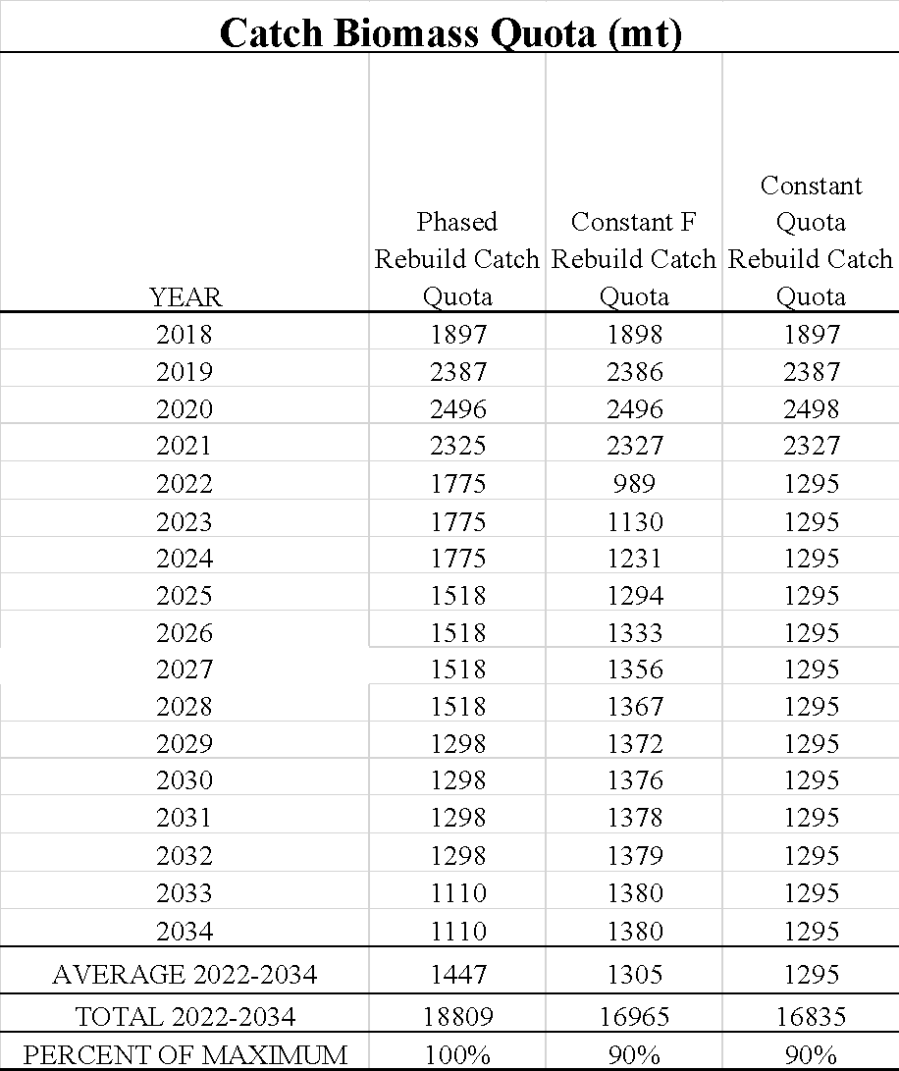

Table 7. The median projected spawning biomass time series (thousand mt) under the phased rebuilding scenario along with the 10th (P10) and 90th (P90) percentiles of the spawning biomass distributions.

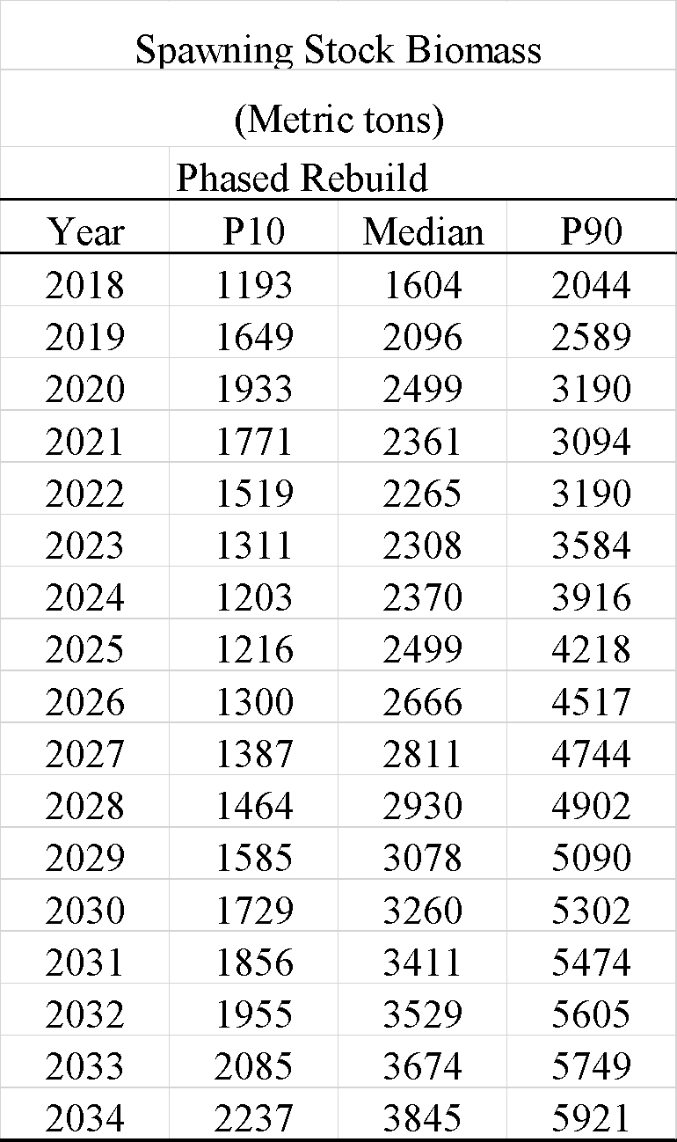

Table 8. The median projected spawning biomass time series (thousand mt) under the constant F rebuilding scenario along with the 10th (P10) and 90th (P90) percentiles of the spawning biomass distributions.

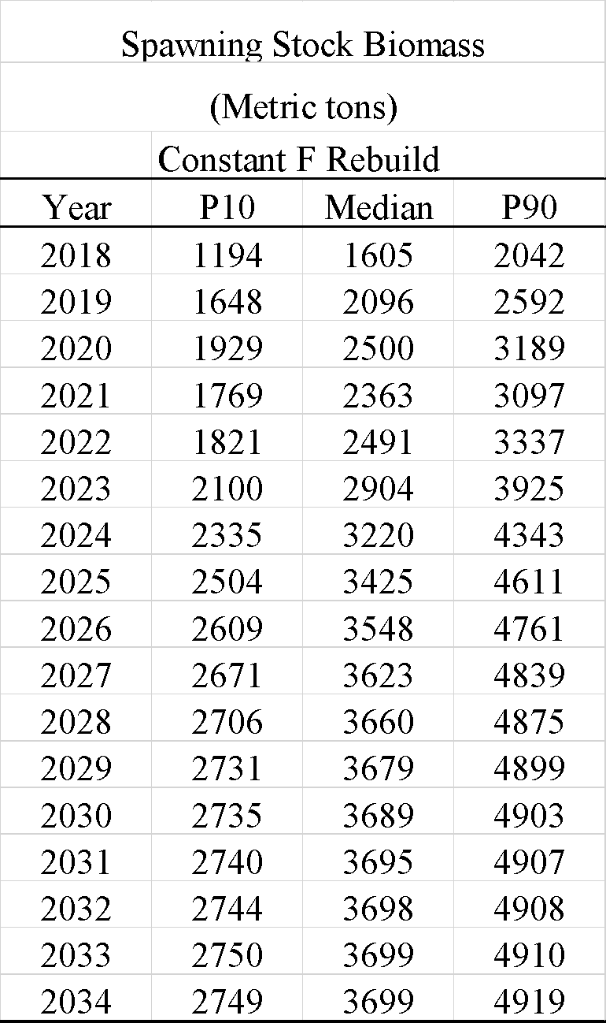

Table 9. The median projected spawning biomass time series (thousand mt) under the constant quota rebuilding scenario along with the 10th (P10) and 90th (P90) percentiles of the spawning biomass distributions.

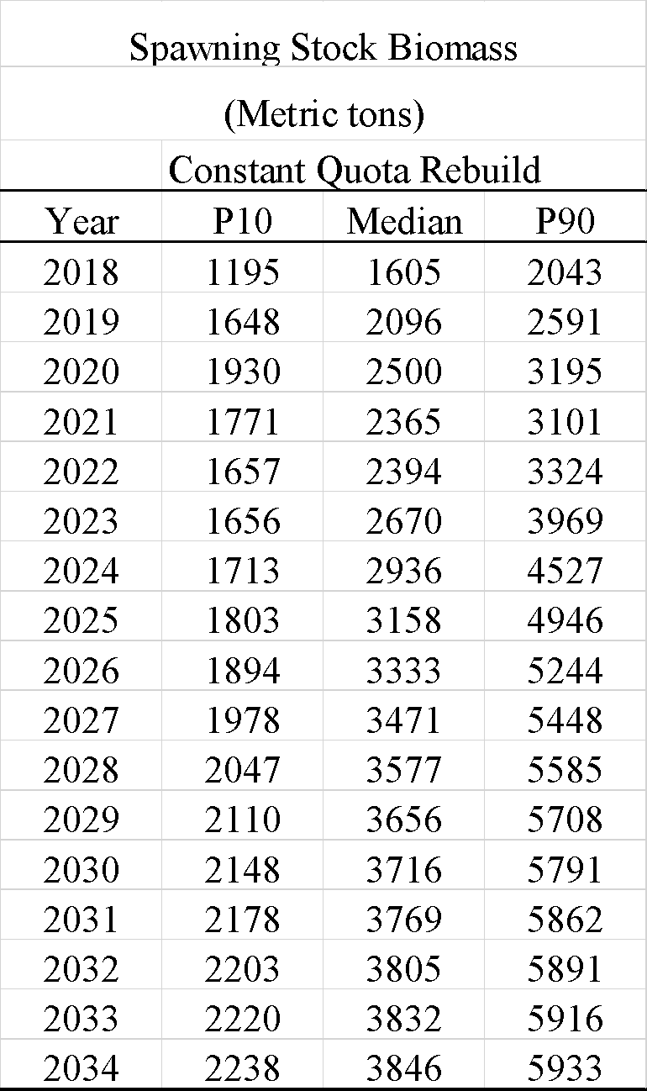

Table 10a. Comparison of the central tendencies of the projected spawning biomass time series (median spawning biomass, thousand mt) under the phased, constant F, and constant quota rebuilding scenarios along with the average, total, and percent of the maximum, of the median spawning biomass during 2022–2034.

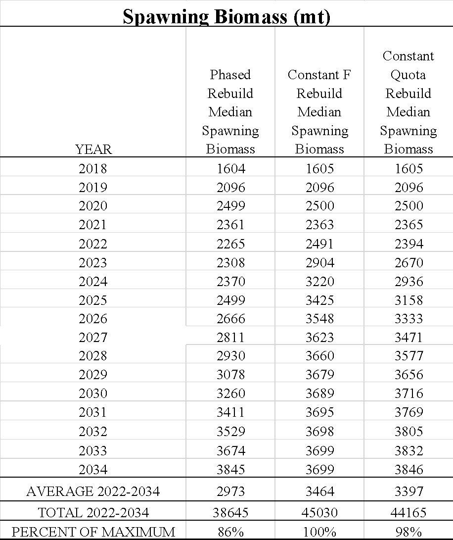

Table 10b. Comparison of the central tendencies of the projected spawning biomass time series (median spawning biomass, thousand mt) based on a 66% target probability of rebuilding success under the phased, constant F, and constant quota rebuilding scenarios along with the average, total, and percent of the maximum, of the median spawning biomass during 2022–2034.

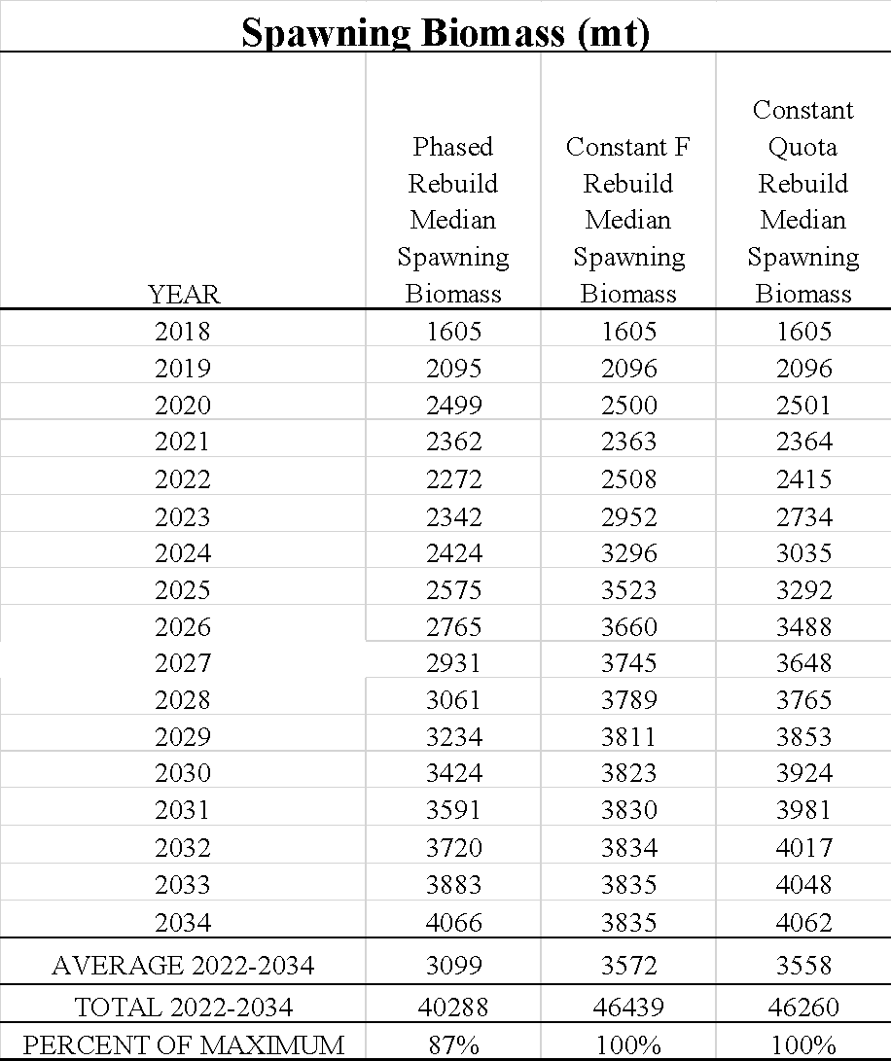

Table 11. The median projected annual fishing mortality time series under the phased rebuilding scenario along with the 10th (P10) and 90th (P90) percentiles of the fishing mortality distributions.

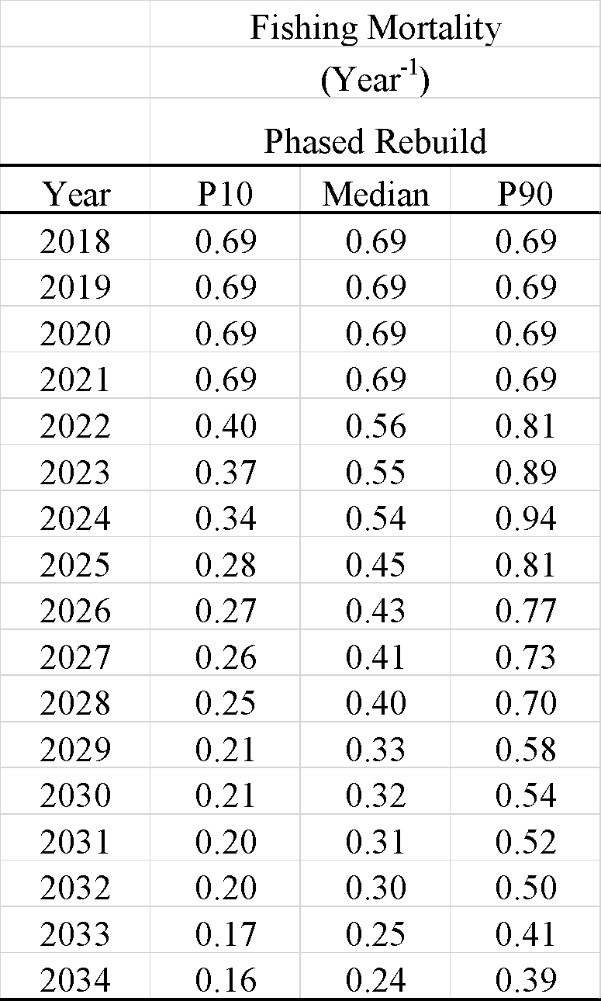

Table 12. The median projected annual fishing mortality time series under the constant F rebuilding scenario along with the 10th (P10) and 90th (P90) percentiles of the fishing mortality distributions.

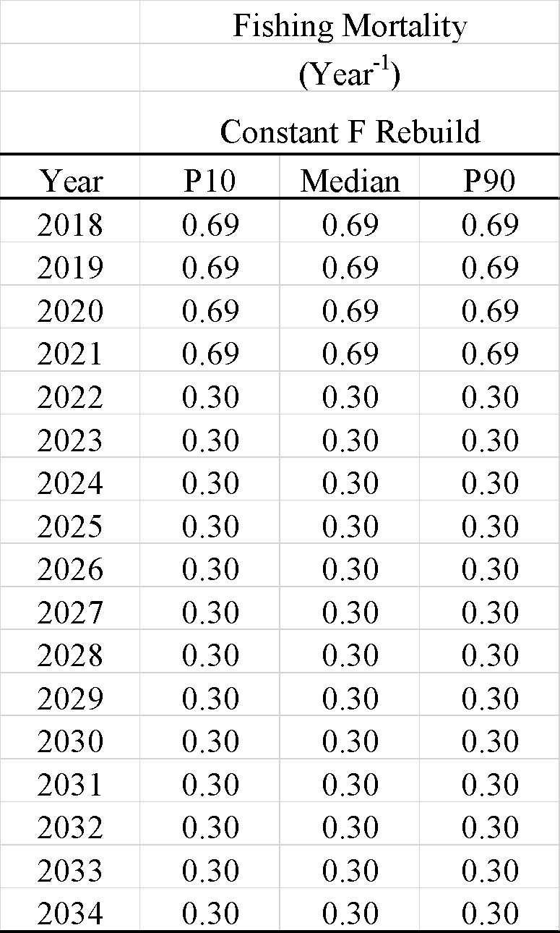

Table 13. The median projected annual fishing mortality time series under the constant quota rebuilding scenario along with the 10th (P10) and 90th (P90) percentiles of the fishing mortality distributions.

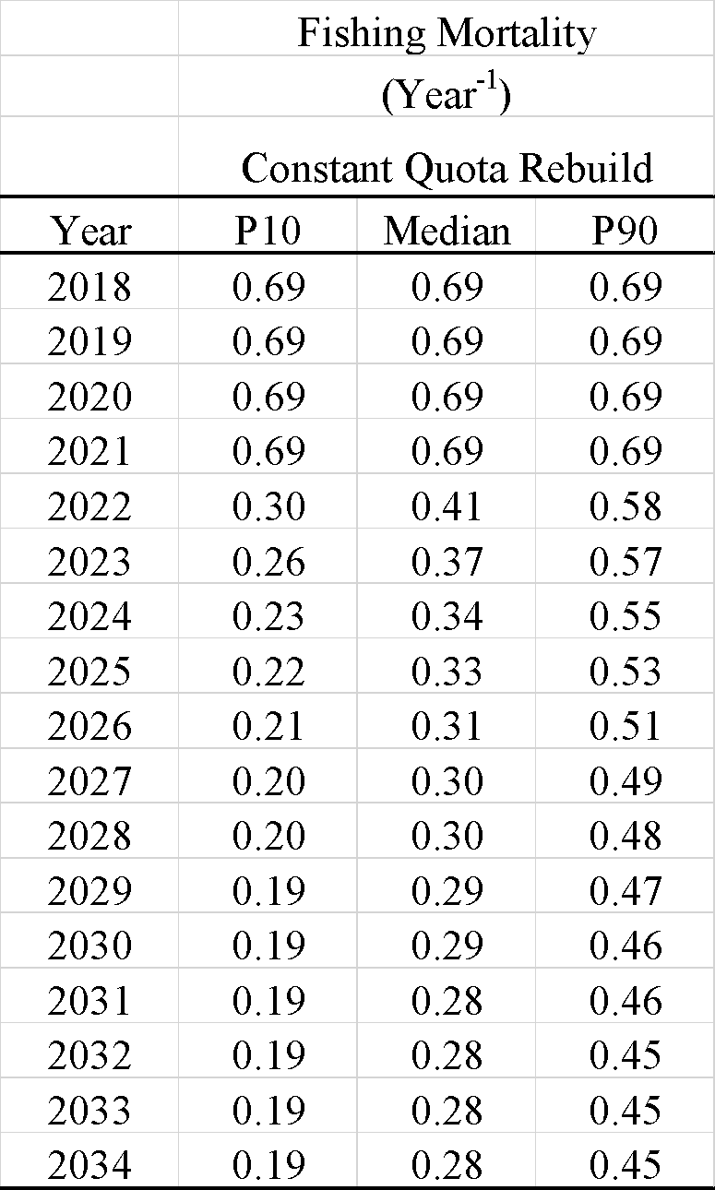

Table 14a. Comparison of the central tendencies of the projected fishing mortality time series (median fishing mortality, yr-1) under the phased, constant F, and constant quota rebuilding scenarios along with the average of the median fishing mortality during 2022–2034.

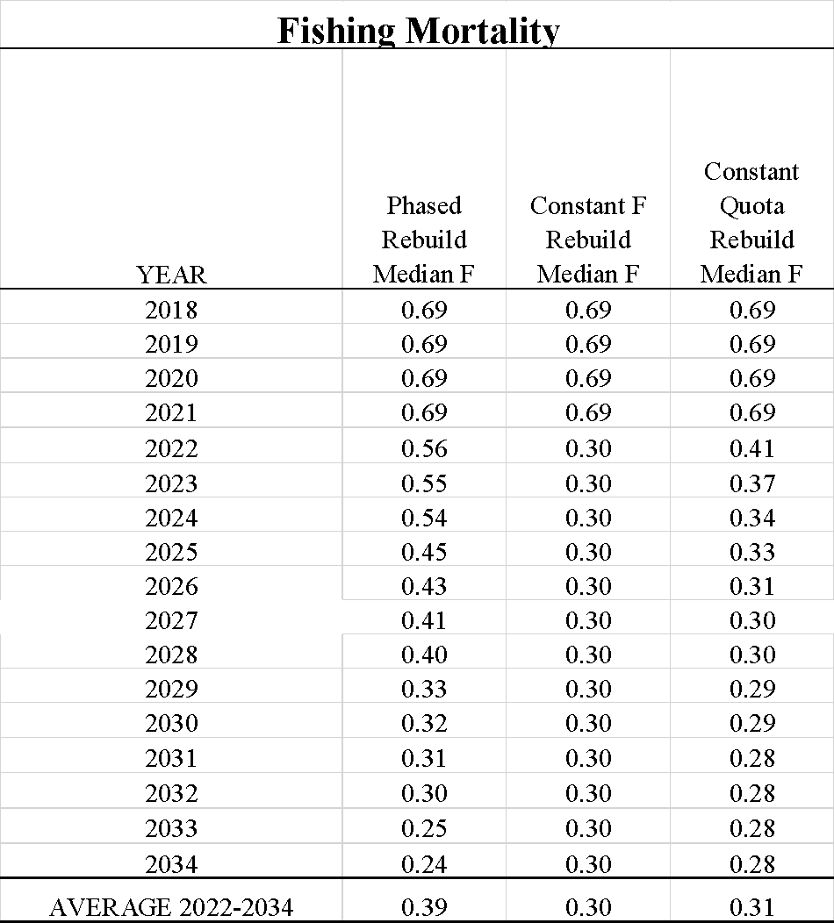

Table 14b. Comparison of the central tendencies of the projected fishing mortality time series (median fishing mortality, yr-1) based on a 66% target probability of rebuilding success under the phased, constant F, and constant quota rebuilding scenarios along with the average of the median fishing mortality during 2022–2034.

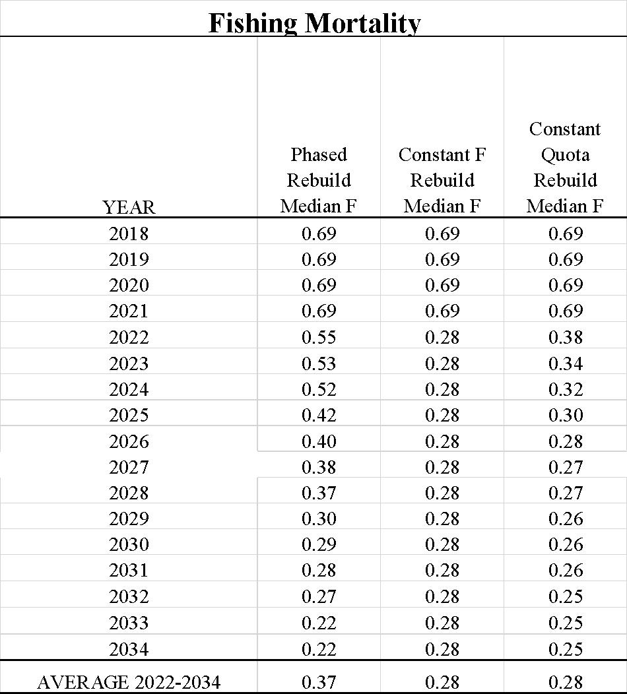

Table 15a. Comparison of the annual probabilities of rebuilding the stock during 2022–2034 under the phased, constant F, and constant quota rebuilding scenarios along with the first year when the probability of rebuilding the stock was greater than or equal to 60%.

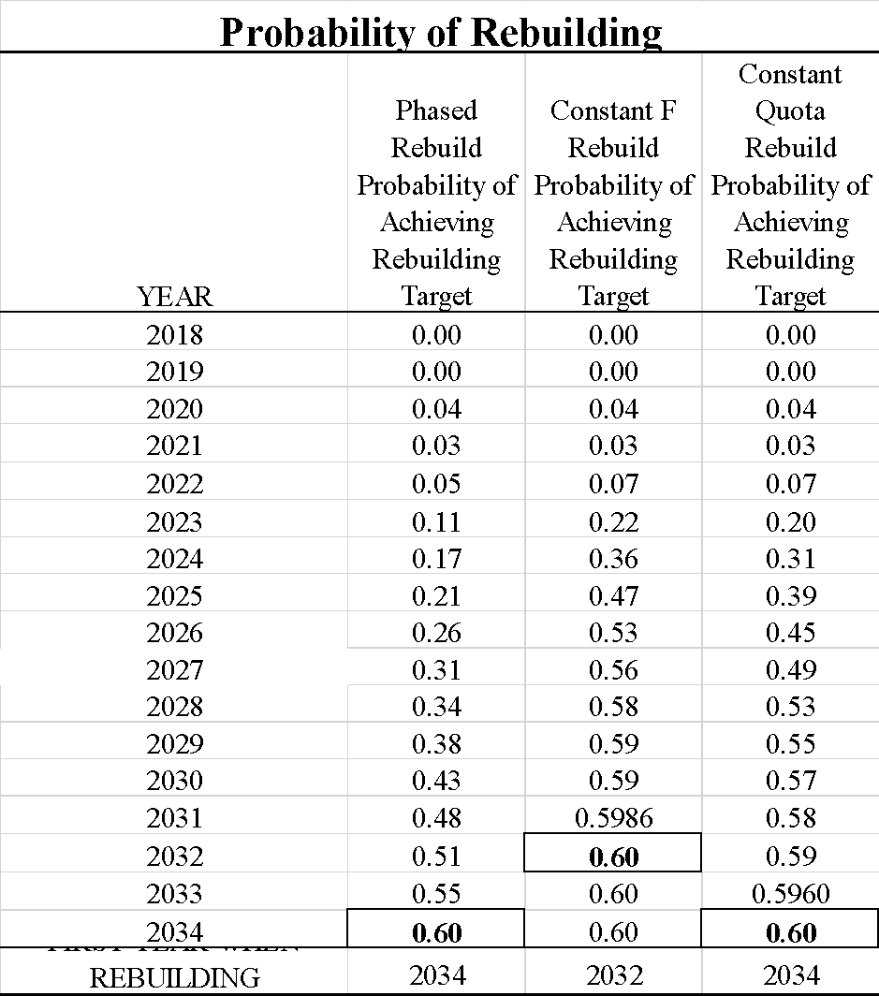

Table 15b. Comparison of the annual probabilities of rebuilding the stock during 2021–2034 based on a 66% target probability of rebuilding success under the phased, constant F, and constant quota rebuilding scenarios along with the first year when the probability of rebuilding the stock was greater than or equal to 66% (cells with thick borders).

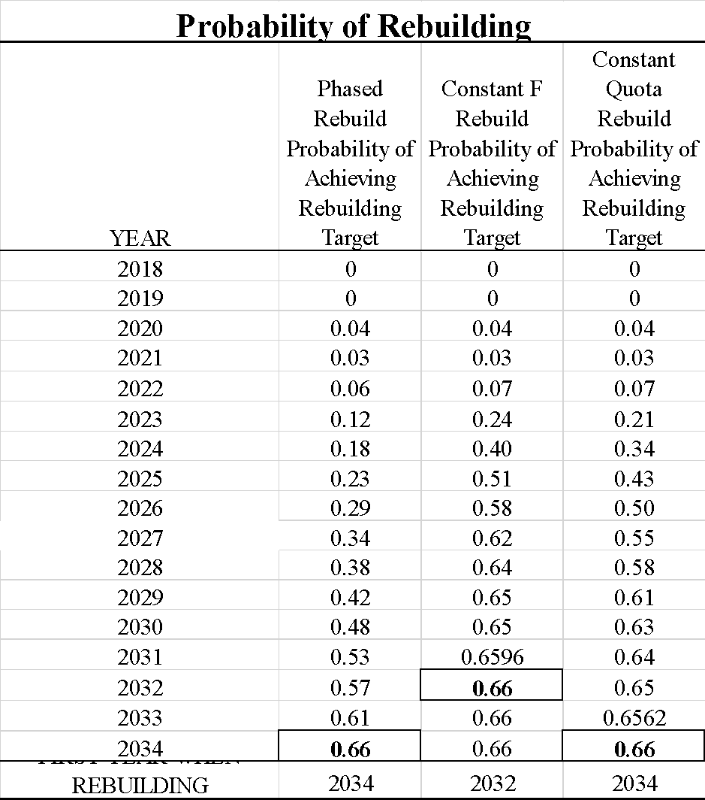

Table 16a. Comparison of the annual probabilities of the stock experiencing overfishing during 2022–2034 under the phased, constant F, and constant quota rebuilding scenarios along with the first year when the probability of overfishing the stock relative to FMSY was less than or equal to 50% (cells with thick borders).

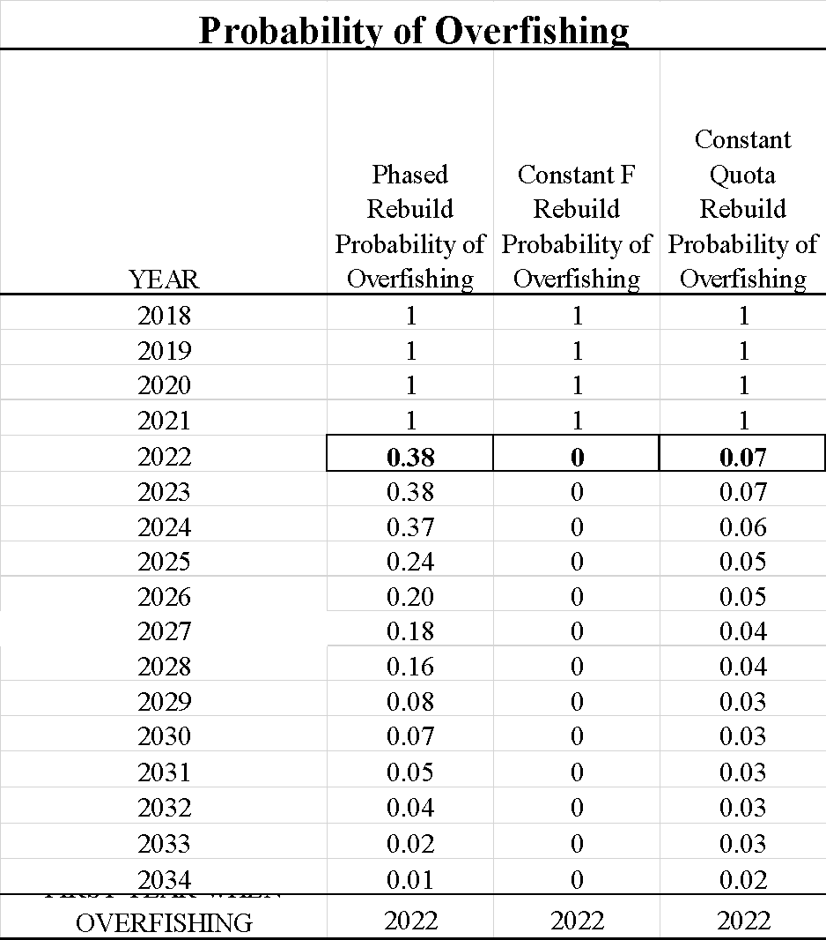

Table 16b. Comparison of the annual probabilities of the stock experiencing overfishing during 2022–2034 based on a 66% target probability of rebuilding success under the phased, constant F, and constant quota rebuilding scenarios along with the first year when the probability of overfishing the stock relative to FMSY was less than or equal to 50% (cells with thick borders).

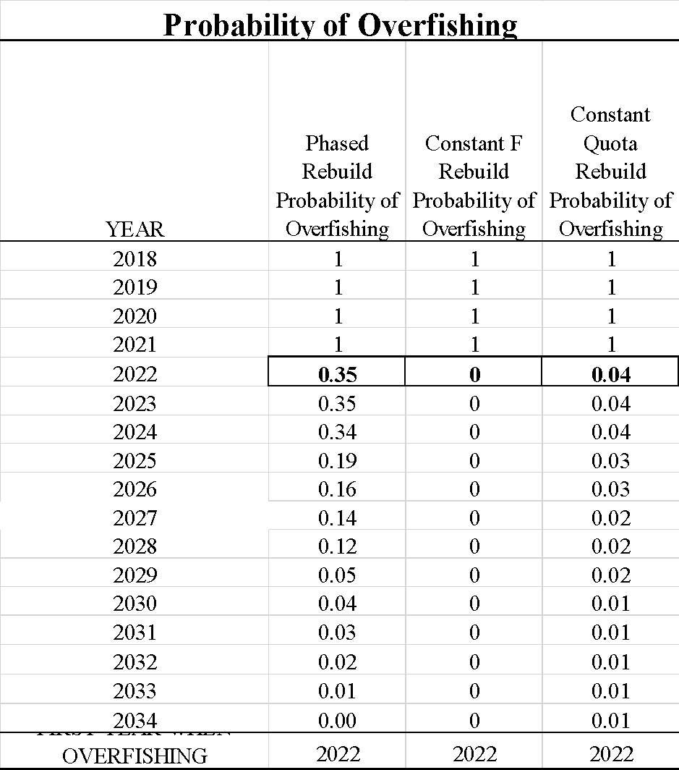

Figure 1. Estimates of annual population biomass (age-1 and older, solid line) and unfished population biomass (dashed line) as well as annual reported catch biomass of WCNPO striped marlin during 1975-–2017 for the revised 2021 stock assessment.

50000

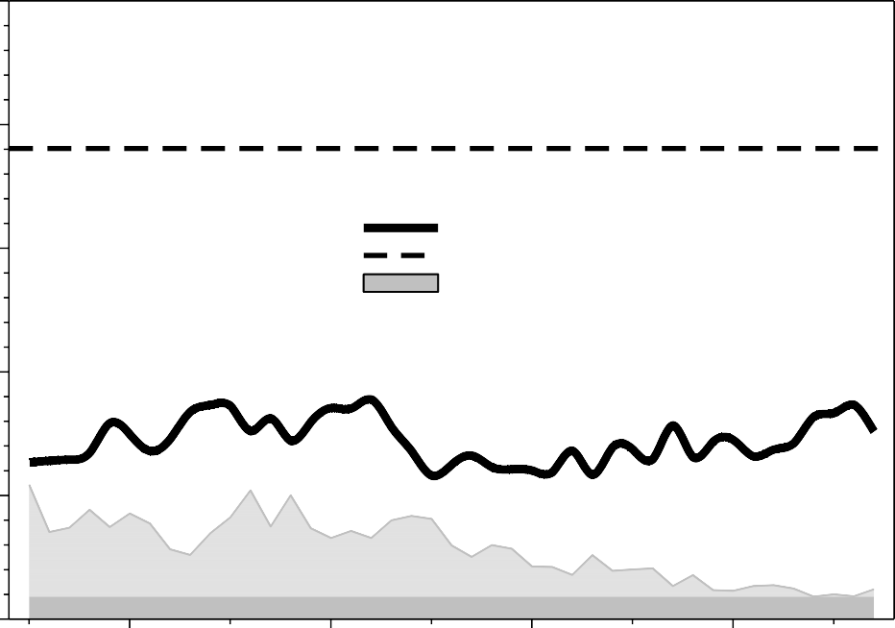

Population Biomass Unfished Population Biomass Catch Biomass

40000

30000

Biomass (mt)

20000

10000

0

1975

1980

1985

1990

1995

Year

2000

2005

2010

2015

Figure 2. Time series of estimates of spawning biomass of Western and Central North Pacific striped marlin (*Kajikia audax*) from the revised 2021 stock assessment (solid black circles) with 80% confidence intervals relative to BMSY (dashed green line) and unfished spawning biomass (solid blue triangle with 80% confidence interval).

Western and Central North Pacific Striped Marlin Estimates of Spawning Biomass Relative to BMSY, 1975-2017

25000



20000

Spawning Biomass (mt)

15000

5000

BMSY

0

1970

1975

1980

1985

1990

1995

2000

2005

2010

2015

Year

Figure 3. Time series of estimates of fishing mortality rates (average for age 3-12, year-1) for Western and Central North Pacific striped marlin (*Kajikia audax*) from the revised 2021 stock assessment (solid black circles) with 80% confidence intervals relative to FMSY (dashed red line).

Western and Central North Pacific Striped Marlin Estimates of Fishing Mortality Relative to FMSY, 1975-2017

2.5



2.0

Fishing Mortality (Average ages 3-12)

1.5

1.0

0.5

FMSY

0.0

1975

1980

1985

1990

1995

Year

2000

2005

2010

2015

Figure 4. Boxplots by age group of the bootstrap replicates of population numbers at age from the revised 2021 stock assessment used in each of the projection analyses.

1000



100

Numbers at Age (thousands)

10

1

0.1

0.01

0.001

1 2 3 4 5 6 7 8 9 10

## Age Class

11 12 13 14 15

Figure 5. Stock-recruitment dynamics of WCNPO striped marlin as estimated in the revised 2021 benchmark stock assessment including the estimated stock recruitment curve (solid black line), recruitment during 1976–2011 (green triangle), recruitment during 2012–2016 (open circle), and recruitment during 2017–2018 (blue square).

1000

BMSY BRebuild

800



Estimated Stock Recruitment Curve Recruitment 1976-2011

Recruitment 2012-2016

Recruitment 2017-2018

20% of Unfished Spawning Biomass Spawning Biomass to Produce MSY

Recruitment (thousands of age-1 recruits)

600

400

200

0

0 2000

4000 6000 8000 10000 12000

Spawning Biomass (metric tons)

Figure 6. Time series of recruitment estimates (age-1 fish, solid black circles) for WCNPO striped marlin with 80% confidence intervals along with the expected magnitude of recruitment under the short-term (solid red line) and long-term (dashed green line) scenarios from the revised 2021 stock assessment.

1400



Estimated Recruitment

Average Recruitment Long-Term Scenario Average Recruitment Short-Term Scenario

1200

Recruitment (thousands of age-1 recruits)

1000

800

600

400

200

0

1975 1980 1985 1990 1995 2000 2005 2010 2015 2020

Year

Figure 7. Empirical cumulative distribution functions of recruitment of WCNPO striped marlin under the short-term (dashed blue line) and long-term (solid green line) recruitment scenarios from the revised 2021 stock assessment.

1.0

Short-term Recruitment Long-term Recruitment

0.8

Cumulative Probability

0.6

0.4

0.2

0.0

0 200 400 600 800 1000

# Recruitment (000s age-1 fish)

Figure 8. The time series of median catch biomass quotas to rebuild the stock under the phased rebuilding scenario along with the 10th (P10) and 90th (P90) percentiles of the annual catch biomass distributions relative to the recent average yield during 2015–2017 of 2,077 mt. A sample of 10 simulated catch trajectories are shown for comparison (light blue lines).

5000

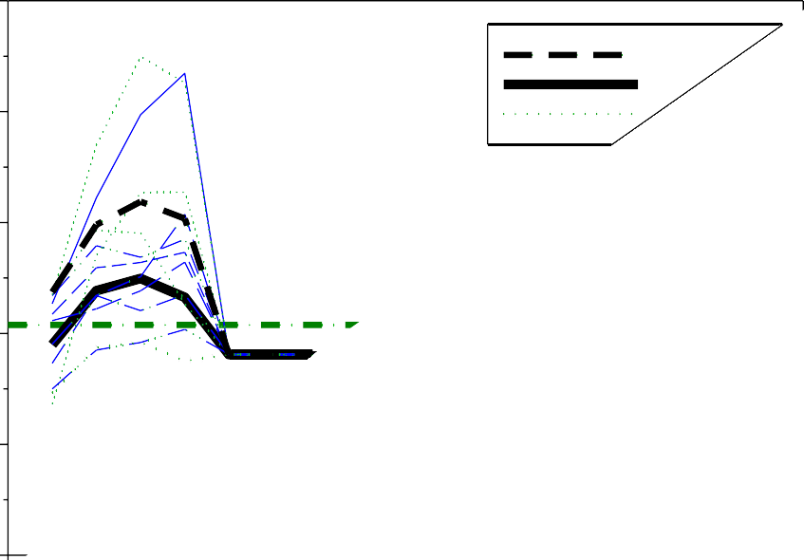

P90

Me

4000

Catch Biomass (mt)

3000

2000

1000

0

Figure 9. The time series of median catch biomass quotas to rebuild the stock under the constant F rebuilding scenario along with the 10th (P10) and 90th (P90) percentiles of the annual catch biomass distributions relative to the recent average yield during 2015–2017 of 2,077 mt. A sample of 10 simulated catch trajectories are shown for comparison (light blue lines).

5000

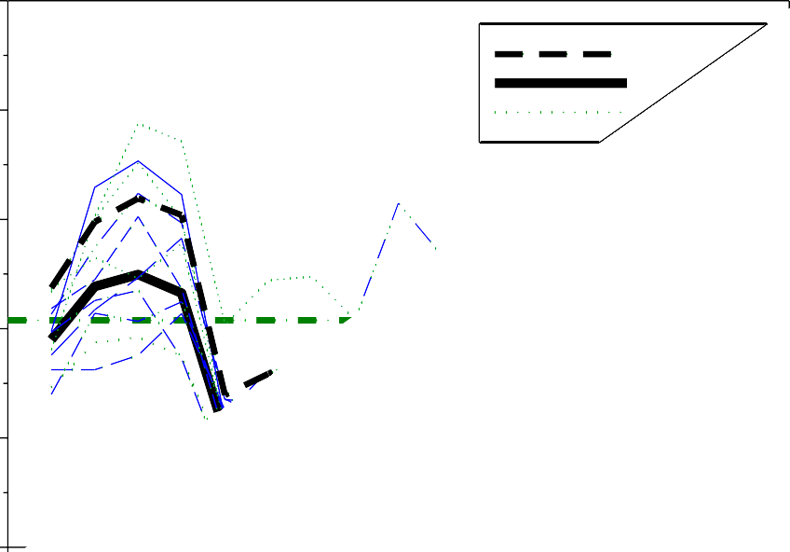

P90

Me

4000

Catch Biomass (mt)

3000

2000

1000

0

Figure 10. The time series of median catch biomass quotas to rebuild the stock under the constant quota-rebuilding scenario along with the 10th (P10) and 90th (P90) percentiles of the annual catch biomass distributions relative to the recent average yield during 2015–2017 of 2,077 mt. A sample of 10 simulated catch trajectories are shown for comparison (light blue lines).

5000

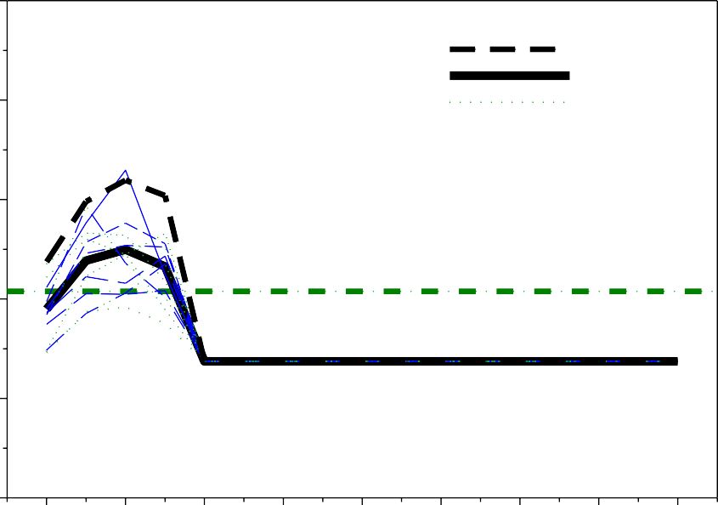

P90

Median P10

4000

Catch Biomass (mt)

3000

2000

Recent Average

1000

0

2018 2020 2022 2024 2026 2028 2030 2032 2034

##### Year

Figure 11. Comparison of the time series of median catch biomass quotas to rebuild the stock under the phased, constant F, and constant quota rebuilding scenarios relative to the recent average yield during 2015–2017 of 2,077 mt.

4000



3000



Phased Constant F Constant Quota

Median Catch Biomass (mt)

2000

Recent Average

1000

0

2018 2020 2022 2024 2026 2028 2030 2032 2034

##### Year

Figure 12. The time series of median spawning biomasses to rebuild the stock under the phased rebuilding scenario along with the 10th (P10) and 90th (P90) percentiles of the annual spawning biomass distributions relative to the rebuilding target of 3,493 mt. A sample of 10 simulated spawning biomass trajectories is shown for comparison (light blue lines).

14000

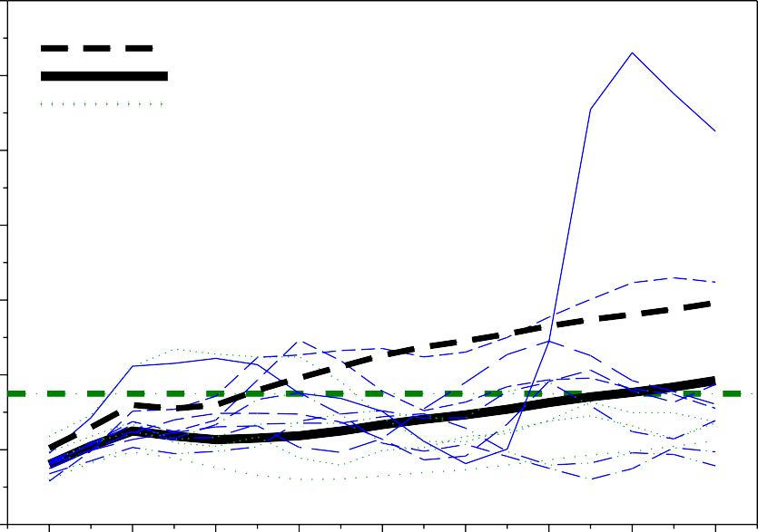

P90

Median P10

12000

Spawning Biomass (mt)

10000

8000

6000

4000

2000

Target

0

2018 2020 2022 2024 2026 2028 2030 2032 2034

###### Year

Figure 13. The time series of median spawning biomasses to rebuild the stock under the constant F rebuilding scenario along with the 10th (P10) and 90th (P90) percentiles of the annual spawning biomass distributions relative to the rebuilding target of 3,493 mt. A sample of 10 simulated spawning biomass trajectories are shown for comparison (light blue lines).

10000

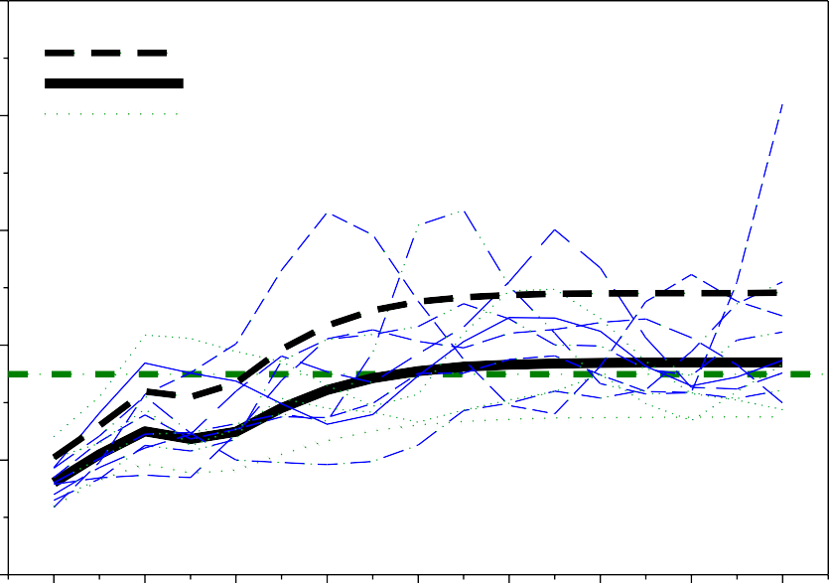

P90

Median P10

8000

Spawning Biomass (mt)

6000

4000

Target

2000

0

2018 2020 2022 2024 2026 2028 2030 2032 2034

###### Year

Figure 14. The time series of median spawning biomasses to rebuild the stock under the constant quota rebuilding scenario along with the 10th (P10) and 90th (P90) percentiles of the annual spawning biomass distributions relative to the rebuilding target of 3,493 mt. A sample of 10 simulated spawning biomass trajectories are shown for comparison (light blue lines).

10000

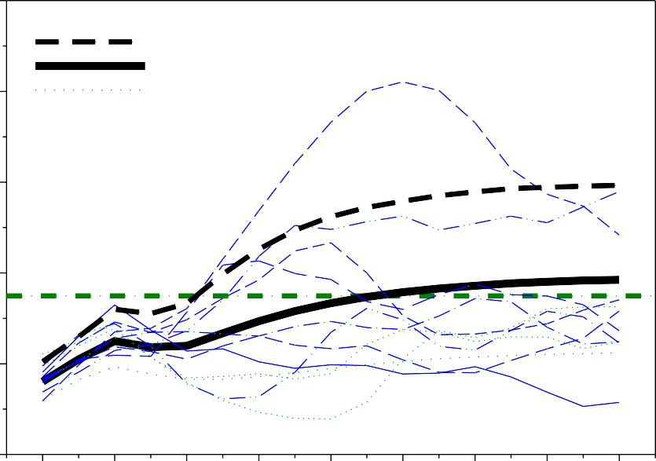

P90

Median P10

8000

Spawning Biomass (mt)

6000

4000

Target

2000

0

2018 2020 2022 2024 2026 2028 2030 2032 2034

###### Year

Figure 15. Comparison of the time series of median spawning biomasses to rebuild the stock under the phased, constant F, and constant quota rebuilding scenarios relative to the rebuilding target of 3,493 mt.

5000



Phased Quota Constant F Constant Quota

4000

Median Spawning Biomass (mt)

Target

3000

2000

1000

2018 2020 2022 2024 2026 2028 2030 2032 2034

##### Year

Figure 16. The time series of median fishing mortalities to rebuild the stock under the phased rebuilding scenario along with the 10th (P10) and 90th (P90) percentiles of the annual fishing mortality distributions relative to the potential overfishing reference point of FMSY=0.61. A sample of 10 simulated fishing mortality trajectories are shown for comparison (light blue lines).

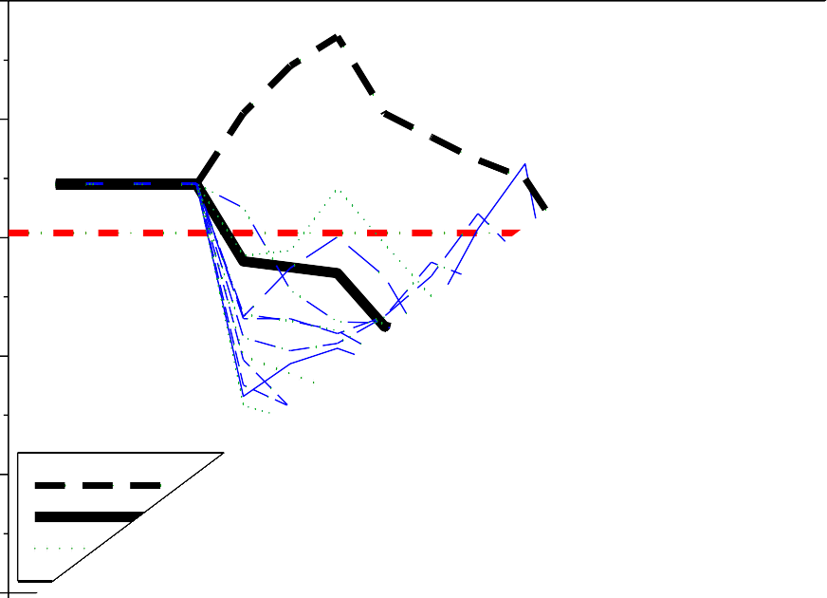1.0

0.8

Fishing Mortality (yr-1)

0.6

0.4

0.2

0.0

Figure 17. The time series of median fishing mortalities to rebuild the stock under the constant F rebuilding scenario along with the 10th (P10) and 90th (P90) percentiles of the annual fishing mortality distributions relative to the potential overfishing reference point of FMSY=0.61. A sample of 10 simulated fishing mortality trajectories are shown for comparison (light blue lines).

1.0

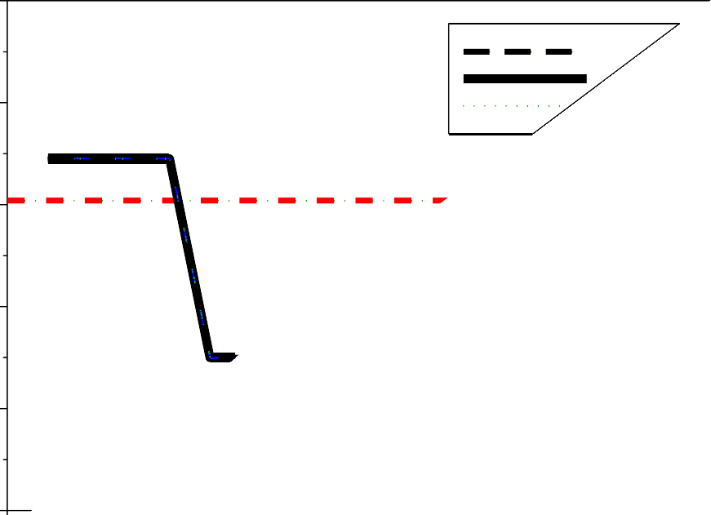

P9

0.8

Fishing Mortality (yr-1)

0.6

0.4

0.2

0.0

Figure 18. The time series of median fishing mortalities to rebuild the stock under the constant quota rebuilding scenario along with the 10th (P10) and 90th (P90) percentiles of the annual fishing mortality distributions relative to the potential overfishing reference point of FMSY=0.61. A sample of 10 simulated fishing mortality trajectories are shown for comparison (light blue lines).

1.0

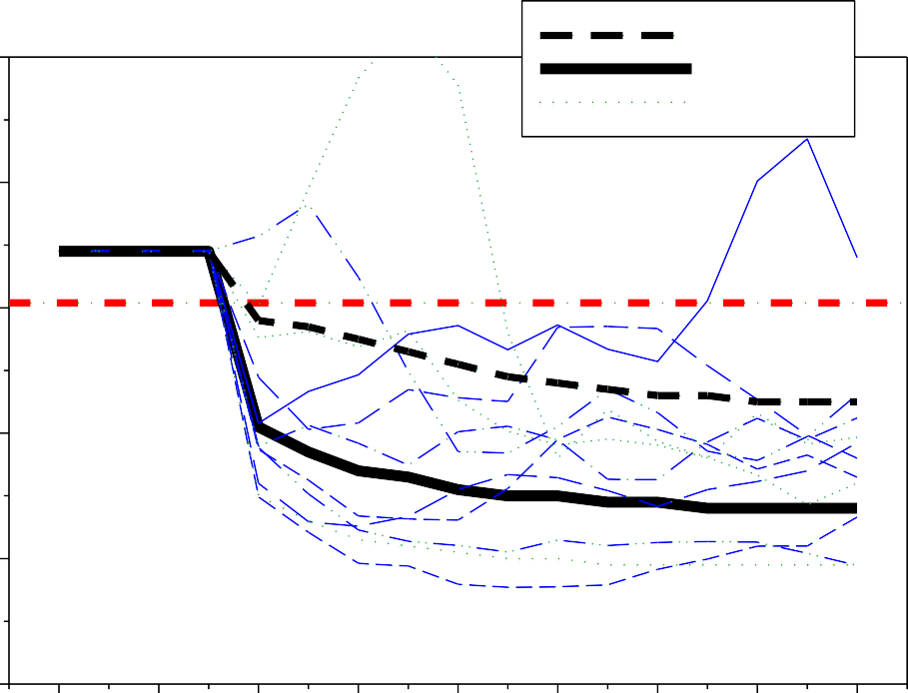

P90

Median P10

0.8

Fishing Mortality (yr-1)

0.6 FMSY

0.4

0.2

0.0

2018 2020 2022 2024 2026 2028 2030 2032 2034

## Year

Figure 19. Comparison of the time series of median fishing mortalities to rebuild the stock under the phased, constant F, and constant quota rebuilding scenarios relative to the potential overfishing reference point of FMSY=0.61.

1.0



Phased Constant F Constant Quota

0.8

Median Fishing Mortality (yr-1)

0.6 FMSY

0.4

0.2

0.0

2018 2020 2022 2024 2026 2028 2030 2032 2034

### Year

Figure 20. Annual probabilities of achieving the rebuilding target of 3,493 mt of spawning biomass with at least 60% probability during 2022–2034 under the phased rebuilding scenario.

1.0

Probability of Achieving Biomass Target

0.8

0.6

Target Probability

0.4

0.2

0.0

2018 2020 2022 2024 2026 2028 2030 2032 2034

###### Year

Figure 21. Annual probabilities of achieving the rebuilding target of 3,493 mt of spawning biomass with at least 60% probability during 2022–2034 under the constant F rebuilding scenario.

1.0

Probability of Achieving Biomass Target

0.8

0.6

Target Probability

0.4

0.2

0.0

2018 2020 2022 2024 2026 2028 2030 2032 2034

###### Year

Figure 22. Annual probabilities of achieving the rebuilding target of 3,493 mt of spawning biomass with at least 60% probability during 2022–2034 under the constant quota-rebuilding scenario.

1.0

Probability of Achieving Biomass Target

0.8

0.6

Target Probability

0.4

0.2

0.0

2018 2020 2022 2024 2026 2028 2030 2032 2034

###### Year

Figure 23. Comparison of annual probabilities of achieving the rebuilding target of 3,493 mt of spawning biomass with at least 60% probability during 2022–2034 under the phased, constant F, and constant quota rebuilding scenarios.

1.0



Probability of Achieving Biomass Target

0.8



Phased Contant F Constant Quota

0.6

Target Probability

0.4

0.2

0.0

2018 2020 2022 2024 2026 2028 2030 2032 2034

###### Year

Figure 24. Annual probabilities of exceeding the potential overfishing reference point of FMSY=0.61 during 2022–2034 under the phased rebuilding scenario relative to the even odds reference of not overfishing (red dash-dot line).

1.0

0.8

Probability of Overfishing

0.6

0.4

Even Odds

0.2

0.0

2018 2020 2022 2024 2026 2028 2030 2032 2034

### Year

Figure 25. Annual probabilities of exceeding the potential overfishing reference point of FMSY=0.61 during 2022–2034 under the constant F rebuilding scenario relative to the even odds reference of not overfishing (red dash-dot line).

1.0

0.8

Probability of Overfishing

0.6

Even Odds

0.4

0.2

0.0

2018 2020 2022 2024 2026 2028 2030 2032 2034

### Year

Figure 26. Annual probabilities of exceeding the potential overfishing reference point of FMSY=0.61 during 2022–2034 under the constant quota rebuilding scenario relative to the even odds reference of not overfishing (red dash-dot line).

1.0

0.8

Probability of Overfishing

0.6

Even Odds

0.4

0.2

0.0

2018 2020 2022 2024 2026 2028 2030 2032 2034

### Year

Figure 27. Comparison of the annual probabilities of exceeding the potential overfishing reference point of FMSY=0.61 during 2022–2034 under the phased, constant F, and constant quota rebuilding scenarios relative to the even odds reference of not overfishing (red dash-dot line).

1.0



Phased Contant F Constant Quota

0.8

Probability of Overfishing

0.6

Even Odds

0.4

0.2

0.0

2018 2020 2022 2024 2026 2028 2030 2032 2034

Year