B.Tech CS (AI/ML) (III YEAR – V SEM) (2025–26)
DEPARTMENT OF COMPUTER SCIENCE ENGINEERING & APPLICATIONS

GLA UNIVERSITY
17km Stone, NH-2, Mathura-Delhi Road, P.O. Chaumuhan, Mathura – 281406
(Uttar Pradesh) India
Project Title: eBPF-Shield AI: Kernel-Level Cloud-Native Runtime Threat & Container Escape Engine
Team Leader: | Arpit Sharma | UR: 2415500099
Team Member 1: | Aryan Gupta | UR: 2415500102
Team Member 2: | Ananya Mishra | UR: 2415500068
Mentor Name: | Sanjana Shaw Mam
Signature :

Project Synopsis
  - eBPF-Shield AI: Kernel-Level Cloud-Native Runtime Threat & Container Escape Engine

Cover
Field | Details
Project title | eBPF-Shield AI: Kernel-Level Cloud-Native Runtime Threat & Container Escape Engine
Team | Arpit Sharma, Aryan Gupta, Ananya Mishra
Institute / course | GLA University, B.Tech CS (AI/ML)
Domain | eBPF, Kubernetes, Container Security, Machine Learning
GitHub Repository | https://github.com/PILOT-SHARMA/ebpf-shield-ai
Version / date | v1.0 / September 2026

1. Overview
- Problem: Container attacks are difficult to detect using normal application-level monitoring.
- Goal: Monitor container activity from the Linux kernel and detect suspicious behavior quickly.
- Main idea: Use eBPF for monitoring, machine learning for anomaly detection and a dashboard for alerts.
- Non-goal: The project will not replace a complete commercial security platform.
Value proposition: eBPF-Shield AI combines low-overhead kernel monitoring, explainable anomaly detection and Kubernetes-aware response in one academic platform.

2. Scope and Control

2.1 In-scope
- Process, file and network monitoring using eBPF.
- Kubernetes pod and container identification.
- Rule-based and ML-based threat detection.
- Live dashboard, alerts and approved response actions.

2.2 Out-of-scope
- Windows and macOS monitoring.
- Full packet-content inspection.
- Automatic destructive action without approval.

2.3 Assumptions
- The test system supports eBPF.
- Kubernetes information is available.
- Normal workload data is available for ML training.

2.4 Constraints
- Limited project time and attack data.
- Different Linux kernel versions.
- Possible false alerts from ML models.

2.5 Dependencies
- Linux kernel and eBPF tools.
- Docker and Kubernetes.
- FastAPI, PostgreSQL and Next.js.
- Python ML libraries.

2.6 Acceptance Criteria and Sign-off
- Live events should appear within about three seconds.
- Selected attack tests should generate alerts.
- Response actions should require approval and be logged.
- Sensor overhead should remain within the tested limit.
Stakeholder | Decision area | Approval | Date
Sanjana Shaw Mam - Mentor | Scope and final acceptance | ________________ | ________
Arpit Sharma - Team Lead | Release readiness | ________________ | ________

3. Stakeholders and RACI
R = Responsible, A = Accountable, C = Consulted, I = Informed.
Activity | Mentor | Arpit | Aryan | Ananya | Department
Requirements | C | A/R | C | C | I
Architecture and design | C | A/R | R | C | I
eBPF and backend | I | A | R | C | I
ML detection | C | A/R | C | I | I
Frontend and UX | I | A | C | R | I
Testing and documentation | C | A | C | R | I
Release and submission | C | A/R | C | C | I

4. Team and Roles
Member | Role | Responsibilities | Key skills | Availability | Contact
Arpit Sharma | Team Lead / ML | Scope, architecture, anomaly models, integration and reviews | Python, ML, security, Kubernetes | 10 hrs/week | arpit.sharma_cs.aiml24@gla.ac.in
Aryan Gupta | eBPF / Backend | Kernel sensors, collector, FastAPI, database and WebSockets | C/eBPF, Python, APIs, PostgreSQL | 10 hrs/week | aryan.gupta_cs.aiml24@gla.ac.in
Ananya Mishra | Frontend / QA | Dashboard, UX, testing, documentation and demo support | React, TypeScript, testing, writing | 8 hrs/week | ananya.mishra_cs.aiml24@gla.ac.in

5. Week-wise Plan and Assignments
Week / dates | Milestone | Arpit | Aryan | Ananya | Deliverable | Status
1 / 7-13 Sep | Requirements | Finalize scope and metrics | Study eBPF feasibility | User flow and test plan | SRS and backlog | Planned
2 / 14-20 Sep | Architecture | Threat model and ML plan | Probe and API design | UI wireframes | Architecture, ERD, API v1 | Planned
3 / 21-27 Sep | Telemetry | Feature specification | Process/file/network collector | Live-events screen | Telemetry demo | Planned
4 / 28 Sep-4 Oct | Backend | Detection rules | FastAPI, enrichment, database | Alert and detail screens | Integrated backend | Planned
5 / 5-11 Oct | ML detection | Isolation Forest and thresholds | Streaming and model API | Model-result UI | Detection demo | Planned
6 / 12-18 Oct | Feature complete | Autoencoder evaluation | Kubernetes response API | Response and filters | Feature-complete build | Planned
7 / 19-25 Oct | Hardening | Security review and metrics | Performance tuning | Regression and accessibility | Test report | Planned
8 / 26 Oct-1 Nov | Release | Final sign-off and presentation | Deployment support | Manual and final demo | v1.0 submission | Planned

6. Users and UX

6.1 Users
- Security analyst: checks and responds to alerts.
- Platform engineer: monitors Kubernetes workloads.
- Faculty evaluator: reviews the working and results.

6.2 User Flow
FLOW Login → select cluster → view live events → open alert → check evidence → approve or reject response.

6.3 User Stories
- As a security analyst, I want clear alerts with evidence so that I can quickly understand suspicious activity.
- As a platform engineer, I want pod and container details so that I can identify the affected workload.
- As an authorized responder, I want an approval step so that an unsafe action is not performed accidentally.

6.4 Accessibility
- Simple labels and readable colors.
- Keyboard-friendly dashboard.
- Severity shown using text as well as color.

7. Market and Competitors
Competitor | Product | Target users | Key features | Pricing | Strengths | Weaknesses | Our differentiator
Falco | Runtime security | Security teams | Rule-based syscall alerts | Open source | Mature CNCF project | Mostly rule-based | Rules plus ML and project dashboard
Tetragon | eBPF observability | Platform teams | Process/network visibility and enforcement | Open source | Deep Kubernetes context | More complex to deploy | Focused academic workflow
Tracee | Linux runtime security | Researchers and SOC teams | eBPF events and signatures | Open source | Rich event collection | Needs separate product layer | Sensor-to-dashboard prototype
Commercial CNAPP | Enterprise cloud security | Large organizations | Broad cloud security platform | Paid | Support and integrations | High cost and closed design | Transparent and reproducible design

7.2 Positioning
eBPF-Shield AI is an academic prototype that combines kernel monitoring, anomaly detection and Kubernetes response in one understandable system.

8. Objectives and Success Metrics
Objective | Target | KPI | Measurement
O1 - Fast event visibility | p95 event-to-dashboard time <= 3 seconds | p95 latency in seconds | Timestamped event replay
O2 - Useful detection | Detect at least 90% of selected test scenarios | Recall percentage | Labeled attack scenario matrix
O3 - Fewer false alerts | False-positive rate <= 5% on validation data | False-positive rate | Held-out normal workload data
O4 - Low overhead | Average sensor CPU < 3% and memory < 150 MB in reference test | CPU and memory usage | Baseline comparison
O5 - Clear investigation | All high/critical alerts include workload and evidence | Alert completeness percentage | Acceptance checklist

9. Key Features
Feature | Description | Priority | Dependencies | Acceptance criteria
Kernel monitoring | Collect selected process, file and network events | Must | Linux eBPF and collector | Events contain time, process and container details
Context enrichment | Add cluster, namespace, pod, container and image details | Must | Kubernetes API | Event links to the correct workload
Threat detection | Combine rules, Isolation Forest and Autoencoder | Must | Feature pipeline and trained model | Versioned score and reason appear on alerts
Live dashboard | Show live events, filters, alerts and timelines | Must | FastAPI and WebSockets | New alert appears without page refresh
Kubernetes response | Simulate, approve and execute isolation or termination | Should | Kubernetes RBAC | Action requires approval and creates audit record
AI explanation | Summarize alert evidence in simple language | Could | Optional LLM provider | Feature fails safely when provider is unavailable

10. Architecture
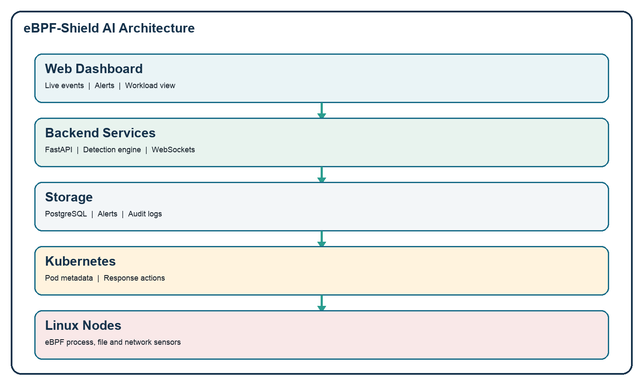
Figure 1. Architecture of eBPF-Shield AI.

Snapshots:
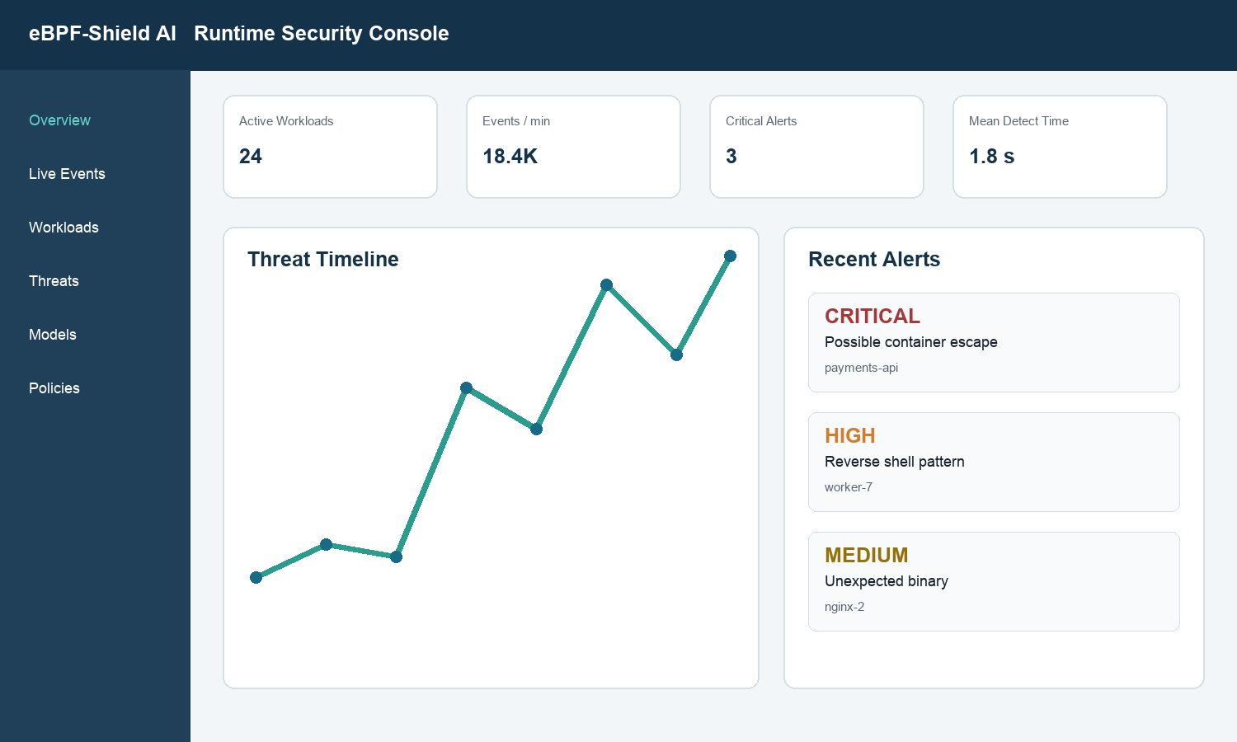
Figure 2. Runtime security dashboard.
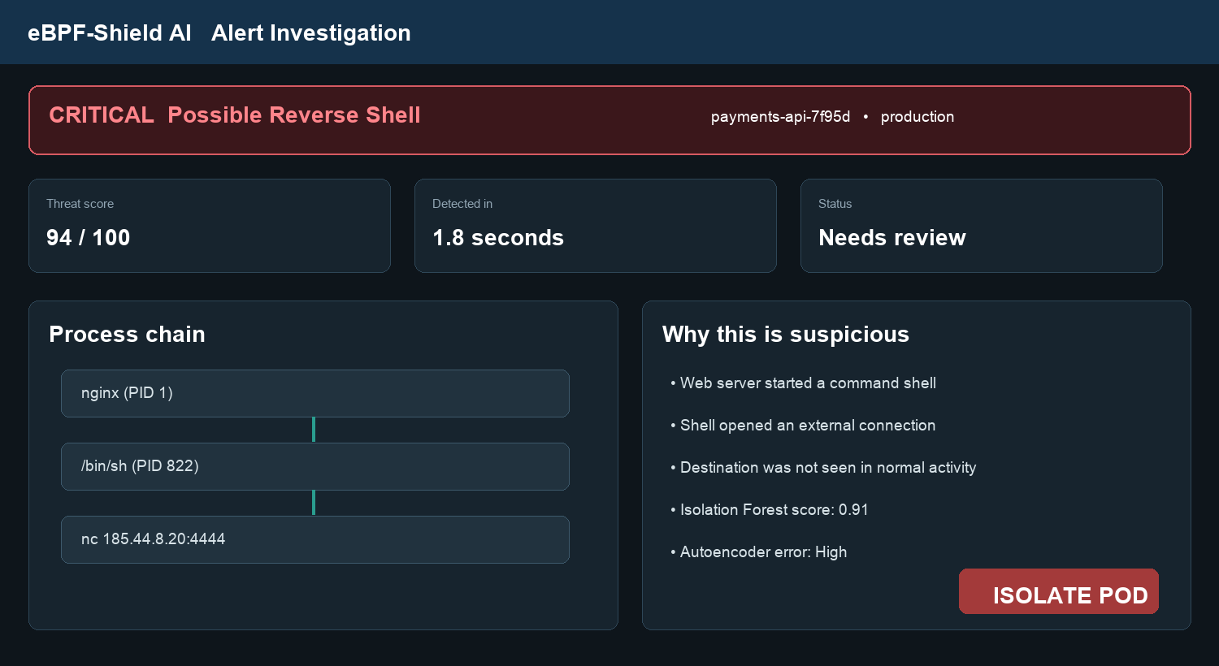
Figure 3. Alert investigation screen.

10.1 High-Level Architecture
- Client: Next.js dashboard for live events, alerts and response.
- Backend: FastAPI services receive and process events.
- Detection engine: Rules and ML models calculate the threat score.
- Database: PostgreSQL stores events, alerts, models and audit records.
- Sensor: eBPF programs collect activity from Linux nodes.
- Kubernetes: Provides workload details and controlled response.

10.2 API Spec Snapshot
Endpoint | Method | Purpose
/api/v1/events/batch | POST | Receive sensor events
/api/v1/events | GET | View runtime events
/api/v1/alerts | GET | View alerts
/api/v1/alerts/{id} | GET | View alert evidence
/api/v1/responses | POST | Request response action
/ws/v1/stream | WS | Send live updates

10.3 Configuration and Secrets
- Secrets are stored outside the source code.
- Environment variables are used for configuration.
- API keys and tokens are not committed to GitHub.
- Access is limited using roles and permissions.

11. Data Design

11.1 Data Dictionary
Entity | Important fields | Type / format | Required | Description | Notes
Workload | id, cluster, namespace, pod, container, image | UUID and strings | Yes | Identifies the monitored Kubernetes workload | Indexes on pod and container IDs
Runtime Event | id, observed_at, type, pid, ppid, executable, workload_id | UUID, timestamp, enum, integers | Yes | Stores normalized process, file or network activity | Time-based index or partition
Alert | id, severity, score, status, rule_id, model_version | UUID, enum and number | Yes | Stores the investigation result | Indexes on time, severity and status
Alert Evidence | alert_id, event_id, reason | UUIDs and text | Yes | Links an alert to the events that support it | Composite key
Model Version | id, algorithm, feature_list, threshold, artifact_hash | UUID, text and JSON | Yes | Records which model produced the score | Immutable model metadata
Response Action | id, alert_id, action, mode, actor, result, created_at | UUID, enum, text and timestamp | Yes | Records simulation, approval and execution | Append-only history
Audit Log | id, actor, action, object, timestamp | UUID, strings and timestamp | Yes | Records important user and system actions | Restricted access

11.2 Schemas and Migrations
- SQLAlchemy models define the database schema.
- Alembic manages versioned schema changes.
- UUIDs identify records and UTC is used for timestamps.
- JSONB stores optional event fields when required.

11.3 Privacy, Retention, Backup and DR
- Only required event information is stored.
- Sensitive command arguments and paths are redacted where possible.
- Raw events are retained for a limited period; alerts and audit records are kept longer.
- Backups are encrypted and restore steps are tested.

12. Technical Workflow
- 1. eBPF observes an event in the Linux kernel.
- 2. The collector adds pod and container information.
- 3. FastAPI receives and stores the event.
- 4. Rules and ML models calculate a threat score.
- 5. The dashboard displays an alert.
- 6. The user may approve a Kubernetes response.

13. Quality: NFRs and Testing

13.1 Non-functional Requirements
- Fast: Alerts should appear quickly.
- Lightweight: Sensor CPU and memory use should stay low.
- Reliable: Dropped events should be counted and reported.
- Secure: APIs and response actions require authorization.
- Usable: Alert evidence should be easy to understand.

13.2 Test Plan
Area | Type | Tools | Owner | Coverage target | Exit criteria
eBPF sensors | Unit and compatibility | Fixtures, verifier checks, kernel matrix | Aryan | Selected probes and supported kernels | Expected fields; no verifier failures
Backend API | Unit and integration | pytest, httpx, PostgreSQL test DB | Aryan | Critical endpoints and auth paths | All critical tests pass
Machine learning | Model evaluation | scikit-learn, PyTorch and replay data | Arpit | All features and selected scenarios | Precision, recall and FPR reported
Frontend | Unit, E2E and accessibility | Vitest, Playwright and axe | Ananya | Critical user flows | No serious accessibility issue
Security | Threat and dependency tests | STRIDE, SAST, image and RBAC review | Arpit | High-risk controls | No open critical/high finding
System | Scenario, load and soak | kind/minikube and replay scripts | Team | Acceptance criteria | Demo and benchmark report pass

13.3 Environments
Environment | Purpose | Main controls
Development | Local coding and synthetic event replay | Mock Kubernetes data and debug logging
Integration | Combined testing in kind/minikube | Pinned images and test credentials
Demonstration | Final repeatable project demo | Approved scenarios and read-only default

14. Security and Compliance

14.1 Threat Model (STRIDE)
Asset / boundary | Threat | STRIDE | Impact | Likelihood | Mitigation | Owner
Sensor to API | Fake or changed telemetry | Spoofing / Tampering | High | Medium | mTLS or token identity, TLS, validation and idempotency | Aryan
User account | Unauthorized access | Spoofing / Elevation | High | Low | OIDC/JWT, secure password storage and RBAC | Arpit
Event database | Evidence changed or exposed | Tampering / Disclosure | High | Low | Least-privilege roles, encryption, backups and audit | Arpit
Kubernetes response | Unauthorized isolation or termination | Elevation / DoS | High | Medium | Separate service account, allowlist, dry-run and approval | Aryan
API and WebSocket | Resource exhaustion | DoS | Medium | Medium | Authentication, rate limits, backpressure and pagination | Aryan
Logs and AI explanation | Sensitive data exposure | Disclosure | Medium | Medium | Redaction, minimization and restricted access | Ananya
Policy/model changes | Action denied later | Repudiation | Medium | Low | Actor, time and object recorded in audit log | Arpit

14.2 Authentication and Authorization
- OIDC-compatible login or short-lived JWT tokens.
- Roles: Viewer, Analyst, Responder and Administrator.
- Sensors use a separate identity from human users.
- Response permission is separate from read and ingestion permissions.

14.3 Audit and Logging
- Structured logs use event and request identifiers.
- Sensitive values are removed from application logs.
- Policy, model and response changes record the actor and time.

14.4 Compliance
- All attack simulations run only in an authorized academic test cluster.
- The design follows OWASP, NIST container guidance and Kubernetes security practices.
- The prototype does not claim formal compliance certification.

15. Delivery and Operations

15.1 Release Plan
Release | Scope | Exit gate
v0.1 | Sensor-to-database flow | Process events are visible and schema is stable
v0.5 | Rules, ML baseline and dashboard | Selected scenario produces a clear alert
v0.9 | Response, tests and documentation | Acceptance rehearsal and security review complete
v1.0 | Final submission and reproducible demo | Mentor sign-off and archived artifacts

15.2 CI/CD and Rollback
- CI runs formatting, tests, static analysis and dependency checks.
- Builds use versioned container images and pinned dependencies.
- Deployment uses Kubernetes manifests or Helm values.
- Rollback restores the previous image, model and configuration version.

15.3 Monitoring and Alerting
Metric | Threshold / symptom | Runbook
sensor_up | Sensor unavailable for more than two minutes | RB-01 Sensor unavailable
event_drop_rate | More than 1% for five minutes | RB-02 Event drops
ingestion_latency_p95 | More than three seconds for ten minutes | RB-03 Pipeline latency
alert_rate | Five times normal rate or unexpectedly zero | RB-04 Alert storm or silence
database_storage | More than 80% used | RB-05 Storage and retention
response_failure | Any failed enforced action | RB-06 Response failure

15.4 Runbooks
- Check the trigger, affected workload and sensor health.
- Inspect logs, queues, database status and recent configuration changes.
- Apply safe containment, confirm recovery and preserve evidence.
- Escalate unresolved issues and record the final result.

15.5 Communication Plan
Cadence | Audience | Information shared
Twice weekly | Project team | Progress, blockers and decisions
Weekly | Faculty mentor | Demo, metrics and risks
At each milestone | Reviewer and cluster owner | Release notes and permission changes
After a serious test issue | Team and mentor | Timeline, evidence and corrective action

16. Risks and Mitigations
Risk | Probability | Impact | Score | Mitigation | Owner | Status
Kernel incompatibility | Medium | High | 6 | Use CO-RE, stable tracepoints and a tested kernel matrix | Aryan | Open
High event volume | Medium | High | 6 | Filter, batch, apply backpressure and monitor drops | Aryan | Open
False alerts | High | Medium | 6 | Tune per-workload thresholds and combine rules with ML | Arpit | Open
Limited attack data | High | Medium | 6 | Use authorized scripted scenarios and held-out normal data | Arpit | Open
Privileged sensor risk | Medium | High | 6 | Use minimum capabilities, signed images and restricted access | Arpit | Open
Unsafe automated response | Low | High | 3 | Use dry-run, approval, allowlisted actions and RBAC | Team | Controlled
Project delay | Medium | Medium | 4 | Complete must-have features before optional features | Arpit | Open

17. Research and Evaluation
- Run normal workloads and collect baseline behavior.
- Perform safe attack simulations in the test cluster.
- Compare rules, Isolation Forest, Autoencoder and the combined result.
- Measure precision, recall, false alerts and detection time.
- Measure CPU, memory and event loss.
- Record model version and test settings for repeatability.

18. Appendices

18.1 Glossary
Term | Meaning
eBPF | Linux technology used to observe kernel activity
Container escape | Breaking container isolation to reach the host
Isolation Forest | ML model used to find unusual records
Autoencoder | Neural network that detects unusual reconstruction error
RBAC | Role-based access control
STRIDE | Method used to study security threats

18.2 References
- Linux Kernel BPF Documentation — https://docs.kernel.org/bpf/
- Kubernetes Security Documentation — https://kubernetes.io/docs/concepts/security/
- NIST SP 800-190 — Application Container Security Guide
- Falco Documentation — https://falco.org/docs/
- Tetragon Documentation — https://tetragon.io/docs/
- MITRE ATT&CK for Containers — https://attack.mitre.org/matrices/enterprise/containers/
- FastAPI Documentation — https://fastapi.tiangolo.com/
- Liu, Ting and Zhou, “Isolation Forest,” IEEE ICDM, 2008.

