PINIT ECOSYSTEM
Product & Development Completion Documentation
Pinit HUB & Pinit Exchange
Document purpose | Official development-status record of the functionality that has been fully implemented in Pinit HUB and Pinit Exchange
Version | 1.0
Documentation date | 21 September 2026
Prepared by | Pinit Development Team
Products | Pinit HUB · Pinit Exchange

How to Read This Document
This is an implementation-status document. It describes what has been built in the Pinit HUB and Pinit Exchange repository and what evidence exists that it works.

Definition of COMPLETED
A capability is listed as completed only when all of the following hold:
- Implemented end to end: a frontend screen, a backend route and service, and (where data is stored) a database entity all exist and are connected.
- Evidenced: either automated tests for the capability pass [T], or the capability has demonstrably run against the production database, leaving real records [O].
- No known failing tests: a capability whose own automated tests currently fail is not presented as completed, even if a screen exists.

Evidence key
Code | Meaning
[T] | Automated test suites covering the capability pass in the reviewed tree.
[O] | Real records created by the capability exist in the production database (row counts taken read-only on the documentation date).
[C] | Frontend, backend and schema were reviewed together in the repository and are consistent.

Repository baseline
Item | Value
Repository | Pinit-DNA (Hub backend, Hub client, Python AI service, Exchange app and server)
Branch / latest commit | ashwitha / aa0cacd
Hub schema | Prisma, 111 models at the committed baseline, PostgreSQL (Supabase)
Exchange schema | 21 tables, PostgreSQL schema 'exchange' in production; SQLite for local development
Review date | 21 September 2026

Two disclosures that shape the scope
Uncommitted work. Several capabilities were developed and verified locally but are not yet committed or deployed, so they are excluded from the completed scope (see “Not Included in Completed Scope”).
Test status. Where a module’s own tests fail in the reviewed tree, the module is excluded and the failing suites are named. Section 26 reports the full test status without rounding.

Contents
1 Executive Summary
2 Product Vision
3 Pinit Ecosystem Overview
4 Pinit HUB: Product Overview
5 Pinit HUB: Complete User Flow
6 Asset Protection Workflow
7 Pinit DNA Architecture
8 Vault and Asset Architecture
9 Database Architecture (HUB)
10 Backend Architecture
11 API Architecture
12 Security and Authentication
13 Sharing and Access Control
14 Certificate and Verification System
15 Monitoring and Intelligence
16 Business Workspace
17 Pinit Exchange: Product Overview
18 Exchange Seller Workflow
19 Exchange Buyer Workflow
20 Exchange Database Architecture
21 HUB + Exchange Integration
22 Frontend Architecture
23 File and Project Structure
24 End-to-End Data Flow
25 Completed Development Inventory
26 Testing and Validation
27 Deployment Architecture
28 User Journeys
29 Technical Entity Map
30 Completed Product Capabilities
31 Final Development Status
Not Included in Completed Scope
Documentation Scope

1. Executive Summary
Pinit is a connected pair of products for protecting, proving, sharing and trading digital creative work.

Pinit HUB
Pinit HUB is where a digital asset is protected, identified and managed. When a file is protected, HUB computes its Pinit DNA, stores an encrypted copy in the Vault, records the file as an Asset with a canonical identifier, and can issue a signed Certificate that anyone can verify. The owner can then share the asset through controlled Secure Share links, see who opened them, and enrol the asset in Monitoring. HUB also provides a Business Workspace (clients, campaigns, people and review workflows) and a Portfolio.
- Digital asset protection and asset identity (Pinit DNA, Layers 1 to 6)
- Secure, encrypted asset management in the Vault
- Ownership and provenance records linking file, DNA, vault copy and certificate
- Controlled sharing with access controls, activity records and revocation
- Certificate issue, public verification and revocation
- Monitoring of protected assets against supported public sources
- Business Workspace, Portfolio, notifications and plans

Pinit Exchange
Pinit Exchange is the marketplace. A creator lists a protected asset from HUB, a buyer discovers it, pays, and receives a licence; the seller sees the sale and the earnings. Exchange does not hold the master identity or the vault: HUB remains the source of the asset and its protection, and the two products are joined by a verified bridge.
- Marketplace discovery, listing detail, cart and wishlist
- Seller onboarding, listing from a HUB asset, sales and earnings
- Buyer checkout with Razorpay, sealed licence records, invoices and licensed delivery
- Opportunities: briefs, proposals, invitations and awards between buyers and creators

How the two fit together
Pinit HUB = protect, manage, verify and monitor digital assets.
Pinit Exchange = discover, list, buy, sell and license digital assets.
Together they form one asset lifecycle: an asset protected in HUB is the same asset that is listed, sold and delivered through Exchange.

2. Product Vision
Pinit treats a digital asset as something with an identity, a proof of origin and a controlled life, rather than as a file in a folder.

Protection lifecycle (implemented)
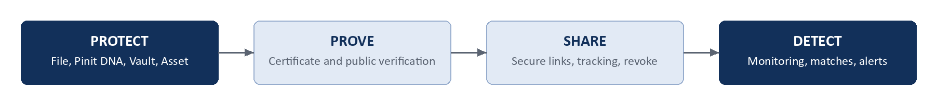
Figure 1. Protection lifecycle in Pinit HUB
The fifth stage of the originally intended lifecycle, Investigate, is not part of the completed scope; see “Not Included in Completed Scope”.

Commercial lifecycle (implemented)
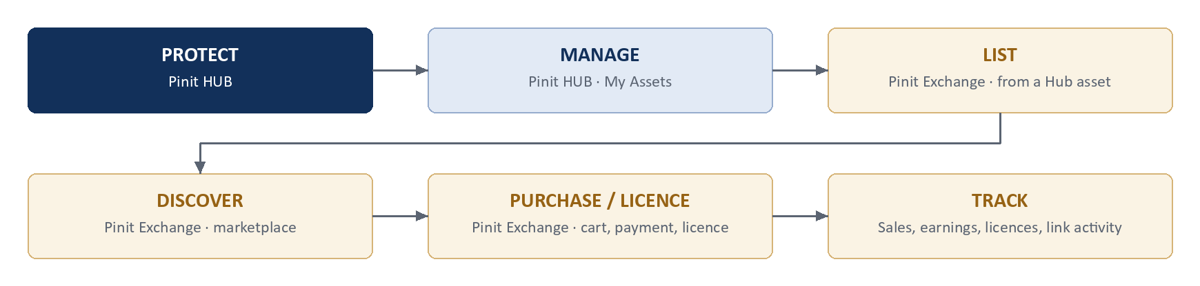
Figure 2. Commercial lifecycle across HUB and Exchange

What is different from ordinary storage
Concept | Ordinary file storage | Pinit
Digital asset identity | A filename and a path | A canonical Asset.id, distinct from the vault, DNA and certificate identifiers
Protection | Access control on a folder | File bytes encrypted with AES-256-GCM in the Vault; an ownership watermark carried in the file
Provenance | Modified-time metadata | Pinit DNA: hash, structural, perceptual, colour and metadata layers recorded at protection time
Proof | None | A signed Certificate with a public verification link; status can be ACTIVE, REVOKED or EXPIRED
Controlled access | Shared folder permissions | Secure Share links with expiry, view and download limits, one-time use, OTP, country/device/IP rules, viewer blocking and revocation
Marketplace transactions | External to the file | Listings and licences in Exchange tied to the same Asset.id, with sealed order records

3. Pinit Ecosystem Overview
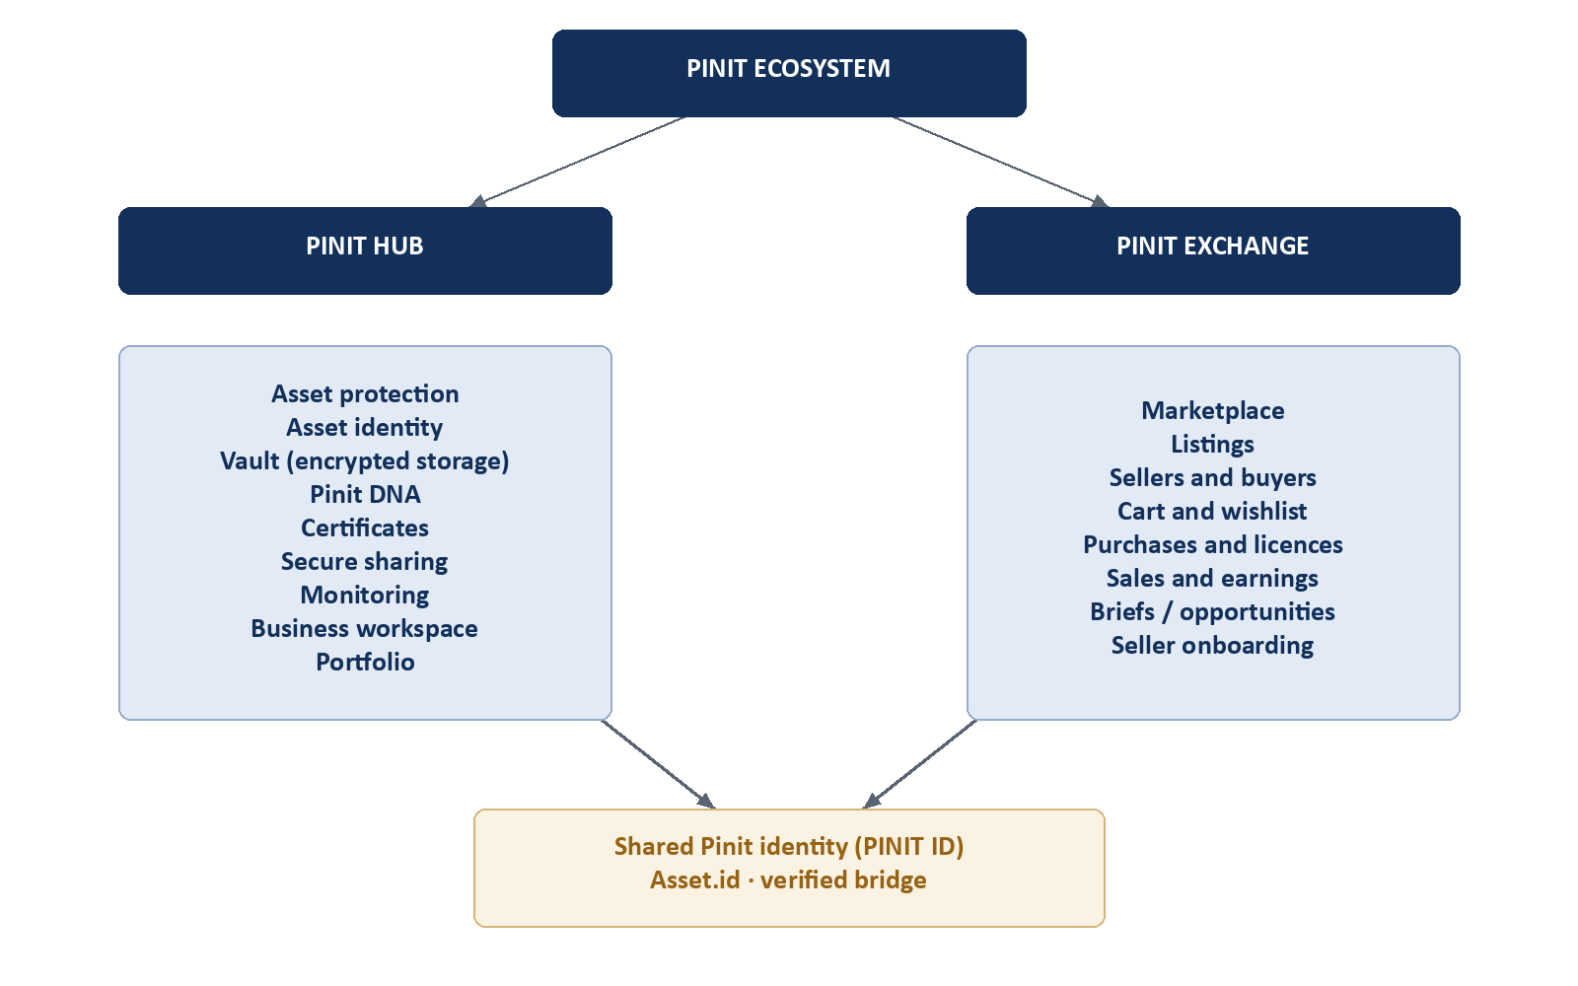
Figure 3. Pinit ecosystem architecture
Only relationships that exist in the implementation are drawn. The two products are separate applications with separate servers and separate schemas. They are joined by:
- Shared Pinit identity: the HUB user’s public PINIT ID is the identity Exchange uses for sellers and buyers.
- Asset.id: the canonical HUB asset identifier is the value Exchange stores as the asset of a listing.
- A verified bridge: HUB-to-Exchange calls carry a bridge secret; Exchange receives only public-safe listing data and short-lived sign-in tokens. Vault keys and full forensic DNA never leave HUB.

4. Pinit HUB: Product Overview
Each module below is completed by the definition on page 2. Modules that do not meet it are listed in the final section.

4.1 Authentication and Identity
Purpose | Create a Pinit account and sign in. Authentication proves who is signing in; it is never used as ownership.
User workflow | Create account, then sign in with password, face verification or a passkey. The session is an access token (Bearer JWT) plus an HttpOnly refresh cookie; the user can refresh or log out.
Frontend | pages/auth, components/auth (FaceRoundScan, BiometricStep, CameraStage), context/AuthContext, components/auth/RequireAuth, lib/webauthn, lib/face-liveness
Backend / API | POST /auth/create, /login, /refresh, /logout; GET /auth/me; /auth/face/{challenge, register, login, identify, status}; /auth/passkey/{register, login}/{start, finish}. Middleware requireAuth; lib/auth-cookies.
Database | User, RefreshToken, BiometricIdentity, FaceTemplate, WebAuthnCredential, LoginHistory, UserSession, UserDevice, SecurityEvent
Completed | Password accounts, JWT access and refresh handling, face enrolment and login with liveness checks, passkey enrolment and login, session listing and revocation.
Evidence | [T] auth suites: auth-cookies, face-liveness-pad, face-match-gate, face-verify-claimed, pad-face-presence, passkey-enroll-gate, webauthn-passkey, webauthn-ownership-fix, and the integration suites (JWT subject and isolation, 1:1 login, duplicate registration, no embedding in logs or responses). [O] 7 face templates recorded. No passkey enrolment is recorded in production data; passkeys are evidenced by tests only.

4.2 Personal and Business Accounts
Purpose | Let one identity work as a personal creator or as a business owner with a workspace.
User workflow | Choose an account type, complete business setup, switch between personal and business views.
Frontend | components/nav/WorkspaceSwitcher, context/AccountViewModeContext, hooks/useSyncBusinessSetup, layouts/DashboardLayout
Backend / API | POST /auth/account-type, POST /auth/business-setup, GET /auth/business-setup/status, POST /organization/setup, GET /organization/me
Database | Organization, Workspace, OrganizationMember, Department
Completed | Account-type selection, business setup, workspace creation and view switching.
Evidence | [T] login-workspace-default. [O] 4 organizations.

4.3 Protect New
Purpose | Turn a file into a protected asset in one guided flow.
User workflow | Upload a file, watch the 15 DNA layers run, encrypt and store in the Vault, then receive the certificate. Detail in Section 6.
Frontend | pages/GeneratePage (wraps App.tsx), UploadZone, LayerPipeline, LayerCard, GenerationProgress, EncryptionStep, VaultStep, ProtectReadyStep, SuccessPanel
Backend / API | POST /dna/generate, POST /vault/store, POST /certificates
Database | DnaRecord and layer records, VaultRecord, Asset, Certificate
Completed | The whole flow from upload to a stored, identified, certified asset.
Evidence | [T] duplicate-check, duplicate-unowned-records, asset-identity-chain, asset-linkage-phase1. [O] 42 assets, 42 vault records, 32 certificates and 575 DNA records (which include records generated internally for video frames).

4.4 Vault, My Assets and Asset Details
Purpose | Keep the protected files and manage them.
User workflow | Open My Assets, filter and search, open an asset for preview, details, sharing, tracking and certificate; rename, retrieve, download a protected copy or remove the stored file.
Frontend | pages/VaultPage, pages/assets/AssetsPage, pages/assets/AssetDetailPage, components/VaultDetailSidePanel, VaultFileThumbnail
Backend / API | GET /vault/, GET /vault/:id, GET /vault/:id/preview, POST /vault/:id/retrieve, PATCH /vault/:id/rename, DELETE /vault/:id, POST /vault/:id/protected-download/prepare and /protected-download, GET /vault/:id/tracking; GET /assets, GET /assets/:id
Database | VaultRecord, Asset, TrackedExportPackage
Completed | Encrypted storage and retrieval, preview, rename, protected download packages, removal that keeps the DNA record and the asset record.
Evidence | [T] vault suites: owner-binding, protected-download, vault-blob-integrity, vault-delete-asset-cleanup, asset-identity-chain, asset-linkage-phase1; services/vault-storage-path, vault-preview-bytes. [O] 42 vault records.

4.5 Security Check
Purpose | Confirm that stored files are present and uncorrupted.
User workflow | Run the integrity check; problems raise a notification.
Frontend | pages/VaultIntegrityPage
Backend / API | GET /vault/integrity-check
Database | VaultRecord, PlatformEvent
Completed | Integrity verification of stored vault files, with issues reported as events.
Evidence | [T] vault-blob-integrity. [O] integrity-issue events recorded.

4.6 Certificates and Verification
Purpose | Give an asset a verifiable proof and let anyone check it.
User workflow | Issue a certificate from an asset, preview and download it, share the verification link, revoke it if needed. A third party opens the link or scans the QR code to check the status. Detail in Section 14.
Frontend | pages/CertificatesPage, pages/VerifyCertificatePage, components/certificates (CredentialPreviewModal, DownloadCertificateButton, ShareCertificateButton, PinitCredentialDocument)
Backend / API | POST /certificates, GET /certificates, GET /certificates/dna/:dnaRecordId, GET /certificates/verify/:certificateId (public), POST /certificates/revoke/:certificateId; GET /credentials/me
Database | Certificate, Credential
Completed | Issue (idempotent per DNA and vault pair), HMAC signature, verification with ACTIVE / REVOKED / EXPIRED / NOT_FOUND results, revocation with a reason, expiry handling, certificate document with QR code.
Evidence | [T] credentials-phase1 (certificate to credential projection, ownership isolation). [O] 32 certificates.

4.7 Secure Sharing and Link Intelligence
Purpose | Share a protected asset under the owner’s control and see what happens to it.
User workflow | Choose an asset, set the controls, create the link, send it. The owner sees each open, download and blocked action, a map of access, and the chain of any onward sharing; the owner can block a viewer, force a logout or revoke the link. Detail in Section 13.
Frontend | pages/VaultSharePage, VaultShareManagePage, ShareViewerPage (public), AccessIntelligencePage, LinkIntelligencePage, LinkTreePage; components/share, maps
Backend / API | POST /share, POST /share/file, GET /share, GET /share/:token, POST /share/:token/access, /verify-otp, /share-further, GET /share/:token/logs, /tree, /export, DELETE /share/:token, block-viewer, force-logout; GET /share/analytics/geo and /live-map; /recipients
Database | ShareLink, ShareRecipient, ShareAccessLog, LinkForwardEvent, BlockedShareViewer, RecipientProfile
Completed | Link creation with access rules, recipient records, access logging with device and location, forwarding chains, viewer blocking, revocation, CSV export.
Evidence | [T] share-link-revoked-parent, share-unavailable-copy, share-viewer-url, authz-boundary, tenant-isolation. [O] 39 links, 195 access-log rows.

4.8 Monitoring
Purpose | Watch supported public sources for copies of a protected asset.
User workflow | Enrol assets, let scans run, review alerts, confirm or dismiss them. Detail in Section 15.
Frontend | pages/MonitoringPage
Backend / API | /monitor: enroll, enroll-all, list, alerts, alerts/:id/confirm and /dismiss, :id/check, :id/runs, pause, resume, watch-urls, scan-type, stats
Database | MonitorRecord, MonitoringRun, MonitoringFailure, CrawlerJob, CrawlResult, CrawlerMatch, AssetDiscovery
Completed | Enrolment, scheduled scanning through the crawler engine, result and match records, alerts with a confirm or dismiss decision.
Evidence | [O] 96 monitor records, 20,527 crawl results, 3,847 scan-completed events for the largest account. There is no dedicated automated test suite for the crawler; it is evidenced by operation only.

4.9 Business Workspace
Purpose | Let an agency or company organise protected assets by client and campaign, with people, review and handover.
User workflow | Business, clients, campaigns, people, assets, collaboration. Detail in Section 16.
Frontend | pages/business (BusinessDashboardPage, ClientsPage, ClientWorkspacePage, CampaignWorkspacePage, BusinessTeamPage, OrganizationSettingsPage, BusinessAuditLogsPage)
Backend / API | /business (clients, campaigns, members, people access, assets, versions, review, approvals, messages, handovers) and /organization (profile, team, invites, roles, workspaces, departments, audit logs)
Database | Organization, OrganizationMember, OrganizationInvite, Department, Workspace, Client, Campaign, CampaignMember, CampaignMemberAsset, AssetVersion, VersionApproval, ReviewComment, CampaignMessage, CampaignHandover, OrganizationAuditLog
Completed | Clients, campaigns, campaign members and per-person access, campaign assets and versions, review comments and approvals, campaign messages, handovers, team roles, departments, audit log.
Evidence | [T] campaign-people-team, share-review. [O] 4 organizations, 2 clients, 2 campaigns, 14 version-approved events. share-message: not yet in the automated test suite.

4.10 Portfolio
Purpose | Present a creator’s protected work publicly.
User workflow | Build the portfolio from protected assets, preview, publish or unpublish, share the public page.
Frontend | pages/ProfilePage (Portfolio tab), components for portfolio editing
Backend / API | GET and PUT /portfolio/me, POST /portfolio/me/publish and /unpublish, GET /portfolio/me/preview, GET /portfolio/public/:slug
Database | Portfolio, PortfolioProfile, PortfolioProject, PortfolioProjectMedia (and related section models)
Completed | Draft, preview, publish and unpublish with a frozen published snapshot; public page by slug.
Evidence | [T] portfolio-phase1. [O] 6 portfolios.

4.11 Profile, Settings and Notifications
Purpose | Account details, preferences, sessions and the notification inbox.
User workflow | Edit the profile and avatar, change the password, manage sessions, choose what to be notified about, read and archive notifications.
Frontend | pages/ProfilePage, components/nav (Topbar, notification bell)
Backend / API | /profile (profile, avatar, password, notifications, stats, activity, sessions); /notifications (stream, list, read, read-all, archive, delete)
Database | User, UserSession, Notification, PlatformEvent
Completed | Profile and session management; a notification inbox delivered over a server-sent event stream; platform events raised by protection, sharing, certificates and monitoring.
Evidence | [T] notification-inbox, notification-policy, historical-notification-link.

4.12 Plans and Entitlements
Purpose | Define what each account may do.
User workflow | View plans and current subscription; features are enabled or blocked by the plan.
Frontend | pages/UpgradePage, pages/subscription, hooks/useSubscription
Backend / API | GET /subscription/me, /plans, /billing/config, /billing/history; requireFeature middleware
Database | Plan, Subscription, FeatureEntitlement, UsageRecord, BillingHistory
Completed | Plan catalogue, subscription state, feature gating and storage-policy limits.
Evidence | [T] asset-upload-storage-policy, enterprise-feature-flags. [O] 7 subscriptions. Payment collection for Hub plans is outside the completed scope (see final section).

5. Pinit HUB: Complete User Flow
The table follows one asset from account creation to a shareable, monitored, verifiable asset. Every stage shown is implemented.
Step | What happens | Frontend | Backend / API | Records | Output
1 Account | User creates an account and receives a PINIT ID. | pages/auth | POST /auth/create | User | Account
2 Authenticate | Password, face or passkey sign-in. | pages/auth, components/auth | POST /auth/login, /face/login, /passkey/login/* | RefreshToken, UserSession, LoginHistory | Access JWT + refresh cookie
3 Dashboard | Home view for the account. | pages/DashboardPage, pages/home | GET /assets/stats, GET /profile/stats | reads | Summary of assets and activity
4 Protect New | File uploaded and validated. | GeneratePage, UploadZone | POST /dna/generate | DnaRecord | DNA record id
5 Analysis and DNA | Layers 1 to 6 computed. | LayerPipeline | dna.orchestrator, layers 1 to 6 | Layer records | Pinit DNA
6 Vault | Encrypted copy stored. | VaultStep, EncryptionStep | POST /vault/store | VaultRecord + file in storage | Vault id
7 Asset identity | Asset record created, linked to DNA and vault. | (automatic) | assetService.ensureAssetFromProtect | Asset | Asset.id
8 Certificate | Signed certificate issued. | ProtectReadyStep, CertificatesPage | POST /certificates | Certificate | Certificate id
9 My Assets | Asset appears for management. | VaultPage, AssetsPage | GET /vault, GET /assets | reads | Managed asset
10 Share / Monitor | Owner shares or enrols in monitoring. | VaultSharePage, MonitoringPage | POST /share, POST /monitor/enroll/:dnaRecordId | ShareLink, MonitorRecord | Link; monitoring profile
11 Verify | Anyone checks the certificate. | VerifyCertificatePage | GET /certificates/verify/:id | reads (and a lifecycle event) | ACTIVE / REVOKED / EXPIRED / NOT_FOUND

Not in this flow
Investigation and evidence reporting is excluded from the completed scope. Steps 9 to 11 are the end of the completed HUB flow.

6. Asset Protection Workflow
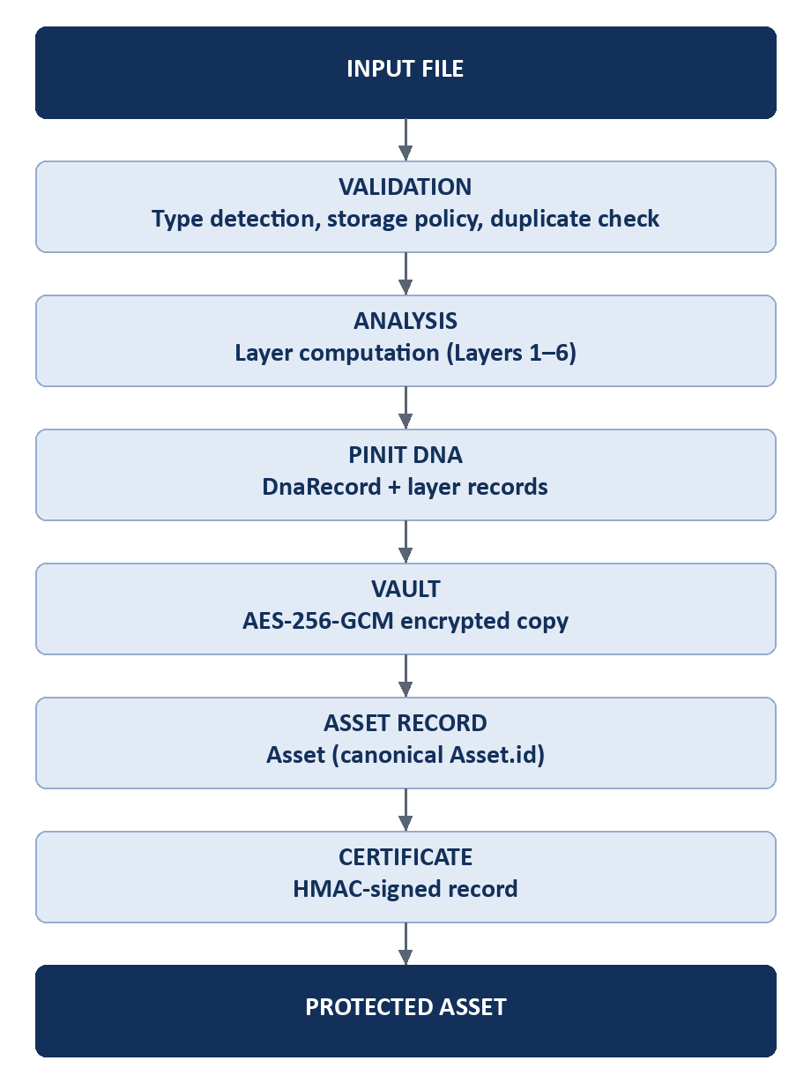
Figure 5. Asset protection flow
Stage | What happens | Verified in
Input file | The user selects or drops a file. Supported types are declared by the backend (GET /dna/supported-types). | UploadZone, dna.routes
Validation | File type detection, storage-policy limits for the plan, and a duplicate check that compares the file with existing records so that a file already owned by someone else is refused. | universal-file-router, duplicate-check.service, tests duplicate-check and duplicate-unowned-records
Analysis | Layers 1 to 6 are computed from the file bytes (Section 7). Some analysis is delegated to the Python AI service. | src/services/layers, python-ai
DNA | A DnaRecord is created with the layer results and status. Identity is deterministic for the same file content. | dna.orchestrator, deterministic-identity test
Vault | The file is encrypted with AES-256-GCM using a key derived per vault record and stored (Supabase Storage in production). A VaultRecord links it to the DNA record. | encryption.service, vault.service
Asset record | An Asset row is created or reused, linked to the DNA record and the vault record, carrying the SHA-256 of the file. This is the canonical Asset.id. | assetService.ensureAssetFromProtect (vault.service)
Ownership and provenance | The owner is stamped on every record. The ownership watermark is embedded (Layer 6) and provenance events are appended. | layer6, forensic-provenance.service
Certificate | A certificate is issued for the DNA and vault pair and linked to the asset. | certificate.service
Availability | The asset appears in Vault / My Assets with its certificate, sharing and monitoring options. | VaultPage, AssetsPage

The order in which records are created is: DnaRecord, then VaultRecord, then Asset, then Certificate. The Asset row is the canonical identity but is created at vault storage, after the DNA record exists.

7. Pinit DNA Architecture
Pinit DNA is the recorded identity of a file: a set of independent characteristics computed from the file at protection time and stored against a DnaRecord. It exists so that a file can later be recognised, compared and proven, even after it has been re-saved, resized or partly altered.
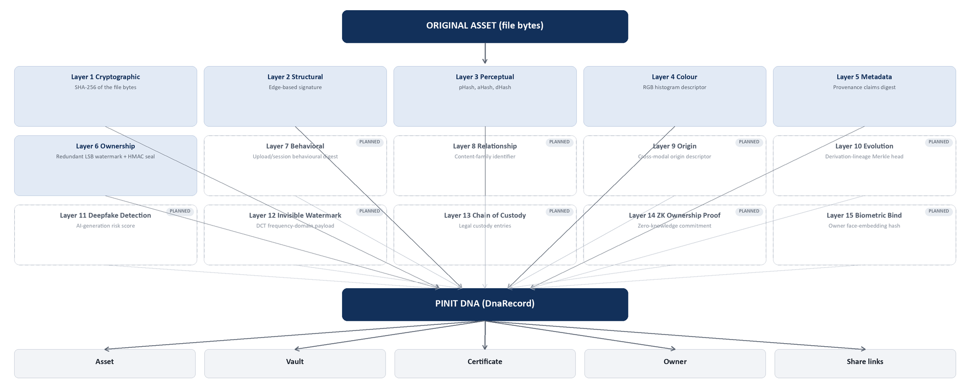
Figure 6. Pinit DNA architecture — all 15 layers (6 implemented and tested; 9 designed, pending testing)
Layer | What it records | Use | Tests
1 Cryptographic | SHA-256 of the raw file bytes (exact file identity) | Exact-match identity; part of the certificate and asset record | layer1.cryptographic
2 Structural | Edge-based structural signature | Recognising the same structure after mild change | layer2.structural
3 Perceptual | pHash, aHash and dHash of a reduced greyscale image | Recognising visually similar files | layer3.perceptual
4 Colour | RGB histogram descriptor | Colour profile of the file | layer4.semantic
5 Metadata | Provenance claims digest | Deterministic identity from content and claims | layer5.metadata
6 Ownership watermark | Redundant least-significant-bit signature tiled across the image plus an HMAC identity seal over layers 1 to 5 | Recovering ownership from a cropped copy | layer6.steganography, ownership-watermark
7 Behavioral | Upload/session behavioural digest (content-only in deterministic mode) | Distinguishing near-identical uploads by behavioural context | Planned — not yet in the test suite
8 Relationship | Content-family identifier linking related or duplicate uploads | Grouping derivative files under one lineage | Planned — not yet in the test suite
9 Origin | Cross-modal origin descriptor (content-derived bundle hash) | Tracing where a file's identity bundle originated | Planned — not yet in the test suite
10 Evolution | Merkle head over a file's derivation history | Proving a derivative's place in a file's edit history | Planned — not yet in the test suite
11 Deepfake Detection | AI-generation risk score from decoded-pixel noise and frequency analysis | Flagging synthetic or AI-edited media | Planned — not yet in the test suite
12 Invisible Watermark | DCT frequency-domain watermark payload | Recovering ownership from a re-encoded or cropped copy | Planned — not yet in the test suite
13 Chain of Custody | Legal custody entries: event, actor, file hash, timestamp | Court-admissible record of who held the file and when | Planned — not yet in the test suite
14 ZK Ownership Proof | Zero-knowledge commitment over a secret, file hash and owner | Proving ownership without revealing the underlying secret | Planned — not yet in the test suite
15 Biometric Bind | Owner's face-embedding hash, when face authentication is enrolled | Binding a file's identity to the registered owner's biometric | Planned — not yet in the test suite

Relationships of a DnaRecord
- Asset: Asset.dnaId is a foreign key to the DnaRecord.
- Vault: VaultRecord.dnaRecordId is a foreign key (unique) to the DnaRecord.
- Certificate: Certificate.dnaRecordId holds the DNA record id; it is signed into the certificate.
- Owner: DnaRecord.ownerUserId references the User.
- Sharing and monitoring: ShareLink.dnaRecordId and MonitorRecord.dnaRecordId (foreign key) point back to it.
Scope of this section
Only Layers 1 to 6, which have implementation and passing tests, are documented. The schema also defines further layer tables and the codebase contains additional DNA modes; they are outside the verified scope.

8. Vault and Asset Architecture
These concepts are separate identifiers on purpose. Asset.id is the canonical identity used across HUB and Exchange. Vault, DNA and Certificate identifiers address the records they belong to and are never used in place of Asset.id.
Concept | Model | What it is | Linked to Asset by
User | User | The owner and the identity behind every record | Asset.ownerUserId (foreign key)
Asset | Asset | Canonical identity of a protected file; carries the file SHA-256, type, status, monitoring profile | (itself)
DNA record | DnaRecord | The Pinit DNA of the file | Asset.dnaId (foreign key)
Vault record | VaultRecord | The encrypted stored copy and its size and path | Asset.vaultId (value); VaultRecord.dnaRecordId (foreign key)
Certificate | Certificate | Signed proof; status ACTIVE, REVOKED, EXPIRED | Certificate.assetId (value), Asset.certificateId (value)
Protected file | file in Supabase Storage | The encrypted bytes, addressed by vault id | through VaultRecord
Activity | AssetTimelineEvent, PlatformEvent, ShareAccessLog | What happened to the asset | AssetTimelineEvent.assetId (foreign key)
Monitoring | MonitorRecord, CrawlResult | Watching for copies | MonitorRecord.dnaRecordId (foreign key); Asset.monitorRecordId (value)
Discovery | AssetDiscovery | A copy found by monitoring | AssetDiscovery.assetId (foreign key)

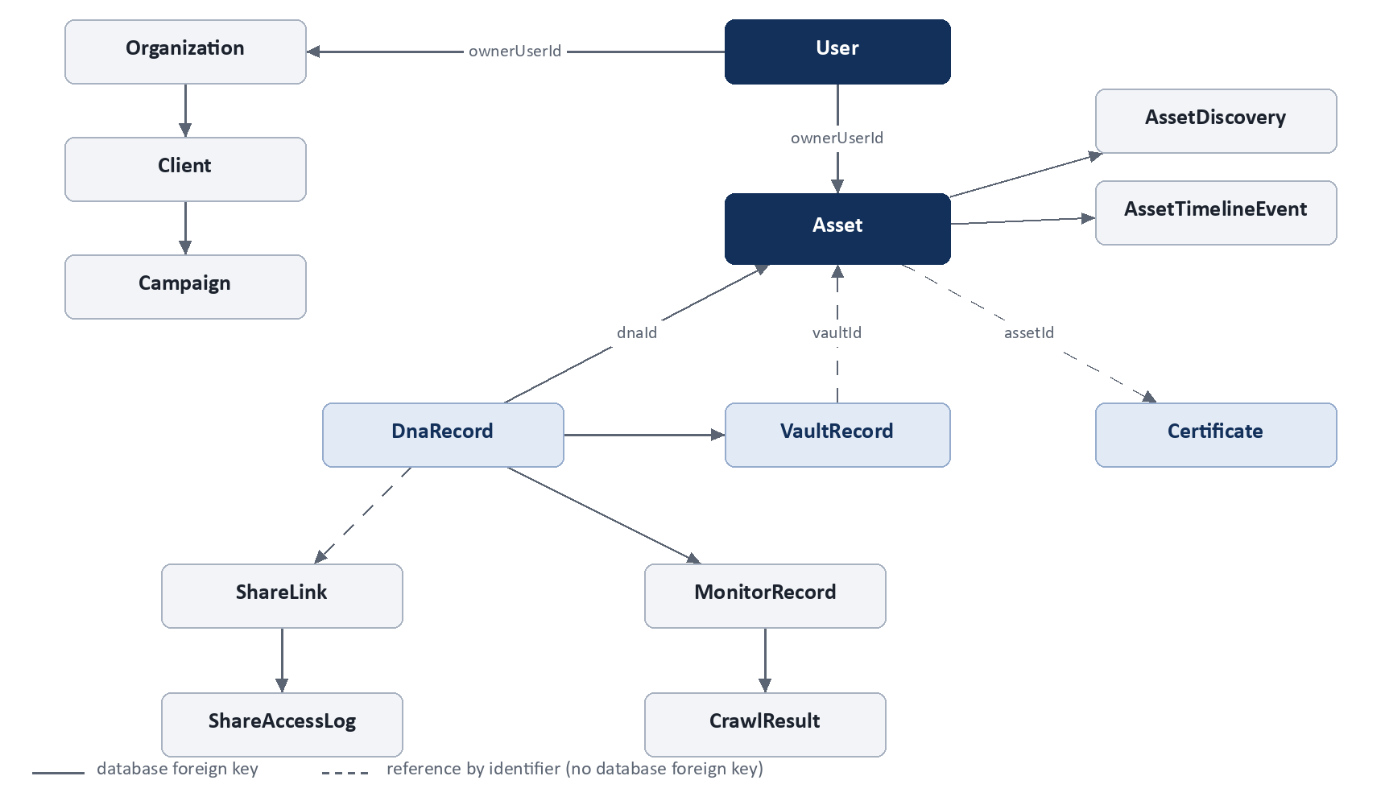
Figure 7. Asset and vault architecture (HUB entity relationships)
Reading the diagram
Solid lines are database foreign keys. Dashed lines are references by identifier that the application maintains but the database does not enforce (for example Asset.vaultId and Certificate.assetId). Arrows run from the referenced record to the record that holds the reference. Share links also carry the vault and DNA identifiers as plain values.

9. Database Architecture (HUB)
Item | Detail
Technology | PostgreSQL hosted on Supabase, accessed through Prisma 5 (@prisma/client)
Schema | prisma/schema.prisma: 111 models at the committed baseline; every model uses a UUID string primary key named id unless stated
Ownership model | Records carry ownerUserId; every protected API enforces that the JWT subject equals the resource owner (lib/tenant-scope)
Changes to the production schema | Applied by idempotent ensure-*.cjs scripts run at start-up (start:prod), not by migrations

A. High-level entity relationships
Figure 8. HUB core ER diagram

B. Core entity relationship table
Entity | Purpose | Primary key | Important relationships | Used by
User | Account and identity | id | Owns Asset, Organization, ShareLink, Certificate (ownerUserId) | Every module
Asset | Canonical asset identity | id | ownerUser; dnaRecord (FK dnaId); timeline, discoveries, versions; vaultId and certificateId by value | Vault, sharing, Exchange, portfolio
DnaRecord | Pinit DNA of a file | id | ownerUser; layer records; VaultRecord and MonitorRecord (FK) | Protection, verification, monitoring
VaultRecord | Encrypted stored copy | id | dnaRecord (FK dnaRecordId, unique, cascade) | Vault, sharing
Certificate | Signed proof | id (certificateId unique) | ownerUser (FK); dnaRecordId, vaultId, assetId by value | Certificates, credentials
Credential | Credential projection of a certificate | id | user (FK); unique (sourceType, sourceId) | Credentials screen
ShareLink | A secure link and its rules | id (token unique) | ownerUser, shareRecipient, parentLink (FK); vaultId, dnaRecordId, assetId by value | Sharing, business handover
ShareAccessLog | One access to a link | id | shareLink (FK, cascade) | Link intelligence
MonitorRecord | A monitoring profile | id | dnaRecord, ownerUser (FK) | Monitoring
CrawlResult | A scanned result | id | monitorRecord (FK, cascade) | Monitoring
AssetDiscovery | A copy found online | id | asset (FK, cascade) | Monitoring
AssetTimelineEvent | Recorded event on an asset | id | asset (FK, cascade) | Asset history
Organization | A business | id | ownerUser (FK); Client, Workspace, OrganizationMember | Business workspace
Client / Campaign | Client and project | id | Client to organization; Campaign to organization and client (FK) | Business workspace
CampaignMember / CampaignMemberAsset | People and their assets | id | CampaignMember to campaign; CampaignMemberAsset to member (FK) | Business workspace
Portfolio | A creator portfolio | id (userId unique) | user (FK); projects, media (PortfolioProjectMedia.assetId and vaultId by value) | Portfolio
PlatformEvent | Event stream | id | ownerUser (FK); entityType and entityId by value | Notifications, audit
Subscription / Plan | Plan and entitlement state | id | Subscription to user and plan | Feature gating

C. Data lifecycle
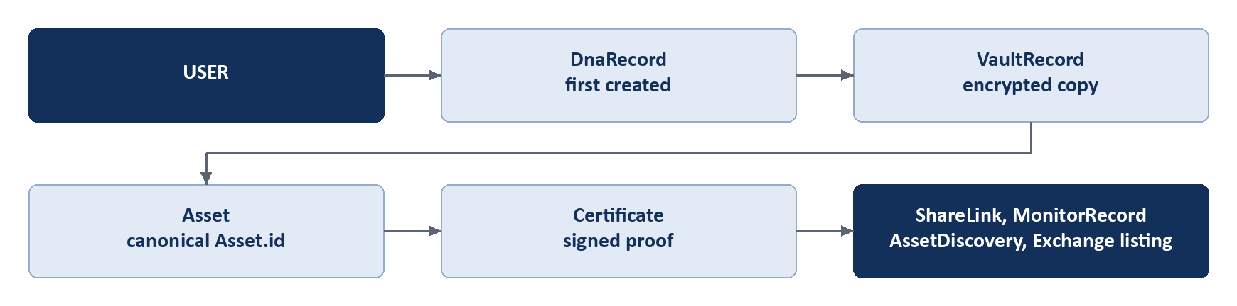
Figure 9. Order in which records are created for a protected asset
The order differs from the ownership view in Section 8 because the DNA record is generated first; the Asset row is created when the file is stored in the Vault.

10. Backend Architecture
Item | Implementation
Framework | Node.js with Express 4, TypeScript (src/server.ts, src/app.ts)
Structure | src/api/{routes, controllers, middleware}; src/services/*; src/lib; src/config; prisma/schema.prisma
Authentication | JWT access tokens (Bearer) verified by requireAuth; HttpOnly refresh cookie (pinit_rt); bcrypt for password hashes
Authorization | Ownership middleware (requireVaultOwnership, requireDnaOwnership, requireCertificateOwnership, requireShareLinkOwnership) and tenant scope helpers
Feature gating | requireFeature middleware backed by plan entitlements
Database access | Prisma client; a small number of read-only reporting queries use raw SQL
File storage | Supabase Storage (bucket vault-files); local disk in development
Encryption | AES-256-GCM; key = HKDF-SHA256(master secret, salt = vault id); random 96-bit IV per file
External services | Python AI service (FastAPI, port 8001), Razorpay, Supabase
Events and audit | Platform event engine with notification, timeline and audit subscribers; forensic provenance events; organization audit log
Security middleware | helmet (content-security-policy disabled), CORS, a global API rate limit and a stricter limit on authentication routes, input validation

Service domains implemented
Domain | Location | Responsibility
DNA | services/layers, dna, dna.orchestrator | Layer computation and DNA records
Vault | services/vault | Encryption, storage, retrieval, protected download
Assets | services/assets | Canonical asset identity and linkage
Certificates | services/certificates, services/credentials | Issue, verify, revoke, credential projection
Sharing | services/share | Link rules, access checks, risk engine, review and approval
Monitoring | services/crawler | Crawler engine, connectors, scoring
Organization | services/organization | Teams, roles, workspaces
Platform events | services/platform-events | Event engine, notifications, timeline
Subscription | services/subscription | Plans, entitlements, feature checks
Exchange bridge | services/exchange | Hub to Exchange calls and single sign-on

11. API Architecture
The tables below were generated from the route files (Hub: src/api/routes; Exchange: exchange/server/routes), so every listed endpoint exists in code. Route-level guard shows the middleware declared on the route. Exchange resolves the buyer or seller identity from its session token inside many handlers, so “None at route level” does not mean the endpoint is unauthenticated. Request and response bodies are defined in the corresponding controllers and are not reproduced here.
Endpoints that belong to modules outside the completed scope, and endpoints whose feature has no evidence of use, are omitted (for example organization API keys, webhooks and integrations; business investigations, evidence and reports; spatial authentication; Exchange refunds, coupons and reviews).

11.1 Pinit HUB API (base path /api/v1)

Authentication (17)
Database entities: User, RefreshToken, FaceTemplate, BiometricIdentity, WebAuthnCredential, UserSession, LoginHistory, SecurityEvent
Method | Endpoint | Resource / function | Route-level guard
POST | /auth/create | Create account | None at route level
POST | /auth/login | Auth: login | None at route level
POST | /auth/refresh | Refresh | None at route level
POST | /auth/logout | Logout | None at route level
GET | /auth/me | Auth: me | Bearer JWT required
POST | /auth/account-type | Set account type | Bearer JWT required
POST | /auth/business-setup | Setup business workspace | Bearer JWT required
GET | /auth/business-setup/status | Business setup: status | Bearer JWT required
POST | /auth/face/challenge | Face: challenge | None at route level
POST | /auth/face/register | Face: register | None at route level
POST | /auth/face/login | Face: login | None at route level
POST | /auth/face/identify | Face: identify | None at route level
GET | /auth/face/status | Face: status | Bearer JWT required
POST | /auth/passkey/register/start | Register: start | None at route level
POST | /auth/passkey/register/finish | Register: finish | None at route level
POST | /auth/passkey/login/start | Login: start | None at route level
POST | /auth/passkey/login/finish | Login: finish | None at route level

Users and Profile (12)
Database entities: User, UserSession, Notification preferences
Method | Endpoint | Resource / function | Route-level guard
GET | /profile/avatar/:shortId | Get public avatar | None at route level
POST | /profile/avatar | Upload profile avatar | Bearer JWT required
DELETE | /profile/avatar | Delete profile avatar | Bearer JWT required
GET | /profile/ | Get profile | Bearer JWT required
PUT | /profile/ | Update profile | Bearer JWT required
PUT | /profile/notifications | Update notification prefs | Bearer JWT required
PUT | /profile/password | Profile: password | Bearer JWT required
GET | /profile/stats | Get profile stats | Bearer JWT required
GET | /profile/activity | Get activity timeline | Bearer JWT required
GET | /profile/sessions | Get sessions | Bearer JWT required
DELETE | /profile/session/:id | Revoke session | Bearer JWT required
DELETE | /profile/sessions | Revoke all sessions | Bearer JWT required

Assets (6)
Database entities: Asset, AssetTimelineEvent, AssetPlatformLink
Method | Endpoint | Resource / function | Route-level guard
POST | /assets/protect | Protect asset | Bearer JWT required
GET | /assets/stats | Get asset stats | Bearer JWT required
GET | /assets | List assets | Bearer JWT required
GET | /assets/:id/graph | Get asset graph | Bearer JWT required
GET | /assets/:id | Get asset | Bearer JWT required
PATCH | /assets/:id/status | Transition asset | Bearer JWT required

DNA (8)
Database entities: DnaRecord and the layer records, VerificationLog
Method | Endpoint | Resource / function | Route-level guard
GET | /dna/ | List dna records | Bearer JWT required
GET | /dna/supported-types | Get supported types | None at route level
GET | /dna/duplicate-attempts | Get duplicate attempts | Bearer JWT required
POST | /dna/generate | Generate dna | Bearer JWT required
POST | /dna/compare | Compare dna | Bearer JWT required
POST | /dna/auto-compare | Dna: auto compare | Bearer JWT required
POST | /dna/:id/verify | Verify dna | Bearer JWT required
GET | /dna/:id | Get dna record | Bearer JWT required

Vault (15)
Database entities: VaultRecord, Asset, TrackedExportPackage
Method | Endpoint | Resource / function | Route-level guard
GET | /vault/ | List vault records | Bearer JWT required
GET | /vault/integrity-check | Vault: integrity check | Bearer JWT required
GET | /vault/protected-shares | List protected file shares | Bearer JWT required
POST | /vault/store | Store in vault | Bearer JWT required
GET | /vault/:id | Get vault record | Bearer JWT required
PATCH | /vault/:id/rename | Rename vault record | Bearer JWT required
DELETE | /vault/:id | Delete vault record | Bearer JWT required
GET | /vault/:id/preview | Preview vault file | Bearer JWT required
POST | /vault/:id/retrieve | Retrieve from vault | Bearer JWT required
POST | /vault/:id/protected-download/prepare | Prepare protected download | Bearer JWT required
POST | /vault/:id/protected-download | Protected download from vault | Bearer JWT required
GET | /vault/:id/tracking | Get vault tracking | Bearer JWT required
POST | /vault/:id/tep/:tepCode/revoke | Revoke vault tep | Bearer JWT required
GET | /tep/manifests | List tep manifests | Bearer JWT required
GET | /tep/:tepCode | Get tep manifest | Bearer JWT required

Certificates and Credentials (7)
Database entities: Certificate, Credential
Method | Endpoint | Resource / function | Route-level guard
POST | /certificates/ | Issue certificate | Bearer JWT required
GET | /certificates/verify/:certificateId | Verify certificate | None at route level
POST | /certificates/revoke/:certificateId | Revoke certificate | Bearer JWT required
GET | /certificates/ | List certificates | Bearer JWT required
GET | /certificates/dna/:dnaRecordId | List certificates by dna | Bearer JWT required
GET | /credentials/me | List my credentials handler | Bearer JWT required
GET | /credentials/:credentialId | Get my credential handler | Bearer JWT required

Sharing (38)
Database entities: ShareLink, ShareRecipient, ShareAccessLog, LinkForwardEvent, BlockedShareViewer
Method | Endpoint | Resource / function | Route-level guard
POST | /share/ | Create share link | Bearer JWT required
POST | /share/file | Create file share | Bearer JWT required
GET | /share/ | List share links | Bearer JWT required
GET | /share/vault/:vaultId | Get vault share links | Bearer JWT required
GET | /share/timeline/:dnaId | Get share timeline | Bearer JWT required
GET | /share/analytics/geo | Get geo analytics | Bearer JWT required
GET | /share/analytics/global | Get global share stats | Bearer JWT required
GET | /share/analytics/live-map | Get live tracking map | Bearer JWT required
GET | /share/sessions/live | Get live sessions | Bearer JWT required
GET | /share/messages | List share viewer messages | Bearer JWT required
POST | /share/messages/:id/reply | Reply share viewer message | Bearer JWT required
GET | /share/:token | Get share link info | None at route level
POST | /share/:token/access | Record access | None at route level
POST | /share/:token/share-further | Share further | None at route level
POST | /share/:token/verify-otp | Verify share otp | None at route level
GET | /share/:token/file | Share: file | None at route level
GET | /share/:token/preview.png | Preview image | None at route level
GET | /share/:token/masked-text | Get masked text | None at route level
POST | /share/:token/messages | Post share viewer message | None at route level
GET | /share/:token/messages/mine | Get my share viewer messages | None at route level
GET | /share/:token/review | Get share review | None at route level
GET | /share/:token/review/comments | Get share review comments | None at route level
POST | /share/:token/review/comments | Post share review comment | None at route level
GET | /share/:token/review/decisions | Get share review decisions | None at route level
POST | /share/:token/review/decision | Post share review decision | None at route level
GET | /share/:token/messages/stream | Stream share messages | None at route level
GET | /share/handover/:token | Get handover view | None at route level
GET | /share/:token/logs | Get share link logs | Bearer JWT required
GET | /share/:token/export | Export share logs csv | Bearer JWT required
DELETE | /share/:token | Revoke share link | Bearer JWT required
POST | /share/:token/block-viewer | Block share viewer | Bearer JWT required
DELETE | /share/:token/block-viewer/:blockId | Share: block viewer (by id) | Bearer JWT required
POST | /share/:token/force-logout | Force logout link | Bearer JWT required
GET | /share/:token/tree | Get link tree | Bearer JWT required
GET | /recipients/ | List recipients | Bearer JWT required
POST | /recipients/ | Create recipient | Bearer JWT required
GET | /recipients/:id | Get recipient | Bearer JWT required
DELETE | /recipients/:id | Delete recipient | Bearer JWT required

Monitoring (15)
Database entities: MonitorRecord, MonitoringRun, CrawlResult, CrawlerMatch, AssetDiscovery
Method | Endpoint | Resource / function | Route-level guard
GET | /monitor/stats | Get monitoring stats | Bearer JWT required
GET | /monitor/engine/stats | Get engine stats | Bearer JWT required
POST | /monitor/enroll-all | Enroll all | Bearer JWT required
GET | /monitor/ | List monitors | Bearer JWT required
POST | /monitor/enroll/:dnaRecordId | Enroll monitor | Bearer JWT required
GET | /monitor/alerts | Get alerts | Bearer JWT required
POST | /monitor/alerts/:id/dismiss | Dismiss alert | Bearer JWT required
POST | /monitor/alerts/:id/confirm | Confirm alert | Bearer JWT required
POST | /monitor/:id/check | Run check now | Bearer JWT required
GET | /monitor/:id/runs | Get monitor runs | Bearer JWT required
PATCH | /monitor/:id/scan-type | Update scan type | Bearer JWT required
PATCH | /monitor/:id/watch-urls | Update watch urls | Bearer JWT required
POST | /monitor/:id/pause | Pause monitor | Bearer JWT required
POST | /monitor/:id/resume | Resume monitor | Bearer JWT required
DELETE | /monitor/:id | Stop monitor | Bearer JWT required

Notifications (7)
Database entities: Notification, PlatformEvent
Method | Endpoint | Resource / function | Route-level guard
GET | /notifications/stream | Stream notifications | Role / ownership guard
GET | /notifications/ | Get notifications | Bearer JWT required
PUT | /notifications/read-all | Mark all read | Bearer JWT required
PUT | /notifications/clear-inbox | Clear inbox | Bearer JWT required
PUT | /notifications/:id/read | Mark read | Bearer JWT required
PUT | /notifications/:id/archive | Archive notification | Bearer JWT required
DELETE | /notifications/:id | Delete notification | Bearer JWT required

Business: Organization, Team, Workspaces (22)
Database entities: Organization, OrganizationMember, OrganizationInvite, Department, Workspace, OrganizationAuditLog
Method | Endpoint | Resource / function | Route-level guard
GET | /organization/me | Get mine | Bearer JWT required
POST | /organization/setup | Organization: setup | Bearer JWT required
PATCH | /organization/profile | Update profile | Bearer JWT required
POST | /organization/logo | Upload logo | Bearer JWT required
POST | /organization/welcome/skip | Skip welcome | Bearer JWT required
GET | /organization/team | Get team | Bearer JWT required
GET | /organization/team/members | List members | Bearer JWT required
GET | /organization/team/invites | List invites | Bearer JWT required
POST | /organization/team/invite | Invite member | Bearer JWT required
GET | /organization/team/invites/preview/:token | Preview invite | Bearer JWT required
POST | /organization/team/accept | Accept invite | Bearer JWT required
GET | /organization/team/lookup-pinit-id | Lookup pinit id | Bearer JWT required
DELETE | /organization/team/invites/:id | Revoke invite | Bearer JWT required
PATCH | /organization/team/members/:id/role | Update member role | Bearer JWT required
DELETE | /organization/team/members/:id | Remove member | Bearer JWT required
GET | /organization/workspaces | List workspaces | Bearer JWT required
POST | /organization/workspaces | Create workspace | Bearer JWT required
GET | /organization/departments | List departments | Bearer JWT required
POST | /organization/departments | Create department | Bearer JWT required
PATCH | /organization/departments/:id | Update department | Bearer JWT required
DELETE | /organization/departments/:id | Delete department | Bearer JWT required
GET | /organization/audit-logs | List audit logs | Bearer JWT required

Business: Clients, Campaigns, People, Review (51)
Database entities: Client, Campaign, CampaignMember, CampaignMemberAsset, AssetVersion, VersionApproval, ReviewComment, CampaignMessage, CampaignHandover
Method | Endpoint | Resource / function | Route-level guard
GET | /business/overview | Get overview | Bearer JWT required
GET | /business/clients | List clients | Bearer JWT required
POST | /business/clients | Create client | Bearer JWT required
GET | /business/clients/:clientId | Get client | Bearer JWT required
PATCH | /business/clients/:clientId | Update client | Bearer JWT required
DELETE | /business/clients/:clientId | Delete client | Bearer JWT required
GET | /business/clients/:clientId/campaigns | List campaigns | Bearer JWT required
POST | /business/clients/:clientId/campaigns | Create campaign | Bearer JWT required
GET | /business/campaigns/:campaignId | Get campaign | Bearer JWT required
PATCH | /business/campaigns/:campaignId | Update campaign | Bearer JWT required
DELETE | /business/campaigns/:campaignId | Delete campaign | Bearer JWT required
GET | /business/campaigns/:campaignId/members | List campaign members | Bearer JWT required
POST | /business/campaigns/:campaignId/members | Campaigns: members | Bearer JWT required
DELETE | /business/campaigns/:campaignId/members/:memberId | Remove campaign member | Bearer JWT required
GET | /business/campaigns/:campaignId/assets | List campaign assets | Bearer JWT required
POST | /business/campaigns/:campaignId/assets | Campaigns: assets | Bearer JWT required
GET | /business/campaigns/:campaignId/activity | List campaign activity | Bearer JWT required
GET | /business/assets/:assetId/versions | List asset versions | Bearer JWT required
POST | /business/assets/:assetId/versions | Create asset version | Bearer JWT required
GET | /business/versions/:versionId | Get asset version | Bearer JWT required
GET | /business/versions/:versionId/file | Versions: file | Bearer JWT required
PATCH | /business/versions/:versionId/review-status | Set version review status | Bearer JWT required
GET | /business/versions/:versionId/comments | List version comments | Bearer JWT required
POST | /business/versions/:versionId/comments | Create version comment | Bearer JWT required
PATCH | /business/comments/:commentId/status | Set comment status | Bearer JWT required
GET | /business/campaigns/:campaignId/change-requests | List campaign change requests | Bearer JWT required
POST | /business/versions/:versionId/decision | Decide version | Bearer JWT required
GET | /business/versions/:versionId/approvals | List version approvals | Bearer JWT required
GET | /business/campaigns/:campaignId/approvals | List campaign approvals | Bearer JWT required
GET | /business/share-eligibility/:vaultId | Get share review eligibility | Bearer JWT required
GET | /business/campaigns/:campaignId/messages | List campaign messages | Bearer JWT required
POST | /business/campaigns/:campaignId/messages | Send campaign message | Bearer JWT required
POST | /business/campaigns/:campaignId/messages/read | Mark campaign messages read | Bearer JWT required
GET | /business/campaigns/:campaignId/messages/stream | Stream campaign messages | Role / ownership guard
GET | /business/messages/unread | Get campaign unread | Bearer JWT required
GET | /business/campaigns/:campaignId/people | List campaign people | Bearer JWT required
POST | /business/campaigns/:campaignId/people/:memberId/access | Grant campaign access | Bearer JWT required
PATCH | /business/campaigns/:campaignId/people/:memberId/access | Update campaign access | Bearer JWT required
DELETE | /business/campaigns/:campaignId/people/:memberId/access | Revoke campaign access | Bearer JWT required
GET | /business/campaigns/:campaignId/people/:memberId/links | List campaign access links | Bearer JWT required
GET | /business/campaigns/:campaignId/rights | List campaign rights | Bearer JWT required
GET | /business/campaigns/:campaignId/handover/candidates | List handover candidates | Bearer JWT required
GET | /business/campaigns/:campaignId/handovers | List handovers | Bearer JWT required
POST | /business/campaigns/:campaignId/handovers | Create handover | Bearer JWT required
POST | /business/campaigns/:campaignId/handovers/:handoverId/send | Send handover | Bearer JWT required
DELETE | /business/campaigns/:campaignId/handovers/:handoverId | Revoke handover | Bearer JWT required
GET | /business/clients/:clientId/deliveries | Clients: deliveries | Bearer JWT required
GET | /business/clients/:clientId/rights | Clients: rights | Bearer JWT required
GET | /business/clients/:clientId/activity | Clients: activity | Bearer JWT required
GET | /business/clients/:clientId/assets | Clients: assets | Bearer JWT required
GET | /business/clients/:clientId/people | Clients: people | Bearer JWT required

Portfolio (7)
Database entities: Portfolio, PortfolioProfile, PortfolioProject, PortfolioProjectMedia
Method | Endpoint | Resource / function | Route-level guard
GET | /portfolio/me | Get my portfolio | Bearer JWT required
PUT | /portfolio/me | Portfolio: me | Bearer JWT required
POST | /portfolio/me/publish | Publish my portfolio | Bearer JWT required
POST | /portfolio/me/unpublish | Unpublish my portfolio | Bearer JWT required
GET | /portfolio/me/preview | Preview my portfolio | Bearer JWT required
GET | /portfolio/me/contains/:vaultId | Me: contains (by id) | Bearer JWT required
GET | /portfolio/public/:slug | Get public portfolio | None at route level

Subscription and Entitlements (4)
Database entities: Plan, Subscription, FeatureEntitlement, BillingHistory, UsageRecord
Method | Endpoint | Resource / function | Route-level guard
GET | /subscription/me | Get my subscription | Bearer JWT required
GET | /subscription/plans | List subscription plans | Bearer JWT required
GET | /subscription/billing/config | Get billing config | Bearer JWT required
GET | /subscription/billing/history | Get billing history | Bearer JWT required

11.2 Pinit Exchange API (base path /api)

Exchange Authentication and Session (9)
Database entities: users
Method | Endpoint | Resource / function | Route-level guard
GET | /auth/me | Auth: me | None at route level
POST | /auth/signup | Auth: signup | None at route level
POST | /auth/login | Auth: login | None at route level
POST | /auth/hub-sso | Auth: hub sso | None at route level
POST | /auth/profile | Auth: profile | None at route level
POST | /auth/become-creator | Auth: become creator | Session required
POST | /auth/enable-buyer | Auth: enable buyer | Role / ownership guard
POST | /auth/onboard-seller | Auth: onboard seller | Role / ownership guard
POST | /auth/logout | Auth: logout | None at route level

Hub Bridge (Exchange side) (11)
Database entities: hub_assets, listings, hub_bridge_events
Method | Endpoint | Resource / function | Route-level guard
GET | /hub/assets | Hub: assets | Role / ownership guard
POST | /hub/protect-upload | Hub: protect upload | Role / ownership guard
GET | /hub/preview/:assetId | Hub: preview (by id) | None at route level
GET | /hub/monitoring-summaries | Hub: monitoring summaries | None at route level
POST | /hub/protect | Hub: protect | None at route level
GET | /hub/portfolios | Hub: portfolios | Role / ownership guard
GET | /hub/portfolio | Hub: portfolio | Role / ownership guard
PUT | /hub/portfolio | Hub: portfolio | Role / ownership guard
GET | /hub/seller-listings | Hub: seller listings | Role / ownership guard
GET | /hub/seller-desk | Hub: seller desk | Role / ownership guard
GET | /hub/buyer-desk | Hub: buyer desk | Role / ownership guard

Listings (6)
Database entities: listings, hub_assets
Method | Endpoint | Resource / function | Route-level guard
GET | /listings/ | Listings | None at route level
GET | /listings/:id | Listings (by id) | None at route level
POST | /listings/from-hub | Listings: from hub | Role / ownership guard
POST | /listings/ | Listings | Role / ownership guard
POST | /listings/:id/status | Listings: status | Role / ownership guard
PATCH | /listings/:id | Listings (by id) | Role / ownership guard

Orders, Payments and Licences (10)
Database entities: orders_sealed, payment_intents, asset_commerce_locks, seller_earnings, hub_bridge_events
Method | Endpoint | Resource / function | Route-level guard
GET | /orders/billing/config | Billing: config | None at route level
POST | /orders/create-payment | Orders: create payment | Role / ownership guard
POST | /orders/verify-payment | Orders: verify payment | None at route level
POST | /orders/checkout | Orders: checkout | Role / ownership guard
GET | /orders/my-licenses | Orders: my licenses | Session required
GET | /orders/certificate/:seal_id | Orders: certificate (by id) | Session required
POST | /orders/download/authorize | Download: authorize | Session required
GET | /orders/my-orders | Orders: my orders | Session required
GET | /orders/invoice/:sealId | Orders: invoice (by id) | Session required
POST | /orders/bridge-events/retry | Bridge events: retry | None at route level

Cart, Wishlist and Follows (14)
Database entities: cart_items, wishlist, creator_follows, orders_sealed
Method | Endpoint | Resource / function | Route-level guard
GET | /commerce/cart | Commerce: cart | None at route level
POST | /commerce/cart | Commerce: cart | None at route level
DELETE | /commerce/cart/:id | Commerce: cart (by id) | None at route level
POST | /commerce/cart/create-payment | Cart: create payment | Role / ownership guard
POST | /commerce/cart/checkout | Cart: checkout | Role / ownership guard
GET | /commerce/wishlist | Commerce: wishlist | None at route level
POST | /commerce/wishlist | Commerce: wishlist | None at route level
DELETE | /commerce/wishlist/:listingId | Commerce: wishlist (by id) | None at route level
GET | /commerce/follows | Commerce: follows | None at route level
POST | /commerce/follows | Commerce: follows | None at route level
DELETE | /commerce/follows/:creatorId | Commerce: follows (by id) | None at route level
POST | /commerce/claim-guest | Commerce: claim guest | Session required
POST | /commerce/purchases/:sealId/share | Purchases: share | Session required
POST | /commerce/purchases/:sealId/share/copied | Share: copied | Session required

Creators (6)
Database entities: users, listings, orders_sealed
Method | Endpoint | Resource / function | Route-level guard
GET | /creator/desk | Creator: desk | Role / ownership guard
GET | /creator/listings | Creator: listings | Role / ownership guard
GET | /creator/directory | Creator: directory | None at route level
GET | /creator/profile/:pinitId | Creator: profile (by id) | None at route level
GET | /creator/assets/:assetId/activity | Assets: activity | Role / ownership guard
GET | /creator/collectors | Creator: collectors | None at route level

Opportunities (briefs and proposals) (18)
Database entities: requirements and the proposal records
Method | Endpoint | Resource / function | Route-level guard
GET | /opportunities/briefs | Opportunities: briefs | Role / ownership guard
GET | /opportunities/briefs/:reqId | Opportunities: briefs (by id) | Role / ownership guard
POST | /opportunities/briefs/:reqId/propose | Briefs: propose | Role / ownership guard
POST | /opportunities/briefs/:reqId/withdraw | Briefs: withdraw | Role / ownership guard
GET | /opportunities/my-briefs | Opportunities: my briefs | Role / ownership guard
GET | /opportunities/briefs/:reqId/proposals | Briefs: proposals | Role / ownership guard
POST | /opportunities/briefs/:reqId/award | Briefs: award | Role / ownership guard
POST | /opportunities/briefs/:reqId/invite | Briefs: invite | Role / ownership guard
POST | /opportunities/briefs/:reqId/questions | Briefs: questions | None at route level
POST | /opportunities/briefs/:reqId/team | Briefs: team | Role / ownership guard
POST | /opportunities/teams/:teamId/accept | Teams: accept | Role / ownership guard
GET | /opportunities/creators | Opportunities: creators | Role / ownership guard
GET | /opportunities/collabs | Opportunities: collabs | Role / ownership guard
POST | /opportunities/collabs | Opportunities: collabs | Role / ownership guard
POST | /opportunities/collabs/:collabId/close | Collabs: close | Role / ownership guard
POST | /opportunities/asks | Opportunities: asks | Role / ownership guard
POST | /opportunities/asks/:askId/respond | Asks: respond | Role / ownership guard
GET | /opportunities/activity | Opportunities: activity | Role / ownership guard

Seller Onboarding (4)
Database entities: seller_onboarding_intents, seller_payment_methods
Method | Endpoint | Resource / function | Route-level guard
GET | /seller/onboarding/status | Onboarding: status | Session required
POST | /seller/onboarding/payment-method | Onboarding: payment method | Session required
POST | /seller/onboarding/payment-method/verify | Payment method: verify | Session required
POST | /webhooks/razorpay | Webhooks: razorpay | None at route level

12. Security and Authentication
Area | Implemented behaviour | Evidence
Identity creation | Account creation issues a unique PINIT ID. Biometric embeddings are never returned in API responses or written to logs. | [T] pinit-id-uniqueness, no-embedding-in-response, no-embedding-in-logs
Authentication | Password (bcrypt), face verification with presentation-attack (liveness) checks, passkeys (WebAuthn). | [T] face-liveness-pad, face-match-gate, webauthn-passkey
Sessions | Short-lived access JWT sent as Bearer; refresh token in an HttpOnly cookie (SameSite none over HTTPS, lax otherwise); sessions can be listed and revoked. | [T] auth-cookies, jwt-subject-and-isolation
Authorization | Authentication factors only mint a JWT; every protected API still requires JWT subject equal to the resource owner. A biometric mis-identification cannot grant ownership. | [T] authz-boundary, tenant-isolation, jwt-subject-and-isolation
Asset ownership | Ownership middleware on DNA, vault, certificate and share routes; owner-scoped queries. | [T] owner-binding
Protected storage | AES-256-GCM with a per-record derived key; authentication tag detects tampering on decrypt. | [T] vault-blob-integrity
Certificate verification | HMAC-SHA256 signature checked with a constant-time comparison; revoked and expired certificates never verify. | [T] credentials-phase1
Share access control | Expiry, view and download limits, one-time use, OTP, country, device and IP rules, viewer blocking, forced logout, revocation. | [T] share suites; [O] 195 access-log rows
Audit and activity | Security events, login history, share access logs, platform events, forensic provenance events, organization audit log. | [O] events recorded

Not represented as production-ready
Passkeys are covered by tests but no production enrolment is recorded. Helmet runs with its content-security-policy disabled. This document does not assert a formal security audit or penetration test, because none is present in the repository.

13. Sharing and Access Control
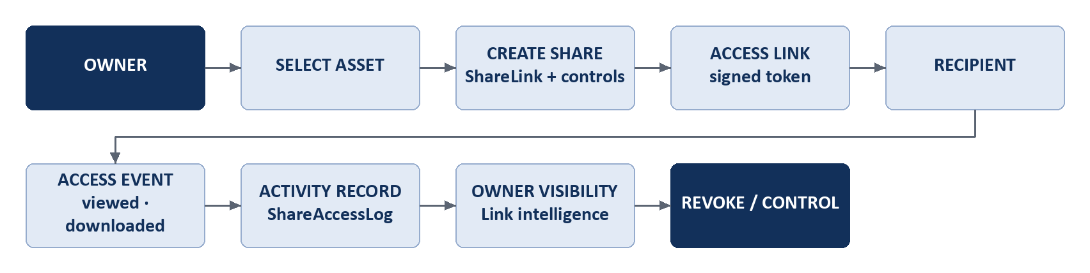
Figure 12. Secure sharing flow
Stage | Implemented
Share creation | Owner selects a protected asset and creates a ShareLink (POST /share). A signed token is issued.
Recipient and access model | Optional recipient e-mail (ShareRecipient); recipient name capture; OTP verification when required.
Access rules enforced | Expiry date, maximum views, maximum downloads, one-time use, allowed countries, allowed device types, allowed IP prefixes, download and print permission, privacy masking options.
View and download | Public viewer page (ShareViewerPage); masked output where privacy masking is configured.
Tracking | Every access is written to ShareAccessLog with device, browser, operating system and location, and a risk assessment.
Activity | PlatformEvents notify the owner; link intelligence pages show accesses, a live map and the forwarding chain (parent and child links).
Onward sharing | A recipient can share further where allowed; the chain is recorded (parentLinkId, depth, forwardedByLabel).
Revoke and control | Owner revokes a link, blocks a viewer, forces a logout, exports the log to CSV.

Relationship to Exchange
A licensed purchase in Exchange is delivered through a share link created in HUB by the bridge (POST /exchange/share/create), so buyers receive licensed access under the same access controls.

14. Certificate and Verification System
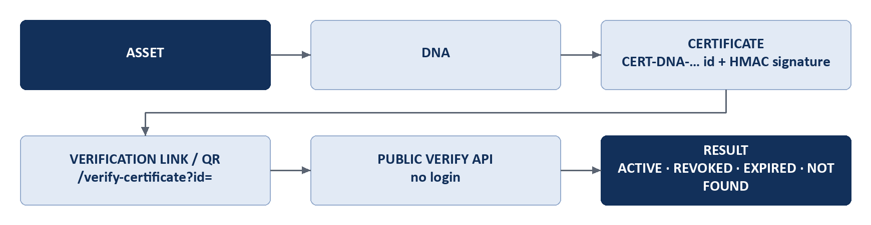
Figure 13. Certificate verification flow
Concept | Role
DNA | The asset identity: what the file is
Certificate | The verifiable proof that the identity was recorded, by whom and when
Vault | The protected file storage
Activity | The lifecycle history of what happened afterwards

Certificate creation | POST /certificates issues a certificate for a DNA record and vault record owned by the caller. If an ACTIVE certificate already exists for the pair, that certificate is returned instead of creating a second.
Certificate ID | CERT-DNA-<UUID>, unique.
Relationships | Certificate.dnaRecordId and vaultId are signed into the certificate; assetId links the certificate to the asset; ownerUserId is the owner.
Signature | HMAC-SHA256 over a canonical string of the certificate id, DNA id, vault id and issue time, keyed from the vault master secret.
Verification | GET /certificates/verify/:certificateId is public. It returns ACTIVE with signatureValid, REVOKED with the date and reason, EXPIRED, or NOT_FOUND. An invalid signature is reported as a possible forgery.
QR / link | The certificate document carries a QR code to the verification page (/verify-certificate?id=…) of the HUB deployment that rendered it. Verification needs no login.
Revocation | POST /certificates/revoke/:certificateId, owner only, with a mandatory reason; sets status REVOKED, the time and the reason.
Expiry | An optional expiry is supported; a scheduler and the verify call move an expired certificate to EXPIRED.
Immutability | There is no update or edit endpoint. A certificate can only be issued, revoked or expire; its record and signed fields are not altered afterwards. Revoked certificates remain stored, so the original stays identifiable.
Issue time | Stored exactly (millisecond timestamp) and part of the signed string; the document shows the date.

Known limitations of the committed baseline
The public verification response returns the full certificate record, including its internal DNA record id, vault id and signature value. A restricted public view that omits them is implemented in the working tree but is not committed (see final section).
The certificate’s signed string does not include the asset id or the file hash; an asset link added after issue is not covered by the signature. A version that seals both is implemented in the working tree but is not committed.
The certificate document does not yet carry the evidence-record disclaimer. Pinit certificates record protection evidence; they are not a government copyright registration and are not a legal determination of ownership.

15. Monitoring and Intelligence
In the completed scope, intelligence means monitoring matches and the link intelligence described in Section 13 (who opened a link, from where, and where it was forwarded). Investigation is not included.
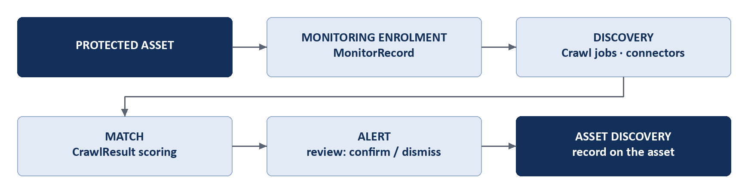
Figure 14. Monitoring flow
Stage | Implemented
Enrolment | An asset is enrolled (POST /monitor/enroll/:dnaRecordId or enroll-all), creating a MonitorRecord with scan type and optional watch URLs.
Supported sources | The crawler engine has connectors for YouTube, Reddit, GitHub, Telegram and general websites, plus filename-search and image-search providers. Browser-automation crawling is disabled by default.
Execution | Scans run through a queue and scheduler; each run is recorded (MonitoringRun) and failures are recorded (MonitoringFailure).
Discovered content | Results are stored as CrawlResult rows.
Matching | Results are scored against the asset’s DNA; matches are stored as CrawlerMatch and, where confirmed, AssetDiscovery.
Alerts | Alerts are listed, and the owner confirms or dismisses each (POST /monitor/alerts/:id/confirm and /dismiss); notifications are raised.

Boundaries
Monitoring covers the listed sources only. It is not universal internet monitoring.
Investigation and evidence reporting after an alert is outside the completed scope (final section). In production data the monitoring engine has executed at scale (20,527 results) but no confirmed discovery is recorded for the largest account.

16. Business Workspace
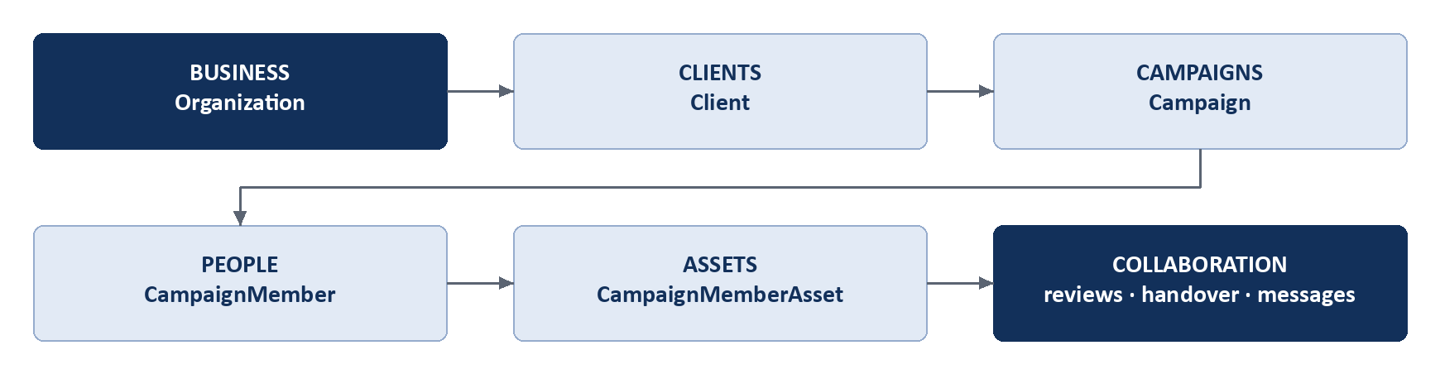
Figure 15. Business Workspace flow
Example. A creative agency creates a business workspace, adds its client “Northwind”, opens a campaign “Spring Launch” under that client, invites team members, attaches the protected assets for the launch, sends versions for review, records the client’s approval or requested changes, and finally hands the approved assets over through a secure link.
Level | Implemented
Business (Organization) | Profile and logo, team, invites, roles, departments, workspaces, audit log.
Clients | Create, edit and delete clients; client workspace with campaigns, deliveries, rights and activity.
Campaigns | Create campaigns under a client; campaign workspace with members, assets, activity and messages.
People | Campaign members with per-person access to selected assets and a view of the links each person holds.
Assets | Protected assets attached to a campaign; asset versions with review status.
Collaboration | Review comments, approvals and change requests on versions, campaign messages, handovers to the client.

 | Personal Workspace | Business Workspace
Owner | One creator | An organization with members
Structure | Assets, sharing, monitoring, portfolio | Clients, campaigns, people, versions, handovers on top of assets
Access | The owner | Owner and members by role; per-person asset access within a campaign

Roles and permissions are those implemented in the organization and campaign services (member roles, campaign member access records). Intelligence, investigation and report views inside the business workspace are outside the completed scope.

17. Pinit Exchange: Product Overview
Pinit Exchange is the marketplace layer for discovering, listing, buying, selling and licensing digital creative work. HUB protects and manages; Exchange markets and transacts.
Item | Implementation
Frontend | React 18 with Vite (exchange/src); page routing in App.jsx driven by lib/exchange-routes
Server | Node.js with Express (exchange/server/server.js), routes under /api
Database | PostgreSQL schema 'exchange' in production; SQLite for local development, selected by environment (tested)
Payments | Razorpay (order creation, signature verification, webhook); demo mode is refused against live keys (tested)
Identity | Hub single sign-on; a signed Exchange session token bound to the PINIT ID (tested)

Roles: one identity can be a seller (creator), a buyer, or both. Listing is gated by seller onboarding (a payment method must be verified) and buying is a separate capability that a creator enables.

18. Exchange Seller Workflow
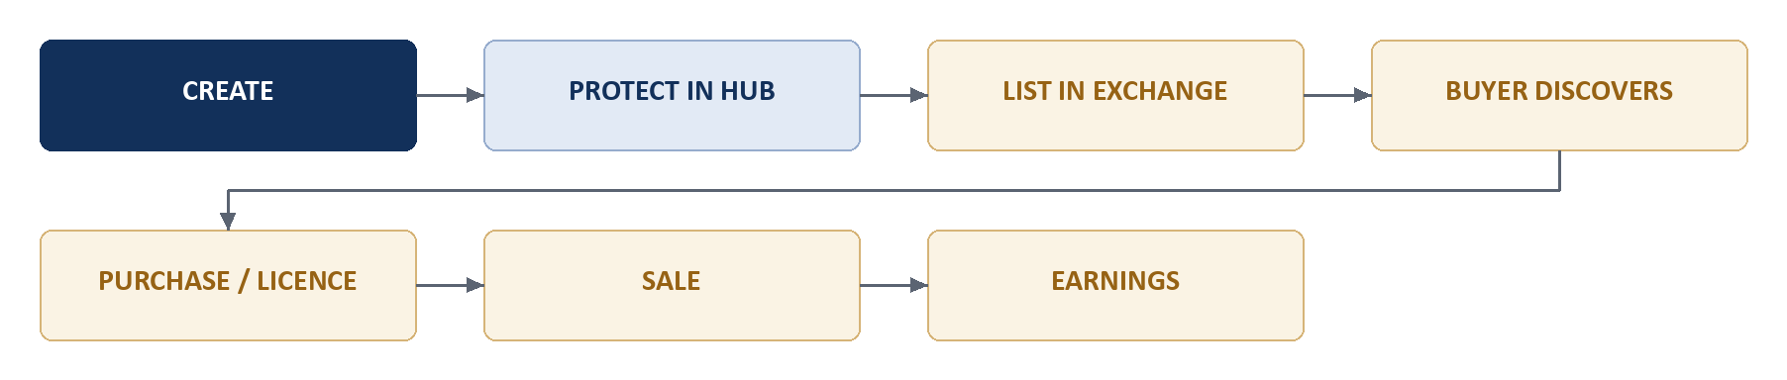
Figure 17. Seller journey
Stage | What happens | Screen | API | Records
Protected asset | The asset was protected in HUB. | HUB | HUB | Asset
List asset | Seller opens “List from Hub”, chooses a protected asset and sets tier prices. | ListFromHubModal | GET /hub/assets, POST /exchange/list-intent, POST /listings/from-hub | hub_assets, listings
Publish | HUB confirms the listing to Exchange; the listing becomes published. | SellerListings | POST /exchange/listings/confirm, POST /listings/:id/status | listings, hub_bridge_events
Buyer discovery | The listing is visible in the marketplace. | Marketplace, ListingDetail | GET /listings | listings
Purchase / licence | A buyer pays; the order is sealed. | CheckoutModal | POST /orders/checkout | orders_sealed, payment_intents
Sale | The seller sees the sale. | SalesCenter | GET /hub/seller-desk | orders_sealed
Earnings | Earnings are recorded per sale. | SellerEarnings | GET /hub/seller-desk | seller_earnings

Seller modules delivered: Overview, Assets, Listings, Sales, Earnings, List an Asset, and Opportunities (Section 19 covers Opportunities together with the buyer side of briefs).

Opportunities
Buyers post briefs; creators propose with work attached from their protected assets; the poster can invite creators, answer questions, form a team split that must add up to 100 percent and be accepted by each member, and award the brief exactly once. Creators can also post opportunities and collaboration requests. This module is covered by 23 passing tests.

19. Exchange Buyer Workflow
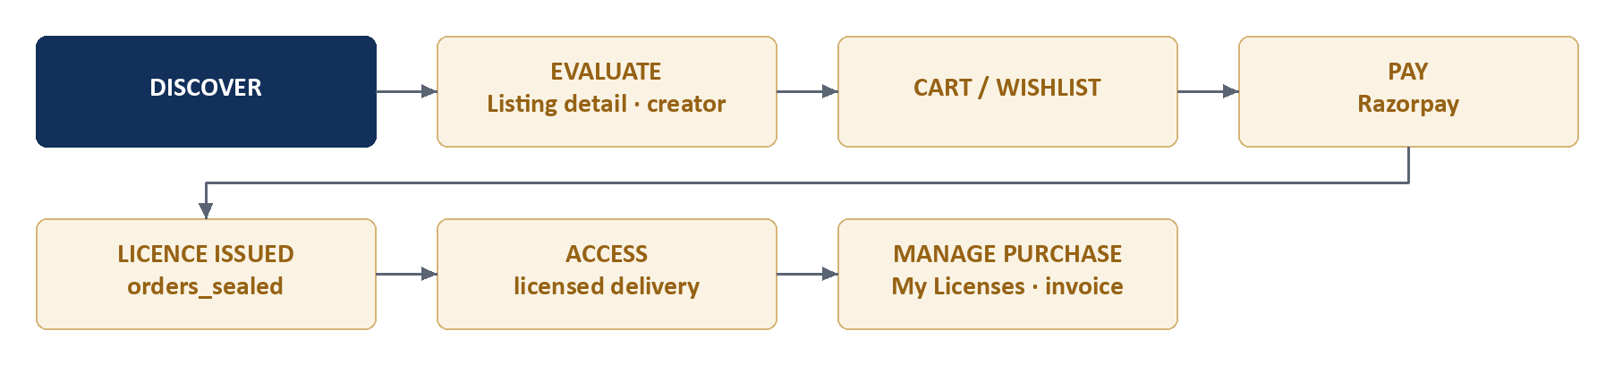
Figure 18. Buyer journey
Stage | What happens | Screen | API
Discover, search, filter | Browse and filter published listings. | HomePage, Marketplace | GET /listings
View asset and creator | Listing detail with the creator’s profile. | ListingDetail, creator pages | GET /listings/:id, GET /creator/profile/:pinitId
Cart and wishlist | Save or collect listings. | CartPage, WishlistPage | /commerce/cart, /commerce/wishlist
Payment | Razorpay order created, paid, signature verified. | CheckoutModal | POST /orders/create-payment, POST /orders/verify-payment
Licence | The sale is sealed as an order with a licence; an exclusive licence locks the asset so a second sale fails. | (automatic) | POST /orders/checkout
Access | Licensed delivery through a HUB share link; download authorization checks buyer and refund status. | MyLicenses | POST /orders/download/authorize, POST /commerce/purchases/:sealId/share
Purchase record | Licences, orders, invoices and the certificate for a purchase. | MyLicenses, BuyerOrders, BuyerPayments | GET /orders/my-licenses, /my-orders, /invoice/:sealId, /certificate/:seal_id

Evidence
[O] 4 sealed orders (all licence and delivery status active) and 2 paid payment intents in production. [T] payment amount and order verification, listing lifecycle, exclusive-purchase locking, download authorization and idempotent bridge events pass. The automated end-to-end marketplace test currently fails at a role-gating assertion before reaching the purchase steps; see Section 26.

20. Exchange Database Architecture
Exchange uses its own schema (exchange) with 21 tables. Its tables are related by identifier values (pinit_id, asset_id, listing_id, seal_id); the schema declares only one database foreign key (seller_payment_methods.pinit_id to users). Integrity of the remaining relationships is enforced by the application.
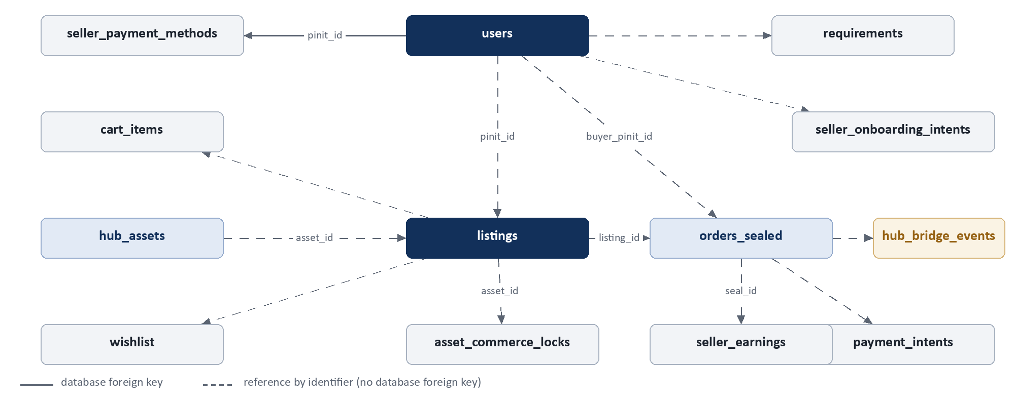
Figure 19. Exchange ER diagram
Table | Purpose | Primary key | Key references | Records in production
users | Sellers and buyers by PINIT ID | pinit_id | (root identity) | 7
hub_assets | Public-safe copy of a HUB asset for listing | asset_id | asset_id = HUB Asset.id | 20
listings | A listing with tier prices and status | listing_id | asset_id, seller pinit_id | 6 (4 published, 2 unlisted)
orders_sealed | A sealed sale and its licence | seal_id | asset_id, listing_id, buyer_pinit_id | 4
payment_intents | Razorpay payment attempts | id | order and buyer identifiers | 2 (paid)
asset_commerce_locks | Exclusive-licence lock on an asset | asset_id | asset_id | 0 (none yet exclusive)
hub_bridge_events | Idempotent Hub to Exchange events with retry | id | seal_id, asset_id | 21
seller_earnings | Earnings per sale | id | seal_id, seller pinit_id | 2
cart_items / wishlist | Buyer cart and saved listings | id | listing, buyer | 4 / 3
creator_follows | Follows between users | id | creator, follower | 1
seller_onboarding_intents / seller_payment_methods | Seller payment onboarding | id | pinit_id (payment methods: foreign key to users) | 8 / 3
requirements and proposal tables | Briefs, proposals, invites, questions, teams | req_id, id | requirement, creator | 3 briefs

Tables not treated as completed
reviews, coupons, refunds, disputes and payouts exist in the schema but hold no records and were not exercised; portfolio_profiles and tracking_jobs belong to the public ledger and monitoring bridge, whose tests currently fail or were not reviewed.

HUB to Exchange data path
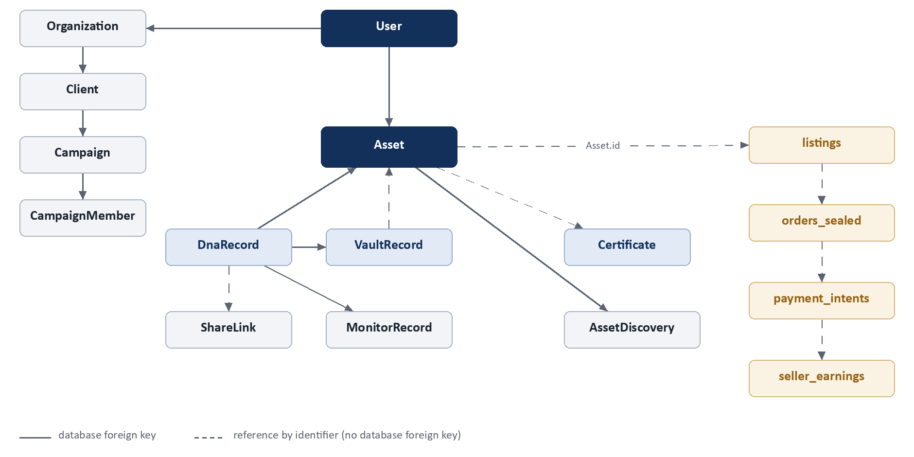
Figure 20. Entity map across HUB and Exchange

21. HUB + Exchange Integration
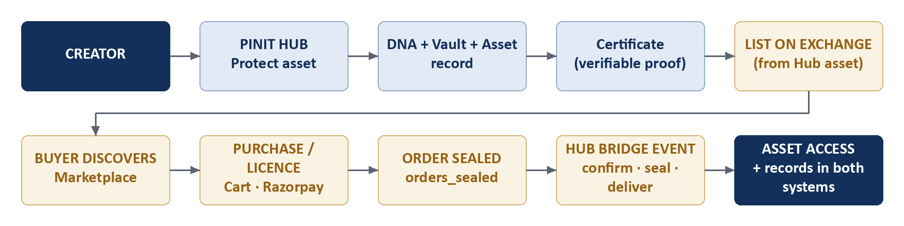
Figure 21. End-to-end integration flow

Implemented integration points
Integration point | How it works | Direction
Single sign-on | POST /exchange/sso returns a short-lived token; Exchange POST /auth/hub-sso exchanges it for an Exchange session bound to the PINIT ID. | HUB to Exchange
Listable assets | HUB exposes the owner’s protected assets (GET /exchange/listable-assets, and a bridge variant secured by X-PinIT-Bridge-Secret). | HUB to Exchange
Listing intent and confirmation | POST /exchange/list-intent, then POST /exchange/listings/confirm; Exchange stores a public-safe hub_assets row and the listing. | Both
Protect from Exchange | POST /hub/protect-upload on Exchange forwards to HUB so a creator can protect a new file without leaving Exchange. | Exchange to HUB
Sale sealing | POST /exchange/sales/seal records the sale against the HUB asset. | Exchange to HUB
Licensed delivery | POST /exchange/share/create creates a HUB share link for the buyer; delivery is prepared and fetched through /exchange/delivery/*. | Exchange to HUB
Activity | POST /exchange/activity writes marketplace events onto the HUB asset timeline. | Exchange to HUB
Idempotent events | hub_bridge_events record each bridge event with retry metadata; replays are safe. | Exchange

Identifiers that connect the systems
Identifier | HUB | Exchange
PINIT ID | User.shortId | users.pinit_id (primary key)
Asset.id | Asset.id (canonical) | hub_assets.asset_id, listings.asset_id, orders_sealed.asset_id
Order / licence | appears on the asset timeline and delivery share link | orders_sealed.seal_id
Vault id, DNA id | HUB only. Never sent to Exchange; Exchange receives only public-safe data. | —

Security of the bridge: service-to-service calls carry a shared secret header; Exchange receives only public-safe listing payloads and short-lived sign-in tokens; vault encryption keys and full forensic DNA never leave HUB.

22. Frontend Architecture
Aspect | Pinit HUB (client/) | Pinit Exchange (exchange/)
Framework | React 18.3, TypeScript, Vite | React 18.3, JavaScript, Vite
Routing | react-router-dom 7; 65 route entries in router.tsx; RequireAuth guard on protected routes; nested DashboardLayout | Page routing in App.jsx using lib/exchange-routes (pageFromPath, pathForPage); role checks in lib/roles
State | React context (AuthContext, AccountViewModeContext) and hooks (useApi with cache keys, useSubscription, useOrganization) | Component state in App.jsx; lib/session (session token), lib/buyer
API communication | One axios instance with a JWT interceptor (services/dashboard.api); base URL from config/api.config | lib/api (apiFetch) with session token; /api rewritten to the Exchange server
Styling | Tailwind CSS 3, design tokens, light and dark themes (hooks/useTheme) | Own CSS (index.css)
UI building blocks | components/ui (Badge, Modal, EmptyState, Skeleton, TableWrap, PageShell); nav (Sidebar, Topbar) | components (ListingCard, CheckoutModal, ExchangeHeader, ProvenanceDrawer)
Notifications | react-hot-toast, notification inbox over server-sent events | toasts and account notification pages
Maps, PDF, QR | Leaflet, jsPDF, qrcode | Shared certificate component (via alias), Razorpay checkout

Layer | HUB | Exchange
Pages | client/src/pages (46 entries incl. business, home, subscription, profile) | exchange/src/pages (18 pages plus seller/, buyer/, info/)
Components | client/src/components | exchange/src/components
Services / API | client/src/services | exchange/src/lib
Hooks / state | client/src/hooks, context | exchange/src/hooks, lib/session

23. File and Project Structure
Simplified from the actual repository (folders not listed are omitted, not renamed).

Pinit-DNA/
prisma/schema.prisma 111 models
src/ Hub backend (Express, TypeScript)
api/{routes,controllers,middleware}
services/ dna, vault, assets, certificates,
credentials, share, crawler, organization,
platform-events, subscription, exchange
lib/ config/ validation/
client/src/ Hub frontend (React, Vite)
{pages,components,services,hooks,context,layouts,shared,lib}
exchange/ Pinit Exchange
src/{pages,components,lib,hooks} frontend
server/{routes,lib,schema,tests} API server and schema
python-ai/ FastAPI AI service (port 8001)
scripts/ ensure-*.cjs schema scripts
tests/ Hub Jest suites (120 committed)
render.yaml Hub backend service definition

24. End-to-End Data Flow
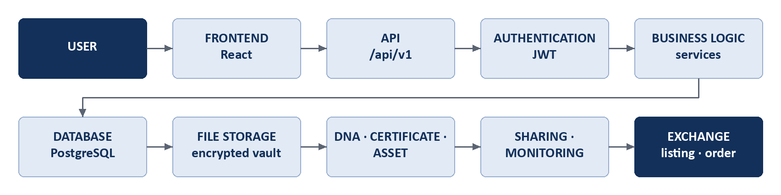
Figure 22. Overall system data flow
Transition | What moves
User to frontend | The user acts in the React application.
Frontend to API | HTTPS request to /api/v1 with a Bearer JWT.
API to authentication | requireAuth verifies the JWT; ownership middleware checks the resource owner.
Authentication to business logic | The controller calls a service with the authenticated owner id.
Business logic to database | Prisma reads and writes owner-scoped records.
Database and file storage | Encrypted file bytes go to Supabase Storage; metadata to PostgreSQL.
DNA, certificate, asset | Created in that order for a protected file (Section 6).
Sharing and monitoring | Links and monitor records reference the DNA record; accesses and scans append records and events.
Exchange and transaction | A HUB asset is listed through the bridge; a purchase is sealed in Exchange, and delivery is created back in HUB as a share link.

25. Completed Development Inventory
Every row is a capability that meets the definition of COMPLETED at the start of this document.
Area | Module | Implemented | Frontend | Backend | Database | Integration | Status
HUB · Identity | Password authentication and sessions | Sign-up, login, JWT + refresh, logout | pages/auth, AuthContext | /auth/* | User, RefreshToken, UserSession | All modules | COMPLETED
HUB · Identity | Face verification | Enrolment and login with liveness | components/auth | /auth/face/* | FaceTemplate, BiometricIdentity | Auth factor | COMPLETED
HUB · Identity | Passkeys | WebAuthn enrolment and login | lib/webauthn | /auth/passkey/* | WebAuthnCredential | Auth factor | COMPLETED
HUB · Workspace | Personal and Business accounts | Account type, business setup, switching | WorkspaceSwitcher | /auth, /organization | Organization, Workspace | Business | COMPLETED
HUB · Protect | Protect New | Upload to certified asset | GeneratePage | /dna, /vault, /certificates | DnaRecord, VaultRecord, Asset | Asset.id | COMPLETED
HUB · Protect | Pinit DNA, Layers 1 to 6 | 15 layers computed and stored | LayerPipeline | /dna/* | DnaRecord, layer records | Vault, monitoring | COMPLETED
HUB · Store | Vault, My Assets, Asset details | Encrypted storage, preview, rename, protected download | VaultPage, AssetsPage | /vault, /assets | VaultRecord, Asset | Sharing, Exchange | COMPLETED
HUB · Store | Security Check | Stored-file integrity check | VaultIntegrityPage | /vault/integrity-check | VaultRecord | Notifications | COMPLETED
HUB · Prove | Certificates | Issue, list, revoke, document with QR | CertificatesPage | /certificates, /credentials | Certificate, Credential | Asset, DNA, Vault | COMPLETED
HUB · Prove | Certificate verification | Public verification by id or link | VerifyCertificatePage | /certificates/verify | Certificate | Certificate document | COMPLETED
HUB · Share | Secure sharing | Links with access rules, revoke | VaultSharePage, ShareViewerPage | /share, /recipients | ShareLink, ShareRecipient | Business, Exchange delivery | COMPLETED
HUB · Share | Link intelligence | Access log, map, forward tree | AccessIntelligencePage | /share analytics, logs, tree | ShareAccessLog, LinkForwardEvent | Notifications | COMPLETED
HUB · Watch | Monitoring | Enrol, scan, match, alert | MonitoringPage | /monitor/* | MonitorRecord, CrawlResult | Asset discoveries | COMPLETED
HUB · Business | Clients and campaigns | CRUD, workspaces | ClientsPage, CampaignWorkspacePage | /business | Client, Campaign | Assets, people | COMPLETED
HUB · Business | People and access | Campaign members, per-person access | BusinessTeamPage | /business people | CampaignMember(Asset) | Sharing | COMPLETED
HUB · Business | Review, approval, handover | Versions, comments, approvals, handovers | CampaignWorkspacePage | /business versions, handovers | AssetVersion, VersionApproval | Sharing | COMPLETED
HUB · Business | Team, roles, departments | Invites, roles, audit log | OrganizationSettingsPage | /organization | OrganizationMember, Department | Business | COMPLETED
HUB · Portfolio | Portfolio | Build, publish, public page | ProfilePage | /portfolio | Portfolio* | Vault assets | COMPLETED
HUB · Account | Profile and sessions | Profile, avatar, sessions | ProfilePage | /profile | User, UserSession | Auth | COMPLETED
HUB · Account | Notifications | Inbox with live stream | notification bell | /notifications | Notification, PlatformEvent | All modules | COMPLETED
HUB · Account | Plans and entitlements | Plans, subscription, feature gating | UpgradePage | /subscription | Plan, Subscription | All gated modules | COMPLETED
Exchange · Market | Marketplace and listing detail | Browse, search, filter, view | Marketplace, ListingDetail | /listings | listings | HUB asset | COMPLETED
Exchange · Seller | Seller onboarding | Payment-method verification | SellerPaymentOnboarding | /seller/onboarding | seller_payment_methods | Razorpay | COMPLETED
Exchange · Seller | List from HUB | Choose protected asset, price, publish | ListFromHubModal | /hub, /listings/from-hub | hub_assets, listings | HUB bridge | COMPLETED
Exchange · Seller | Seller desk | Overview, assets, listings | pages/seller | /hub/seller-desk | listings | HUB | COMPLETED
Exchange · Seller | Sales and earnings | Sales list and earnings ledger | SalesCenter, SellerEarnings | /hub/seller-desk | orders_sealed, seller_earnings | Orders | COMPLETED
Exchange · Seller | Opportunities | Briefs, proposals, invites, awards | SellerOpportunities | /opportunities | requirements, proposals | Creators | COMPLETED
Exchange · Buyer | Cart and wishlist | Save and collect listings | CartPage, WishlistPage | /commerce | cart_items, wishlist | Checkout | COMPLETED
Exchange · Buyer | Checkout, payment, licence | Razorpay payment, sealed order, exclusive lock | CheckoutModal | /orders | payment_intents, orders_sealed | HUB bridge | COMPLETED
Exchange · Buyer | My Licenses and orders | Licences, orders, invoices, certificate | MyLicenses, BuyerOrders | /orders | orders_sealed | HUB delivery | COMPLETED
Integration | HUB to Exchange bridge and SSO | SSO, listing confirm, sale seal, delivery, activity | ListFromHubModal | HUB /exchange, Exchange /hub | hub_bridge_events | Asset.id, PINIT ID | COMPLETED

26. Testing and Validation
Area | Evidence in the reviewed implementation
Unit and integration (Hub) | Jest with ts-jest: 120 committed suites under tests/ (plus 8 added locally for uncommitted work, which are included in the run below) covering authentication and biometrics, DNA layers, vault, sharing, notifications, portfolio, credentials, tenant isolation and authorization boundaries.
Last complete Hub run | 1,072 tests passed, 8 failed, 23 skipped across 119 of 128 suites run. Two failures (credentials-phase1) were then fixed and re-verified; the full suite was not re-run after that fix.
Known Hub failures | Four forensic suites (unified-investigation, enterprise-investigation-pipeline, candidate-ranking-engine, evidence-pairing; 6 tests) and health.test.ts, which cannot compile because the supertest dependency is not installed.
Exchange | node:test, 97 tests: 93 passed, 4 failed. Passing areas: database selection, session and preview tokens, payment verification and demo-mode guard, opportunities (23 tests), listing lifecycle, exclusive-purchase locking, download authorization, bridge-event idempotency. Failing: the end-to-end marketplace flow (stops at a role-gating assertion), two role-policy tests, and one public-ledger field test.
Authentication and security | Face liveness and matching, passkeys, cookies, JWT subject and isolation, no raw biometric data in logs or responses, authorization boundaries, tenant isolation: all passing.
Database | Verified by read-only queries against production for the row counts quoted in this document. No migration test suite exists; schema changes are applied by idempotent scripts.
Frontend | Testing evidence not available in the reviewed implementation. The client has no test runner configured; one stray unit test file exists.
Deployment | Testing evidence not available in the reviewed implementation. There is no CI workflow in the repository.

Reading these numbers
The failing forensic suites are why investigation is excluded from the completed scope. The failing Exchange end-to-end test is on a role-gating expectation that later behaviour contradicts (a passing test states that creators and buyers may share one identity); marketplace purchases nevertheless exist in production. The test needs updating; until it does, the purchase flow is supported by operation and component tests rather than by a passing end-to-end test.

27. Deployment Architecture
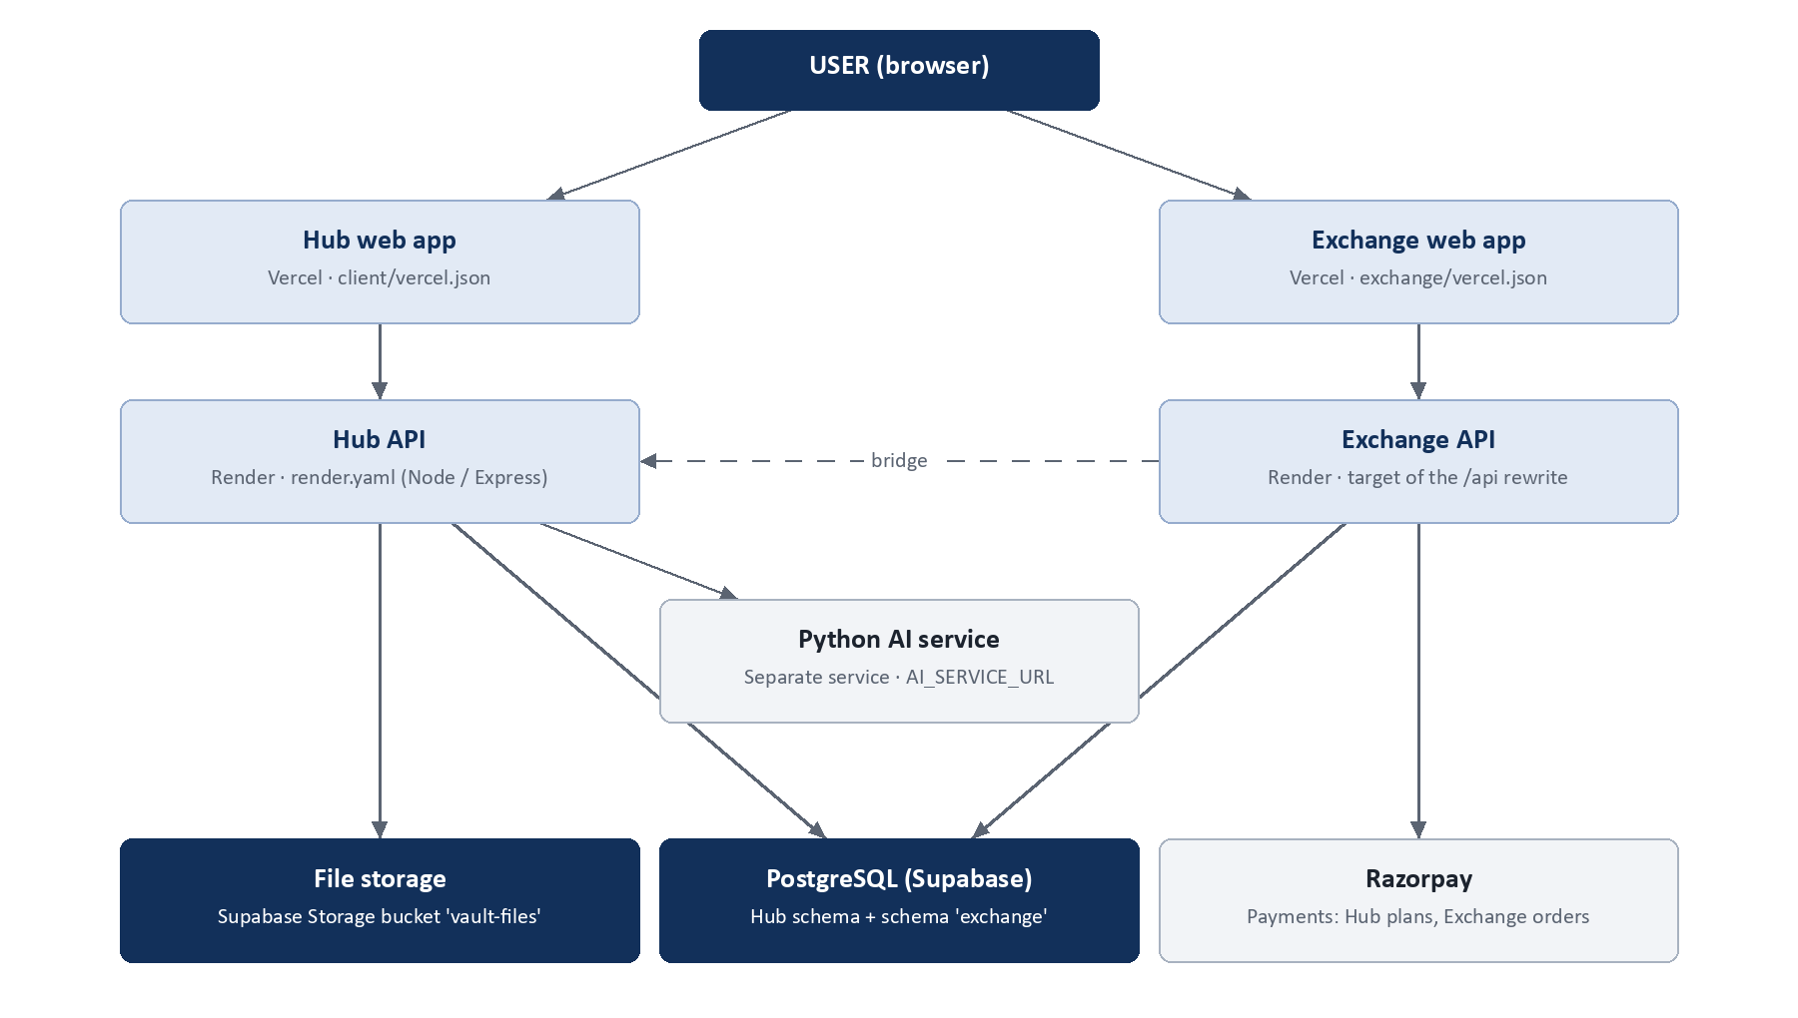
Figure 23. Deployment architecture
Element | Configuration found in the repository
Hub web app | Vercel (client/vercel.json): Vite build, single-page rewrites
Exchange web app | Vercel (exchange/vercel.json): Vite build; /api rewritten to the Exchange server on Render; share paths forwarded to the Hub domain
Hub API | Render web service (render.yaml): npm run build, then start:prod, which applies the ensure-*.cjs schema scripts and starts the server
Exchange API | Render service (target of the Exchange /api rewrite)
AI service | Separate service (python-ai, FastAPI, Dockerfile); reached through AI_SERVICE_URL
Database | Supabase PostgreSQL; Hub schema and the exchange schema
File storage | Supabase Storage bucket vault-files
Payments | Razorpay
Environment | Render environment variables (secrets not in the repository); .env.example files document the variables
Deployment process | Git push to the deploy branch triggers Render and Vercel builds. There are no CI workflow files.

The live status of these services was not re-verified on the documentation date; this section describes the configuration in the repository.

28. User Journeys

Individual user
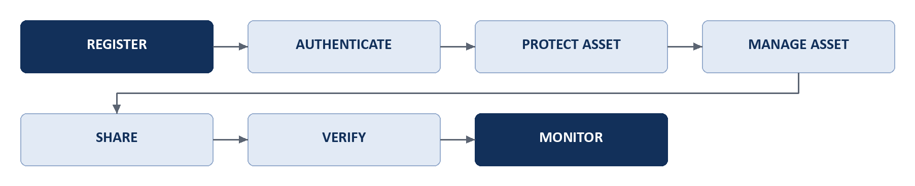
Figure 24. Individual user journey

Business user
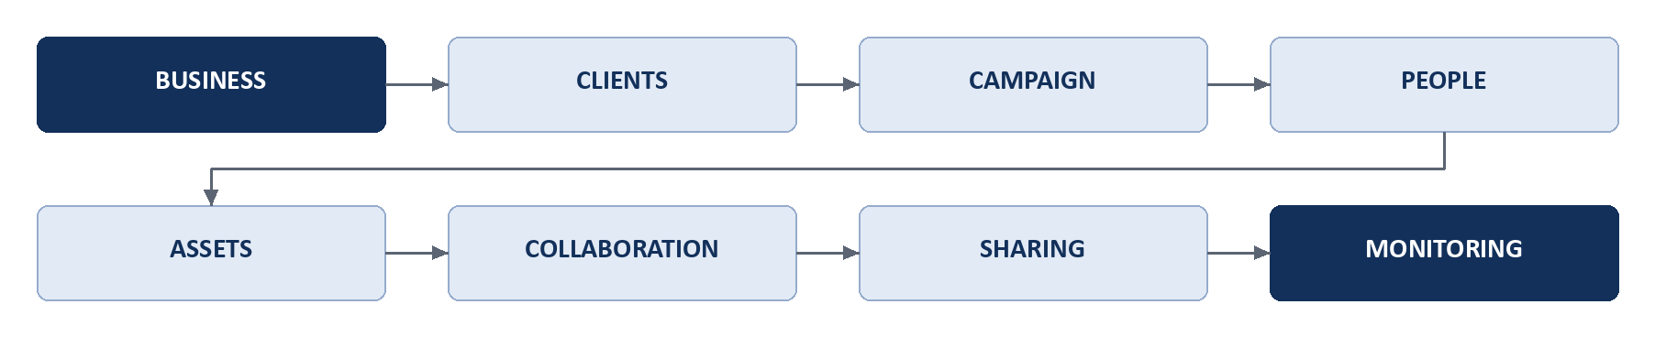
Figure 25. Business user journey

Creator / seller
Figure 26. Creator and seller journey

Buyer
Figure 27. Buyer journey

29. Technical Entity Map
Figure 28. Consolidated entity map (implemented entities only)
The map joins the HUB entities to the Exchange tables through Asset.id. The Exchange tables are related to one another by identifier values (Section 20). Entities named in the brief that are not implemented as separate entities are not shown: there is no separate “Finding”, “Investigation” or “License” entity in the completed scope (a licence is the order_sealed record).

30. Completed Product Capabilities

Pinit HUB
- Identity: password, face verification with liveness, passkeys, sessions
- Asset protection and digital asset identity (Asset.id)
- Pinit DNA (Layers 1 to 6) and an ownership watermark
- Encrypted protected storage (Vault) and asset management
- Certificates and public verification, with revocation and expiry
- Secure sharing with access controls, activity tracking and link intelligence
- Monitoring of protected assets across supported sources
- Business Workspace: clients, campaigns, people, review, approval, handover
- Portfolio, notifications, plans and entitlements

Pinit Exchange
- Marketplace discovery, listing detail, cart and wishlist
- Seller onboarding and listing from a protected HUB asset
- Buyer checkout with Razorpay, sealed licence records, invoices, licensed delivery
- Sales and earnings for sellers
- Opportunities: briefs, proposals, invitations, teams and awards

Integration
- Single sign-on, listable assets, listing confirmation, sale sealing, licensed delivery and activity between HUB and Exchange
- Idempotent bridge events with retry

31. Final Development Status

What Has Been Delivered
As of the documentation date, the following has been fully developed and evidenced:
- Pinit HUB: a complete protect-to-verify path (identity, DNA, encrypted Vault, canonical Asset, signed Certificate), secure sharing with tracking and revocation, monitoring of supported sources, a Business Workspace, a Portfolio, notifications and plans. Backed by a 111-model schema and 120 committed test suites, with production data showing 42 assets, 32 certificates, 39 share links and 96 monitoring profiles.
- Pinit Exchange: a working marketplace with seller onboarding, listing from HUB assets, cart and wishlist, Razorpay checkout, sealed licences, licensed delivery, sales, earnings and opportunities. Production data shows 6 listings, 4 sealed licences and 2 paid payment intents.
- Integration: a verified bridge that carries one asset identity, one user identity and licensed delivery between the two products.
This document represents the implemented product state as of the documentation date.

Not Included in Completed Scope
These items exist in the repository or were developed, but do not meet the definition of COMPLETED. They are listed so that the boundary is explicit.
Item | State | Reason it is not counted
Investigation and evidence reporting (unified investigation, forensic comparison, evidence PDFs, business investigations) | Implemented | Four forensic test suites fail in the reviewed tree; no incident or evidence records exist in production.
Asset Tracking pages and the redesigned Asset Activity lifecycle log | Developed and checked locally | Not committed or deployed. The committed Asset Activity screen is superseded.
Unified lifecycle event layer and compact video-frame DNA storage | Developed and tested locally | Not committed. The lifecycle columns have not been applied to the production database.
Certificate v2 binding (asset id and file hash in the signature), restricted public verification view, evidence-record wording on the certificate, configurable public verification origin, shared certificate component across HUB and Exchange | Developed and tested locally | Not committed or deployed. Until deployed, the limitations listed in Section 14 apply.
Passkey use in production | Implemented and tested | No enrolment is recorded; included in the inventory on test evidence only.
Hub plan payment collection (Razorpay for subscriptions) | Implemented | A demonstration completion path exists and live collection was not verified.
Organization API keys, webhooks and third-party integrations (Slack, Teams, Zapier, Dropbox, Google Drive) | Implemented | No evidence of use or tests.
Exchange reviews, coupons, refunds, disputes, payouts | Schema and routes | No records; not exercised.
Exchange public creator ledger and portfolio pages | Implemented | A test on which public fields may be published fails.
Additional DNA layers and modes (further layer tables, DNA vNext, block DNA), spatial pixel authentication, Publish Guardian and browser extension, Master Admin console | Present in the codebase | Outside the verified scope of this document.

Documentation Scope
This document represents the functionality verified as implemented in the reviewed Pinit HUB and Pinit Exchange codebase as of 21 September 2026. Features that were incomplete, experimental, planned, disabled, or not sufficiently verified have not been represented as completed functionality.

Endpoints documented in Section 11: 287 of 384 route registrations detected in the reviewed route files.

