To: J. Sterling
Subject: Call Center Performance Analysis and Recommended Path Forward

Objectives
Under the current setup, the average wait time is 2.44 minutes, and 47% of customers experience waiting. Able handles 62% of calls, while Baker handles 38%. Demand builds throughout the day and peaks between hours 4–7, when wait times are highest. Our objective is to improve customer experience by reducing wait times, increasing customer satisfaction, and maximizing first-call resolution.
Proposed Solution
Option#1: Update Streaming Policy
Under this policy, Able serves when available; otherwise Baker serves. Customers wait only if both agents are busy. This reduces the average wait time to 0.9 minutes, with 56% of customers served immediately. About 32.8% wait longer than 1 minute, and the 95th percentile wait is under 4.1 minutes. Agent utilization is more balanced, improving efficiency and customer satisfaction.
Option #2: Expert-First Strategy
This approach prioritizes first-call resolution by routing most calls to the more knowledgeable agent. Able serves whenever available, and customers wait for Able even if Baker is free, as long as Able’s queue is no more than one caller. Baker serves only when Able’s queue exceeds this threshold. This results in a higher average wait time of 1.47 minutes (63.3% probability of waiting), but 65.4% of calls are handled by the expert agent. The system remains stable, with a 95th percentile wait of 4 minutes, improving service quality without adding staff.
Option #3: Improve Baker’s Performance

Training and better tools improve Baker’s service time from 3–6 minutes to 2–5 minutes. The average wait drops to 1.15 minutes, and only 28.8% of customers experience any wait. The 95th percentile wait falls to 6 minutes, and only 8.9% of days exceed an average wait of 2 minutes. Workload becomes more balanced (Able 57%, Baker 42%). This avoids hiring costs but requires 3–5 months of training and carries some performance uncertainty.
Recommended Strategy
- Short term: Implement O1 (Updated Streaming Policy) for immediate wait-time reduction.
- Medium term: Pursue O3 (Improve Baker’s Performance) to stabilize service and reduce variability.
- Selective use: Apply O2 (Expert-First) only for high-value or complex calls.
- Long term: As demand grows, consider automating low complexity calls to support scalability.
Key Action Items
- Pilot routing changes for one month.
- Track CSAT, first-call resolution, wait experience, and total time in system.
- Review incentives to reward Able and motivate Baker.
- Begin targeted training for Baker to improve service performance, with monthly progress reviewed.
- Introduce callback options when waits exceed 5 minutes (Priority Stream for Expert-First).
Additional Data to Collect:
- Customer satisfaction by call and wait-time range
- Call complexity / difficulty level (to support future automation decisions as the company scales)
- First-call resolution by agent and call type
- Operational cost metrics (agent cost, cost per call, automation comparison)

----------------------------------------------------------Appendix ----------------------------------------------------------
1: Current Setup
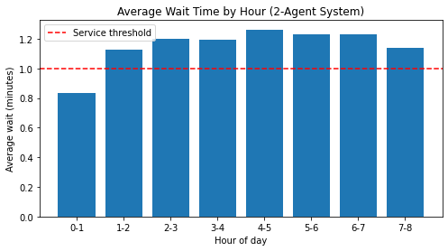
Figure1: Peak Hour on the current set up
2: Update Streaming Policy
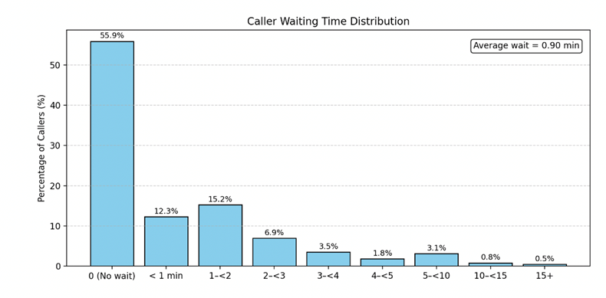
Figure 2.a: Waiting time distribution

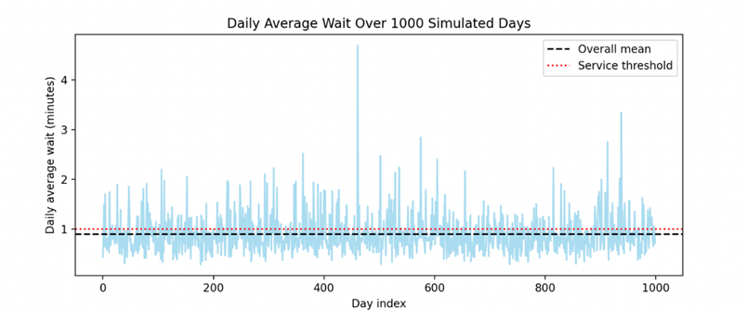
Figure 2.b: Daily average day wait over 1000 days
3: Expert-First Strategy
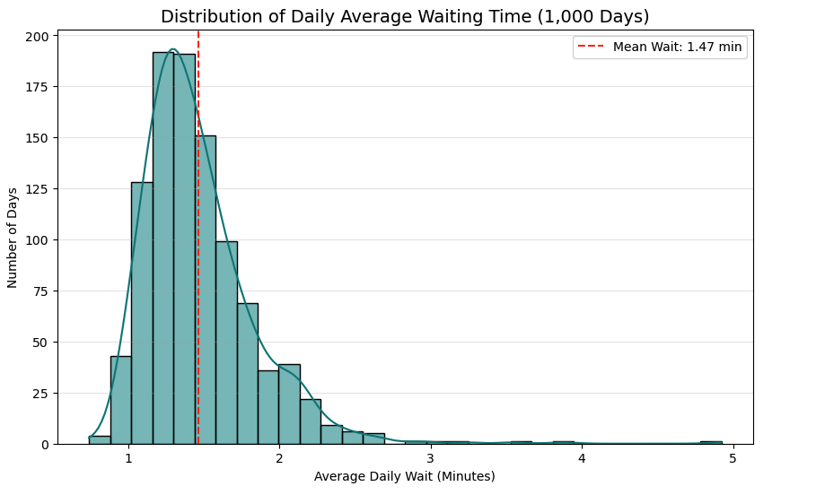
Figure 3.a: Waiting time distribution
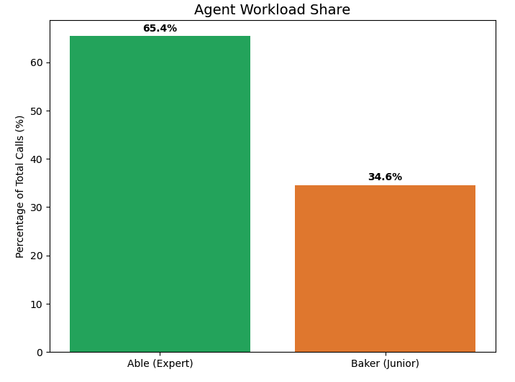
Figure 3.b: Agent workload share
4: Improve Baker’s Performance
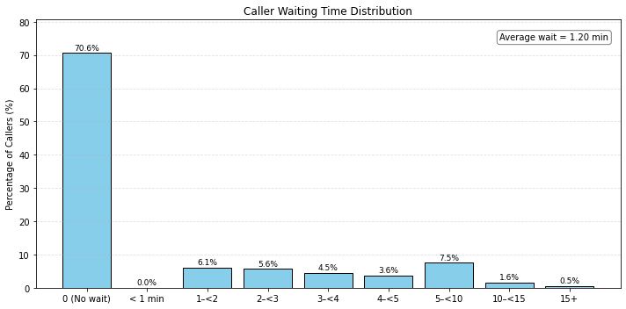
Figure 4.a: Waiting time distribution

