GLOBAL SECURITY REVIEW

Award Hub
  - High-Level Design, Data Flows and Meeting Q&A
Prepared for | Global Security Team
Meeting date | 28 August 2026
Design status | Application implemented; hosting and platform controls pending approval
Source basis | Award-Hub IT Requirements dated 29 June 2026 and current codebase
CONFIDENCE LABELS
IMPLEMENTED Verified in the application or current codebase. PROPOSED Target-state control requiring platform configuration. DECISION Requires Global Security or IT approval.

1. Executive briefing
Use this opening statement
“Award Hub is a single-tenant Microsoft 365 application. Employees authenticate using Microsoft Entra ID through the OIDC authorization-code flow, so the application never receives or stores employee passwords. The web application reads award events from a shared Microsoft 365 calendar and allows employees to copy selected events into their own Outlook calendar. Calendar operations use a separate Microsoft Graph application identity. Application state, Graph identifiers, synchronization cursors and notification queue records are stored in PostgreSQL. Microsoft Graph sends change notifications to a public HTTPS webhook, which validates and durably queues each accepted notification before a background worker performs a Graph delta synchronization. Hosting, region, WAF, SIEM integration, backup policy and the final Exchange permission scope still require approval from Global Security.”

Verified current evidence
- 27 test files and 93 automated tests pass.
- npm audit reports zero known dependency advisories.
- The optimized Next.js production build succeeds with demo mode disabled.
- The build deliberately refuses production startup when passwordless demo mode is enabled.
- Security headers, webhook validation, durable notification queuing and duplicate-event controls are implemented.

What must not be overclaimed
- The hosting provider, region, network topology and data residency are not finalized.
- The current public showcase routes are not protected by sign-in; only protected APIs and write operations are authenticated.
- The Entra access-group setting is supported but must be made mandatory in production configuration.
- The in-process rate limiter is a backstop, not a multi-replica WAF control.
- Central SIEM, backup/restore, retention, RPO/RTO and incident runbooks are not yet configured.

2. High-level security architecture
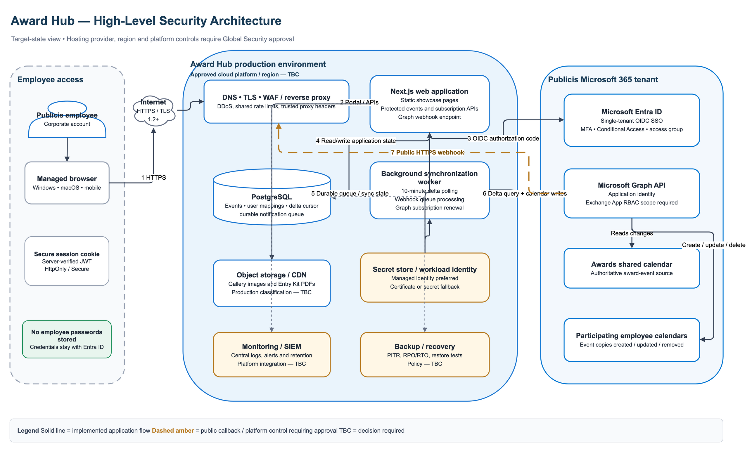
Figure 1. Target-state architecture. Amber controls and all “TBC” labels require platform or Global Security approval.

3. Data flows

1. Sign-in
Employee browser → Microsoft Entra ID → OIDC authorization-code response → server-verified Award Hub session.

2. View awards
Authenticated browser → protected events API → PostgreSQL event cache. The worker refreshes the cache from the shared Microsoft 365 calendar.

3. Add to calendar
Authenticated employee → protected subscription API → unique database claim → Microsoft Graph → copy created in that employee’s calendar → source/copy mapping stored.

4. Synchronize changes
Graph change notification → public HTTPS webhook → validation → durable NotificationQueue row → worker delta query → database update → employee event copies updated or cancelled.

5. Static content
Browser → application or approved object storage/CDN → gallery images and Entry Kit PDFs. There is no employee file-upload function.

4. Identity and access
Q1. Is this SSO?
[IMPLEMENTED] Suggested answer: Yes. It uses single-tenant Microsoft Entra ID SSO with OpenID Connect and the authorization-code flow. Credentials are entered on Microsoft’s login page; Award Hub never receives employee passwords.
Q2. Does corporate MFA and Conditional Access apply?
[PROPOSED] Suggested answer: Yes. Because authentication is performed by Entra ID, tenant MFA, sign-in risk, device-compliance, location and Conditional Access policies can apply. Global Security must confirm the exact production policy.
Q3. Who is allowed to use the application?
[DECISION] Suggested answer: The implementation supports an Entra access-group ID and fails closed on missing or ambiguous group claims when that setting is configured. Production must require ACCESS_GROUP_ID and configure Entra group claims or application assignment.
Q4. Are all pages private?
[DECISION] Suggested answer: Not currently. Calendar APIs and write operations require authentication, but the landing, gallery, awards-information and sample calendar pages are statically public. Security must decide whether the showcase remains public or the whole application is gated.
Q5. How are sessions managed?
[IMPLEMENTED] Suggested answer: NextAuth uses signed, server-verified JWT sessions and secure HTTP-only cookies in production. Calendar operations use the employee identity taken from the verified server session, not from browser-supplied identifiers.
Q6. Does the application have administrative roles?
[IMPLEMENTED] Suggested answer: There is no application administration interface today. Content and configuration are deployed by the technical team. A future administration function would require separate role-based authorization and audit logging.

5. Microsoft Graph permissions
Q7. Why is Calendars.ReadWrite application permission required?
[IMPLEMENTED] Suggested answer: The worker requires unattended access to read the shared awards calendar and create, update or remove event copies in participating employees’ calendars. Delegated permission alone would not support background synchronization while users are offline.
Q8. How will tenant-wide Graph access be restricted?
[DECISION] Suggested answer: Exchange should scope the application to the awards mailbox plus staff permitted to use copy-to-calendar. Scoping only the awards mailbox would break the feature because the application writes to participating employees’ own calendars. Microsoft now recommends Exchange Online App RBAC; the older Application Access Policy commands in the requirements document are legacy guidance.
Q9. Is the employee login token used for calendar synchronization?
[IMPLEMENTED] Suggested answer: No. The employee login establishes identity and access within Award Hub. Calendar synchronization uses the application identity, so employee refresh tokens are not stored.
Q10. How will Graph credentials be protected?
[DECISION] Suggested answer: The application supports managed identity, certificate authentication or a client secret for Graph. Managed identity is preferred when the approved host supports it; otherwise use a certificate in the approved vault. Rotation ownership and timing must be agreed with IAM.

6. Webhook and API security
Q11. Why is there a public endpoint?
[IMPLEMENTED] Suggested answer: Microsoft Graph must reach the notification webhook over public HTTPS. It is the only intentionally unauthenticated application endpoint; business APIs require an authenticated session.
Q12. How are forged webhook requests rejected?
[IMPLEMENTED] Suggested answer: Notifications are schema-validated and checked against the expected client state and stored subscription metadata. Client-state comparison is constant-time. Payloads are limited to 64 KB and 100 notification items, and rejected deliveries disclose no validation details.
Q13. Could a notification be lost after HTTP 202?
[IMPLEMENTED] Suggested answer: Accepted notifications are persisted in PostgreSQL before acknowledgement and marked processed only after a successful delta cycle. Ten-minute polling also recovers changes when a webhook is delayed or missed.
Q14. How are duplicate Outlook events prevented?
[IMPLEMENTED] Suggested answer: A unique employee-and-source-event mapping is claimed in PostgreSQL before calling Graph. Concurrent requests therefore produce one event. A Graph failure marks the record so a later attempt can retry.
Q15. How is denial-of-service protection handled?
[DECISION] Suggested answer: The code provides request-size limits and an in-process rate limiter as a backstop. Production still requires shared WAF or gateway rate limits, request-size enforcement and a trusted proxy that overwrites forwarded IP headers.

7. Data protection and privacy
Q16. What personal or business data is stored?
[IMPLEMENTED] Suggested answer: Employee Entra object ID, business email, source and copied Graph event IDs, synchronization state, error status and award event details. The application does not store employee passwords, mailbox messages or unrelated calendar data.
Q17. Is data encrypted?
[PROPOSED] Suggested answer: All production traffic must use TLS. Database, backup, secret-vault and object-storage encryption at rest must be enabled through the selected hosting platform. These are mandatory target controls, but the platform is not yet approved.
Q18. What is the data-retention period?
[DECISION] Suggested answer: A formal schedule is not yet approved. Owners and retention periods are required for events, failed subscription records, processed notification rows, logs and backups, including deletion procedures for departed employees.
Q19. Can users upload malicious files?
[IMPLEMENTED] Suggested answer: There is no end-user upload function. Gallery images and PDFs are supplied during deployment. Any future upload function would require validation, malware scanning and controlled private storage.
Q20. Where will the data be hosted?
[DECISION] Suggested answer: Not yet decided. The application needs a Next.js web runtime, one background worker, PostgreSQL, a credential store or workload identity, object storage and a public HTTPS edge. Security must approve the platform, region, residency and networking model.

8. Application security and assurance
Q21. What security testing has been completed?
[IMPLEMENTED] Suggested answer: The seven identified code findings have been addressed. Current evidence is 27 test files with 93 passing tests, zero npm audit advisories and a successful production build. Demo-mode production startup is also blocked.
Q22. How are software dependencies governed?
[PROPOSED] Suggested answer: Supported framework and library versions are recorded in the lockfile, and the current audit is clean. CI should enforce automated tests, production build, dependency audit, static analysis and secret scanning before deployment.
Q23. What browser security controls are enabled?
[IMPLEMENTED] Suggested answer: Production responses include Content Security Policy, HSTS, clickjacking protection, MIME-sniffing protection, referrer and permissions policies, and cross-origin headers. The framework identification header is disabled.
Q24. Why does the CSP allow inline scripts?
[DECISION] Suggested answer: This is a documented residual risk. Per-request nonces would require dynamically rendering the currently static pages and would affect CDN caching. The current policy limits sources, blocks framing and plugins, and the application has no user-authored HTML. Security must accept the residual risk or approve dynamic rendering.
Q25. Can passwordless demo authentication reach production?
[IMPLEMENTED] Suggested answer: No. Production build and startup abort when either demo-mode environment variable is enabled. Production authentication exposes only the Entra provider.

9. Operations and resilience
Q26. How does the application scale?
[DECISION] Suggested answer: The web tier can scale horizontally, but the current worker should run as a single active replica. Multiple worker replicas require a PostgreSQL advisory lock, distributed lease or platform singleton-job control.
Q27. What monitoring and audit logging exists?
[DECISION] Suggested answer: The application logs operational failures without returning Graph or database details to users. Central collection, SIEM forwarding, correlation IDs, alert rules, log retention and dashboards remain platform decisions.
Q28. What alerts should be configured?
[PROPOSED] Suggested answer: Alert on Graph subscription renewal failure, failed delta cycles, queue growth, repeated webhook rejection, authentication denial spikes, database or backup failure, and approaching certificate or secret expiry.
Q29. What are the recovery objectives?
[DECISION] Suggested answer: RPO and RTO are not defined. The business and Security must approve point-in-time database recovery, backup retention, restore testing and recovery of Graph subscriptions and delta cursors.
Q30. What is the incident-response procedure?
[DECISION] Suggested answer: Containment would include disabling the service principal or credential, removing its Exchange role assignment, stopping the worker, preserving logs, rotating credentials and reviewing Graph and database activity. A formal runbook and named contacts still need to be approved.
Q31. Who owns each control?
[DECISION] Suggested answer: The application team owns code and application configuration; IAM owns Entra registration, Conditional Access and credential governance; Exchange owns Graph scope; Platform Operations owns WAF, TLS, database, backups, monitoring and runtime; the business owner owns access membership and data retention.

10. Decisions to request from Global Security
- Exchange Online App RBAC scope: awards mailbox plus eligible participating employees.
- Whether every page must require sign-in or the public showcase may remain available.
- Mandatory Entra access group, application assignment, MFA and Conditional Access rules.
- Approved hosting platform, region, data residency and network topology.
- Managed identity versus certificate authentication and credential-rotation ownership.
- WAF, trusted-proxy, DDoS, request-size and shared rate-limit requirements.
- PostgreSQL backup, point-in-time recovery, RPO/RTO and restore-test standards.
- SIEM destination, security alerts, log fields and retention.
- Retention and deletion periods for application records, queue rows, logs and backups.
- Acceptance or remediation of the inline-script CSP residual risk.
- Single worker replica versus a required distributed execution lock.
- Production migration, CI/CD evidence and deployment-approval process.

Safe wording when a control is not approved
“That is not finalized in the current design. The application supports the control, but we need your approved standard before production.”
“The code-level mitigation is implemented. The platform-level control—such as WAF, SIEM, backup or Exchange scope—depends on the approved production environment.”
“I do not want to overstate the current position. I will record that as a required security decision and return with implementation evidence.”

11. References
Internal requirements: Award-Hub-IT-Requirements-29.6.2026.docx, pages 2–7.
Implementation security record: SECURITY.md in the AwardHubCalendar repository.
Microsoft Graph permissions: Open Microsoft Learn guidance
Exchange Online App RBAC: Open Microsoft Learn guidance
Application Access Policies — legacy guidance: Open Microsoft Learn guidance

