Award Hub
A short overview for the GSO Team

What is Award Hub?
Award Hub is an internal Publicis web application that brings together award information and a gallery showcasing work from across Publicis Groupe Thailand. Employees can follow award dates and timelines, then explore each work through its write-up, video, and contributor credits.

What can employees do?
- View award dates, deadlines, and timelines, and add selected events to their own Outlook calendar.
- Explore a gallery of work produced across Publicis Groupe Thailand.
- Read project write-ups, watch videos, and view credits for the people and teams behind the work.
Employees sign in with their Publicis Microsoft account. Award Hub is intended for internal use and the target service is hosted on DigitalOcean.

High-level architecture
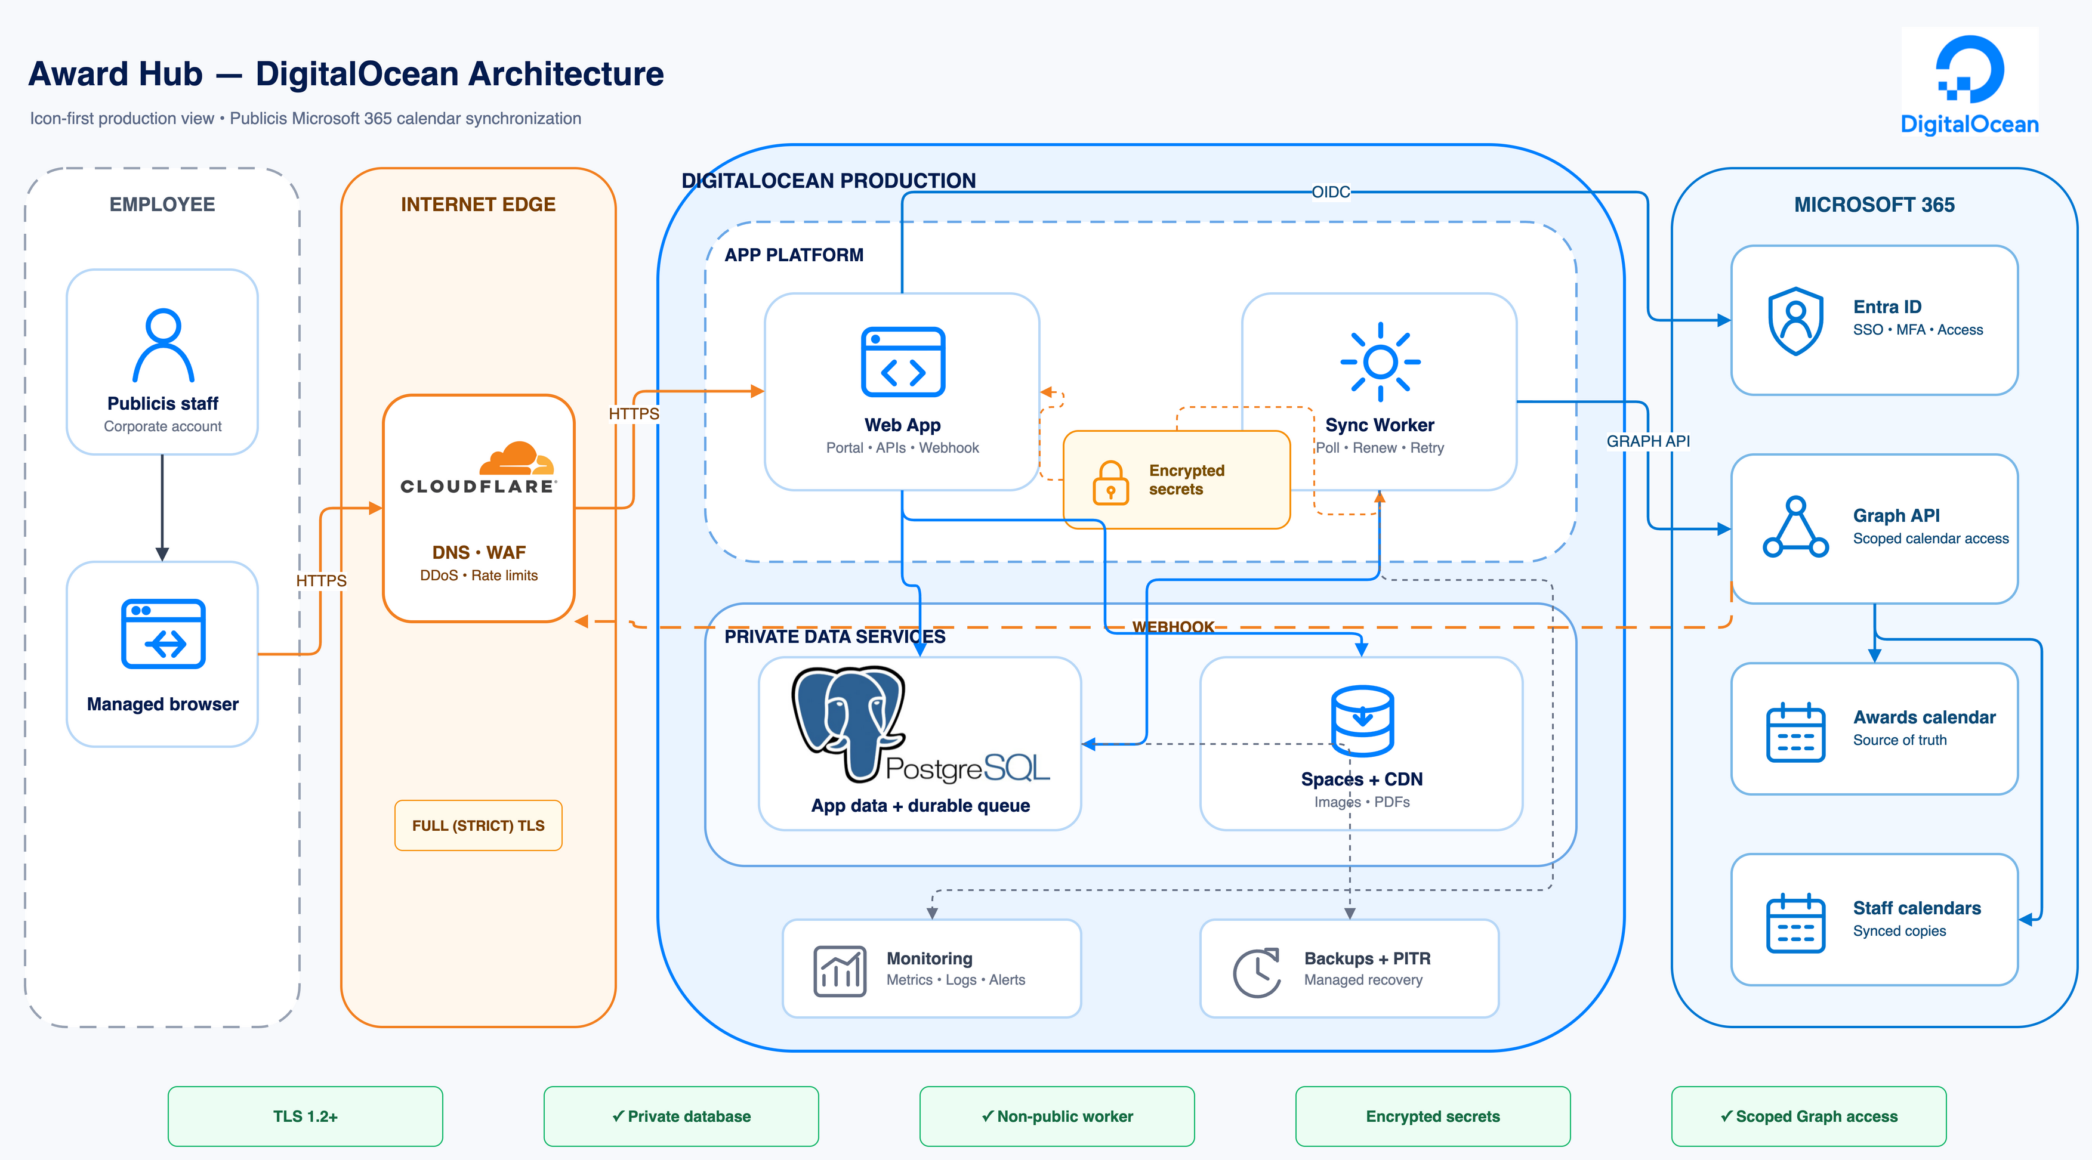
Figure 1. Award Hub target high-level architecture on DigitalOcean.

