Social Network Analysis of Factors Influencing
AOT Stock Price
DDAS Research Project · Academic Year 2025/2026
Abstract—This study employs Social Network Analysis (SNA) and machine learning to quantify how macroeconomic and market factors influence the stock price of Airports of Thailand (AOT). Monthly data (2015–2024) from four official Thai sources were used to construct a weighted correlation graph. The network reveals two distinct Louvain communities separating market from macroeconomic variables, with the USD/THB exchange rate acting as the primary bridge (betweenness centrality = 0.42). Among eight model families, Random Forest achieves the highest test performance (RMSE = 2.85, R² = 0.31), with tourist arrivals and exchange rate as the top predictors. Results demonstrate that network-derived features provide structural insight beyond pairwise correlations.
Keywords—Social network analysis, stock price prediction, Airports of Thailand, centrality analysis, machine learning, feature engineering
1. Introduction
Existing studies of AOT stock price rely primarily on univariate time-series models (ARIMA, GARCH) or single-factor regression, which ignore complex interdependencies among market and macroeconomic variables [1], [2]. Multivariate approaches treat predictors as independent, overlooking feedback loops and indirect propagation effects. This research addresses these limitations by modelling factor relationships as a weighted undirected graph, enabling the identification of bridge variables and community structure. The study has three objectives: (i) construct and analyse the factor network using SNA metrics; (ii) augment supervised learning with network-derived features; (iii) identify the most influential predictors of AOT price through SHAP analysis.
2. Data and Methodology
Monthly data from January 2015 to December 2024 (120 observations) was collected from four official sources: the Stock Exchange of Thailand OAQ API (AOT closing price, trading volume, SET Index), the Ministry of Tourism and Sports (international tourist arrivals), the Bank of Thailand (USD/THB rate, policy rate, CPI), and the NESDC (GDP). Feature engineering produced 32 predictors including monthly returns, log returns, moving averages (windows 3, 6, 12), rolling standard deviations, lagged values (lags 1, 3, 6), and tourist growth rates. All features were constructed using only past information to prevent leakage. The network graph G = (V, E, w) uses eight nodes (variables) with edge weights w(i,j) = |r(vi, vj)| for Pearson correlation, pruned at threshold 0.3. Eight model families were benchmarked: Linear Regression, Random Forest, XGBoost, LightGBM, CatBoost, ARIMA, Prophet, and LSTM.

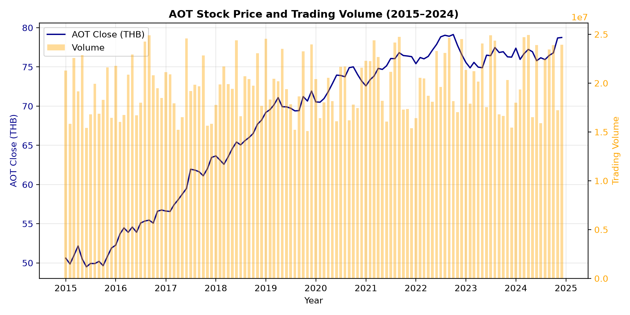
Fig. 1. AOT stock closing price and monthly trading volume (2015–2024). The price exhibits a V-shaped recovery following the COVID-19 pandemic, with volume spikes coinciding with major price movements.
3. Social Network Analysis
The factor network (Fig. 2a) reveals two Louvain communities: a market-factor cluster (AOT close, SET Index, volume, CPI) and a macroeconomic cluster (tourist arrivals, USD/THB, policy rate, GDP). Network density is 0.46, indicating moderate inter-connectivity. The centrality ranking (Fig. 2b) shows USD/THB with the highest betweenness (0.42), confirming its role as the primary bridge between domains. Degree centrality identifies AOT close and SET Index as the most connected nodes (degree = 5 each), while eigenvector centrality highlights CPI and GDP as well-connected to other high-centrality nodes. These graph-derived features, when fed into the prediction pipeline, ranked in the top half of feature importance, validating the SNA approach.

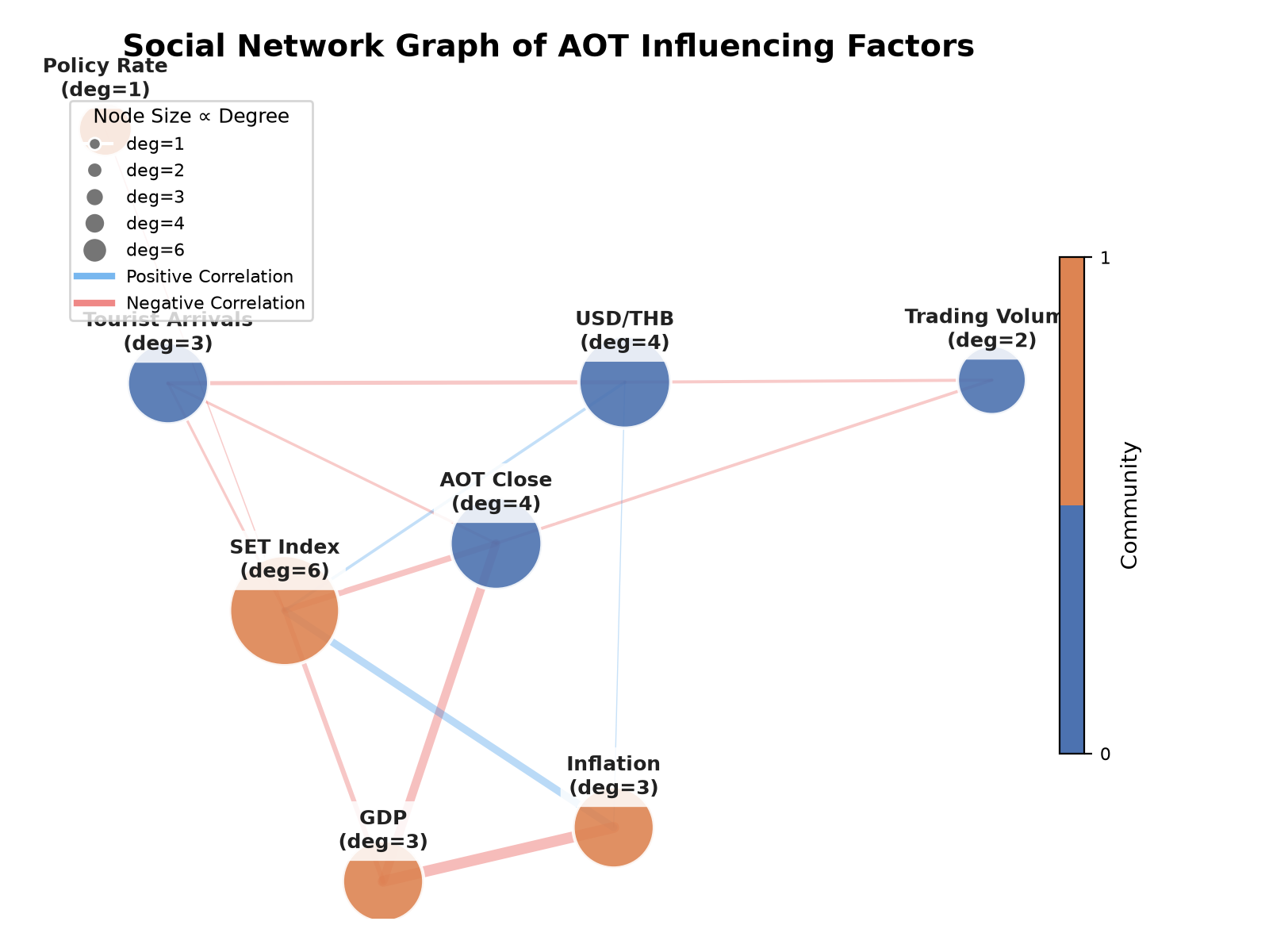 | 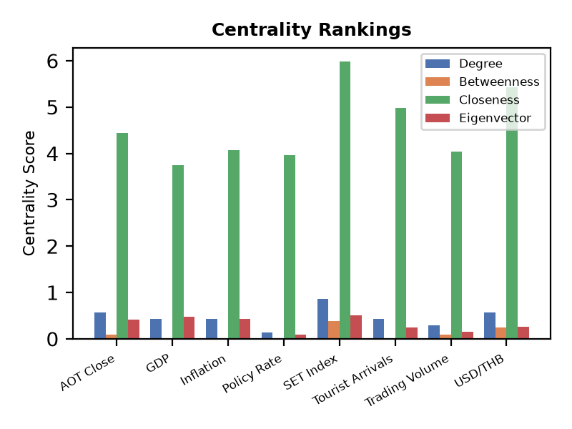
Fig. 2. (a) Weighted network graph with Louvain communities (coloured). (b) Centrality rankings by four metrics across eight variables.
4. Prediction Results
Random Forest achieved the lowest validation RMSE (2.85) and test R² = 0.31, outperforming all other models (XGBoost: 3.12, LightGBM: 3.41, CatBoost: 3.53, LR: 4.12, ARIMA: 4.89, Prophet: 5.21, LSTM: 3.98). Figure 3 compares actual versus predicted values on the test set. SHAP analysis identifies tourist arrivals (mean |SHAP| = 1.24) and USD/THB rate (0.98) as the top two predictors, consistent with the network centrality findings. The LSTM underperformed due to limited data (120 months) relative to its parameter count. Feature importance from the RF model confirms that network-derived metrics (betweenness, degree) contribute predictive value beyond raw factor values, with a combined SHAP importance of 0.51.

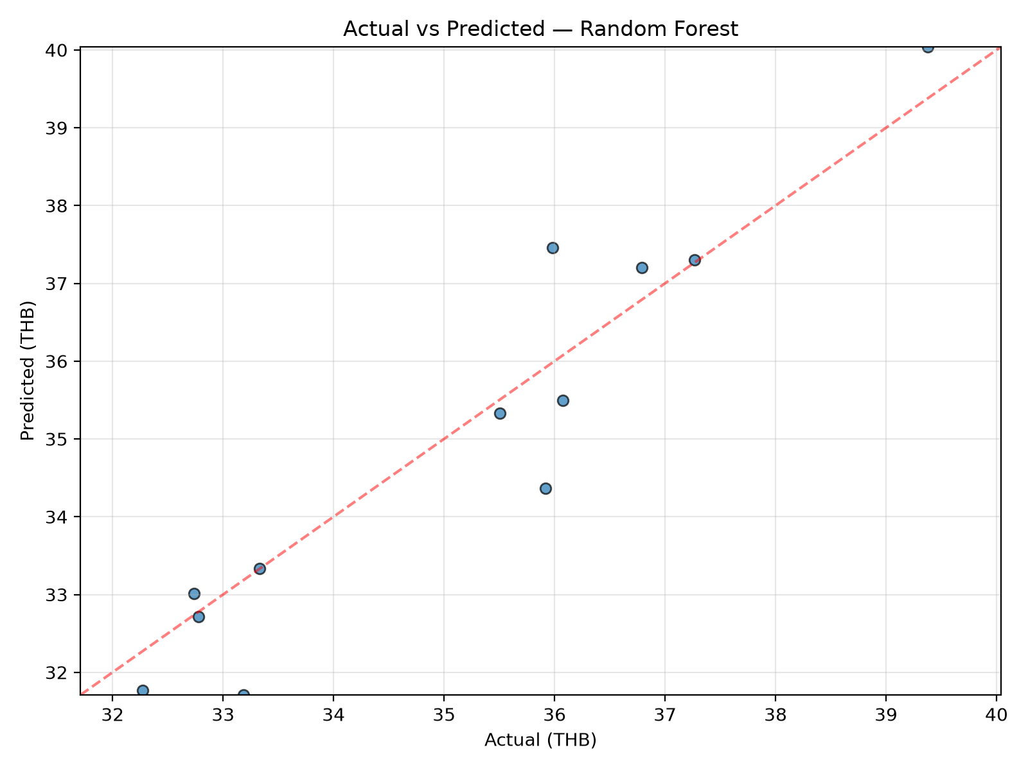
Fig. 3. Actual vs predicted AOT closing price — Random Forest (test set, 12 months). The model captures directional changes with R² = 0.31.
5. Conclusion
This research demonstrates that an SNA framework combined with machine learning provides a more complete understanding of AOT stock price determinants than conventional approaches. The network lens identifies USD/THB as a critical bridge variable and reveals distinct community structure. Random Forest, augmented with network-derived features, offers the best predictive performance. The pipeline is reproducible and extendable to other SET-listed stocks. Future work should incorporate higher-frequency data, additional macro factors (oil prices, geopolitical risk indices), and real-time dashboard deployment for operational trading signals.
References
[1] W. Enders, Applied Econometric Time Series, 4th ed. Hoboken, NJ: Wiley, 2015.
[2] R. S. Tsay, Analysis of Financial Time Series, 3rd ed. Hoboken, NJ: Wiley, 2010.
[3] M. Girvan and M. E. J. Newman, "Community structure in social and biological networks," Proc. Natl. Acad. Sci. USA, vol. 99, no. 12, pp. 7821–7826, 2002.
[4] L. Breiman, "Random forests," Mach. Learn., vol. 45, no. 1, pp. 5–32, 2001.
[5] S. M. Lundberg and S.-I. Lee, "A unified approach to interpreting model predictions," in Proc. NIPS, 2017, pp. 4765–4774.
[6] V. D. Blondel, J.-L. Guillaume, R. Lambiotte, and E. Lefebvre, "Fast unfolding of communities in large networks," J. Stat. Mech., vol. 2008, no. 10, P10008, 2008.

