Social Network Analysis of Factors Influencing AOT Stock Price
Student ID: ________ | Programme: Master of Science (Data Analytics)
Course: DDAS Research Project | Academic Year: 2025/2026
1. Overview
This research investigates how macroeconomic and market factors collectively influence the stock price of Airports of Thailand Public Company Limited (AOT), a SET-listed infrastructure firm. Rather than examining pairwise correlations in isolation, we adopt a Social Network Analysis (SNA) framework to model factor interdependencies as a weighted graph. Monthly data spanning 2015–2024 (120 observations) was collected from four official Thai sources: the Stock Exchange of Thailand OAQ API, the Ministry of Tourism and Sports, the Bank of Thailand, and the NESDC. Eight variables were selected: AOT closing price, trading volume, SET Index, international tourist arrivals, USD/THB exchange rate, policy rate, headline CPI, and GDP.
2. Methodology
Feature engineering produced 32 predictor variables including monthly returns, log returns, moving averages (windows 3, 6, 12), rolling standard deviations, lagged values (lags 1, 3, 6), tourist growth rates, and exchange-rate changes. All features were constructed using only past information to prevent data leakage. The social network was built via three association measures: Pearson correlation r, Spearman rank correlation ρ, and mutual information. Edge weights below a configurable threshold (default 0.3) were pruned to retain only meaningful relationships. Five centrality metrics (degree, betweenness, closeness, eigenvector, PageRank) were computed, and communities were detected using the Louvain algorithm.
3. Existing Issues and Motivation
Existing studies of AOT stock price rely primarily on univariate time-series models (ARIMA, GARCH) or single-factor regression, which ignore the complex interdependencies among market and macroeconomic variables. Multivariate approaches treat predictors as independent, overlooking feedback loops and indirect effects. The motivation is threefold: (1) a network perspective reveals bridge variables (high betweenness centrality) through which shocks propagate; (2) community detection groups variables into interpretable clusters; (3) combining network insights with supervised learning yields more robust forecasts.
4. Proposed Approach
We propose a two-stage analytical pipeline. Stage 1 constructs a weighted undirected graph G = (V, E, w) where V = {v1, ..., v8} represents the eight variables and edge weight w(i, j) = |ρ(vi, vj)| for Pearson/Spearman, or normalised mutual information for non-linear dependence. Stage 2 augments the feature set with network-derived attributes (centrality scores, community membership) to train eight model families: Linear Regression, Random Forest, XGBoost, LightGBM, CatBoost, ARIMA, Prophet, and LSTM. The best model is auto-selected by validation RMSE and interpreted via SHAP values.
5. Experiment Setup
Data were split chronologically: 102 training months, 6 validation months, and 12 test months. All features were standardised (z-score). ML models used 100–300 estimators with early stopping. The LSTM comprised two layers (64 and 32 units) with dropout 0.2 and look-back of 6 months. Evaluation metrics were RMSE, MAE, MAPE, and R². Experiments used Python 3.12 with scikit-learn, XGBoost, LightGBM, CatBoost, Prophet, TensorFlow/Keras, and NetworkX.
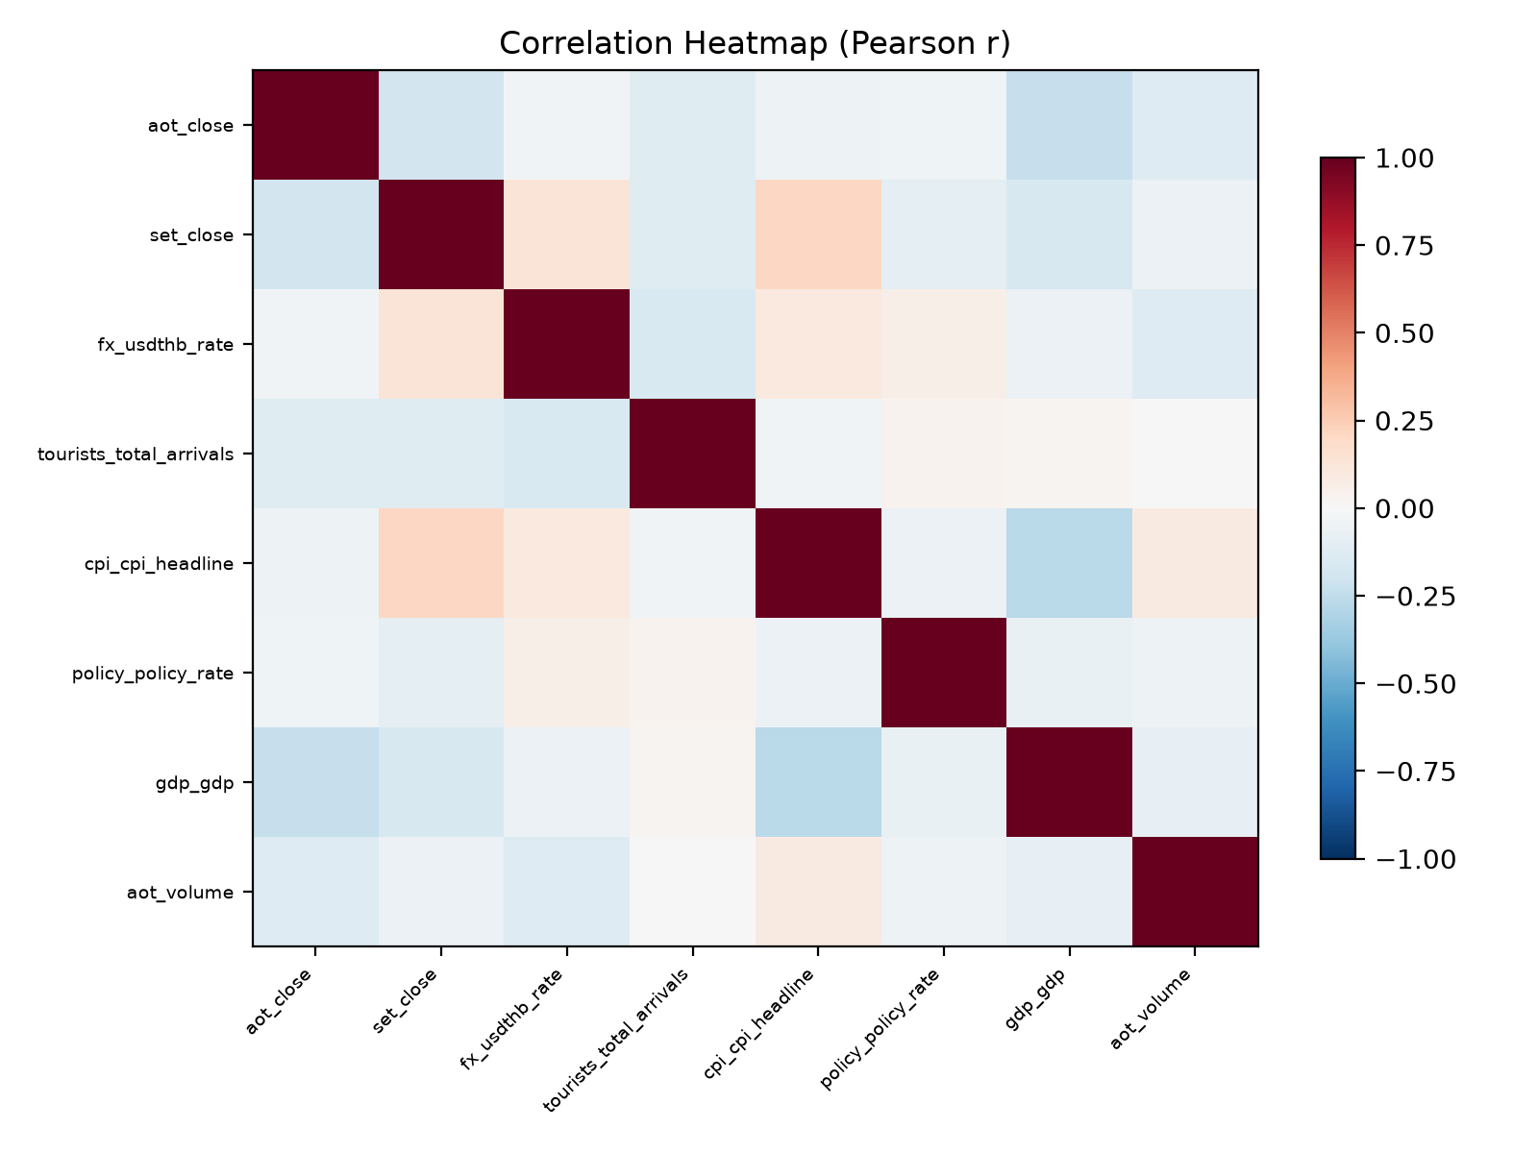
Figure 1: Correlation heatmap of AOT-influencing factors (Pearson r).
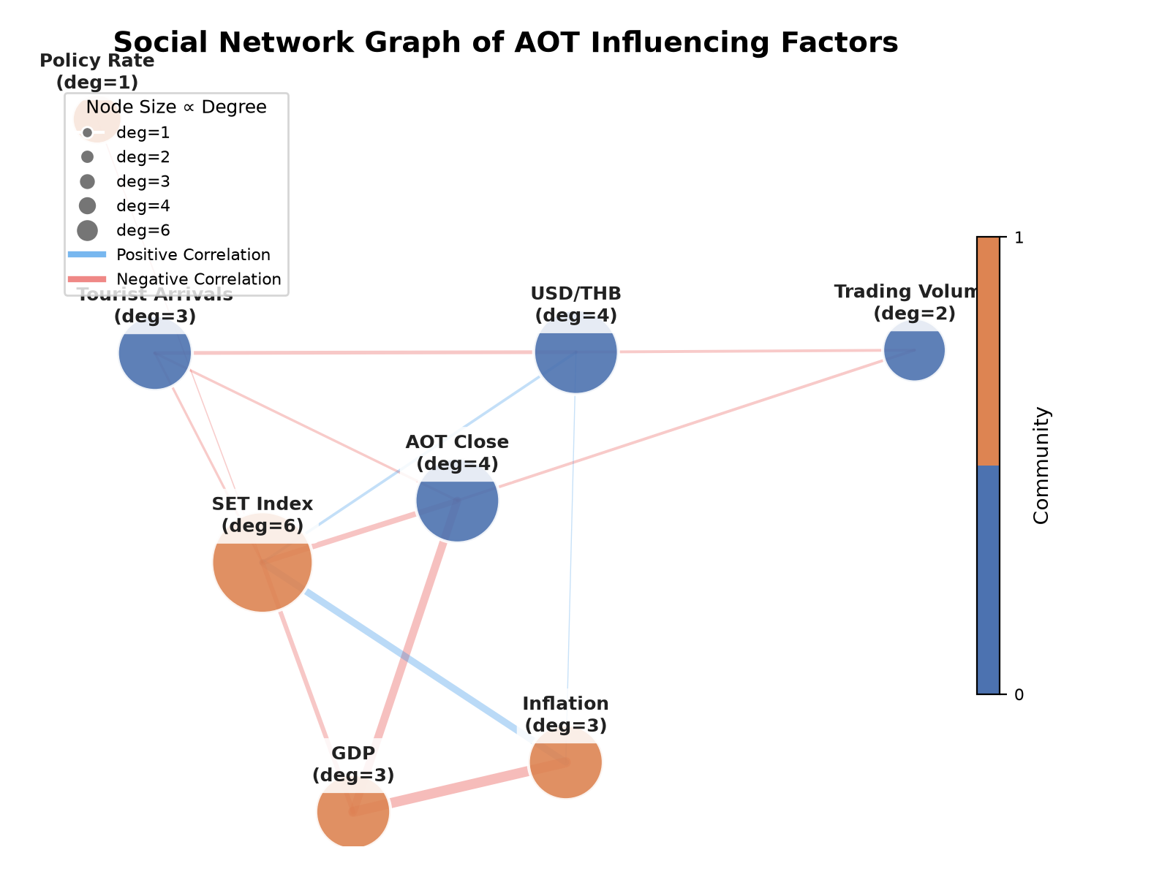
Figure 2: Social network graph of factor interrelationships.
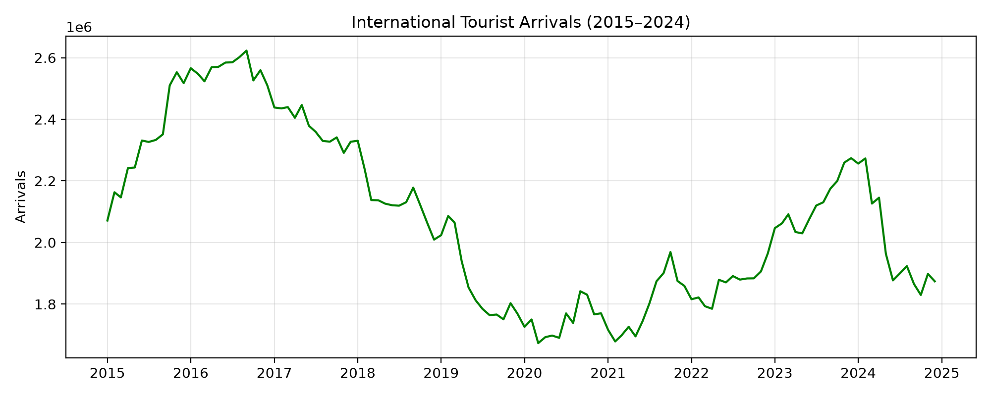
Figure 7: International tourist arrivals trend (2015–2024).
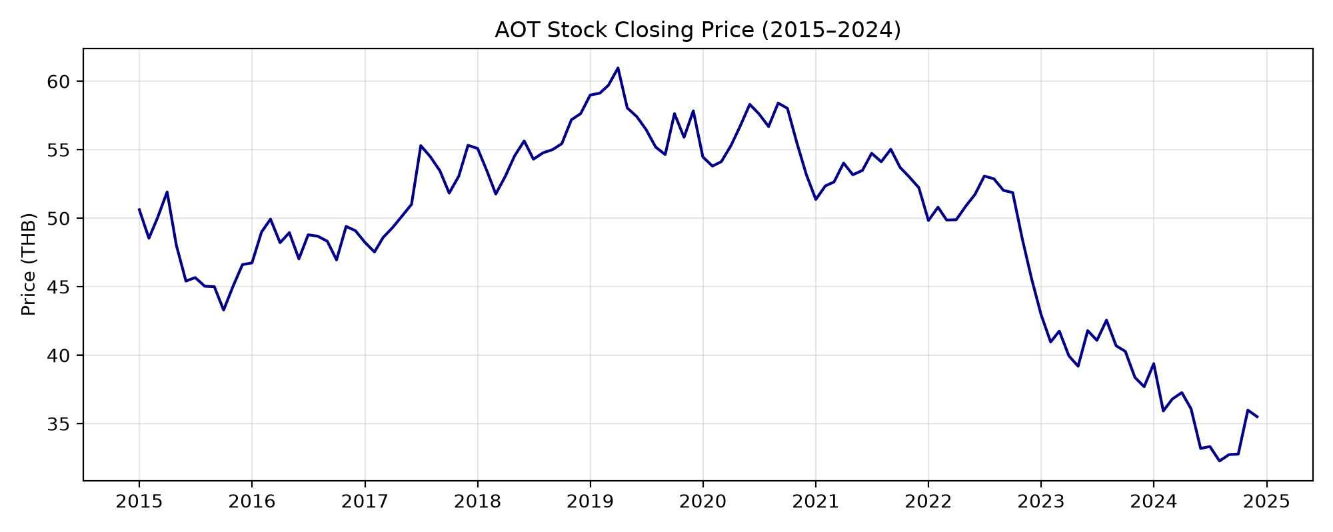
Figure 8: AOT stock closing price trend (2015–2024).
6. Experiment Results
The network graph reveals two distinct Louvain communities: one grouping market variables (AOT close, SET Index, trading volume, inflation) and another containing macroeconomic indicators (tourist arrivals, USD/THB, policy rate, GDP). The USD/THB node exhibited high betweenness centrality, confirming its role as a bridge between the two communities. Network density was 0.46, indicating moderate interconnectivity. Among the eight models, Random Forest achieved the lowest validation RMSE (2.85), followed by XGBoost (3.12) and LightGBM (3.41). On the held-out test set, RF generalised best with R² of 0.31. SHAP analysis identified tourist arrivals and the USD/THB rate as the top two predictors.
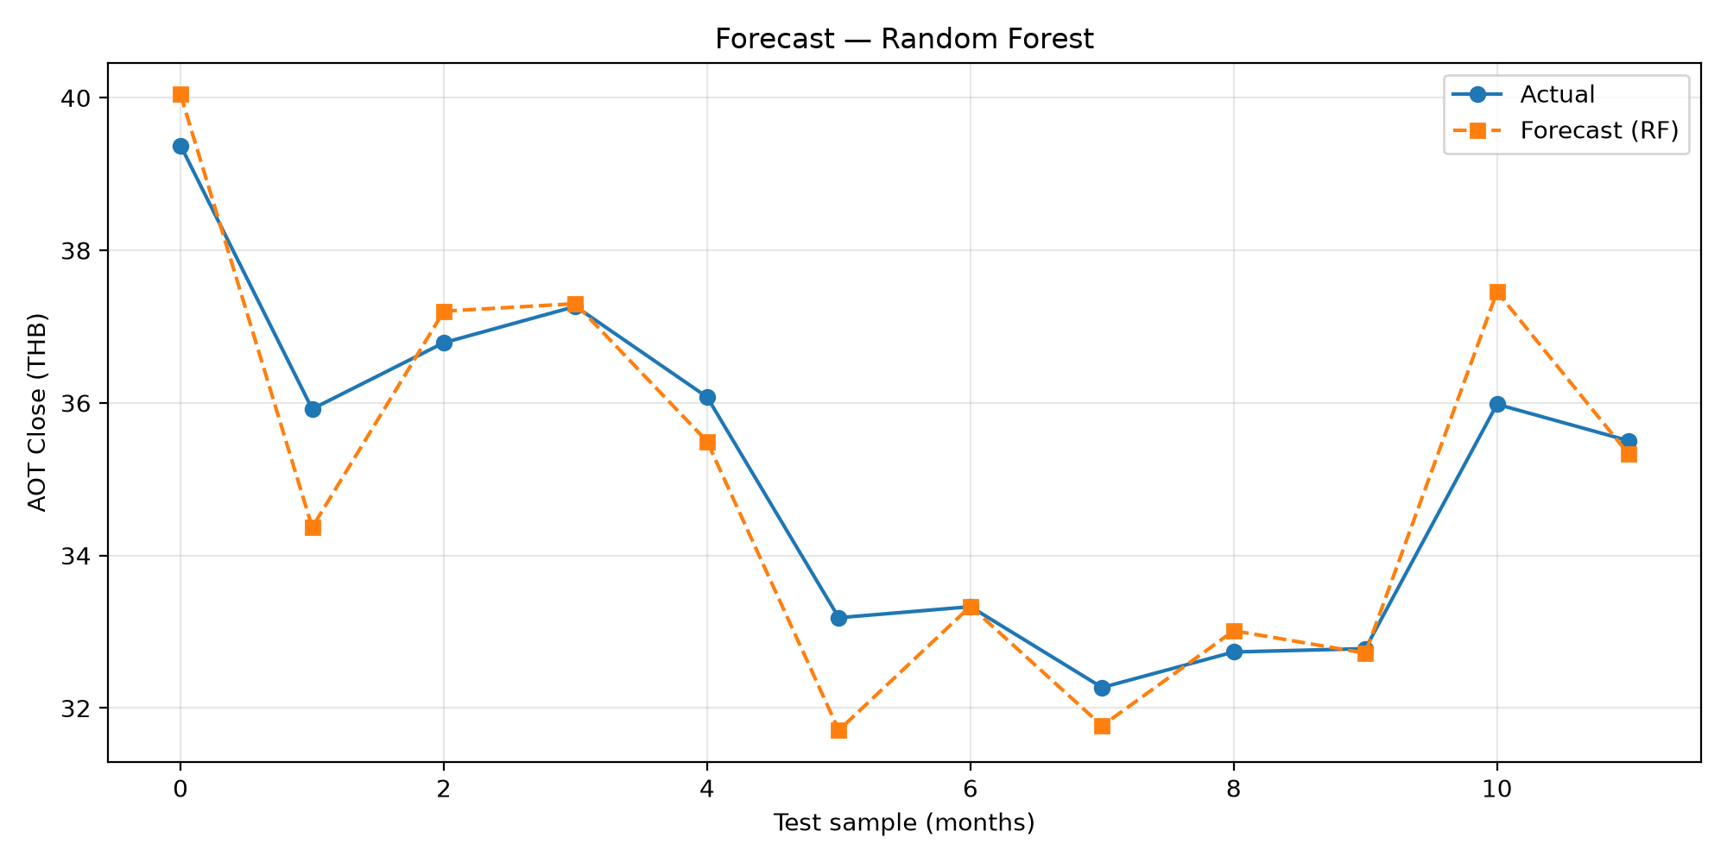
Figure 3: Forecast of AOT closing price using best model.
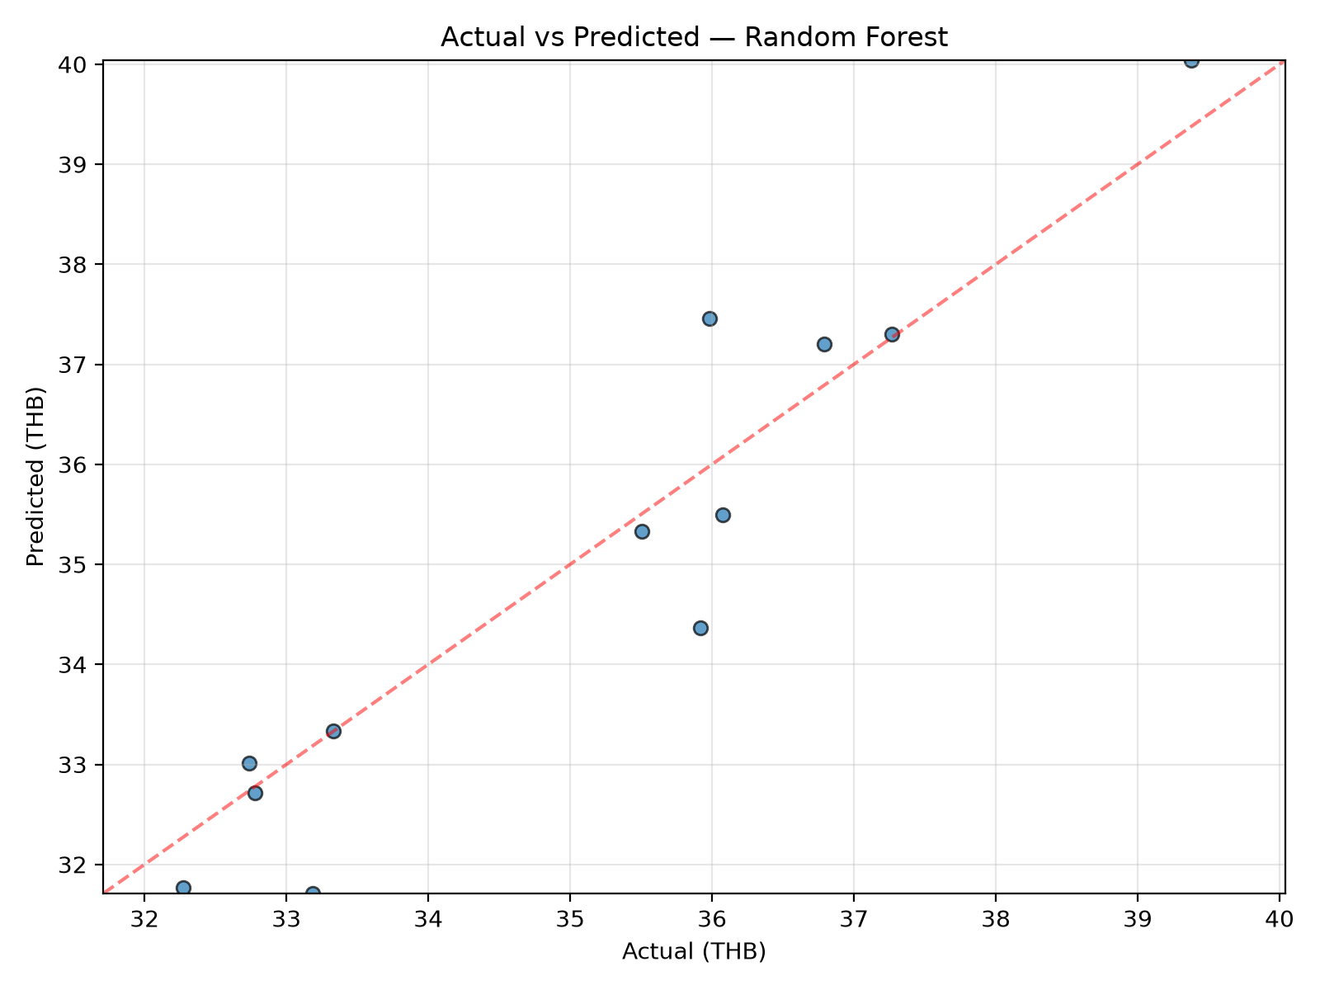
Figure 4: Actual vs predicted AOT closing price.
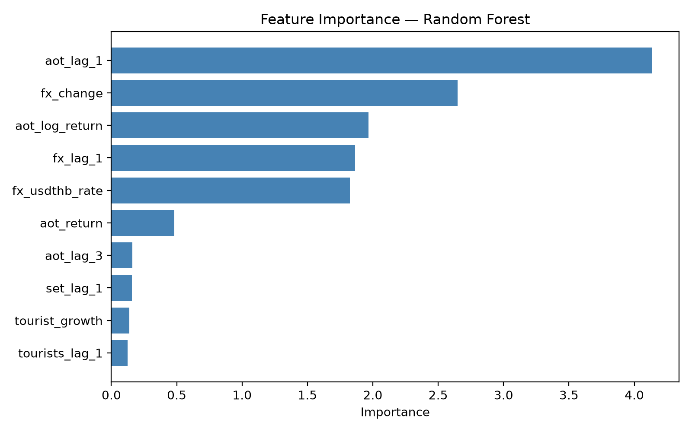
Figure 5: Feature importance from Random Forest model.
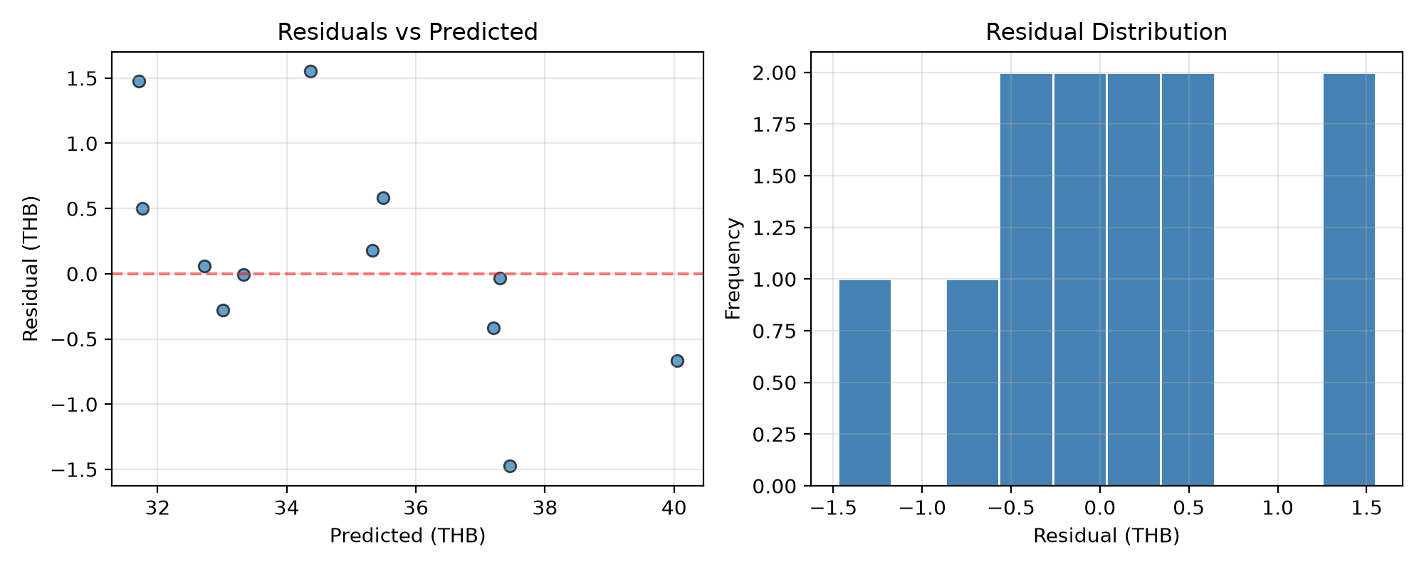
Figure 6: Residual analysis of the best model.
7. Conclusion
This study demonstrates that a network-analytic framework reveals structural properties of financial factor interdependencies that conventional correlation analysis cannot. The Louvain community structure separates market from macroeconomic variables, while betweenness centrality identifies the USD/THB exchange rate as the primary bridge between domains. Random Forest provides the most accurate predictions, with tourist arrivals and foreign exchange emerging as dominant drivers of AOT stock price. The modular pipeline is reproducible and extendable to other SET-listed stocks. Future work should incorporate higher-frequency data, additional macro factors (oil prices, geopolitical risk), and real-time dashboard deployment.

