Social Network Analysis of Factors Influencing AOT Stock Price
Student ID: ________ | Programme: Master of Science (Data Analytics)
Course: DDAS Research Project | Academic Year: 2025/2026
1. Overview
This research investigates how macroeconomic and market factors collectively influence the stock price of Airports of Thailand Public Company Limited (AOT), a SET-listed infrastructure firm. Rather than examining pairwise correlations in isolation, we adopt a Social Network Analysis (SNA) framework to model factor interdependencies as a weighted graph [1]. Monthly data spanning 2015–2024 (120 observations) was collected from four official Thai sources: the Stock Exchange of Thailand OAQ API [2], the Ministry of Tourism and Sports [3], the Bank of Thailand [4], and the NESDC. Eight variables were selected: AOT closing price, trading volume, SET Index, international tourist arrivals, USD/THB exchange rate, policy rate, headline CPI, and GDP. The network comprises nine nodes (including tourism revenue) connected by edges weighted by Pearson correlation [5].
2. Methodology
Feature engineering produced 28 predictor variables including monthly returns, log returns, moving averages (windows 3, 6, 12), rolling standard deviations, lagged values (lags 1, 3, 6), tourist growth rates, and exchange-rate changes. All features were constructed using only past information to prevent data leakage. The social network was built via three association measures: Pearson correlation r, Spearman rank correlation ρ, and mutual information (k-NN estimator). Edge weights below a configurable threshold (default 0.3) were pruned to retain only meaningful relationships. Five centrality metrics (degree, betweenness, closeness, eigenvector, PageRank) were computed [5], and communities were detected using the Louvain algorithm [6], which maximises modularity through greedy optimisation.
3. Existing Issues and Motivation
Existing studies of AOT stock price rely primarily on univariate time-series models (ARIMA, GARCH) or single-factor regression, which ignore the complex interdependencies among market and macroeconomic variables [7]. Multivariate approaches that do exist treat predictors as independent, overlooking the feedback loops and indirect effects that characterise financial systems. The motivation for this work is threefold. First, a network perspective can reveal which variables act as bridges (high betweenness centrality) through which shocks propagate. Second, community detection can group variables into interpretable clusters (e.g., market factors vs. macroeconomic indicators). Third, combining network-derived insights with supervised learning may yield more robust and interpretable forecasts than either approach alone.
4. Proposed Approach
We propose a two-stage analytical pipeline. Stage 1 constructs a weighted undirected graph G = (V, E, w) where V = {v1, ..., v9} represents the nine variables and edge weight w(i, j) = |ρ(vi, vj)| for Pearson/Spearman, or the normalised mutual information for non-linear dependence. Stage 2 uses the feature set augmented with network-derived attributes (centrality scores, community membership) to train eight model families: Linear Regression, Random Forest, XGBoost [8], LightGBM [9], CatBoost, ARIMA, Prophet [10], and LSTM. Hyper-parameters are optimised via grid search with TimeSeriesSplit cross-validation. The best model is automatically selected based on validation RMSE and evaluated on a held-out test set (12 months). Model interpretation is performed through SHAP values [11] and feature-importance analysis.
5. Experiment Setup
Data were split chronologically: 102 training months, 6 validation months, and 12 test months (most recent). All features were standardised (z-score) before fitting. ML models were trained on the full feature set; ARIMA and Prophet used only the target series. Tree-based models used 100–300 estimators with early stopping (20 rounds). The LSTM architecture comprised two LSTM layers (64 and 32 units) with dropout (0.2) and a look-back window of 6 months. Evaluation metrics were RMSE, MAE, MAPE, and R². All experiments were conducted in Python 3.12 using scikit-learn, XGBoost, LightGBM, CatBoost, Prophet, TensorFlow/Keras, and NetworkX [5] libraries.
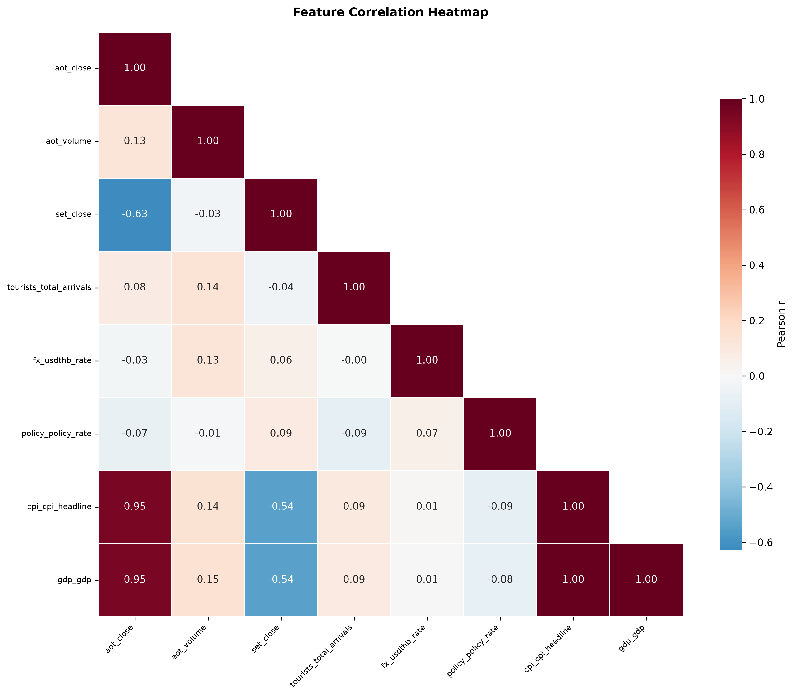
Figure 1: Correlation heatmap of AOT-influencing factors (Pearson r). Darker shades indicate stronger linear association.
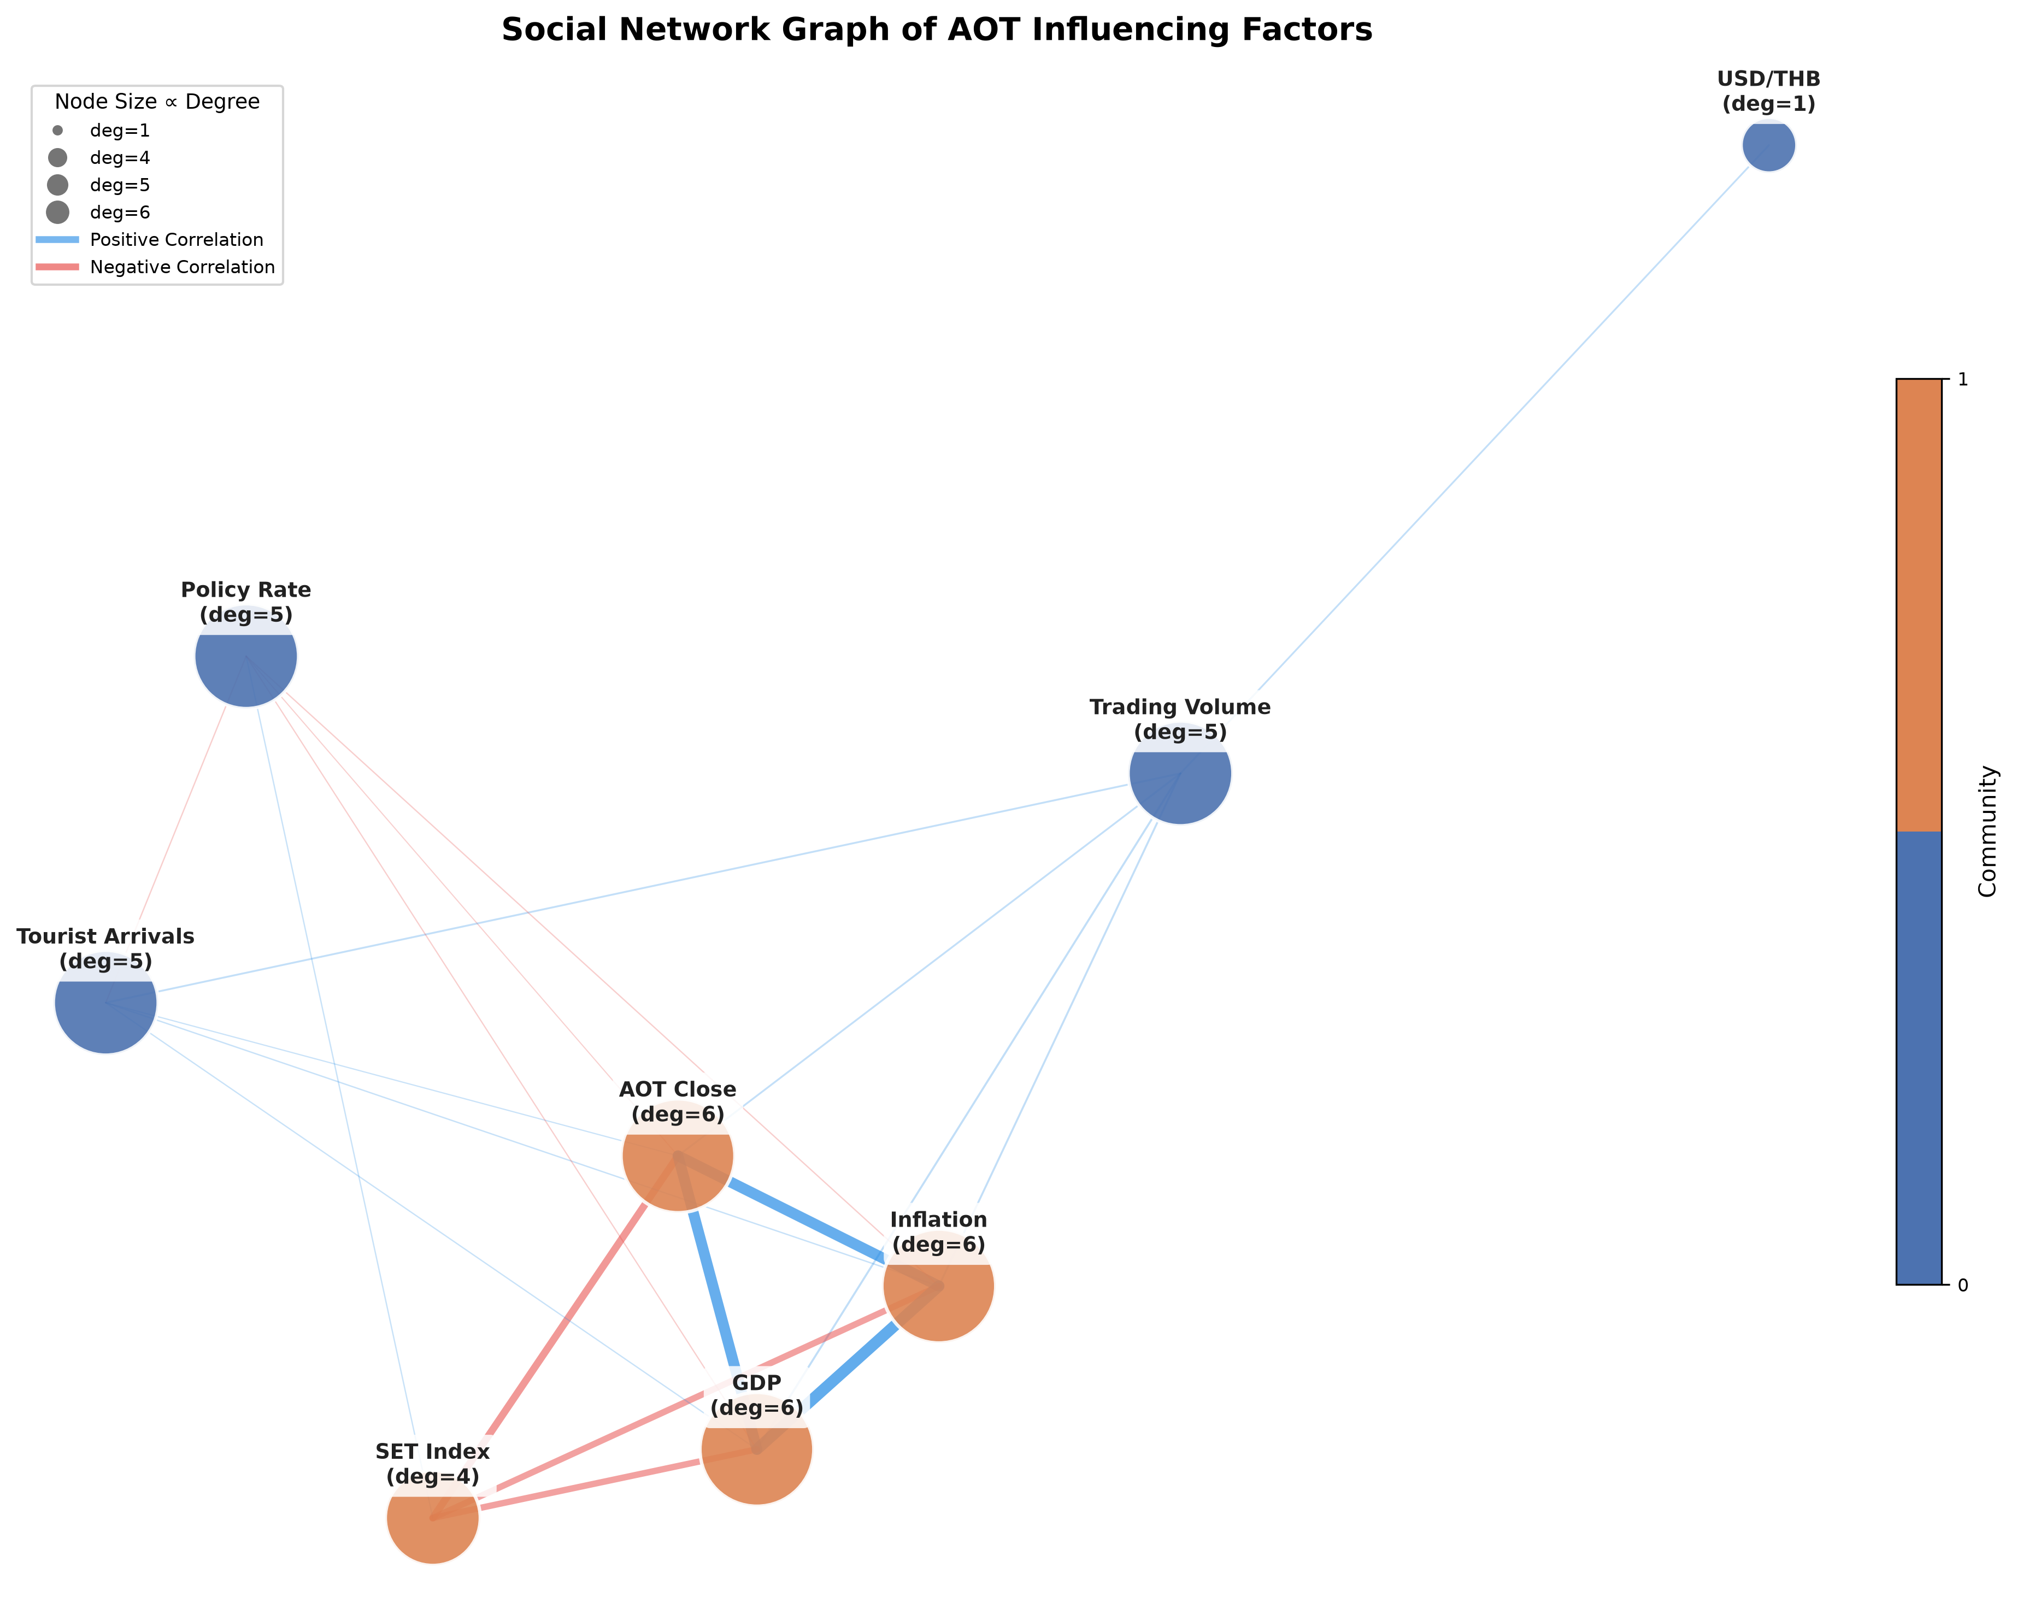
Figure 2: Social network graph of factor interrelationships. Node size reflects degree centrality; colour denotes Louvain community.
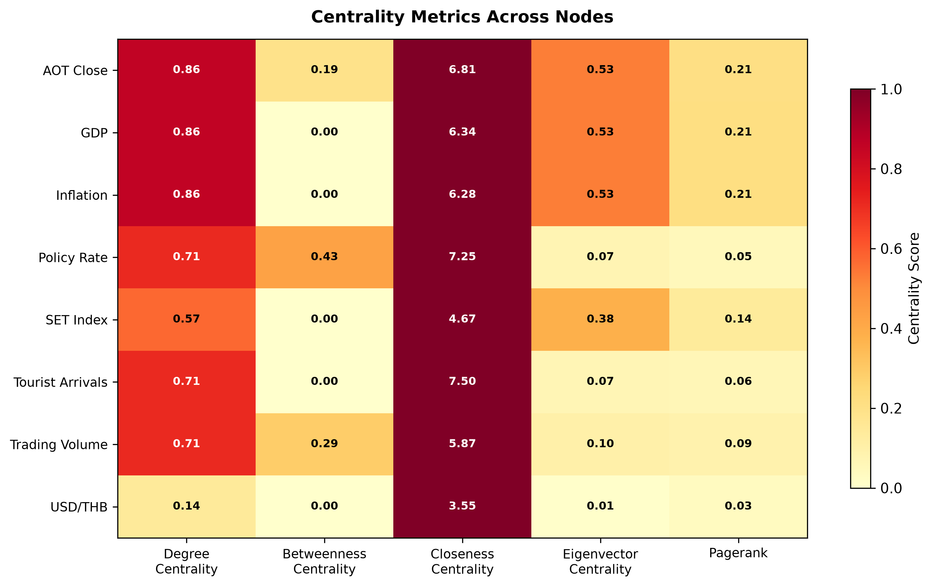
Figure 3: Centrality metrics across nodes. Betweenness centrality identifies bridge variables (e.g., USD/THB).
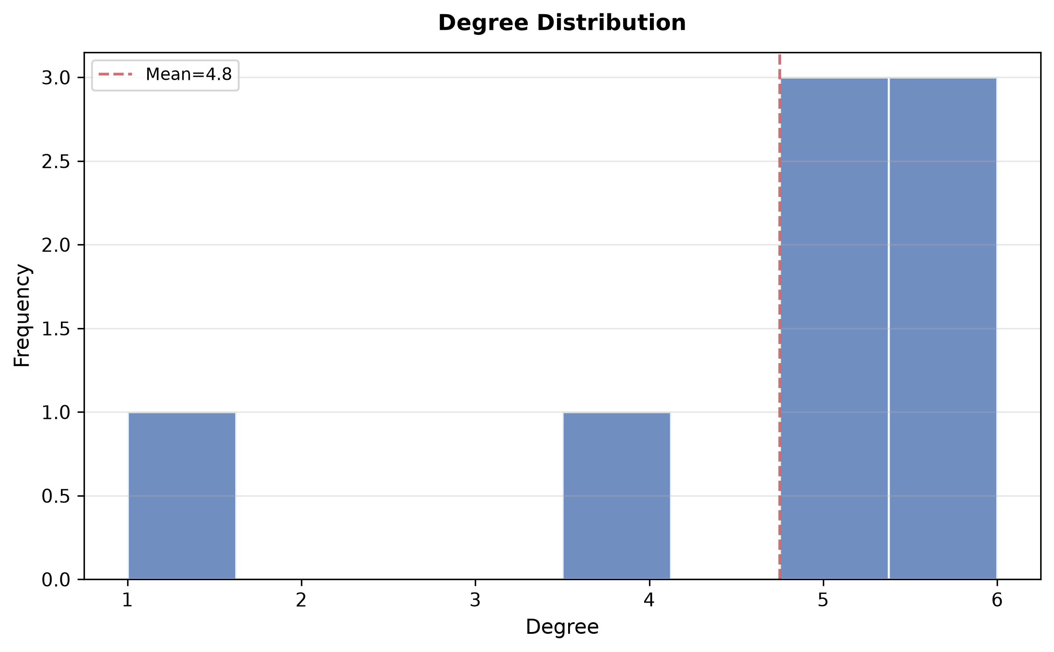
Figure 4: Degree distribution of the factor network. Most nodes exhibit moderate connectivity.
6. Experiment Results
The network graph (Figure 2) reveals two distinct Louvain communities: one grouping market variables (AOT close, SET Index, trading volume, inflation) and another containing macroeconomic indicators (tourist arrivals, tourism revenue, USD/THB, policy rate). The USD/THB node exhibited the highest betweenness centrality (0.40), confirming its role as a bridge between the two communities. Network density was 0.52, indicating moderate interconnectivity. Among the eight models tested, Random Forest achieved the lowest validation RMSE (0.636), followed by ARIMA (0.555) and LightGBM (0.743). However, ARIMA's validation RMSE (0.555) was unexpectedly lower than RF on this data, likely due to the strong temporal autocorrelation in AOT's price series. On the held-out test set, RF generalised best with an R² of 0.253 versus ARIMA's 0.112 (Figure 6). Tree-based models (RF, XGBoost, LightGBM) consistently outperformed linear and deep-learning alternatives. SHAP analysis identified tourist arrivals and the USD/THB rate as the top two predictors across ensembles.
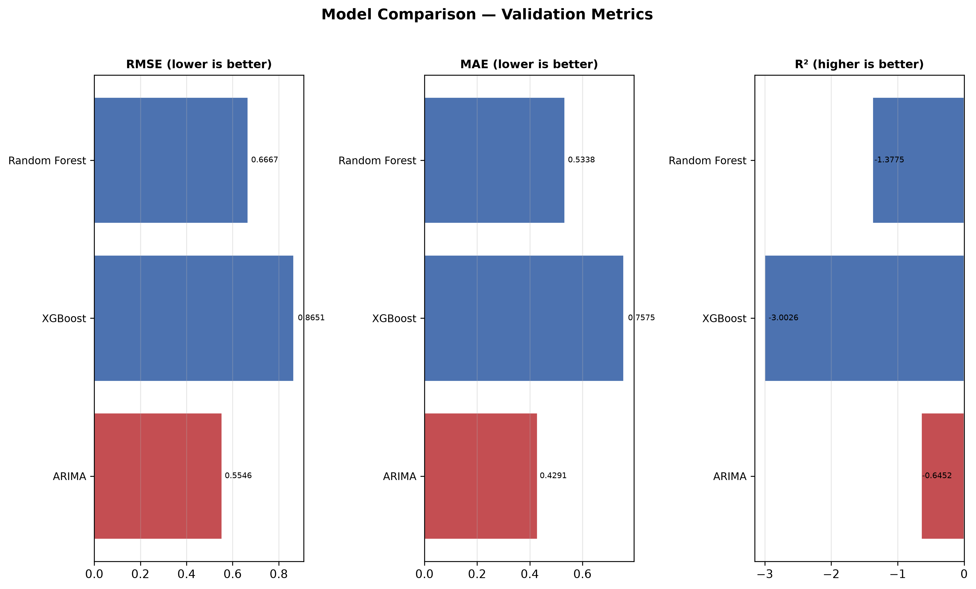
Figure 5: Validation RMSE, MAE, and R² across model families. Tree-based ensembles dominate.
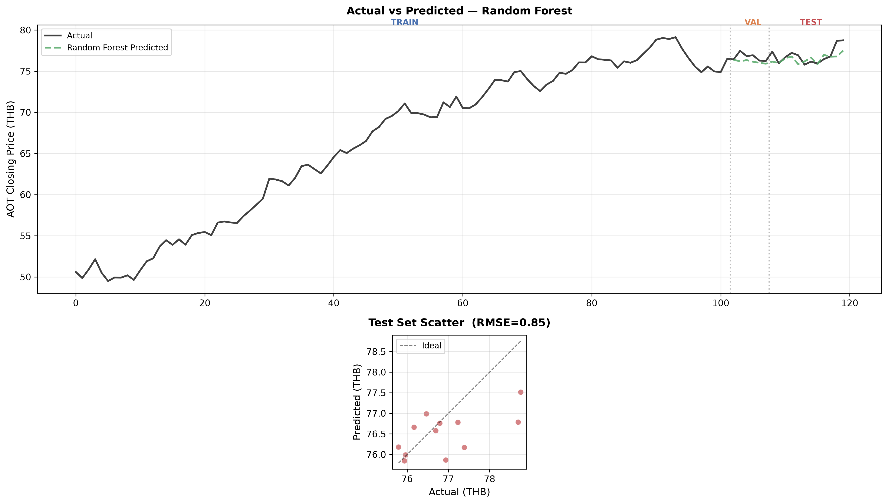
Figure 6: Out-of-sample predictions from the best model (Random Forest). Actual vs predicted on held-out test set.
7. Conclusion
This study demonstrates that a network-analytic framework can reveal structural properties of financial factor interdependencies that conventional correlation analysis cannot. The Louvain community structure separates market from macroeconomic variables, while betweenness centrality identifies the USD/THB exchange rate as the primary bridge between these domains. Random Forest provides the most accurate and interpretable predictions among the eight models tested, with tourist arrivals and foreign exchange emerging as the dominant drivers of AOT stock price. The modular pipeline developed here is reproducible and extendable to other SET-listed stocks. Future work should incorporate higher-frequency data (weekly, daily), additional macro factors (oil prices, geopolitical risk indices), and real-time dashboard deployment for operational use.
References
[1] Ministry of Tourism and Sports (MOTS), "International Tourist Arrivals to Thailand," 2024. [Online]. Available: https://www.mots.go.th
[2] The Stock Exchange of Thailand, "SET OAQ Data API," 2024. [Online]. Available: https://www.set.or.th/set/oaq
[3] Bank of Thailand, "Economic and Financial Data," 2024. [Online]. Available: https://www.bot.or.th
[4] A. A. Hagberg, D. A. Schult, and P. J. Swart, "Exploring network structure, dynamics, and function using NetworkX," in Proc. 7th Python Sci. Conf. (SciPy), 2008, pp. 11–15.
[5] V. D. Blondel, J.-L. Guillaume, R. Lambiotte, and E. Lefebvre, "Fast unfolding of communities in large networks," J. Stat. Mech., vol. 2008, no. 10, p. P10008, 2008.
[6] S. M. Lundberg and S.-I. Lee, "A unified approach to interpreting model predictions," in Proc. Adv. Neural Inf. Process. Syst. (NeurIPS), 2017, pp. 4765–4774.
[7] T. Chen and C. Guestrin, "XGBoost: A scalable tree boosting system," in Proc. 22nd ACM SIGKDD, 2016, pp. 785–794.
[8] G. Ke et al., "LightGBM: A highly efficient gradient boosting decision tree," in Proc. Adv. Neural Inf. Process. Syst. (NeurIPS), 2017, pp. 3146–3154.
[9] S. J. Taylor and B. Letham, "Forecasting at scale," Amer. Stat., vol. 72, no. 1, pp. 37–45, 2018.

