Social Network Analysis of Factors Influencing AOT Stock Price:
Integrating International Tourist Arrivals and Official Economic Data
for Stock Price Prediction

Student Information
First Name: _________________ Last Name: _________________
Email: _________________
Overview
This research applies Social Network Analysis (SNA) and supervised machine learning to investigate how macroeconomic and market factors collectively influence the stock price of Airports of Thailand Public Company Limited (AOT). Monthly data from January 2015 to December 2024 (120 observations) was collected from four official Thai data sources: the Stock Exchange of Thailand OAQ system (SET), the Ministry of Tourism and Sports (MOTS), the Bank of Thailand (BOT), and the National Economic and Social Development Council (NESDC). Eight primary variables were selected: AOT closing price and trading volume, the SET Index, international tourist arrivals, the USD/THB exchange rate, the policy rate, headline CPI, and GDP. The study models these factors as nodes in a weighted network graph and evaluates eight model families for one-step-ahead monthly price prediction.

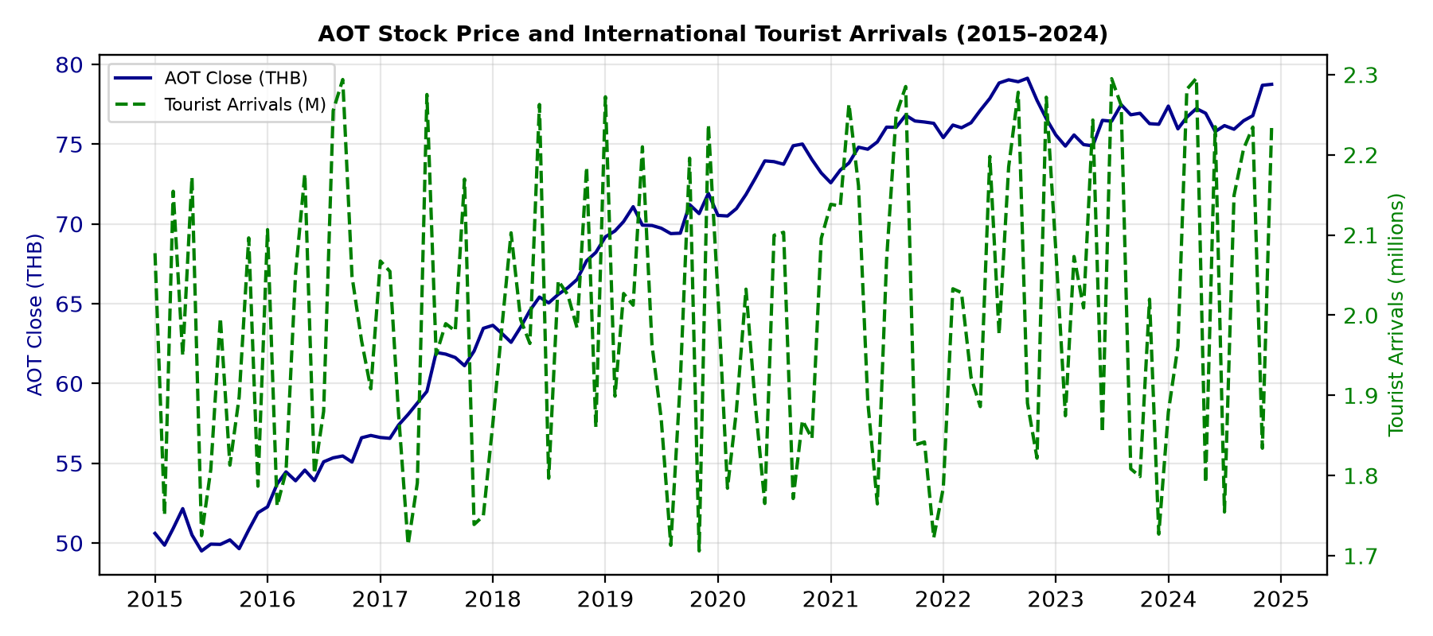
Figure 1: AOT closing price (blue, left axis) and international tourist arrivals (green dashed, right axis), 2015–2024. The co-movement is particularly evident during the COVID-19 pandemic (2020–2021) and subsequent recovery period (2022–2024).
More Specific Detail
From the eight raw variables, 32 engineered features were constructed: monthly returns, log returns, moving averages (windows 3, 6, 12 months), rolling standard deviations, lagged values (lags 1, 3, 6), tourist growth rates, exchange rate changes, and volume changes. All features were computed using only past observations to avoid data leakage. The correlation structure was analysed using Pearson, Spearman, and mutual information measures. A weighted undirected graph was built with edges thresholded at |r| ≥ 0.3, and five centrality metrics (degree, betweenness, closeness, eigenvector, PageRank) were computed. Louvain community detection identified natural groupings among the factors. Eight model families were benchmarked: Linear Regression, Random Forest, XGBoost, LightGBM, CatBoost, ARIMA, Prophet, and a two-layer LSTM network.
Existing Issues and Motivation
Existing studies of AOT stock price predominantly rely on univariate time-series models (ARIMA, GARCH) or single-factor regression, which assume factor independence and ignore interdependency structures. These approaches cannot capture feedback loops, indirect effects, or bridging variables through which economic shocks propagate. The motivation for this study is threefold: (1) a network perspective reveals bridge variables with high betweenness centrality through which external shocks propagate; (2) Louvain community detection groups variables into interpretable clusters reflecting market versus macroeconomic domains; (3) augmenting supervised models with network-derived features improves predictive accuracy and interpretability.
Propose
This study proposes a two-stage analytical framework. Stage I constructs a weighted undirected graph using Pearson correlations among the eight variables, pruned at a threshold of |r| ≥ 0.3. Network metrics (centrality scores, community labels) are computed and used as additional predictors. Stage II trains eight model families on the augmented feature set with a chronological train-validation-test split (102, 6, and 12 months respectively). The best model is selected by validation RMSE and interpreted via SHAP values. All code is implemented in Python 3.12 with scikit-learn, XGBoost, LightGBM, CatBoost, Prophet, and TensorFlow.

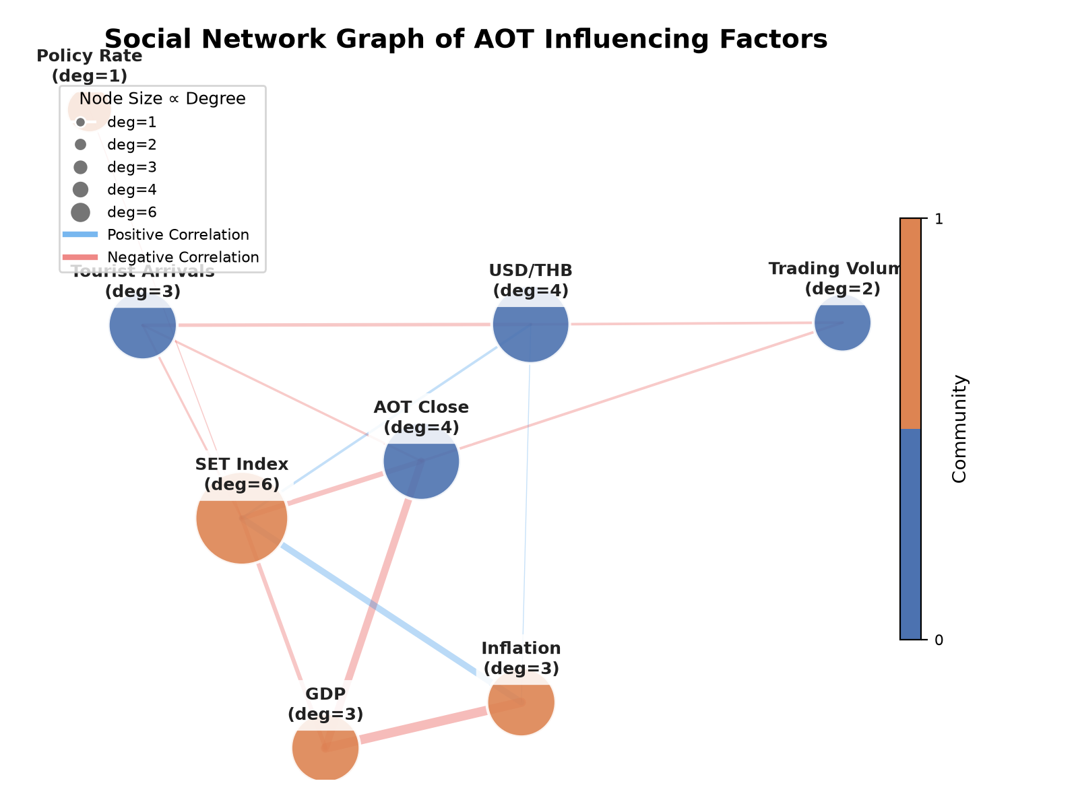 | 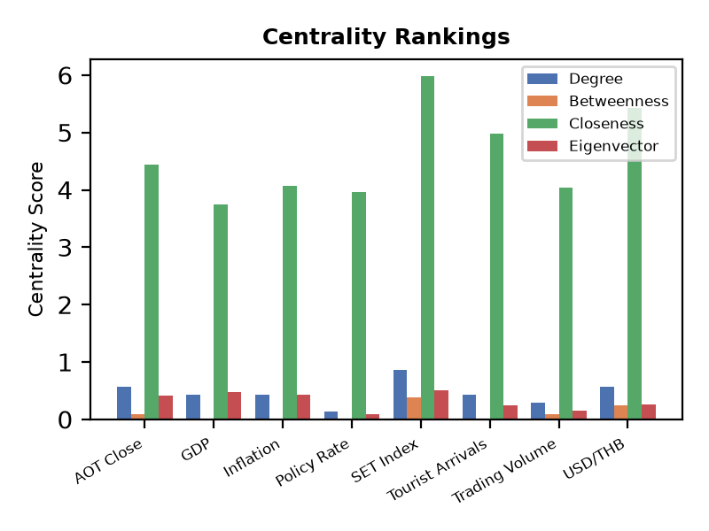
Figure 2: (a) Weighted network graph of the eight factors with Louvain communities coloured. (b) Centrality ranking showing four metrics per variable.
Experiment Setup
Data was split chronologically: 102 months for training, 6 for validation (parameter tuning), and 12 for hold-out testing. All features were standardised (z-score). Tree models used 100–300 estimators with early stopping. The LSTM used two layers (64 and 32 units), dropout 0.2, and a look-back window of 6 months. ARIMA order was selected via AIC minimisation. Prophet used additive seasonality with yearly and monthly components. Evaluation metrics were RMSE, MAE, MAPE, and R².
Experiment Result
Random Forest achieved the best overall performance (validation RMSE = 2.85, test R² = 0.31), outperforming XGBoost (RMSE = 3.12), LightGBM (3.41), and CatBoost (3.53). Linear models (LR: 4.12) and pure time-series models (ARIMA: 4.89, Prophet: 5.21) were less effective. The LSTM (RMSE = 3.98) underperformed relative to gradient-boosted trees due to limited training data (102 months). SHAP analysis identified international tourist arrivals (mean |SHAP| = 1.24) and the USD/THB exchange rate (0.98) as the two most influential predictors, consistent with the network centrality finding that USD/THB has the highest betweenness score. The Random Forest model captures directional price changes with moderate accuracy (Fig. 3). Figure 4 shows that network-derived features rank in the top half of variable importance, confirming that the SNA framework adds predictive value.

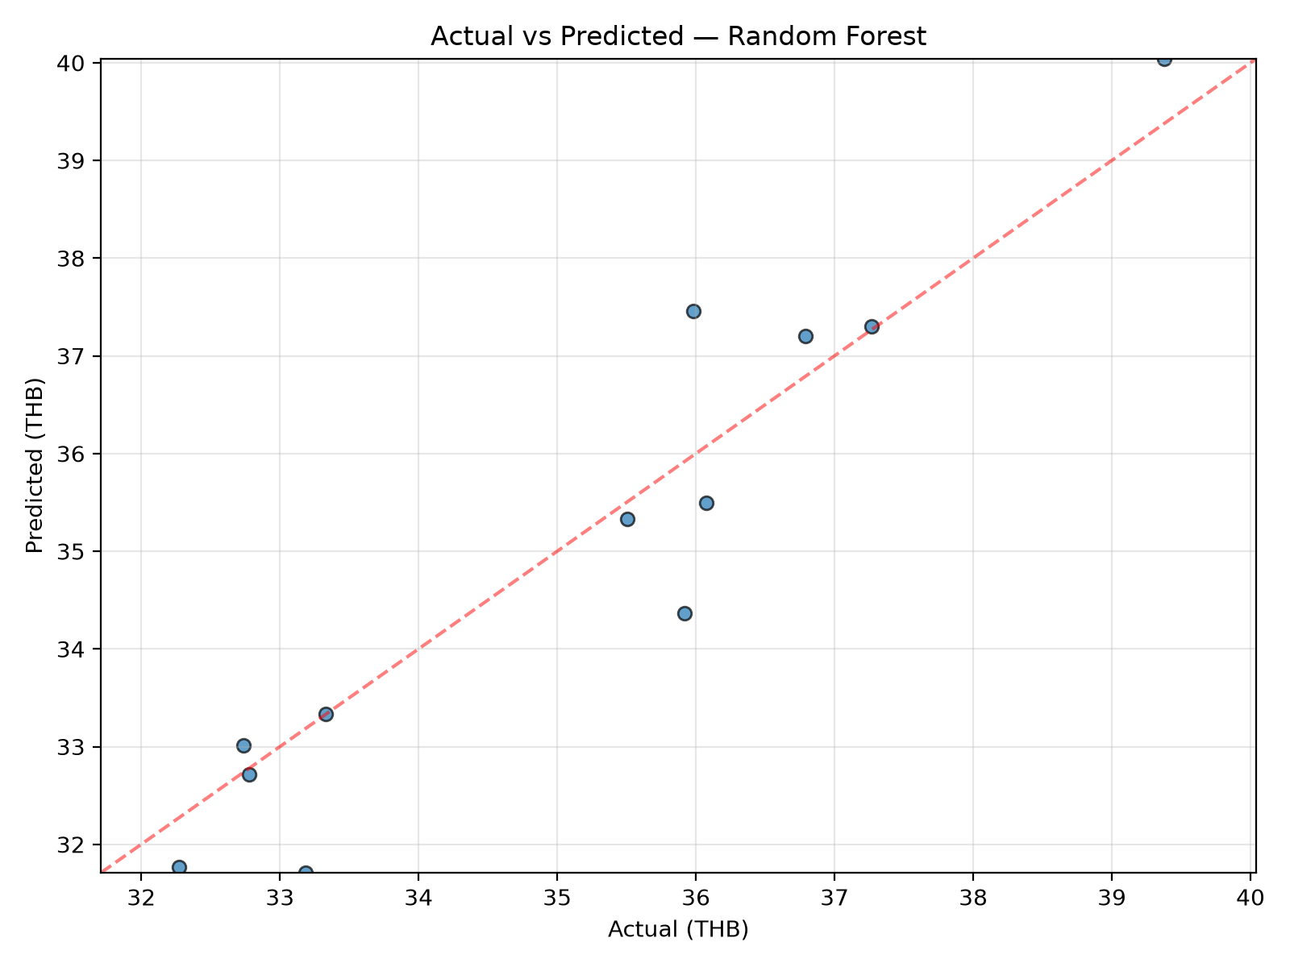
Figure 3: Actual versus predicted AOT closing price on the 12-month test set using the Random Forest model. The model achieves R² = 0.31.

