A PROJECT REPORT

ON

**“ Online CCTV Camera Selling & Security Solutions ”**

SUBMITTED TO

GUJARAT UNIVERSITY



For Partial Fulfillment of Degree Of

Bachelor of Computer Application(BCA)

SEM – 5 System Development Project-1

Submitted by

**Malhan Mansuri**

**Sohel Mansuri**

**Internal Guide External Guide**

**Prof. Bhavik Pandya Dr.Vimal Pandya**

**NAVGUJARAT COLLEGE OF COMPUTER APPLICATIONS**

**ASHRAM ROAD , AHMEDABAD-380014**

**Website:-www.navgujaratbca.com Contact:-079-27542859**

**Year 2018-19**

## collhead.png

Certificate of Completion

This is to Certify that Software Development Project

On

**“Online CCTV Camera Selling & Security Solutions”**

For

**“Global Vision Security Solutions”**

Is Submitted to Gujarat University by:

**1 . Malhan Mansuri**

**2.Sohel Mansuri**

They Have Successfully Completed The Project For The Duration Of Six Months (Sem-5) Towards The Partial Fulfillment For The Award Of “Bachelors In Computer Applications”[B.C.A] In Year Of 2018.

This Is The Original Work Carried Out Under Our Guidance And Supervision. We Further Certify That The Details Are Best To Our Knowledge And Believe That The Matter Presented In This Project Is Bonafied. We Appreciate Their Enthusiasm And Dedication Towards Work Submitted.

Best Wishes For Their Future Endeavors.

## ACKNOWLEDGEMENT

We Express Our Heart Gratitude To A Number Of People Who Extended Their Full Support And Cooperation In Developing This Project . Firstly , We Would Like To Take This Opportunity To Thank Our College ***“Navgujarat College Of Computer Application ”*** For Giving Us This Opportunity And A Platform For Discovering And Developing Our Potential , The King Of Experience That We Have Received While Making This Project Report Is So Immense That Narrating That In Few Word Is Difficult .

After Putting In Such A Hard-work We Have Realized That Takes To Work In Company And Do A Project . Our Company ***“Global Vision”*** And Colleagues Have Been Great Source Of Help Without Them We Were Unable To Do This Project . Therefore Our Project As If Small Drop Of Water Of Sea . We Have Learnt Many Things From Being A Part Of Concept Family .

After That Our Heartiest Thanks To Our Internal Guide As Well As Respected Faculty ***“Prof . Bhavik pandya”*** For Entrusting Upon Us The Responsibility And Acting As Ray Of Light In Darkness . We Find Our Self-Short Of Words To Describe Our Feeling For The Role She Played Of Friend , A Philosopher And Guide , Whenever We Were In Need .

Lastly , We Are Thank Full To Our Parents Without Their Blessing , Love , And Support We Are Unable To Traverse Through This Most Significant Stage Of Life. And Also We Would Like To Take This Opportunity To Express Our Regards To All Friends And Faculties Who Have Helped Us Directly Or Indirectly During The Execution Of The Project. We Are Privileged And Thankful To All In Bringing Out Errors And Shortcoming.

Thanking You,

**Sohel Mansuri**

**Malhan Mansuri**

**INDEX PAGE**

**PAGE NO :**

1. COMPANY PROFILE………………………………………………...………………………………………1

2. PROJECT PROFILE……………………………………………………..……………………………………2

3. EXISTING SYSTEM…….……………………………………………………………………….…………...3

4. PROPOSED SYSTEM………………………………………………………………………………………...4

5. DEVLOPMENT TOOLS & TECHNOLOGY……………………………………………….………………5

6. WHAT IS JSP & SERVLET..………………………………………………………………………………....6

7. WHAT IS JDBC,ORACLE,TOMCAT……… ……………………………………………….………………7

8. SYSTEM FLOW DIAGRAM………………………………………………………………………...............8

9. USECASE DIAGRAM………………………………………………………………………………………10

10. SEQUENCE DIAGRAM……………………………………………………………………………….…..12

10.1. LOGINACTIV…………………………………………………………………………………....13

10.2. MANAGE PRODUCT DETAILS………………………………………………………………..14

10.3. VIEW PRODUCT…..…………………………………………………………..………………...15

10.4. ORDER PRODUCT……………………………………………………………………………....16

10.5. MANAGE ORDER DETAILS………………………………………………………...………...17

10.6. CANCEL ORDER……………..……………………………………………………………........18

10.7. ENTER DELIVERY DETAILS………………………………………………………….………19

10.8. GET DELIVERY DETAILS ……………………………………………………………..……..20

10.9. GENRATE INVOICE…….………………………………………………………………………21

11. ACTIVITY DIAGRAM………………………………………………………………………………….....22

11.1. LOGIN ACTIVITY……..………………………………………………………………………..23

11.2. ORDER PRODUCT …………………………………………………………………………......24

11.3. CANCEL PRODUCT…..………………………………………………………………………...25

11.4. MANAGE PRODUCT…………………………………………………………………….……..26

11.5. MANAGE ORDER DETAILS…………………………………………………………………..27

11.6. ENTER DELIVERY DETAILS………………………………………………………………....28

11.7. GET DELIVERY DETAILS …………………………………………………………………….29

11.8. GENRATE INVOICE……….……………………………………………………………………30

12. CLASS DIAGRAM………………………………………………………………………………..…….....31

13. ER DIAGRAM……………………………………………………………………………………….……..33

14. DATA DICTIONARY…………………………………………………………………………………...…35

14.1. ADMIN ……………………………………………………………………………....................36

14.2. CUSTOMER..……………………………………………………………………………………37

14.3. EMPLOYEE……………………………………………………………………………………...38

14.4. PRODUCT………………………………………………………………………………………..39

14.5. ORDER…………………………………………………………………………………………...40

14.6. DELIVERY ………………………………………………………………………………………41

14.7. INVOICE……….……………………………………………………………………………......42

1

## COMPANY PROFILE

* + **Company Name :-** GLOBALVISION.
  + **Address :-** Gpo Road, Patthar

Kuva,gheekanta,

* + - bhadra, Ahmedabad gujarat 380001.
  + **Contact :-** 079-72-752-4541.
  + Email :- [Globalvision7600@gmail.Com](mailto:globalvision7600@gmail.com).
* Now Days This Shop Is Very Popular And Famous.
* Because Of This Shop Provide A Lot Of Services.
* This shop having high experienced employees.

2

# PROJECT PROFILE

* + **Project Title:-** Online CCTV Camera Selling & Security Solutions.
  + **College Name:-**Navgujarat Computer Application.
  + **Objective :-**This Project Provide Benefit To Customer And Employee. And Faster, simpler And Better services

## Group Member Name:-

* Mansuri Malhan
* Mansuri Sohel

## Project duration:-

* + 1 Year

3

# EXISTING SYSTEM

* The Currunt System Of The product Selling Is Fully

Offline.

* In Currunt System Customer For Purchase The products Must Have To Go Shop.

## Limitations Of Currunt System :

o For Offline Work Require More Employee/Staff.

* It’s Very Time Consuming For Customer.
* Large paper work.
* Data inconsistancy.
* Difficult to manage and modify.

4

# PROPOSED SYSTEM

* Now Days All Human Being Spend Their Lots Of Time Online

.As Per Surway We Decide To Make A System Online And Support Digital India.

* Customer Do Not Need Wait During Holiday Period, It Is

Available24*7.

* Customer Can Purchase Product At Anywhere ,Any Time.
* Customer Can Order the product in 3(Three) Steps Only .
* This System Is Provide Fast ,better Simpler Service.

5

# DEVLOPMENT TOOLS & TECHNOLOGYS

## HARDWARE REQUIREMENT : ~

**PROCESSOR**

**SPEED RAM HARD DISK**

**:** INTEL DUAL CORE / CORE 2 DUO / i3/

i5/i7

**:** MINIMUM 1.8GHz

**:** MINIMUM 512MB

**:** MINIMUM 256GB

## SOFTWARE REQUIREMENT : ~

* **FRONT END :**

HTML/ CSS/ JAVASCRIPT.

## BACK END :

ORACLE 11G/ JSP/ SERVALET/ JDBC/ APACHE TOMCAT 9.

6

# WHAT IS JSP AND SERVLET?

## JSP:-

Java Server Pages (**JSP**) is a technology that helps software developers create dynamically generated web pages based on HTML, XML, or other document types. Released in 1999 by Sun Microsystems, **JSP** is similar to PHP and ASP, but it **uses**the Java programming language.

## SERVLET:-

A **servlet** is a Java programming language class that is **used** to extend the capabilities of servers that host applications accessed by means of a request-response programming model. Although **servlets** can respond to any type of request, they are commonly **used** to extend the applications hosted by web servers.

7

**WHAT IS JDBC ,ORACLE AND TOMCAT?**

## JDBC:-

A JDBC driver is a software component enabling a Java application to interact with a database. JDBC **drivers** are analogous to ODBC **drivers**, ADO.NET data providers, and OLE DB providers. To connect with individual databases, JDBC (the Java Database Connectivity API) requires **drivers** for each database

**ORACLE:-**

**Oracle** database (**Oracle** DB) is a relational database

management system (RDBMS) from the **Oracle** Corporation.

... **Oracle** is a fully scalable relational database architecture and is often used by global enterprises, which manage and process data across wide and local area networks.

**TOMCAT:-**

Born out of the Apache Jakarta Project, **Tomcat** is an application **server** designed to execute Java servlets and render web pages that **use** Java **Server** page coding. Accessible as either a binary or a source code version, **Tomcat's** been used to power a wide range of applications and websites across the Internet.

8

# SYSTEM FLOW DIAGRAM

9

**SYSTEM FLOW DIAGRAM**

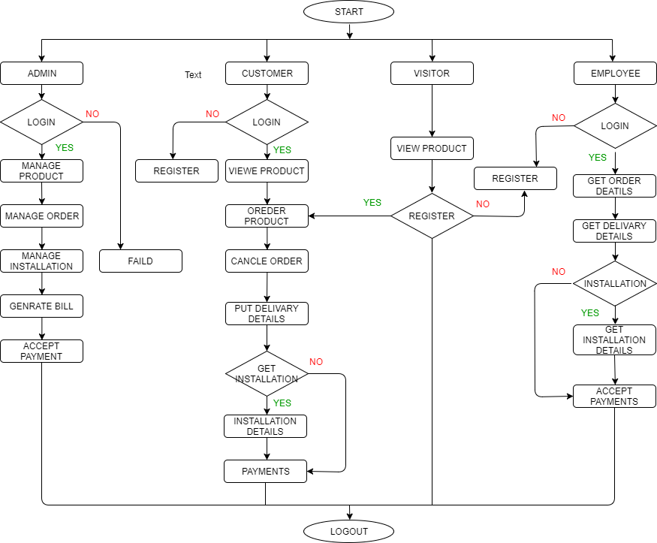

10

**USE CASE DIAGRAM**

11

**USE CASE DIAGRAM**

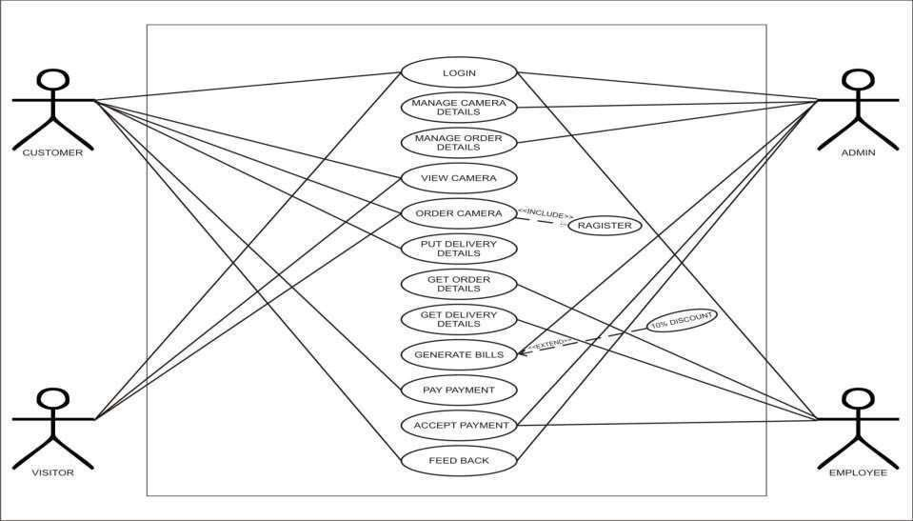

12

**SEQUANCE DIAGRAM**

13

**LOGIN ACTIVITY**

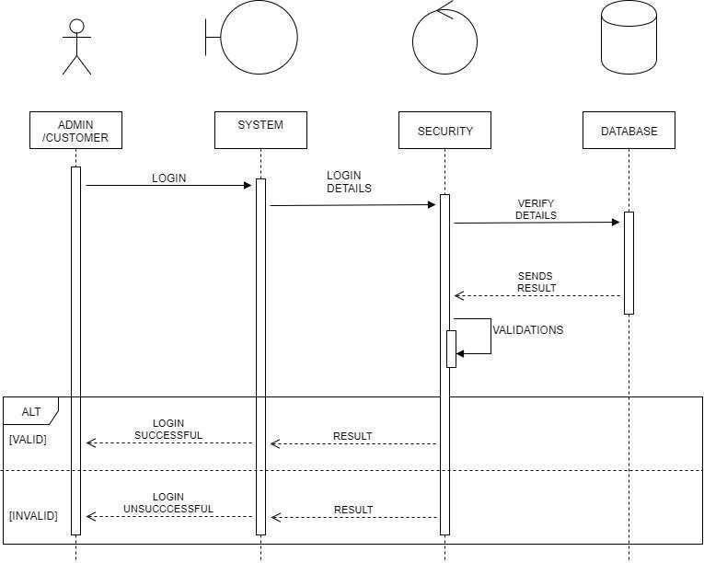

14

**MANAGE PRODUCT DETAILS**

**(ADMIN)**

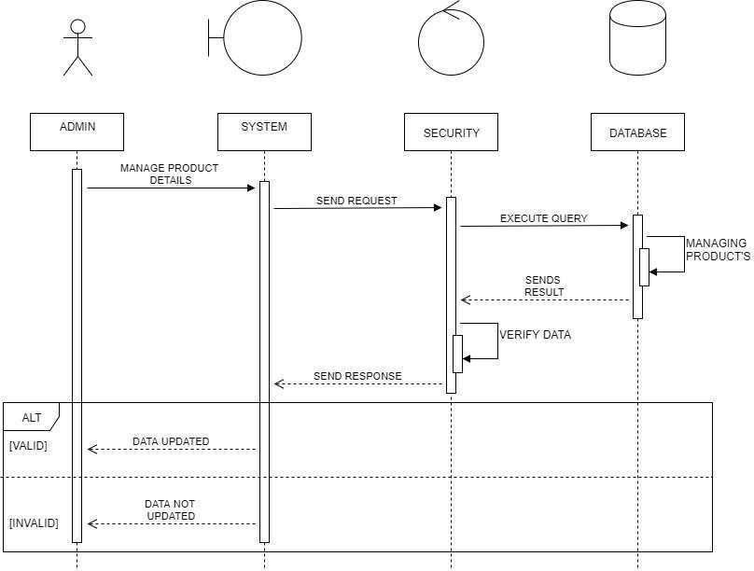

15

# VIEW PRODUCT

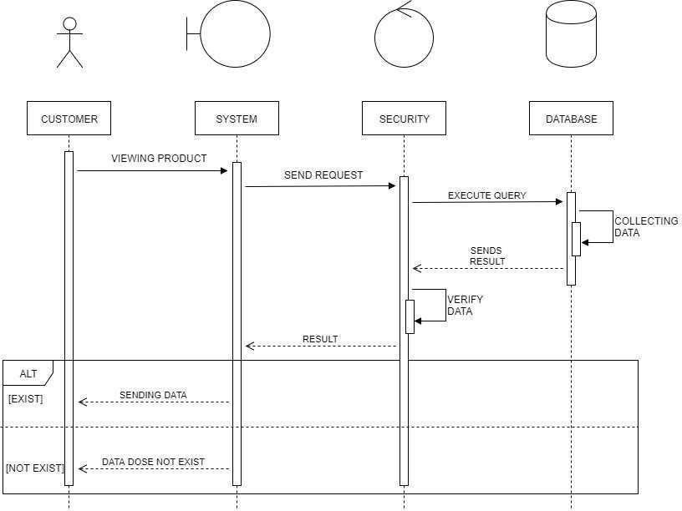

16

**ORDER PRODUCT**

**(CUSTOMER)**

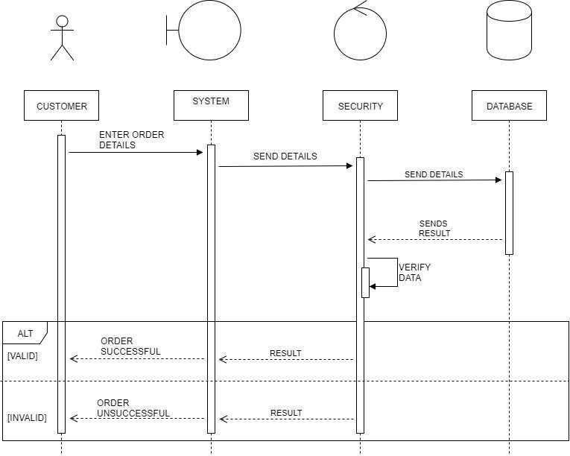

17

**MANAGE ORDER DETAILS (ADMIN)**

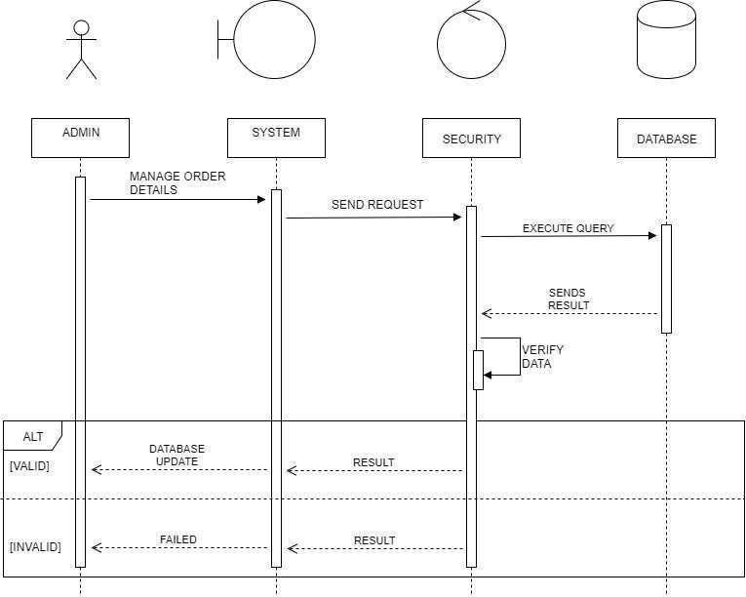

18

**CANCEL ORDER**

**(CUSTOMER)**

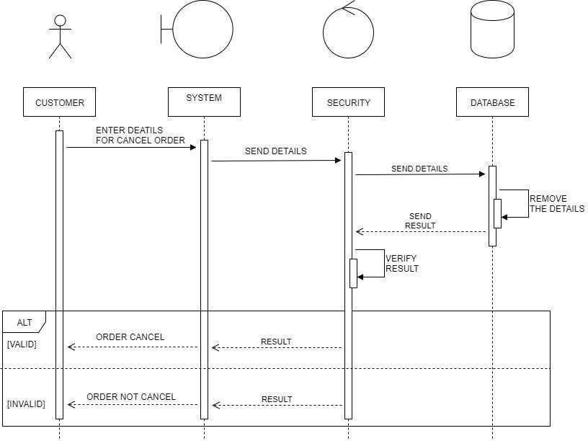

19

**ENTER DELIVERY**

**DETAILS(CUSTOMER)**

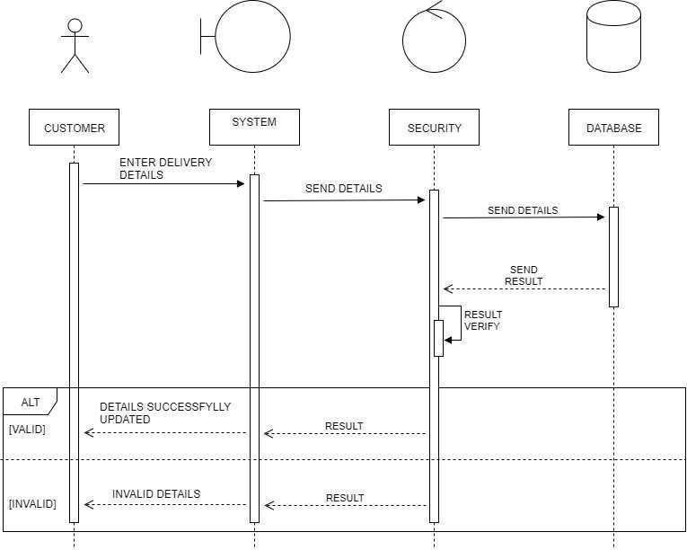

20

**GET DELIVERY DETAILS**

**(EMPLOYEE)**

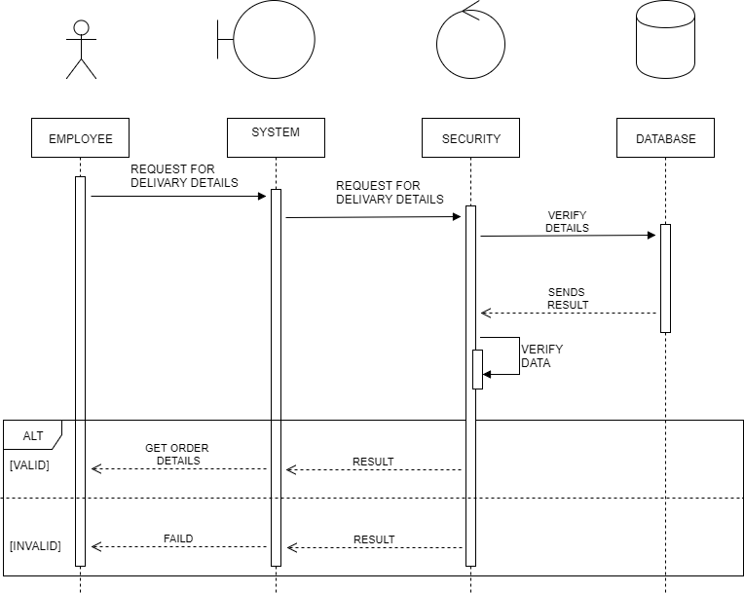

21

**GENRATE INVOICE**

**(ADMIN)**

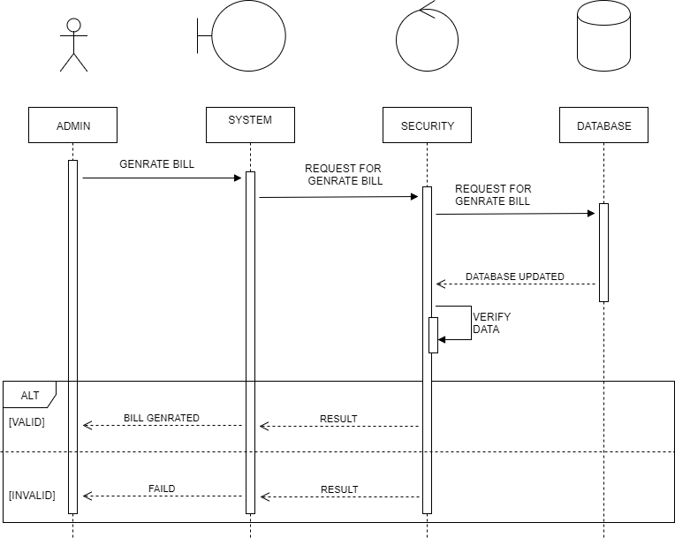

22

**ACTIVITY DIAGRAM**

23

**LOGIN**

**ACTIVITY**

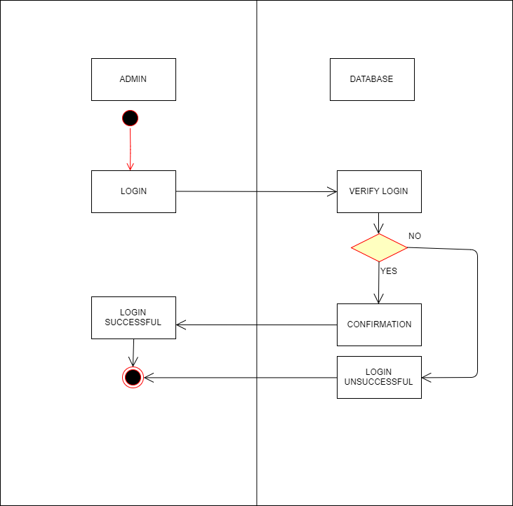

24

**ORDER**

**PRODUCT**

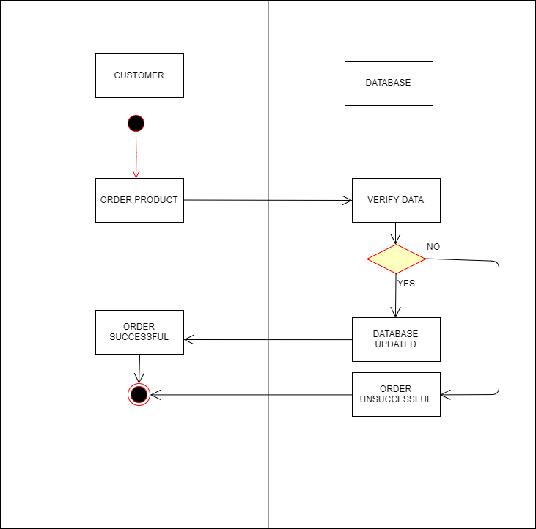

25

**CANCEL**

**ORDER**

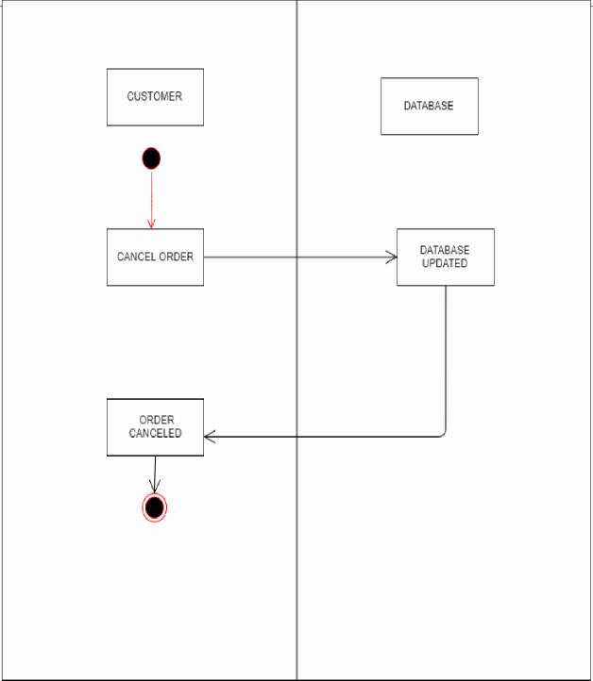

26

**MANAGE PRODUCT**

**(ADMIN)**

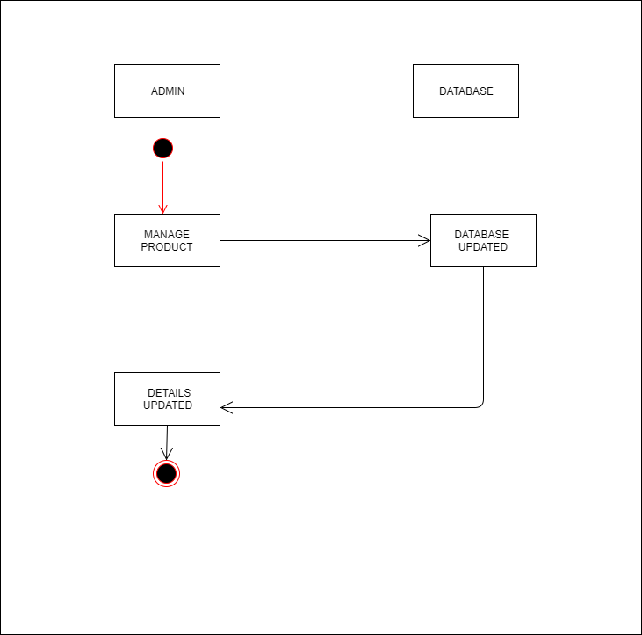

27

**MANAGE ORDER DETAILS**

**(ADMIN)**

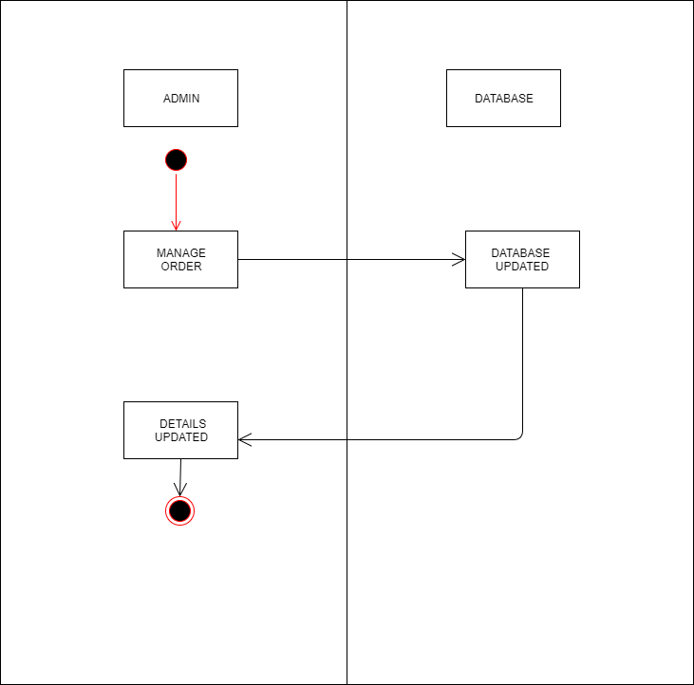

28

# ENTER DELIVARY DETAILS

**(CUSTOMER)**

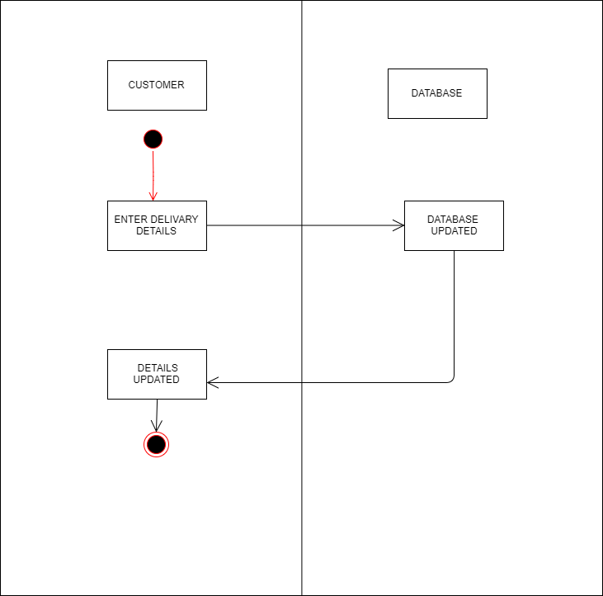

29

**GET DELIVERY DETAILS**

**(EMPLOYEE)**

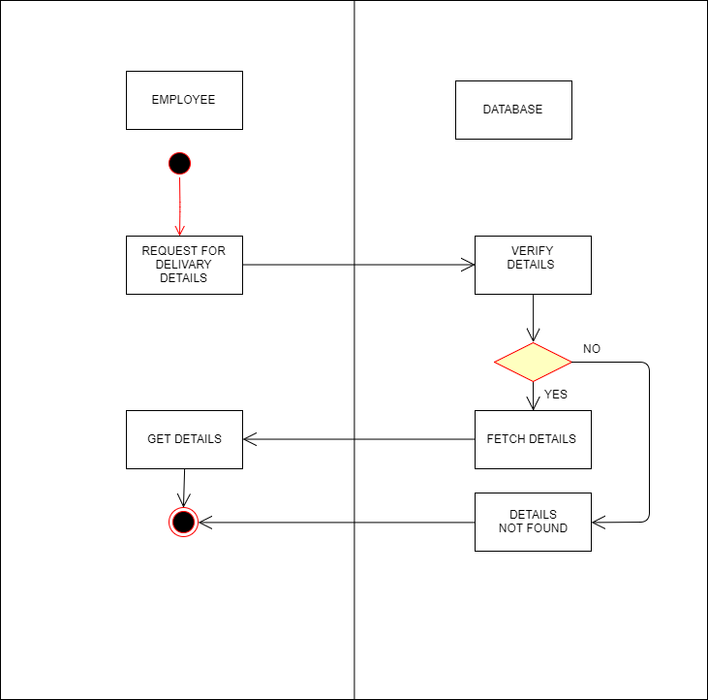

30

**GENRATE**

**INVOICE (ADMIN)**

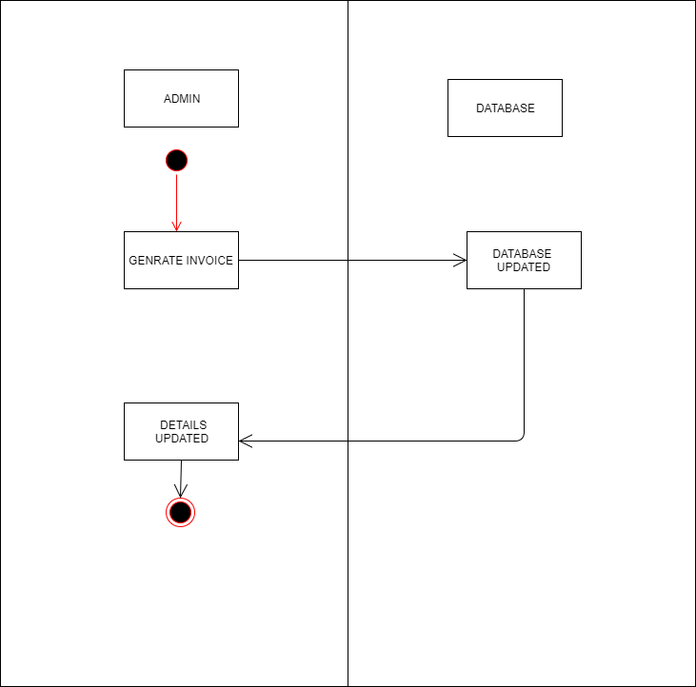

31

**CLASS DIAGRAM**.

32

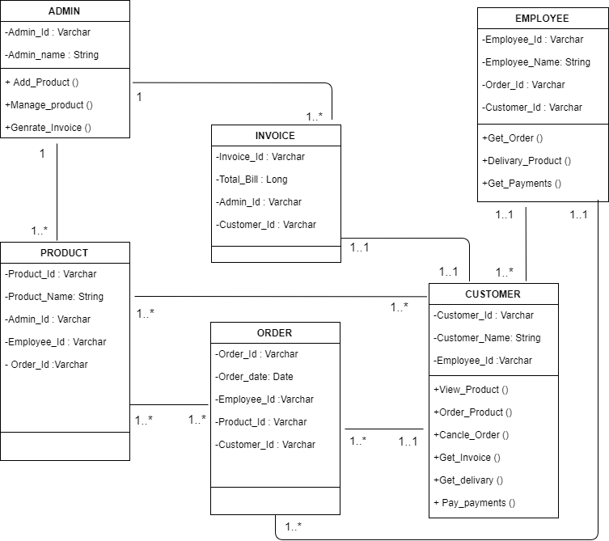

33

**ENTITY-RELATIONSHIP DIAGRAM**

**(ER DIAGRAM)**

34

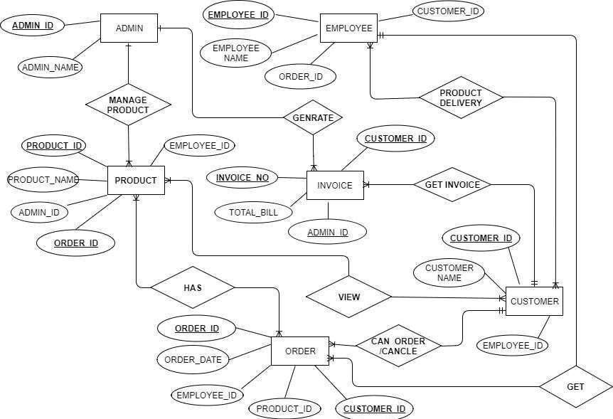

35

**DATA DICTIONARY.**

**(ADMIN, CUSTOMER, EMPLOYEE, PRODUCT, ORDER, DELIVARY, INVOICE)**

36

|  |  |  |  |  |
| --- | --- | --- | --- | --- |
| **TABLE NAME :- ADMIN**  **DESC. :-IT STORES INFORMATION FOR ADMIN PRIMARY KEY :- ADMIN_ID** | | | | |
| **FIELD** | **TYPE** | **SIZE** | **CONS.** | **DESC.** |
| ADMIN  _ID | VARCHAR | 10 | PRIMAY KEY | IT PROVIDE LOGIN _ID FOR ADMIN |
| ADMIN  _NAME | VARCHAR | 20 | NOT  _NULL | IT PROVIDE ADMIN  NAME |
| PASSWORD | VARCHAR | 10 | NOT  _NULL | IT STORES ADMIN  PASSWORD |

37

|  |  |  |  |  |
| --- | --- | --- | --- | --- |
| **TABLE NAME :- CUSTOMER**  **DESC. :-IT STORES INFORMATION FOR CUSTOMER**  **PRIMARY KEY :- CUST_ID** | | | | |
| **FIELD** | **TYPE** | **SIZE** | **CONS.** | **DESC.** |
| CUST  _ID | VARCHAR | 10 | PRIMAY KEY | IT PROVIDES LOGIN  _ID  FOR CUSTOMER |
| CUST  _NAME | VARCHAR | 20 | NOT  _NULL | IT PROVIDES CUSTOMER NAME |
| PASSWORD | VARCHAR | 10 | NOT  _NULL | IT STORES CUSTOMER PASSWORD |
| ADDRESS | VARCHAR | 30 | NOT  _NULL | IT STORES CUSTOMER  ADDRESS |
| MOBILE | NUMBER | 10 | NOT  _NULL | IT STORES CUSTOMER  MOBILE_NO |

38

|  |  |  |  |  |
| --- | --- | --- | --- | --- |
| **TABLE NAME :- EMPLOYEE**  **DESC. :-IT STORES INFORMATION FOR EMPLOYEE PRIMARY KEY :- EMP_ID** | | | | |
| **FIELD** | **TYPE** | **SIZE** | **CONS.** | **DESC.** |
| EMP  _ID | VARCHAR | 10 | PRIMAY KEY | IT PROVIDES LOGIN  _ID  FOR EMPLOYEE |
| EMP  _NAME | VARCHAR | 20 | NOT  _NULL | IT PROVIDES EMPLOYEE NAME |
| PASSWORD | VARCHAR | 10 | NOT  _NULL | IT STORES EMPLOYEE PASSWORD |
| ADDRESS | VARCHAR | 30 | NOT  _NULL | IT STORES EMPLOYEE  ADDRESS |
| MOBILE | NUMBER | 10 | NOT  _NULL | IT STORES EMPLOYEE  MOBILE_NO |

39

|  |  |  |  |  |
| --- | --- | --- | --- | --- |
| **TABLE NAME :- PRODUCT**  **DESC. :-IT STORES INFORMATION FOR PRODUCT PRIMARY KEY :- PRO_ID** | | | | |
| **FIELD** | **TYPE** | **SIZE** | **CONS.** | **DESC.** |
| PRO  _ID | VARCHAR | 10 | PRIMAY  KEY | IT PROVIDE LOGIN _ID  FOR ADMIN |
| PRO  _NAME | VARCHAR | 20 | NOT  _NULL | IT PROVIDE ADMIN  NAME |
| PRO_QTY_O  N_HAND | NUMBER | 4 | NOT  _NULL | IT STORES PRODUCT  QUANTITY ON HAND |
| BRAND | VARCHAR | 10 | NOT  _NULL | IT STORES PRODUCT  BRANDS |
| PRO_PRICE | NUMBER | 8 | NOT  _NULL | IT STORES PRODUCT PRICE |

40

|  |  |  |  |  |
| --- | --- | --- | --- | --- |
| **TABLE NAME:- ORDER**  **DESC.:- IT STORES INFORMATION FOR ORDER**  **DETAILS**  **PRIMARY KEY :- ORDER_ID**  **FORAIGN KEY :- CUST_ID, PRO_ID.** | | | | |
| **FIELD** | **TYPE** | **SIZE** | **CONS.** | **DESC.** |
| ORDER  _ID | VARCHAR | 10 | PRIMAY KEY | IT STORES ORDER_ID |
| ORDER  _DATE | DATE | - | NOT  NULL | IT STORES ORDER DATE |
| CUST_ID | VARCHAR | 10 | F.K. | IT PROVIDES CUSTOMER DETAILS |
| PRO_ID | VARCHAR | 10` | F.K. | IT PROVIDES PRODUCT DETAILS |
| PRO_QTY | NUMBER | 4 | NOT  _NULL | IT STORES PRODUCT  QUANTITY |

41

|  |  |  |  |  |
| --- | --- | --- | --- | --- |
| **TABLE NAME :- DELIVARY**  **DESC. :- IT STORES INFORMATION FOR ADMIN PRIMARY KEY :- DEL_ID**  **FORAIGN KEY :-ORDER_ID,EMP_ID.** | | | | |
| **FIELD** | **TYPE** | **SIZE** | **CONS.** | **DESC.** |
| DEL_ID | VARCHAR | 10 | PRIMAY KEY | IT STORES DEL_ID |
| DEL_DATE | DATE | - | NOT  _NULL | IT STORES DELIVARY DATE |
| ORDER_ID | VARCHAR | 10 | F.K. | IT PROVIDES ORDER DETAILS |
| EMP_ID | VARCHAR | 10 | F.K. | IT PROVIDES EMPLOYEE DETAILS |

42

|  |  |  |  |  |
| --- | --- | --- | --- | --- |
| **TABLE NAME :- INVOICE**  **DESC. :-IT STORES INFORMATION FOR INVOICE**  **PRIMARY KEY :- INVOICE_ID**  **FORAIGN KEY:-ORDER_ID.** | | | | |
| **FIELD** | **TYPE** | **SIZE** | **CONS.** | **DESC.** |
| INV  _ID | VARCHAR | 10 | PRIMAY  KEY | IT STORES  INVOICE_ID |
| ORDER_ID | VARCHAR | 10 | F.K. | IT PROVIDES ORDER  DETAILS |
| TOTAL  _AMM | NUMBER | 8 | NOT  _NULL | IT STORES TOTAL  AMMOUNT |