Formulario: Login

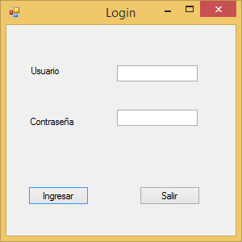

From1: Login

Label1: Lbuser

Lbael2: Lbpass

Textbox1: txtuser

Textbox2: txtpass

button1: btningresar

button2: btnsalir

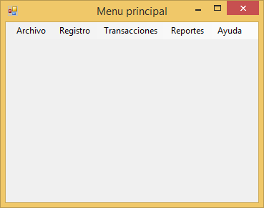

From2: Menu_principal

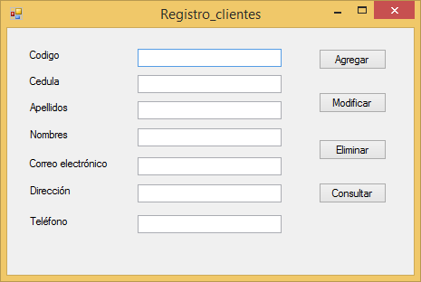

Form3: Registro_clientes

textBox1: txtcodigo

textBox2: txtcedula

textBox3: txtapellidos

textBox4: txtnombres

textBox5: txtmail

textBox6: txtdireccion

textBox7: txttelefono

button1: btnagregar

button2: btnsalir

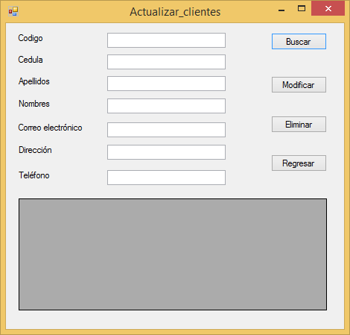

textBox1: txt_cod_actualizar

textBox2: txt_ced_actualizar

textBox3: txt_ape_actualizar

textBox4: txt_nom_actualizar

textBox5: txt_mail_actualizar

textBox6: txt_dir_actualizar

textBox7: txt_tlf_actualizar

button1: btnbuscar

button2: btnmodificar

button3: btneliminar

button4: btnregresar