EXT: LayerSlider
Extension Key: pits_layerslider
Language: en
Keywords: layer slider,Typo3 slider,Typo3 layer slider,PIT Solutions
Copyright 2010-2020, Akhil Jayan <akhil.jn@pitsolutions.com>

This document is published under the Open Content License
available from http://www.opencontent.org/opl.shtml

The content of this document is related to TYPO3
- a GNU/GPL CMS/Framework available from www.typo3.org

Introduction

What does it do?
- Overview;LayerSlider TYPO3 plugin for creating image galleries, content sliders, and mind-blowing slideshows with must-see effects. It uses cutting edge technologies to provide the smoothest experience and it comes with more than 200 preset 2D and 3D slide transitions. It has a beautiful and easy-to-use typo3 admin interface with supporting modern features. It’s device friendly by supporting responsive mode, multiple layouts, touch gestures on mobile devices.
- Key features
- Accelerated CSS3 transitions with jQuery fall-back mechanism.
- Fully responsive & multiple layouts support for Typo3 websites.
- Many fall-back features for old browsers.
- Lazy loading images for better performance.
- Unlimited layers with image, video, audio, text or custom HTML content
- Strong API for more customization
- Multiple sliders can be added on the same Typo3 page.
- Free slide transition gallery

Users manual
PITS layers slider is used to render a very smooth slideshow in Typo3 websites. Install the pluigin using Typo3 extension manager , Once the extension is installed place the extension in a specific page where you want to render slider show . To add a new slider , Create a new storage as shown in figure . Choose “List” module and then create a new storage folder .

Once the storage folder is created , Select Layerslider module , A new screen will appear as shown in fig .

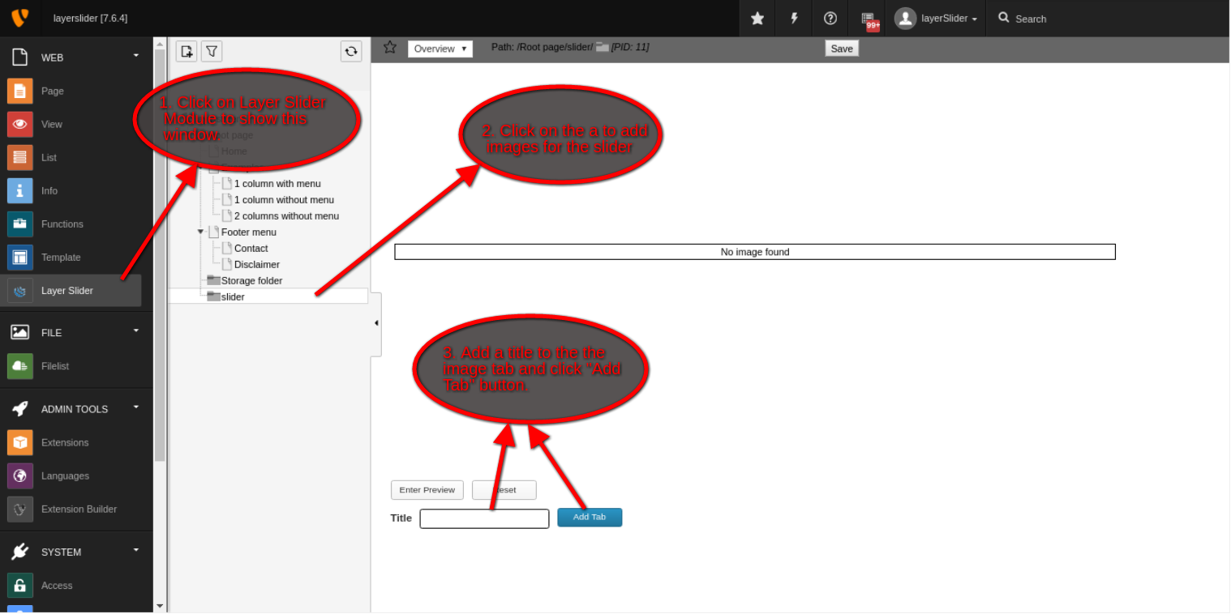
(fig. 1)

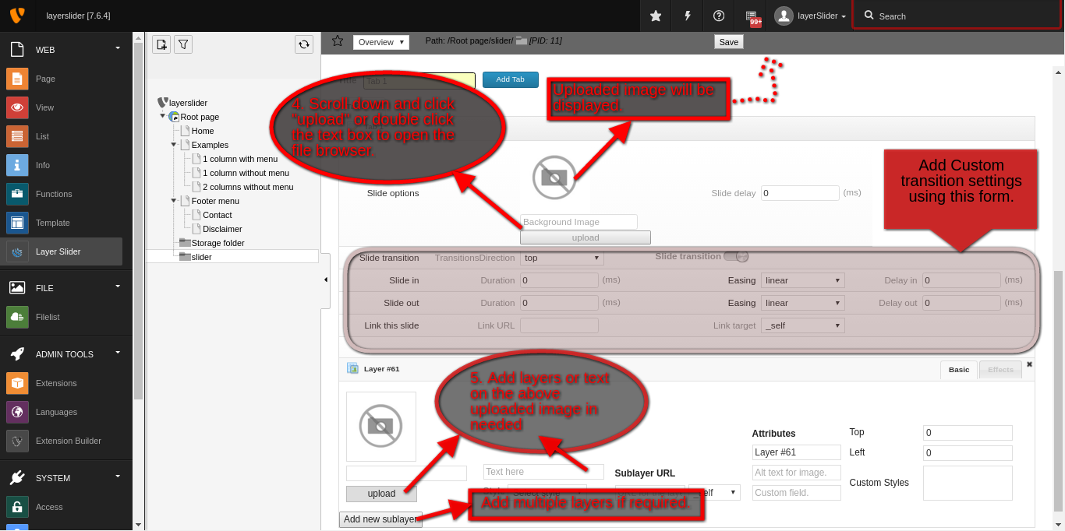
(fig. 2)

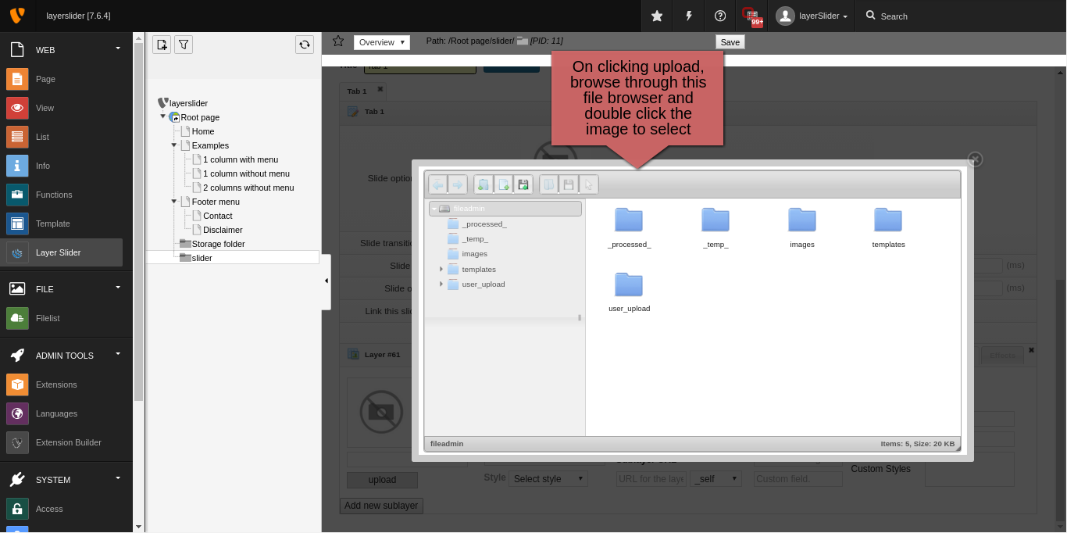
(fig. 3)

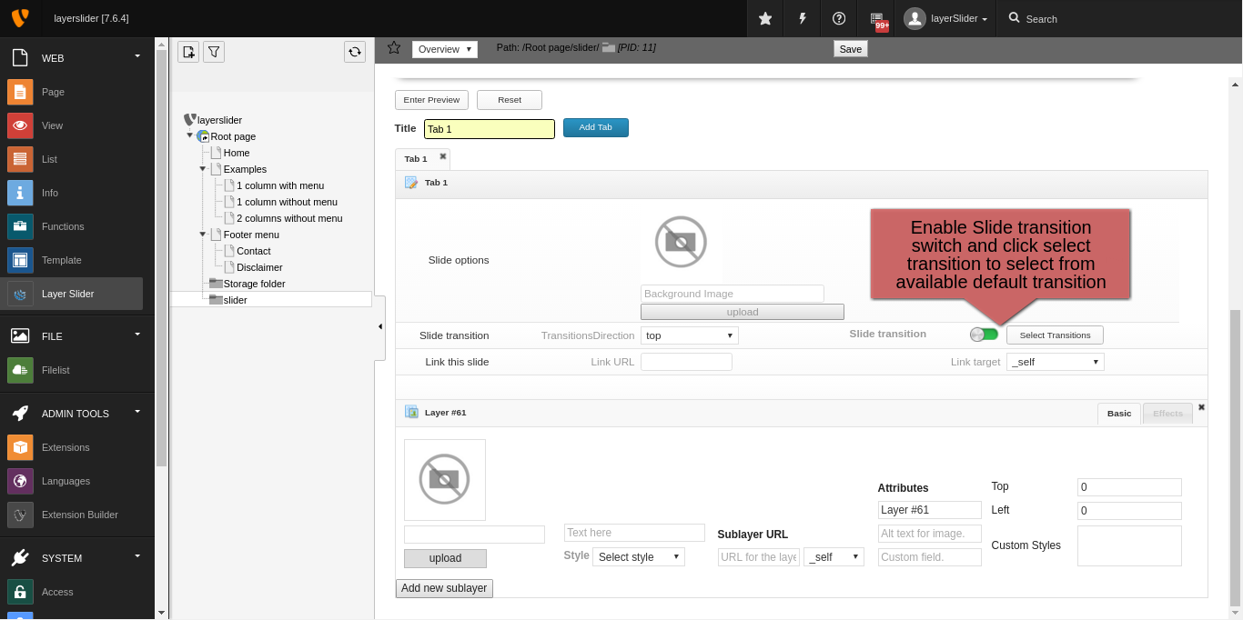
(fig. 4)
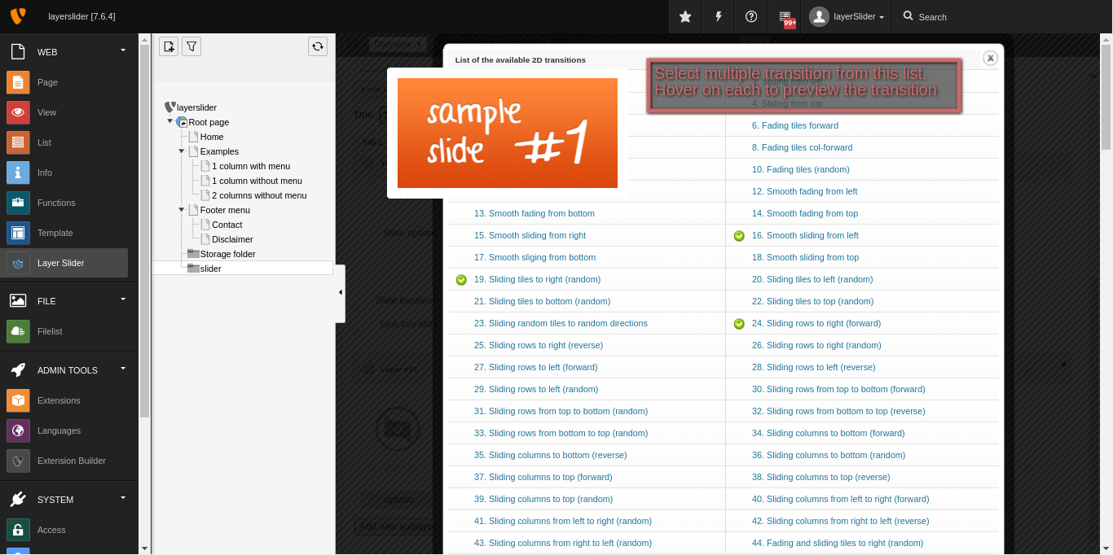

(fig. 5)

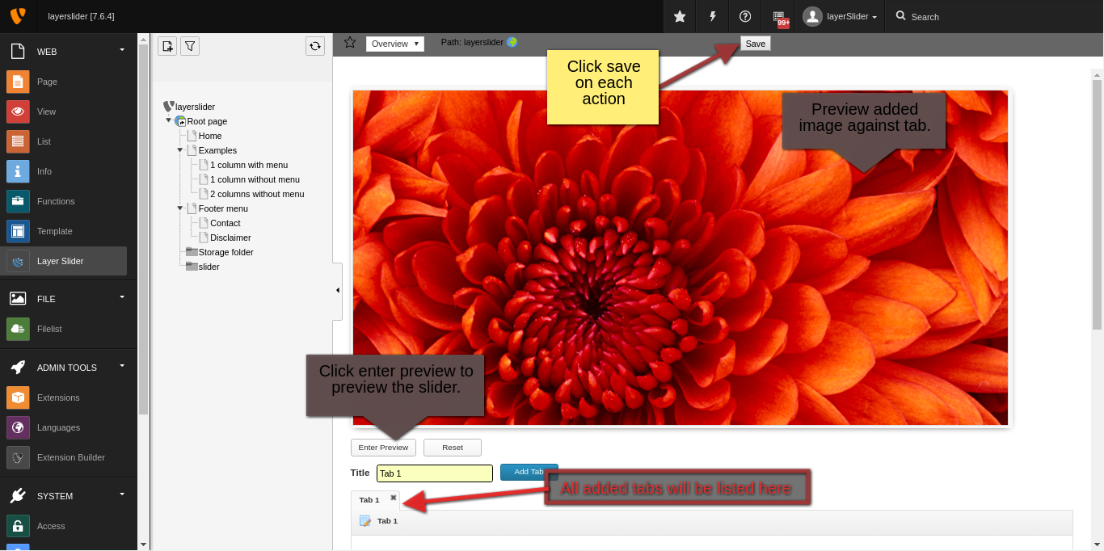
(fig. 6)

Screen shots
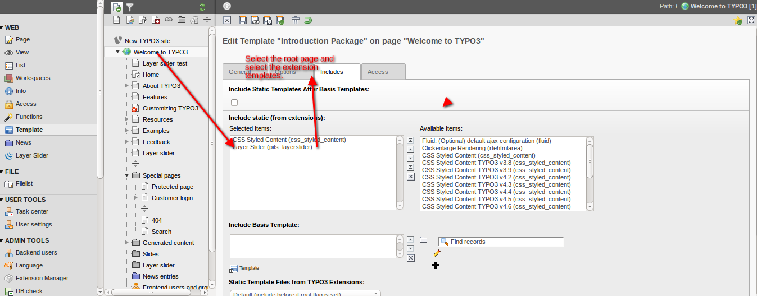
Fig(a)
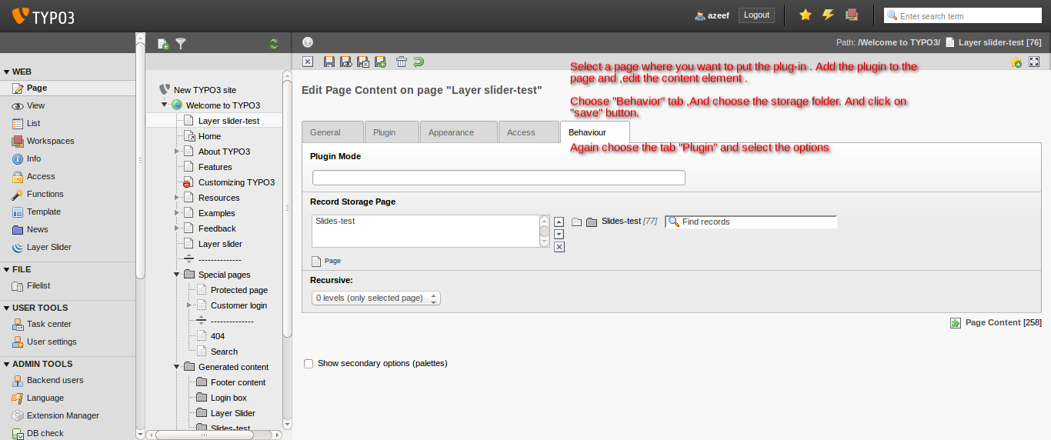
Fig(b)
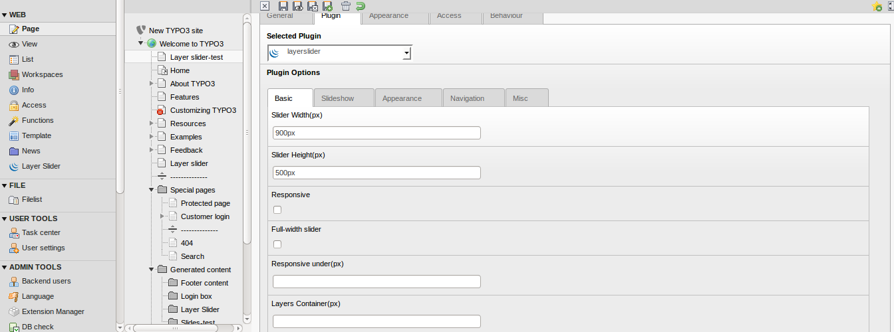

Fig(c)

Change Log

Version | Changes:
0.0.1 | Initial version uploaded
0.0.2 | Manual updated & emconf updated

