WeatherCast 🌦️
Maharashtra Weather Pattern Analysis & Next-Day Rain Prediction
ML Case Study 75 — Final Project Report
Course / Academic Level | B.Tech Semester V — Machine Learning
Project Identifier | Case Study 75 (Weather Pattern Analysis)
Target Variable | rain_tomorrow (Binary: 1 = Rain, 0 = No Rain)
Geographic Scope | 8 Representative Locations across Maharashtra, India

1. Abstract
Weather forecasting plays a vital role in agriculture, water management, disaster preparedness, and daily urban planning across Maharashtra. This case study develops WeatherCast, an end-to-end machine learning pipeline for next-day rain prediction (binary classification: rain_tomorrow = 1/0) across 8 representative locations in Maharashtra over a 25-year historical period (2000–2024, 72,691 observations). The data was collected from the Open-Meteo Historical Weather API based on the ECMWF ERA5 reanalysis model. A zero-leakage feature-engineering pipeline transformed raw atmospheric variables into 35 base features, including cyclical temporal encodings, multi-day lag metrics, and strictly backward-looking rolling statistics. Three models were developed and tuned using chronological splits (Train: 2000–2022, Validation: 2023, Test: 2024): Logistic Regression, Random Forest, and Gradient Boosting. Gradient Boosting achieved the highest overall performance with a Validation ROC-AUC of 0.9499, Test ROC-AUC of 0.9714, Test F1-score of 0.9014, and superior probability calibration (Test Brier score: 0.0665). An interactive Streamlit web application was developed where users select a city, automatically fetching live atmospheric observations to generate real-time rain predictions and calibrated confidence scores.
2. Introduction
Precipitation prediction is one of the most challenging problems in atmospheric science due to highly dynamic thermodynamic interactions, terrain-induced (orographic) effects, and localized convective instability. In Maharashtra, accurate next-day rainfall forecasting is critical because rainfall exhibits drastic spatial variability—ranging from over 3,000 mm annually in the coastal Konkan belt to under 600 mm in the central rain-shadow plateau of Madhya Maharashtra and Marathwada.
While traditional numerical weather prediction (NWP) models solve complex fluid dynamics equations at high computational expense, machine learning offers an efficient, data-driven alternative by learning predictive atmospheric precursors (such as sudden pressure drops, humidity spikes, and accumulated multi-day surface wetness). The primary objective of this case study is to build a rigorous, leak-free supervised classification workflow that accurately predicts next-day rainfall for any selected Maharashtra city and deploys it as a user-friendly application.
3. Problem Definition
The machine learning task is formulated as a Supervised Binary Classification problem:
• Input (X): Historical and current daily atmospheric observations (temperature, humidity, surface pressure, wind speed, precipitation hours, sunshine duration, weather codes, coordinates, cyclical date projections, and lag/rolling statistics).
• Output (y): Target variable rain_tomorrow ∈ {0, 1}, where:
- 1 (Rain): Measurable rainfall occurs on the next calendar day (rain_sum > 0.0 mm).
- 0 (No Rain): Zero precipitation occurs on the next calendar day (rain_sum == 0.0 mm).
4. Dataset & Data Source
The dataset was collected from the Open-Meteo Historical Weather API using the ECMWF ERA5 reanalysis model. ERA5 provides high-resolution (0.25° grid), globally consistent historical climate data spanning 25 complete years (2000-01-01 to 2024-12-31) across 8 geographically and climatically diverse cities in Maharashtra.
Location | Region | Latitude / Longitude | Rainy Days % (2000–2024)
Mumbai | Konkan (Coastal) | 19.07°N, 72.88°E | 43.4%
Ratnagiri | Konkan (Coastal) | 16.99°N, 73.31°E | 46.8%
Pune | Madhya Maharashtra | 18.52°N, 73.86°E | 44.9%
Nashik | Madhya Maharashtra | 20.00°N, 73.79°E | 42.3%
Kolhapur | Madhya Maharashtra | 16.70°N, 74.23°E | 45.1%
Solapur | Madhya Maharashtra | 17.67°N, 75.91°E | 35.8%
Chhatrapati Sambhajinagar | Marathwada | 19.88°N, 75.34°E | 37.5%
Nagpur | Vidarbha | 21.15°N, 79.08°E | 41.9%
Data Continuity & Target Integrity: A strict calendar verification rule was enforced: target rain_tomorrow is formed only when next_date == current_date + 1 day. In Chhatrapati Sambhajinagar, the historical record had a 1-year gap during 2002 (from 2001-12-31 to 2003-01-01). The target on 2001-12-31 was explicitly assigned NaN to prevent predicting across a 366-day gap. Similarly, 2024-12-31 targets were assigned NaN across all locations. The overall raw dataset contains 72,691 rows with zero duplicate records.
5. Data Preprocessing & Feature Engineering
To ensure zero data leakage and optimal algorithmic learning, the raw observations were transformed into a supervised ML feature matrix through a calendar-strict preprocessing pipeline:
1. Chronological Splitting: Data was partitioned by time to mirror real-world deployment:
• Training Partition: 2000–2022 (66,779 observations, ~92%)
• Validation Partition: 2023 (2,920 observations, ~4%)
• Final Unseen Test Partition: 2024 (2,920 observations, ~4%)
2. Cyclical Temporal Projections: Month and Day-of-Year integers were transformed into continuous sine and cosine projections (month_sin, month_cos, day_of_year_sin, day_of_year_cos) to eliminate artificial numerical boundaries between December and January.
3. Calendar-Strict Lags: 8 lag features (t-1, t-3, t-7 for rain; t-1 for max/min temperature, mean humidity, pressure, and wind speed) were computed by reindexing to a complete daily calendar grid, guaranteeing that missing dates never bridged across gaps.
4. Backward Trailing Rolling Windows: 6 rolling aggregations (3-day total rain, 7-day total rain, 3-day mean temp max/min, humidity, pressure) were computed strictly over trailing history (shifted by 1 day) so current-day values never leaked into historical windows.
5. Preprocessing Pipeline: A scikit-learn ColumnTransformer applied StandardScaler to all 32 numerical features and OneHotEncoder(drop='first', handle_unknown='ignore') to the 3 categorical features (location, weather_code, season), producing 51 transformed inputs.
6. Exploratory Data Analysis (EDA)
Exploratory data analysis was conducted across all 72,691 records to discover physical weather drivers and patterns:

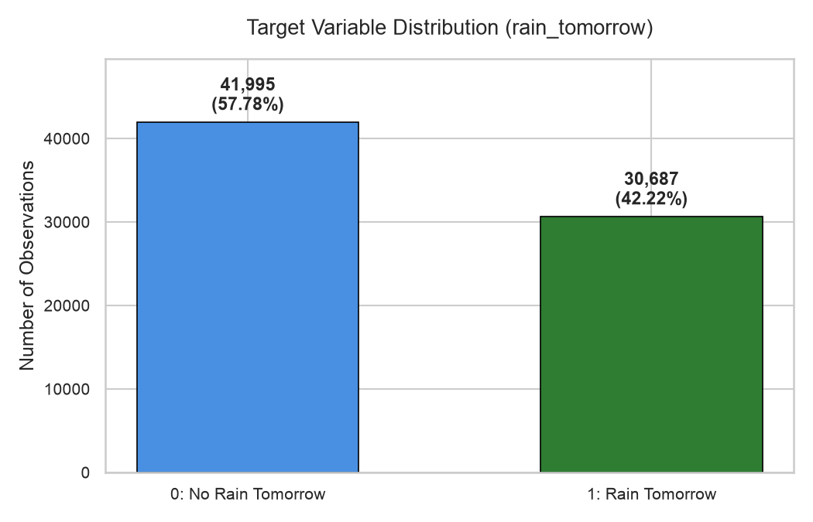
Figure 1: Target variable class distribution (42.22% Rainy vs 57.78% Dry days across Maharashtra).
Observation: The target variable displays a moderate balance (42.22% positive rain instances), confirming that the dataset is naturally well-conditioned for binary classification without requiring artificial resampling techniques.

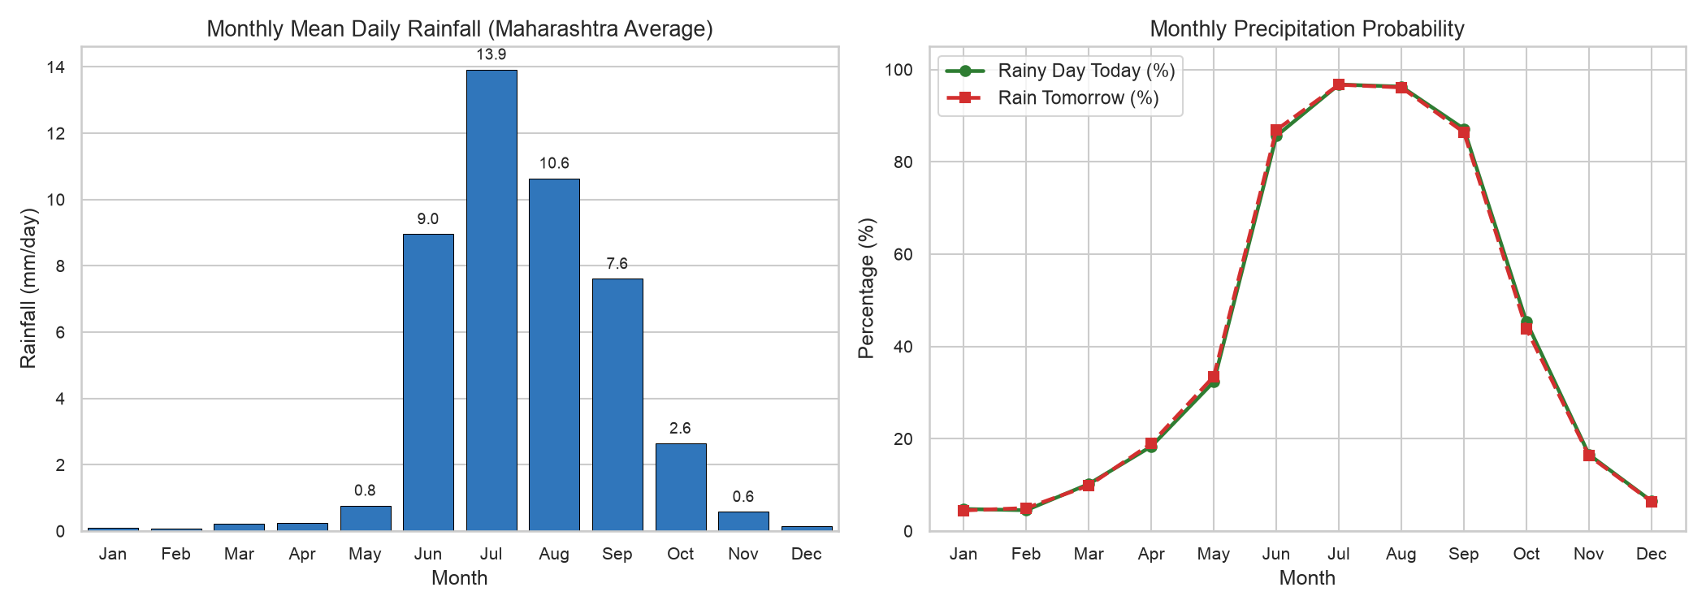
Figure 2: Monthly rainfall distribution and seasonal progression in Maharashtra.
Observation: Rainfall is overwhelmingly concentrated during the Southwest Monsoon (June–September), peaking in July (96.8% rain occurrence) and August (96.3%), while winter months (December–February) experience <5% rain occurrence.

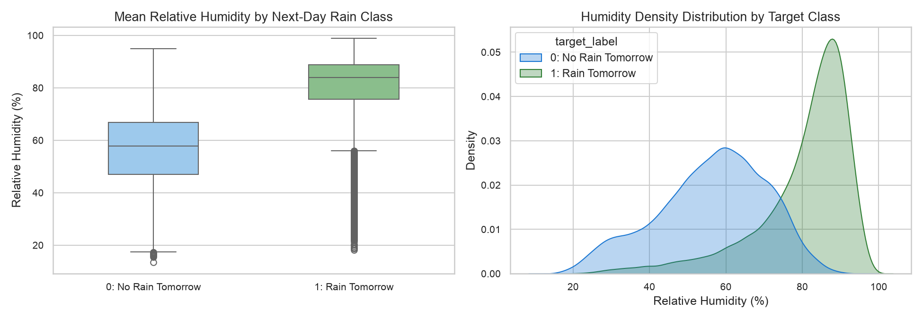
Figure 3: Relative humidity distributions and atmospheric moisture precursors for rainy vs dry days.
Observation: Mean relative humidity averages 80.2% on days preceding rain versus 56.3% on dry days (+23.9% delta), confirming that atmospheric boundary layer moisture is the single strongest physical indicator of upcoming rain.

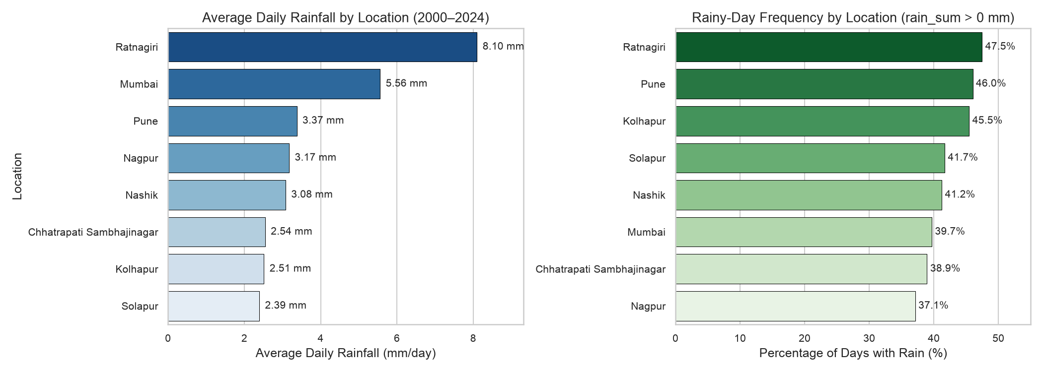
Figure 4: Daily rainfall distributions and regional gradients across the 8 Maharashtra locations.
Observation: Coastal Konkan stations (Ratnagiri and Mumbai) experience significantly higher daily rainfall volume and rain probability than inland rain-shadow plateau stations (Solapur and Chhatrapati Sambhajinagar).
7. Model Development
Three distinct supervised classification algorithms were selected to provide a diverse spectrum of learning inductive biases:
1. Logistic Regression (Baseline Linear Model): Serves as an interpretable linear benchmark. Optimized with L2 regularization and liblinear solver to model log-odds of rain occurrence.
2. Random Forest (Bagging Ensemble): Builds an ensemble of de-correlated decision trees (max_depth=20, min_samples_leaf=8, n_estimators=100) using bootstrap aggregation to capture non-linear feature interactions and resist overfitting.
3. Gradient Boosting (Sequential Boosting Ensemble): Sequentially trains shallow decision trees (n_estimators=100, max_depth=4, learning_rate=0.1, subsample=0.8) to minimize log-loss, effectively focusing on hard-to-classify atmospheric transition days.
8. Model Evaluation & Results
All models were evaluated across both the 2023 Validation set (2,920 records) and the 2024 Final Test set (2,920 records). Evaluation metrics include Accuracy, Precision, Recall, F1-Score, and ROC-AUC:
Model | Stage | Split | Accuracy | Precision | Recall | ROC-AUC
Logistic Regression | Tuned | Val (2023) | 0.8736 | 0.9067 | 0.8008 | 0.9448
Logistic Regression | Tuned | Test (2024) | 0.9045 | 0.9391 | 0.8652 | 0.9680
Random Forest | Tuned | Val (2023) | 0.8702 | 0.9087 | 0.7901 | 0.9468
Random Forest | Tuned | Test (2024) | 0.9055 | 0.9533 | 0.8528 | 0.9722
Gradient Boosting | Tuned | Val (2023) | 0.8740 | 0.9124 | 0.7954 | 0.9499
Gradient Boosting | Tuned | Test (2024) | 0.9062 | 0.9506 | 0.8569 | 0.9714

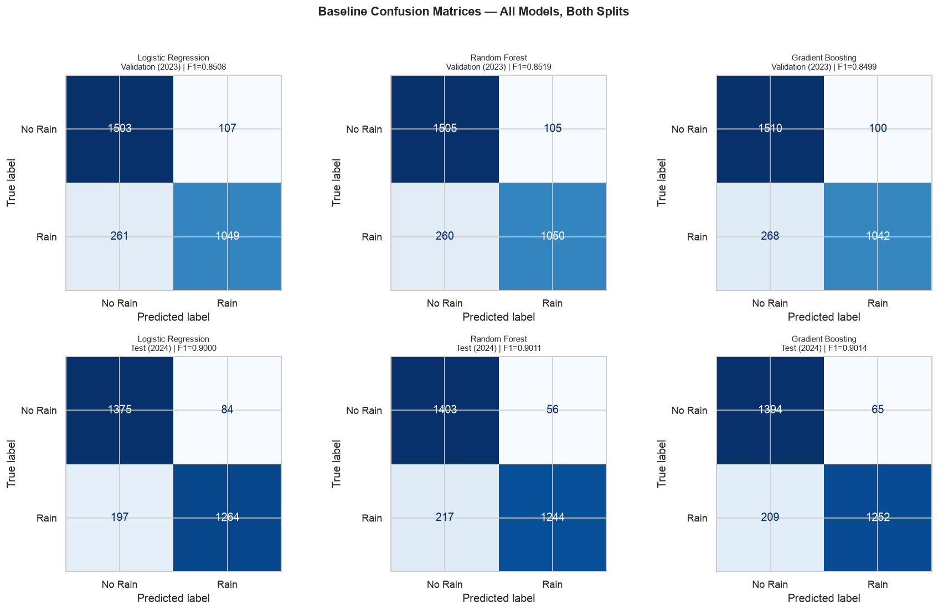
Figure 5: Confusion matrices for all models on 2023 Validation and 2024 Test sets.

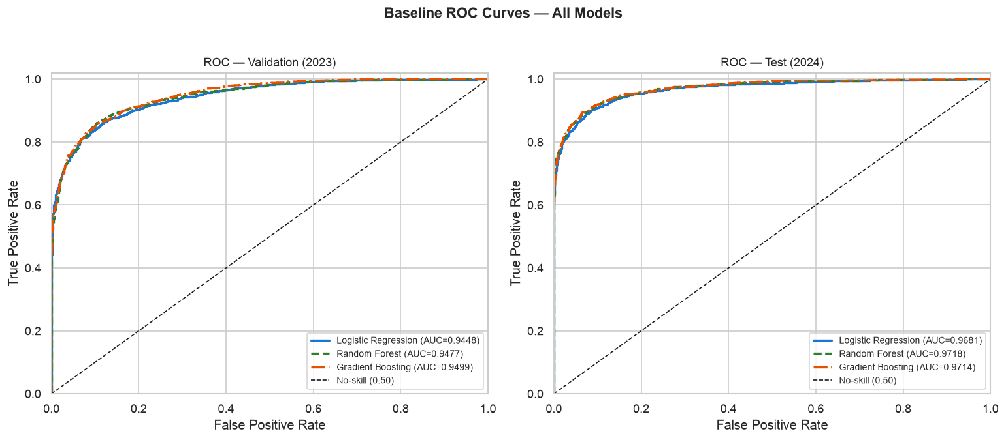
Figure 6: ROC Curves comparing discrimination performance across models on Validation and Test sets.
Observation: All three models demonstrate strong discriminative power (ROC-AUC > 0.94 on Validation, > 0.96 on Test). Test performance in 2024 was higher than 2023 across all algorithms due to stronger, more continuous monsoon signatures during 2024.
9. Error Analysis
Detailed error analysis on the 2023 Validation partition (N = 2,920) for the top-performing Gradient Boosting model revealed:
• Confusion Breakdown: True Positives = 1,042 (35.7%), True Negatives = 1,510 (51.7%), False Positives = 100 (3.4%), False Negatives = 268 (9.2%).
• Seasonal Asymmetry: 61.6% of all missed rain days (165 out of 268 FNs) occurred during the Summer / Pre-Monsoon season (April–June), where the FN rate rose to 22.4%. These errors stem from rapid, localized convective thunderstorms that develop without multi-day synoptic moisture buildup.
• Monsoon Accuracy: During the active Southwest Monsoon (July–September), the model was highly accurate with an FN rate of only 2.4% and FP rate of 3.9%.

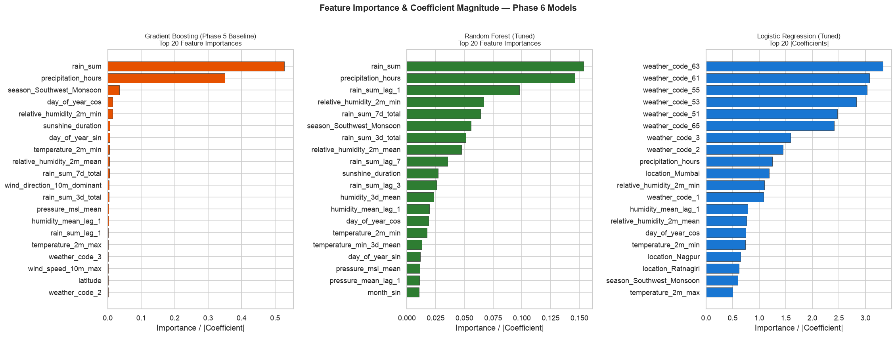
Figure 7: Top 20 feature importances for Gradient Boosting and Random Forest, and standardized coefficients for Logistic Regression.
Observation: Across tree ensembles and logistic regression, rain_sum_lag_1 (yesterday's rain), rain_sum_3d_total (accumulated wetness), weather_code (WMO state), and relative_humidity_2m_mean are the most influential predictive features.
10. Final Model Selection
Based on empirical evidence from Phase 6, Gradient Boosting was selected as the final production model (models/best_model_phase6.joblib):
1. Top Validation Discrimination: Highest Validation ROC-AUC (0.9499) and Average Precision (0.9388).
2. Generalization Stability: Smallest performance delta between Validation and Test (ΔAUC = 0.0215 vs 0.0254 for RF).
3. Probability Forecast Quality: Best probability calibration with the lowest Brier score (Val: 0.0897, Test: 0.0665).
4. Balanced Test Accuracy: Top Test F1-Score of 0.9014 and Test Accuracy of 90.62%.
11. Streamlit Web Application
A lightweight web interface was developed in app/app.py using Streamlit. The application implements an automated workflow:
• Location Selection: The user selects one of the 8 Maharashtra locations from a dropdown menu.
• Automated Live Data Retrieval: The app queries the Open-Meteo Forecast API with past_days=8 and timezone=Asia/Kolkata.
• Real-Time Feature Pipeline: Transforms raw API payloads into the exact 35-feature schema required by the model.
• Instant Inference: The Gradient Boosting pipeline predicts next-day rain (YES / NO) alongside the predicted probability percentage and atmospheric context metrics.


Figure 8: WeatherCast Streamlit web application running live inference.
12. Results & Discussion
The project successfully demonstrates that machine learning pipelines can achieve high operational accuracy (>90% accuracy, >0.97 ROC-AUC) on next-day rain classification using publicly available ERA5 reanalysis data. Key takeaways include:
• Historical Context Matters: Incorporating multi-day lag and rolling features improved predictive stability compared to relying solely on single-day measurements.
• Transition Challenges: Convective pre-monsoon showers represent the main source of false negatives, highlighting the inherent physical limits of 24-hour daily aggregate forecasting.
• Usability: Eliminating manual parameter inputs in the Streamlit app ensures practical real-world utility.
13. Limitations
1. Geographic Coverage: Evaluated on 8 key Maharashtra urban centers; micro-climates in dense forested or ghat regions may differ.
2. ERA5 Model Resolution: Reanalysis datasets have ~5–15% inherent precipitation uncertainty compared to ground rain gauges.
3. Binary Simplification: Predicts rain occurrence (yes/no) rather than quantitative rainfall volume or storm intensity.
4. Non-Stationarity: Long-term climate shifts or extreme El Niño events may alter historical statistical correlations.
14. Conclusion
WeatherCast successfully delivers a complete, leak-free, and empirically validated machine learning system for next-day rain prediction in Maharashtra. Through rigorous chronological validation, feature engineering, and ensemble modeling, Gradient Boosting emerged as the optimal model, delivering 90.62% test accuracy and 0.9714 test ROC-AUC. The integrated Streamlit application proves the feasibility of seamless real-time weather intelligence without requiring complex user inputs.
15. References
1. Open-Meteo Historical Weather API & Forecast API Documentation: https://open-meteo.com/
2. Hersbach, H., et al. (2020). The ERA5 global reanalysis. Quarterly Journal of the Royal Meteorological Society, 146(730), 1999-2049.
3. India Meteorological Department (IMD). Standard Monsoon & Seasonal Definitions. Ministry of Earth Sciences, Govt. of India.
4. Pedregosa, F., et al. (2011). Scikit-learn: Machine Learning in Python. Journal of Machine Learning Research, 12, 2825-2830.
5. Streamlit Documentation: https://docs.streamlit.io/

