"E-Commerce Sales Analysis using SQL – UK Online Retail Dataset"

Created By: Piyush Bidwaikar

Role: Aspiring Data Analyst / BI Analyst

Tools Used: SQLite, Kaggle Dataset, sqliteonline.com

Date Completed: November 2025

Contact: linkedin.com/in/piyush-bidwaikar / piyushbidwaikar123@gmail.com /

Project Summary:
This project analyzes UK-based e-commerce retail data using SQL to derive business insights, build relational tables, perform data cleaning exploration, and optimize queries. Through SQL joins, subqueries, views, and indexing, the analysis identifies product-level and country-level performance, customer value, and potential business opportunities.

Business Problem Statement:
The objective is to understand customer purchasing behavior, identify high-revenue products, measure country-wise sales contribution, and detect high-value customer segments to help stakeholders optimize sales strategies and improve profitability.

Dataset Details:
Attribute | Description
Source | Kaggle
Dataset Name | UK Online Retail
Records | ~541K rows (2010-2011)
Columns | InvoiceNo,StockCode,Description,Quantity,Data,Unitprice,CustomerID,Country
Format | CSV
Tool Used | SQLite (Browser via sqliteonline.com)

Project Workflow
List steps performed:
- Data import from CSV into SQLite
- Exploratory queries & data quality checks
- Creation of relational data model
- Perform SQL operations
- Analyze insights using joins, aggregates, subqueries
- Create views for reusability
- Apply indexing for optimization
- Prepare documentation & final deliverables

Database Design
Entities:
- customers (CustomerID, Country)
- products (StockCode, Description, UnitPrice)
- invoices (InvoiceNo, InvoiceDate, CustomerID)
- invoice_items (InvoiceNo, StockCode, Quantity, UnitPrice)

SQL Implementation

Data Exploration (SELECT, WHERE, ORDER, GROUP BY)
Recent invoices for a specific customer
SELECT
InvoiceNo,
InvoiceDate,
CustomerID
FROM invoices
WHERE CustomerID = 17850
ORDER BY InvoiceDate DESC
LIMIT 20;

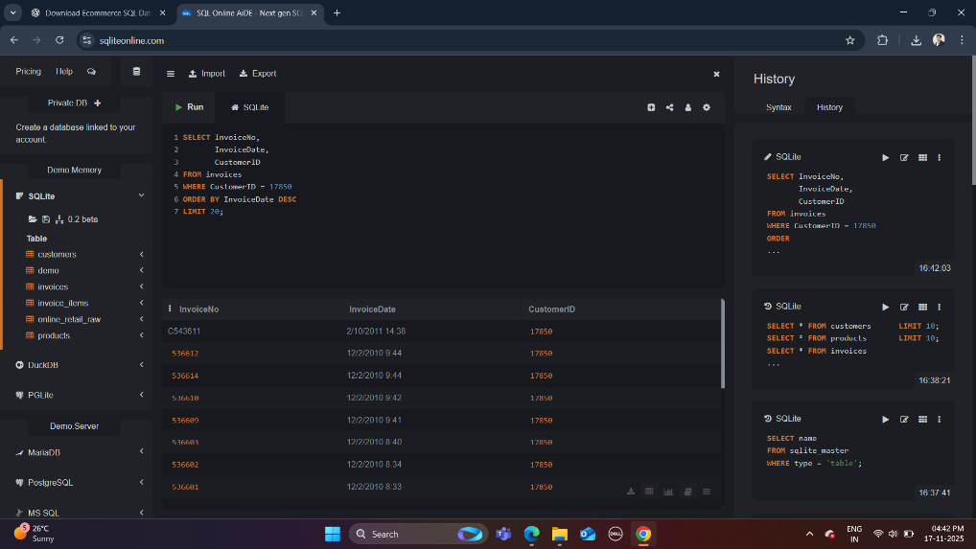

Revenue by country

SELECT
Country,
SUM(Quantity * UnitPrice) AS total_revenue
FROM online_retail_raw
GROUP BY Country
ORDER BY total_revenue DESC;

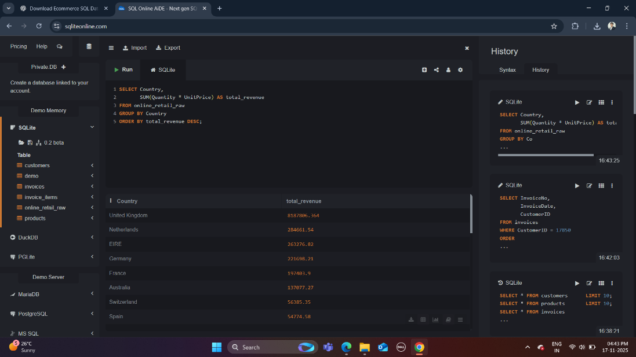
“This query aggregates line-level transaction value by country to identify major revenue-contributing regions. The results indicate that the United Kingdom dominates the revenue share significantly compared to other countries, suggesting a highly domestic market focus and potential opportunities for international expansion.”

Joins for Relationship Analysis
INNER JOIN – invoices with customers
SELECT
i.InvoiceNo,
i.InvoiceDate,
i.CustomerID,
c.Country
FROM invoices AS i
INNER JOIN customers AS c
ON i.CustomerID = c.CustomerID
LIMIT 20;

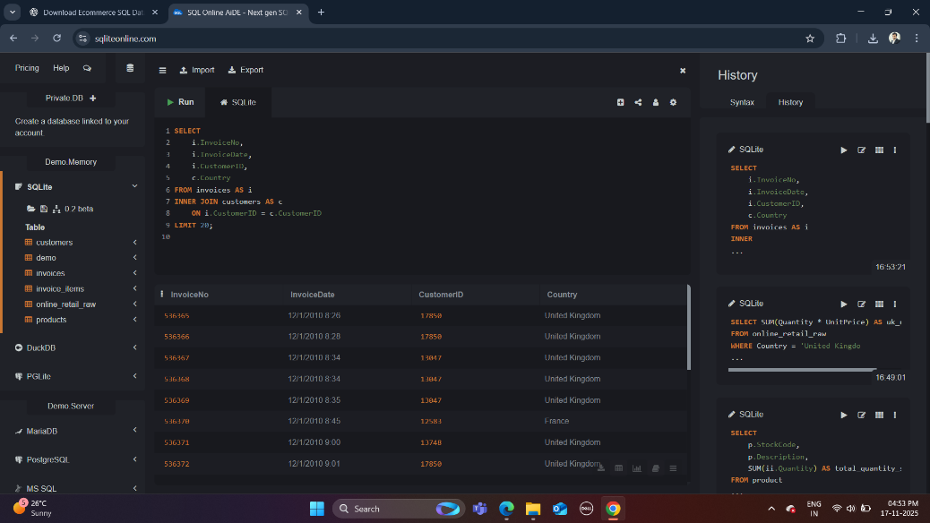

LEFT JOIN – all invoices, customers if available

SELECT
i.InvoiceNo,
i.InvoiceDate,
i.CustomerID,
c.Country
FROM invoices AS i
LEFT JOIN customers AS c
ON i.CustomerID = c.CustomerID
ORDER BY i.InvoiceDate
LIMIT 20;
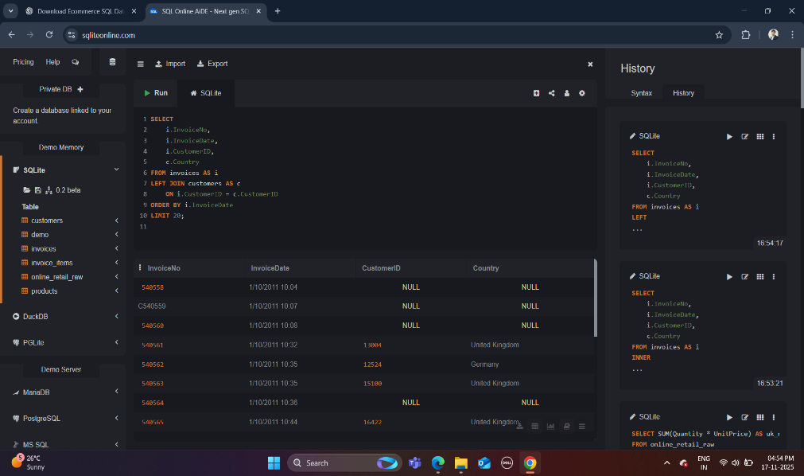

Multi-table JOIN – product performance

SELECT
p.StockCode,
p.Description,
SUM(ii.Quantity) AS total_qty,
SUM(ii.Quantity * ii.UnitPrice) AS revenue
FROM invoice_items AS ii
JOIN products AS p
ON ii.StockCode = p.StockCode
JOIN invoices AS i
ON ii.InvoiceNo = i.InvoiceNo
GROUP BY p.StockCode, p.Description
ORDER BY revenue DESC
LIMIT 15;
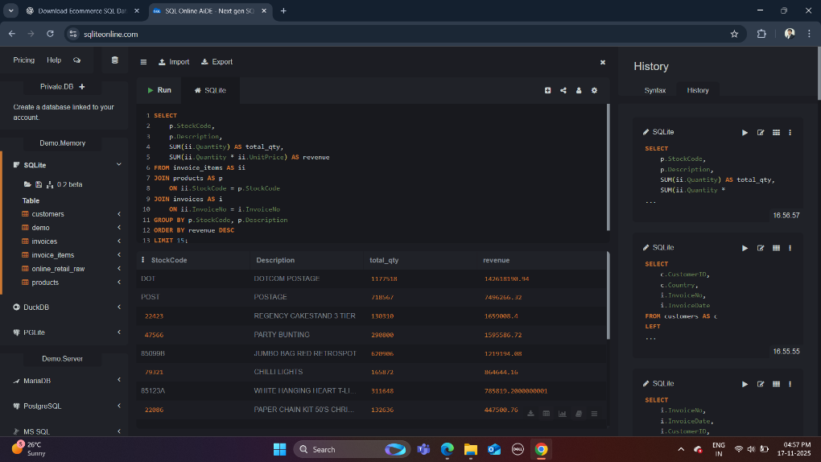
“By joining invoice headers, invoice items, and product master data, this query computes total quantity sold and total revenue per product. The output highlights the top-performing SKUs, enabling data-driven decisions on inventory management, pricing strategy, product promotion, and catalogue optimization.”
Subqueries / CTE for Customer Insights
High-value customers (CTE + subquery)

WITH customer_sales AS (
SELECT
i.CustomerID,
SUM(ii.Quantity * ii.UnitPrice) AS revenue
FROM invoices AS i
JOIN invoice_items AS ii
ON i.InvoiceNo = ii.InvoiceNo
WHERE i.CustomerID IS NOT NULL
GROUP BY i.CustomerID
)
SELECT *
FROM customer_sales
WHERE revenue > (SELECT AVG(revenue) FROM customer_sales)
ORDER BY revenue DESC
LIMIT 20;
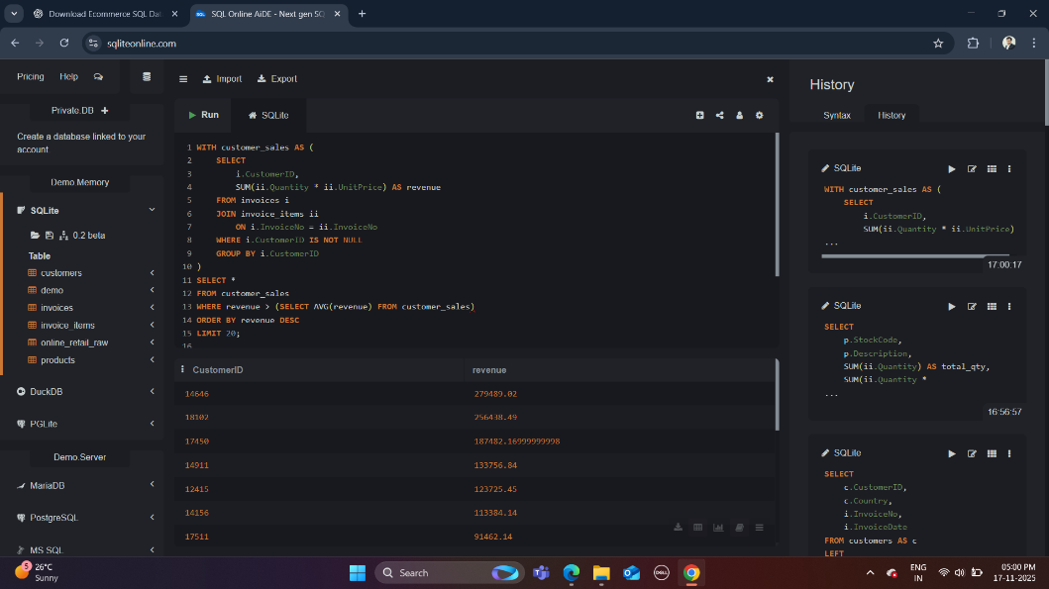

“Using a Common Table Expression (CTE), this query calculates the total revenue generated per customer and compares it against the average customer revenue to isolate high-value customers. This analysis helps in identifying priority customers for loyalty programs, targeted marketing, and retention initiatives.”

Top 5 countries by revenue (subquery in FROM)

SELECT
Country,
total_revenue
FROM (
SELECT
Country,
SUM(Quantity * UnitPrice) AS total_revenue
FROM online_retail_raw
GROUP BY Country
) AS t
ORDER BY total_revenue DESC
LIMIT 5;

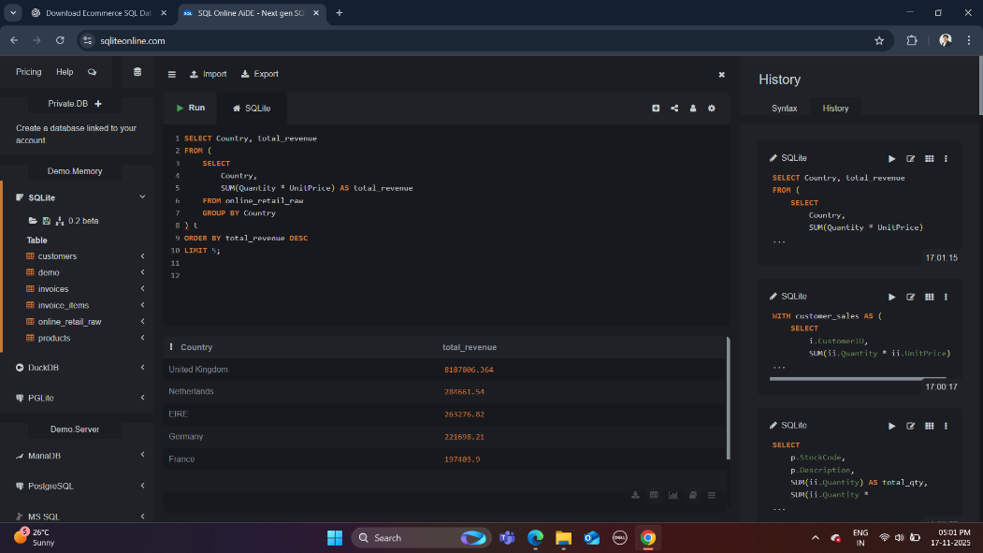

Views for BI-Friendly Analysis

View – revenue per country

DROP VIEW IF EXISTS v_country_revenue;

CREATE VIEW v_country_revenue AS
SELECT
Country,
SUM(Quantity * UnitPrice) AS total_revenue
FROM online_retail_raw
GROUP BY Country;
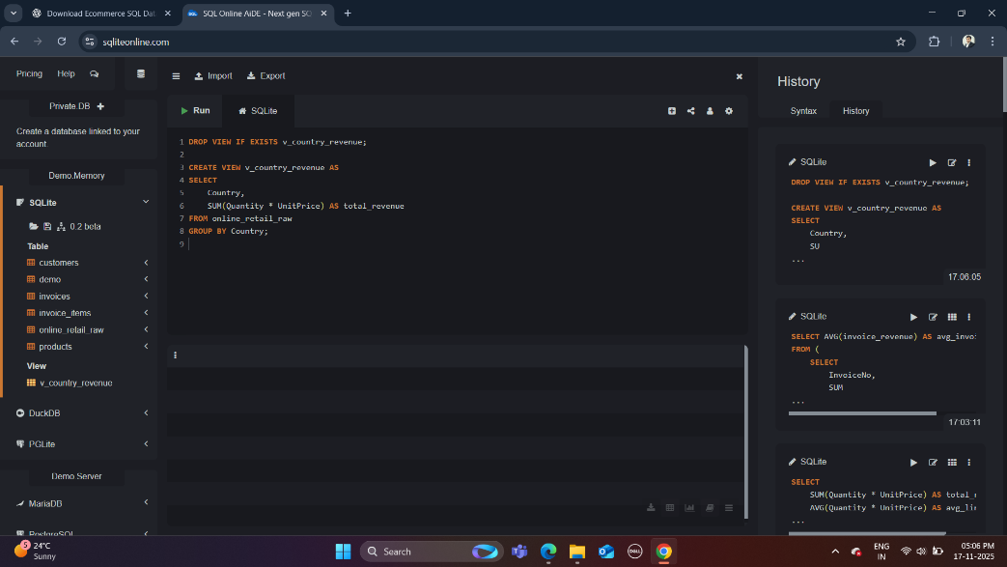

Using the view:

SELECT *
FROM v_country_revenue
ORDER BY total_revenue DESC
LIMIT 10;

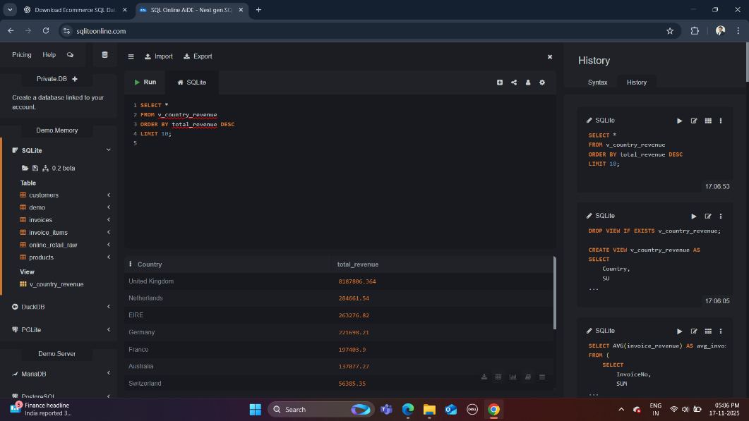

View – detailed invoice analysis

DROP VIEW IF EXISTS v_invoice_details;

CREATE VIEW v_invoice_details AS
SELECT
i.InvoiceNo,
i.InvoiceDate,
c.CustomerID,
c.Country,
p.StockCode,
p.Description,
ii.Quantity,
ii.UnitPrice,
ii.Quantity * ii.UnitPrice AS line_revenue
FROM invoices AS i
JOIN invoice_items AS ii
ON i.InvoiceNo = ii.InvoiceNo
JOIN products AS p
ON ii.StockCode = p.StockCode
LEFT JOIN customers AS c
ON i.CustomerID = c.CustomerID;

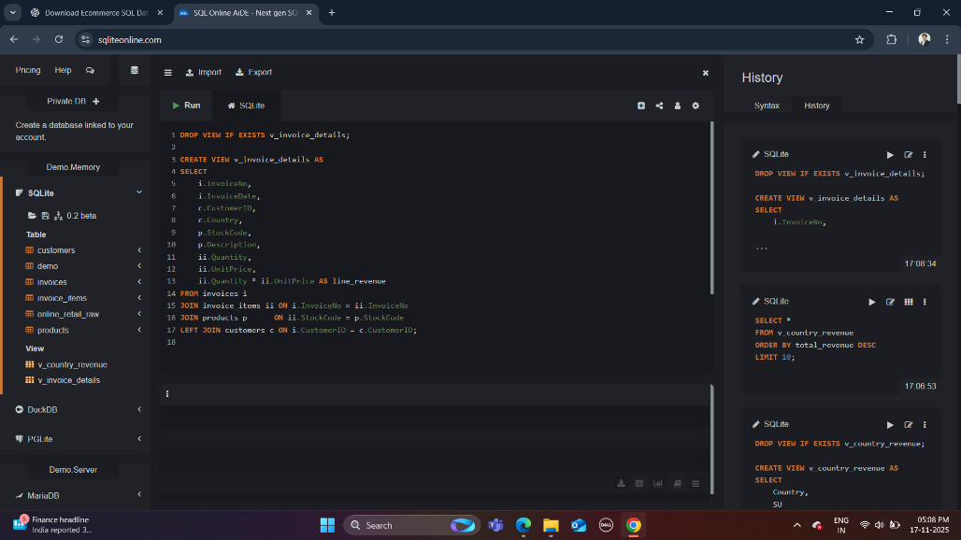

Using the view:

SELECT *
FROM v_invoice_details
LIMIT 20;

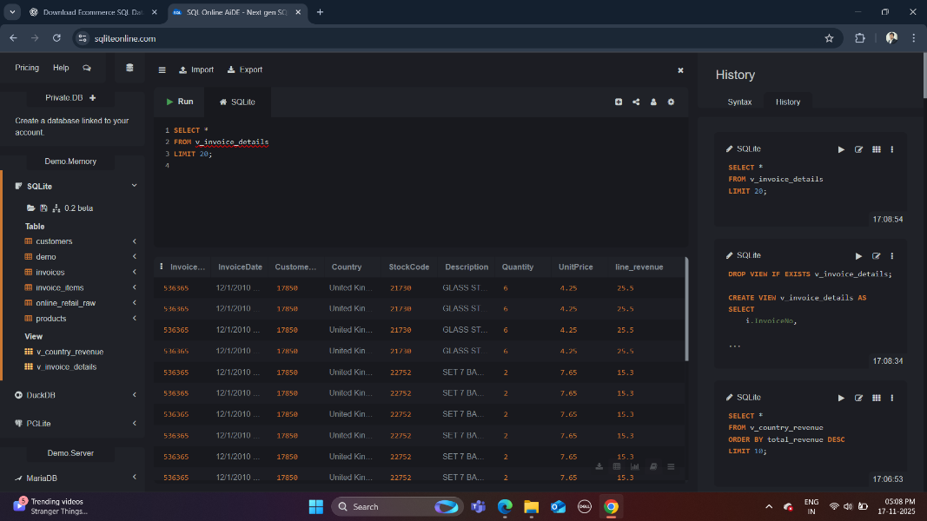

Indexing & Query Optimisation
Creating indexes

CREATE INDEX IF NOT EXISTS idx_invoices_customer
ON invoices(CustomerID);

CREATE INDEX IF NOT EXISTS idx_invoice_items_invoice
ON invoice_items(InvoiceNo);

CREATE INDEX IF NOT EXISTS idx_invoice_items_stock
ON invoice_items(StockCode);

CREATE INDEX IF NOT EXISTS idx_customers_country
ON customers(Country);

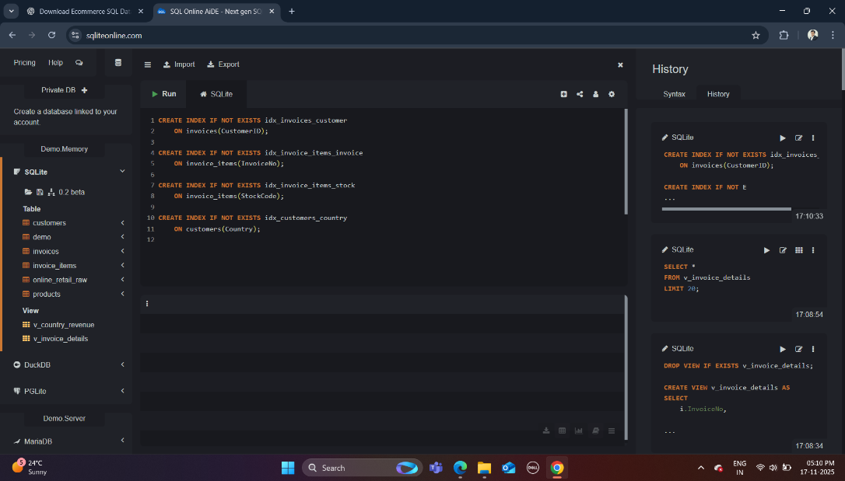

Checking query plan (example)

EXPLAIN QUERY PLAN
SELECT *
FROM invoices AS i
JOIN invoice_items AS ii
ON i.InvoiceNo = ii.InvoiceNo
WHERE i.CustomerID = 17850;

