The Open Source Audit

A Capstone Project for OSS NGMC Course

Chosen Software: Kali Linux

Student Name | Registration Number
Piyush Prasad | 24BCY10249
Slot | Date of Submission
E22 | 31.03.26

Part A — Origin and Philosophy

A1. The Problem Apache HTTP Server Was Created to Solve

Early Challenges in Web Hosting
In the earlier days of the internet, hosting websites was not that easy. The internet was still in the development phase, and the server software that was being used had many limitations.
Most of the web servers were either too costly, inflexible, or were owned by certain companies. This created a problem for students and developers to host their websites freely.

Shortcomings of Existing Web Servers
One of the most popular web servers at that time was the NCSA HTTP Server. However, the development of this server gradually stopped, and proper updates were not provided. There were many bugs that were still not fixed. Developers had to fix these bugs themselves by developing small improvements or “patches.”

The Birth of Apache
In order to resolve these problems, some developers decided to work together to develop a single improved server using their individual patches. This led to the development of the Apache HTTP Server. The name ‘Apache’ is usually related to the term ‘patchy server’ because it is a combination of many patches.

Goal and Purpose
The main idea behind the development of Apache is to provide a free and open-source server that is highly customizable. It provides access to the source code of the server, enabling developers to make improvements to the source code according to their needs.

Growth and Impact
The Apache server was very successful because it was reliable, flexible, and had support from a large community. It could be used on different operating systems and could be used to host both small and large websites. Eventually, Apache became one of the most popular web servers across the globe. It had a huge impact on the development of the internet.

A2. The License — What It Actually Says

Understanding Apache License
The Apache HTTP Server is covered by the Apache License 2.0. This is a permissive open-source software license that allows users to use, modify, and redistribute the software freely. The Apache License also provides protection for contributors by granting patent rights and limiting liability. The Apache License is not as restrictive as other licenses; rather, it is more permissive for developers and organizations.

The Four Freedoms of Open Source
The open-source software is based on four major open-source software freedoms. These four open-source software freedoms are as follows:
The freedom to run the program for any purpose. The freedom to study how the program works and modify it. The freedom to redistribute copies. The freedom to distribute modified versions.
These four open-source software freedoms ensure that the user has complete freedom to use open-source software. The Apache License allows users to use and modify the software without any major restrictions.
Can Companies Modify and Sell It?
Yes, companies can take the source code of the Apache HTTP Server and can even sell it by making the necessary modifications to it. Companies do not need to disclose the source code of the modified version of the product. They need to disclose the original license and give proper credit to the original developers of the product. This makes the Apache License more businessfriendly compared to the GPL and MIT Licenses.

GPL vs MIT vs Apache License
The GPL license is a strict license that requires the source code to be open source if the software is modified by a company or an individual. The MIT License is a permissive license that provides almost complete freedom with minimal restrictions.
The Apache License is similar to the MIT License but provides additional features such as patent protection and clear terms for contribution. If I had to choose a license for my product, I would choose the Apache License because it provides complete flexibility and security.

Free vs Freedom
There is a fundamental difference between "Free as in Free Beer" and "Free as in Freedom." "Free as in Free Beer" refers to something that is available for free, while "Free as in Freedom" refers to something where one is allowed to use and modify it in any manner he or she wishes.
Apache HTTP Server is "Free as in Freedom" because one is allowed to use, modify, and distribute it in any manner he or she wishes.

A3. The Ethics of Open Source

Should All Software Be Open Source?
In my opinion, not all software needs to be open source, but a larger part of it does. This is because open source software allows for learning and transparency and hence is a good idea for the development of technology and software.

Is It Ethical for Companies to Use Open Source for Profit?
It is a fact that many companies use open source software for making profits, and in my opinion, it is ethical for companies to do so, provided they follow the rules and regulations and give proper credit to the developers of the software. This is because open source software is based on the idea of sharing and helping each other, and companies do the same by improving the software and making it better.

Standing on the Shoulders of Giants
“Standing on the shoulders of giants” refers to building upon existing knowledge to form new ideas. This is exactly what open source achieves in the field of software, where developers are able to build upon existing ideas and improve them. This, in my opinion, is a form of innovation and not a hindrance to it, because it provides a strong base upon which to build in the future.

Part B — Linux Footprint of Apache HTTP Server

This section discusses the operation of the Apache HTTP server on a Linux operating system.
The discussion in this section is based on real-world observation by installing and running the Apache server on a Debian-based Linux distribution, namely Kali Linux. This gives an idea about the actual operation of the server.

Installation Method
Apache HTTP Server installation on a Debian-based system is quite easy using the Advanced Package Tool (APT). The package name used for installation is apache2. The installation command is as follows:
• sudo apt install apache2
This installation method includes all necessary dependencies along with the installation of the software. Apache HTTP Server is open-source software; therefore, it is freely available in the repositories of any Linux distribution. The package is maintained by the Linux distribution itself.

Key Directories
Apache HTTP Server utilizes a number of significant directories in the Linux file system, which are listed below:
- /etc/apache2/ → This directory contains all configuration files for Apache, including main configuration and module configuration files. This is the core control center for managing the Apache server.
- /var/log/apache2/ → This directory contains log files such as access log and error log files. These log files are helpful in monitoring and troubleshooting server activities.
- /usr/sbin/apache2 → This is a binary file that is utilized to execute the Apache server.

User and Group
Apache operates as a specific system user and group, usually www-data in a Debian-based system. This is significant for security as it doesn’t allow the web server to operate as the root user.
This way, the system minimizes the potential for damage in case of a vulnerability or an attack by limiting its permissions. This is a common practice in securing a Linux system.

Service Management
Apache runs as a system service and can be controlled using systemctl. The following commands are used
- sudo systemctl start apache2
- sudo systemctl stop apache2
- sudo systemctl restart apache2
This allows administrators to manage the server easily. The service can also be enabled to start automatically during system boot.

Update Model
Apache HTTP Server receives updates through the Linux package management system. Security patches and updates are provided by the open-source community and distributed via system updates.
The following command is used to update Apache:
- sudo apt update
- sudo apt upgrade

Part C — The FOSS Ecosystem Around Apache HTTP Server

Apache HTTP Server does not work alone. It is part of a larger open-source ecosystem where different tools and technologies work together. This ecosystem helps in building and running modern web applications efficiently. Dependencies and Supporting Tools
Apache relies on several open-source packages to run properly. Some of these packages include system libraries, networking tools, and modules to extend its functionality. Some of these modules include mod_ssl for secure https connections and mod_rewrite for managing URLs.
The Linux operating system is another component that the Apache server relies upon. Linux provides the platform to run the server.
Overall, these packages make the Apache server flexible and powerful.

Role in the LAMP Stack
Apache plays a major role in the LAMP stack, which consists of Linux, Apache, MySQL, and PHP. The roles of each of these components in the stack are as follows:
- Linux acts as the OS.
- Apache acts as the web server.
- MySQL acts as the database.
- PHP acts as the backend.
This combination is typically used for the development of dynamic web applications and sites. Apache acts as a bridge between the user and the backend system. What Apache Has Enabled
Apache has enabled the development of a modern web by providing a free and reliable web server. There are many sites, applications, and platforms that have been developed using Apache. It has also enabled other web servers, such as Nginx.
Apache is an open-source system, and this has enabled developers to build new technologies and tools on top of it, leading to the rapid development of web technology.

Part D — Open Source vs Proprietary Comparison

Apache HTTP Server can be compared with a proprietary web server like Microsoft IIS (Internet Information Services). Both are used to host websites, but they differ in several important aspects.
Comparison Table
Dimension | Apache HTTP Server (Open Source) | Microsoft IIS (Proprietary)
Cost | Free to use and distribute | Requires Windows Server license
Security | Code is open for public review, making vulnerabilities easier to detect and fix | Source code is closed, so only the company can fix vulnerabilities
Support and Reliability | Community support, documentation, forums | Official support from Microsoft
Freedom to Modify | Users can modify and customize the source code | No access to source code
Control | Community-driven development | Controlled by a single company

Conclusion and Verdict
Having studied Linux in depth I think it's a choice for real-world servers and infrastructure. Linux is free to use. Its open source code means you can see exactly how it works. It can handle a lot of traffic & is very scalable. It has a community of users who help each other out. It's no surprise that Linux is used by cloud platforms, supercomputers and the internet. It's the result of years of people working together to make something really good. I would like to contribute to Linux. However I know it won't be easy. The Linux code is very complex. You need to know C and operating systems really well to contribute. Here are the steps to contribute: Start by reporting bugs. Then help with documentation. Next try fixing parts of the code. Eventually you can make contributions. The process of contributing to Linux is well documented and open, to developers who're willing to learn and do the work.

Shell Script Documentation

Script 1 — System Identity Report
This script is intended for displaying fundamental system information about the Linux system in a structured way. It is similar to a welcome screen that gives information about the system and the user.
In this script, various system information is stored in the form of variables using the Linux commands uname, whoami, uptime, and date. The system information includes the kernel version of the system, the name of the user currently using the system, the home directory of the user, the system's running time, the date and time of the system, and the name of the Linux distribution.
The $( ) in the script is used for executing the Linux commands and storing the output in the variables. The echo command is used for displaying the system information in a structured way. This script is a demonstration of the use of fundamental concepts of shell scripting programming language.

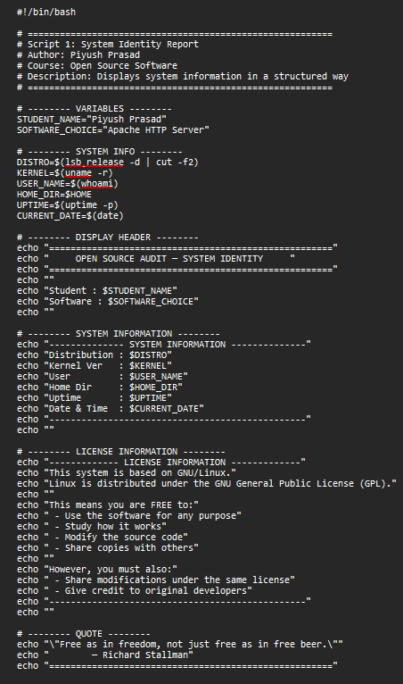

SCRIPT OUTPUT :

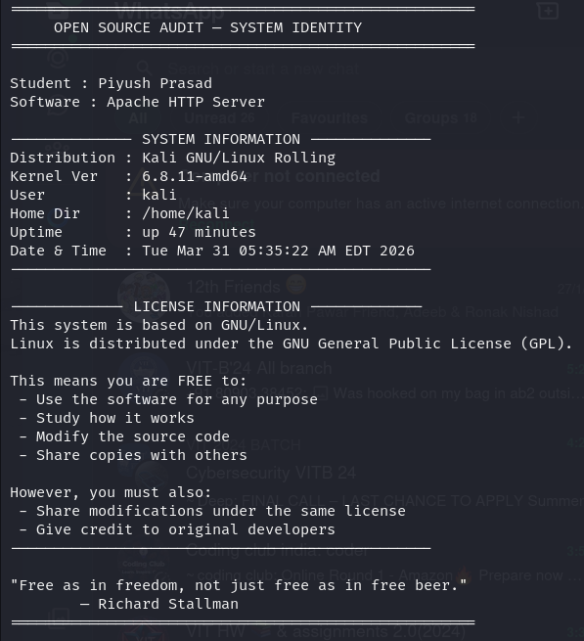

Script 2 — FOSS Package Inspector

The script is designed to check if a certain open-source software package is installed on a system and show information about it. This script is utilized to check information about the Apache HTTP Server package.
The script makes use of an if-else statement to check if a certain package is installed by executing a command with the help of the dpkg command and grep command. It shows information about the package if it is installed and shows a message saying that the package is not installed if it is not installed.
The script makes use of a case statement to show a description of the software package based on the name of the package installed on the system, adding a logical decisionmaking feature to the script.
The script shows a demonstration of conditional statements, pattern matching, and package management commands in a Linux system, and it shows a demonstration of shell scripting and its capabilities in a Linux system.

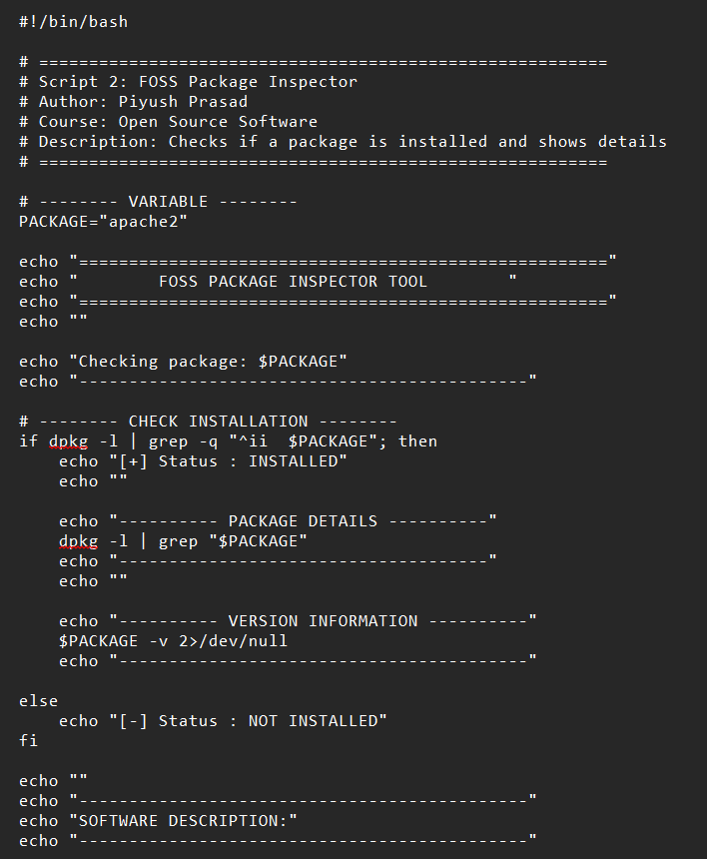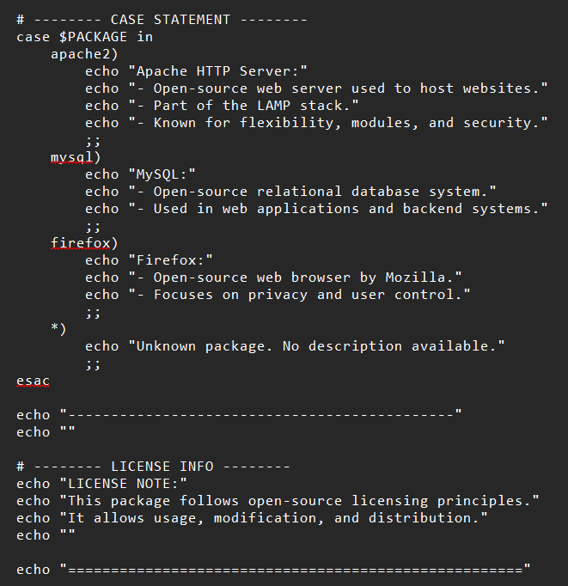
SCRIPT OUTPUT : 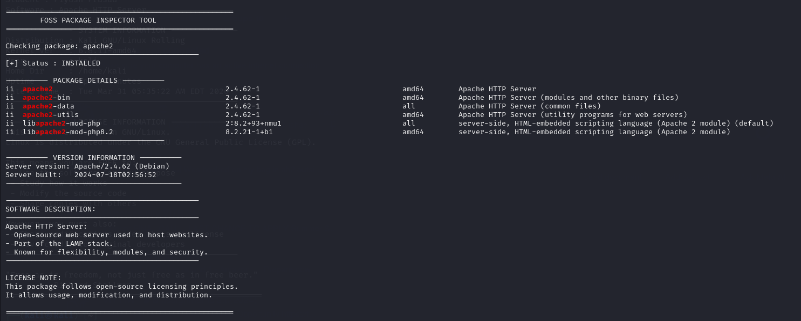

Script 3 - Disk and Permission Auditor

The script discussed in this section can be used to analyze some of the key system directories. This script uses a series of commands to retrieve information about the usage of disk space and permissions associated with a Linux system.
The script uses a 'for' loop to iterate through a list of key directories such as /etc, /var/log, /home, /usr/bin, etc. For each of these directories, the script checks if the directory exists. Then, it uses commands such as 'du' to retrieve information about the usage of disk space. Similarly, 'ls -ld' is used to retrieve information about permissions. Other commands such as 'awk' and 'cut' are used to extract specific information from the output.
The script discussed in this section uses a series of commands such as 'for' loops, conditional checks, etc. This script can be used to retrieve information about a Linux system.

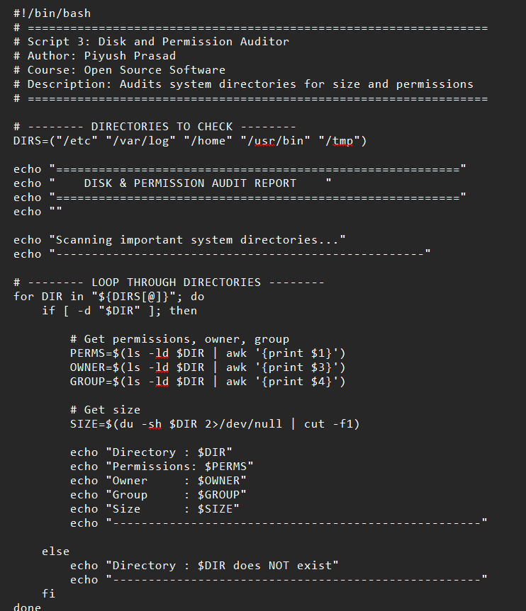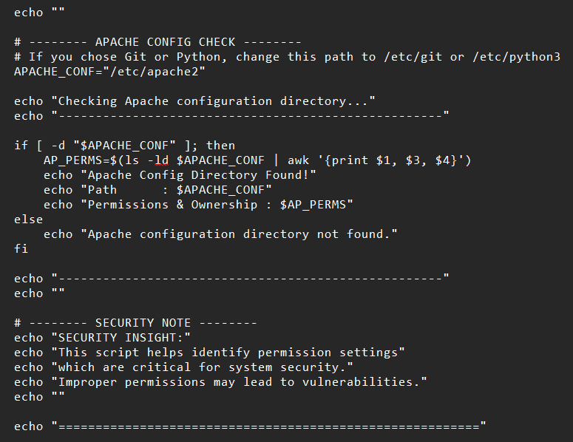

SCRIPT OUTPUT :
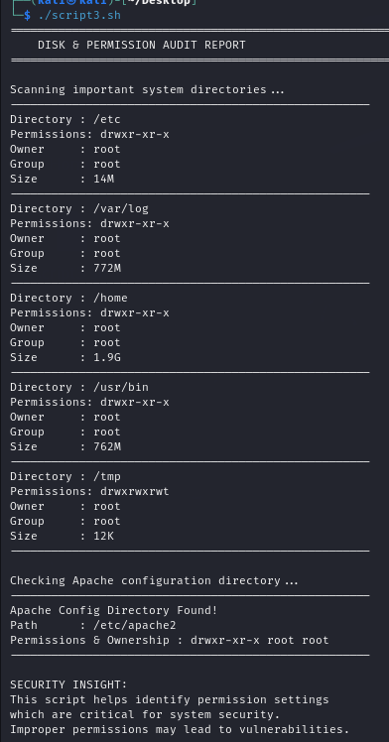

Script 4 – Log File Analyzer

This is a simple script that will read a given log file and determine how many times a particular keyword is found in the file. The script will be useful in identifying errors in the system. The script will be passed the name of the log file as a parameter, and it will use the word “error” as the default keyword.
The script will then read the file line by line using a while loop. Inside the loop, it will check to see if the word is found in the line using the grep command. If the word is found, it will increment the count. At the end, it will print out the count.
This is one simple way to use loops and conditionals in scripting. It is also useful in the field of cybersecurity to keep an eye out for suspicious activity.

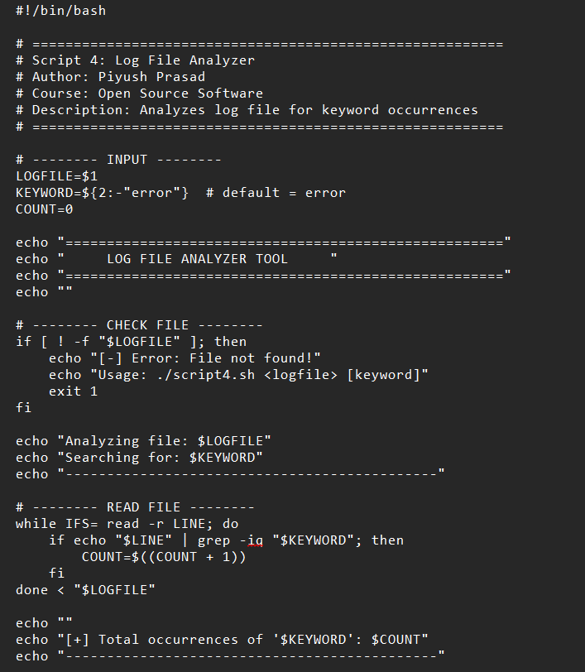

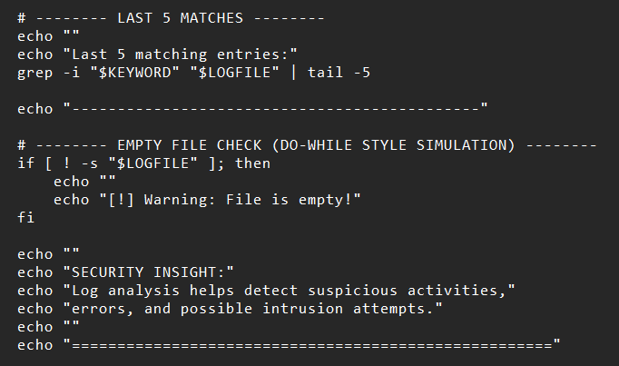

SCRIPT OUTPUT : 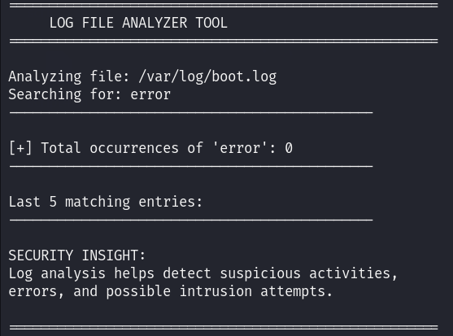

Script 5 – Open Source Manifesto Generator

This is an interactive program that generates a personalized open source philosophy statement.
The script will utilize the read command to prompt the user to enter their input, such as the name of an open source tool, the definition of freedom, and something that the user wants to create and share. These will be stored in variables.
The script will then use meaningful concatenation to create a paragraph from the input. It will also utilize the date command to insert the current date. The output will be saved to a file using output redirection.
This script will illustrate the use of user input, variables, strings, and file writing in shell scripting. It will also illustrate the creative aspect of open source philosophy.
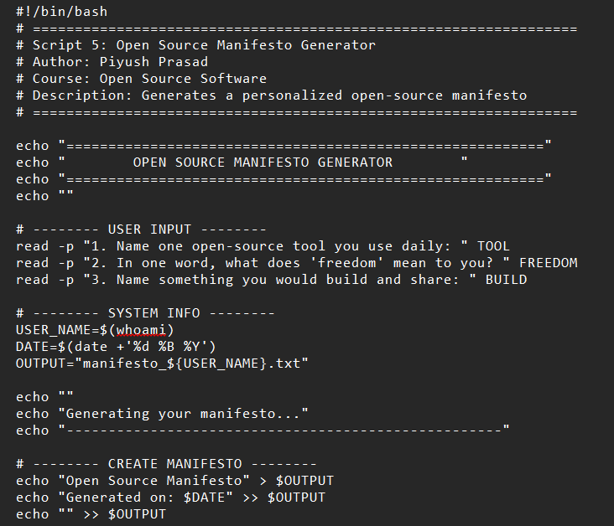

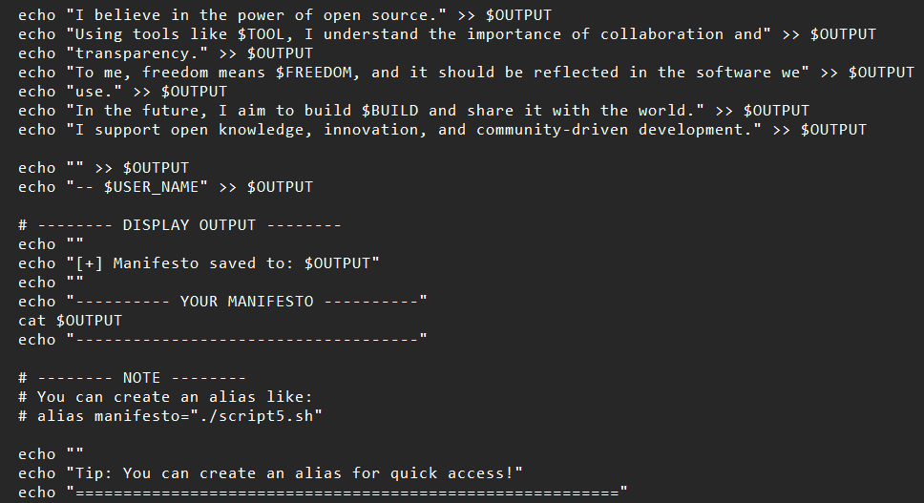

SCRIPT OUTPUT :
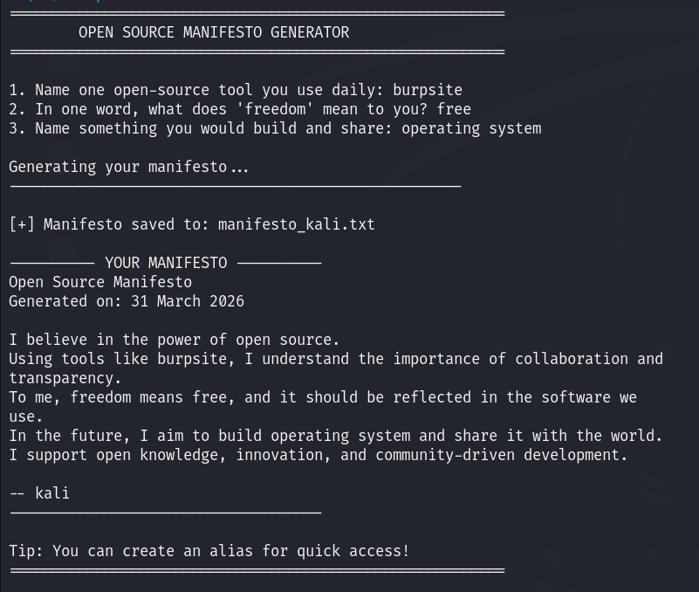

References

Use these as starting points, not as sources to copy from. The report has been written in my own understanding and words.

On open source philosophy
- GNU Project — The Free Software Definition:
https://www.gnu.org/philosophy/free-sw.html
- Open Source Initiative — The Open Source Definition: https://opensource.org/osd
- Eric S. Raymond — The Cathedral and the Bazaar:
http://catb.org/~esr/writings/cathedral-bazaar
- The Apache Software Foundation — About Apache: https://www.apache.org/

On Apache HTTP Server
- Apache HTTP Server Documentation: https://httpd.apache.org/docs/
- Apache License 2.0: https://www.apache.org/licenses/LICENSE-2.0

On Linux and shell scripting
- The Linux Command Line by William Shotts: https://linuxcommand.org/
- GNU Bash Manual: https://www.gnu.org/software/bash/manual/
- Linux man pages: https://manpages.ubuntu.com/

For finding license texts
- SPDX License List:
https://spdx.org/licenses/
- Choose a License: https://choosealicense.com/
- Apache official repository (LICENSE file): https://github.com/apache/httpd

A closing thought
Open source software plays a major role in modern technology. It allows developers to learn, modify, and improve existing systems. Through this project, I understood how open-source tools like Apache HTTP Server are built collaboratively and how they contribute to the growth of the internet and software development.

