Vehicle Control Unit (VCU)

Report submitted to GITAM (Deemed to be University) as a partial fulfillment of the requirements for the award of the Degree of Bachelor of Technology in Electrical and Electronics Engineering



DEPARTMENT OF ELECTRICAL, ELECTRONICS AND COMMUNICATION ENGINEERING

GITAM SCHOOL OF TECHNOLOGY

GITAM (DEEMED TO BE UNIVERSITY)

BENGALURU -561203

NOV 2025

**Shravani C L BU22EECE0200009**

**Ch Pavan Kumar BU22EECE0200014**

**Patil Janardhan Reddy BU22EECE0200022**

**DECLARATION**

We declare that the project work contained in this report is original and it has been done by us under the guidance of my project guide.

Name: Shravani C L

Ch Pavan Kumar

Patil Janardhan Reddy

Date:

Signature of the Student:

**Department of Electrical, Electronics and Communication Engineering GITAM School of Technology, Bengaluru-561203**



**CERTIFICATE**

This is to certify that Shravani C L, Ch Pavan Kumar and Patil Janardhan Reddy has satisfactorily completed Mini Project Entitled in partial fulfillment of the requirements as prescribed by University for VIIth semester, Bachelor of Technology in “Electrical, Electronics and Communication Engineering” and submitted this report during the academic year 2025-2026.

[Signature of the Guide] [Signature of HOD]

**Table of contents**

**Chapter 1: Introduction 1**

* 1. Overview of the problem statement 1
  2. Objectives and goals 1

**Chapter 2 : Literature Review 2**

**Chapter 3 : Strategic Analysis and Problem Definition 3**

* 1. SWOT Analysis 3
  2. Project Plan - GANTT Chart 3
  3. Refinement of problem statement 3

**Chapter 4 : Methodology 4**

* 1. Description of the approach 4
  2. Tools and techniques utilized 4
  3. Design considerations 4

**Chapter 5 : Implementation5**

* 1. Description of how the project was executed 5
  2. Challenges faced and solutions implemented 5

**Chapter 6: Results 6**

* 1. outcome 6
  2. Interpretation of results 6
  3. Comparison with existing technologies 6

**Chapter 7: Conclusion 7**

**Chapter 8 : Future Work 8**

**References 9**

**Chapter 1: Introduction**

* 1. Overview of the problem statement
* The rapid evolution of **electric mobility systems** has created the need for intelligent **Vehicle Control Unit (VCU)** capable of supervising key automotive subsystems. In this project, the primary focus is on designing and implementing a prototype VCU responsible for **motor control** and **battery management**.
* The motor control subsystem ensures precise **actuation of the electric drive** using techniques such as **Pulse Width Modulation (PWM)** for speed regulation and torque optimization. In parallel, the battery management subsystem is designed to perform **real-time monitoring of critical parameters** such as voltage, current, and **State of Charge (SOC)**.
* To enable reliable and synchronized operation, the modules communicate via the **Controller Area Network (CAN) protocol**, which has become the de-facto standard in automotive applications due to its **robustness, fault tolerance, and deterministic message delivery**.
  1. Objectives and goals
* To design and prototype of VCU for educational and experimental validation.
* To implement **PWM-driven motor control strategies** ensuring accurate and stable drive actuation.
* To implement **battery parameter acquisition and management**, including voltage and current sensing.
* To enable real-time interconnection of the motor and battery nodes using **CAN communication**.
* To validate the concept through breadboard-based prototyping prior to PCB realization.

**Chapter 2 : Literature Review**

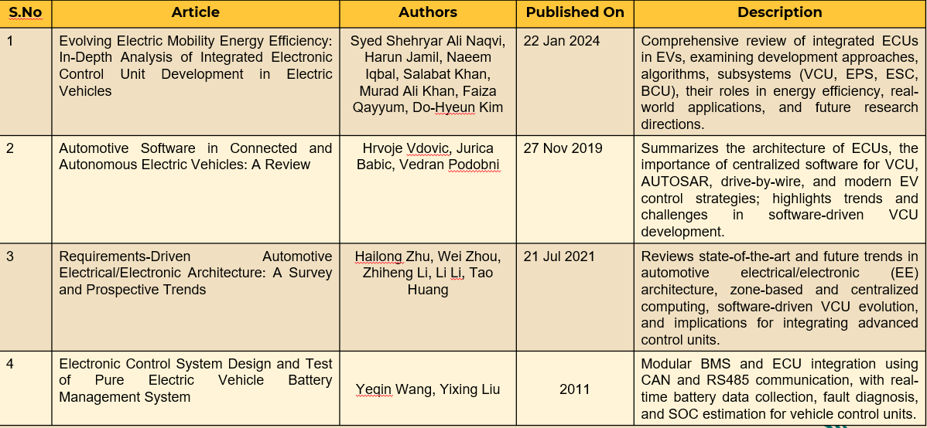

* + In modern automotive systems, the Vehicle Control Unit acts as the **centralized intelligence** that coordinates diverse subsystems such as the traction motor, Battery Management System (BMS), regenerative braking modules, and auxiliary controllers.
  + **Motor Control:** Research emphasizes the application of **closed-loop PWM modulation**, feedback from **Hall sensors or encoders**, and **current regulation** to achieve torque stability and energy-efficient operation. These methods ensure smooth drive response, reduced energy loss, and increased system reliability.
  + **Battery Management:** A robust BMS must provide accurate **SOC estimation**, protect against **over-voltage/under-voltage conditions**, and implement **cell balancing algorithms** for long-term performance. Thermal monitoring and **protection circuits** are also critical for safety.
  + **CAN Communication:** The CAN protocol is highlighted in multiple studies for its ability to support **real-time distributed communication** with high error detection capability and arbitration features that guarantee deterministic priority-driven messaging.
  + This literature indicates that combining **low-cost embedded controllers** with **CAN networking** forms an ideal foundation for educational prototypes that simulate industry-grade vehicle control units.

**Chapter 3 : Strategic Analysis and Problem Definition**

* 1. SWOT Analysis

**Strength:**

* + Modular node-based architecture enabling independent development of motor and battery modules.
  + Cost-effective prototyping using off-the-shelf microcontrollers.
  + Flexibility to scale the system with additional subsystems such as regenerative braking.

**Weaknesses:**

* + Breadboard limitations for handling high current applications.
  + Restricted computational capacity of basic controllers compared to industrial-grade processors.

**Opportunities:**

* + Expansion toward advanced EV-grade **Battery Management Systems** with thermal management.
  + Future transition to **real-time operating systems (RTOS)** and model-based control algorithms.

**Threats:**

* + Hardware synchronization issues under high loads.
  + Potential errors in sensor calibration and data acquisition
  1. Project Plan - GANTT Chart

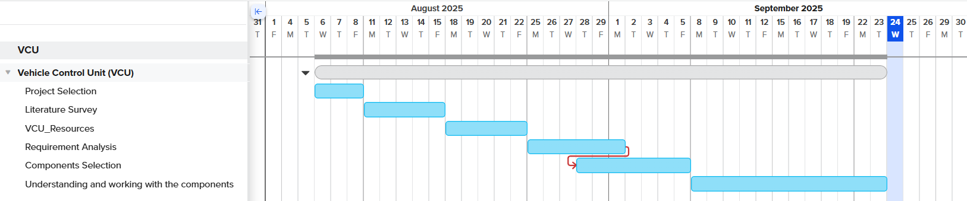

* 1. Problem statement
* To design and validate a **Vehicle Control Unit prototype** that integrates **motor control** and **battery management subsystems**, ensuring reliable operation through **CAN-based interoperability**, while maintaining modularity, scalability, and cost efficiency.

**Chapter 4 : Methodology**

* 1. Description of the approach
  + The adopted methodology follows a **node-based modular approach**. One controller node is dedicated to **motor control**, implementing PWM techniques for speed regulation and interfacing with the motor driver circuitry. Another node functions as the **battery management unit**, acquiring battery parameters through **voltage dividers, current sensors, and ADC channels**.
  + Both nodes exchange messages over a **CAN bus**, ensuring synchronized operation and real-time data sharing. Error-checking mechanisms inherent to CAN safeguard the communication against noise and collision.
  1. Tools and techniques utilized
* Embedded C/C++ programming.
  + - Arduino IDE for firmware development.
    - CAN transceiver modules (MCP2515/2551).
    - Breadboard and supporting hardware components.
  1. Design considerations
* Isolation and safety in battery sensing circuits.
* Stable PWM generation for motor drive control.
* Scalability for additional subsystems.
* Ensuring deterministic communication cycles via CAN arbitration.

**Chapter 4: Methodology**

* 1. Description of the approach
  2. Tools and techniques utilized
  3. Design considerations

**Chapter 5: Implementation**

* 1. Description of how the project was executed
  2. Challenges faced and solutions implemented

**Chapter 6: Results**

* 1. outcomes
  2. Interpretation of results
  3. Comparison with existing literature or technologies

**Chapter 7: Conclusion**

Here write Suggestions for further research or development and Potential improvements or extensions

**Chapter 8 : Future Work**

Here write Suggestions for further research or development Potential improvements or extensions

Bengaluru City Office No 5/1, First Floor, Prestige Terraces, Union Street, Infantry Road, Bengaluru - 560003 Karnataka, India



**GIMSR**

GITAM Medical College Rd, Gandhi Nagar, Rushikonda, Visakhapatnam - 530045 Andhra Pradesh, India