流行病學與生物統計計算Homework9

學號：b07401048 系級：醫學五 姓名：賴柏瑞

**# Homework9**

*# homework9*

rate <- **read.csv**("/Users/raymond/Desktop/R/course/data/rate.csv", header = TRUE)

rate

*# creating data with dummy variables*

(ratema <- **as.data.frame**(rate))

for (j in 2 : 12) {

for (i in 1 : **length**(rate$Age)) {

if (ratema[i, 1] == j) {

ratema[i, j + 3] <- 1

} else {

ratema[i, j + 3] <- 0

}

}

}

ratema

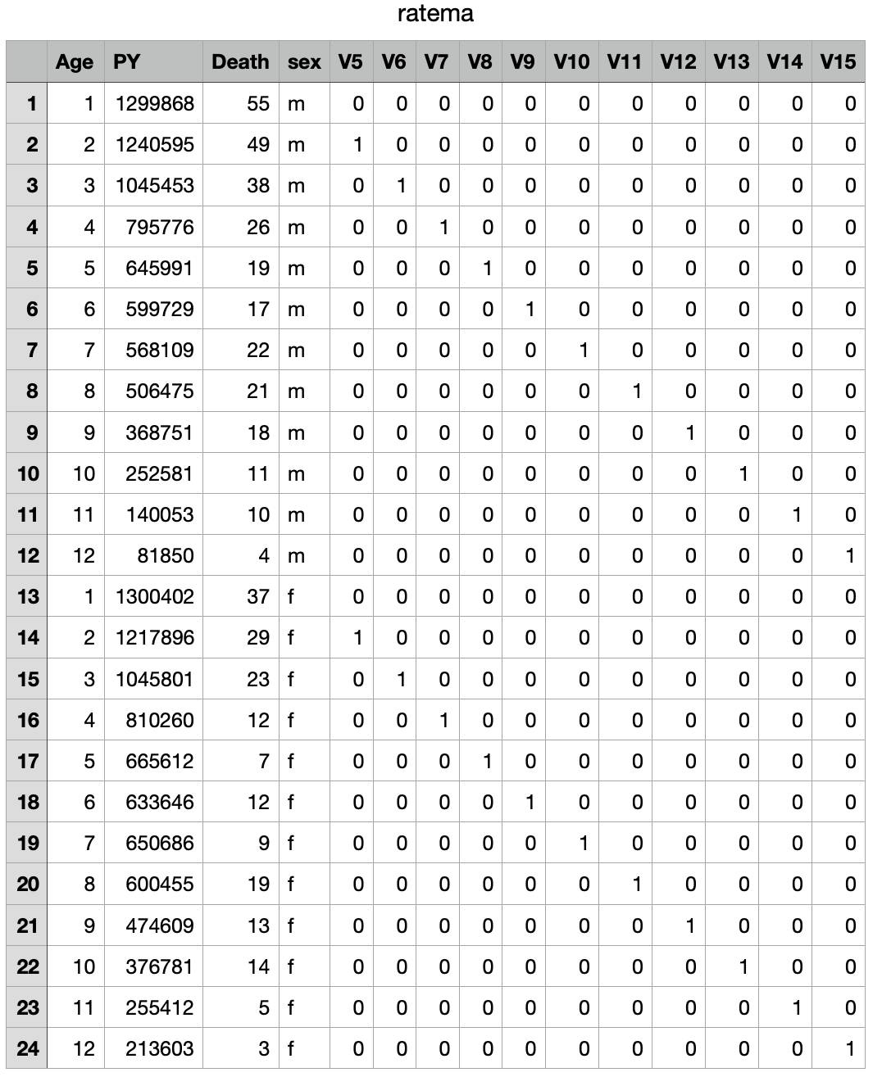

*# use NR method to find MLE of the coefficeints of Poison regression*

y <- rate$Death

x <- **cbind**(**rep**(1, **length**(y)),

ratema$V5,

ratema$V6,

ratema$V7,

ratema$V8,

ratema$V9,

ratema$V10,

ratema$V11,

ratema$V12,

ratema$V13,

ratema$V14,

ratema$V15,

ifelse(ratema$sex == "m", 1, 0))

**ftn** <- function(betacoef) {

mu <- **exp**(x %*% betacoef + **log**(ratema$PY / 100000))

gradient <- **t**(x) %*% (y - mu)

hessian <- -**t**(x) %*% **diag**(**c**(mu), **length**(y)) %*% x

loglike <- **sum**(-mu + y * **log**(mu) - **log**(**factorial**(y)))

return(list(gradient, hessian, loglike))

}

**highnew** <- function(ftn, x0, tol, maxiter) {

x <- x0

fx <- ftn(x)

iter <- 0

while ((**max**(**abs**(fx[[1]])) > tol) && (iter < maxiter)) {

x <- x - (**solve**(fx[[2]]) %*% fx[[1]])

fx <- ftn(x)

iter <- iter + 1

}

if (**max**(**abs**(fx[[1]])) > tol) {

**cat**("algorithm failed to converge\n")

return(NULL)

} else {

**cat**("algorithm converges to\n")

return(x)

}

}

(beta <- highnew(ftn, x0 = **c**(0, 0, 0, 0, 0, 0, 0, 0, 0, 0, 0, 0, 0), tol = 1e-9, maxiter = 100))*#nolint*

**write.csv**(beta, file = "/Users/raymond/Desktop/R/course/beta.csv")

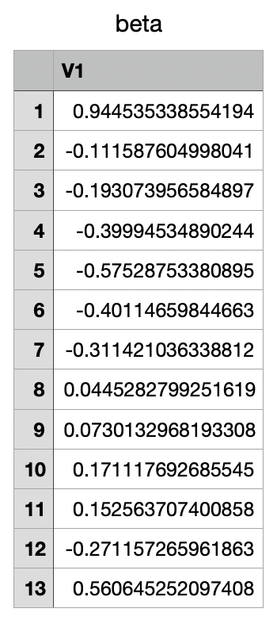

*#variance covariance matrix*

(vcov <- **solve**(-ftn(beta)[[2]]))

**vcov**(model)

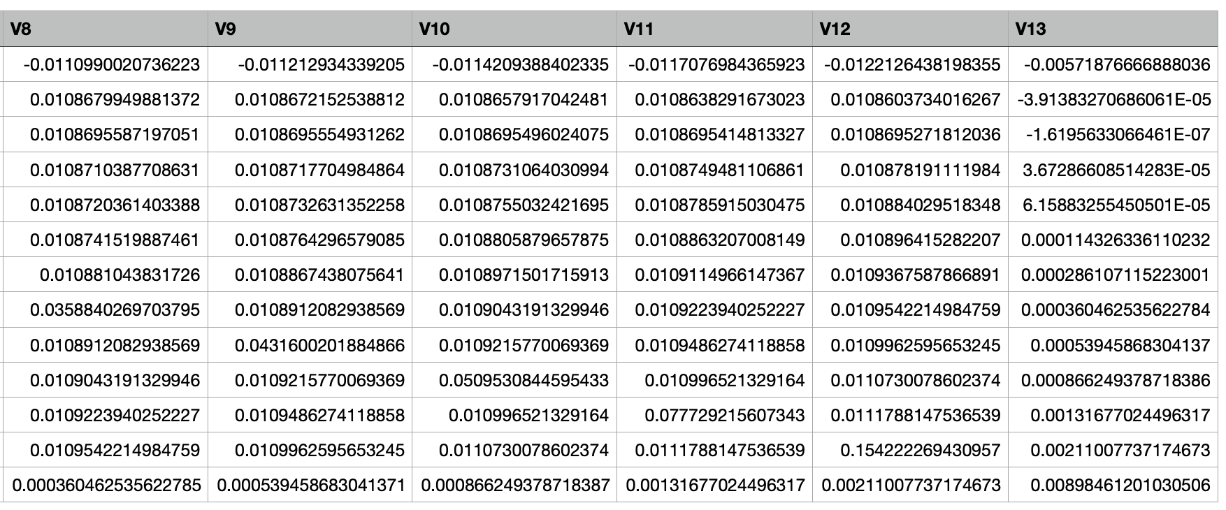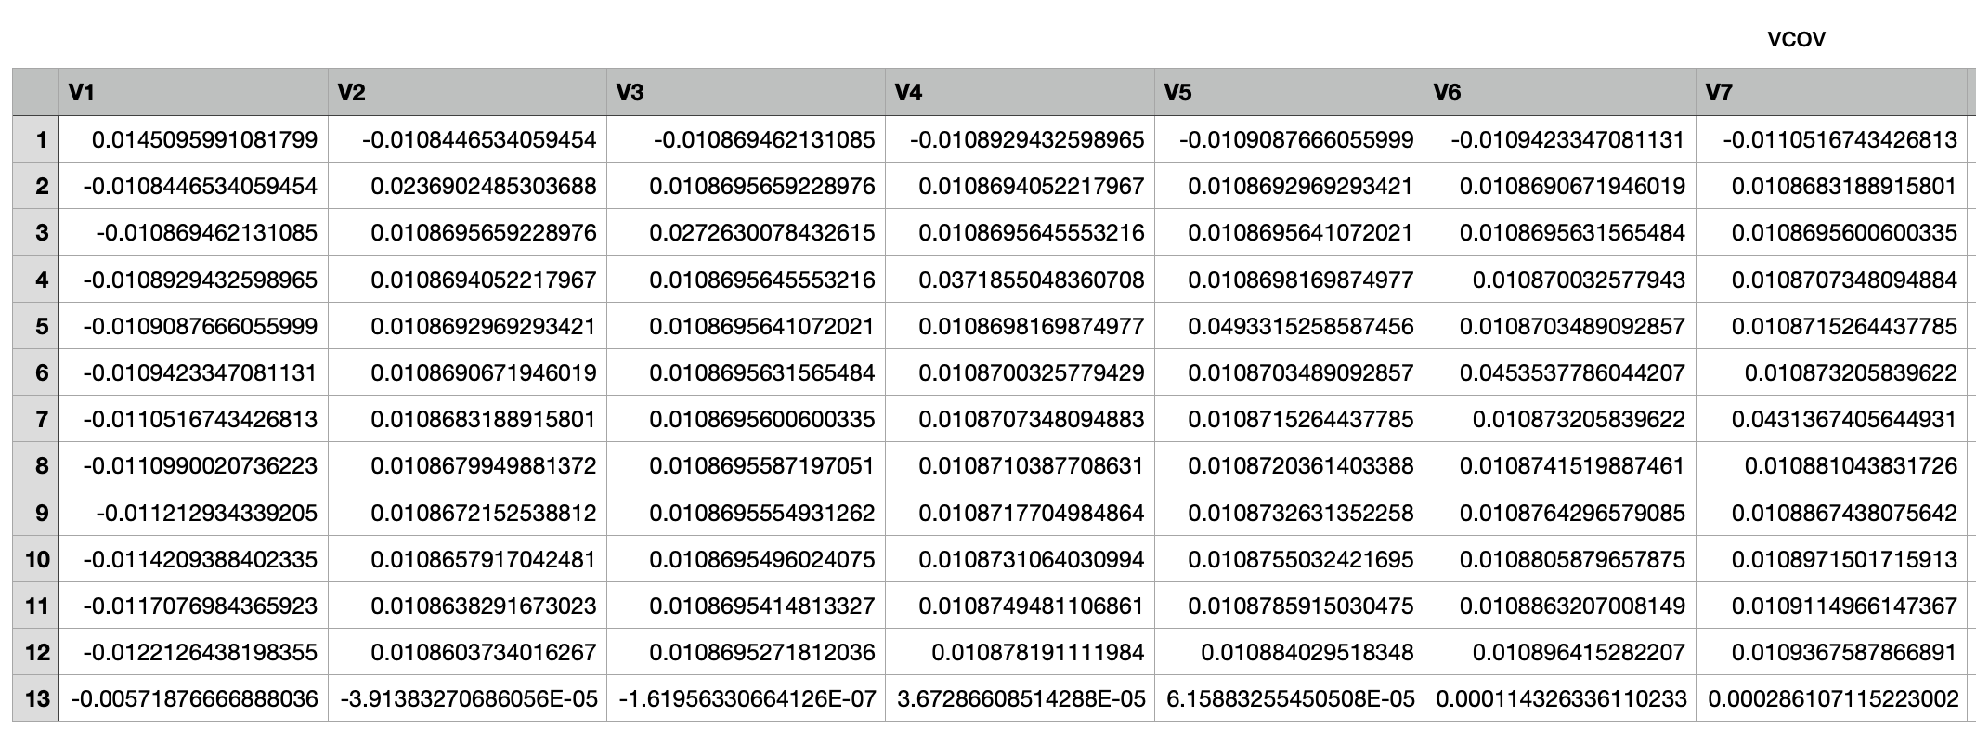**write.csv**(vcov, file = "/Users/raymond/Desktop/R/course/vcov.csv")

*#loglike*

(loglike <- ftn(beta)[[3]])

**write.csv**(loglike, file = "/Users/raymond/Desktop/R/course/loglike.csv")

