File: homework2.pdf
Author: P.J. Leyden
Date: October 1st, 2019

Homework 2

- Code is in folder marked ‘myapriori’. To run, simply type ‘make’.
- Answer to question 2
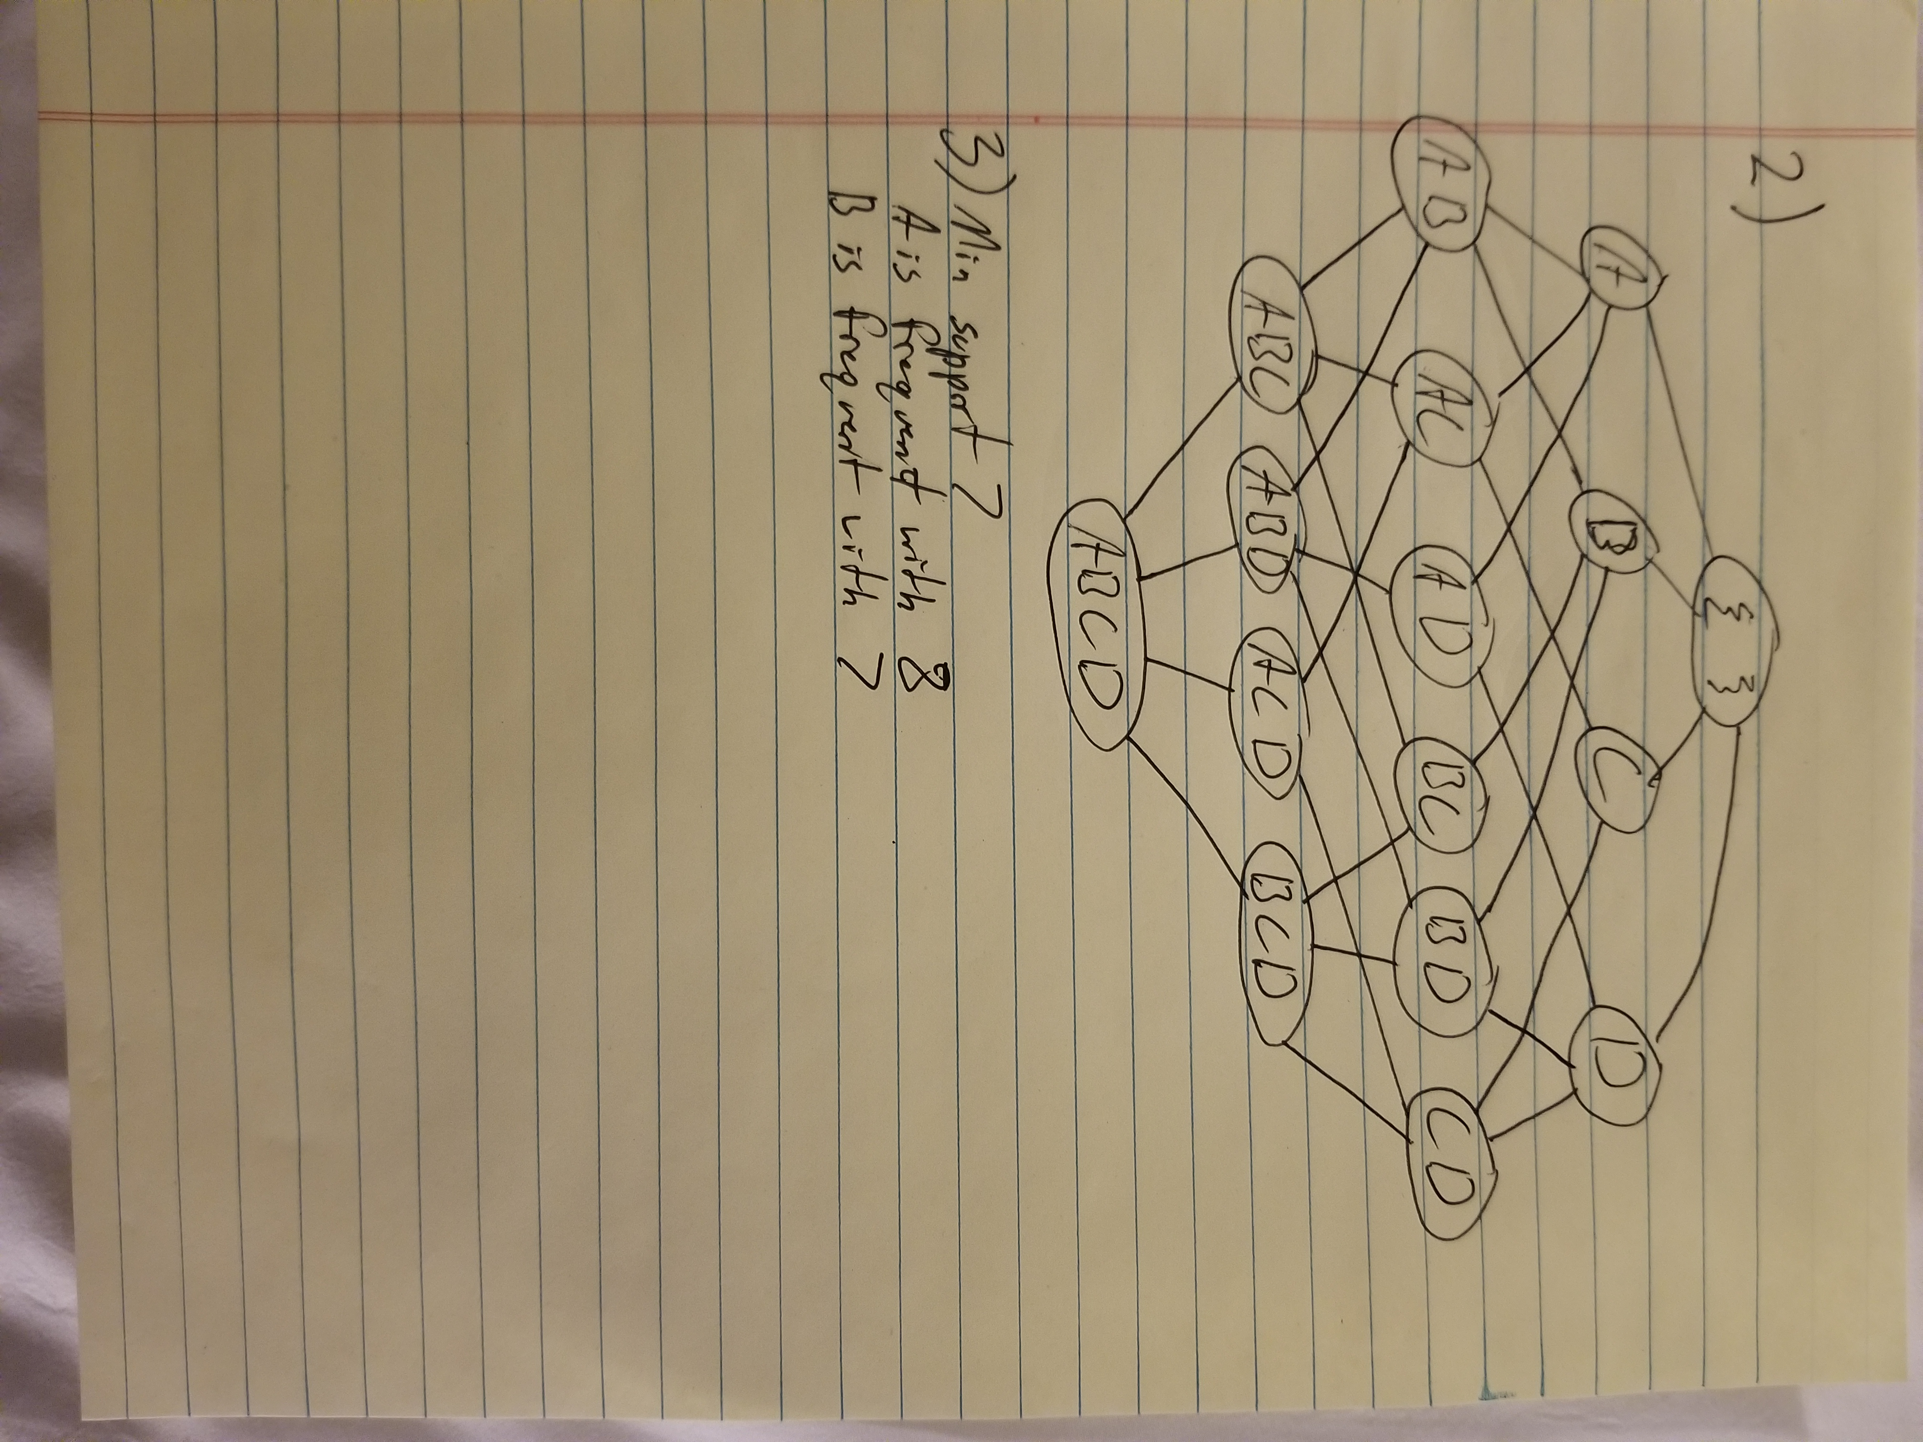

- Answer to question 3


