File: homework2.pdf
Author: P.J. Leyden
Date: October 1st, 2019

Homework 2

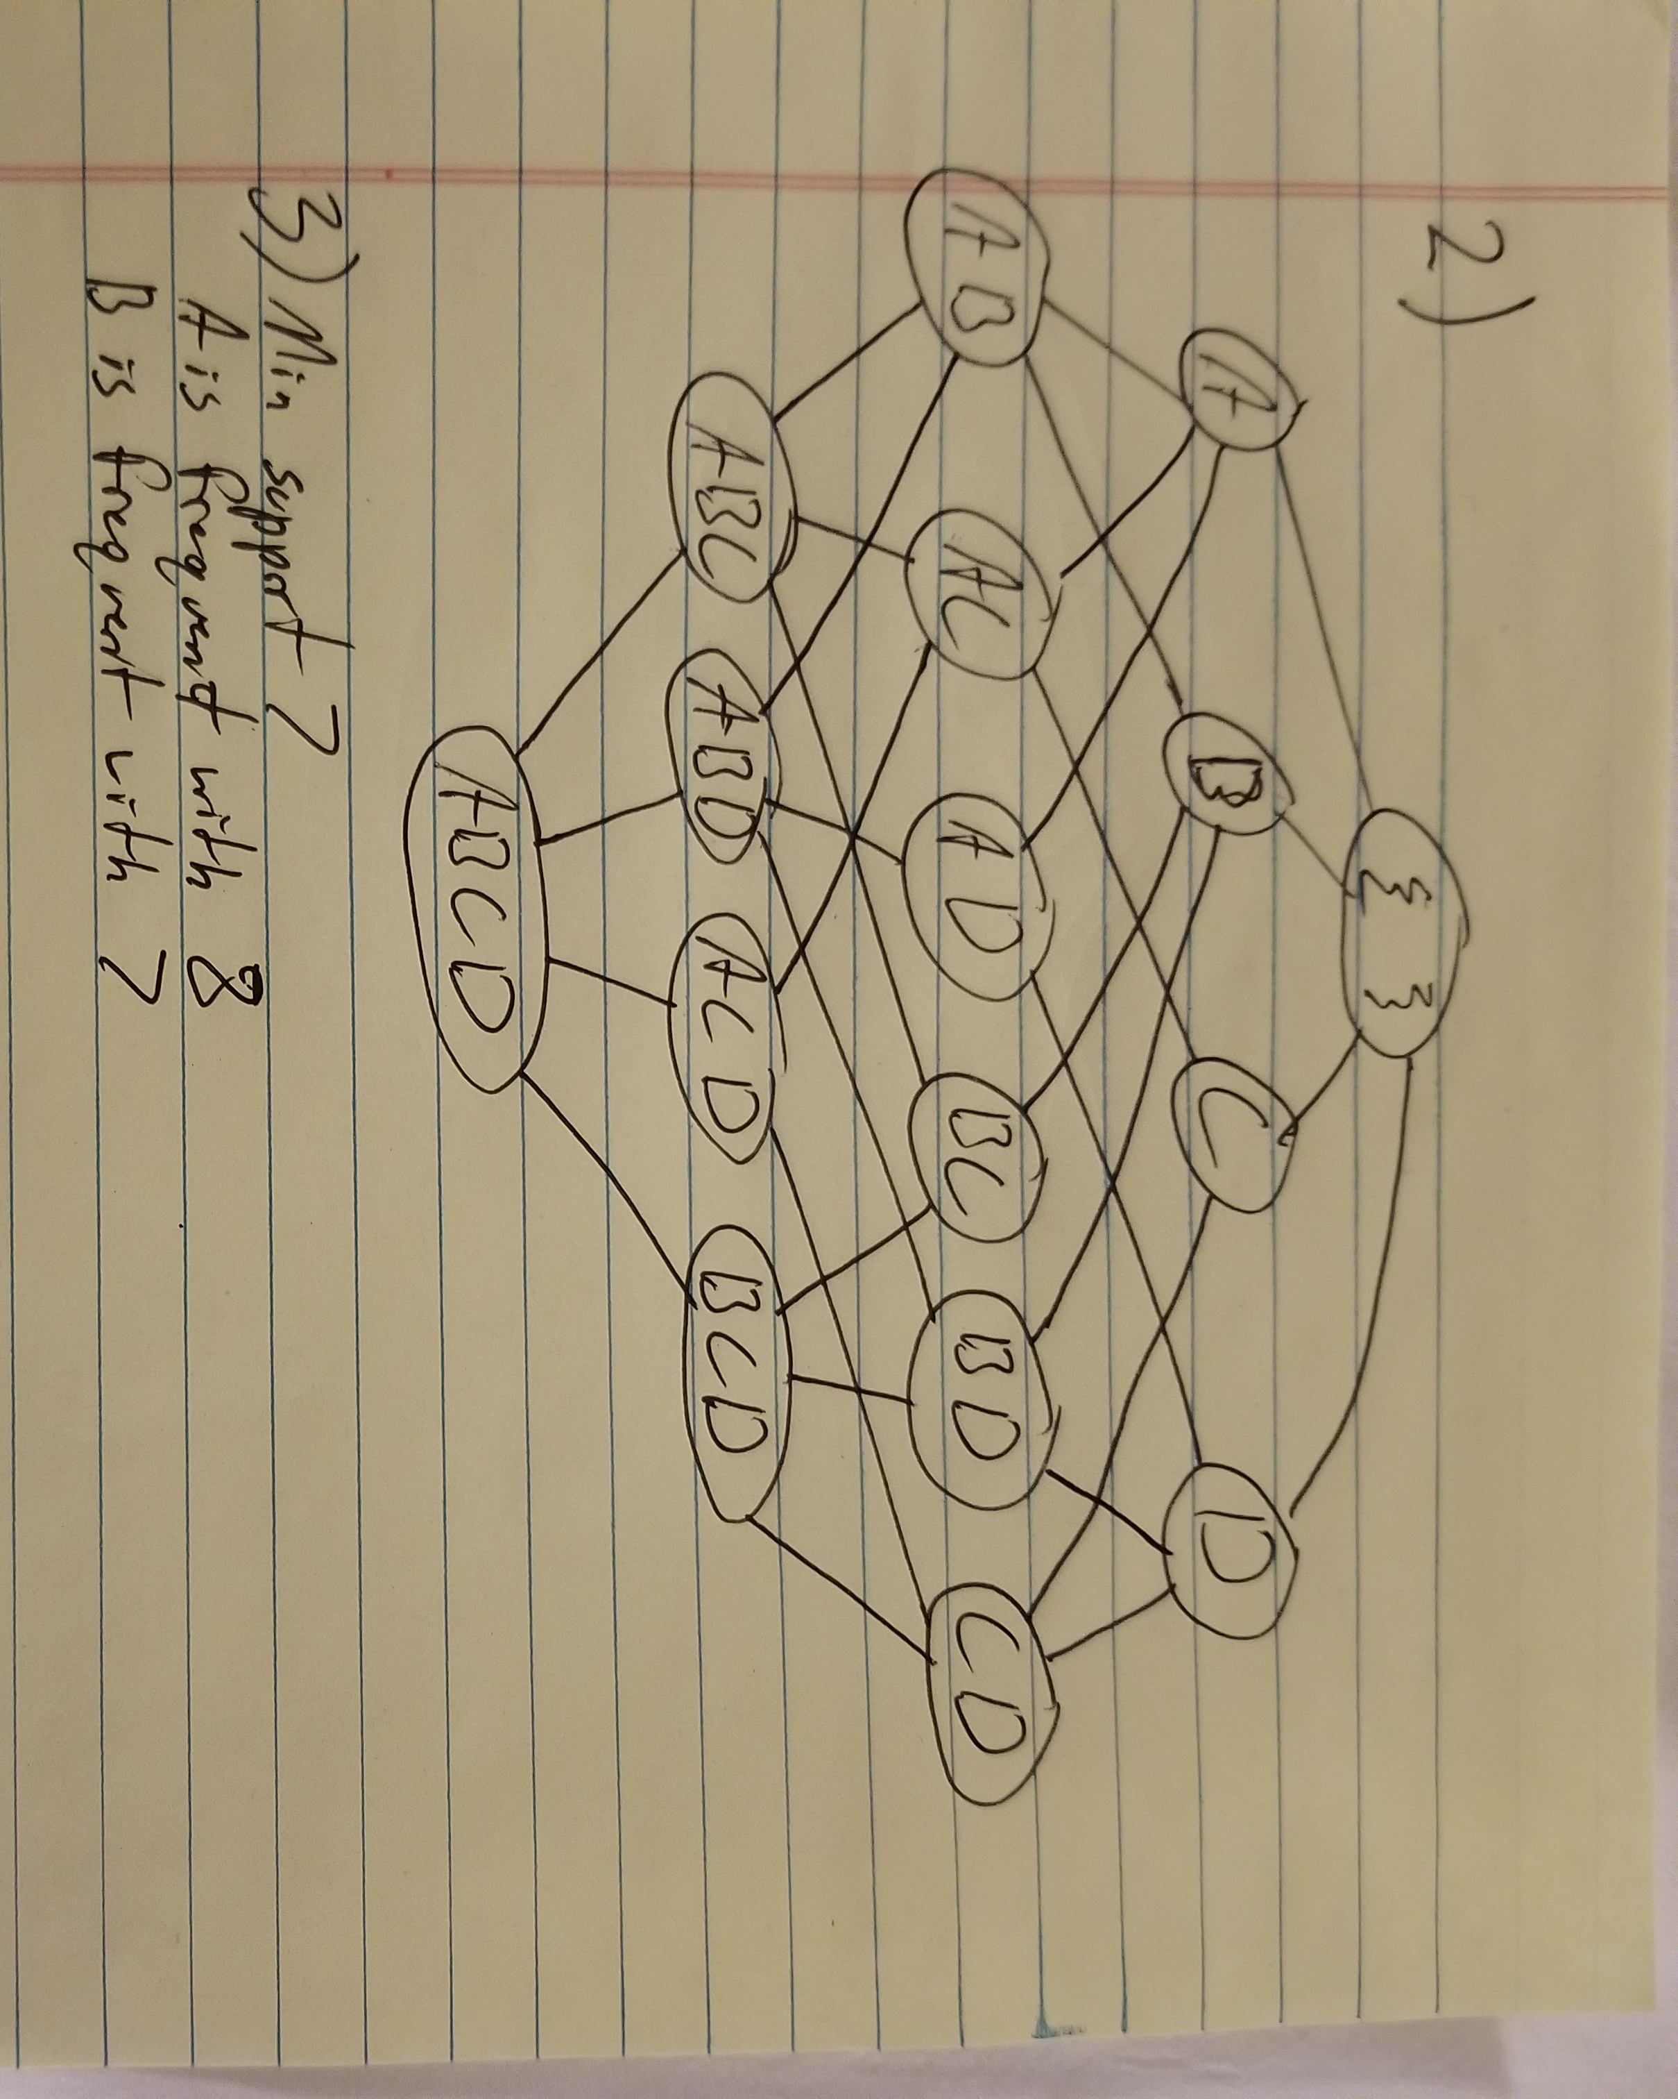
- Code is in zip marked ‘myapriori.zip’. To run, simply type ‘make’.
- Answer to question 2

- Answer to question 3

- Answer to the Bonus Question:


