File: homework4.pdf
Author: P.J. Leyden
Date: November 13th, 2019
Homework 4

1)
Input: k = number of clusters | datapoints = set of data points
Output: data points will be labeled with their cluster id

k_means(k, datapoints):
centroids[k] //array of size k for storing centroids
for i = 0, i < k, ++i:
centroids[i] = random point from datapoints
bool significant_change = true
while(significant_change)
significant_change = false
for each x in datapoints
smallest_dist = dist(x, centroids[0])
smallest_dist_id = 0
cluster_id = 0
for each c in centroids
if(dist(x, c) < smallest_dist)
smallest_dist = dist(x, c)
smallest_dist_id = cluster_id
cluster_id += 1
if(x.label != smallest_id)
significant_change = true
x.label = smallest_id
end

2)
Note: Will be using a KDTree for quick nearest neighbour lookup
Input: k = number of clusters | datapoints = set of data points
Output: data points will be labeled with their cluster id

agglomerative(k, datapoints):
kdtree kdt = kdtree(datapoints)
while kdt.root.num_children > k:
node1 = datapoints[0]
node2 = datapoints[1]
shortest_dist = dist(node1, node2)
for each x in datapoints
y = kdt.nearestNeighbour(x)
if(dist(x, y) < shortest_dist)
node1 = x; node2 = y
shortest_dist = dist(x, y)
z = merge(node1, node2)
kdtree.remove(node1)
kdtree.remove(node2)
kdtree.add(z)
end

3)
Input: k = number of clusters | datapoints = set of data points
Output: data points wili be labeled with their cluster id

divisive(k, datapoints):
num_clusters = 2
k_means(2, datapoints) //initial split of the system
while num_clusters < k
x = random cluster id
particular_cluster = datapoints.cluster(x)
k_means(2, particular_cluster)

4)
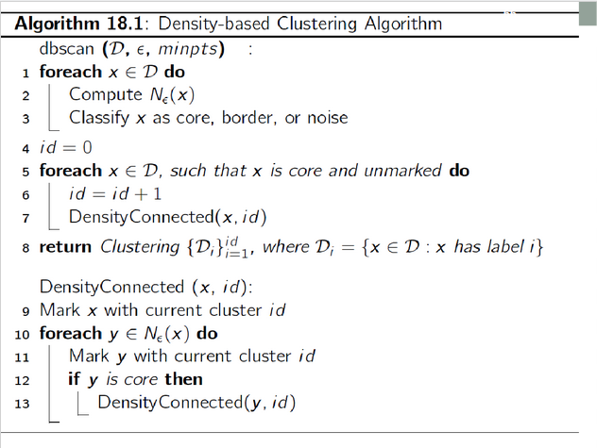

Above is the pseudo-code for the DBSCAN Algorithm given in the slides. I will explain what is happening in this algorithm, step by step.

