File: homework5.pdf
Author: P.J. Leyden
Date: December 4th, 2019
Homework 5
  - Summary
  - Strong Points
    - temp
    - temp
    - temp
  - Weak Points
    - temp
    - temp
    - temp
  - Technical Details
    - Motivation
    - Problem Definition
    - Solution
    - Example
    - Pros/Cons
  - Conclusion
  - Future Work
    - The solution presented by the paper uses a hierarchy-encoded transaction table. What this means is that every item in a transaction is encoded to a sequence of numbers based on the levels in a taxonomy of relevant data items. What this means is that every relevant item in any of the transactions is categorized in a tree like structure where a read from the root to a leaf is a single relevant item. Figure 1 is an image taken from Han and Fu showing the taxonomy hierarchy [1].
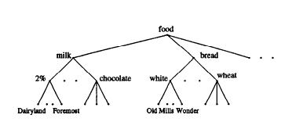
Figure 1 - Taken from Han and Fu paper, a tree structure representing the taxonomy of relevant data items.

    - An example of an encoding
      - Old Mills White Bread would be {2, 1, 1}. The 2 is for bread whish is the second leaf of the root. The first 1 is for white and the second 1 is Old Mills. Therefore, in a particular transaction Old Mills White Bread would be replaced with its encoded ID.
    - The steps for applying this algorithm are as follows:
      - Generate the encoded transaction table T1.
      - Use T1 to determine the Level-1 Large 1-Itemset L[1, 1]. This represents a list all the itemsets of size 1 who fit the definition of large above.
      - L[1, 1] is then used to prune T1 and generate T2.
      - We then generate all of the possible sets from L[1, 2] … L[L, |L[1, 1]|]. These sets are again used to trim T2 to T3 etc…
      - We repeat until done and start on L[2, *]. Candidates for this table can only come form decedents of the large items at level-1.
      - Once calculated, these tables represent multi-level associations, thus achieving a multi-level association mining algorithm.

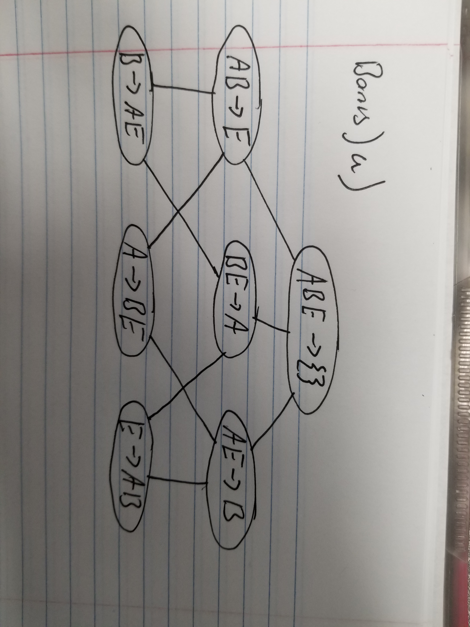
- Bonus Question

  - support(AB→E) = 3/10 or 0.3 | confidence(AB→E) = 3/5 or 0.6
References

[1] Han, J. and Fu, Y. (1995). Discovery of Multiple-Level Association Rules from Large Databases.
In: 21th International Conference on Very Large Data Bases. San Francisco, California: Morgan
Kaufmann Publishers Inc., pp.420-431.

