**CS 43105 Data Mining Techniques**

**Homework 4**

**Instructor:** Xiang Lian

**Due Date:** Please refer to the course website

1. Give the pseudo code of *k*-means clustering algorithm. **[20 points]**

2. Please write the pseudo code of agglomerative clustering algorithm. **[20 points]**

3. Please write the pseudo code of divisive clustering algorithm. **[20 points]**

4. Please explain what are core points, border points, and noise points. **[15 points]**

5. Please explain the pseudo code for DBSCAN algorithm in the lecture slides. **[25 point]**

**Bonus Question** [extra 20 points]

Please provide the centroids of 3 initial cluster assignments C1={x1, x2, x3}, C2={x4, x5, x6}, C3={x7, x8}, for the *k*-means algorithmover the data set in Figure 1, where K=3.

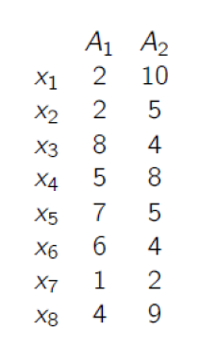

**Figure 1.** A 2D Database

**Submission**

Submit an electronic copy of your homework solution to the [Blackboard](https://learn.kent.edu/).

18