**Author's Instruction for Preparing a Manuscript for "Extended Abstract"**

**YOUNG SEOK KANG1 and JOON AHN**2

1Aeropropulsion Research Division, KARI, Daejeon, Korea

2School of Mechanical Engineering, Kookmin University, Seoul, Korea

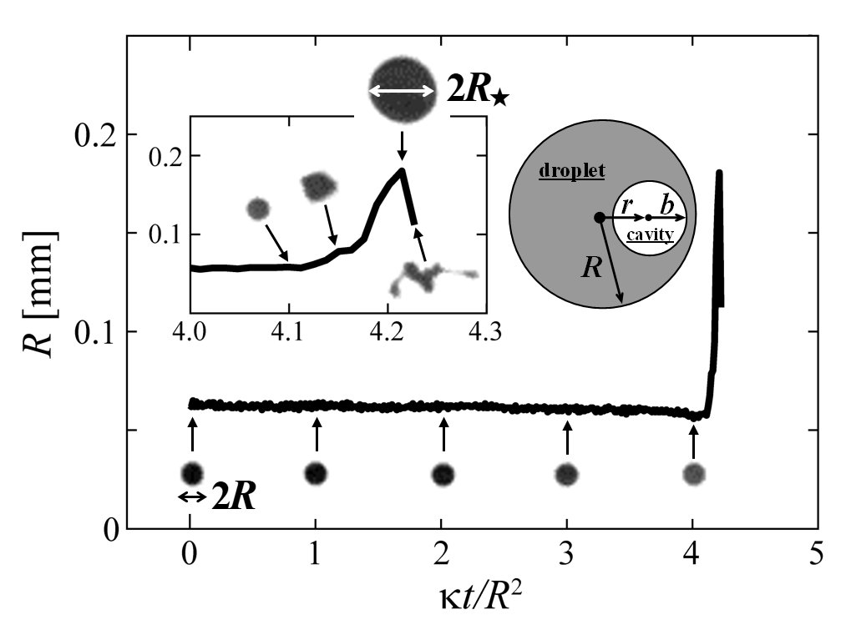

Fig.1 Evolution of a droplet with initial radius *R* as it bursts, inflated up to *R*⋆ by a gas cavity with radius *b*.

The abstract should consist of;

1. Paper Title
2. Author's Name(s)
3. Author's Affiliation(s)
4. Body text
5. Figures and Tables, if needed.
6. References.

The body text should outline the contents of your full length paper.

The page style should be as follows;

1. Paper : A4 size (210 cm by 297 cm)
2. Margins : Top 2.5 cm, Bottom 2.5 cm, Left 2.5 cm, Right 2.5 cm
3. Font : Times New Roman or similar
4. Letter Size : 14 pt bold for Title, 11 pt for Names and Affiliations, 9 pt for others
5. Column : Two-Column
6. Spacing : Single

The authors are requested to submit the abstract file **in PDF format** via acgt2022.org by April 1st, 2022.

The instruction ends here.

(The following texts are samples.)

Because the decomposition reactions are fast, the limiting step of the process of the gas production inside the droplets is the diffusion of heat in the liquid (the corrections due to the relative motion of the droplets with air are negligible), which occurs on a time scale given by

.

Here, the drop radius is *R* and the thermal diffusivity is **. Bubbles of gas that nucleate in the heated liquid, grow in size, and burst at the drop surface, possibly distort the drop in a catastrophic manner if they are big enough, causing its fragmentation. The process reproduces itself sequentially, down to the final droplet size *Rf* for which the rate of heat loss in the air *a*/*Rf*2 equilibrates the chemical heat production rate *k*,

,

and then, the cascade stops.

At any stage of the cascade, the fate of a drop is conditioned by the dynamics of the gas inclusions it incorporates. These cavities, or bubbles, feed on the available heat in the liquid. Thus, at a time larger than *R*2/** after its formation, a droplet of radius *R* will nucleate bubbles at random in its volume, fed through a diffusion process by the dissolved gas produced by the reaction in the liquid phase. The radius *b* of a gas bubble increases according to



or *b*~(**・*t*)0.5. There is no convection in the liquid, and the gas bubbles Brownian motion is subdominant. Thus, the only way a bubble can reach the drop surface is by growing up to a sufficient size so that, given its nucleation location *r*, its radius fills the gap between its center, and the drop interface [see Fig. 1]. The condition for bursting is thus *b*=*R-r*, if no surfactant rigidifies the drop interface or delays the bubble emerging cap breakup, a bursting time



The probability *p*(*r*)*dr* that the drop has nucleated between *r* and *r*+*dr* is, if nucleation is homogeneous in the drop volume *p*(*r*)=3*r*2/*R*3, giving an average bursting time

,

10 times smaller than the thermal diffusion time across the drop *R*2/**, consistently with Fig. 1.

**References**

Inoue, C., Izato, Y., Miyake, A., and Villermaux, E., 2017, “Direct Self-Sustained Fragmentation Cascade of Reactive Droplets”, *Physical Review Letters*, 118, 074502, pp.1-5.

Furusawa, T., Miyazawa, H., Moriguchi, S., and Yamamoto, S., 2018, “Numerical Method for Simulating High Pressure CO2 Flows with Nonequilibrium Condensation”, *Proc. ASME Turbo Expo 2018*, GT2018-75592.