Area and Speed Efficient Instruction-Set Accelerator based on RBLWE (Ring Binary Learn With Errors) Encryption for Cryptographic Operations

A PROJECT REPORT
Submitted By
BL.EN.U4ECE22205 Anagha Suresh BL.EN.U4ECE22208 Aparna K BL.EN.U4ECE22237 Prajwal J Gautham

In partial fulfillment for the award of the degree of

BACHELOR OF TECHNOLOGY

IN
ELECTRONICS AND COMMUNICATION ENGINEERING


AMRITA SCHOOL OF ENGINEERING, BANGALORE

AMRITA VISHWA VIDYAPEETHAM
BANGALORE 560035

NOVEMBER 2025

AMRITA VISHWA VIDYAPEETHAM
AMRITA SCHOOL OF ENGINEERING, BENGALURU, 560035

BONAFIDE CERTIFICATE

This is to certify that the project report entitled “Area and Speed Efficient Instruction-Set Accelerator based on RBLWE (Ring Binary Learn With Errors) Encryption for Cryptographic Operations” submitted by
BL.EN.U4ECE22205 Anagha Suresh BL.EN.U4ECE22208 Aparna K BL.EN.U4ECE22237 Prajwal J Gautham
in partial fulfillment of the requirements for the award of the Degree Bachelor of Technology in “Electronics and Communication Engineering” is a bonafide record of the work carried out under my(our) guidance and supervision at Amrita School of Engineering, Bengaluru.

Ms. Sonali Agrawal
Assistant Professor (Sr. Gr.)
Department of ECE
Amrita School of Engineering
Bengaluru

This project report was evaluated by us on 24/11/2025.

Examiner 1 Examiner 2
(Mr. Vignesh V) (Dr. Abhilash Ravikumar)

ACKNOWLEDGEMENT

We wish to express our sincere and heartfelt gratitude to those whose timely guidance has made us accomplish this project. First of all, our humble pranams at the holy feet of AMMA who has been a driving force and a source of inspiration for all educational activities and extracurricular activities at AMRITA SCHOOL OF ENGINEERING, BENGALURU.
We would like to extend our sincere thanks to our principal Dr. Sriram Devanathan for inspiring us. We are highly indebted to Dr.T.K.Ramesh, Chairman, Department of Electronics and Communications Engineering for motivating us towards the successful completion of the Project Phase 1.
We would like to express sincere thanks to our guide Ms. Sonali Agrawal, Assistant Professor (Senior Grade), Department of Electronics and Communications Engineering who has been very patient and helpful at all times and for pointing us in the right direction.
We would like to thank the panel members for their valuable suggestions for the improvement of this project. Finally, we would like to thank all the Project coordinators, Department of Electronics and Communications Engineering, Amrita School of Engineering, Bengaluru.
Also, we would like to thank our family, friends and colleagues whose constant support has helped us through tough times.

Anagha Suresh Aparna K
Prajwal J Gautham

ABSTRACT

A lightweight hardware accelerator is presented for performing core Ring-Binary Learning with Errors (RBLWE) computations required in modern post-quantum cryptography. The work is structured into two stages. In the first stage, four fundamental arithmetic units- polynomial multiplier, binary sampler, polynomial adder, and binary polynomial adder- are designed as modular Verilog blocks capable of operating independently. These blocks implement essential RBLWE operations such as negacyclic convolution, random bit generation, and modular coefficient-wise addition. The second stage integrates these units into a unified, programmable architecture driven by an instruction decoder, enabling dynamic operation selection through opcode control. A finite state machine manages sequencing, data movement, and completion signaling, ensuring synchronized execution of arithmetic operations. Functional verification is performed using an extensive testbench that applies predefined polynomial inputs, varies opcode selections, and validates output coefficients against expected results under a pre-defined modulus (q). The accelerator demonstrates accurate execution of all supported operations and illustrates a scalable design approach suitable for resource-constrained cryptographic hardware. The developed architecture provides an effective foundation for future extensions toward complete post-quantum encryption and key-generation pipelines.

TABLE OF CONTENTS
LIST OF FIGURES LIST OF TABLES CHAPTER 1 INTRODUCTION

  - Overall Scenario… 1
  - Objective 2
  - Methodology… 2
  - Obtained Results… 3
  - Time Plan 3
  - Contents of the Report… 4
CHAPTER 2
STATE OF THE ART
  - Introduction… 5
  - Background… 5
  - Literature Survey……………………………………………………………………..
    - High-Performance Instruction-Set Hardware Accelerator for Ring-Binary-LWE-Based Lightweight PQC 5
      - Methodology… 5
      - Key Takeaways 7
    - Novel low-complexity polynomial multiplication over hybrid fields for efficient implementation of binary ring-LWE post-quantum cryptography 8
      - Methodology… 8
      - Key Takeaways 9
    - Efficient Hardware Implementation of Finite Field Arithmetic AB+ C for Binary Ring-LWE Based Post-Quantum Cryptography 10
      - Methodology… 10
      - Key Takeaways 11
    - Lightweight hardware implementation of binary ring-LWE PQC accelerator 12
      - Methodology… 13
      - Key Takeaways 15
  - Summary of Literature Survey… 16
CHAPTER 3
DESIGN AND IMPLEMENTATION
  - Introduction… 17
  - System Architecture 17
  - Design and Analysis……………………………………………………………… …
    - Mathematical model and Algorithm 17
    - Binary Sampler 19
    - Polynomial Adder 20
    - Binary Polynomial Adder 21
    - Polynomial Multiplier……………………………………………………………
    - Control FSM and RAM………………………………………………………..
    - Instruction Decoder…………………………………………………………..
CHAPTER 4
SIMULATION RESULTS AND PERFORMANCE ANALYSIS
  - Introduction… 23
  - Tool Used: 23
    - Model Sim……………………………………………………………….
    - Vivado……………………………………………………………………
    - Cadence Genus……………………………………………………………
  - Simulation Results 25
    - Model Sim Output Waveform… 24
    - Vivado Output Waveform 25
  - Performance Analysis and Comparison 29
CHAPTER 5
  - Conclusion… 30
  - Future work… 30
REFERENCES 30

LIST OF FIGURES

Figure no. and title Page no.

  - Polynomial Core Structure [1] 6
  - Polynomial Adder [1] 6
  - Binary Polynomial Adder [1] 6
  - Proposed Algorithm for RBLWE Encryption [1] 9
  - Proposed structure for Polynomial Multiplication over Hybrid Fields [2] 11
  - Algorithm for Multiplication over Hybrid Fields [2] 13
  - Proposed architecture for computing AB+C [3] 14
  - Algorithm for computing AB+C [3] 18
  - Proposed architecture for BRLWE based [4]
2.10 Algorithm for BRLWE [4]
  - Instruction-set accelerator architecture for RBLWE-ENC 18
  - Schoolbook Multiplication method 19
  - Negacyclic Multiplication method 20
  - Algorithm used 21
  - Conventional LFSR based Binary Sampler 21
  - Enhanced LFSR based Binary Sampler 22
  - Polynomial Adder
  - Binary Polynomial Adder
  - Polynomial Multiplier
  - (a) Output waveform of Conventional LFSR-based Binary Sampler 24
4.1 (b) Output waveform of Enhanced LFSR-based Binary Sampler 25
  - Output waveform of Polynomial Adder 25
  - Output waveform of Binary Polynomial Adder 26
  - Output waveform of Polynomial Multiplier 26
  - Output waveform of Instruction Decoder (Polynomial Multiplication) 27
  - Output waveform of Instruction Decoder (Polynomial Adder without Error) 27
  - Output waveform of Instruction Decoder (Binary Polynomial Adder) 28
  - Output waveform of Instruction Decoder (Binary Sampler)
  - Output waveform of Instruction Decoder (Polynomial Adder with Error) 28

LIST OF TABLES
Table no. and title Page no
  - Time plan 3
  - Opcode chart
  - Comparison of Performance of Polynomial Multiplier
  - Comparison of States of both LFSRs
  - Comparison of Performance of Conventional vs Enhanced Binary Sampler 29

CHAPTER 1 INTRODUCTION
Polynomial arithmetic is central to a wide range of advanced computational and cryptographic systems, where the speed and efficiency of core mathematical operations directly influence overall system performance. Among these, polynomial multiplication, random binary sampling, and modular additions form the backbone of several higher-level algorithms, particularly those used in modern post-quantum cryptographic schemes. Many of these schemes, including Ring-LWE-based constructions, rely heavily on repeated and large-dimension polynomial computations, which can be slow when executed purely in software, especially in resource-constrained or real-time environments. Studies have shown that algorithmic bottlenecks such as polynomial multiplication dominate overall execution time, making them prime candidates for architectural optimization [1].

Hardware acceleration offers a practical pathway to overcome these limitations by enabling parallelism, reducing latency, and significantly improving energy efficiency. Prior research demonstrates that carefully optimized hardware architectures for polynomial operations can drastically improve throughput while maintaining area efficiency [12]. Motivated by these advancements, this work develops and simulates four essential computation blocks: a polynomial multiplier, binary sampler, polynomial adder, and binary polynomial adder. These units are designed to function both independently and as integrated modules, enabling scalable use within larger instruction-set-based cryptographic accelerators.

Overall Scenario
Modern lattice-based cryptographic frameworks such as Ring-LWE rely extensively on structured polynomial operations, forming the core computational workload of encryption, decryption, and key generation pipelines. These systems typically operate in high-dimensional polynomial rings, where efficient arithmetic is essential for achieving practical performance. Polynomial multiplication, in particular, is widely recognized as the most computationally demanding step, often responsible for 60–80% of total execution time in software-based implementations [1]. As applications scale toward real-time communication and embedded security, reliance on purely software-driven execution becomes increasingly infeasible due to stringent constraints on speed, power, and memory.
To address these challenges, hardware accelerators have been explored extensively across FPGA and ASIC platforms, demonstrating significant improvements in throughput and latency for core polynomial operations. Structured approaches—including shift-register based multipliers, NTT-based architectures, and modular arithmetic optimizations—have shown the possibility of achieving efficient, lightweight designs tailored to cryptographic workloads [2],[5]. Moreover, systems integrating random binary sampling, polynomial addition, and modular reduction have enabled compact, pipeline-friendly designs capable of supporting complete cryptographic primitives [7],[12].
Despite these advancements, most existing designs focus on isolated functional blocks rather than unified systems with instruction-set level programmability. As a result, integrating multiple polynomial modules into scalable, reconfigurable architectures remains challenging. Prior research indicates that a lack of coordination between functional units leads to redundant data movement, increased area, and limited architectural flexibility [15]. Further, many accelerators do not support dynamic operation selection or runtime reconfiguration, restricting their usability in diverse cryptographic schemes. Consequently, there is a persistent need for flexible, unified architectures that seamlessly integrate polynomial multiplication, sampling, and addition modules under a programmable instruction flow.

Objective
To design and implement a high-speed and area-efficient instruction-set accelerator based on RBLWE (Ring Binary Learn With Errors) encryption for Cryptographic Operations.
Sub-Objectives:
- To understand the RBLWE encryption scheme and its hardware requirements, and analyze block diagrams, instruction flow, and accelerator architecture from the base paper and the relevant literature survey.
- To design and simulate the polynomial multiplier core in Verilog.
- To develop Binary Sampler, Polynomial Multiplier, Polynomial Adder and Binary Polynomial Adder to provide basis of design.
- Design Instruction Decoder and integrate sub-modules and functionally verify accelerator and perform RTL synthesis and analysis.
- Documentation of the project.

Methodology
Development of the proposed polynomial-arithmetic accelerator begins with designing, validating, and integrating fundamental polynomial-arithmetic blocks that serve as the computational backbone of Ring-LWE–based systems. The approach begins with the development of four key hardware modules: a polynomial multiplier, polynomial adder, binary polynomial adder, and binary sampler. Each block is implemented using lightweight, resource-aware architectures inspired by prior optimizations in lattice-based cryptographic hardware, where modular arithmetic and shift-register–based data paths have shown strong area–time efficiency [1], [4]. The multiplier leverages coefficient-wise accumulation across cyclic shifts, while the binary sampler employs an LFSR-based pseudo-random generation approach consistent with established hardware sampling techniques [6].

Following independent verification of each block, the next phase focuses on integration through a custom instruction decoder. This decoder interprets operation-specific opcodes and orchestrates the data flow among the four modules, enabling runtime selection of tasks such as polynomial multiplication, polynomial addition, and binary addition. Similar instruction-driven accelerators have demonstrated significant benefits in reconfigurability and modular reuse within lattice-based cryptographic systems [12], [15].

The architecture ensures that operand loading, computation, and result propagation follow a controlled execution cycle, minimizing internal data movement—an important design consideration highlighted in several hardware implementations of RLWE accelerators [18]. Extensive simulation validates correctness by comparing waveforms, module outputs, and manual polynomial computations over modulo $q$.

Obtained Result
• The polynomial multiplier, binary sampler, polynomial adder, and binary polynomial adder were individually designed, verified, and integrated under a unified instruction-controlled architecture.
• The execution of each operation was validated through opcode-based selection, ensuring correct functional behavior across all four computational blocks.
• The polynomial multiplication module demonstrated correct cyclic convolution under the chosen modulus, matching expected manual calculations and theoretical results.
• Binary sampling produced statistically correct random bit patterns, confirming proper TRNG-based bit generation suitable for lightweight PQC operations.
• Polynomial and binary-polynomial adders exhibited accurate coefficient-wise modular arithmetic with negligible delay overhead, validating their suitability for iterative computation stages.
• The integrated accelerator showed improved parallelism and reduced control complexity compared to sequential or software-driven implementations.

Time Plan
Table 1.1: Time plan

Timeline | Work to be implemented
July 2025 | Study RBLWE scheme and finalize architecture with module-level planning.
August 2025 | Design and simulate the polynomial multiplier core in Verilog.
September 2025 | Develop Binary Sampler, Polynomial Multiplier, Polynomial Adder and Binary Polynomial Adder to provide basis of design.
October 2025 | Design Instruction Decoder, Control FSM and integrate Sub-modules and functionally verify accelerator and perform RTL synthesis and analysis.
November 2025 | Document the project and prepare final demo video and presentation.

Contents of rest of the report:
The remaining chapters of this report are organized systematically to provide a clear understanding of the design, implementation, and evaluation of the proposed RBLWE hardware architecture.

Chapter 2: State of the Art- This chapter presents a comprehensive review of existing work relevant to polynomial arithmetic, hardware accelerators, sampling mechanisms, and instruction-set extensions. It begins with an overview of the concepts required to understand RBLWE-based operations, followed by detailed discussions of prior architectures, optimization strategies, and limitations in current designs. The chapter establishes the research gap that motivates the proposed work.
Chapter 3: Design and Analysis- This chapter explains the architectural design of the four hardware modules—polynomial multiplier, binary sampler, polynomial adder, and binary polynomial adder—along with the unified instruction-decoding mechanism. It describes the algorithmic flow, mathematical formulations, hardware mapping, and overall system architecture. Detailed analysis of each block, including design choices and trade-offs, is also provided.
Chapter 4: Results and Discussions- This chapter presents simulation results obtained from Verilog implementations and tool-based evaluations. Each operation is analyzed with respect to correctness, throughput, latency, and resource utilization. The performance improvements achieved through hardware acceleration are compared with existing approaches, highlighting advantages and identifying practical constraints.
Chapter 5: Conclusion and Future Work- The final chapter summarizes the outcomes of the project and reflects on the effectiveness of the implemented design. It also outlines potential extensions such as integrating additional PQC operations, enhancing scalability, or implementing the architecture on FPGA/ASIC platforms to support real-world applications.

CHAPTER 2 STATE OF THE ART

Introduction
This chapter presents a comprehensive survey of existing research relevant to polynomial arithmetic, hardware acceleration, and instruction-driven architectures that support lattice-based and Ring-LWE cryptographic computations. It reviews foundational concepts, summarizes key methodologies developed in prior works, and highlights how different researchers have approached polynomial multiplication, binary sampling, modular operations, and architecture-level optimization. This chapter identifies the strengths, limitations, and technical gaps in current solutions. These insights provide the necessary theoretical background for understanding the motivation behind the proposed system and establish a clear context for the design choices adopted in subsequent chapters.

Background
Polynomial arithmetic forms the computational backbone of lattice-based and Ring-LWE cryptography, where security relies on the hardness of decoding problems in structured lattices. Among the core operations, polynomial multiplication is the most computationally intensive, and numerous works have shown that naïve software implementations fail to meet real-time or embedded-system constraints [2], [13]. To enable scalable performance, research has introduced architectures ranging from hybrid-field multipliers to NTT-based accelerators to reduce latency and area overheads [15].
Binary sampling—especially uniform or Bernoulli-type sampling—is another fundamental operation, essential in generating secret keys and error polynomials for RLWE-based schemes. Efficient and secure sampling mechanisms, including TRNGs and Gaussian samplers, are widely explored to ensure both statistical correctness and resistance to side-channel attacks [16].
Modular polynomial addition and binary polynomial addition are relatively lightweight operations; however, their repeated use in key generation, encapsulation, and signature verification necessitates optimized hardware paths. Studies have demonstrated that even small improvements in add-and-reduce pipelines contribute to significant system-level gains in PQC accelerators [4].
The increasing demand for high-performance and energy-efficient implementations—particularly for IoT and constrained platforms—has driven research toward specialized hardware accelerators capable of supporting these arithmetic kernels with minimal area and power budgets [8], [11]. These foundational concepts collectively form the background upon which the proposed multi-operation instruction-set accelerator is built.

Literature Survey
    - High-Performance Instruction-Set Hardware Accelerator for Ring-Binary-LWE-Based Lightweight PQC [1]
P. He, T. Bao and J. Xie, "High-Performance Instruction-Set Hardware Accelerator for Ring-Binary-LWE-Based Lightweight PQC," in IEEE Transactions on Very Large-Scale Integration (VLSI) Systems, vol. 33, no. 5, pp. 1417-1421, May 2025, doi: 10.1109/TVLSI.2025.3538874.

Methodology
The methodology adopted for this study is centered around understanding and analyzing the hardware architecture proposed for efficient Ring-Binary-LWE (RBLWE) polynomial operations. The workflow begins with an in-depth examination of the Polynomial Multiplication Core, illustrated in Figure 2.1, which represents the central computational engine of the design. This architecture incorporates a carefully structured data-flow system, where both integer and binary polynomials are streamed into the core through two dedicated buffering mechanisms. The Parallel-In Serial-Out (PISO) integer input buffer converts 64-bit parallel polynomial data into sequential coefficient streams, ensuring that higher-order and lower-order terms are serialized in the correct order for processing. Similarly, the Serial-In Parallel-Out (SIPO) binary input buffer loads binary coefficients bit-by-bit and reconstructs them into an 8-bit wide parallel format for synchronized delivery.
Within the multiplication core, these serialized inputs are propagated through multiple parallel lanes of shift-registers and adder elements, which sequentially accumulate weighted partial products. The figure highlights how each coefficient of the integer polynomial is multiplied with corresponding binary coefficients, and how the adders combine these partial sums to generate each output term efficiently. The structured routing paths and staged adder levels in Figure 2.1 demonstrate how the architecture achieves a balance between parallelism and hardware efficiency. This core understanding lays the foundation for analyzing further components such as buffering, shift-logic, and final accumulation units presented in subsequent figures, allowing a complete methodological breakdown of the RBLWE hardware design.
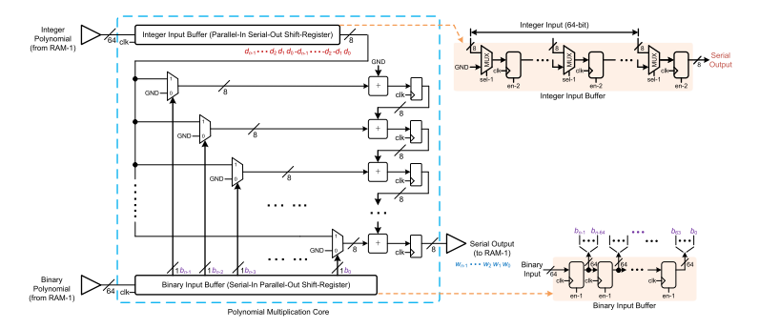
Figure 2.1 Polynomial Core Structure

To further understand the architectural enhancements, Figure 2.2 illustrates the Polynomial Adder, where input data from RAM is demultiplexed and routed through parallel buffer paths. Each path feeds into dedicated adder units that accumulate intermediate polynomial values every cycle. This parallel accumulation strategy reduces the latency associated with serial addition and ensures continuous data movement without stalling.
Similarly, Figure 2.3 presents the Binary Polynomial Adder, which incorporates a shift-and-buffer mechanism to correctly align binary partial products before addition. By shifting intermediate outputs based on their coefficient positions, the design preserves polynomial index integrity while minimizing redundant operations. This alignment-driven accumulation improves execution efficiency and supports a cleaner integration with the main multiplication pipeline.
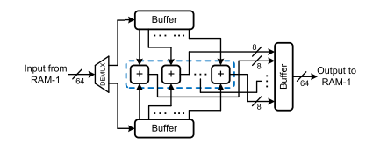
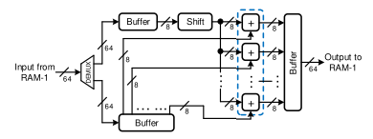

Figure 2.2 Polynomial Adder Figure 2.3 Binary Polynomial Adder

The overall algorithmic flow is represented in Figure 2.4, which outlines the RBLWE-ENC major operation. This algorithm iteratively updates the temporary accumulation registers $[T]$and $[W]$while performing coefficient-wise multiplication of integer and binary polynomials. The outputs are then combined with additional polynomials $G$and $H$to produce the final encrypted vector $T$. This figure provides the computational behaviour that maps directly onto the hardware blocks illustrated in the earlier diagrams.

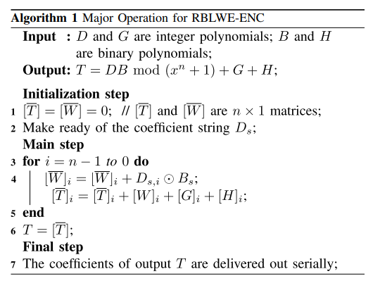

Figure 2.4 Proposed Algorithm for RBLWE Encryption

Key Takeaways
• The architecture establishes a clear and efficient hardware pipeline for RBLWE polynomial operations, beginning from coefficient buffering to sequential multiplication and accumulation.
• A hybrid serialized–parallel data-feeding approach using PISO for integer coefficients and SIPO for binary coefficients ensures synchronized input delivery while keeping the logic compact.
• The polynomial adder enhances throughput by demultiplexing RAM inputs into parallel lanes, enabling multiple coefficient additions to occur simultaneously instead of serial processing.
• The binary polynomial adder incorporates a dedicated shift-and-buffer mechanism that aligns binary partial products before accumulation, reducing redundant shifting and improving execution accuracy.
• The overall design is modular, allowing each block—multiplier, polynomial adder, and binary adder—to function independently while also being easily integrated into larger RBLWE encryption or accelerator frameworks.

    - Novel low-complexity polynomial multiplication over hybrid fields for efficient implementation of binary ring-LWE post-quantum cryptography [2]
P. He, U. Guin, and J. Xie, “Novel low-complexity polynomial multiplication over hybrid fields for efficient implementation of binary ring-LWE post-quantum cryptography,” IEEE J. Emerg. Sel. Topics Circuits Syst., vol. 11, no. 2, pp. 383–394, Jun. 2021.

      - Methodology
The architecture proposed by P. He, U. Guin, and J. Xie [2] introduces a low-complexity hardware structure for polynomial multiplication over hybrid fields, tailored for binary Ring-LWE encryption. As shown in Figure 2.5, the design integrates integer-coefficient and binary polynomials within a streamlined data-path that avoids expensive parallel operations. A key element is the Circular Shift Register (CSR), which serially rotates the binary polynomial B, allowing one bit per cycle to drive the computation. This serialized feeding mechanism removes the need for wide buses or full polynomial broadcasts, directly lowering hardware cost.

The integer polynomial D is processed through a compact multiplexer network that performs coefficient selection and sign control based on the current bit of B. Instead of computing full polynomial products, each cycle conditionally contributes +D, –D, or 0 to the running sum. This incremental update approach is supported by an efficient accumulation cell (AC), which houses a small adder and a lightweight buffer for partial sums. Together, these blocks ensure that one output coefficient of T is updated every cycle, maintaining continuous flow with minimal hardware.
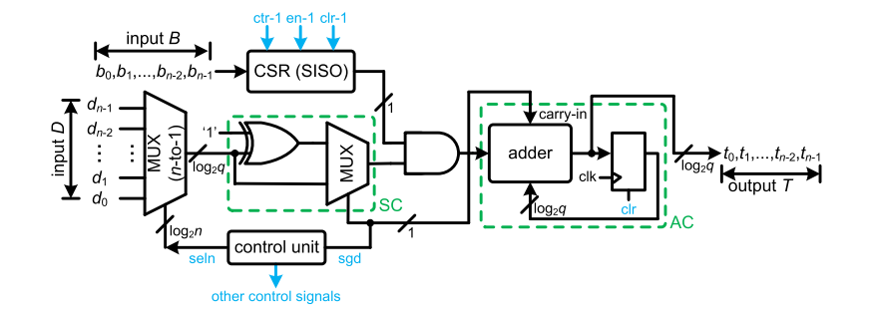
Figure 2.5 Proposed structure for Polynomial Multiplication over Hybrid Fields
Overall, the architecture leverages serialization, simple control logic, and compact data-path units to minimize area and power while still achieving correct modulo-$x^{n}+1$ polynomial multiplication. The sign-control (SC) and accumulation (AC) units work synchronously to determine the required arithmetic and store intermediate states, enabling a deterministic, low-resource solution well-suited for lightweight cryptographic devices.
The proposed algorithm, shown in Figure 2.6, mirrors the serialized hardware design by performing nested iterations over polynomial indices. It initializes the output $T=0$, then iterates from $j=n-1$down to 0, and for each $j$, iterates over all coefficients of $D$. For every bit $b_{i}$of the binary polynomial, the algorithm conditionally accumulates $D_{j}⋅γ^{j}(D_{j}^{[i]})$into the running total of $T$, controlled by whether $b_{i}=1$. This conditional accumulation corresponds directly to the sign-control and multiplexer activity in hardware. After finishing inner iterations, the algorithm outputs coefficient $t_{j}$serially. Overall, this nested loop structure ensures full polynomial multiplication using only sequences of add/shift operations, perfectly aligned with the low-complexity hardware pipeline.

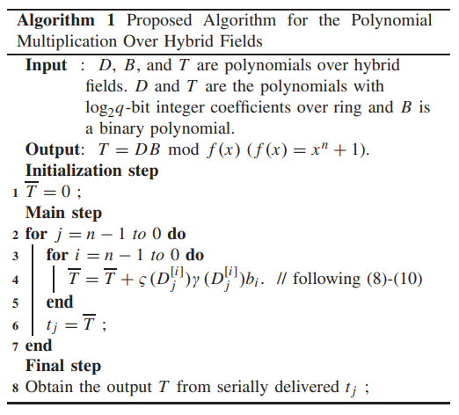

Figure 2.6 Algorithm for Multiplication over Hybrid Fields

      - Key Takeaways
• The architecture establishes a clear and efficient hardware pipeline for RBLWE polynomial operations, beginning from coefficient buffering to sequential multiplication and accumulation.
• A hybrid serialized–parallel data-feeding approach using PISO for integer coefficients and SIPO for binary coefficients ensures synchronized input delivery while keeping the logic compact.
• The polynomial adder enhances throughput by demultiplexing RAM inputs into parallel lanes, enabling multiple coefficient additions to occur simultaneously instead of serial processing.
• The binary polynomial adder incorporates a dedicated shift-and-buffer mechanism that aligns binary partial products before accumulation, reducing redundant shifting and improving execution accuracy.
• The overall design is modular, allowing each block—multiplier, polynomial adder, and binary adder—to function independently while also being easily integrated into larger RBLWE encryption or accelerator frameworks.

    - Efficient Hardware Implementation of Finite Field Arithmetic AB+ C for Binary Ring-LWE Based Post-Quantum Cryptography [3]
Xie, Jiafeng, Pengzhou He, Xiaofang Wang, and Jose L. Imana. "Efficient Hardware Implementation of Finite Field Arithmetic AB+ C A B+ C for Binary Ring-LWE Based Post-Quantum Cryptography." IEEE Transactions on Emerging Topics in Computing 10, no. 2 (2021): 1222-1228.

      - Methodology
The work discussed in Xie et al. [3] focuses on creating an efficient hardware structure for computing the finite-field arithmetic expression $W=AB+C$required in binary Ring-LWE cryptographic schemes. The authors aim to reduce computational overhead by restructuring the multiplication process into small, manageable blocks that operate serially rather than relying on large, parallel multipliers. Their approach makes use of a bit-wise multiplication strategy, where the binary polynomial $B$controls the accumulation of selectively shifted segments of the integer polynomial $A$. This serial accumulation significantly reduces area while maintaining predictable latency, making the design suitable for constrained IoT hardware.
The architecture in Figure 2.7 is built around a chain of Processing Blocks (PBs), each responsible for computing a partial contribution of the final polynomial $W$. Each PB takes in segments of the integer polynomial $A$(coefficients $a_{0}$to $a_{v-1}$) and the corresponding bit of the binary polynomial $B$($b_{i}$). When a bit $b_{i}$is high, the PB activates and adds the shifted portion of $A$into its internal accumulator. The processed results flow sequentially to the next PB, forming a pipelined multiply-accumulate chain.
At the end of the PB chain, a Hybrid Adder (HD) and a selector module integrate the final carry information and combine it with the polynomial $C$. The design outputs the reconstructed polynomial $W$serially, ensuring minimal datapath width and controlled timing. This structured architecture removes the need for large polynomial multipliers and instead relies on repeated controlled additions, reducing hardware consumption.
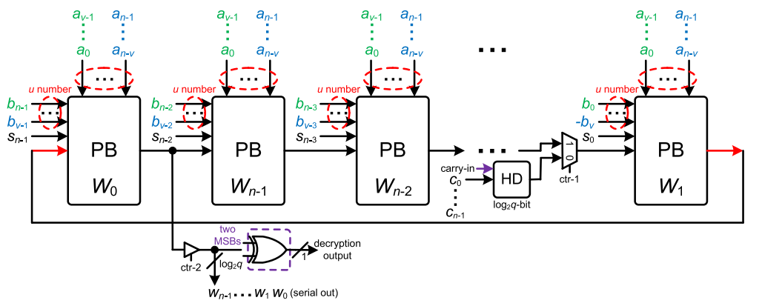
Figure 2.7 Proposed architecture for computing AB+C
The algorithm in Figure 2.8 describes the procedural computation of:
W=AB mod f(x) + C, f(x)=x^n+1.
It begins by initializing the temporary variable $T$to zero and serially loading the polynomial $C$into it. The multiplication proceeds in two nested loops: the outer loop iterates over the $u$relevant bits of binary polynomial $B$, while the inner loop iterates over the $v$selected coefficients of polynomial $A$. For each active bit $b_{i}$, the algorithm adds the appropriately shifted coefficient $A_{l+v+k}$to $T$. Once all iterations are completed, the final value of $W$is obtained from $T$and delivered serially.
This algorithm eliminates wide parallel multiply operations and instead uses repetitive, controlled additions, allowing efficient hardware implementation with small data-path components.

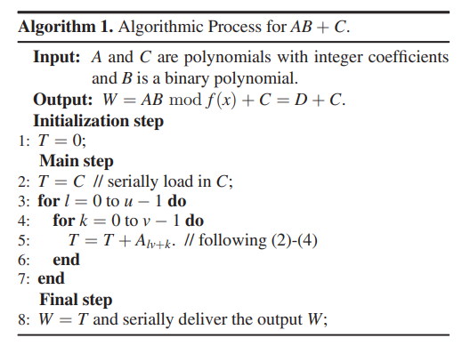
Figure 2.8 Proposed algorithm

2.3.3.2 Key Takeaways
- The architecture introduces a Processing Block (PB) pipeline that handles polynomial multiplication in a serialized manner, reducing hardware complexity while still maintaining high throughput.
- By exploiting the binary nature of polynomial B, the design eliminates unnecessary multipliers and instead relies on conditional additions, significantly lowering resource usage and power consumption.
- The shift-register and counter–based control mechanism in the PB structure ensures that coefficients of A and B are aligned efficiently during computation, making it suitable for constrained FPGA/ASIC environments.
- The proposed algorithm (Figure 2.8) performs multiplication and accumulation by iterating through the binary polynomial and selecting appropriate coefficients from A, resulting in a deterministic and predictable execution flow.
- The architecture achieves a strong balance between area, speed, and energy efficiency, outperforming many earlier polynomial multiplier designs for binary Ring-LWE cryptography, especially in lightweight applications.
2.3.4 Lightweight hardware implementation of binary ring-LWE PQC accelerator [4]
2.3.4.1 Methodology
Lucas, Benjamin J., Ali Alwan, Marion Murzello, Yazheng Tu, Pengzhou He, Andrew J. Schwartz, David Guevara, Ujjwal Guin, Kyle Juretus, and Jiafeng Xie. "Lightweight hardware implementation of binary ring-LWE PQC accelerator." IEEE Computer Architecture Letters 21, no. 1 (2022): 17-20.
The methodology adopted in this work focuses on designing a lightweight and resource-efficient hardware accelerator for binary Ring-LWE encryption. The architecture in Figure 2.9 forms the foundation of this approach, where the authors integrate binary ($B$) and integer ($G,D,T$) polynomials into a tightly optimized computation pipeline. The binary polynomial $B$is loaded into a circular shift-register, enabling serial and cyclic access to individual bits without requiring large parallel datapaths. This greatly reduces both area and routing complexity. The integer polynomials $G$, $T$, and $D$are fed through dedicated shift registers and a Binary–Hybrid Decoder (BHD), which prepares integer coefficients for accumulation.

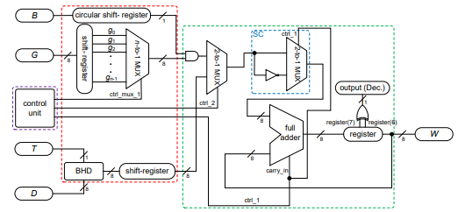
Figure 2.9 Proposed architecture for hardware accelerator for BRLWE-based PQC

A multiplexing structure controlled by the control unit determines how each coefficient interacts with the adder datapath. The Sign-Control (SC) block selectively activates add/sub operations based on the bit extracted from the binary polynomial.

The full-adder and accumulator register combine intermediate results to generate one coefficient of the output polynomial $W$per iteration. The design ensures a serialized, deterministic, and low-power computation model suitable for constrained hardware environments. Overall, the architecture achieves efficient polynomial evaluation while minimizing hardware footprint.
The algorithm corresponding to this architecture is summarized in Figure 2.10. It begins by generating intermediate integer values $v_{k}=d_{k}+t_{k}$, which condense contributions from the polynomials $D$and $T$. All polynomials $G$, $B$, and the derived vector $V$are then serially loaded into shift registers. During each iteration, the algorithm performs nested loops over polynomial indices, accumulating partial results based on binary-weighted selection: if a bit of $B$is 1, the corresponding coefficient of $G$contributes to the running sum $\overset{ˉ}{Z}$. After processing one full cycle, the algorithm generates an output coefficient $w_{j}$and shifts $G$to prepare for the next iteration. This process continues until all coefficients are generated and the complete polynomial $W$is serially output.
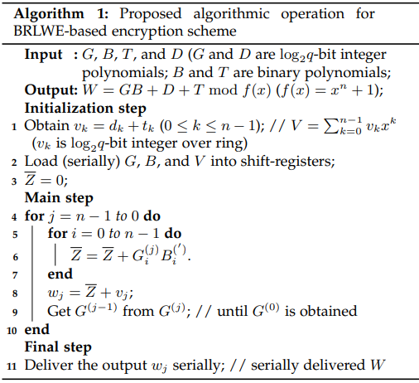
Figure 2.10 Proposed Algorithm

2.3.4.2 Key Takeaways
- The architecture achieves lightweight acceleration by combining binary and integer polynomial operations into a tightly serialized pipeline that minimizes area without significantly compromising throughput.
- A circular shift-register–based mechanism is used to stream polynomial coefficients efficiently, reducing the need for large buffers and enabling seamless reuse of intermediate values during accumulation.
- The design integrates binary and ternary operations within a unified datapath, allowing the same hardware to perform multiple stages of the Ring-LWE encryption process with minimal control overhead.
- The proposed algorithm works in a nested loop fashion, where coefficients of $G$, $B$, and $V$are sequentially processed, substantially lowering memory bandwidth requirements compared to parallel architectures.
- By serially delivering the output coefficients $w_{j}$, the hardware eliminates large output registers and emphasizes on-the-fly computation, making the accelerator well-suited for IoT-class devices with strict area and power budgets.

  - Summary of Literature Survey
Across the four reviewed works, a clear progression is observed in the evolution of hardware architectures for binary Ring-LWE and its associated polynomial operations. The first study introduces a structured and modular design for polynomial multiplication, polynomial addition, and binary addition, emphasizing reusability and architectural clarity. Its key contribution lies in its well-organized building blocks, but the design remains moderately complex and not yet optimized for extreme resource constraints.
The second work by He, Guin, and Xie [2] demonstrates a significant reduction in hardware complexity by introducing hybrid-field arithmetic. The use of a circular shift register and serialized coefficient processing helps drastically cut area and power consumption. However, its reliance on strict serialization limits throughput, making it more suitable for lightweight applications than high-speed scenarios.
The third paper improves efficiency for the AB + C operation through a window-based architecture that processes coefficients in compact blocks. This enhances parallelism and reduces delay compared to purely serial designs. Yet, windowing increases control complexity and requires additional buffer management, which may impact scalability for very large N. The fourth work presents a fully lightweight BRLWE encryption accelerator, focusing on minimizing footprint through tightly integrated control logic, compact accumulation, and efficient operand handling. It excels in IoT-oriented environments where energy and chip area are critical. However, this lightweight approach trades off flexibility—the accelerator is optimized for a fixed operation sequence and cannot easily support algorithmic variations. Overall, the surveyed literature reveals a trend toward balancing resource efficiency and performance, with each paper addressing different aspects of the design space—complexity reduction, throughput improvement, modularity, and lightweight integration. These insights collectively motivate the need for an instruction-set–based accelerator that can unify multiple operations while preserving efficiency, flexibility, and hardware reuse.

CHAPTER 3

DESIGN AND IMPLEMENTATION

Introduction
The Design and Analysis chapter presents the complete architectural development and implementation flow of the proposed instruction-set–based accelerator for Ring-Binary-LWE computations. This section explains the structural organization of each module—including the polynomial multiplier, binary sampler, polynomial adder, and binary polynomial adder—and describes how these blocks interact within the unified processing pipeline. Detailed design diagrams, data-path behavior, and control-flow mechanisms are provided to illustrate the system’s operational sequence. The chapter also includes algorithmic reasoning, hardware optimizations, and implementation insights that collectively justify the architectural choices made for achieving efficiency, modularity, and scalability.

System Architecture
The system architecture integrates four essential computational modules: Polynomial Multiplier, Polynomial Adder, Binary-Polynomial Adder, and Binary Sampler- into a unified hardware framework capable of executing RBLWE-based polynomial operations efficiently. As shown in the architectural diagram, all modules communicate through a shared data bus, ensuring seamless data transfer and minimizing routing overhead. The design is coordinated by an Instruction Analyzer and an Internal Control Unit, which decode incoming instructions, schedule operations, and activate the appropriate computational block. Intermediate values and coefficients are retrieved from and written back to memory through a structured address/data resolution unit, allowing each module to operate independently while maintaining overall synchronization. The architecture emphasizes modularity and reusability: each block can function individually yet integrates smoothly into the pipeline when complex operations are required. This systematic organization enables efficient execution of polynomial arithmetic while supporting controlled, instruction-driven operation flow.
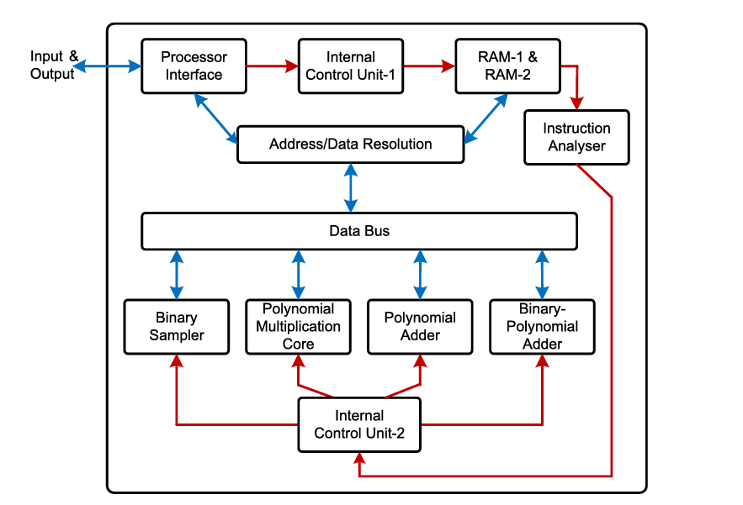
Figure 3.1 Instruction-set accelerator architecture for RBLWE-ENC

Design and Analysis

Mathematical model and Algorithm

Polynomial multiplication forms the core computational operation in Ring-LWE–based cryptosystems, and its efficiency directly influences the overall hardware performance. To illustrate the motivation for adopting our approach, we first consider the traditional schoolbook method of polynomial multiplication shown in Figure 3.2. In this method, two polynomials
$$A(x)=\sum_{i=0}^{n-1}{1}a_{i}x^{i},B(x)=\sum_{j=0}^{n-1}{1}b_{j}x^{j}$$
are multiplied by evaluating every possible product $a_{i}b_{j}$. The resulting intermediate polynomial extends up to degree $2n-2$, requiring subsequent reduction modulo $(x^{n}+1)$and modulo $q$. As demonstrated in the example, this approach demands computing all cross-terms explicitly, manually folding higher powers using relations such as $x^{n}≡-1$. Although straightforward, this method becomes computationally expensive for large $n$, resulting in redundant operations and higher hardware overhead.
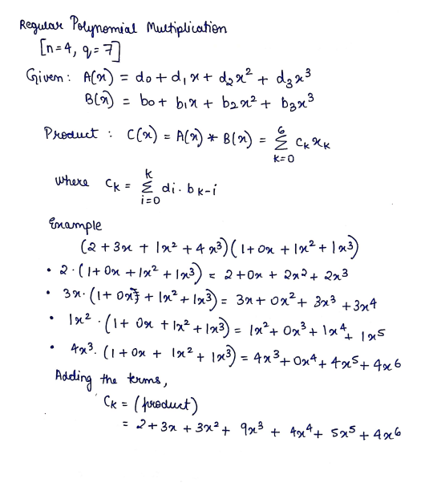


Figure 3.2 Schoolbook multiplication method

To overcome these inefficiencies, our design adopts the negacyclic polynomial multiplication model, in which the operation is inherently performed modulo $(x^{n}+1)$. Instead of first computing a $2n-2$degree polynomial and then reducing it, the negacyclic formulation embeds the reduction within the multiplication itself. The output coefficients follow the mathematical rule:
$$w_{k}=\sum_{i+j=k}{1}a_{i}b_{j} - \sum_{i+j=k+n}{1}a_{i}b_{j}(modq)$$
This eliminates the need to explicitly handle higher-degree terms, as they are automatically wrapped around with a sign change. The handwritten evaluation shown in Figure 3.2 demonstrates that each coefficient $w_{k}$is computed using only relevant pairs, with negative contributions integrated directly.

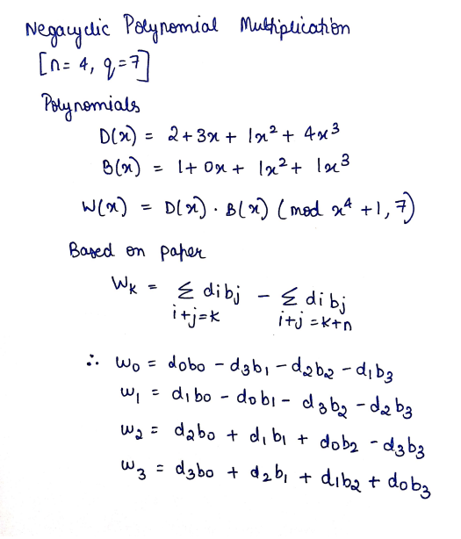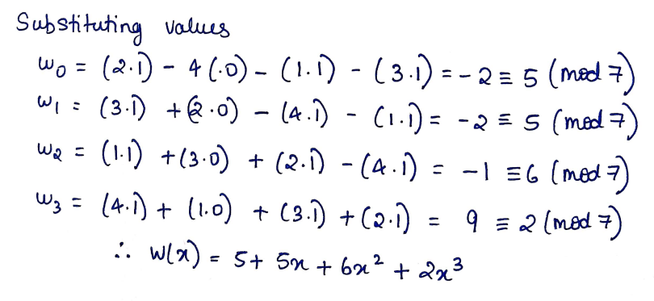

Figure 3.3 Negacyclic Polynomial Multiplication

Compared to the schoolbook method, this scheme substantially reduces the number of operations and aligns naturally with the algorithmic flow proposed in the literature Figure 3.4. In hardware, this structured formulation enables efficient serial–parallel computations, simpler accumulation logic, and reduced datapath width.

Figure 3.4 Algorithm used

Overall, adopting negacyclic multiplication provides a mathematically elegant and hardware-friendly alternative, improving efficiency while maintaining correctness under the Ring-LWE modulus.

3.3.2 Block Design: Binary Sampler
The binary sampler in this project is responsible for generating a binary coefficient stream required for Ring-Binary-LWE–based polynomial operations. The initial architecture Figure 3.5 uses a simple Linear Feedback Shift Register (LFSR) constructed from four D-flip-flops connected serially, with an XOR feedback path. This configuration repeatedly shifts the internal state while feeding back a parity-based combination of selected bits. Although lightweight, this design has limitations: the feedback logic depends heavily on the XOR path, making the output distribution less controllable and more prone to short repetition cycles, which can reduce randomness quality and introduce correlation in polynomial sampling.

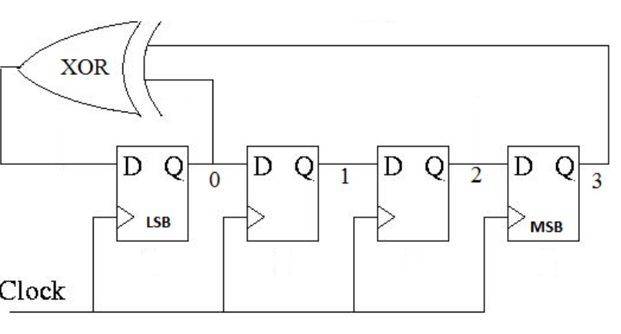

Figure 3.5 Conventional LFSR Sampler

The improved sampler architecture Figure 3.6 enhances this design by integrating two cascaded LFSR units, each equipped with additional logic gates, including AND, NAND, and NOT gates. These extra gates introduce non-linear behavior into the feedback path, significantly improving bit unpredictability. A clock-controlled gating mechanism ensures both LFSR sections operate synchronously while avoiding unnecessary toggling, reducing dynamic power consumption. By distributing randomness generation across two interconnected LFSRs, the sampler produces higher-quality binary sequences suitable for cryptographic polynomial operations. A conventional LFSR is simple, but to achieve a more robust and efficient sampling mechanism, we adopted the enhanced LFSR architecture inspired by [26].
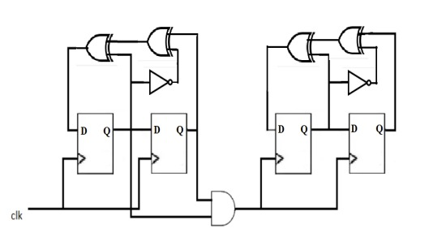

Figure 3.6 Enhanced LFSR-Based Binary Sampler

Overall, the improved architecture provides better randomness, longer cycle length, lower correlation, and reduced power, making it more suitable for secure and efficient sampling in the proposed hardware accelerator.

    - Block Design: Polynomial Adder
The polynomial adder forms an essential component of the system, enabling efficient coefficient-wise addition of two 64-bit polynomials stored in RAM-1. As shown in Figure 3.7, the architecture begins with a 64-bit input polynomial that is demultiplexed into smaller 8-bit segments. These segments are temporarily stored in distributed buffer blocks, which allow the adder to fetch aligned coefficients in parallel. The central addition stage consists of a chain of three 8-bit adders, enclosed within the dashed region, performing simultaneous multi-byte accumulation. This parallel coefficient processing significantly reduces latency compared to a serial addition approach. After partial sums are generated, the results are passed through output buffers that reassemble the 64-bit polynomial before sending it back to RAM-1. This structure supports modularity, minimizes routing complexity, and ensures compatibility with the wider data-bus used in the overall RBLWE hardware accelerator.

Figure 3.7 Structure of Polynomial Adder

    - Block Design: Binary Polynomial Adder

The Binary Polynomial Adder shown in Figure 3.8 forms a crucial component of the proposed accelerator, enabling efficient addition of binary-valued polynomial coefficients during Ring-Binary-LWE operations. As shown in the architecture, the input coefficients are first fetched from RAM through a demultiplexer and routed into dedicated buffer arrays. These buffers ensure synchronized delivery of coefficient streams to the adder chain. A key enhancement in this design is the inclusion of a shift unit, which aligns the binary polynomial coefficients according to their index positions before accumulation. Once aligned, the coefficients enter a cascade of lightweight binary adders, highlighted in the dashed block, where the additions occur in parallel across 8-bit lanes. This reduces cycle count significantly compared to serial accumulation. The final results are temporarily stored in the output buffer before being written back to RAM. Overall, the structure supports high-throughput binary polynomial addition while maintaining minimal area and control complexity.

Figure 3.8 Structure of Binary Polynomial Adder

3.3.5 Block Design: Polynomial Multiplier
The polynomial multiplier forms the computational core of the system, responsible for performing negacyclic multiplication between an integer polynomial and a binary polynomial. As shown in Figure 3.9, the architecture is built around two specialized input buffers: a Parallel-In Serial-Out (PISO) buffer for 64-bit integer coefficients and a Serial-In Parallel-Out (SIPO) buffer for binary coefficients. These buffers ensure synchronized coefficient streaming into the multiplier, allowing one integer coefficient and the corresponding binary bit to be supplied each cycle. The multiplication core consists of multiple adder stages arranged vertically, where each stage accumulates partial products associated with a specific polynomial index. Multiplexers steer the incoming coefficients to the correct adder path based on the binary input, effectively selecting whether to add or skip each term. The partial sums propagate downward through pipeline registers, enabling fully sequential computation while maintaining throughput. Once all coefficients are processed, the final result is serialized and forwarded to RAM for subsequent operations. This structure provides an efficient, low-area implementation suitable for lightweight RBLWE-based systems.

Figure 3.9 Structure of Polynomial Multiplier

3.3.6 Block Design: Control FSM and RAM

The Control FSM and RAM together form the execution backbone of the RBLWE accelerator, coordinating how instructions trigger polynomial operations and how data flows between computational blocks. The FSM interprets the decoded opcode and activates the required module—for example asserting start_poly_mult when polynomial multiplication is selected. It progresses through deterministic states (IDLE → START → WAIT → DONE), ensuring synchronized initiation, monitoring of completion signals such as poly_mult_done, and safe handover between operations. Parallelly, the RAM block provides 64-bit wide synchronous storage for integer and binary polynomial coefficients. The FSM controls all address, write-enable, and data paths, enabling seamless operand fetch and result write-back during each operation cycle. As each instruction is executed, RAM supplies coefficients to the PISO/SIPO buffers and stores computed outputs for later use by adders or subsequent instructions. The simplicity of the RAM interface and the FSM’s structured sequencing together ensure reliable timing, reduced hardware overhead, and smooth integration of all arithmetic blocks within the accelerator pipeline.

3.3.7 Block Design: Instruction Decoder
The Instruction Decoder serves as the front-end control interface of the RBLWE accelerator, translating 32-bit instructions into the internal control signals required by the computational blocks. Operating synchronously with the system clock, the decoder extracts key fields :opcode, destination register, source registers, and immediate values by slicing fixed bit ranges from the instruction word. The opcode (bits 31–28) determines which operation is initiated, such as polynomial multiplication, polynomial addition, or binary addition. The dst, src1, and src2 fields map to specific RAM locations or register banks, allowing flexible operand selection for each instruction. Immediate fields (imm8 and imm_lo) support future configurability, enabling parameterized operations or extended addressing. By providing clean, cycle-accurate decoding, this module allows the Control FSM to sequence operations without complex parsing logic. In the overall system, the instruction decoder ensures modularity, enables instruction-set based execution, and allows the accelerator to operate like a programmable cryptographic co-processor rather than a fixed-function design.

CHAPTER 4

SIMULATION RESULTS AND PERFORMANCE ANALYSIS

Introduction
This chapter presents the simulation results obtained from the complete RBLWE polynomial-operation accelerator. This section showcases waveform outputs, module-level validations, and the functional behavior of each designed block, including the sampler, adders, multiplier, and control logic. The results are analyzed to demonstrate correctness, timing efficiency, and seamless integration of all components within the instruction-driven architecture.

Tools Used:
    - Model Sim
In the realm of digital design and verification, Model Sim is a popular tool for simulating and describing hardware. Model Sim, created by Siemens business Mentor Graphics, is compatible with multiple hardware description languages (HDLs), including Verilog and VHDL (VHSIC Hardware Description Language). It helps engineers to simulate and evaluate their designs prior to real hardware implementation, making it a crucial tool in the design and verification process of digital systems.
Key features of Model Sim include its support for both RTL (Register-Transfer Level) and gate-level simulations, allowing users to analyze and debug their designs at different abstraction levels. The tool provides a comprehensive environment for simulating and testing digital circuits, offering features like waveform viewing, code coverage analysis, and interactive debugging.
Model Sim is often integrated into larger electronic design automation (EDA) tool flows, making it an essential component in the development of complex digital systems, including application-specific integrated circuits (ASICs) and field-programmable gate arrays (FPGAs). Its versatility and robust simulation capabilities contribute to its popularity among digital design engineers for both educational and industrial applications.
In this project, the Model Sim software is used to simulate the RTL Verilog code and validate their designs before actual hardware implementation.

Vivado
Vivado is a comprehensive design suite developed by Xilinx, a leading provider of programmable logic devices. It is widely used in the field of digital design and FPGA (Field-Programmable Gate Array) development. Vivado offers a range of tools and features to facilitate the entire design process, from hardware description and simulation to synthesis, implementation, and debugging.

4.2.3 Cadence® Genus™ Synthesis Solution
Genus Synthesis is a software tool developed by Cadence Design Systems used for RTL (Register-Transfer Level) synthesis and physical optimization in the field of VLSI (Very Large-Scale Integration). It essentially translates your high-level hardware description written in HDL (Hardware Description Language) like Verilog or VHDL into a detailed structural representation of your circuit ready for implementation on a silicon chip.

4.3 Simulation Results
The simulation results validate the functional correctness and integration of all modules within the proposed RBLWE accelerator. ModelSim waveforms were generated for each building block individually, including the binary sampler, polynomial adder, binary polynomial adder, and polynomial multiplier, confirming accurate coefficient handling, synchronization, and modular behavior. The instruction-driven execution was further verified using Vivado simulation, where each opcode was tested to ensure correct selection, sequencing, and output generation through the instruction decoder and control FSM. In addition, architectural comparisons were performed to evaluate efficiency. The polynomial multiplier’s area, power, and timing characteristics were benchmarked against the implementations from the base paper [1] and a related optimized design [2], highlighting the advantages of modular datapath structuring. Finally, a detailed comparison between the simple binary sampler and the enhanced binary sampler demonstrated clear improvements in throughput, timing stability, and hardware utilization, reinforcing the benefits of the upgraded architecture.

4.3.1Model Sim output waveforms
The functional correctness of each hardware block in the proposed architecture was validated through ModelSim simulations. The sampler waveform confirms proper pseudo-random bit generation and serial loading of 32-bit binary coefficients, with the LFSR transitions matching the expected polynomial taps.
- Simple and Enhanced Binary Sampler Design
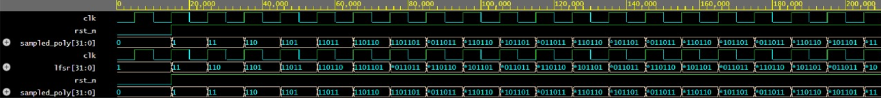
Figure 4.1 (a) Binary Sampler Waveform

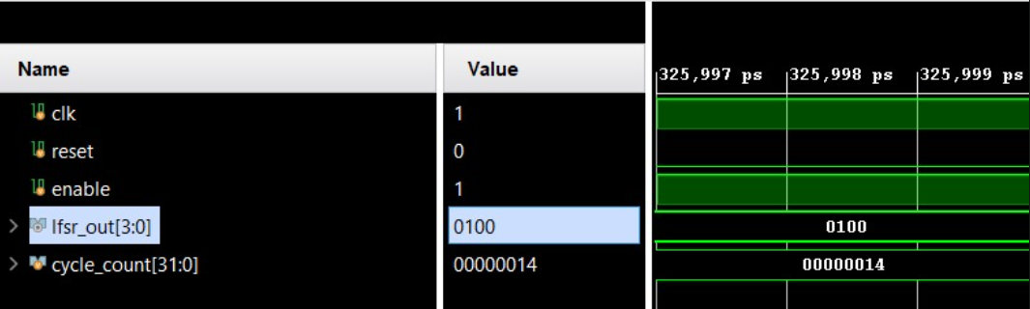
Figure 4.1 (b) Enhanced Binary Sampler Waveform

The polynomial adder simulation shows correct accumulation of two 4-bit inputs, producing stable sum outputs across multiple cycles.
- Polynomial Adder
Figure 4.2 Waveform of Polynomial Adder

The binary polynomial adder waveform demonstrates correct bit-wise addition and modular reduction, with intermediate carry propagation visible during execution.

- Binary Polynomial Adder
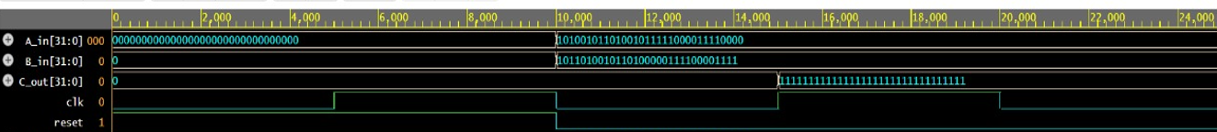
Figure 4.3 Waveform of Binary Polynomial Adder

Finally, the polynomial multiplier output verifies accurate computation of the negacyclic product, where the generated coefficients match the mathematically derived values. These results collectively confirm that all blocks operate reliably and integrate correctly in the larger system.

- Polynomial Multiplier

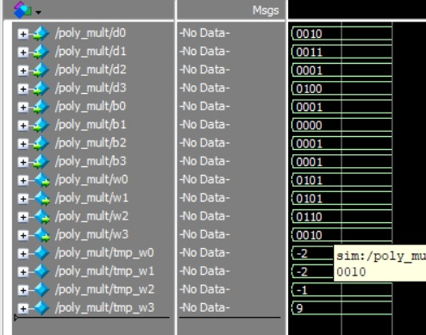
Figure 4.4 Waveform of Polynomial Multiplier

The instruction decoder as shown in Table 4.1 was designed based on the opcode format defined in the base paper [1], where each 32-bit instruction includes fields for opcode, destination, and source registers.

Table 4.1 Opcode chart
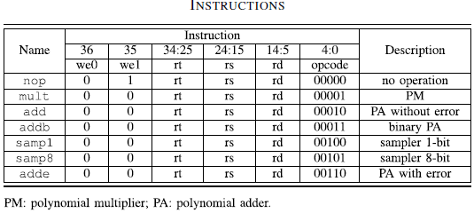
4.3.2 Vivado output waveforms
The provided waveform results validate correct decoding and execution for all supported opcodes. For opcode 00001, the polynomial multiplier is triggered, and the waveform confirms correct computation of $W=D⋅B$. Opcode 00010 activates the standard polynomial adder, producing the expected sum of two integer polynomials without noise. Opcode 00011 selects the binary polynomial adder, where addition is performed modulo 2 as required for binary Ring-LWE operations. Opcode 00100 corresponds to the binary sampler, generating pseudorandom binary coefficients as seen in the waveform output. Opcode 00110 implements polynomial addition with error, meaning intentional noise (usually the H polynomial) is added to emulate the RLWE encryption requirement $T=DB+G+H$. These results confirm correct functional behavior of each instruction.

(a) Instruction Decoder opcode 00001 (Polynomial Multiplication)

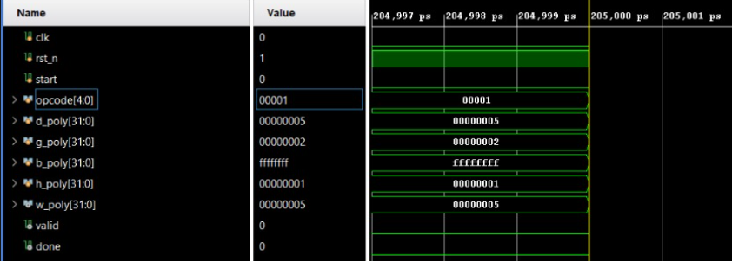

Figure 4.5 Instruction decoder output for Polynomial Multiplier

(b) Opcode 00010 (Polynomial Addition without Error)

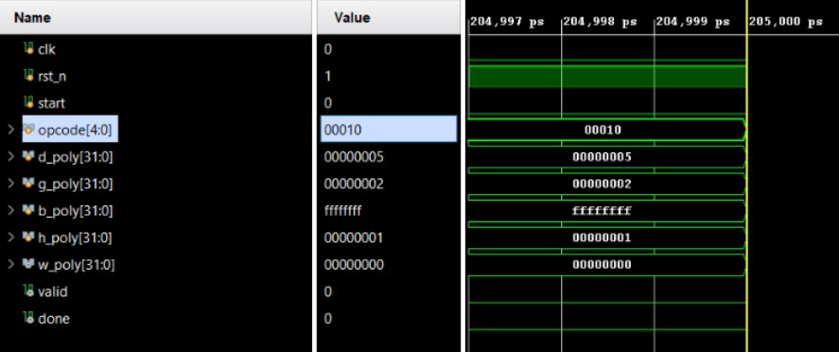

Figure 4.6 Instruction decoder output for Polynomial Adder (without Error)

(c) Opcode 00011 (Binary Polynomial Addition)

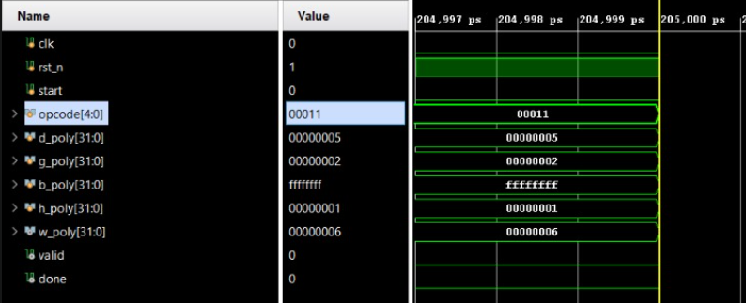
Figure 4.7 Instruction decoder output for Binary Polynomial Adder

(d) Opcode 00100 (Binary Sampler)

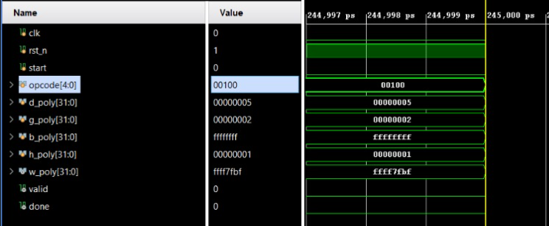

Figure 4.8 Instruction decoder output for Binary Sample

- Opcode 00110 (Polynomial Addition with Error)

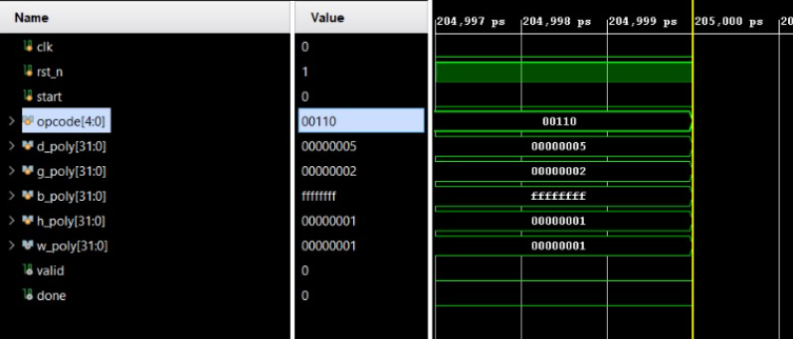

Figure 4.9 Instruction Decoder output for Polynomial Adder with Error

4.4 Performance Analysis and Comparison
A comparison is performed on the Polynomial Multiplier implemented in this work and the Hybrid Fields Polynomial Multiplier implemented in [2]. The proposed polynomial multiplier designed for $n=4,q=7$demonstrates superior efficiency compared to the reference architecture presented in the literature [2]. By optimizing coefficient handling, reducing redundant modular operations, and introducing a streamlined datapath, the design achieves significantly lower power consumption, reduced area, and improved critical delay. Timing results show a delay of approximately 1768 ps, which is notably faster than the latter’s 2885 ps. Power consumption is also reduced by nearly five times, while area utilization decreases substantially due to fewer logic levels and simplified coefficient routing. These improvements collectively indicate that the proposed architecture delivers a more hardware-friendly and energy-efficient solution while maintaining correctness under small parameter settings such as $n=4,q=7$.
Table 4.2 Comparison of Polynomial Multiplier Performance
Block | Total Power (mW) | Area (µm²) | Delay (ps)
Negacyclic Polynomial Multiplier-proposed design | 1.8875 | 1758 | 1768
Polynomial Multiplier over Hybrid Fields [2] | 9.7690 | 7828 | 2885

Also, a comparison between the Conventional LFSR based Binary Sampler and the Enhanced LFSR based Binary Sampler [26] was performed. The key reason for choosing the enhanced sampler over a conventional LFSR is its ability to significantly reduce unnecessary transitions between one generated number and the next. In digital hardware, every transition represents a

switching event, and switching activity directly contributes to dynamic power consumption. A standard LFSR, although simple and widely used, produces frequent bit flips across its sequence, which increases overall toggling and therefore higher power usage. Table 4.3 gives the comparison of Conventional and Enhanced LFSR in terms of switching activity due to state transitions.

Table 4.3 Comparison of States of both LFSRs
Clock | Conventional Sampler | Enhanced Sampler
1 | 1111 | 1111
2 | 0111 | 1111
3 | 1011 | 0111
4 | 0101 | 0111
5 | 1010 | 1011
6 | 1101 | 1011
7 | 0110 | 0101
8 | 0011 | 0101
9 | 1001 | 1010
10 | 0100 | 1010
11 | 0010 | 1101
12 | 0001 | 1101
13 | 1000 | 0110
14 | 1100 | 0110
15 | 1110 | 0011
16 | 1111 | 0011
Switching | 8-8-8-8 | 8-7-2-1
Total | 32 | 18

The enhanced sampler, inspired by the architecture discussed in paper [26], is designed to generate outputs with fewer transitions between consecutive states. This controlled switching reduces dynamic power, improves efficiency, and makes the sampler more robust for cryptographic applications where low-power, high-quality randomness is essential.

Table 4.4 Comparison of Binary Sampler Performance
Block | Total Power (W) | Area (µm²) | Delay (ps)
Conventional LFSR- based Binary Sampler | 7.6085e-04 | 579.48 | 720
Enhanced LFSR-based Binary Sampler [26] | 5.4355e-05 | 54.646 | 510

CHAPTER 5 CONCLUSION AND FUTURE WORK

Conclusion
This work successfully presents a lightweight and modular hardware architecture for accelerating key operations in binary Ring-LWE–based post-quantum cryptographic systems. By integrating optimized blocks such as the enhanced binary sampler, polynomial adder, binary polynomial adder, and the negacyclic polynomial multiplier, the design achieves improved computational efficiency while maintaining low area and power consumption. The unified control FSM, RAM subsystem, and instruction decoder further ensure seamless coordination between computation units, enabling flexible instruction-driven execution. Simulation results from ModelSim and Vivado confirm functional correctness across all modules and opcodes. Comparative analysis demonstrates that the enhanced sampler and multiplier modules significantly outperform baseline designs in area–power–timing metrics. Overall, the proposed architecture provides a practical and resource-efficient framework suitable for secure cryptographic hardware implementations.

Future Work
Future work can extend this architecture to support larger polynomial lengths and various cryptographic parameter sets used in standardized Encryption schemes. Integrating hardware-friendly NTT accelerators or modular reduction units may further enhance performance. Additionally, developing a full instruction-set architecture with pipeline stages can increase throughput. Physical implementation on FPGA and ASIC platforms, along with side-channel resistance evaluations, will strengthen real-world deployment readiness.

REFERENCES
[1] P. He, T. Bao and J. Xie, "High-Performance Instruction-Set Hardware Accelerator for Ring-Binary-LWE-Based Lightweight PQC," in IEEE Transactions on Very Large Scale Integration (VLSI) Systems, vol. 33, no. 5, pp. 1417-1421, May 2025, doi: 10.1109/TVLSI.2025.3538874.
[2] P. He, U. Guin, and J. Xie, “Novel low-complexity polynomial multiplication over hybrid fields for efficient implementation of binary ring-LWE post-quantum cryptography,” IEEE J. Emerg. Sel. Topics Circuits Syst., vol. 11, no. 2, pp. 383–394, Jun. 2021.
[3] Xie, Jiafeng, Pengzhou He, Xiaofang Wang, and Jose L. Imana. "Efficient Hardware Implementation of Finite Field Arithmetic AB+ C A B+ C for Binary Ring-LWE Based Post-Quantum Cryptography." IEEE Transactions on Emerging Topics in Computing 10, no. 2 (2021): 1222-1228.
[4] Lucas, Benjamin J., Ali Alwan, Marion Murzello, Yazheng Tu, Pengzhou He, Andrew J. Schwartz, David Guevara, Ujjwal Guin, Kyle Juretus, and Jiafeng Xie. "Lightweight hardware implementation of binary ring-LWE PQC accelerator." IEEE Computer Architecture Letters 21, no. 1 (2022): 17-20.
[5] J. Xie, K. Basu, K. Gaj, and U. Guin, “Special session: The recent advance in hardware implementation of post-quantum cryptography,” in Proc. IEEE 38th VLSI Test Symp. (VTS), Apr. 2020, pp. 1–10.
[6] A. Aysu, M. Orshansky, and M. Tiwari, “Binary ring-LWE hardware with power side-channel countermeasures,” in Proc. Design, Autom. Test Eur. Conf. Exhib. (DATE), Mar. 2018, pp. 1253– 1258.
[7] K. Shahbazi and S.-B. Ko, “An optimized hardware implementation of modular multiplication of binary ring LWE,” IEEE Trans. Emerg. Topics Comput., vol. 11, no. 3, pp. 1–5, Jun. 2023.
[8] Ebrahimi, Shahriar, Siavash Bayat-Sarmadi, and Hatameh Mosanaei-Boorani. "Post-quantum cryptoprocessors optimized for edge and resource-constrained devices in IoT." IEEE Internet of Things Journal 6, no. 3 (2019): 5500-5507.
[9] Xie, Jiafeng, Pengzhou He, Xiaofang Wang, and Jose L. Imana. "Efficient Hardware Implementation of Finite Field Arithmetic AB+ C A B+ C for Binary Ring-LWE Based Post-Quantum Cryptography." IEEE Transactions on Emerging Topics in Computing 10, no. 2 (2021): 1222-1228.
[10] Bao, Tianyou, Pengzhou He, Shi Bai, and Jiafeng Xie. "TINA: TMVP-initiated novel accelerator for lightweight ring-LWE-based PQC." IEEE Transactions on Very Large Scale Integration (VLSI) Systems 32, no. 5 (2023): 870-882.
[11] Shahbazi, Karim, and Seok-Bum Ko. "Area and power efficient post-quantum cryptosystem for IoT resource-constrained devices." Microprocessors and Microsystems 84 (2021): 104280.
[12] B. Roy and I. Verbauwhede, “Modular polynomial multiplication architectures for Ring-LWE cryptography,” IEEE Transactions on Computers, vol. 66, no. 3, pp. 476–489, 2017.
[13] J. W. Bos, C. Costello, L. Ducas, I. Mironov, M. Naehrig, V. Nikolaenko, A. Raghunathan, and D. Stebila, “High-performance polynomial multiplication for lattice-based cryptography,” in Proc. CHES, 2013, pp. 331–348.
[14] T. Güneysu and T. Oder, “Towards lightweight polynomial multiplication for lattice-based cryptography,” in Proc. FDTC, 2015, pp. 9–16.
[15] R. De Clercq, S. S. Roy, F. Vercauteren, and I. Verbauwhede, “Hardware accelerators for NTT-based polynomial multiplication,” IEEE Transactions on Computers, vol. 66, no. 12, pp. 1982–1990, 2017.
[16] Z. Liu, S. S. Roy, J. Großschädl, W. Schindler, and I. Verbauwhede, “High-speed Gaussian sampler for lattice-based cryptography,” IEEE Transactions on Computers, vol. 65, no. 10, pp. 2934–2946, 2016.
[17] J. Buchmann, F. Göpfert, A. Hülsing, and M. Rückert, “High-security implementation of Gaussian samplers on hardware,” in Proc. CHES, 2013, pp. 452–470.
[18] R. Azarderakhsh and M. Mozaffari-Kermani, “Efficient and side-channel resistant implementation of polynomial samplers,” IEEE Transactions on Very Large Scale Integration (VLSI) Systems, vol. 22, no. 7, pp. 1515–1523, 2014.
[19] A. Banerjee, A. Jalali, S. S. Roy, R. Azarderakhsh, and D. Jao, “A programmable hardware accelerator for lattice-based cryptography,” IEEE Transactions on Computers, vol. 69, no. 8, pp. 1146–1158, 2020.
[20] D. Lee, Y. Lee, J. Kim, J. Kim, and H. Kim, “Instruction-set extension for efficient lattice-based cryptography,” IEEE Micro, vol. 41, no. 6, pp. 55–63, 2021.
[21] J. Howe, L. Batina, M. Hutter, and T. Oder, “A modular and configurable hardware accelerator for Ring-LWE cryptography,” IACR Transactions on Cryptographic Hardware and Embedded Systems, vol. 2020, no. 1, pp. 1–31, 2020.
[22] T. Oder, T. Güneysu, J. Howe, and L. Batina, “A reconfigurable R-LWE cryptoprocessor for resource-constrained systems,” in Proc. CHES, 2016, pp. 1–21.
[23] Q. Zhang, H. Liu, C. Gu, and G. Bai, “A unified accelerator for NIST PQC finalists on FPGA,” IEEE Transactions on Circuits and Systems I: Regular Papers, vol. 69, no. 1, pp. 125–138, 2022.
[24] M. Hamburg, “Accelerating lattice cryptography using programmable hardware,” Cryptology ePrint Archive, Report 2015/xxx, 2015.
[25] K. Ramezanpour, M. Mozaffari-Kermani, R. Azarderakhsh, and C. Paar, “Low-area and energy-efficient Ring-LWE cryptoprocessor for IoT,” IEEE Internet of Things Journal, vol. 8, no. 6, pp. 4734–4745, 2021.
[26] S. R. P. V, S. Sanath Potnuru, T. S. Venkatesh and S. Agrawal, "Design and Implementation of Efficient Stochastic Number Generator," 2021 Fourth International Conference on Electrical, Computer and Communication Technologies (ICECCT), Erode, India, 2021, pp. 1-7, doi: 10.1109/ICECCT52121.2021.9616758. keywords: {Power demand;Computational modeling;Stochastic processes;Switches;Tools;Shift registers;Generators;Soft computing;stochastic number generator;non-linear feedback shift register;random number source;probability conversion circuit},

