Components of

1. Files
   1. Processing
      1. All the way from seq to right before they enter the network
      2. *Have already existing outline of this*
   2. Makeup of files
      1. What each pixel represents (temperature/size variations)
      2. Source of information (type of camera)
   3. Anomalies
      1. Possible rain events (high GPP but skewed temperatures)
      2. Number of these events (expressed as percentage)
   4. Source of files
      1. Summary of information about BCI
         1. Climate
         2. GPP Ranges for monthly data collected
   5. Summary Stats
      1. Distribution of GPP values (measured)
         1. Show the range of values, frequency (histogram?)
         2. Average GPP values per 30 minute period across months (measured)
         3. Average GPP values per 30 minute period across months (predicted)
      2. Distribution of temperature values
      3. Heat map style layering of images all together
         1. Image of each hour, average temperatures
2. Network
   1. Diagram of composition
      1. as seen in firefighting paper A Deep Learning Framework for Detection of Targets in Thermal Images to Improve Firefighting MANISH BHATTARAI a,b,∗,1 , MANEL MARTÍNEZ-RAMÓN
   2. History of architecture
      1. (started with one conv layer, so on and so on)
   3. classes vs regression,
      1. why the change was made
   4. CNN
      1. Why this chosen
      2. HOW IT WORKS?

* Find example images for certain peaks
* Finding function from network
* Throwing in a variable
* Looking to predict  
  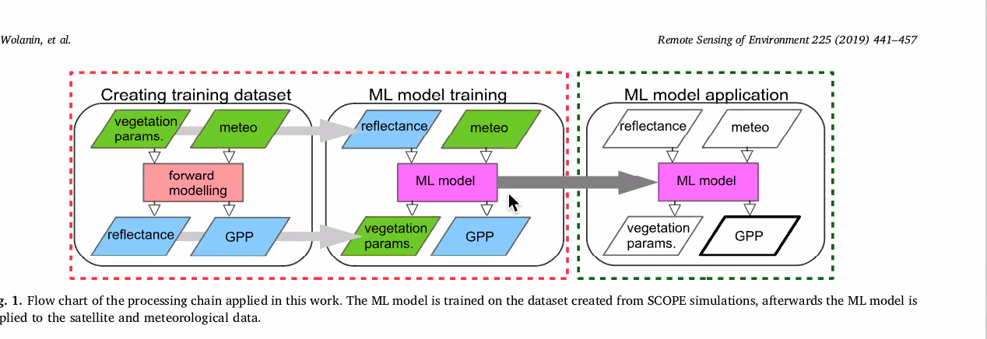
* 27 28 degrees is peak GPP and then dropoff
* Heat map correlation of target vs predction training
* Time Splits
  + Morning before 4:00am - 12:00pm
  + Midday 12:00am – 2:00pm
  + afternoon after 2:00-19:59pm
  + Evening 4:00pm-6:00pm
  + 12:30-1:30pm
* Wavelet analysis
  + To find patterns
* Jan-May dry
* Everything else wet
* **STARTING OUT WITH R PROJECT**