**Da wikipedia English**

**Specifications (DC-4-1009)**

[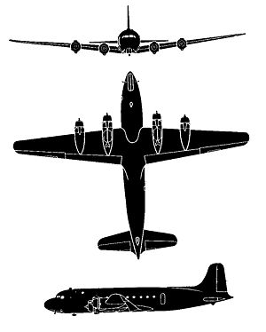](https://en.wikipedia.org/wiki/File:DC4_Silh.jpg)

**General characteristics**

* **Crew:** four
* **Capacity:** 40 to 80 passengers[[1]](https://en.wikipedia.org/wiki/Douglas_DC-4" \l "cite_note-Boeing_history-1)
* **Length:** 93 ft 10 in (28.6 m)
* [**Wingspan**](https://en.wikipedia.org/wiki/Wingspan)**:** 117 ft 6 in (35.8 m)
* **Height:** 27 ft 6 in (8.38 m)
* **Wing area:** 1,460ft² (135.6 m²)
* [**Empty weight**](https://en.wikipedia.org/wiki/Manufacturer%27s_empty_weight)**:** 43,300 lb (19,640 kg)
* **Loaded weight:** 63,500 lb (28,800 kg)
* [**Max. takeoff weight**](https://en.wikipedia.org/wiki/Maximum_takeoff_weight)**:** 73,000 lb (33,100 kg)
* [**Powerplant**](https://en.wikipedia.org/wiki/Aircraft_engine)**:** 4 × [Pratt & Whitney R-2000](https://en.wikipedia.org/wiki/Pratt_%26_Whitney_R-2000) [radial engine](https://en.wikipedia.org/wiki/Radial_engine), 1,450 hp (1,081 kW) each

**Performance**

* [**Maximum speed**](https://en.wikipedia.org/wiki/V_speeds#Regulatory_V-speeds)**:** 280 mph (450 km/h)
* [**Cruise speed**](https://en.wikipedia.org/wiki/V_speeds#Vc)**:** 227 mph/197kts (365 km/h)
* [**Range**](https://en.wikipedia.org/wiki/Range_%28aeronautics%29)**:** 4,250 mi (6,839 km)
* [**Service ceiling**](https://en.wikipedia.org/wiki/Ceiling_%28aeronautics%29)**:** 22,300 ft (6,800 m)
* [**Wing loading**](https://en.wikipedia.org/wiki/Wing_loading)**:** 43.5 lb/ft² (212.4 kg/m²)
* [**Power/mass**](https://en.wikipedia.org/wiki/Power-to-weight_ratio)**:** 10.9 lb/hp (6.6 kg/kW)

Runway length: 1130m, document pdf ap\_jan000.pdf

From: http://www.airvectors.net/avdc4.html

# The Douglas DC-4, DC-6, & DC-7

v1.0.0 / 01 aug 14 / greg goebel / public domain

\* Following development of the landmark DC-3 / C-47 twin-piston airliner, the Douglas firm went on to develop a four-engine successor, which emerged as the "DC-4" AKA "C-54". While not as successful as the DC-3, the DC-4 was built in good numbers, and led to improved "DC-6" and "DC-7" derivatives, which were also built in fair numbers. This document provides a history and description of the DC-4, DC-6, and DC-7.

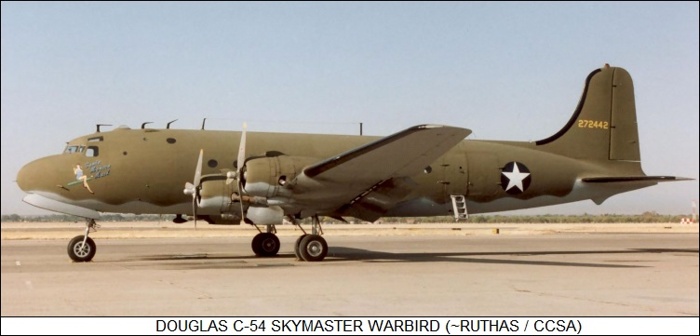

[[1] DC-4 ORIGINS](http://www.airvectors.net/avdc4.html#m1)  
[[2] DC-4 PRODUCTION VARIANTS / DC-4 IN SERVICE](http://www.airvectors.net/avdc4.html#m2)  
[[3] C-54 SPECIAL MODIFICATIONS / CANADAIR NORTH STAR / CARVAIR](http://www.airvectors.net/avdc4.html#m3)  
[[4] DC-6](http://www.airvectors.net/avdc4.html#m4)  
[[5] DC-7](http://www.airvectors.net/avdc4.html#m5)  
[[6] COMMENTS, SOURCES, & REVISION HISTORY](http://www.airvectors.net/avdc4.html#m6)

## [1] DC-4 ORIGINS

\* In 1935, in response to a requirement from United Air Lines, the Douglas firm began work on a four-engine airliner to follow the company's twin-engine DC-3. The new airliner, of course the "DC-4", was to have twice the passenger capacity of the DC-3, with 42 passenger seats, or 30 seats as a sleeper transport, along with cabin pressurization and climate control.

The prototype performed its first flight on 9 June 1938. It was low-wing aircraft, made mostly of aircraft aluminum alloy, with a triple-fin tail; power-boosted controls; four radial engines; and tricycle landing gear, at the time an innovation. Length was 29.74 meters (97 feet 7 inches), wingspan was 42.14 meters (138 feet 3 inches), and empty weight was 19,305 kilograms (42,565 pounds). Powerplants were Pratt & Whitney (P&W) Twin Hornet 14-cylinder two-row air-cooled radials, providing 1,080 kW (1,450 kW) each. The engines were toed out slightly to improve engine-out handling; three tailfins were used to ensure that the aircraft could keep flying more or less straight if both engines on one wing went down.

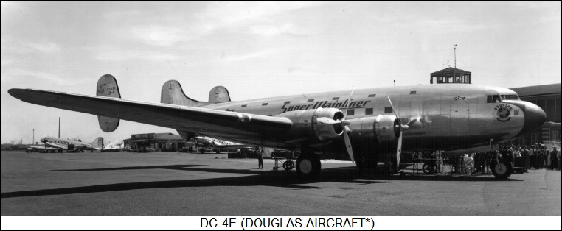

Service evaluation by United showed that the DC-4 was underpowered, as well as overly complicated, making it expensive to maintain. In response to requests from United and Eastern Air Lines, Douglas decided to simplify and downsize the design, again giving it the designation of "DC-4", with the original DC-4 being retroactively designated the "DC-4E", with "E" for "experimental". The DC-4E was sold off to Imperial Japanese Airways, which at the time was being used as a "front" operation by the Japanese government to obtain advanced aeronautical technologies from other countries for evaluation. The DC-4E was reverse-engineered, to be used as the basis for the Nakajima G5N heavy bomber, which did not enter production.

\* While design work on the "new" DC-4 proceeded, World War II broke out, and US aircraft manufacturers switched to military production. The US Army Air Forces (USAAF) liked the DC-4 design and decided to bring it into the service inventory as the "C-54 Skymaster", the US Navy to also obtain it as the "R5D". The first C-54 performed its initial flight on 14 February 1942.

The C-54 retained the same general configuration as the DC-4E, but it was generally a new design. It was somewhat scaled down -- with a passenger capacity of 42 seats, shorter span and length, empty weight being reduced to 90% of the DC-4E -- and had a single tailfin instead of the triple-fin tail. Pressurization was also eliminated. The wings had three spars, a dihedral, and were of tapered planform; each wing had a one-piece single-slotted flap inboard and an aileron outboard, with a trim tab on the right aileron. Tail flight controls were conventional, elevators and rudder, with the tailfin featuring a forward fin fillet and the rudder featuring a trim tab. Although the wing had all-metal flight control surfaces, the tail surfaces had metal frames with fabric covering. Most photos of DC-4s show them to have leading-edge pneumatic de-icing boots, but some photos don't show the boots; it is unclear which production had them and which did not.

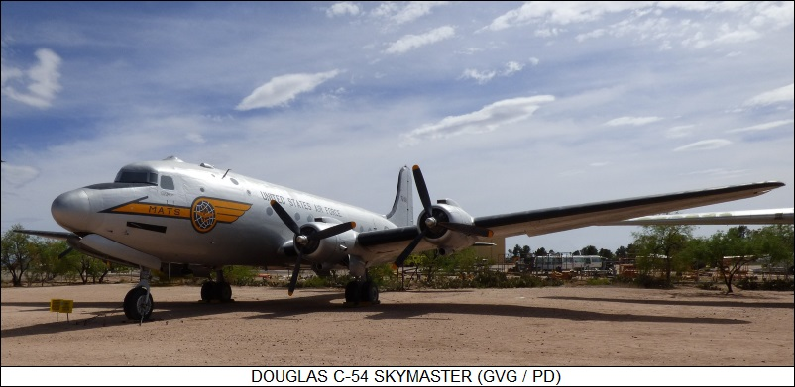

The C-54 was powered by P&W R-2000-3 Twin Wasp engines providing 1,010 kW (1,350 HP) takeoff power, 820 kW (1,100 HP) at low altitude, and 750 kW (1,000 HP) at high altitude, driving three-bladed Hamilton Standard variable pitch propellers. There were integral wing fuel tanks and four fuel tanks in the fuselage, providing a total fuel capacity of 13,568 liters (3,580 US gallons). The fuselage tanks were additions from the baseline DC-4 to the militarized C-54, the military needing more range; all tanks were also self-sealing, another clearly military feature.

The steerable nose landing gear had a single wheel and retracted forward; each main gear had twin wheels, and retracted forward into the inboard engine nacelle. There was a bumper under the rear fuselage to protect against tail strikes. Avionics were typical for the era, including analog instrumentation; radio; radio compass; and, in time, presumably identification friend or foe (IFF) transponder, as well as improved navigation aids, refitted as they were introduced in the course of the war. There was an astrodome behind the cockpit for taking navigation sightings.

**DOUGLAS C-54A SKYMASTER:**

**\_\_\_\_\_\_\_\_\_\_\_\_\_\_\_\_\_\_\_\_\_ \_\_\_\_\_\_\_\_\_\_\_\_\_\_\_\_\_ \_\_\_\_\_\_\_\_\_\_\_\_\_\_\_\_\_\_\_\_\_\_\_**

**spec metric english**

**\_\_\_\_\_\_\_\_\_\_\_\_\_\_\_\_\_\_\_\_\_ \_\_\_\_\_\_\_\_\_\_\_\_\_\_\_\_\_ \_\_\_\_\_\_\_\_\_\_\_\_\_\_\_\_\_\_\_\_\_\_\_**

**wingspan 35.81 meters 117 feet 6 inches**

**wing area 135.9 sq\_meters 1,463 sq\_feet**

**length 28.63 meters 93 feet 11 inches**

**height 8.39 meters 27 feet 6 inches**

**empty weight 17,235 kilograms 38,000 pounds**

**max takeoff weight 33,110 kilograms 73,000 pounds**

**cruise speed 385 KPH 240 MPH / 210 KT**

**service ceiling 6,700 meters 22,000 feet**

**range with full load\* 4,025 kilometers 2,500 MI / 2,175 NMI**

**\_\_\_\_\_\_\_\_\_\_\_\_\_\_\_\_\_\_\_\_\_ \_\_\_\_\_\_\_\_\_\_\_\_\_\_\_\_\_ \_\_\_\_\_\_\_\_\_\_\_\_\_\_\_\_\_\_\_\_\_\_\_**

**\* Full load of 26 passengers or 4,355 kilograms (9,600 pounds)**

**Range with partial load was 4,800 kilometers (3,000 miles).**

There were typically six crew, including pilot, co-pilot, radio operator, navigator, and two relief crew. There was a rest compartment with toilet and bunks behind the cockpit. There was a lavatory, wardrobe, and buffet in the rear for passenger use. There was a passenger door in the rear on the left, a crew door up front on the right, and emergency exit windows placed near the front and back of the wing on both side. There were oval windows running up the sides. The initial C-54 was strictly a personnel transport, with 26 seats; it is unclear why the number of seats was so far below design, one possibility being a tradeoff with fuel. There were inflatable life rafts for crew and passengers, as well as personal emergency oxygen supplies.