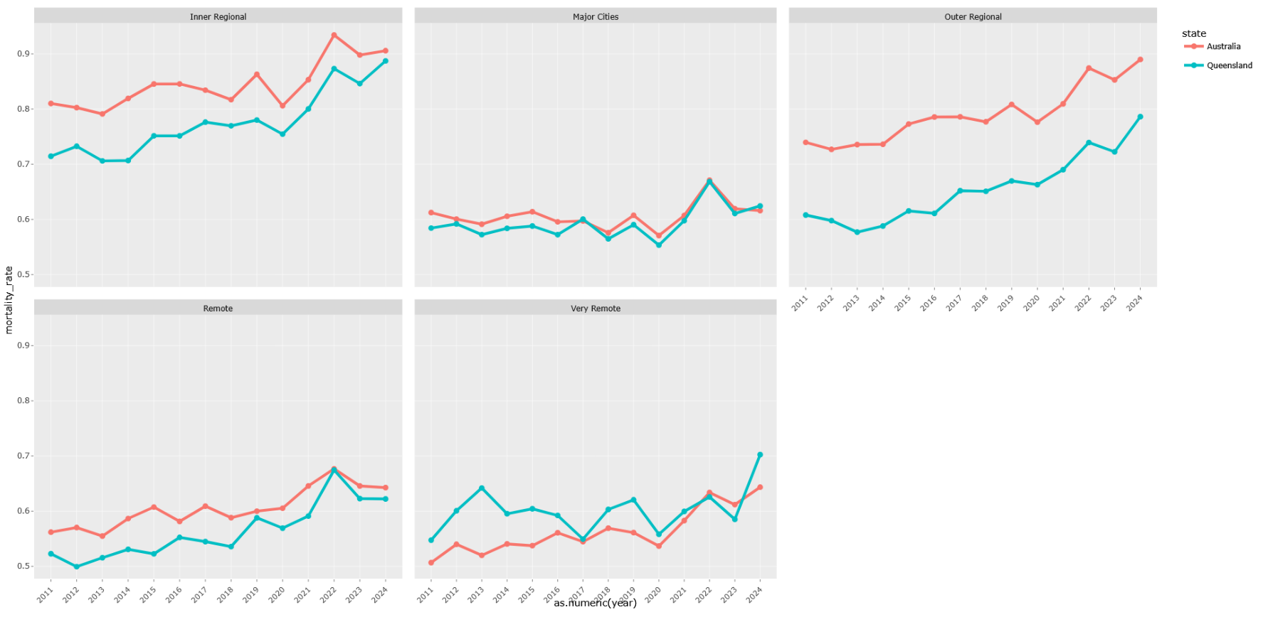
Mortality Rates vary by Remoteness Area and over time between Queensland to Australia
Figure 1 – Mortality Rates varying over time between 2011 to 2024 by remoteness area Queensland to Australia
Figure 1 presents temporal trends in crude mortality rates between 2011 and 2024 across remoteness areas in Queensland and Australia.
The formula of mortality rate is defined as
$MortalityRate= \frac{Deaths_no. }{Total Resident Population (persons)}×100\%$ (1)
Overall, mortality rates exhibit a broadly similar temporal pattern across jurisdictions, characterised by gradual fluctuations followed by a marked increase during the COVID-19 pandemic period. This suggests that large-scale systemic factors, such as pandemic-related health system pressures and population-level exposure risks, affected both Queensland and Australia in comparable ways. However, small but persistent differences between jurisdictions are evident within specific remoteness categories. In several areas, particularly Outer Regional regions, mortality rates in Australia remain consistently higher than in Queensland, indicating potential variation in demographic composition, health service accessibility, or underlying disease burden.
The temporal analysis further demonstrates that the most pronounced increase in mortality occurred between 2021 and 2022 arise of 0.83% in Australia and 0.752% in Queensland for Inner Regional, corresponding with the peak pandemic period.
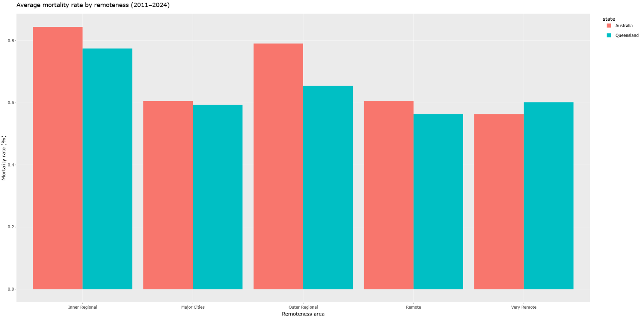
This pattern is observed across all remoteness categories, highlighting the widespread population health impact of COVID-19. While mortality rates stabilised or declined slightly after this period, they did not fully return to pre-pandemic trajectories in all regions, suggesting possible lagged effects such as delayed healthcare utilisation, long-term complications, or demographic shifts including mortality displacement among vulnerable populations.
Figure 2 – 2011 to 2024 Average Mortality Rate by Remoteness
Figure 2 presents the average crude mortality rate between 2011 and 2024 across remoteness areas for Queensland and Australia. A clear spatial gradient in mortality is evident, with mortality rates generally increasing with greater geographic remoteness. In Remote areas, the difference between jurisdictions narrows but remains evident, with Australia recording an average mortality rate of approximately 0.61% compared with 0.56% in Queensland, corresponding to a difference of 0.05 percentage points. However, the pattern reverses in Very Remote areas, where Queensland exhibits higher mortality (approximately 0.60%) compared with Australia (0.56%), representing a relative excess of about 0.04 percentage points. This suggests that while Queensland generally performs better than the national average in moderately remote regions, it may experience comparatively worse outcomes in the most geographically isolated communities.
Importantly, the magnitude of differences across remoteness categories is larger than the differences between Queensland and Australia within the same category. For example, within Australia, mortality increases from approximately 0.61% in Major Cities to 0.85% in Inner Regional areas, representing a gradient of around 0.24 percentage points. This spatial disparity exceeds most jurisdictional differences, indicating that geographic inequality is a more substantial determinant of mortality variation than state-level context alone. Such findings align with established public health evidence linking remoteness with reduced healthcare accessibility, higher prevalence of chronic disease risk factors, and socioeconomic disadvantage.
Taken together, these results highlight the persistent influence of structural geographic inequality on mortality outcomes in Australia. While Queensland generally demonstrates slightly lower mortality rates than the national average in several remoteness categories, the overall gradient indicates that residents in more remote areas face systematically higher mortality risks. These findings underscore the importance of targeted health policy interventions aimed at reducing spatial disparities in health service provision and addressing broader social determinants of health.

