Predicting Churn out Model

Pranjul Gupta

25 January 2018

Contents

1 | Introduction |  |  | 2
 | 1.1 | Problem Statement . . . . . . . . . . . . . . . . . . . . . . . . . . . . . . . . . . . . . . . . . . |  | 2
 | 1.2 | Data . | . . . . . . . . . . . . . . . . . . . . . . . . . . . . . . . . . . . . . . . . . . . . . . . . . | 2
2 | Methodology |  |  | 4
 | 2.1 | Pre Processing . . . . . . . . . . . . . . . . . . . . . . . . . . . . . . . . . . . . . . . . . . . . |  | 4
 |  | 2.1.1 | Outlier Analysis . . . . . . . . . . . . . . . . . . . . . . . . . . . . . . . . . . . . . . . | 4
 |  | 2.1.2 | Feature Selection . . . . . . . . . . . . . . . . . . . . . . . . . . . . . . . . . . . . . . . | 10
 | 2.2 | Modeling . . . . . . . . . . . . . . . . . . . . . . . . . . . . . . . . . . . . . . . . . . . . . . . |  | 12
 |  | 2.2.1 | Model Selection . . . . . . . . . . . . . . . . . . . . . . . . . . . . . . . . . . . . . . . . | 12
 |  | 2.2.2 | Multiple Linear Regression . . . . . . . . . . . . . . . . . . . . . . . . . . . . . . . . . | 12
 |  | 2.2.3 | Regression Trees . . . . . . . . . . . . . . . . . . . . . . . . . . . . . . . . . . . . . . . | 14
 |  | 2.2.4 | Classification . . . . . . . . . . . . . . . . . . . . . . . . . . . . . . . . . . . . . . . . . | 14
3 | Conclusion |  |  | 15
 | 3.1 | Model Evaluation . . . . . . . . . . . . . . . . . . . . . . . . . . . . . . . . . . . . . . . . . . . |  | 15
 |  | 3.1.1 | Mean Absolute Error (MAE) . . . . . . . . . . . . . . . . . . . . . . . . . . . . . . . . | 15
 |  | 3.1.2 | Mean Squared Error (MSE) . . . . . . . . . . . . . . . . . . . . . . . . . . . . . . . . . | 15
 | 3.2 | Model Selection . . . . . . . . . . . . . . . . . . . . . . . . . . . . . . . . . . . . . . . . . . . . |  | 16
Appendix A - Extra Figures |  |  |  | 17
Appendix B - R Code |  |  |  | 23
 |  | Red Wine Muliple Histograms (Fig: 2.1) . . . . . . . . . . . . . . . . . . . . . . . . . . . . . . |  | 23
 |  | Red Wine Histograms with Means (Fig: 2.2) . . . . . . . . . . . . . . . . . . . . . . . . . . . |  | 23
 |  | White Wine Muliple Histograms (Fig: 3.1) . . . . . . . . . . . . . . . . . . . . . . . . . . . . |  | 23
 |  | Red Wine Boxplots (Fig: 2.3) . . . . . . . . . . . . . . . . . . . . . . . . . . . . . . . . . . . . |  | 23
 |  | Eﬀect of Outliers (Fig: 2.4) . . . . . . . . . . . . . . . . . . . . . . . . . . . . . . . . . . . . . |  | 24
 |  | White Wine Boxplots (Fig: 3.2) . . . . . . . . . . . . . . . . . . . . . . . . . . . . . . . . . . . |  | 25
 |  | Complete R File . . . . . . . . . . . . . . . . . . . . . . . . . . . . . . . . . . . . . . . . . . . |  | 25
References |  |  |  | 29

1

Chapter 1

Introduction

1.1 Problem Statement

Predicting the churning out rate of customer for Telecom Company according to user’s behavior dependent on their usage of calls, minutes and other attributes. Churn out meaning is the no. of customer we are losing each year. The aim of the model is to predict customer churn out, and reducing the cost to get a new customer, in fact getting a new customer is more expensive comparing to keeping the old one. With analytics concept we can predict for customer, which have probability to leave the company. We can give those customer extra support and attention.

1.2 Data

Our task is to build classification models which will classify the churn out of customer depending on multiple call usage factors. Given below is a sample of the data set that we are using to predict the churning out of the customer:

Table 1.1: Churning Out Sample Data (Columns: 1-8)

state | account length | area code | phone number | international plan | voice mail plan | number vmail messages
KS | 128 | 415 | 382-4657 | no | yes | 25
OH | 107 | 415 | 371-7191 | no | yes | 26
NJ | 137 | 415 | 358-1921 | no | no | 0
OH | 84 | 408 | 375-9999 | yes | no | 0
OK | 75 | 415 | 330-6626 | yes | no | 0
AL | 118 | 510 | 391-8027 | yes | no | 0
MA | 121 | 510 | 355-9993 | no | yes | 24
MO | 147 | 415 | 329-9001 | yes | no | 0
LA | 117 | 408 | 335-4719 | no | no | 0

Table 1.2: Churning Out Sample Data (Columns: 9-16)

total day minutes | total day calls | total day charge | total eve minutes | total eve calls | total eve charge | total night minutes | total night calls
265.1 | 110 | 45.07 | 197.4 | 99 | 16.78 | 244.7 | 91
161.6 | 123 | 27.47 | 195.5 | 103 | 16.62 | 254.4 | 103
243.4 | 114 | 41.38 | 121.2 | 110 | 10.3 | 162.6 | 104
299.4 | 71 | 50.9 | 61.9 | 88 | 5.26 | 196.9 | 89
166.7 | 113 | 28.34 | 148.3 | 122 | 12.61 | 186.9 | 121
223.4 | 98 | 37.98 | 220.6 | 101 | 18.75 | 203.9 | 118
218.2 | 88 | 37.09 | 348.5 | 108 | 29.62 | 212.6 | 118
157 | 79 | 26.69 | 103.1 | 94 | 8.76 | 211.8 | 96
184.5 | 97 | 31.37 | 351.6 | 80 | 29.89 | 215.8 | 90

Table 1.3: Churning Out Sample Data (Columns: 16-21)

total night charge | total intl minutes | total intl calls | total intl charge | number customer service calls | Churn
11.01 | 10 | 3 | 2.7 | 1 | False.
11.45 | 13.7 | 3 | 3.7 | 1 | False.
7.32 | 12.2 | 5 | 3.29 | 0 | False.
8.86 | 6.6 | 7 | 1.78 | 2 | False.
8.41 | 10.1 | 3 | 2.73 | 3 | False.
9.18 | 6.3 | 6 | 1.7 | 0 | False.
9.57 | 7.5 | 7 | 2.03 | 3 | False.
9.53 | 7.1 | 6 | 1.92 | 0 | False.
9.71 | 8.7 | 4 | 2.35 | 1 | False.

Table 1.4: Churning Out predictor Variables

Serial no. | Predictor Variable
1 | state
2 | account length
3 | area code
4 | phone number
5
  Total night charge
6
  total intl
7
  international plan
8
  total intl call
9
  total intl charge
10
  number customer service calls
11
  voice mail plan
12 | number vmail messages
14
  total day minutes
15
  total day calls
16
  total day charge
17
  total eve minutes
18
  total eve calls
19
  total eve charge
20
  total night minutes
21 | total night calls

3

Chapter 2

Methodology

2.1 Pre Processing

Preprocessing is very important part of any predictive analysis, we need to select right data for the model. If you choose data which is biased and supporting some special cases, so it will generate biased and inaccurate results. We can’t choose right data just looking on it, so we used analysis methods and graphs to see the right data for model. We use box plot, histogram, scatter plot and various graph for this, we are using the term Exploratory Data Analysis for all these process.

In figure 2.1, we have plotted PDF (probability density function) for each numeric variable which are actually affecting the result of churning out customers, we can see some variable are skewed, some are left and right skewed. In the graphs, we have histograms, and the blue line showing density graph overall the data. Which are normally distributed, we will see that data have low stats at starting and high in mid, again low at edges. We need to closely watch data for model

2.1.1 Outlier Analysis

We can clearly observe the predictive variables are skewed, for example “total day calls”, “total eve calls”, “total night calls”, “total night calls”. We can see the probability distribution and mean of these is changed because of these outliers. And we can see the in plots. So these are affecting the result of actual model in last, so we need to handle these things without affecting the actual intent of result. The blue line for PDF, and red for mean distribution.

Various methods for outliers, one of the other steps of pre-processing apart from checking for normality is the presence of outliers. In this case we use a classic approach of removing outliers. We visualize the outliers using boxplots.

- In Statistics, Kernel Density Estimations is a non-parametric way to estimate the Probability Density Function. Using KDE inferences about the population are made based on the finite data sample.
²In Tukey’s Method, outliers have been defined as the data points which are ±1.5SD, and should be removed from the data. It was given by J. W. Tukey in his famous 1977 book Exploratory Data Analysis

4

 | 0.3 |  |  |  |  | 2.0 |  |  |  | 3.0
Density | 0.1 0.2 |  |  |  | Density | 1.0 |  |  | Density | 1.0 2.0
 | 00. |  |  |  |  | 0.0 |  |  |  | 0.0
 | 4 | 6 | 8 | 10 | 14 |  | 0.5 | 1.0 | 1.5 | 0.0 | 0.2 | 0.4 | 0.6 | 0.8 | 1.0
 |  |  | Fixed Acidity |  |  |  | Volatile Acidity |  |  |  |  | Citric Acid
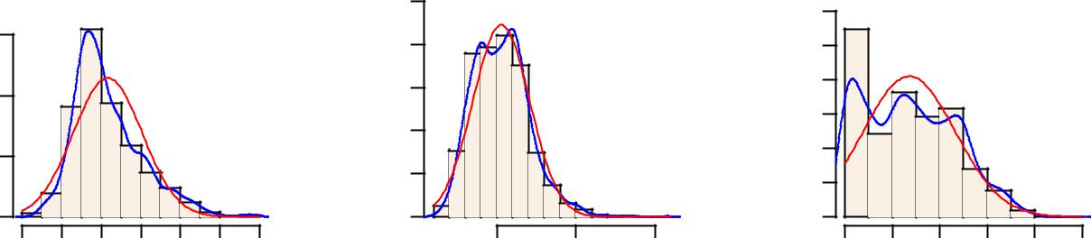

 |  |  |  |  |  | 35 |  |  |  |  | 0.06
Density | 4 80.0. |  |  |  | Density | 15 25 |  |  |  | Density | 0. 0.0402
 |  |  |  |  |  | 5 |  |  |  |  | 0.00
 | 00. |  |  |  |  | 0 |  |  |  |  | 0.00
 | 0 | 5 | 10 | 15 |  | 0.0 | 0.2 | 0.4 | 0.6 |  | 0 | 20 | 40 | 60
 |  | Residual Sugar |  |  |  |  | Chlorides |  |  |  |  | Free Sulphurdioxide
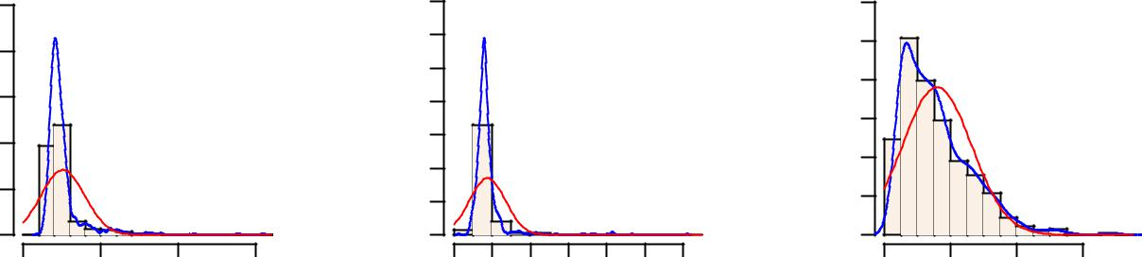

 | 0200. |  |  |  |  | 250 |  |  |  | 3.0
Density | 0100. |  |  |  | Density | 150 |  |  | Density | 1. 2.00
 | 0000. |  |  |  |  | 50
 | 0000. |  |  |  |  | 0 |  |  |  | 0.0
 | 0 | 50 | 150 | 250 |  | 0.990 | 0.996 | 1.002 |  | 2.8 | 3.2 | 3.6 | 4.0
 |  | Total Sulfurdioxide |  |  |  |  | Density |  |  |  |  | pH
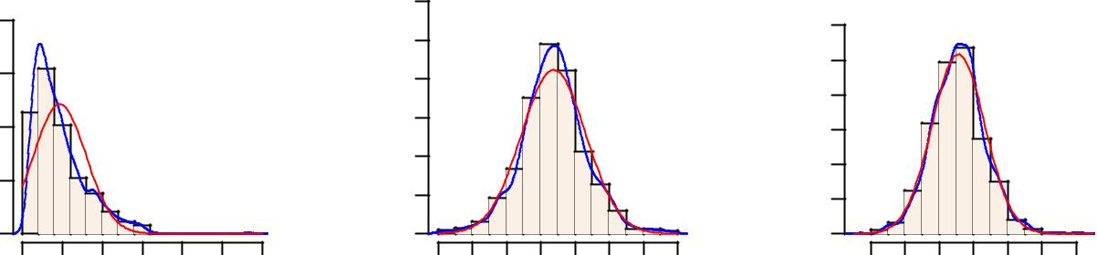

 | 4 |  |  |  |  | 0.6 |  |  |  |  |  | 1.2
Density | 1 2 3 |  |  |  | Density | 0. 0.42 |  |  |  |  | Density | 0. 0.84
 | 0 |  |  |  |  | 0.0 |  |  |  |  |  | 0.0
 | 0.5 | 1.0 | 1.5 | 2.0 |  | 8 | 9 | 11 | 13 | 15 |  | 3 | 4 | 5 | 6 | 7 | 8
 |  | Sulphates |  |  |  |  |  | Alcohol |  |  |  |  |  | Quality
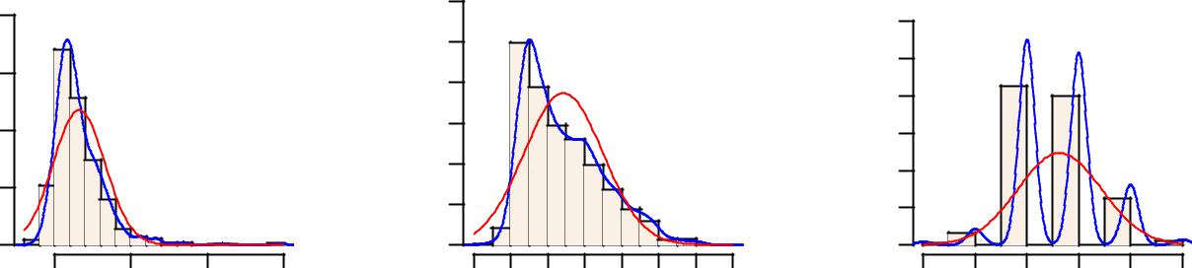

Figure 2.1: Probability Density Functions of churning out model (See R code in Appendix) 5

Histogram and Mean of Residual Sugar
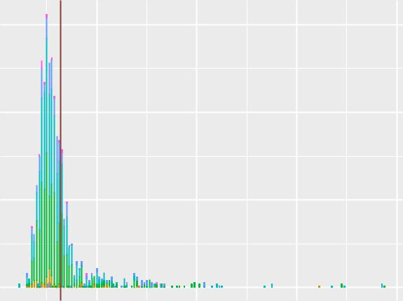

Histogram and Mean of Chlorides
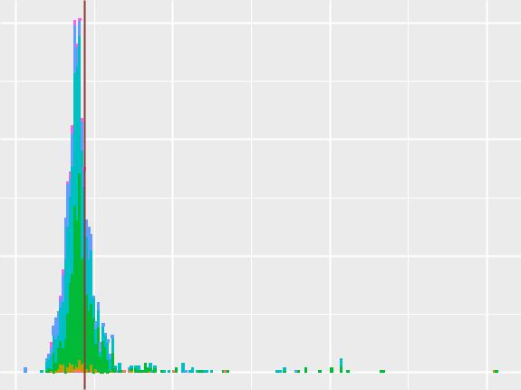

150

100

Frequency

50

0

 | 40
 | 30
Frequency | 20
 | 10
 | 0

4 8 12

Residual Sugar

Histogram and Mean of Total Sulfurdioxide

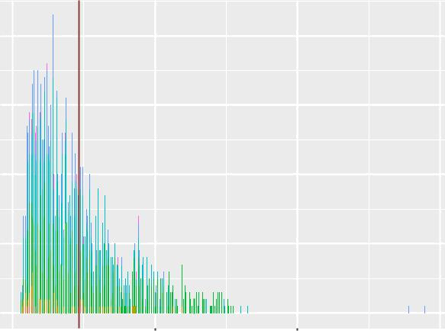

Quality

 | 3
 | 4 | Frequency
 | 5 | Frequency
 | 6
 | 7
 | 8

16

Quality

 | 3
 | 4 | Frequency
 | 5
 | 6
 | 7
 | 8

150

100

50

0

0.0

60

40

20

0

Quality

3
4
5
6
7
8

0.2 0.4 0.6
Chlorides
Histogram and Mean of Sulphates
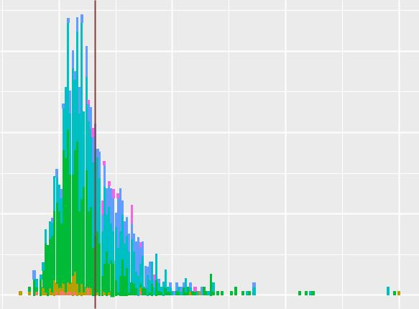

Quality

3
4
5
6
7
8

0

- 200

Total Sulfurdioxide

300 0.5 1.0 1.5 2.0

Sulphates

Figure 2.2: Histogram and Mean of Predictor Variables

6

Other useful inferences can also be drawn from these plots. For example, if we see from the diagrams, the box plots are for true and false value are differently plotted, in false category the no. of outliers are more than true category, also mean and coordinates are different. Some of them are very close, like charges and minutes have parallel proportionate, if minutes increases the charge will also increase. Plotting the phone will not affect the target.
Quality Boxplots for Each Predictor

16

12

8

Values | 0.6
Physico−chemical | 0.6
Physico−chemical | 0.4
 | 0.2
 | 0.0

4.0

3.5

3.0

Fixed Acidity | Volatile Acidity | Citric Acid | 16 | Residual Sugar
 | 1.6 | 1.00 | 16
 | 1.2 | 0.75 | 12
 | 0.8 | 0.50 | 8
 | 0.4 | 0.25 | 4
 |  | 0.00 |  | Quality
Chlorides | Free Sulphurdioxide | Total Sulfurdioxide |  | Density
 |  | 300 |  | 3
 | 60 | 200 | 1.000 | 4
 | 40 | 200 |  | 5
 | 20 | 100 | 0.995 | 6
 | 0 | 0 | 0.990 | 7
pH | Sulphates | Alcohol |  | 8
 | 2.0 | 14
 | 1.5 | 12
 | 1.0 | 12
 | 0.5 | 10
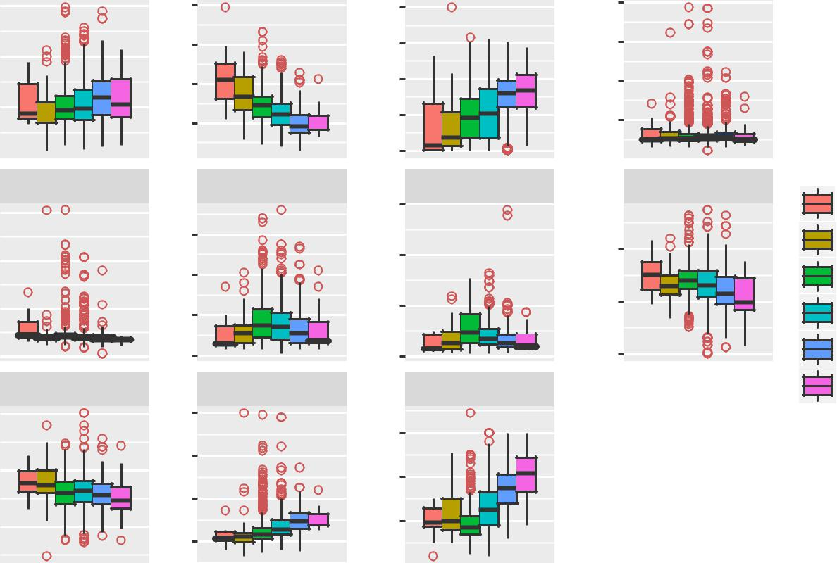

Predictor Variables

Figure 2.3: Churn vs Predictor Boxplots for True and False (See R code in Appendix)

You can see in figure 2.4 what eﬀect outliers have on the normalisation of our data. Similar graphs can be seen in the appendix (Figures 3.3, 3.4, 3.5, 3.6, 3.7, 3.8, 3.9)

After performing outlier Analysis and removing outliers using Tukey’s Boxplot Method, We plot the Predictor vs Quality boxplots again. You can compare the diﬀerences in Fig:2.5 for Red Wine and Fig:2.6 for White Wine

7

Effect of 155 ( 9.7 %) Outliers on Residual Sugar
With Outliers |  | With Outliers
15 | 0.4
5 | 0.0
 | 0 | 5 | 10 | 15
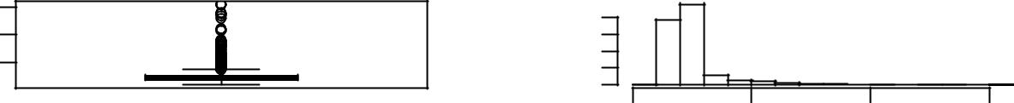

Without outliers |  | Without outliers
3.0 | 0.8
01. | 0.0
 | 1.0 | 1.5 | 2.0 | 2.5 | 3.0 | 3.5
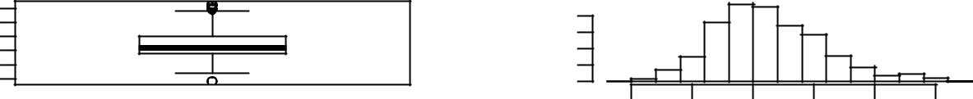

Figure 2.4: Eﬀect of Outlier on a Predictor Variable of Red Wine (See R code in Appendix)

Quality Boxplots for Each Predictor

Physico−chemical Values

11

9

7

5

0.12

0.10

0.08

0.06

0.04

3.7

3.5

3.3

3.1

Fixed Acidity | Volatile Acidity | Citric Acid | Residual Sugar
 | 1.00
 | 0.75 | 0.6 | 3
 | 0.50 | 0.4
 | 0.50 |  | 2
 |  | 0.2 | 2
 | 0.25 | 0.2
 | 0.25 | 0.0
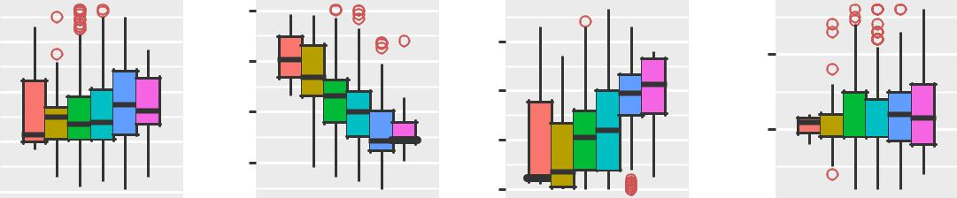
Quality
Chlorides | Free Sulphurdioxide | Total Sulfurdioxide |  | Density
 | 40 | 125 | 1.000 | 3
 | 40 | 100 | 1.000
 |  | 100 | 1.000 | 4
 | 30 | 100 | 0.998 | 4
 | 30 | 75 | 0.998
 |  | 75 | 0.998 | 5
 | 20 | 75 |  | 5
 | 20 |  | 0.996 | 5
 | 20 | 50 | 0.996
 |  | 50 | 0.996 | 6
 | 10 | 25 | 0.994 | 6
 | 10 | 25 | 0.994 | 7
 | 0 |  | 0.992 | 7
pH | Sulphates | Alcohol |  | 8
 | 1.0 | 13
 | 0.8 | 12
 | 0.6 | 11
 | 0.6 | 10
 | 0.4 | 9

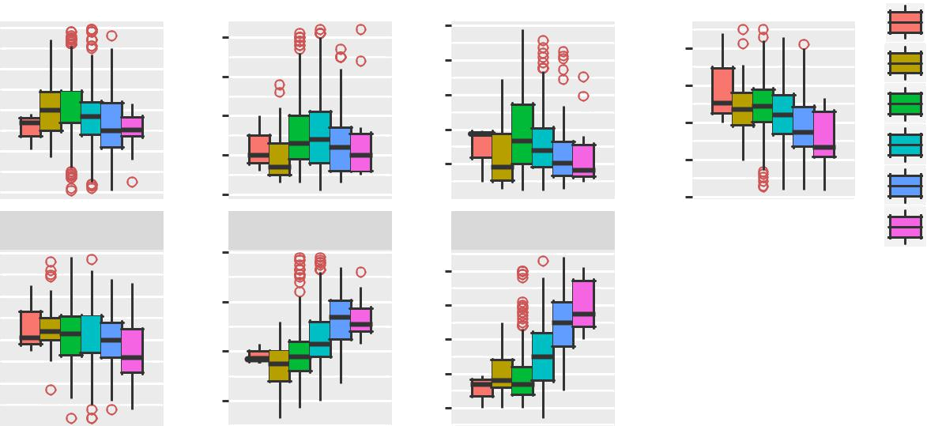

Predictor Variables

Figure 2.5: Quality vs Predictor Boxplots for Red Wine Predictors After Outlier Removal

8

Quality Boxplots for Each Predictor

 | 9
 | 8
 | 7
 | 6
Values | 5
Values | 0.06
Physico−chemical | 0.06
Physico−chemical | 0.04
 | 0.02

3.4

3.2

3.0

2.8

Fixed Acidity | Volatile Acidity | Citric Acid | Residual Sugar
0.5 |  | 20
0.4 | 0.5 | 20
0.4 | 0.4 | 15
0.3 | 0.4 | 15
0.3 | 0.3 | 10
0.2 | 0.3 | 10
0.2 | 0.2 | 5
0.1 | 0.1 | 0 |  | Quality
Chlorides | Free Sulphurdioxide | Total Sulfurdioxide | Density | 3
80 | 250 | 1.000 |  | 4
60 | 200 | 1.000
60 | 200 |  |  | 5
 | 150 | 0.995 |  | 5
40 | 150 | 0.995 |  | 6
40 | 100 |  |  | 6
20 | 100 | 0.990
20 | 50 | 0.990 |  | 7
0 | 50 |  |  | 7
0 |  |  |  | 8
pH | Sulphates | Alcohol |  | 9
 | 14 |  |  | 9
0.7 | 14
0.6 | 12
0.5 | 12
0.4 | 10
0.3 | 10
0.2
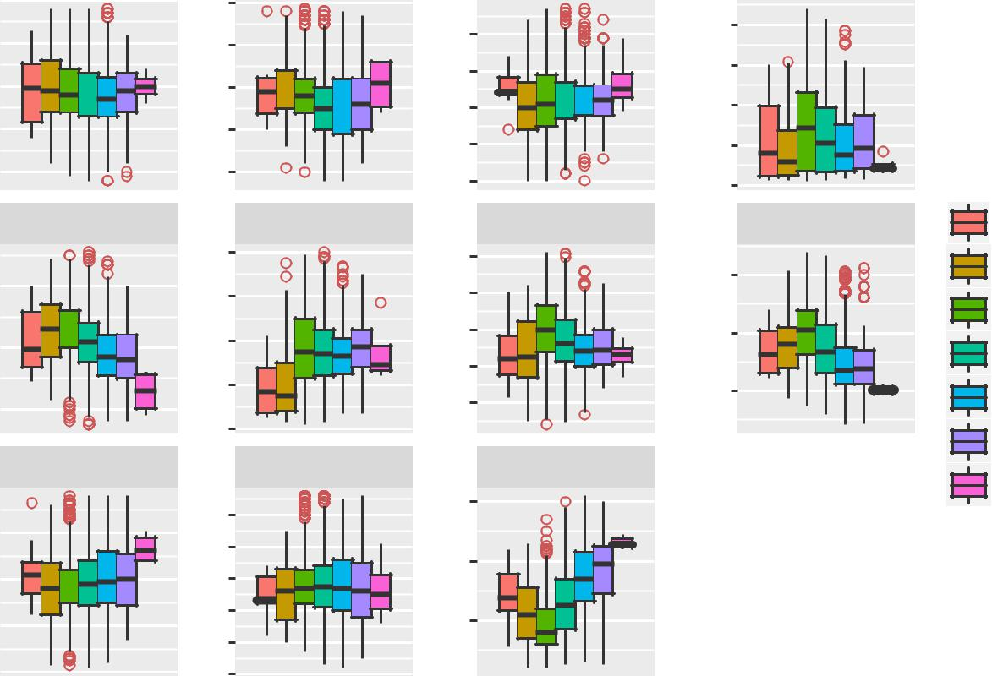
Predictor Variables

Figure 2.6: Quality vs Predictor Boxplots for White Wine Predictors After Outlier Removal

9

2.1.2 Feature Selection

Before performing any type of modeling we need to assess the importance of each predictor variable in our analysis. There is a possibility that many variables in our analysis are not important at all to the problem of class prediction. There are several methods of doing that. Below we have used Correlation plot to select the features for numeric variable and chi2square method for categorical values.

2.1.2.1 Red Wine

imppred <- randomForest(quality ~ ., data = d1,

ntree = 100, keep.forest = FALSE, importance = TRUE)

importance(imppred, type = 1)

## | %IncMSE
## fixed.acidity | 12.62263
## volatile.acidity | 19.74335
## citric.acid | 12.31410
## residual.sugar | 11.20579
## chlorides | 13.47935
- free.sulfur.dioxide 11.57610

- total.sulfur.dioxide 16.22204

## density |  | 19.82939
## pH |  | 12.67484
## | sulphates | 22.05664
## | alcohol | 24.57563

2.1.2.2 White Wine

imppred <- randomForest(quality ~ ., data = d2,

ntree = 100, keep.forest = FALSE, importance = TRUE)

importance(imppred, type = 1)

## | %IncMSE
## fixed.acidity | 23.56129
## volatile.acidity | 44.55030
## citric.acid | 30.69948
## residual.sugar | 27.37064
## chlorides | 25.41836
- free.sulfur.dioxide 46.03742

- total.sulfur.dioxide 26.67965

## density |  | 22.26679
## pH |  | 29.20979
## | sulphates | 24.42959
## | alcohol | 32.10414

One thing that becomes clear from above predictor variable importance of numeric variable is seen by correlation plot, the darkest blue section depicting that they are highly correlated, and with chi2square test we see that some of the variable have no significance in prediction. Example phone-number adding no information in prediction.

From the graph we are taking the observation graphical manner and easy to filter the data. A very simple way of looking at correlations in the data is shown below. Without much detail and at a glance you can see that Red Wine data does not any variables with higher correlation than 0.8, but Residual Sugar and Density in White wine data are highly correlated (0.8 - 0.9).

10

Red Wine

symnum(cor(d1.r))
## | FA VA CA RS C FS TS D p S A Q
## Fixed Acidity | 1
## Volatile Acidity |  | 1
## Citric Acid | , | . 1
## Residual Sugar |  | 1
## Chlorides |  |  | 1
## Free Sulphurdioxide |  |  | 1
## Total Sulfurdioxide |  |  | , | 1
## Density | , | . . |  | 1
## pH | , | . |  | . 1
## Sulphates |  | . | . |  | 1
## Alcohol |  |  |  | . | 1
## Quality |  | . |  |  | . 1
- attr(,"legend")

- [1] 0 ' ' 0.3 '.' 0.6 ',' 0.8 '+' 0.9 '*' 0.95 'B' 1

White Wine

symnum(cor(d2.r))
## | FA VA CA RS C FS TS D p S A Q
## Fixed Acidity | 1
## Volatile Acidity | 1
## Citric Acid | 1
## Residual Sugar | 1
## Chlorides |  | 1
## Free Sulphurdioxide |  | 1
## Total Sulfurdioxide | . | , | 1
## Density | + |  | . | 1
## pH | . |  |  |  | 1
## Sulphates |  |  |  |  | 1
## Alcohol | . | . | . | , | 1
## Quality |  |  |  | . | . 1
- attr(,"legend")

- [1] 0 ' ' 0.3 '.' 0.6 ',' 0.8 '+' 0.9 '*' 0.95 'B' 1

11

2.2 Modeling

2.2.1 Model Selection

In our early stages of analysis during pre-processing we have come to understand that true and false values are there, but true values are very less than false observations. As we researched online 5-10% churn is normal in telecom industry. So it is obvious to have less true values.

The dependent variable can fall in either of the four categories:

- Nominal

- Ordinal

- Interval

- Ratio

If the dependent variable, in our case Churn, is binary value (yes/no) only predictive analysis that we can perform is Classification, and if the dependent variable is Interval or Ratio the normal method is to do a Regression analysis, or classification after binning. But this data set having both kind of variable like categorical as well as numerical values. So here we applied some method to take best fit, Random forest, naïve bay’s, logistic regression.

There for we started to build a model with random forest, then applied other methods also.

2.2.2 Multiple Linear Regression

lrmodel.red <- lm(Quality ~ ., data = d1.r)

summary(lrmodel.red)

##

- Call:

- lm(formula = Quality ~ ., data = d1.r)

- Residuals:

## Min 1Q Median 3Q Max

- -2.68911 -0.36652 -0.04699 0.45202 2.02498

- Coefficients:

## | Estimate Std. Error t value |  |  | Pr(>|t|)
## (Intercept) | 2.197e+01 | 2.119e+01 | 1.036 | 0.3002
## `Fixed Acidity` | 2.499e-02 2.595e-02 |  | 0.963 | 0.3357
## `Volatile Acidity` | -1.084e+00 1.211e-01 |  | -8.948 | < 2e-16 | ***
## `Citric Acid` | -1.826e-01 1.472e-01 -1.240 |  |  | 0.2150
## `Residual Sugar` | 1.633e-02 1.500e-02 |  | 1.089 | 0.2765
## Chlorides | -1.874e+00 4.193e-01 -4.470 |  |  | 8.37e-06 | ***
## `Free Sulphurdioxide` | 4.361e-03 2.171e-03 |  | 2.009 | 0.0447 | *
## `Total Sulfurdioxide` -3.265e-03 |  | 7.287e-04 | -4.480 | 8.00e-06 | ***
## Density | -1.788e+01 | 2.163e+01 | -0.827 | 0.4086
## pH | -4.137e-01 1.916e-01 -2.159 |  |  | 0.0310 | *
## Sulphates | 9.163e-01 1.143e-01 |  | 8.014 | 2.13e-15 | ***
## Alcohol | 2.762e-01 | 2.648e-02 | 10.429 | < 2e-16 | ***
- ---

- Signif. codes: 0 '***' 0.001 '**' 0.01 '*' 0.05 '.' 0.1 ' ' 1

12

- Residual standard error: 0.648 on 1587 degrees of freedom

- Multiple R-squared: 0.3606, Adjusted R-squared: 0.3561

- F-statistic: 81.35 on 11 and 1587 DF, p-value: < 2.2e-16

As you can see the Adjusted R-squared value, we can explain only about 36% of the data using our multiple linear regression model. This is not very impressive, but at least looking at the F-statistic and combined p-value we can reject the null hypothesis that target variable does not depend on any of the predictor variables.

Looking at the significance values of some of the predictor we can see that there is some scope of improvement in this model. We can improve this multiple linear regression model using ANOVA.

kable(anova(lrmodel.red), booktabs = T)

 | Df | Sum Sq | Mean Sq | F value | Pr(>F)
‘Fixed Acidity‘ | 1 | 16.0376825 | 16.0376825 | 38.1923671 | 0.0000000
‘Volatile Acidity‘ | 1 | 143.5727497 | 143.5727497 | 341.9062054 | 0.0000000
‘Citric Acid‘ | 1 | 0.0244028 | 0.0244028 | 0.0581132 | 0.8095345
‘Residual Sugar‘ | 1 | 0.1580759 | 0.1580759 | 0.3764443 | 0.5396003
Chlorides | 1 | 13.0618667 | 13.0618667 | 31.1057168 | 0.0000000
‘Free Sulphurdioxide‘ | 1 | 2.9742159 | 2.9742159 | 7.0828404 | 0.0078611
‘Total Sulfurdioxide‘ | 1 | 30.0926593 | 30.0926593 | 71.6630904 | 0.0000000
Density | 1 | 61.3103726 | 61.3103726 | 146.0054007 | 0.0000000
pH | 1 | 7.1536526 | 7.1536526 | 17.0358108 | 0.0000386
Sulphates | 1 | 55.6965637 | 55.6965637 | 132.6365956 | 0.0000000
Alcohol | 1 | 45.6721611 | 45.6721611 | 108.7643394 | 0.0000000
Residuals | 1587 | 666.4107004 | 0.4199185 | NA | NA

lrmodel.red2 <- update(lrmodel.red, . ~ . - `Citric Acid` - `Residual Sugar`)

summary(lrmodel.red2)

##

- Call:

- lm(formula = Quality ~ `Fixed Acidity` + `Volatile Acidity` +

- Chlorides + `Free Sulphurdioxide` + `Total Sulfurdioxide` +

- Density + pH + Sulphates + Alcohol, data = d1.r)

##
## Residuals:
## | Min | 1Q | Median | 3Q | Max
- -2.69252 -0.36640 -0.04809 0.46154 2.02199

- Coefficients:

## | Estimate | Std. Error t value |  | Pr(>|t|)
## (Intercept) | 9.2835190 | 17.0048169 | 0.546 | 0.5852
## `Fixed Acidity` | 0.0032712 | 0.0219874 | 0.149 | 0.8817
## `Volatile Acidity` | -1.0096872 | 0.1020966 | -9.890 | < 2e-16 | ***
## Chlorides | -2.0099867 | 0.4045139 | -4.969 | 7.46e-07 | ***
## `Free Sulphurdioxide` | 0.0050613 | 0.0021275 | 2.379 | 0.0175 | *
## `Total Sulfurdioxide` -0.0034664 |  | 0.0007018 | -4.939 | 8.68e-07 | ***
## Density | -4.9004699 | 17.3651139 | -0.282 | 0.7778
## pH | -0.4705130 | 0.1806878 | -2.604 | 0.0093 | **
## Sulphates | 0.8892038 | 0.1120163 | 7.938 | 3.85e-15 | ***
## Alcohol | 0.2851370 | 0.0224255 | 12.715 | < 2e-16 | ***
## ---

13

- Signif. codes: 0 '***' 0.001 '**' 0.01 '*' 0.05 '.' 0.1 ' ' 1

- Residual standard error: 0.6481 on 1589 degrees of freedom

- Multiple R-squared: 0.3595, Adjusted R-squared: 0.3559

- F-statistic: 99.1 on 9 and 1589 DF, p-value: < 2.2e-16

Using ANOVA we saw that Citric Acid and Residual Sugar contribute the least for the reduction of the fitting error of the model. However removing these variables also did not change the predictive power of our regression model. Therefore, this is the maximum accuracy that we can get from this model.

2.2.3 Regression Trees

Now we will try and use a diﬀerent regression model to predict our Quality target variable. We will use a regression tree to predict the values of our target variable.

 |  |  |  |  |  |  |  | Alcohol< 10.53
Sulphates< |  |  | 0.575 |  |  |  |  | | |  |  |  |  | Sulphates< |  |  |  | 0.645
 | Volatile |  |  |  | Acidity>=0.405Volatile |  |  |  |  | Acidity>=1.015 |  |  |  |  |  |  |  |  |  | Alcohol< |  | 11.55
5.151
 |  |  |  |  |  |  |  |  | Volatile |  |  | Acidity>=0.495Volatile |  |  |  |  |  |  | Acidity>=0.395
5.404 |  |  |  |  |  | 5.833 |  | 4 |  |  |  |  |  |  |  |  |  |  |  |  | 6.652
 |  |  |  |  |  |  |  |  |  |  |  |  |  |  |  |  |  |  | pH>=3.255
 |  |  |  |  |  |  |  | 5.575 |  |  |  | 6.069 |  |  | 5.928
 |  |  |  |  |  |  |  |  |  |  |  |  |  |  | 6.068 |  |  |  |  |  | 6.806

Figure 2.7: Regression Tree for Red Wine

2.2.4 Classification

Using Classification for prediction analysis in this case is not normal, though it can be done. The reason is, the values of the target variable, quality are ranks. And Rank is not a purely categorical variable, like male, female categories because there is an order in rank. For example rank 1 is better than rank 2. Such variables are called ordinal. Though Classification predictions have been done on ordinal variables it is not a recommended approach, because the information stored in terms of the order is lost.

14

Chapter 3

Conclusion

3.1 Model Evaluation

Now that we have a few models for predicting the target variable, we need to decide which one to choose. There are several criteria that exist for evaluating and comparing models. We can compare the models using any of the following criteria:

- Predictive Performance

- Interpretability

- Computational Eﬃciency

In our case of Wine Data, the latter two, Interpretability and Computation Eﬃciency, do not hold much significance. Therefore we will use Predictive performance as the criteria to compare and evaluate models.

Predictive performance can be measured by comparing Predictions of the models with real values of the taret variables, and calculating some average error measure.

3.1.1 Mean Absolute Error (MAE)

MAE is one of the error measures used to calculate the predictive performance of the model. We will apply this measure to our models that we have generated in the previous section.

lrm.pred.red <- predict(lrmodel.red, d1.r) rt.pred.red <- predict(rtmodel.red, d1.r) mae.lrm.red <- mean(abs(lrm.pred.red - d1.r[,

12]))

mae.rt.red <- mean(abs(rt.pred.red - d1.r[, 12]))

mae.lrm.red

- [1] 0.50049 mae.rt.red

- [1] 0.5023972

3.1.2 Mean Squared Error (MSE)

MSE can be obtained as follows

(mse.lrm.red <- mean((lrm.pred.red - d1.r[, 12])^2))

## [1] 0.4167672

15

(mse.rt.red <- mean((rt.pred.red - d1.r[, 12])^2))

## [1] 0.4122482

3.2 Model Selection

We can see that both models perform comparatively on average and therefore we can select either of the two models without any loss of information.

16

Appendix A - Extra Figures

17

 | 0.6 |  |  |  |  |  | 5 6 |  |  |  | 5 6
Density | 0. 0.24 |  |  |  |  | Density | 2 3 4 |  |  | Density | 2 3 4
 |  |  |  |  |  |  | 1 |  |  |  | 1
 | 0.0 |  |  |  |  |  | 0 |  |  |  | 0
 | 4 | 6 | 8 | 10 | 14 |  | 0.0 | 0.4 | 0.8 |  | 0.0 | 0.5 | 1.0 | 1.5
 |  | Fixed Acidity |  |  |  |  |  | Volatile Acidity |  |  |  | Citric Acid
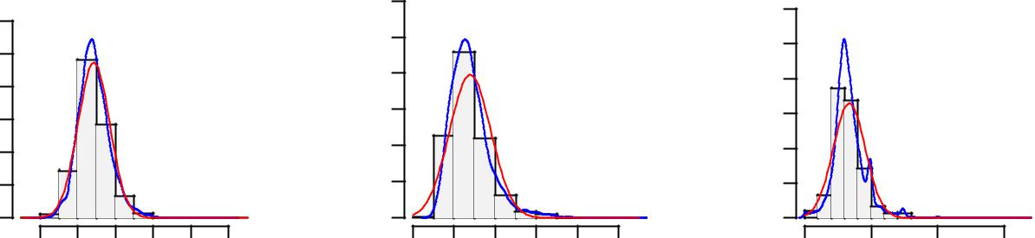

Density | 0.05 0.10 0.15 |  |  |  | Density | 10 20 30 40 |  |  |  | Density | 0.010 0.020 0.030
 | 0.00 |  |  |  |  | 0 |  |  |  |  | 0000.
 | 0 | 20 | 40 | 60 |  | 0.00 | 0.10 | 0.20 | 0.30 |  | 0 | 50 | 150 | 250
 |  | Residual Sugar |  |  |  |  | Chlorides |  |  |  |  | Free Sulphurdioxide
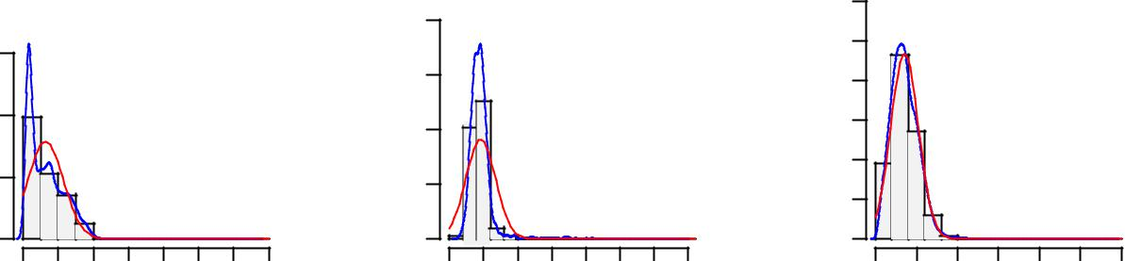

Density | 0. 0.004008 |  |  | Density | 50 100 150 |  |  | Density | 0 0 01.2.3.
 | 0.000 |  |  |  | 0 |  |  |  | 00.
 | 0 | 100 | 300 |  | 0.99 | 1.01 | 1.03 |  | 2.8 | 3.2 | 3.6
 |  | Total Sulfurdioxide |  |  |  | Density |  |  |  | pH
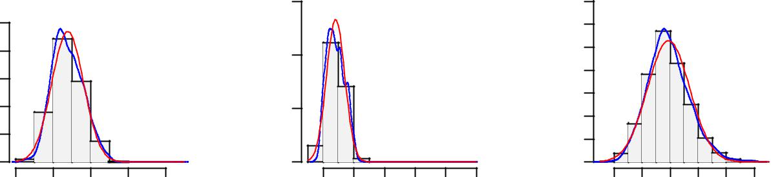

 | 5
 | 4 |  |  |  |  |  | 0.4 |  |  |  |  |  | 51.
Density | 1 2 3 |  |  |  |  | Density | 0.1 0.2 0.3 |  |  |  |  | Density | 5 00.1.
 | 0 |  |  |  |  |  | 00. |  |  |  |  |  | 00.
 | 0.2 | 0.4 | 0.6 | 0.8 | 1.0 |  | 8 | 9 | 10 | 12 | 14 |  | 3 | 4 | 5 | 6 | 7 | 8 | 9
 |  |  | Sulphates |  |  |  |  |  | Alcohol |  |  |  |  |  |  | Quality
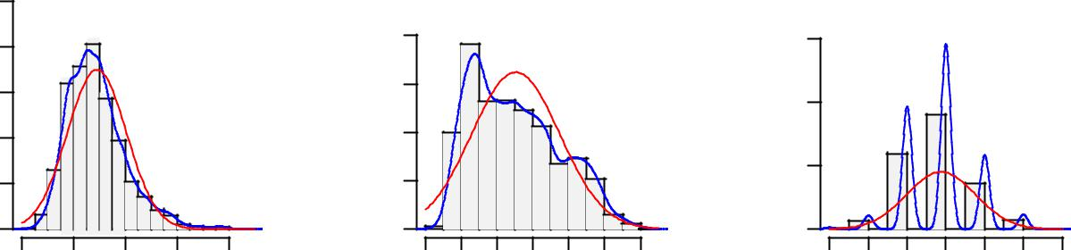

Figure 3.1: Probability Density Functions of White Wine data (See R code in Appendix) 18

Quality Boxplots for Each Predictor

12

9

6

Values | 0.3
Physico−chemical | 0.3
Physico−chemical | 0.2
 | 0.1
 | 0.0

3.6

3.3

3.0

2.7

Fixed Acidity | Volatile Acidity | Citric Acid | Residual Sugar
0.9 | 1.5 | 60
0.6 | 1.0 | 40
0.3 | 0.5 | 20
 | 0.0 | 0 |  | Quality
Chlorides | Free Sulphurdioxide | Total Sulfurdioxide | Density | 3
300 | 400 | 1.04 |  | 4
 | 400 | 1.03 |  | 4
200 | 300 | 1.03
200 | 300 | 1.02 |  | 5
100 | 200 | 1.01 |  | 6
100 | 100 | 1.00
 | 100 | 1.00 |  | 7
 |  | 0.99 |  | 7
0 | 0 | 0.99
0 | 0 |  |  | 8
pH | Sulphates | Alcohol |  | 9
 | 14 |  |  | 9
1.0 | 14
0.8 | 12
0.6 | 10
0.4 | 10
0.2 | 8
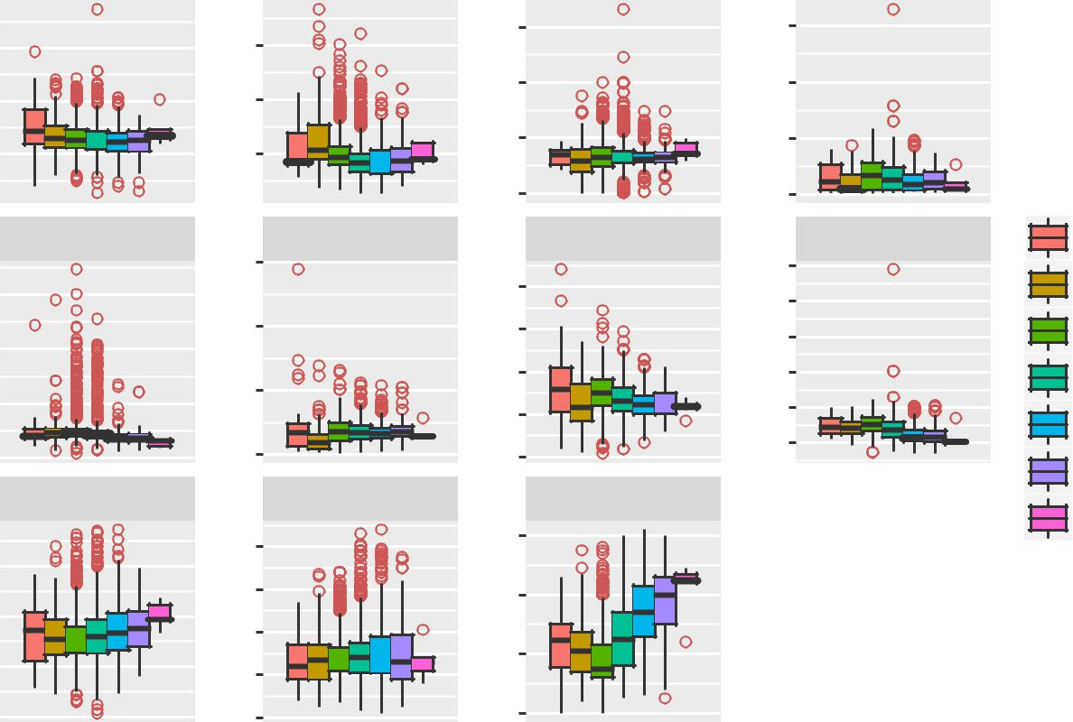
Predictor Variables

Figure 3.2: Quality Boxplots for all the Predictor Variables for White Wine (See R code in Appendix)

Effect of 112 ( 7 %) Outliers on Chlorides
With Outliers |  |  | With Outliers
0.5 | 10
00. | 0
 | 0.0 | 0.1 | 0.2 | 0.3 | 0.4 | 0.5 | 0.6
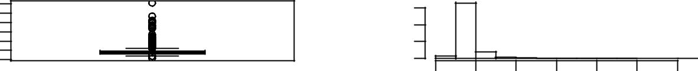

Without outliers |  | Without outliers
0.12 | 20
040. | 0
 | 0.04 | 0.06 | 0.08 | 0.10 | 0.12
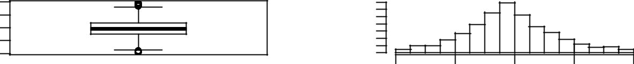

Figure 3.3: Eﬀect of Outliers on Predictor Variables of Red Wine

19

Effect of 59 ( 3.7 %) Outliers on Sulphates
With Outliers |  | With Outliers
2.0 | 2.5
0.5 | 0.0
 | 0.5 | 1.0 | 1.5 | 2.0
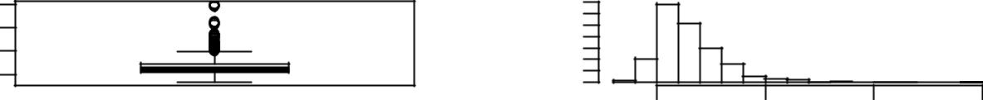

Without outliers |  | Without outliers
0.9 | 4
0.4 | 2
0.4 | 0
 | 0.3 | 0.5 | 0.7 | 0.9
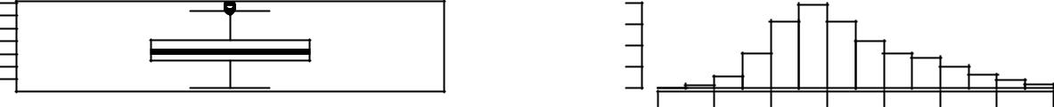

Figure 3.4: Eﬀect of Outliers on Predictor Variables of Red Wine

Effect of 119 ( 2.4 %) Outliers on Fixed Acidity
With Outliers |  | With Outliers
10 | 0.4
4 | 0.0
 | 4 | 6 | 8 | 10 | 12 | 14
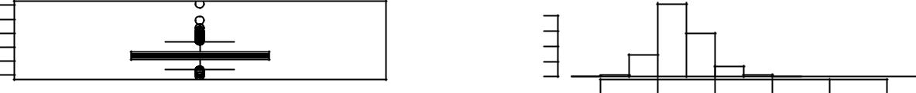

 |  | Without outliers |  |  |  |  |  |  |  |  |  |  |  |  | Without outliers
7 |  |  |  |  |  |  |  |  | 0.4
5 |  |  |  |  |  |  |  |  | 0.0
 |  |  |  |  |  |  |  |  | 5 |  |  |  |  |  | 6 |  |  |  | 7 |  |  | 8 |  |  | 9

Figure 3.5: Eﬀect of Outliers on Predictor Variables of White Wine

20

Effect of 208 ( 4.2 %) Outliers on Chlorides
With Outliers |  | With Outliers
0.30 | 15
000. | 0
 | 0.00 | 0.10 | 0.20 | 0.30
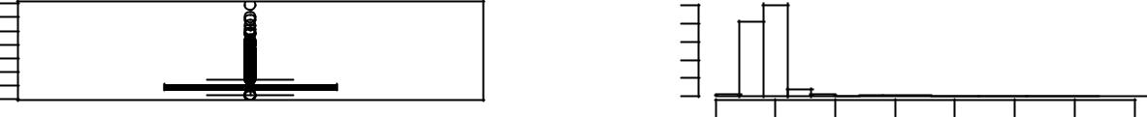

Without outliers |  |  | Without outliers
020. 0.07 | 0 20
 |  | 0.02 | 0.04 | 0.06
Figure 3.6: Eﬀect of Outliers on Predictor Variables of White Wine
Effect of 50 ( 1 %) Outliers on Free Sulphurdioxide
With Outliers |  |  | With Outliers
200 | 0.000
0 | 0.000
 | 0 | 50 | 100 | 200 | 300
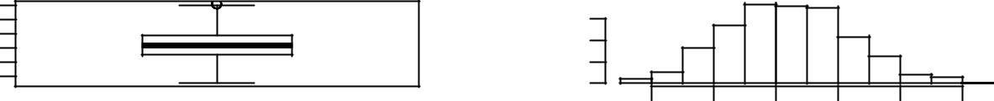
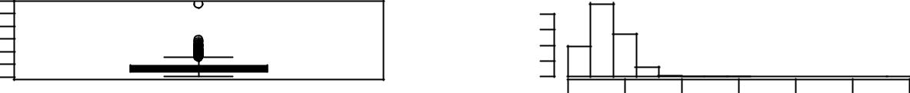

Without outliers |  | Without outliers
60
0 | 0.000
 | 0 | 20 | 40 | 60 | 80
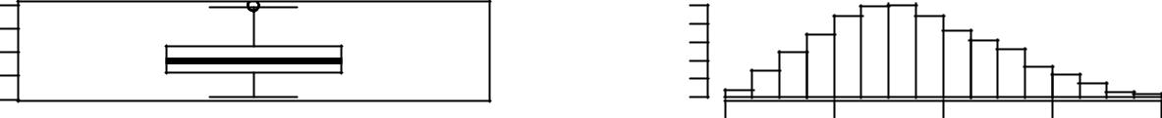

Figure 3.7: Eﬀect of Outliers on Predictor Variables of White Wine

21

 |  |  |  |  | Effect of 5 ( 0.1 %) Outliers on Density
 |  |  | With Outliers |  |  |  |  |  |  |  |  |  |  |  |  |  |  | With Outliers
99 040.1. |  |  |  |  |  |  |  |  |  | 0 60
 |  |  |  |  |  |  |  |  |  | 0.99 |  |  |  |  |  |  | 1.01 |  |  |  |  |  | 1.03

Without outliers |  | Without outliers
9900. | 0 80
 |  | 0.990 | 0.995 |  | 1.000
Figure 3.8: Eﬀect of Outliers on Predictor Variables of White Wine
Effect of 124 ( 2.5 %) Outliers on Sulphates
With Outliers |  | With Outliers
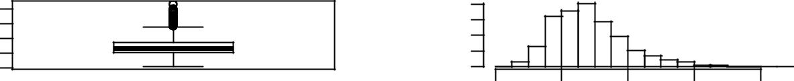  1.0 | 4
 | 2
0.2 | 0
 | 0.2 | 0.4 | 0.6 | 0.8 | 1.0
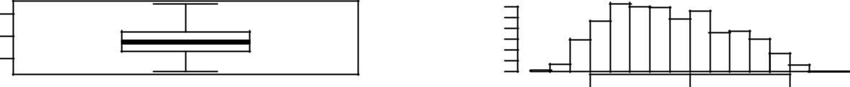

Without outliers |  | Without outliers
0.6 | 2 4
0.2 | 0
 | 0.2 | 0.3 | 0.4 | 0.5 | 0.6 | 0.7 | 0.8
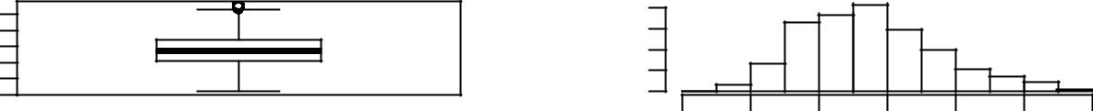

Figure 3.9: Eﬀect of Outliers on Predictor Variables of White Wine

22

Appendix B - R Code

Red Wine Muliple Histograms (Fig: 2.1)

multi.hist(d1.r, main = NA, dcol = c("blue", "red"), dlty = c("solid", "solid"), bcol = "linen")

Red Wine Histograms with Means (Fig: 2.2)

d1.b <- d1.r

d1.b[, 12] <- as.factor(d1.b[, 12])

lh <- c(4, 5, 7, 10)

bw <- c(0.05, 0.003, 0.6, 0.01)

for (i in 1:4) {

base <- ggplot(d1.b)

layering.h <- geom_histogram(aes(x = d1.b[, lh[i]], fill = Quality), binwidth = bw[i])

layering.l <- geom_vline(aes(xintercept = mean(d1.b[, lh[i]])), color = "indianred4")

theming.x <- xlab(colnames(d1.b)[lh[i]])

theming.y <- ylab("Frequency")

theming.t <- ggtitle(paste("Histogram and Mean of ", colnames(d1.b)[lh[i]], ""))

themed <- base + layering.h + layering.l +

theming.x + theming.y + theming.t

print(themed)

}

White Wine Muliple Histograms (Fig: 3.1)

multi.hist(d2.r, main = NA, dcol = c("blue", "red"),

dlty = c("solid", "solid"), bcol = "grey95")

Red Wine Boxplots (Fig: 2.3)

qboxp <- function(df) {

d1.b <- df

d1.b[, 12] <- as.factor(d1.b[, 12])

23

df.m <- melt(d1.b, id.var = "Quality")

base <- ggplot(data = df.m, aes(x = variable, y = value))

layering <- geom_boxplot(aes(fill = Quality), outlier.shape = 1, outlier.color = "indianred3")

scaling <- scale_x_discrete(breaks = NULL)

faceting <- facet_wrap(~variable, scales = "free")

theming.x <- xlab("Predictor Variables")

theming.y <- ylab("Physico-chemical Values")

theming.title <- ggtitle("Quality Boxplots for Each Predictor")

theming.facet <- theme(strip.text = element_text(size = 7),

axis.text.x = element_blank(), axis.ticks.x = element_blank())

themed <- base + layering + scaling + faceting +

theming.x + theming.y + theming.title +

theming.facet

themed

}

qboxp(d1.r)

Eﬀect of Outliers (Fig: 2.4)

outtona <- function(vl, df) {

for (i in vl) {

outlier <- boxplot.stats(df[, i])$out

df[, i] <- ifelse(df[, i] %in% outlier,

NA, df[, i])

}

return(df)

}

outliereff <- function(varlist, df) {

for (i in varlist) {

total = length(df[, i])

par(mfrow = c(2, 2), oma = c(0, 0, 3,

0))

boxplot(df[, i], main = "With Outliers")

hist(df[, i], main = "With Outliers",

xlab = NA, ylab = NA, prob = TRUE)

df <- outtona(i, df)

boxplot(df[, i], main = "Without outliers")

hist(df[, i], main = "Without outliers",

xlab = NA, ylab = NA, prob = TRUE)

out <- sum(is.na(df[, i]))

per <- round((out)/total * 100, 1)

title(paste("Effect of", out, "(", per,

"%)", "Outliers on", colnames(df)[i],

sep = " "), outer = TRUE)

}

}

outliereff(4, d1.r)

d1.on <- outtona(1:11, d1.r)

d1.f <- d1.on[complete.cases(d1.on), ]

24

d2.on <- outtona(1:11, d2.r)

d2.f <- d2.on[complete.cases(d2.on), ]

White Wine Boxplots (Fig: 3.2)

qboxp(d2.r)

Complete R File

knitr::opts_chunk$set(echo = FALSE, tidy.opts = list(width.cutoff = 45), tidy = TRUE, comment = "##")
library(knitr)

library(tidyverse)

library(xtable)

library(MASS)

library(psych)

library(reshape2)

library(randomForest)

library(rpart)

rm(list = ls())

d1 <- read.csv("./casestudy/winequality-red.csv", sep = ";")

d2 <- read.csv("./casestudy/winequality-white.csv", sep = ";")

d1.r <- dplyr::rename(d1, `Fixed Acidity` = fixed.acidity,

`Volatile Acidity` = volatile.acidity, `Citric Acid` = citric.acid, `Residual Sugar` = residual.sugar, Chlorides = chlorides,

`Free Sulphurdioxide` = free.sulfur.dioxide, `Total Sulfurdioxide` = total.sulfur.dioxide, Density = density, Sulphates = sulphates, Alcohol = alcohol, Quality = quality)

d2.r <- dplyr::rename(d2, `Fixed Acidity` = fixed.acidity,

`Volatile Acidity` = volatile.acidity, `Citric Acid` = citric.acid, `Residual Sugar` = residual.sugar, Chlorides = chlorides,

`Free Sulphurdioxide` = free.sulfur.dioxide, `Total Sulfurdioxide` = total.sulfur.dioxide, Density = density, Sulphates = sulphates, Alcohol = alcohol, Quality = quality)

head(d1.r[, 1:6]) %>% kable(caption = "Red Wine Sample Data (Columns: 1-6)", booktabs = TRUE, longtable = TRUE)
head(d1.r[, 7:12]) %>% kable(caption = "Red Wine Sample Data (Columns: 7-12)", booktabs = TRUE, longtable = TRUE)

head(d2.r[, 1:6]) %>% kable(caption = "White Wine Sample Data (Columns: 1-6)", booktabs = TRUE, longtable = TRUE)

head(d2.r[, 7:12]) %>% kable(caption = "White Wine Sample Data (Columns: 7-12)", booktabs = TRUE, longtable = TRUE)

var <- colnames(d1.r)[-ncol(d1.r)]

num <- 1:length(var)

25

df <- data.frame(S.No. = num, Predictor = var)

kable(df, caption = "Predictor Variables", booktabs = TRUE, longtable = TRUE)

multi.hist(d1.r, main = NA, dcol = c("blue", "red"), dlty = c("solid", "solid"), bcol = "linen")
d1.b <- d1.r

d1.b[, 12] <- as.factor(d1.b[, 12])

lh <- c(4, 5, 7, 10)

bw <- c(0.05, 0.003, 0.6, 0.01)

for (i in 1:4) {

base <- ggplot(d1.b)

layering.h <- geom_histogram(aes(x = d1.b[, lh[i]], fill = Quality), binwidth = bw[i])

layering.l <- geom_vline(aes(xintercept = mean(d1.b[, lh[i]])), color = "indianred4")

theming.x <- xlab(colnames(d1.b)[lh[i]])

theming.y <- ylab("Frequency")

theming.t <- ggtitle(paste("Histogram and Mean of ", colnames(d1.b)[lh[i]], ""))

themed <- base + layering.h + layering.l +

theming.x + theming.y + theming.t

print(themed)

}

qboxp <- function(df) {

d1.b <- df

d1.b[, 12] <- as.factor(d1.b[, 12])

df.m <- melt(d1.b, id.var = "Quality")

base <- ggplot(data = df.m, aes(x = variable, y = value))

layering <- geom_boxplot(aes(fill = Quality), outlier.shape = 1, outlier.color = "indianred3")

scaling <- scale_x_discrete(breaks = NULL)

faceting <- facet_wrap(~variable, scales = "free")

theming.x <- xlab("Predictor Variables")

theming.y <- ylab("Physico-chemical Values")

theming.title <- ggtitle("Quality Boxplots for Each Predictor")

theming.facet <- theme(strip.text = element_text(size = 7),

axis.text.x = element_blank(), axis.ticks.x = element_blank())

themed <- base + layering + scaling + faceting +

theming.x + theming.y + theming.title +

theming.facet

themed

}

qboxp(d1.r)

outtona <- function(vl, df) {

for (i in vl) {

outlier <- boxplot.stats(df[, i])$out

df[, i] <- ifelse(df[, i] %in% outlier,

NA, df[, i])

26

}

return(df)

}

outliereff <- function(varlist, df) {

for (i in varlist) {

total = length(df[, i])

par(mfrow = c(2, 2), oma = c(0, 0, 3,

0))

boxplot(df[, i], main = "With Outliers")

hist(df[, i], main = "With Outliers",

xlab = NA, ylab = NA, prob = TRUE)

df <- outtona(i, df)

boxplot(df[, i], main = "Without outliers")

hist(df[, i], main = "Without outliers",

xlab = NA, ylab = NA, prob = TRUE)

out <- sum(is.na(df[, i]))

per <- round((out)/total * 100, 1)

title(paste("Effect of", out, "(", per,

"%)", "Outliers on", colnames(df)[i],

sep = " "), outer = TRUE)

}

}

outliereff(4, d1.r)

d1.on <- outtona(1:11, d1.r)

d1.f <- d1.on[complete.cases(d1.on), ]

d2.on <- outtona(1:11, d2.r)

d2.f <- d2.on[complete.cases(d2.on), ]

qboxp(d1.f)

qboxp(d2.f)

imppred <- randomForest(quality ~ ., data = d1,

ntree = 100, keep.forest = FALSE, importance = TRUE)

importance(imppred, type = 1)

imppred <- randomForest(quality ~ ., data = d2,

ntree = 100, keep.forest = FALSE, importance = TRUE)

importance(imppred, type = 1)

symnum(cor(d1.r))

symnum(cor(d2.r))

lrmodel.red <- lm(Quality ~ ., data = d1.r)

summary(lrmodel.red)

kable(anova(lrmodel.red), booktabs = T)

lrmodel.red2 <- update(lrmodel.red, . ~ . - `Citric Acid` - `Residual Sugar`)

summary(lrmodel.red2)

rtmodel.red <- rpart(Quality ~ ., data = d1.r)

plot(rtmodel.red, uniform = T, branch = 1, margin = 0.05, cex = 0.9)

text(rtmodel.red, cex = 0.7)

lrm.pred.red <- predict(lrmodel.red, d1.r) rt.pred.red <- predict(rtmodel.red, d1.r) mae.lrm.red <- mean(abs(lrm.pred.red - d1.r[,

12]))

mae.rt.red <- mean(abs(rt.pred.red - d1.r[, 12]))

27

mae.lrm.red

mae.rt.red

(mse.lrm.red <- mean((lrm.pred.red - d1.r[, 12])^2))

(mse.rt.red <- mean((rt.pred.red - d1.r[, 12])^2))

multi.hist(d2.r, main = NA, dcol = c("blue", "red"),

dlty = c("solid", "solid"), bcol = "grey95")

qboxp(d2.r)

outliereff(5, d1.r)

outliereff(10, d1.r)

outliereff(1, d2.r)

outliereff(5, d2.r)

outliereff(6, d2.r)

outliereff(8, d2.r)

outliereff(10, d2.r)

28

References

James, Gareth, Daniela Witten, Trevor Hastie, and Robert Tibshirani. 2013. An Introduction to Statistical Learning. Vol. 6. Springer.

Wickham, Hadley. 2009. Ggplot2: Elegant Graphics for Data Analysis. Springer Science & Business Media.

29

