Predicting Absenteeism

*Pranjul Gupta*

*24 February 2018*

**Contents**

|  |  |  |  |  |
| --- | --- | --- | --- | --- |
| **1** | **Introduction** | | | **3** |
|  | 1.1 | Problem Statement . . . . . . . . . . . . . . . . . . . . . . . . . . . . . . . . . . . . . . . . . . . . . . . . . . . . | | 3 |
|  | 1.2 | Data. | . . . . . . . . . . . . . . . . . . . . . . . . . . . . . . . . . . . . . . . . . . . . . . . . . . . . . . . . . . . . . . | 4 |
| **2** | **Methodology** | | | **6** |
|  | 2.1 | Pre Processing . . . . . . . . . . . . . . . . . . . . . . . . . . . . . . . . . . . . . . . . . . . . . . . .. . . . . . . | | 6 |
|  |  | 2.1.1 | Outlier Analysis . . . . . . . . . . . . . . . . . . . . . . . . . . . . . . . . . . . . . . . . . . . . . . . . . | 4 |
|  |  | 2.1.2 | Feature Selection . . . . . . . . . . . . . . . . . . . . . . . . . . . . . . . . . . . . . . . . . . . . . . . | 15 |
|  | 2.2 | Modeling . . . . . . . . . . . . . . . . . . . . . . . . . . . . . . . . . . . . . . . . . . . . . . . . . . . . . . . . . . . | | 12 |
|  |  | 2.2.1 | Model Selection . . . . . . . . . . . . . . . . . . . . . . . . . . . . . . . . . . . . . . . . . . . . . . . . . | 17 |
|  |  | 2.2.2 | Random Forest . . . . . . . . . . . . . . . . . . . . . . . . . . . . . . . . . . . . . . . . . . . . . . . . . | 17 |
|  |  | 2.2.3 | Regression Trees . . . . . . . . . . . . . . . . . . . . . . . . . . . . . . . . . . . . . . . . . . . . . . . | 18 |
|  |  | 2.2.4 | Classification . . . . . . . . . . . . . . . . . . . . . . . . . . . . . . . . . . . . . . . . . . . . . . . . . . . | 18 |
| **3** | **Conclusion** | |  | **19** |
|  | 3.1 | Model Evaluation . . . . . . . . . . . . . . . . . . . . . . . . . . . . . . . . . . . . . . . . . . . . . . . . . . . . . | | 19 |
|  |  | 3.1.1 | Accuracy . . . . . . . . . . . . . . . . . . . . . . . . . . . . . . . . . . . . . . . . . . . . . . . . . . . . . . . | 19 |
|  |  | 3.1.2 | True positive rate . . . . . . . . . . . . . . . . . . . . . . . . . . . . . . . . . . . . . . . . . . . . . . . . | 20 |
|  | 3.2 | Model Selection . . . . . . . . . . . . . . . . . . . . . . . . . . . . . . . . . . . . . . . . . . . . . . . . . . . . . . | | 21 |
| **Appendix A - Extra Figures** | | | | **22** |
| **Appendix B - R Code** **and Python** | | | | **26** |
|  |  | Predictor variable Histograms (Fig: 2.1, 2.2 ). . . . . . . . . . . . . . . . . . . . . . . . . . . . . . . . . | | 26 |
|  |  | Predictor variable Histograms with density (Fig: 2.3) . . . . . . . . . . . . . . . . . . . . . . . . . . | | 26 |
|  |  | Predictors boxplot with churn (Fig: 2.4, 2.5, 2.6) . . . . . . . . . . . . . . . . . . . . . . . . . . . . . | | 27 |
|  |  | Effect of outliers (Fig: 4.1, 4.2, 4.3) . . . . . . . . . . . . . . . . . . . . . . . . . . . . . . . . . . . . . . . | | 27 |
|  |  | Predictor boxplots (Fig: 4.4) . . . . . . . . . . . . . . . . . . . . . . . . . . . . . . . . . . . . . . . . . . . . | | 27 |
|  |  | Complete R File. . . . . . . . . . . . . . . . . . . . . . . . . . . . . . . . . . . . .. . . . .. . . . . . . . . .. . . . | | 27 |
|  |  | Complete Python File. . . . . . . . . .. . . . . . . . . .. . . . . . . . . . . . . .. . . . .. . . . .. . . . . . | | 29 |
| **References** | | |  | **32** |

**Chapter 1**

**Introduction**

* 1. **Problem Statement**

Absenteeism is a problem of parcel industry, where each employee’s accountability is so important for good productivity of company. Each employee is equally important for the company to client customer satisfaction. In this even for hourly absent in work also effects the delivery service time, and ultimately it is getting adverb effect on profitability, accountability and business operations. This data set actually showing employee absent in hours in a particular month, season and day. We need to predict future absent of hours in month, and provide solutions we should take to make presentences of employees.

* 1. **Data**

Our task is to build a model to predict future absent hours of employees, as our set is looking like a normal data which have different numerical variables, but if we observe the data it is a time series data which have seasonality. Here are sample of the various predictor variables.

**Table 1.1**: Absenteeism Sample Data (Columns: 1-8)

|  |  |  |  |  |  |  |  |  |  |  |  |  |  |  |  |  |  |  |  |  |  |  |  |  |  |  |  |  |  |  |  |  |  |  |  |  |  |  |  |  |  |  |  |  |  |  |  |  |  |  |  |  |  |  |  |  |  |  |  |  |  |  |  |  |  |  |  |  |  |  |  |  |  |  |  |  |  |  |  |  |  |  |  |  |  |  |  |  |  |  |
| --- | --- | --- | --- | --- | --- | --- | --- | --- | --- | --- | --- | --- | --- | --- | --- | --- | --- | --- | --- | --- | --- | --- | --- | --- | --- | --- | --- | --- | --- | --- | --- | --- | --- | --- | --- | --- | --- | --- | --- | --- | --- | --- | --- | --- | --- | --- | --- | --- | --- | --- | --- | --- | --- | --- | --- | --- | --- | --- | --- | --- | --- | --- | --- | --- | --- | --- | --- | --- | --- | --- | --- | --- | --- | --- | --- | --- | --- | --- | --- | --- | --- | --- | --- | --- | --- | --- | --- | --- | --- | --- |
| |  |  |  |  |  |  |  |  |  | | --- | --- | --- | --- | --- | --- | --- | --- | --- | | **ID** | **Reason for absence** | **Month of absence** | **Day of the week** | **Seasons** | **Transportation expense** | **Distance from Residence to Work** | **Service time** |  | | 11 | 26 | 7 | 3 | 1 | 289 | 36 | 13 |  | | 36 | 0 | 7 | 3 | 1 | 118 | 13 | 18 |  | | 3 | 23 | 7 | 4 | 1 | 179 | 51 | 18 |  | | 7 | 7 | 7 | 5 | 1 | 279 | 5 | 14 |  | | 11 | 23 | 7 | 5 | 1 | 289 | 36 | 13 |  | | 3 | 23 | 7 | 6 | 1 | 179 | 51 | 18 |  | | 10 | 22 | 7 | 6 | 1 |  | 52 | 3 |  | | 20 | 23 | 7 | 6 | 1 | 260 | 50 | 11 |  | | 14 | 19 | 7 | 2 | 1 | 155 | 12 | 14 |  | |

**Table 1.2**: Absenteeism Sample Data (Columns: 9-16)

|  |  |  |  |  |  |  |  |  |  |  |  |  |  |  |  |  |  |  |  |  |  |  |  |  |  |  |  |  |  |  |  |  |  |  |  |  |  |  |  |  |  |  |  |  |  |  |  |  |  |  |  |  |  |  |  |  |  |  |  |  |  |  |  |  |  |  |  |  |  |  |  |  |  |  |  |  |  |  |  |  |
| --- | --- | --- | --- | --- | --- | --- | --- | --- | --- | --- | --- | --- | --- | --- | --- | --- | --- | --- | --- | --- | --- | --- | --- | --- | --- | --- | --- | --- | --- | --- | --- | --- | --- | --- | --- | --- | --- | --- | --- | --- | --- | --- | --- | --- | --- | --- | --- | --- | --- | --- | --- | --- | --- | --- | --- | --- | --- | --- | --- | --- | --- | --- | --- | --- | --- | --- | --- | --- | --- | --- | --- | --- | --- | --- | --- | --- | --- | --- | --- | --- |
| |  |  |  |  |  |  |  |  | | --- | --- | --- | --- | --- | --- | --- | --- | | **Age** | **Work load Average/day** | **Hit target** | **Disciplinary failure** | **Education** | **Son** | **Social drinker** | **Social smoker** | | 33 | 239,554 | 97 | 0 | 1 | 2 | 1 | 0 | | 50 | 239,554 | 97 | 1 | 1 | 1 | 1 | 0 | | 38 | 239,554 | 97 | 0 | 1 | 0 | 1 | 0 | | 39 | 239,554 | 97 | 0 | 1 | 2 | 1 | 1 | | 33 | 239,554 | 97 | 0 | 1 | 2 | 1 | 0 | | 38 | 239,554 | 97 | 0 | 1 | 0 | 1 | 0 | | 28 | 239,554 | 97 | 0 | 1 | 1 | 1 | 0 | | 36 | 239,554 | 97 | 0 | 1 | 4 | 1 | 0 | | 34 | 239,554 | 97 | 0 | 1 | 2 | 1 | 0 | |

**Table 1.3**: Absenteeism Sample Data (Columns: 17-21)

|  |  |  |  |  |  |  |  |  |  |  |  |  |  |  |  |  |  |  |  |  |  |  |  |  |  |  |  |  |  |  |  |  |  |  |  |  |  |  |  |  |  |  |  |  |  |  |  |  |  |  |
| --- | --- | --- | --- | --- | --- | --- | --- | --- | --- | --- | --- | --- | --- | --- | --- | --- | --- | --- | --- | --- | --- | --- | --- | --- | --- | --- | --- | --- | --- | --- | --- | --- | --- | --- | --- | --- | --- | --- | --- | --- | --- | --- | --- | --- | --- | --- | --- | --- | --- | --- |
| |  |  |  |  |  | | --- | --- | --- | --- | --- | | **Pet** | **Weight** | **Height** | **Body mass index** | **Absenteeism time in hours** | | 1 | 90 | 172 | 30 | 4 | | 0 | 98 | 178 | 31 | 0 | | 0 | 89 | 170 | 31 | 2 | | 0 | 68 | 168 | 24 | 4 | | 1 | 90 | 172 | 30 | 2 | | 0 | 89 | 170 | 31 | 4 | | 4 | 80 | 172 | 27 | 8 | | 0 | 65 | 168 | 23 | 4 | | 0 | 95 | 196 | 25 | 40 | |

**Table 1.4**: Absenteeism predictor Variables

|  |  |
| --- | --- |
| **Variables List 1** | **Variable List 2** |
| ID | |  | | --- | | Work load | |
| Average/day | |  |  |  | | --- | --- | --- | | Disciplinary failure |  |  | |
| Hit target | Education |
| |  |  | | --- | --- | | Reason for absence |  | | Son |
| Month of absence | |  | | --- | | Distance from Residence to Work | |
| Day of the week | Service time |
| Transportation expense | |  | | --- | | Weight | |
| Seasons | |  | | --- | | Height | |
| |  | | --- | | Body mass index | | Absenteeism time in hours |
| |  |  | | --- | --- | |  | Socialsmoker | | Social drinker |

**Methodology**

**2.1** **Pre Processing**

Preprocessing is very important part of any predictive analysis, we need to select right data for the model. If you choose data which is biased and supporting some special cases, so it will generate biased and inaccurate results. We can’t choose right data just looking on it, so we used analysis methods and graphs to see the right data for model. We use box plot, histogram, scatter plot and various graph for this, we are using the term **Exploratory Data Analysis** for all these process.

In figure 2.1, we plotted the box plots for various variables, and we can easily identify the some instances are really out of range, and these data can make erroneous prediction model, and along with this data is also tested on correlation diagram.

**2.1.1 Outlier Analysis**

We can clearly observe the predictive variables are skewed, near to mean, cyclic. The observations we get from the graph that body mass index is dependent on height and weight,

Various methods for outliers, one of the other steps of **pre-processing** apart from checking for normality, is the presence of outliers. In this case we use a classic approach of removing outliers.We visualize the outliers using *boxplots*.

In preprocessing, we filter the data on the basis missing values, outliers [Turkey’s method1] and skewness2 tendency of data. Here we have the whole population, and we applied the analysis on each variable, some variables like ID are always unique, month and season have cyclic data, so we have different tendencies, we need to recognize them for best model.

This data having features of time series data, so we also checked for **seasonality**, **trend** and **cyclic** tendencies. So we observed that this data is actually cyclic flow with the respect to absent hours and month.

1In Turkey’s Method, outliers have been defined as the data points which are ±1*.*5*SD*, and should be removed from the data. It was given by J. W. Tukey in his famous 1977 book *Exploratory Data Analysis.*

**2**Skewness is asymmetry in a statistical distribution, in which the curve appears distorted or skewed either to the left or to the right.

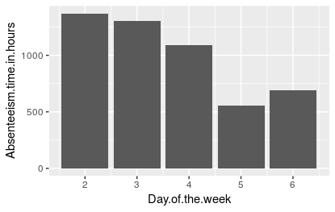

Fig - Plot of hours according to days of week

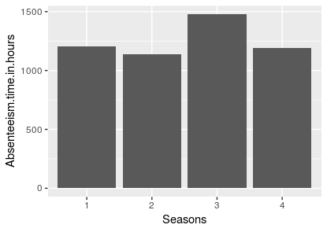

Fig- Plot of Hours according to the Seasons of week

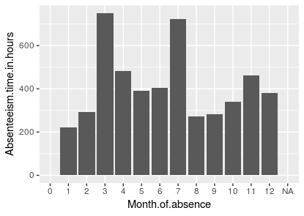

Fig- Plot of hours according to the Month

We plotted bar graphs above, as we observed that from above graph fig , in season plot clearly in season 3,4 having more number of absent hours. In month plots 3,4 and 5 having more number of hours comparing to any other month, so we could say these data sets are following seasonality.

For getting better stimulation, plotting the hour’s data graph with the respect to year cycle. And we will have prescribed and detailed aspect of data.

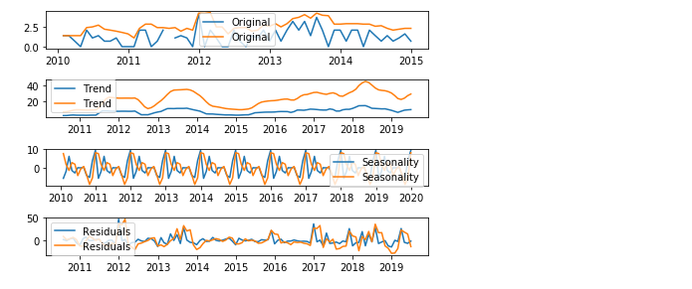Fig- Figure are showing Original, trend, seasonality and Residuals of data

In above graph data is swinging in period, and that is confirming seasonality is, but we can see there is no trend in actual data. With all these observation we can tell, there might be an occasion, or something important, that can be a reason of more absenteeism.

Then we plotted the box plots to check the outliers of data, first drawn as whole data, then we plotted data with classification month, season and days.

Here below box plots of variables.

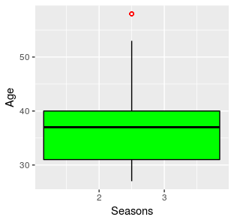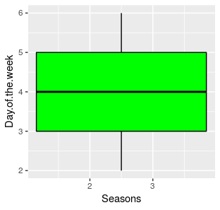

Fig-

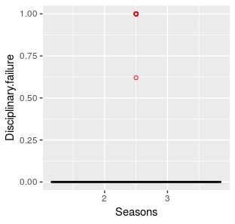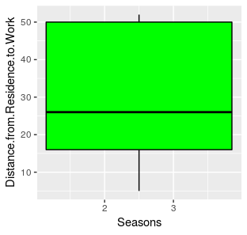

Fig-

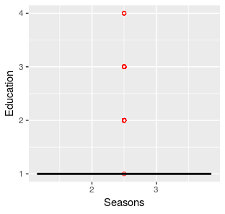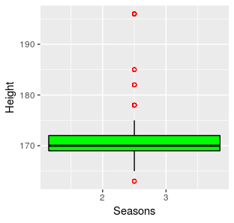

Fig

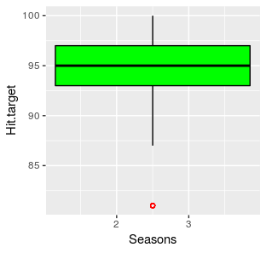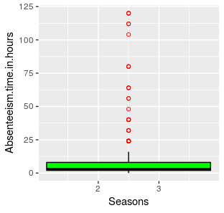

Fig-

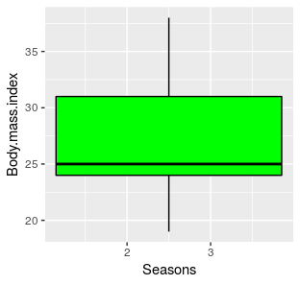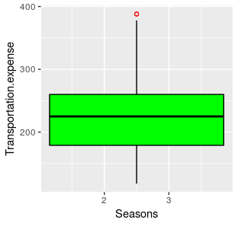

Fig-

Here all the boxplots of numeric variable, these out of range data can make model bias, so for further data analysis plotting box plot against various time periods.

Here are plots against various time periods.

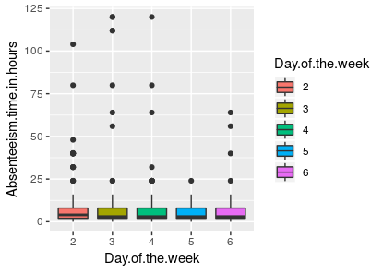

Fig-

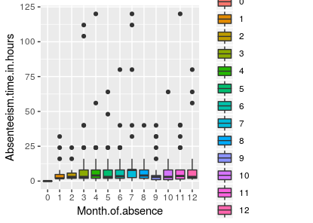

Fig-

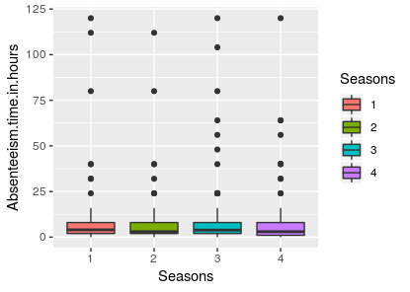Fig-

We can have different inferences from these plots, each plot depict facts of different levels. The season 3 having more outliers on upside, and in month 6,7,8 having less no. of out of range values, but it is clearly noted that we don’t have any outliers on down side of box plots.

But for the same we go for days analysis, we figured out, there is not much difference in hours with respect to days of week.

**2.1.2 Missing Values**

In this data set we have confronted with a problem of missing values, some variables have missing values, and mentioned with the help of table below.

**Table 1.2**: Missing Values (Columns: 9-16)

|  |  |  |  |  |  |  |  |  |  |  |  |  |  |  |  |  |  |  |  |  |  |  |  |  |  |  |  |  |  |  |  |  |  |  |  |  |  |  |  |  |  |  |  |  |  |  |  |  |  |  |  |  |  |  |  |  |  |  |  |  |  |  |  |  |  |  |
| --- | --- | --- | --- | --- | --- | --- | --- | --- | --- | --- | --- | --- | --- | --- | --- | --- | --- | --- | --- | --- | --- | --- | --- | --- | --- | --- | --- | --- | --- | --- | --- | --- | --- | --- | --- | --- | --- | --- | --- | --- | --- | --- | --- | --- | --- | --- | --- | --- | --- | --- | --- | --- | --- | --- | --- | --- | --- | --- | --- | --- | --- | --- | --- | --- | --- | --- |
| |  |  |  | | --- | --- | --- | | **Variables** | **Missing Val** | **Percentage** | | Body mass index | 31 | 4.189189189 | | Absenteeism time in hours | 22 | 2.972972973 | | Height | 14 | 1.891891892 | | Work load Average/day | 10 | 1.351351351 | | Education | 10 | 1.351351351 | | Transportation expense | 7 | 0.945945946 | | Son | 6 | 0.810810811 | | Disciplinary failure | 6 | 0.810810811 | | Hit target | 6 | 0.810810811 | | Social smoker | 4 | 0.540540541 | | Age | 3 | 0.405405405 | | Reason for absence | 3 | 0.405405405 | | Service time | 3 | 0.405405405 | | Distance from Residence to Work | 3 | 0.405405405 | | Social drinker | 3 | 0.405405405 | | Pet | 2 | 0.27027027 | | Weight | 1 | 0.135135135 | | Month of absence | 1 | 0.135135135 | | Seasons | 0 | 0 | | Day of the week | 0 | 0 | | ID | 0 | 0 | |

In above table have the sum of missing values of various variables, and in another column having the percentage of missing values. Most of them less than 3%. And maximum percentage of missing 4% in **“Body Mass Index3”**

For this, we applied body mass index formula to calculate BMI from height and weight.

3In Body Mass Index, **Body Mass Index** is a simple calculation using a person's height and weight. The **formula** is **BMI** = kg/m2 where kg is a person's weight in kilograms and m2 is their height in meters squared.

**2.1.2 Feature Selection**

Before performing different models we need to assess the importance of each predictor variable in our analysis. There is a possibility that many variables in our analysis are not important at all to the problem of regression. Feature selection become more important in this data set, because it have features of time series as well as regression. So we analyzed all the data again with various plots, we are plotting the correlation plot below.

**We have 20 numeric variables but 5 of them are with levels.**

|  |
| --- |
| * Disciplinary failure |
| * Education |
| * Son |
| * Social drinker |
| * Social smoker |
| * Pet |

**And Id is a unique value for each customer.**

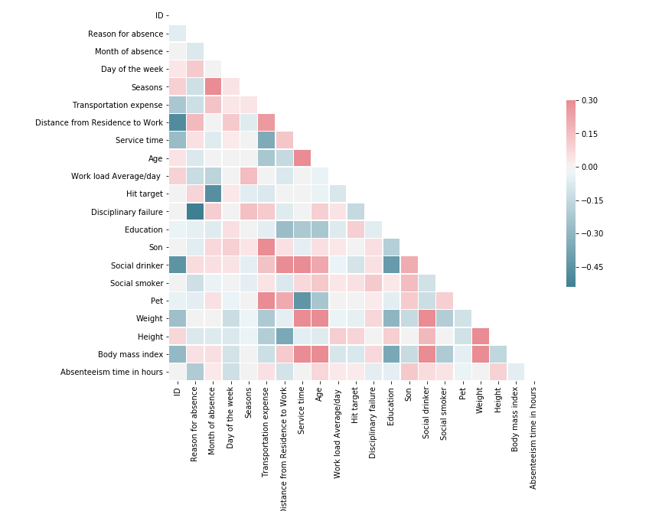

**Fig- Correlation Diagram**

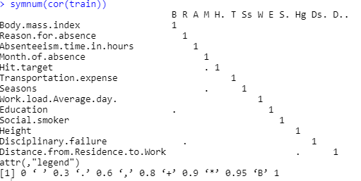

**Figure 2.13**

**Above is correlation plot of selected variable, and most them selected on the basis independence from each other. And we observed that some variables have more collinear to others.**

**For example BMI is correlated to height, weight and age, with the age BMI is increasing and this is also affecting the absent hours.**

**For further to see the effect of various variables on hours. We plotting more bar graphs for this.**

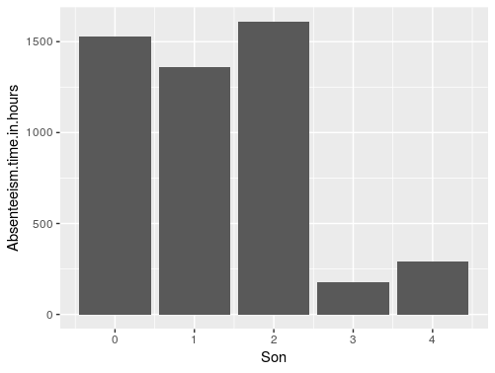

**Figure -**

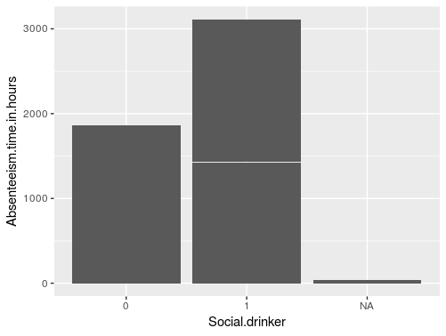

**Figure**

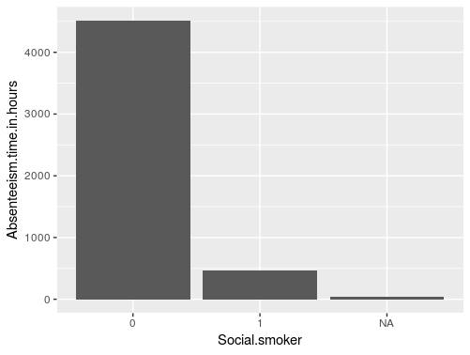

**Figure**

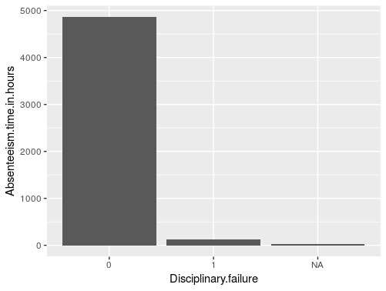

**Figure**

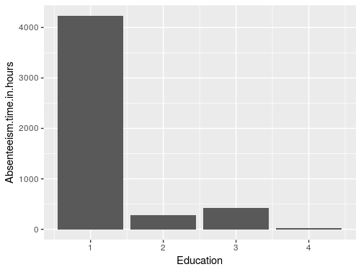

**Figure-**

**Facts from figures**

* We figured out from the figures that, social drinker and hours is regressively related, we can see in the sums having significant hike comparing to nondrinker.
* In next point the education is also affecting, the hours, the more educated level have less no. of absenteeism hours.
* In figure of Discipline, we have clear cut off that a non-discipline employee is getting more absents comparing discipline employee.
* In other figure is not depicting that much about the trend and cause of absent hours.

That’s the various methods we applied for feature selection.

**2.2 Modeling**

**2.2.1 Model Selection**

In our early stages of analysis during pre-processing we have come to understand that hours have trend as well as effect of other predictors so need to choose our model that both aspects in modelling. As we researched online that parcel industry have seasonality, for example have more delivery load in different season. And it also depend employees that dedicated and punctual.

If the dependent variable, in our case *Absent hours ,* is Continuous value, so in predictive analysis that we can perform is **Regression**, and if the dependent variable is ordinal or levels the normal method is to do a **Classification** analysis, or classification after binning. But this needs to use linear regression, for specific and precise results we used time series model

There for we started to build a model with time series, then applied other methods also.

**2.2.2 Linear Regression**

In above figure, the summary stating all the variables of model. In this on the basis of previous analysis, we used all the variables for model which is filtered from correlation test and graph analysis.

Linear regression model summary is stated below.

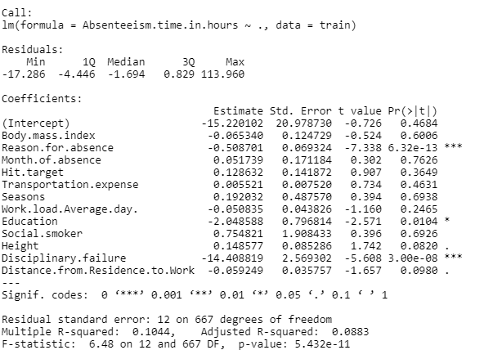

**2.2.3 Time series model**

**Univariate analysis** is the simplest form of analysing data. “Uni” means “one”, so in other words your data has only one variable. It doesn't deal with causes or relationships (unlike regression) and it's major purpose is to describe; it takes data, summarizes that data and finds patterns in the data.

We used this method to see the other perspective of data set, before using this we have change the data to make data sets to put in the model, we changed data into two variables dates and data, and dates are in range of years. And after the analysis we got good results in respect of prediction. We also tried different order of model to get the best result. Actually ARIMA model is having 3 inputs for creating model. A seasonal ARIMA model is classified as an **ARIMA (p,d,q)x(P,D,Q)** model, where P=number of seasonal autoregressive (SAR) terms, D=number of seasonal differences, Q=number of seasonal moving average (SMA)

**2.2.4 Regression**

**We could not use simple technique to predict the values of upcoming absent hours, we need a model which need to fit to the real time scenario, we have used that model but the errors are high, and can’t use this model. In this we used ARIMA model which change, it’s fitting according to seasonality. Because as we clearly explored that this data is having seasonality.**

**Chapter 3**

**Conclusion**

**3.1 Model Evaluation**

Now that we have number of models for predicting the target variable, we need to decide which one to choose. There are several criteria that exist for evaluating and comparing models. We can compare the models using any of the following criteria:

1. Mean absolute error percentage
2. R squared

In our case of Absenteeism, The absent hours matter always having significant variable for parcel industry, if we evaluate rightly evaluate, we can work on employees, and can hire the people which have good lifestyle and education.

,

Predictive performance can be measured by comparing Predictions of the models with real values of the target variables, and calculating absolute error percentage of model.

**3.1.1 Accuracy**

Accuracy is defined as how much predicted value is deviated from the real values.

Below is the code for this

#testing data

absent <- predict(linearMod, test) # predict absentism

actuals_preds <- data.frame(cbind(actuals=test$Absenteeism.time.in.hours, predicteds=absent)) # make actuals_predicteds dataframe.

correlation_accuracy <- cor(actuals_preds) # 82.7%

head(actuals_preds)

**Figure 3.1**

**3.1.2 MAPE**

MAPE is defined as square of the different between the average and actual value divided with actual value. So we can calculate with this the actual percentage. Of error in our model

#percentage error

min_max_accuracy <- mean(apply(actuals_preds, 1, min) / apply(actuals_preds, 1, max)) #42.7

mape <- sum(abs((actuals_preds$predicteds - actuals_preds$actuals))) # for it has zero values

**Figure 3.2 (****code in appendix****)**

We calculated all the stats, but as we observed all the details, accuracy is approx. 42% but the values are too deviated on linear regression. So then we used ARIMA model for this.

Here is result of metrics of various methods result in table below.

**Figure 3.3**

**3.2 Model Selection**

We can see all three models perform comparatively on average and therefore we can select either of the models without any loss of information.

.

**Appendix A - Extra Figures**

We potting some extra figures for better perspective of data

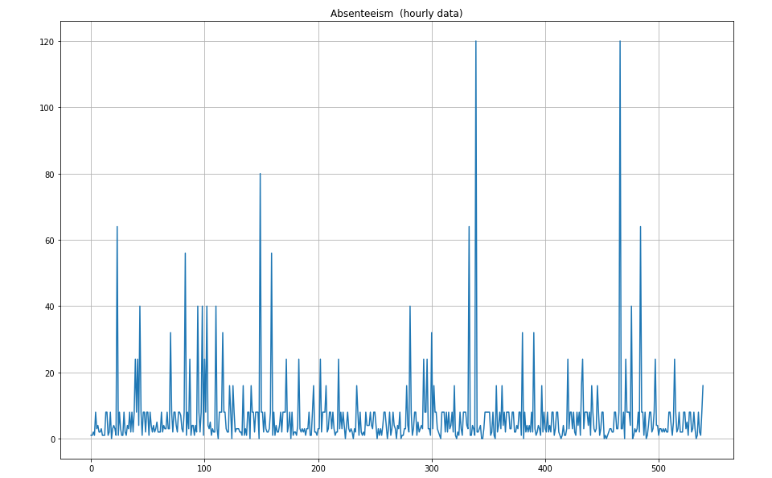

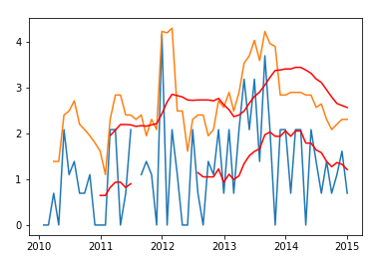

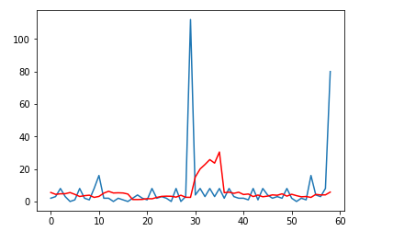

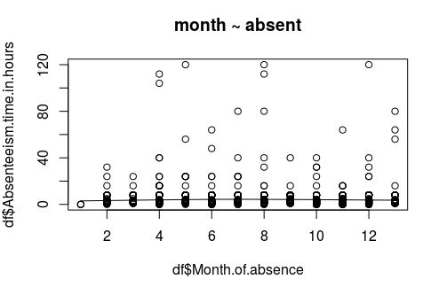

**Appendix B - R Code**

#clearing RAM

rm(list=ls())

setwd("/cloud/project/Project-ed2") #seeting working directory

getwd() #getting working directory

install.packages(c("dplyr","DMwR","ggplot2"))

library("dplyr") #used for manipulationg select arrange

library("DMwR") #used for msining with R

library("ggplot2") #used for plotting the graphs

require(gdata) #to read xl data

#reading file df

df = read.xls("Absent.xls", sheet = 1, header = TRUE)

#missing values

miss=data.frame(apply(df,2,function(x){sum(is.na(x))}))

miss$variables=row.names(miss)

colnames(miss)[1]="values"

miss=miss[,c(2,1)]

miss$percentage=((miss$value/dim(df)[1]))*100

row.names(miss)=NULL

#histogram of missing values in data set

hist(miss$values)

#replacing missing values with data

df=knnImputation(df,k=3)

df$Body.mass.index=ceiling(df$Weight/((df$Height/100)**2)) #replaced with actual formula

df$Month.of.absence=as.integer(df$Month.of.absence)

cname=colnames(df[,c(-1)])

#box plot seasons

ggplot(df,aes(x=Month.of.absence,y=Absenteeism.time.in.hours,fill=Seasons))+geom_boxplot()

#box plot vs month

ggplot(df,aes(x=Seasons,y=Absenteeism.time.in.hours,fill=Seasons))+geom_boxplot()

#plotting sum of absent hours with resprct to Season and month

bar_season=ggplot(df, aes(x=Seasons, y=Absenteeism.time.in.hours)) + geom_bar(stat="identity")

bar_month=ggplot(df, aes(x=Month.of.absence, y=Absenteeism.time.in.hours)) + geom_bar(stat="identity")

bar_day=ggplot(df, aes(x=Day.of.the.week, y=Absenteeism.time.in.hours))+geom_bar(stat="identity")

#plotting with bin variables

bar_disciplinary=ggplot(df, aes(x=Disciplinary.failure, y=Absenteeism.time.in.hours)) + geom_bar(stat="identity")

bar_education=ggplot(df, aes(x=Education, y=Absenteeism.time.in.hours)) + geom_bar(stat="identity")

bar_son=ggplot(df, aes(x=Son, y=Absenteeism.time.in.hours))+geom_bar(stat="identity")

#Box plot analysis

for (i in 1:length(cname))

{nam=paste0("box_",cname[i])

assign(nam,ggplot(data=df, aes_string(x="Seasons",y=cname[i]), group="Seasons")+

geom_boxplot(fill="green", color="black",outlier.color = "red",outlier.shape = 1))

}

#box plot seasons

ggplot(df,aes(x=Month.of.absence,y=Absenteeism.time.in.hours,fill=Seasons))+geom_boxplot()

#box plot vs month

ggplot(df,aes(x=Seasons,y=Absenteeism.time.in.hours,fill=Seasons))+geom_boxplot()

#plotting sum of absent hours with resprct to Season and month

bar_season=ggplot(df, aes(x=Seasons, y=Absenteeism.time.in.hours)) + geom_bar(stat="identity")

bar_month=ggplot(df, aes(x=Month.of.absence, y=Absenteeism.time.in.hours)) + geom_bar(stat="identity")

bar_day=ggplot(df, aes(x=Day.of.the.week, y=Absenteeism.time.in.hours))+geom_bar(stat="identity")

#plotting with bin variables

bar_disciplinary=ggplot(df, aes(x=Disciplinary.failure, y=Absenteeism.time.in.hours)) + geom_bar(stat="identity")

bar_education=ggplot(df, aes(x=Education, y=Absenteeism.time.in.hours)) + geom_bar(stat="identity")

bar_son=ggplot(df, aes(x=Son, y=Absenteeism.time.in.hours))+geom_bar(stat="identity")

bar_drinker=ggplot(df, aes(x=Social.smoker, y=Absenteeism.time.in.hours))+geom_bar(stat="identity")

bar_smoker=ggplot(df, aes(x=Social.drinker, y=Absenteeism.time.in.hours))+geom_bar(stat="identity")

#corrgram plot

corrgram(df[,c(-1)],order=TRUE,lower.panel= panel.ellipse,

upper.panel = panel.shade, text.panel = panel.txt, main="correlation plot" )

#cor plot

numeric=sapply(df, is.numeric)

numeric=df[,numeric]

cor(numeric)

#scatter plot

scatter.smooth(x=df$Month.of.absence, y=df$Absenteeism.time.in.hours, main="month ~ absent") # scatterplot

#applying linear regression

cor(cars$speed, cars$dist)

df_reducted=subset(df, select=c("Body.mass.index","Reason.for.absence","Absenteeism.time.in.hours","Month.of.absence","Hit.target","Transportation.expense","Seasons","Work.load.Average.day.","Education","Social.smoker","Height","Disciplinary.failure","Distance.from.Residence.to.Work"))

train=df_reducted[1:680,]

test=df_reducted[681:740,]

linearMod <- lm(Absenteeism.time.in.hours ~ ., data=train) # build linear regression model on full data

print(linearMod)

summary(linearMod)

#testing data

absent <- predict(linearMod, test) # predict absentism

actuals_preds <- data.frame(cbind(actuals=test$Absenteeism.time.in.hours, predicteds=absent)) # make actuals_predicteds dataframe.

correlation_accuracy <- cor(actuals_preds) # 82.7%

head(actuals_preds)

#percentage error

min_max_accuracy <- mean(apply(actuals_preds, 1, min) / apply(actuals_preds, 1, max)) #42.7

mape <- sum(abs((actuals_preds$predicteds - actuals_preds$actuals))) # for it has zero values

symnum(cor(train))

**Python Code**

#importing all the libraries

import numpy as np

import pandas as pd

import math

from scipy.stats import chi2_contingency

import os

import seaborn as sns #for plotting

import matplotlib.pyplot as plt

%matplotlib inline

#setting working directory

os.getcwd()

df=pd.read_excel("Absent.xls")

#checking data sample

df.shape

df.head()

#missing data analysis

miss = pd.DataFrame(df.isnull().sum())

miss

miss=miss.reset_index() #old index added as column

miss=miss.rename(columns={"index":"variables",0:"miss_values"})

miss['percentage']=(miss['miss_values'] / len(df))*100

miss=miss.sort_values("miss_values",ascending=False).reset_index(drop=True)

#Saving missing value as csv data

miss.to_csv("missing.csv",index=False)

df=df.fillna(df.median())

df.iloc[:,19]=np.ceil(df.iloc[:,17]/(df.iloc[:,18]/100)**2)

#plotting correlation

corr=df.corr()

summary(corr)

#plotting diagram

f, ax= plt.subplots(figsize=(11,9))

mask = np.zeros_like(corr, dtype=np.bool)

mask[np.triu_indices_from(mask)] = True

cmap = sns.diverging_palette(220, 10, as_cmap=True)

sns.heatmap(corr, mask=mask, cmap=cmap, vmax=.3, center=0,

square=True, linewidths=.5, cbar_kws={"shrink": .5})

#loading some essential libraries

from dateutil.relativedelta import relativedelta # working with dates with style

from scipy.optimize import minimize # for function minimization

import statsmodels.formula.api as smf # statistics and econometrics

import statsmodels.tsa.api as smt

import statsmodels.api as sm

import scipy.stats as scs

#plotting absent in hours

plt.figure(figsize=(15, 10))

plt.plot(train["Absenteeism time in hours"])

plt.title('Absenteeism (hourly data)')

plt.grid(True)

plt.show()

df=df.sort_values("Month of absence",ascending=True).reset_index(drop=True)

#Manipulating the data frame to time series

df1=df.loc[df['Month of absence'] == 1]

df2=df.loc[df['Month of absence'] == 2]

df3=df.loc[df['Month of absence'] == 3]

df4=df.loc[df['Month of absence'] == 4]

df5=df.loc[df['Month of absence'] == 5]

df6=df.loc[df['Month of absence'] == 6]

df7=df.loc[df['Month of absence'] == 7]

df8=df.loc[df['Month of absence'] == 8]

df9=df.loc[df['Month of absence'] == 9]

df10=df.loc[df['Month of absence'] == 10]

df11=df.loc[df['Month of absence'] == 11]

df12=df.loc[df['Month of absence'] == 12]

#creating a new time series Data frame for this

len(df12)

new=df[0:1]

for i in range(0,49):

j=i

new=pd.concat([new,df1[j:j+1]])

new=pd.concat([new,df2[j:j+1]])

new=pd.concat([new,df3[j:j+1]])

new=pd.concat([new,df4[j:j+1]])

new=pd.concat([new,df5[j:j+1]])

new=pd.concat([new,df6[j:j+1]])

new=pd.concat([new,df7[j:j+1]])

new=pd.concat([new,df8[j:j+1]])

new=pd.concat([new,df9[j:j+1]])

new=pd.concat([new,df10[j:j+1]])

new=pd.concat([new,df11[j:j+1]])

new=pd.concat([new,df12[j:j+1]])

#chanding data frame to correct format

mod.to_csv('modi.csv', index=False)

mod=pd.read_csv("modi.csv")

mod= mod.drop(mod[mod.index==0].index)

mod=mod.drop('index', axis=1)

mod['Month of absence'] = mod['Month of absence'].astype(int)

#dividing the data in parts

train=mod[0:540]

test=mod[541:588]

#Date time library

from datetime import datetime

date_rng = pd.date_range(start='1/1/2010', end='1/1/2059', freq='M')

ts_uni = pd.DataFrame(date_rng, columns=['date'])

ts_uni["hours"]=mod['Absenteeism time in hours']

ts_uni.to_csv("timeseries.csv")

ts_uni['datetime'] = pd.to_datetime(ts_uni['date'])

ts_uni = ts_uni.set_index('datetime')

ts_uni.drop(['date'], axis=1, inplace=True)

ts_uni['rolling_sum'] = ts_uni.rolling(3).sum()

plt.plot(ts_uni[0:120])

#getting lod to remove seasonality

ts_log=np.log(ts_uni[0:60])

moving_avg = ts_log.rolling(12).mean()

plt.plot(ts_log)

plt.plot(moving_avg, color='red')

#loading stats model to decompose the trend and season

from statsmodels.tsa.seasonal import seasonal_decompose

decomposition = seasonal_decompose(ts_uni[0:120])

trend = decomposition.trend

seasonal = decomposition.seasonal

residual = decomposition.resid

plt.subplot(411)

plt.plot(ts_log, label='Original')

plt.legend(loc='best')

plt.subplot(412)

plt.plot(trend, label='Trend')

plt.legend(loc='best')

plt.subplot(413)

plt.plot(seasonal,label='Seasonality')

plt.legend(loc='best')

plt.subplot(414)

plt.plot(residual, label='Residuals')

plt.legend(loc='best')

plt.tight_layout()

mod.to_csv('modi.csv', index=False)

train=mod[0:540]

test=mod[541:588]

#plotting sublots

plt.subplot(411)

plt.plot(ts_log, label='Original')

plt.legend(loc='best')

plt.subplot(412)

plt.plot(trend, label='Trend')

plt.legend(loc='best')

plt.subplot(413)

plt.plot(seasonal,label='Seasonality')

plt.legend(loc='best')

plt.subplot(414)

plt.plot(residual, label='Residuals')

plt.legend(loc='best')

plt.tight_layout()

#preapring the data for ARIMA model

X = ts_uni['hours'].values

size = int(len(X) * 0.9)

train, test = X[0:size], X[size:len(X)]

history = [x for x in train]

predictions = list()

for t in range(len(test)):

model = ARIMA(history, order=(5,1,0))

model_fit = model.fit(disp=0)

output = model_fit.forecast()

yhat = output[0]

predictions.append(yhat)

obs = test[t]

history.append(obs)

#importing sklearn for testing errors

from sklearn.metrics import mean_squared_error

error = mean_squared_error(test, predictions)

print('Test MSE: %.3f' % error)

# plotting test vs prediction

pyplot.plot(test)

pyplot.plot(predictions, color='red')

pyplot.show()

**References**

**Bibliography:**

1- Hands on Machine Learning With Python Paperback – John Anderson (Author)

# 2- Fundamentals of Mathematical Statistics Paperback – SC Gupta (author)

**Websites:**

**1-** <https://www.r-statistics.com>

**2-** https://www.analyticsvidhya.com/blog/2015/12/complete-tutorial-time-series-modeling/