**CSA0470**

**OPERATING SYSTEMS WITH DESIGN PRINCIPLES**

**1.System calls**

#include<stdio.h>

#include<unistd.h>

#include<sys/types.h>

int main()

{

pid_t p;

printf("before fork\n");

p=fork();

if(p==0)

{

printf("I am child having id %d\n",getpid());

printf("My parent's id is %d\n",getppid());

}

else{

printf("My child's id is %d\n",p);

printf("I am parent having id %d\n",getpid());

}

printf("Common\n");

}

**Output :-**

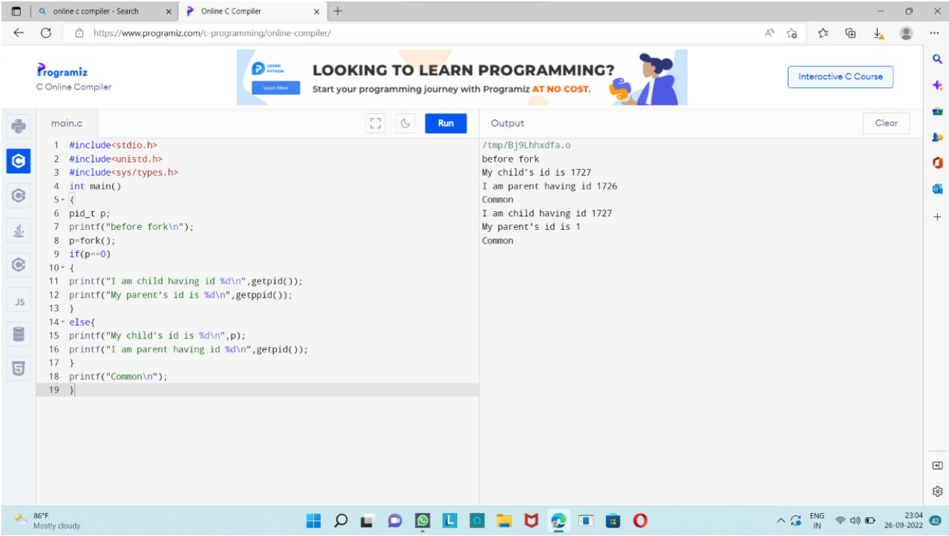

**2.System calls to copy one file to another file**

#include <stdio.h>

#include <stdlib.h> // For exit()

int main(){

FILE *fptr1, *fptr2;

char filename[100], c;

printf("Enter the filename to open for reading \n");

scanf("%s",filename);

// Open one file for reading

fptr1 = fopen(filename, "r");

if (fptr1 == NULL){

printf("Cannot open file %s \n", filename);

exit(0);

}

printf("Enter the filename to open for writing \n");

scanf("%s", filename);

// Open another file for writing

fptr2 = fopen(filename, "w");

if (fptr2 == NULL){

printf("Cannot open file %s \n", filename);

exit(0);

}

// Read contents from file

c = fgetc(fptr1);

while (c != EOF){

fputc(c, fptr2);

c = fgetc(fptr1);

}

printf("\nContents copied to %s", filename);

fclose(fptr1);

fclose(fptr2);

return 0;

}

**Output :-**

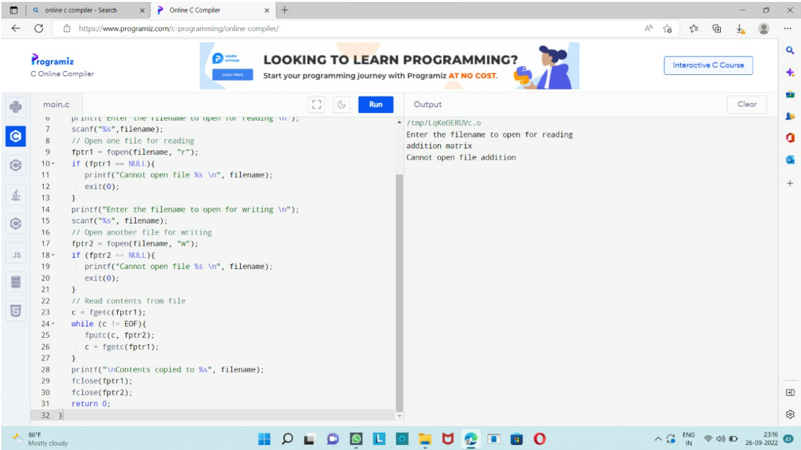

**3. First come first serve**

#include<stdio.h>

int main()

{

int bt[10]={0},at[10]={0},tat[10]={0},wt[10]={0},ct[10]={0};

int n,sum=0;

float totalTAT=0,totalWT=0;

printf("Enter number of processes ");

scanf("%d",&n);

printf("Enter arrival time and burst time for each process\n\n");

for(int i=0;i<n;i++)

{

printf("Arrival time of process[%d] ",i+1);

scanf("%d",&at[i]);

printf("Burst time of process[%d] ",i+1);

scanf("%d",&bt[i]);

printf("\n");

}

for(int j=0;j<n;j++)

{

sum+=bt[j];

ct[j]+=sum;

}

for(int k=0;k<n;k++)

{

tat[k]=ct[k]-at[k];

totalTAT+=tat[k];

}

for(int k=0;k<n;k++)

{

wt[k]=tat[k]-bt[k];

totalWT+=wt[k];

}

printf("Solution: \n\n");

printf("P#\t AT\t BT\t CT\t TAT\t WT\t\n\n");

for(int i=0;i<n;i++)

{

printf("P%d\t %d\t %d\t %d\t %d\t %d\n",i+1,at[i],bt[i],ct[i],tat[i],wt[i]);

}

printf("\n\nAverage Turnaround Time = %f\n",totalTAT/n);

printf("Average WT = %f\n\n",totalWT/n);

return 0;

}

**Output :-**

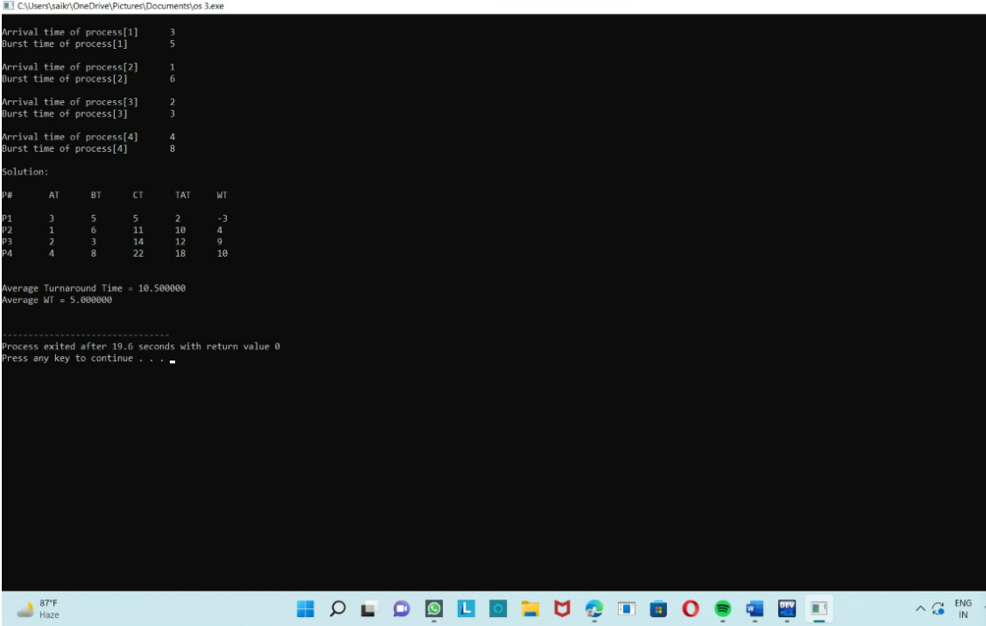

**4.Shortest job first**

#include <stdio.h>

int main()

{

int A[100][4];

int i, j, n, total = 0, index, temp; float avg_wt, avg_tat;

printf("Enter number of process: "); scanf("%d", &n);

printf("Enter Burst Time:\n");

for (i = 0; i < n; i++) {

printf("P%d: ", i + 1); scanf("%d", &A[i][1]); A[i][0] = i + 1;

}

for (i = 0; i < n; i++) {

index = i;

for (j = i + 1; j < n; j++)

if (A[j][1] < A[index][1]) index = j;

temp = A[i][1]; A[i][1] = A[index][1]; A[index][1] = temp;

temp = A[i][0];

A[i][0] = A[index][0]; A[index][0] = temp;

}

A[0][2] = 0;

for (i = 1; i < n; i++) {

A[i][2] = 0;

for (j = 0; j < i; j++)

A[i][2] += A[j][1];

total += A[i][2];

}

avg_wt = (float)total / n; total = 0;

printf("P BT WT TAT\n"); for (i = 0; i < n; i++) {

A[i][3] = A[i][1] + A[i][2];

total += A[i][3];

printf("P%d %d %d %d\n", A[i][0], A[i][1], A[i][2], A[i][3]);

}

avg_tat = (float)total / n;

printf("Average Waiting Time= %f", avg_wt); printf("\nAverage Turnaround Time= %f", avg_tat);

}

**Output :-**

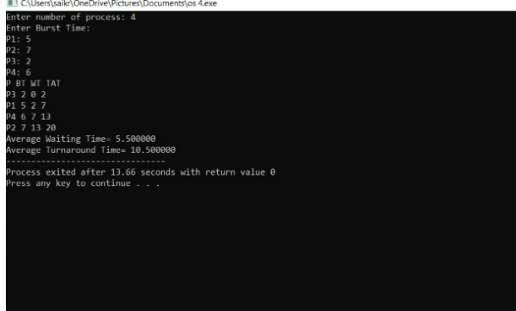

**5.Scheduling program that selects the waiting process with highest priority**

#include<stdio.h>

struct priority_scheduling {

char process_name;

int burst_time;

int waiting_time;

int turn_around_time;

int priority;

};

int main() {

int number_of_process;

int total = 0;

struct priority_scheduling temp_process;

int ASCII_number = 65;

int position;

float average_waiting_time;

float average_turnaround_time;

printf("Enter the total number of Processes: ");

scanf("%d", & number_of_process);

struct priority_scheduling process[number_of_process];

printf("\nPlease Enter the Burst Time and Priority of each process:\n");

for (int i = 0; i < number_of_process; i++) {

process[i].process_name = (char) ASCII_number;

printf("\nEnter the details of the process %c \n", process[i].process_name);

printf("Enter the burst time: ");

scanf("%d", & process[i].burst_time);

printf("Enter the priority: ");

scanf("%d", & process[i].priority);

ASCII_number++;

}

for (int i = 0; i < number_of_process; i++) {

position = i;

for (int j = i + 1; j < number_of_process; j++) {

if (process[j].priority > process[position].priority)

position = j;

}

temp_process = process[i];

process[i] = process[position];

process[position] = temp_process;

}

process[0].waiting_time = 0;

for (int i = 1; i < number_of_process; i++) {

process[i].waiting_time = 0;

for (int j = 0; j < i; j++) {

process[i].waiting_time += process[j].burst_time;

}

total += process[i].waiting_time;

}

average_waiting_time = (float) total / (float) number_of_process;

total = 0;

printf("\n\nProcess_name \t Burst Time \t Waiting Time \t Turnaround Time\n");

printf("------------------------------------------------------------\n");

for (int i = 0; i < number_of_process; i++) {

process[i].turn_around_time = process[i].burst_time + process[i].waiting_time;

total += process[i].turn_around_time;

printf("\t %c \t\t %d \t\t %d \t\t %d", process[i].process_name, process[i].burst_time, process[i].waiting_time, process[i].turn_around_time);

printf("\n-----------------------------------------------------------\n");

}

average_turnaround_time = (float) total / (float) number_of_process;

printf("\n\n Average Waiting Time : %f", average_waiting_time);

printf("\n Average Turnaround Time: %f\n", average_turnaround_time);

return 0;

}

**Output :-** 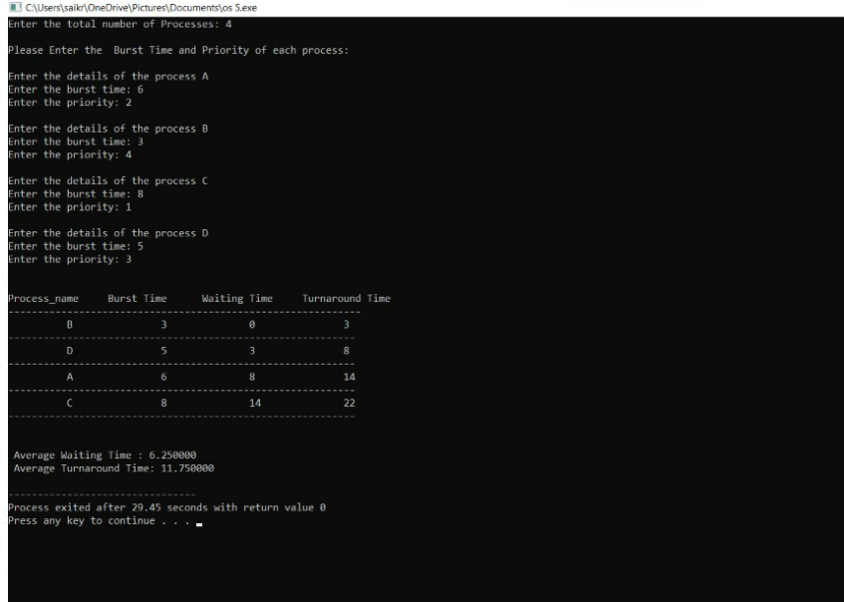

**6.Round Robin**

#include<stdio.h>

int main()

{

int count,j,n,time,remain,flag=0,time_quantum;

int wait_time=0,turnaround_time=0,at[10],bt[10],rt[10];

printf("Enter Total Process:\t ");

scanf("%d",&n);

remain=n;

for(count=0;count<n;count++)

{

printf("Enter Arrival Time and Burst Time for Process Process Number %d :",count+1);

scanf("%d",&at[count]);

scanf("%d",&bt[count]);

rt[count]=bt[count];

}

printf("Enter Time Quantum:\t");

scanf("%d",&time_quantum);

printf("\n\nProcess\t|Turnaround Time|Waiting Time\n\n");

for(time=0,count=0;remain!=0;)

{

if(rt[count]<=time_quantum && rt[count]>0)

{

time+=rt[count];

rt[count]=0;

flag=1;

}

else if(rt[count]>0)

{

rt[count]-=time_quantum;

time+=time_quantum;

}

if(rt[count]==0 && flag==1)

{

remain--;

printf("P[%d]\t|\t%d\t|\t%d\n",count+1,time-at[count],time-at[count]-bt[count]);

wait_time+=time-at[count]-bt[count];

turnaround_time+=time-at[count];

flag=0;

}

if(count==n-1)

count=0;

else if(at[count+1]<=time)

count++;

else

count=0;

}

printf("\nAverage Waiting Time= %f\n",wait_time*1.0/n);

printf("Avg Turnaround Time = %f",turnaround_time*1.0/n);

return 0;

}

**Output :-**

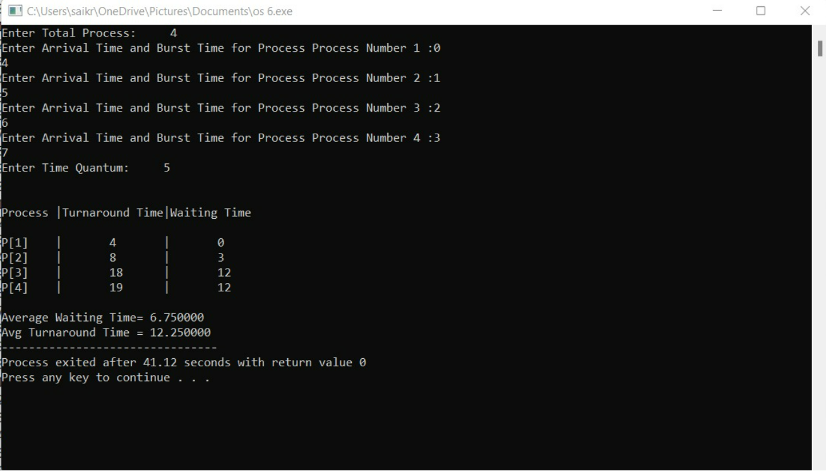

**7.Interprocesses communication using shared memory**

#include<stdio.h>

#include<stdlib.h>

#include<unistd.h>

#include<string.h>

int main()

{

int i;

void *shared_memory;

char buff[100];

int shmid;

shmid=shmget((key_t)2345, 1024, 0666|IPC_CREAT);

printf("Key of shared memory is %d\n",shmid);

shared_memory=shmat(shmid,NULL,0);

printf("Process attached at %p\n",shared_memory);

printf("Enter some data to write to shared memory\n");

read(0,buff,100);

strcpy(shared_memory,buff);

printf("You wrote : %s\n",(char *)shared_memory);

}

**Output :-**

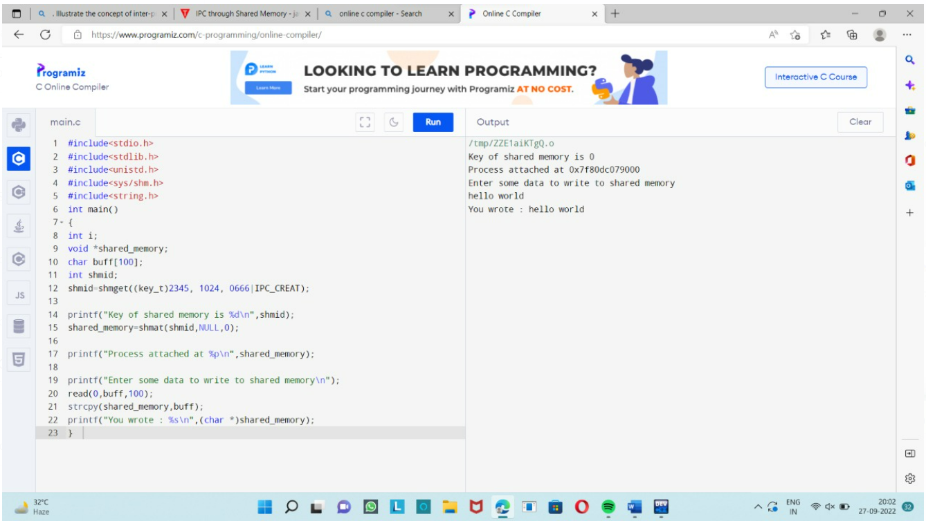

**8.Multithreading**

#include <stdio.h>

#include <stdlib.h>

#include <unistd.h>

#include <pthread.h>

void *myThreadFun(void *vargp)

{

sleep(1);

printf("Printing GeeksQuiz from Thread \n");

return NULL;

}

int main()

{

pthread_t thread_id;

printf("Before Thread\n");

pthread_create(&thread_id, NULL, myThreadFun, NULL);

pthread_join(thread_id, NULL);

printf("After Thread\n");

exit(0);

}

**Output :-**

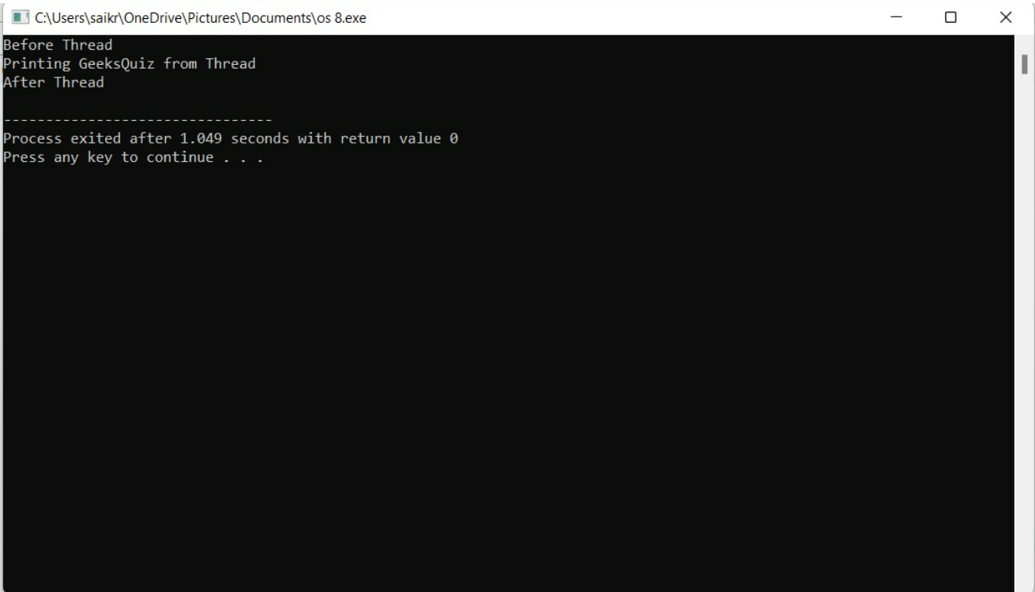

**9.Dining-philosophers**

#include<stdio.h>

#define n 4

int compltedPhilo = 0,i;

struct fork{

int taken;

}ForkAvil[n];

struct philosp{

int left;

int right;

}Philostatus[n];

void goForDinner(int philID){

if(Philostatus[philID].left==10 && Philostatus[philID].right==10)

printf("Philosopher %d completed his dinner\n",philID+1);

else if(Philostatus[philID].left==1 && Philostatus[philID].right==1){

printf("Philosopher %d completed his dinner\n",philID+1);

Philostatus[philID].left = Philostatus[philID].right = 10;

int otherFork = philID-1;

if(otherFork== -1)

otherFork=(n-1);

ForkAvil[philID].taken = ForkAvil[otherFork].taken = 0;

printf("Philosopher %d released fork %d and fork %d\n",philID+1,philID+1,otherFork+1);

compltedPhilo++;

}

else if(Philostatus[philID].left==1 && Philostatus[philID].right==0){

if(philID==(n-1)){

if(ForkAvil[philID].taken==0){

ForkAvil[philID].taken = Philostatus[philID].right = 1;

printf("Fork %d taken by philosopher %d\n",philID+1,philID+1);

}else{

printf("Philosopher %d is waiting for fork %d\n",philID+1,philID+1);

}

}else{

int dupphilID = philID;

philID-=1;

if(philID== -1)

philID=(n-1);

if(ForkAvil[philID].taken == 0){

ForkAvil[philID].taken = Philostatus[dupphilID].right = 1;

printf("Fork %d taken by Philosopher %d\n",philID+1,dupphilID+1);

}else{

printf("Philosopher %d is waiting for Fork %d\n",dupphilID+1,philID+1);

}

}

}

else if(Philostatus[philID].left==0){

if(philID==(n-1)){

if(ForkAvil[philID-1].taken==0){

ForkAvil[philID-1].taken = Philostatus[philID].left = 1;

printf("Fork %d taken by philosopher %d\n",philID,philID+1);

}else{

printf("Philosopher %d is waiting for fork %d\n",philID+1,philID);

}

}else{

if(ForkAvil[philID].taken == 0){

ForkAvil[philID].taken = Philostatus[philID].left = 1;

printf("Fork %d taken by Philosopher %d\n",philID+1,philID+1);

}else{

printf("Philosopher %d is waiting for Fork %d\n",philID+1,philID+1);

}

}

}else{}

}

int main(){

for(i=0;i<n;i++)

ForkAvil[i].taken=Philostatus[i].left=Philostatus[i].right=0;

while(compltedPhilo<n){

for(i=0;i<n;i++)

goForDinner(i);

printf("\nTill now num of philosophers completed dinner are %d\n\n",compltedPhilo);

}

return 0;

}

**Output :-**

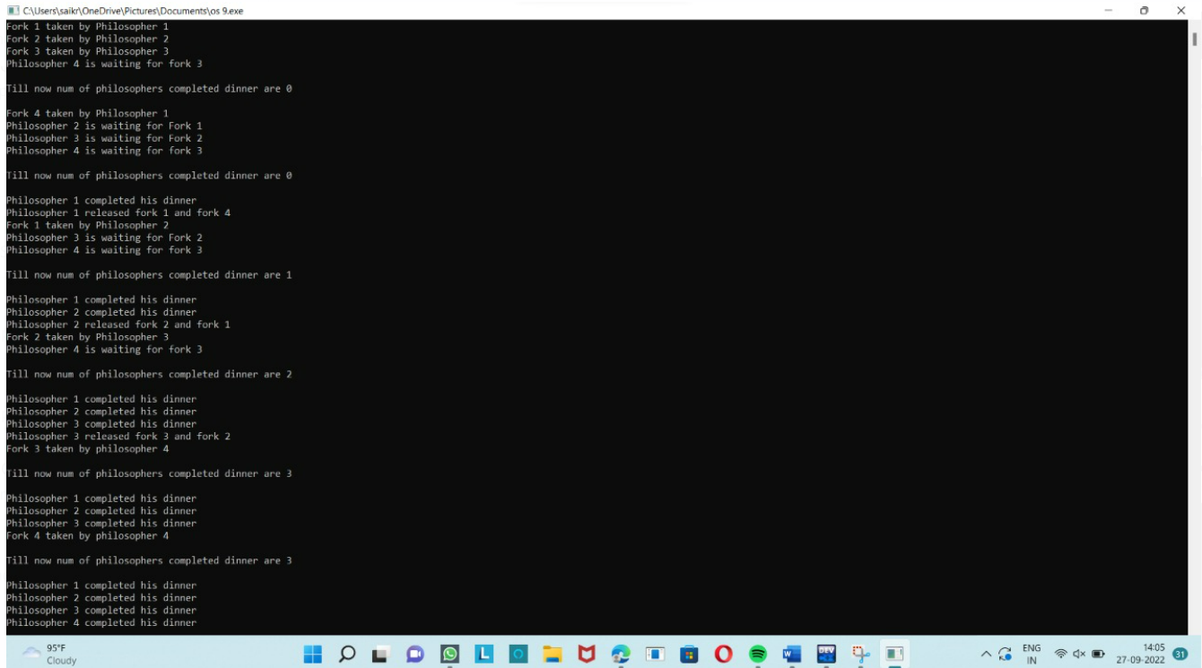

**10.Memory Allocation**

#include<stdio.h>

int main( )

{

int bsize[10], psize[10], bno, pno, flags[10], allocation[10], i, j;

for(i = 0; i < 10; i++)

{

flags[i] = 0;

allocation[i] = -1;

}

printf("Enter no. of blocks: ");

scanf("%d", &bno);

printf("\nEnter size of each block: ");

for(i = 0; i < bno; i++)

scanf("%d", &bsize[i]);

printf("\nEnter no. of processes: ");

scanf("%d", &pno);

printf("\nEnter size of each process: ");

for(i = 0; i < pno; i++)

scanf("%d", &psize[i]);

for(i = 0; i < pno; i++)

for(j = 0; j < bno; j++)

if(flags[j] == 0 && bsize[j] >= psize[i])

{

allocation[j] = i;

flags[j] = 1;

break;

}

printf("\nBlock no.\tsize\t\tprocess no.\t\tsize");

for(i = 0; i < bno; i++)

{

printf("\n%d\t\t%d\t\t", i+1, bsize[i]);

if(flags[i] == 1)

printf("%d\t\t\t%d",allocation[i]+1,psize[allocation[i]]);

else

printf("Not allocated");

}

}

**Output :-**

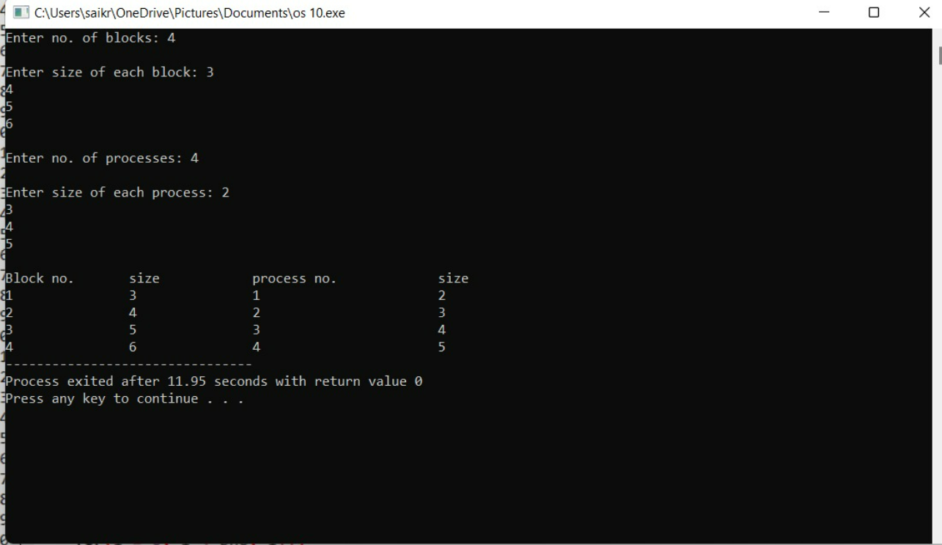

**11.To organise the file using single level directory**

#include<stdio.h>

#include<conio.h>

#include<string.h>

int main( )

{

int nf=0,i=0,j=0,ch;

char mdname[10],fname[10][10],name[10];

printf("Enter the directory name:");

scanf("%s",mdname);

printf("Enter the number of files:");

scanf("%d",&nf);

do

{

printf("Enter file name to be created:");

scanf("%s",name);

for(i=0;i<nf;i++)

{

if(!strcmp(name,fname[i]))

break;

}

if(i==nf)

{

strcpy(fname[j++],name);

nf++;

}

else

printf("There is already %s\n",name);

printf("Do you want to enter another file(yes - 1 or no - 0):");

scanf("%d",&ch);

}

while(ch==1);

printf("Directory name is:%s\n",mdname);

printf("Files names are:");

for(i=0;i<j;i++)

printf("\n%s",fname[i]);

getch();

}

**Output :-**

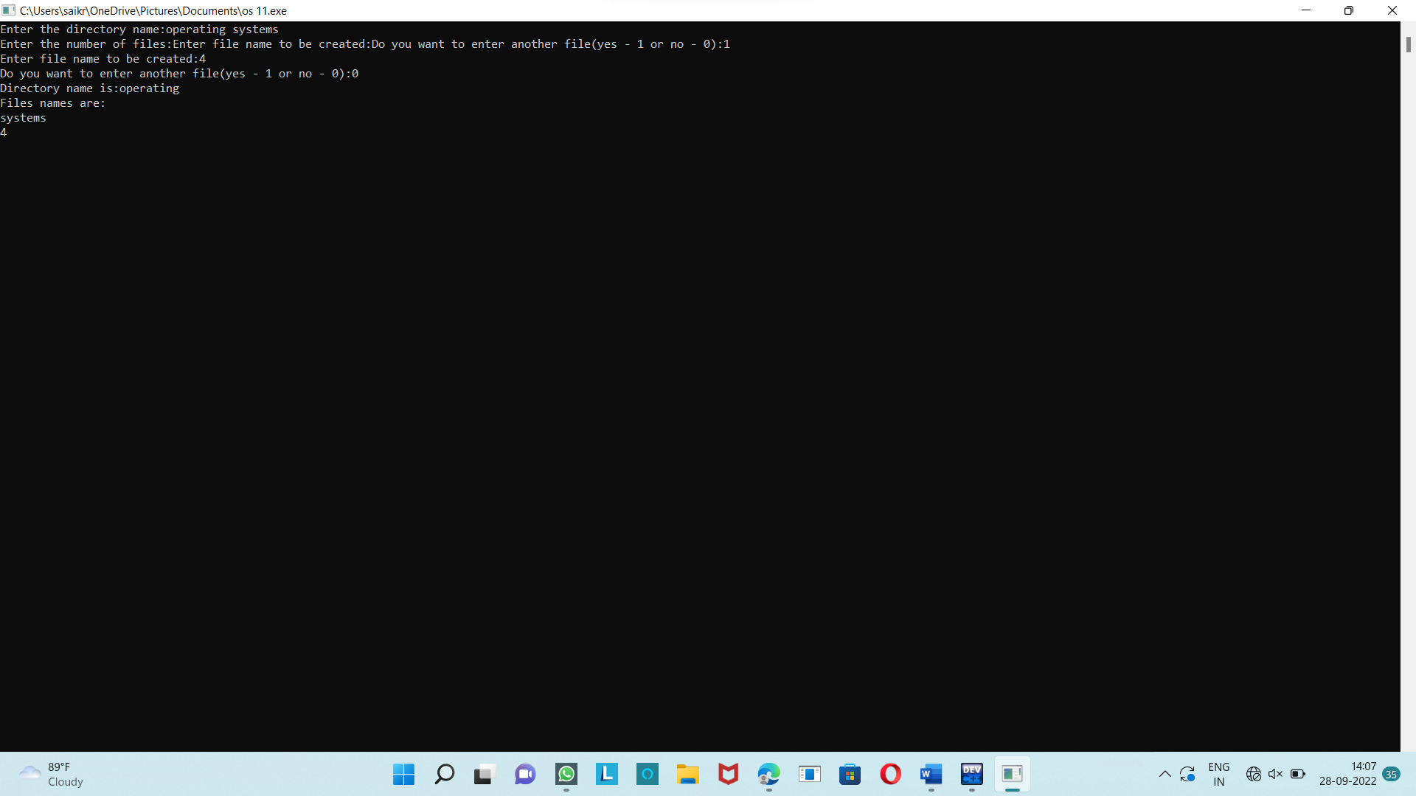

**12.To organism the file using two level directory structure**

#include<stdio.h>

#include<string.h>

#include<stdlib.h>

struct

{

char dname[10],fname[10][10];

int fcnt;

}dir[10];

void main()

{

int i,ch,dcnt,k;

char f[30], d[30];

dcnt=0;

while(1)

{

printf("1. Create Directory\t2. Create File\t3. Delete File");

printf("\n4. Search File\t\t5. Display\t6. Exit\tEnter your choice --");

scanf("%d",&ch);

switch(ch)

{

case 1: printf("\nEnter name of directory -- ");

scanf("%s", dir[dcnt].dname);

dir[dcnt].fcnt=0;

dcnt++;

printf("Directory created");

break;

case 2: printf("\nEnter name of the directory -- ");

scanf("%s",d);

for(i=0;i<dcnt;i++)

if(strcmp(d,dir[i].dname)==0)

{

printf("Enter name of the file -- ");

scanf("%s",dir[i].fname[dir[i].fcnt]);

dir[i].fcnt++;

printf("File created");

break;

}

if(i==dcnt)

printf("Directory %s not found",d);

break;

case 3: printf("\nEnter name of the directory -- ");

scanf("%s",d);

for(i=0;i<dcnt;i++)

{

if(strcmp(d,dir[i].dname)==0)

{

printf("Enter name of the file -- ");

scanf("%s",f);

for(k=0;k<dir[i].fcnt;k++)

{

if(strcmp(f, dir[i].fname[k])==0)

{

printf("File %s is deleted ",f);

dir[i].fcnt--;

strcpy(dir[i].fname[k],dir[i].fname[dir[i].fcnt]);

goto jmp;

}

}

printf("File %s not found",f);

goto jmp;

}

}

printf("Directory %s not found",d);

jmp : break;

case 4: printf("\nEnter name of the directory -- ");

scanf("%s",d);

for(i=0;i<dcnt;i++)

{

if(strcmp(d,dir[i].dname)==0)

{

printf("Enter the name of the file -- ");

scanf("%s",f);

for(k=0;k<dir[i].fcnt;k++)

{

if(strcmp(f, dir[i].fname[k])==0)

{

printf("File %s is found ",f);

goto jmp1;

}

}

printf("File %s not found",f);

goto jmp1;

}

}

printf("Directory %s not found",d);

jmp1: break;

case 5: if(dcnt==0)

printf("\nNo Directory's ");

else

{

printf("\nDirectory\tFiles");

for(i=0;i<dcnt;i++)

{

printf("\n%s\t\t",dir[i].dname);

for(k=0;k<dir[i].fcnt;k++)

printf("\t%s",dir[i].fname[k]);

}

}

break;

default:exit(0);

}

}

}

**Output :-**

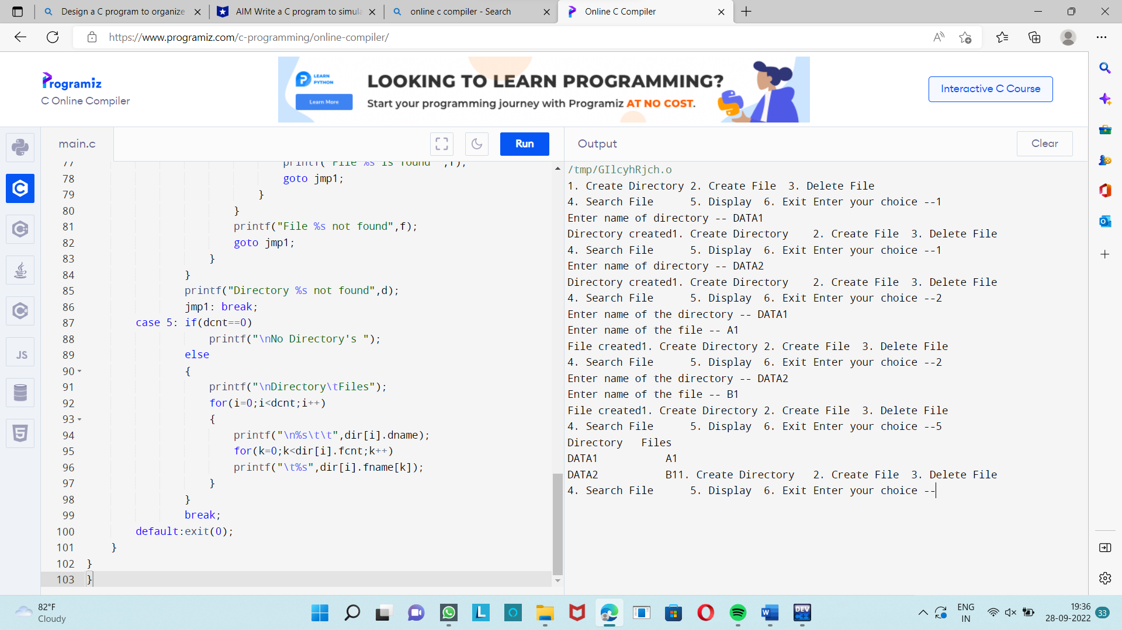

**14.Banker’s Algorithm**

#include <stdio.h>

#include <conio.h>

int main()

{

int Max[10][10], need[10][10], alloc[10][10], avail[10], completed[10], safeSequence[10];

int p, r, i, j, process, count;

count = 0;

printf("Enter the no of processes : ");

scanf("%d", &p);

for(i = 0; i< p; i++)

completed[i] = 0;

printf("Enter the no of resources : ");

scanf("%d", &r);

printf("Enter the Max Matrix for each process : \n");

for(i = 0; i < p; i++)

{

printf("For process %d : ", i + 1);

for(j = 0; j < r; j++)

scanf("%d", &Max[i][j]);

}

printf("Enter the allocation for each process : \n");

for(i = 0; i < p; i++)

{

printf("For process %d : ",i + 1);

for(j = 0; j < r; j++)

scanf("%d", &alloc[i][j]);

}

printf("Enter the Available Resources : ");

for(i = 0; i < r; i++)

scanf("%d", &avail[i]);

for(i = 0; i < p; i++)

for(j = 0; j < r; j++)

need[i][j] = Max[i][j] - alloc[i][j];

do

{

printf("\nMax matrix:\tAllocation matrix:\n");

for(i = 0; i < p; i++)

{

for( j = 0; j < r; j++)

printf("%d ", Max[i][j]);

printf("\t\t");

for( j = 0; j < r; j++)

printf("%d ", alloc[i][j]);

printf("\n");

}

process = -1;

for(i = 0; i < p; i++)

{

if(completed[i] == 0)

{

process = i ;

for(j = 0; j < r; j++)

{

if(avail[j] < need[i][j])

{

process = -1;

break;

}

}

}

if(process != -1)

break;

}

if(process != -1)

{

printf("\nProcess %d runs to completion!", process + 1);

safeSequence[count] = process + 1;

count++;

for(j = 0; j < r; j++)

{

avail[j] += alloc[process][j];

alloc[process][j] = 0;

Max[process][j] = 0;

completed[process] = 1;

}

}

}while(count != p && process != -1);

if(count == p)

{

printf("\nThe system is in a safe state!!\n");

printf("Safe Sequence : < ");

for( i = 0; i < p; i++)

printf("%d ", safeSequence[i]);

printf(">\n");

}

else

printf("\nThe system is in an unsafe state!!");

getch();

}

**Output :-**

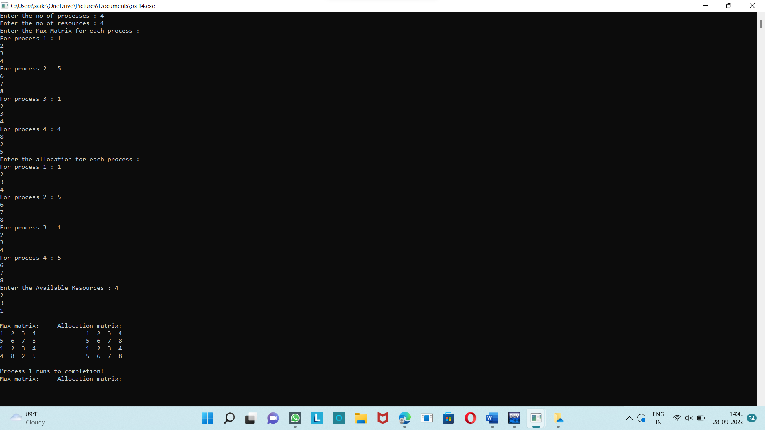

**15.Producer And consumer**

#include <stdio.h>

#include <stdlib.h>

int mutex = 1;

int full = 0;

int empty = 10, x = 0;

void producer()

{

--mutex;

++full;

--empty;

x++;

printf("\nProducer produces"

"item %d",

x);

++mutex;

}

void consumer()

{

--mutex;

--full;

++empty;

printf("\nConsumer consumes "

"item %d",

x);

x--;

++mutex;

}

int main()

{

int n, i;

printf("\n1. Press 1 for Producer"

"\n2. Press 2 for Consumer"

"\n3. Press 3 for Exit");

for (i = 1; i > 0; i++) {

printf("\nEnter your choice:");

scanf("%d", &n);

switch (n) {

case 1:

if ((mutex == 1)

&& (empty != 0)) {

producer();

}

else {

printf("Buffer is full!");

}

break;

case 2:

if ((mutex == 1)

&& (full != 0)) {

consumer();

}

else {

printf("Buffer is empty!");

}

break;

case 3:

exit(0);

break;

}

}

}

**Output :-**

