ALGORITHM
PROBLEM STATEMENT
• RNNs process sequential data by carrying information across time.
• They should learn long-term patterns, useful in speech, language, and control tasks.
• But traditional training methods (BPTT, RTRL) face major issues:
- Vanishing gradients → signals fade
- Exploding gradients → signals blow up
• As a result, RNNs fail to learn long-range dependencies.
• Long-term learning becomes slow, unstable, or impossible on real-world datasets.

INTRODUCTION
Introduction to LSTM
- Long Short-Term Memory (LSTM) is a specialized type of Recurrent Neural Network (RNN) introduced by Hochreiter & Schmidhuber (1997).
- It was designed to overcome the vanishing and exploding gradient problem that prevents traditional RNNs from learning long-term dependencies.
- LSTM introduces a new structure called a memory cell, which can store information for long periods without being overwritten.
- It uses gating mechanisms—Input Gate, Output Gate, and Forget Gate—to control:
  - when information is stored,
  - when it is updated, and
  - when it is retrieved.
- These gates allow LSTMs to maintain stable error flow across time, enabling them to learn patterns spread over hundreds or thousands of time steps.
- Because of this, LSTMs became foundational for tasks such as language modeling, machine translation, speech recognition, and time-series forecasting.

Key Features of LSTM
- Memory Cell
  - Core unit that stores information long-term without being overwritten.
- Gating Mechanisms
  - Input Gate: Controls when new information should enter the cell.
  - Forget Gate: Decides what past information to remove.
  - Output Gate: Controls what information leaves the cell to influence predictions.
- Prevention of Vanishing/Exploding Gradients
  - LSTM maintains constant error flow, allowing learning of long-range dependencies.
- Selective Information Flow
  - Learns when to remember and when to forget, improving accuracy on sequential tasks.
- Handles Noisy and Long Sequences
  - Robust to long time lags, distractions, and noisy inputs.
- Better Performance on Sequence Tasks
  - Excels in language models, translation, speech, time-series forecasting, and more.

Advantages of LSTM Based on Dataset & Context
1. Handles Long-Term Dependencies
- Ideal for datasets where important information appears far apart in time.
- Works well when the output depends on context distributed across long sequences.
2. Robust to Noisy or Irregular Data
- LSTMs can filter out irrelevant inputs using gates.
- Performs better on sequences with random distractors, missing values, or unpredictable patterns.
3. Effective for Variable-Length Sequences
- Suitable for datasets where sequence lengths vary widely (e.g., sentences, sensor logs).
- Maintains context throughout the entire sequence.
4. Selective Memory Through Gates
- Input, Forget, and Output gates allow LSTM to store relevant context and forget noise.
- Provides flexible control over information flow based on data characteristics.
5. Captures Complex Temporal Structures
- Works well when relationships are non-linear, non-Markovian, or occur after long gaps.
- Examples: speech signals, user activity logs, ECG/EEG waves.
6. Context-Aware Predictions
- LSTM retains important historical context, making it effective for:
  - Language modeling
  - Sentiment analysis
  - Machine translation
  - Time-series forecasting
7. Resistant to Vanishing/Exploding Gradients
- Maintains stable learning regardless of sequence length.
- Especially useful when datasets contain dependencies spanning hundreds or thousands of time steps.

LSTM Algorithm – Pseudocode

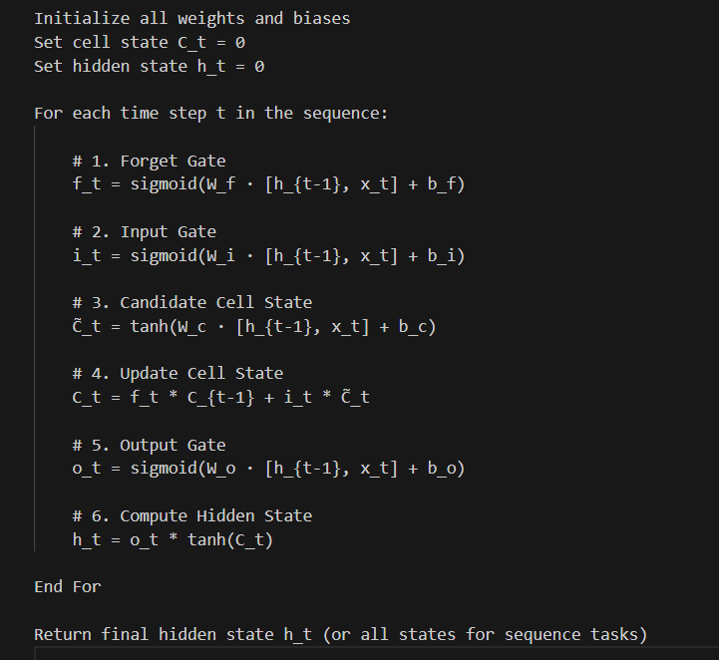

Authors of the LSTM Algorithm
LSTM was introduced by:
1. Sepp Hochreiter
- German computer scientist
- Research focus: neural networks, machine learning, deep learning
- Developed the original analysis of the vanishing gradient problem (1991)
- Co-inventor of Long Short-Term Memory (LSTM) in 1997
- Worked at:
  - Technische Universität München
  - Johannes Kepler University Linz
2. Jürgen Schmidhuber
- Swiss/German computer scientist
- Known for pioneering work in recurrent neural networks and deep learning
- Co-inventor of LSTM
- Directed research at IDSIA (Istituto Dalle Molle di Studi sull’Intelligenza Artificiale)
- Supervised many foundational works in AI and sequence learning
Publication Details
- Title: Long Short-Term Memory
- Published in: Neural Computation
- Year: 1997
- Journal Volume: 9(8): 1735–1780
- Authors’ affiliations from the paper:
  - Sepp Hochreiter — Technische Universität München
  - Jürgen Schmidhuber — IDSIA, Lugano, Switzerland

