**Amrita School of Computing**

**Department of Computer Science and Engineering**

**Project Phase I: 21AIE495**

**(2020-2024 B.Tech. AIE)**

Project Proposal

Group No. 36

1. **Project Title:** Human Centered Design towards blockchain enabled platform for AmritaSREE Self Help Groups

**Team members:**

|  |  |
| --- | --- |
| **Roll No.** | **Name** |
| AM.EN.U4AIE20137 | Kalla Likhit Sai Eswar |
| AM.EN.U4AIE20155 | Pappala Kumar Aditya |
| AM.EN.U4AIE20171 | Vuppala Naga Sushanth Kumar |

1. **Abstract**

AmritaSREE, an initiative by Sri Mata Amritanandamayi Devi, addresses the critical need for rural development by empowering women through Self-Help Groups (SHGs). These groups aim to provide livelihood opportunities and enhance vocational skills for economically vulnerable women in developing nations. As the initiative gains popularity across India, the management of SHGs becomes an administrative burden, particularly when expanding to different states. To tackle these challenges, a unique IoT solution is proposed, leveraging mobile computing and a human-centered design approach to develop an SHG management application. Furthermore, the project suggests incorporating blockchain technology to ensure transparency and boost trust among group members. The mobile application's finance module ensures accurate financial tracking, reducing administrative work by generating summary reports instead of scrutinizing each transaction. This tech-driven approach not only streamlines SHG management but also facilitates better group compatibility, efficiency, and member empowerment. By embracing these innovative solutions, AmritaSREE aims to propel the economic independence and socio-economic welfare of women in rural areas throughout India.

1. **Background Study**

|  |  |  |  |  |
| --- | --- | --- | --- | --- |
| **Title &**  **Year** | **Problem** | **Contributions** | **Limitations** | **Open problems/Future work** |
| Blockchain, adoption, and financial inclusion in India: Research opportunities  International Journal of Information Management  2020 | 1. Limited understanding of user behavior and acceptance of blockchain-based financial services.  2. Addressing the needs of users and bridging the digital divide in India.  3. Ensuring data privacy and security in blockchain-enabled financial systems. | The novel part of the paper lies in its exploration of blockchain technology's potential for promoting financial inclusion in India. By focusing on financial inclusion and addressing specific research opportunities in India, the paper contributes valuable knowledge to the blockchain literature and offers practical insights for policymakers and industry stakeholders seeking to leverage blockchain for societal impact. | Given the rapidly evolving nature of blockchain technology and financial inclusion efforts, the paper's findings might become outdated quickly. While the paper identifies research opportunities, it may not delve deeply into the practical challenges of implementing blockchain solutions in the Indian financial system. The research might rely on a limited perspective, potentially impacting the findings and limiting the representation of diverse perspectives. | 1. Technology adoption in emerging markets such as rural India can be more researched.  2. The research identifies unique opportunities and challenges for adopting blockchain and offers insights into user behavior, regulatory aspects, and the technological infrastructure required for successful implementation. |
| Information and communication technology and the sustainability of microfinance  Electronic Commerce Research and Applications  2012 | 1. challenge of integrating mobile application effectively into microfinance operations to enhance efficiency and outreach.  2. Ensuring the affordability and accessibility of mobile application infrastructure and services for microfinance users.  3. impact of ICT adoption on the financial viability and social impact of microfinance initiatives. | The paper makes a significant contribution to the world by exploring the role of Information and Communication Technology (ICT) in enhancing the sustainability of microfinance institutions. The research examines how ICT tools, such as mobile banking and digital platforms, can improve financial services' accessibility and efficiency for underserved populations. By identifying the potential of ICT in supporting microfinance sustainability, the paper offers valuable insights for policymakers, and development agencies. | The limited access to ICT infrastructure in remote and underserved areas poses a challenge to scaling up digital microfinance services and reaching the financially excluded. The concerns surrounding data privacy, cybersecurity, and digital fraud adversely affect user trust in digital microfinance platforms, impeding widespread adoption. Additionally, the high costs associated with implementing and maintaining ICT solutions present financial barriers | 1. Research is needed to assess the long-term impact of ICT adoption on the sustainability of microfinance institutions and the socio-economic outcomes of microfinance recipients.  2. Investigating how microfinance institutions can effectively navigate digital transformation and leverage emerging technologies to enhance outreach and operational efficiency. |
| Mobile Banking: An Innovative Solution for Increasing Financial Inclusion in Sub-Saharan African Countries: Evidence from Nigeria  Sustainability MDPI  2020 | 1. Traditional banking services have limited reach, especially in rural areas, leading to low banking penetration rates.  2. Trust issues and security concerns related to mobile banking technologies may deter potential users from adopting mobile banking solutions.  3. Low levels of financial literacy among the population limit their understanding and utilization of formal financial products and services. | The research provides evidence and insights into how mobile banking technologies can bridge the financial divide and promote access to formal financial services for underserved populations. By analyzing the impact and adoption of mobile banking in Nigeria, the paper offers valuable information for policymakers, financial providers, and stakeholders to design and implement effective strategies to promote financial inclusion across Sub-Saharan Africa. | It recognizes certain challenges that can influence the effectiveness of mobile banking initiatives. One of the significant limitations is the varying technological infrastructure across different regions, which can affect the accessibility and usability of mobile banking services. The study acknowledges the impact of socioeconomic factors, such as income disparities and digital literacy levels, on mobile banking adoption and usage patterns. Moreover, regulatory challenges concerning financial services and digital technologies are briefly addressed, indicating that a more comprehensive analysis can impact on financial inclusion could provide valuable insights. | 1. Examining the role of regulatory frameworks and policies in shaping the mobile banking landscape and their impact on financial inclusion outcomes.  2. Investigating the broader social and economic impact of mobile banking on poverty alleviation, income generation, and empowerment of marginalized communities. |
| Empowerment of Women Self Help Groups: Human Centered Design of a Participatory IoT solution  IEEE GHTC  2020 | 1. The major requirements of women empowerment through these organizations require effective channels, platforms for training, resource, and finance management.  2. Manual ledger-based approach, telephone network-based approach and WhatsApp group lack multi-level communication model, resource management, financial planning and engagement of each community member and engagement with multiple community member groups. | The paper proposed an IoT architecture and designed a Mobile Application to improve the life of this rural women. The focus of this paper is on discussing the factors that need to be considered for designing a human centered UI services for a target audience consisting of different stakeholders with varying age, education background, varying skill set and citizens with less exposure to mobile phones. | The study might not fully address the various human factors that could impact the successful adoption and empowerment of women self-help groups. The paper does not discuss the technicality of the financial operations involved in the organization. The practical implementation of an IoT solution might face technical challenges, such as connectivity issues, hardware limitations, or compatibility problems. | 1. Significant UI design and user functionalities to ensure user adoption to the mobile application.  2. Character recognition due with image processing functions.  3. Exploration of natural language processing applications for the mobile application |
| Consensus Agreement for Secure Transactions in Self Help Groups  IEEE (ICCCNT)  2021 | 1. Establishing a consensus mechanism that ensures trust among self-help group members and prevents fraudulent transactions.  2. Overcoming challenges related to decentralization while maintaining a distributed and secure transaction ledger.  3. Ensuring compatibility with existing financial systems to facilitate effortless transactions. | In their paper, the authors discussed the overall structure and functioning of financial transactions in a Self-Help Group (SHG) and proposed how consensus agreements could verify the transactions before adding them to the digital ledger. The researchers put forward research on the ideal threshold value chosen for consensus. They also presented human-centered design approaches, such as using regional language and text-to-speech conversion for the application design, to reduce complexity in using the system. The user's age, gender, literacy, and technological capabilities were considered before designing the user interface of the application, thereby increasing the usability of the system. | The challenges of achieving consensus in a distributed system for secure transactions in self-help groups. The complexity of designing and implementing the algorithm, and the need to ensure robust security against potential attacks is a matter of concern. Moreover, the intricate nature of designing a consensus algorithm demands careful consideration to ensure its effectiveness and sustainability. Additionally, ensuring the security of transactions and participant data is paramount to foster trust and privacy among self-help group members. Overcoming these limitations can lead to a more efficient and secure mechanism for consensus in self-help group transactions. | 1. Implementation of consensus algorithm based on user agreement. 2. Maintain data security and avoid data tampering in digital ledgers. |

1. **Challenges**

In the context of app development for rural women with limited technology exposure, several challenges arise, encompassing digital literacy, internet connectivity, and cultural relevance, which necessitate a human-centered approach for successful implementation. Rural women may have minimal familiarity with smartphones and apps, making it crucial to design a user-friendly interface that accommodates their needs and abilities. Ensuring the app is intuitive, with simple navigation and clear instructions, becomes essential to bridge the digital literacy gap. Addressing diverse linguistic and cultural backgrounds within rural communities poses a challenge. The app's content and user interface must be available in local languages and resonate with the target audience's cultural norms and values to foster trust and engagement.

Exploring ways and methods to integrate mobile applications with blockchain technology is another crucial challenge. Overcoming these challenges demands a human-centered design approach, extensive user testing, and proactive engagement with the community to build an inclusive and empowering app for rural women. Few of the technical characteristics faced during app development are Designing the app to adapt to different screen sizes and resolutions is crucial for providing a consistent user experience across devices, balancing functionality with performance is essential to prevent app lag and ensure smooth operation, especially on lower-end devices and implementing strong security measures to safeguard user data and prevent unauthorized access, considering the sensitivity of information users might share.

1. **Deliverables of Phase I**

|  |
| --- |
| * Login and User Registration of the SHG users. * Feasibility analysis for Blockchain Enabled Ledger Maintenance Requirement for Rural Self Help Groups. * Comprehensive study of Blockchain Technology. * Conceptual design of blockchain technology to be integrated with the AmritaSREE system. |

1. **Tools to be used:**

|  |  |
| --- | --- |
| **Software Tools** | **Specifications** |
| * [Dbdiagram.io](https://dbdiagram.io/) | * To create the database schema for the application |
| * Heidi SQL | * To access the database of the application |
| * Android Studio | * To run mobile emulator in the system |
| * IntelliJ | * Project IDE (Server – NodeJS, Client – Flutter) |
| * Google Colab | * Cloud enabled python environment for blockchain deployment. |

1. **High Level Project Architecture**

* The following block diagram includes the technical functioning of the app based on the requests sent by the user between server and client.

* The following architecture includes app’s use case diagram for the user.

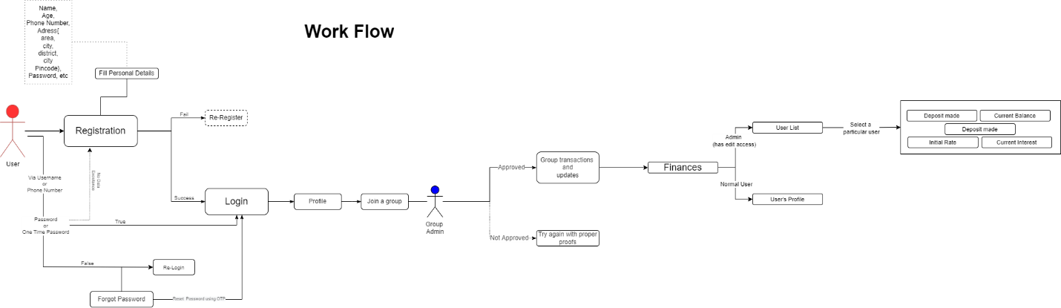

* The following is the group-level block structure for the Proposed Blockchain-based AmritaSREE ledger.

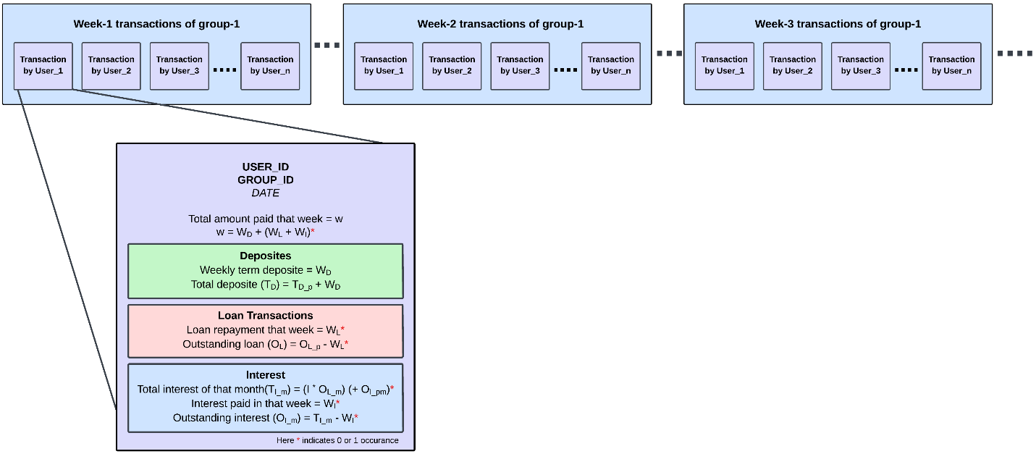

**Modules Executed as part of Phase 1:**

* Login and User Registration Module.
* High level design of application’s financial module.
* Blockchain Conceptual Design.

**Students’ Name and Signature**

Kalla Likhit Sai Eswar:



Pappala Kumar Aditya:

Naga Sushanth Kumar:

**Guide’s Signature**

Mrs. Sruthy Anand: