Connecting via FTP using Fetch on Mac OSX

Fetch is a popular commercial ftp client for Mac OSX that can be used to connect to and upload/download files from your Gemini II.

Fetch is available for purchase from Fetch Softworks at http://www.fetchsoftworks.com

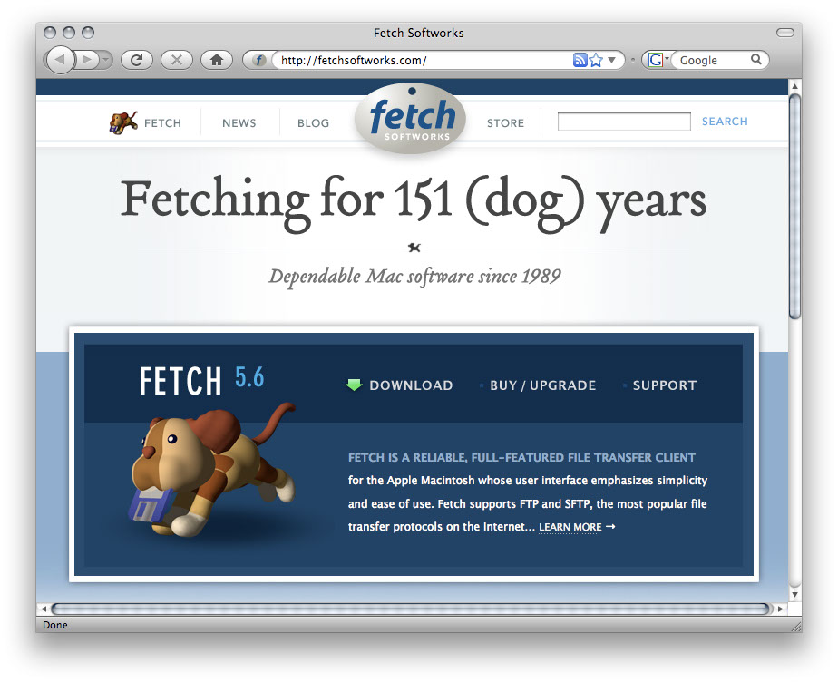

As of the writing of this document Fetch is $29 for a new single user commercial license.

- Purchase, download, and install the app as per the site instructions
- Launch the app
- New Connection
Fetch will automatically open a new connection dialog. If it does not you can always choose “New Connection” from the File menu:

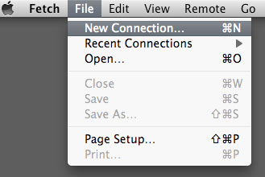

- New Connection Setup

The New Connection Setup is where you enter all the information about your Gemini Mount

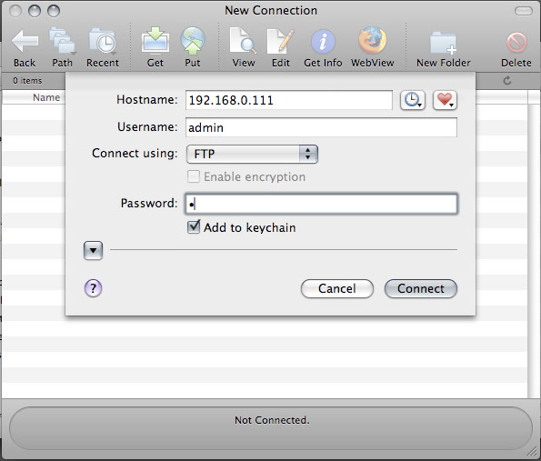

Hostname: Enter your IP address of your Gemini II Mount. If you are using direct connect enter the default value of 192.168.0.111, as shown above.

If you are using DHCP (typically if you connect through a router or home network) you will need to enter the address of your Gemini II as assigned by your DHCP server. Typically it looks something like the address below:



Tip: if you have web access to your Gemini II you can find the DHCP assigned IP address from the Gemini II web page under Network Settings -> current settings.

Tip: As of the writing of this guide, you cannot use the Gemini server name “Gemini” to connect. You must use the ip address.

Username: Enter the username you’ve setup for your Gemini II server, or use “admin” as the default

Connect using: leave the setting as “FTP”

Password: Enter the password you’ve setup (case sensitive) or leave blank as the default.

Add to keychain: This is an option that saves your password on your Mac so when you restart Fetch and connect to the Gemini, you will not have to type in your password again.

Click “Connect” to save the Connection and connect to the Gemini II ftp server

- File Transfer Window

Here is where you can perform all your file upload/download activities. The interface is a little different from traditional ftp clients. You can simply drag files into and out from this windows to upload and download files respectively.
