HSRW Datathon 2026, Kleve
From Messy Factory Data to Actionable Insight
BBMED Production Data Challenge, Datathon case study
Pablo De Villota and Ahmed Azzeh | September 26, 2026

At a glance
The brief: a cosmetics manufacturer (BBMED) runs five packaging lines and records what happens on them in three systems that don't agree with each other. We were asked to turn that raw, uncleaned data into insight on production performance, stoppages, staffing and the energy use of one bottle line, and to recommend how the data itself should be collected in future.
The event: the first-ever HSRW Datathon, hosted by Hochschule Rhein-Waal on its Kleve campus on 24 to 25 September 2026. BBMED, a local cosmetics manufacturer, was invited to provide real production data and the guiding questions. Every team got the same data and the same brief, with 24 hours from data release to a final presentation in front of a jury.
Team: Pablo De Villota and Ahmed Azzeh, working as a team of two.
Outcome: a single winner was named, and it wasn't us, but the jury told the room the decision had been extremely hard to make. As the university's first datathon, the focus was on the challenge itself rather than the podium.
Scale of the data: 20 files across MES, ERP, hand-kept Excel logs and energy meters, including 6,023 production periods, 43,848 stoppage records, 913 production orders, 1,667 Excel log rows and 5,599 ERP product records, spanning January 2025 to September 2026.
Headline | Result
Fleet OEE (availability x performance) | 43.5% across 889 clean orders
Running speed while producing | about 95% of target on every line
Share of time actually producing | about 46%, the real loss is stopped time, not slow running
OEE, largest vs smallest orders | 51.1% vs 33.5% (+17.6 pp)
MES vs Excel agreement | 90% of 263 shared orders within +/-10% (median gap 0.65%)
KM1 line power draw | about 3.2 kW, two sub-machines account for 61% of it
KM1 energy intensity (one fully traced order) | about 2.8 kWh per 1,000 bottles, about a third drawn while stopped

Three things I'd point a plant manager to
- The lines are fast but idle. Every line runs at 93 to 97% of target speed when producing; OEE is lost almost entirely to downtime, and on the tube lines four in five lost minutes are organisational (changeovers, cleaning, breaks), not machine faults.
- Order size is the cheapest lever. Bigger orders spread the fixed setup and cleaning cost over more units; batching small repeat orders lifts availability without touching the machines.
- The data can be trusted, with known gaps. The systems agree for a typical order, but a small tail of mismatches, a third of stoppage rows without a parent record, and almost no scrap data would distort KPIs if nobody knew about them.

The challenge
BBMED develops, mixes and packages cosmetics (including the NO Cosmetics brand). The data covers the packaging stage on five lines:
Line | Type | What it does
KM1, KM2 | Bottle filling | Feed bottles, fill, cap, label, fold cartons and box
AXO10, AXO11, AXO12 | Tube filling | Fill and seal tubes, then box

Since introducing a Manufacturing Execution System (MES), the plant has kept two parallel records of every packaging order: what the MES logs automatically, and what operators write into Excel sheets by hand. ERP holds product master data (fill volume, liquid density, pack sizes), and five energy meters were recently fitted to the sub-machines of KM1.
The explicit brief was not "make charts". It was: understand the tables, find how they relate, assess quality, clean and restructure, document every assumption, and only then generate insight. It was also acceptable to conclude that a question cannot be answered with the current data, as long as we said why and what data would fix it.
Why it was hard. Column names mix German and English (Auf_SollMenge, Art_SollTakt, Chargennummer), identifiers differ by system (machine "1" in Excel is "KM1" in MES), stoppage codes have no documented meaning for some values, one CSV is semicolon-delimited and another comma-delimited, and the Excel log has two-row headers with units in the second row.

Approach
- Map the landscape first. Profiled every table (row counts, keys, null rates, value ranges) and drew the schema before running any analysis, so every later join was a deliberate choice rather than a guess.
- Pick the backbone table. mes_production_periods is the only table that records start, end, units produced, target rate and stoppage time together for the same unit of work, so it became the fact table. One row is one continuous run of a work record on one machine; an order averages 6.6 periods.
- Roll up to the order. Grouped periods by order number (913 orders) and computed, per order: Availability = production time / booked time; Performance = (units / production minutes) / target units per minute; OEE = Availability x Performance.
- Clean with explicit rules, not by eye. Dropped 4 orders that ran on more than one machine or product, and 20 orders whose target rate (10 to 13 units/min) was clearly stale master data against actual rates of 20 to 55/min. 889 orders remained.
- Reconcile the two sources. Mapped Excel machine numbers to MES IDs by cross-tabulating shared order numbers (1 to KM1, 2 to KM2, 10 to 12 to AXO10 to 12, unambiguous), then compared quantities per order and per order-day.
- Attach energy by time window. The energy meters have no order ID, so readings were aligned with MES production periods on the same line and timestamp range.
- Document every limitation next to the number it affects, rather than in a footnote at the end.

Why OEE has no quality factor: reject records link to only 167 of 6,023 work records (under 3%). Rather than invent a scrap rate, OEE is reported as Availability x Performance and labelled an upper bound.

How the data actually connects
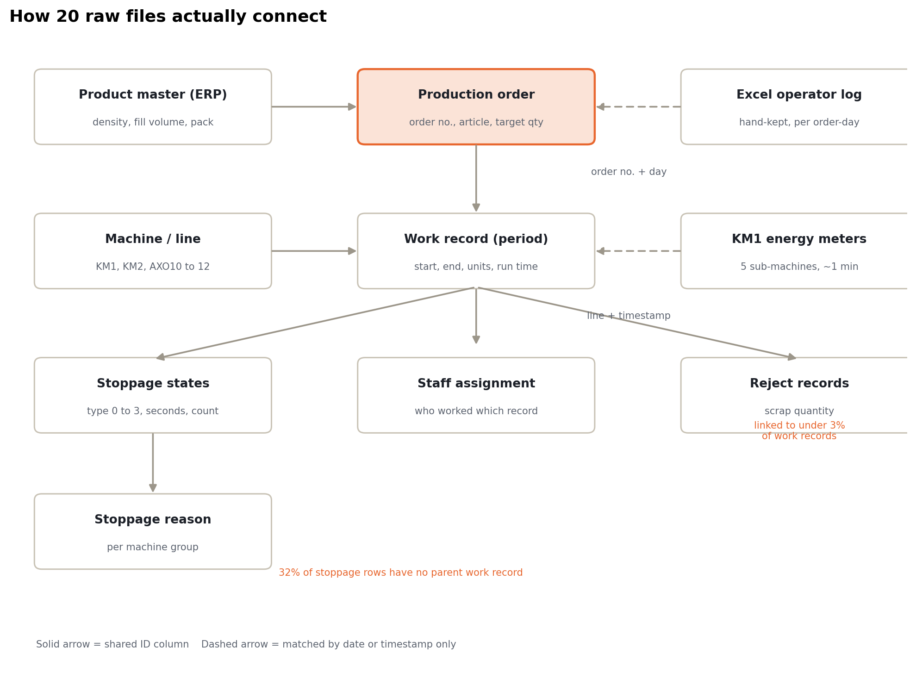
Logical data model, 10 entities from 20 source files.
The first real result of the project was this map. Everything important hangs off two keys: the order number and the work record ID (one row per continuous run). Two sources have no shared ID at all: the Excel log can only be matched on order number plus calendar day, and the energy meters only on line plus timestamp.

Finding 1. The machines are fast. They just don't run enough.
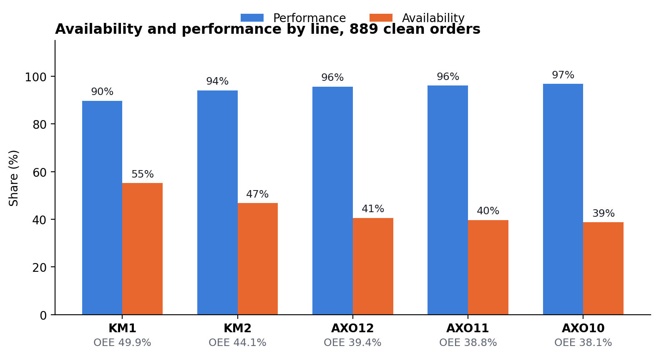
Observed. Fleet OEE averages 43.5% (median 43.2%). Performance sits between 90% and 97% on every line, while availability ranges from 39% to 55%. The ranking between lines is decided almost entirely by uptime.
How it was calculated. Per-order roll-up of CalcProductionTime, CalcUsageTime, units and TargetUnitsPerMinute from the period table; target rate is consistent within an order for 909 of 913 orders.
What it means. Speeding the machines up would buy at most a few points. Keeping them running is worth tens of points. KM1 has the best availability but the lowest performance (89.7%), making it the one line where a speed or micro-stop investigation is also worthwhile.

Finding 2. Bigger orders run better, and only because of uptime
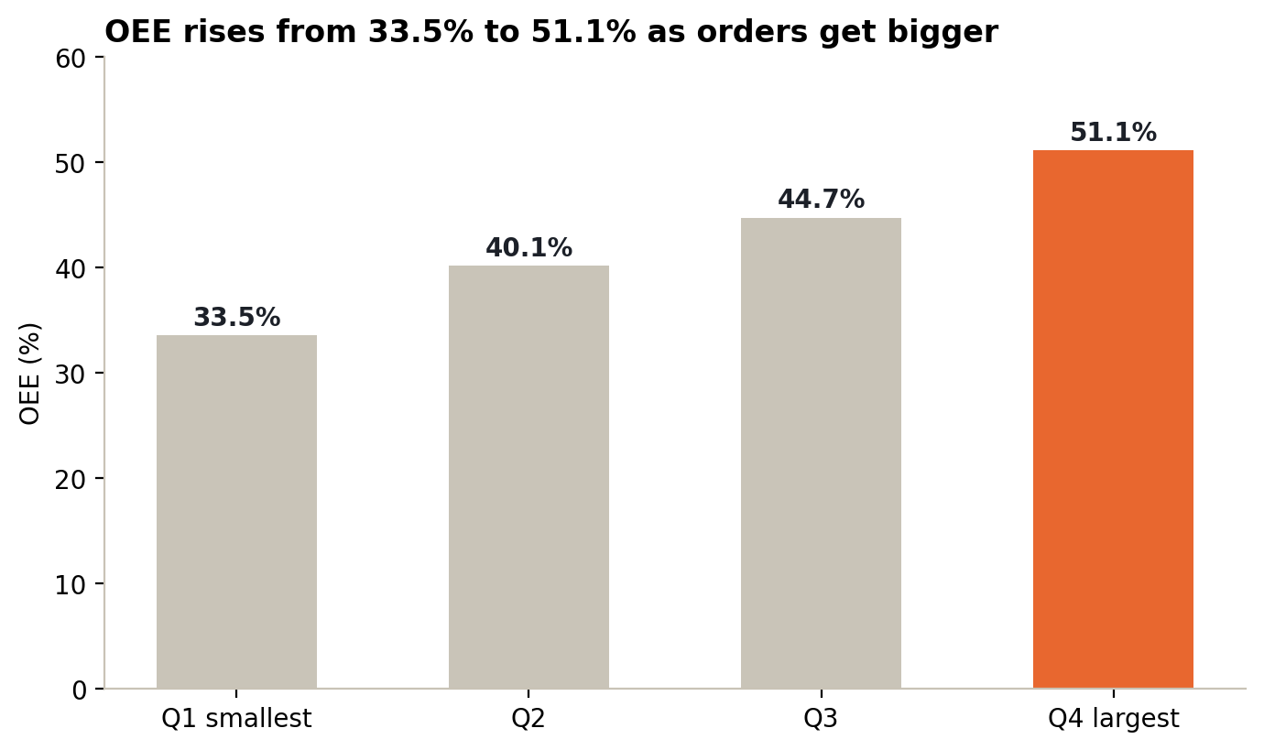
Observed. OEE climbs steadily from 33.5% in the smallest quarter of orders to 51.1% in the largest, a gap of 17.6 percentage points. Running speed barely moves across the groups; availability rises by 16 points.
Why. Every order carries a roughly fixed cost of setup, cleaning and material staging. On a large order that cost is spread over many more running hours. Order size is also the strongest single correlate of availability in the dataset (Pearson r = +0.33), well ahead of crew size (+0.15) or the number of stop/restart events (+0.17).
Product changes point the same way. 800 of 889 orders (90%) started right after a product change on their machine; they averaged 43.7% availability and 41.5% OEE. The 89 orders (10%) that continued the same product averaged 52.6% availability and 50.3% OEE. That comparison is not adjusted for order size, which also differs between the two groups.
Same product, very different results. For the 41 products with at least five orders, running speed varies by about +/-8 points between repeat runs, but availability swings by up to +/-24 points. The product is not what makes an order efficient; how it is scheduled is.
So what: consolidating small repeat orders of the same SKU, or sequencing similar products back to back, should raise availability without any capital spend.

Finding 3. Why the lines stop: changeovers, not breakdowns
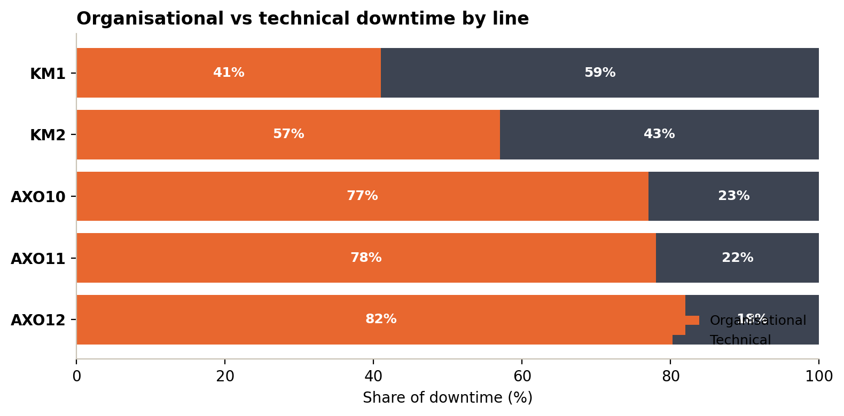
Line | Organisational share | Technical share | Reading
AXO12 | 82% | 18% | Changeover and cleaning dominate
AXO11 | 78% | 22% | Changeover and cleaning dominate
AXO10 | 77% | 23% | Changeover and cleaning dominate
KM2 | 57% | 43% | Mixed
KM1 | 41% | 59% | The only line where faults outweigh organisation

Breaking classified stoppage time down by reason (joined through the per-machine-group reason table; work records without a parent period excluded):
Bottle lines (KM1, KM2) | Hours | Tube lines (AXO10 to 12) | Hours
Setup / cleaning (Rüsten/Reinigen) | 1,940 | Setup / cleaning (Rüsten/Reinigen) | 1,102
Breaks | 982 | Breaks | 762
Cleaning | 685 | Cleaning | 481
Labeller fault | 438 | Disinfection | 344
Disinfection | 262 | Tube-machine fault | 268
Carton folder fault | 197 | Bulk material change | 109

A separate "RUHE" (line at rest) code accounts for a further 1,213 h on the bottle lines and 4,222 h on the tube lines. That is unplanned-looking idle time with no production scheduled, and it deserves its own conversation about scheduling rather than being counted as a fault.
What it means. On the tube lines, four in five lost minutes can be addressed with process discipline: SMED-style changeover work, cleaning standards and material staging. KM1 is the exception, where the labeller and carton folder are the recurring technical culprits, so maintenance focus belongs there.

Finding 4. Can the plant trust its own records?
The brief said explicitly: don't just declare one system correct, find where and how they differ.
Per order. 263 orders appear in both MES and the Excel log with a usable order number.
Quantity gap between MES and Excel | Orders | Share
0 to 5% | 228 | 87%
5 to 10% | 9 | 3%
10 to 50% | 16 | 6%
over 50% | 9 | 3%

The median gap is just 0.65%, but the mean is 30%, dragged up entirely by nine orders where MES shows 2 to 55 times the Excel quantity (order 701145: 1,026 units in Excel, 57,554 in MES). Machine assignment agrees for 261 of 263 orders, so the disagreement is about quantity, not about which line ran the job. The pattern looks like record splitting: one Excel line capturing a single shift of a multi-day order that MES aggregates in full.
Per order-day (follow-up analysis). Matching at the finer grain of order plus calendar day gave 645 comparable order-days, 1,852 MES-only and 520 Excel-only. Three systematic patterns showed up:
- Quantities still agree: median absolute gap 0.6%, three quarters within 2.3%.
- Excel starts about 5 minutes earlier. Operators write the shift start (05:55) while MES logs the first booked minute. Harmless, but it means start times should never be compared to the minute.
- MES keeps the clock running overnight. Many MES order-days run until 06:00 the next morning while Excel closes at the end of the late shift (22:50). On a quarter of matched order-days the MES duration is at least 140 minutes longer than Excel's. Any rate calculated from MES elapsed time will look worse than reality on multi-day orders unless idle night time is removed.

Consequence for KPIs: summarise agreement with medians, not means, and treat any order with a gap above 50% as a data problem to audit before it enters a performance report. Several of the 20 performance-above-150% orders excluded in cleaning trace back to this same mismatch.

Finding 5. Energy on KM1: where it goes and what a bottle costs
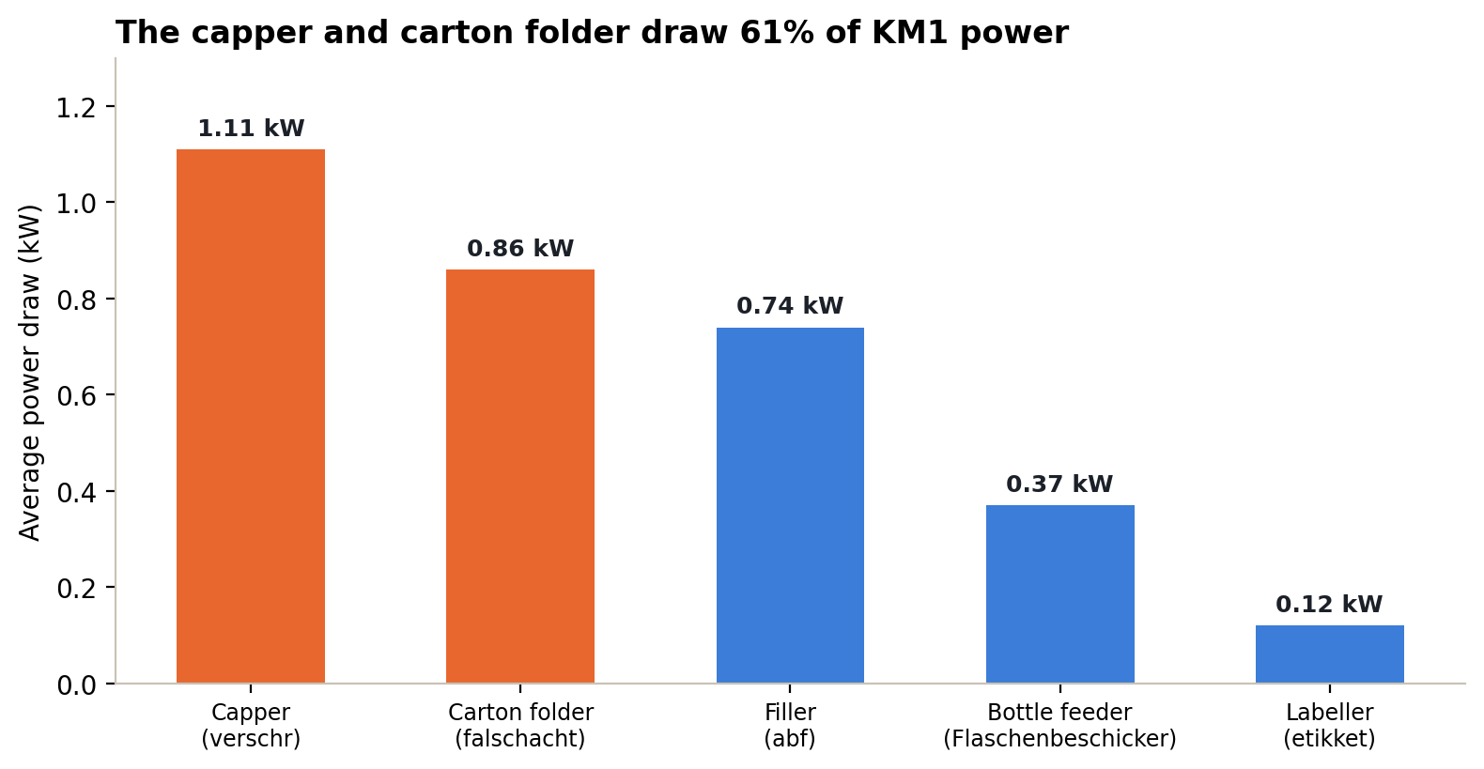
Where it goes. The five meters on KM1 draw about 3.2 kW combined. The capper (verschr) and carton folder (falschacht) account for 61% of that; the labeller draws a tenth of the capper. The split held steady across every hourly block in the window, so it is a property of the machines, not a one-off spike.
Closing the loop to an order. At the datathon we treated energy as impossible to attach to orders. Going back through the data afterwards, the meter window turned out to overlap a single MES work record on KM1: order 702026, product 10269202061-1 (100 ml bottle, liquid density 1.02 g/ml), which ran from 14:31 to 22:46 with a crew of three.
Order 702026 on KM1 | Value
Booked time | 8 h 15 min
Of which producing | 5 h 34 min (67%)
Units produced | 9,112 bottles
Estimated energy (3.1 kW x booked time) | about 25.6 kWh
Energy intensity | about 2.8 kWh per 1,000 bottles
Energy drawn while the line was stopped | about 8.4 kWh (about one third)

The line doesn't power down when it stops. Across fifteen-minute blocks during the order, total draw varied by only +/-5% even though a third of the run was downtime. That is the signature of a baseload-dominated line: the motors, heaters and control cabinets keep drawing whether or not bottles move.
Scaling it up, as an order-of-magnitude estimate. Between January 2025 and September 2026 KM1 was booked for about 6,500 hours and producing for about 3,700. At the same draw, the roughly 2,800 stopped hours represent roughly 8,600 kWh, about EUR 1,700 at an assumed industrial tariff of EUR 0.20/kWh. The money is modest for one line; the point is that the same logic applied to all five lines, with meters on the tube lines too, turns downtime into a number finance can see.
Honesty box: this rests on 3.5 hours of meter data, one order and one product. It cannot yet answer the brief's questions on density, production rate or stoppage-reason energy. What it does prove is that the join works: with meters logging continuously, every one of those questions becomes a query.

Post-event deep dive. Decoding the stoppage table
During the datathon both workstreams hit the same wall in mes_stoppages: stoppage type 0 is not defined anywhere, and summed stoppage durations exceeded the elapsed time of their parent period for most work records (one record showed 1,529,552 seconds, almost 18 days). We treated the table as unreliable and worked around it.
After the event I went back and tested it properly against the period table, record by record. It is not broken; it is a state-time ledger, and every type has a meaning:
Stoppage type | What it actually is | Evidence
3 | Time the line was producing | Equals CalcProductionTime exactly for 6,023 of 6,023 work records
1 | Classified stoppages, one row per reason code | Reason = StoppageNo, looked up per machine group
0 | Unclassified short stops, never given a reason | Many events, short durations (e.g. 54 events, 43 min in one shift)
2 | Idle time before the period began | For gaps over an hour, matches the time since the previous period on the same machine within 2 minutes in 95% of cases (r = 0.92)

Types 0, 1 and 3 together never exceed the booked time of their period (true for 100% of records). The huge numbers all sit in type 2, which is the machine standing idle between orders, over weekends or holidays, not a counting error.
Why this matters. It overturns two conclusions from the presentation ("type 0 is undefined" and "stoppage durations can't be summed") and unlocks the analysis we thought was blocked: lost time by reason, micro-stop frequency per product, and, joined to energy, stoppage energy by reason. It is also a good lesson in not stopping at "the data is wrong": the more useful question is what the data would have to mean for it to be right.

Recommendations

For operations
- Batch small orders. The clearest, largest lever in the data: the smallest quarter of orders loses about 16 points of availability to the largest.
- Run a changeover study on the AXO tube lines. 77 to 82% of their downtime is organisational; a SMED-style review of setup, cleaning and material staging should beat maintenance spend there.
- Focus KM1 maintenance on the labeller and carton folder, the recurring technical stoppages on the only line where faults outweigh organisation.
- Put KM1 into standby during long stops. Power barely drops when the line is idle; an automatic standby for the capper and carton folder, the two largest draws, is the most direct energy saving.

For the data model
- Make order number mandatory on every table, including stoppages and rejects, so no record can exist without a parent order.
- Rename MachineNumber to a single MachineID vocabulary shared by MES, Excel and the energy meters (KM1, KM2, AXO10 to 12), and document the stoppage-type codes in the database itself.
- Log energy continuously and tag it with the active work record, then extend meters to KM2 and the tube lines. That single change answers every energy question in the brief.
- Replace the free-form Excel log with MES entry, or at minimum one Excel row per MES period rather than per shift, and drop redundant columns (Chargennummer, duplicate quantity fields).

Validation rules to introduce
Rule | Catches
Performance must be between 20% and 130% of target | Stale target-rate master data (20 orders today)
MES vs Excel quantity gap above 10% triggers a review | Record-splitting mismatches (9 orders over 50% today)
Every stoppage row must reference an existing work record | Orphaned stoppages (32% of rows today)
Every work record must carry a reject count, even if zero | Missing quality data (97% of records today)
Period end cannot pass the end of the last scheduled shift without an explicit night booking | Overnight clock inflating MES durations

Limitations, stated plainly
Limitation | Effect on the results
No reliable Quality factor (rejects link to <3% of work records) | OEE is an upper bound; true OEE is lower
Energy covers 3.5 hours on one line and one order | Sub-machine split is solid; per-order and scaled figures are estimates, and density or rate effects cannot be tested yet
Only 263 of 913 MES orders have an Excel counterpart | The reconciliation covers roughly a quarter of MES volume
Most products have fewer than 5 orders | Product-level comparisons hold only for the 41 higher-volume SKUs
Correlations are pairwise | Order size, crew size and product are entangled; a multivariate model is the next step before claiming causation
32% of stoppage rows have no parent period | Reason-level hours are a lower bound

Skills and takeaways
Tools and methods: Excel for exploration, plus Python scripts (pandas) to clean, cross-reference and visualise the data and surface patterns; relational data modelling and schema design; OEE and manufacturing KPI design; time-series alignment of energy-meter data to production events; source reconciliation at order and order-day grain; data-quality rules and validation design; translating German shop-floor terminology.

What I'd carry into the next project
- Map before you measure. The schema diagram was the most valuable hour of the 24 we had; every good finding came from knowing exactly which join it rested on.
- Medians before means on operational data. Nine bad orders out of 263 turned a 0.65% typical gap into a 30% average one.
- "The data is broken" is a hypothesis, not a conclusion. The stoppage table looked unusable until it was tested against a second source, at which point it explained itself.
- Say what can't be answered, and what would fix it. The energy workstream was more convincing as 'here is the one join that works, and the meter setup that would scale it' than any chart built on assumptions.
- Presentation is part of the analysis. Our findings were solid on the day but lost clarity in delivery; this write-up is the version I would present now: one claim per section, the evidence under it, and the limits next to the number.

