Basics

The palette

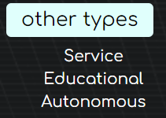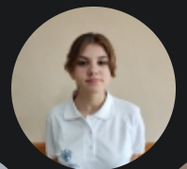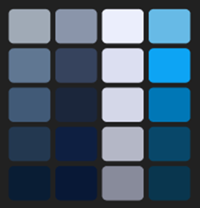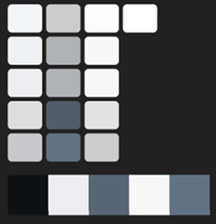All the labeling components

Buttons design

Tools that we used

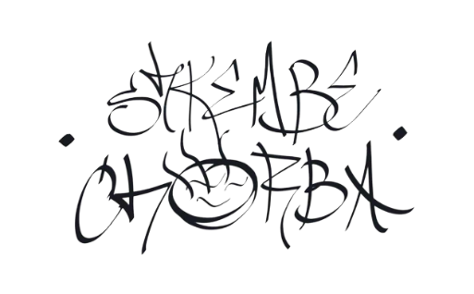

Logo variations

The font we used

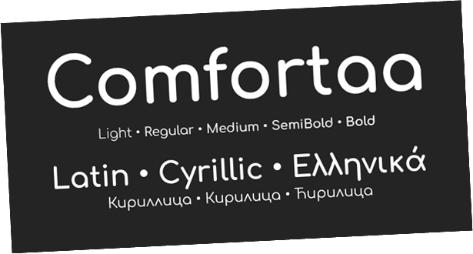

Contact us

Mockups

Mockup overview