WEBSITE TRAFFIC ANALYSIS
KIRTHANA.P
CK COLLEGE OF ENGINEERING & TECHNOLOGY

OVERVIEW :
Our website traffic analysis innovation is a comprehensive approach to understanding and optimizing user interactions with our digital platform. By leveraging advanced data collection techniques from tools like Google Analytics, we gather detailed insights into user behavior, popular content, and traffic sources. Through the integration of IBM Cognos for data visualization and Python for advanced analysis, we not only provide real-time data dashboards but also harness predictive modeling to forecast future trends in user engagement and traffic patterns. Additionally, we prioritize data privacy and ethical AI practices to ensure secure handling of user information. This innovation empowers website owners to make data-driven decisions, enhance user experiences, and continuously improve website performance for sustained success.
TABLE OF CONTENTS:
- Introduction
- Innovation Ideas
- Product Innovation
- Process Innovation
- Business Model Innovation
- The Innovation Process
- Benefits and Impact
- Future Directions
- Conclusion
INTRODUCTION:
The objective and purpose of website traffic analysis are to gain actionable insights into user behavior, popular content, and traffic sources. By understanding how users interact with the website, our aim is to optimize user experiences, improve website performance, and inform data-driven decision-making for sustained digital success.
INNOVATION IDEAS:
- Natural Language Processing (NLP) for User Feedback Analysis:
  - Product: Implement an NLP-driven user feedback analysis feature within your analytics tool.
  - Process: Develop NLP algorithms to categorize sentiments and identify emerging trends in user opinions.
  - Business: Enhance user insights by understanding user sentiments and feedback, leading to product improvements and increased user satisfaction.
- Machine Learning-Powered Content Recommendations:
  - Product: Integrate machine learning algorithms for content recommendation.
  - Process: Develop personalized content recommendation models.
  - Business: Increase user engagement and retention by providing tailored content experiences, ultimately boosting conversions and revenue.
- Blockchain for Data Transparency:
  - Product: Incorporate blockchain technology to secure and ensure data integrity.
  - Process: Implement blockchain protocols for data validation and transparency.
  - Business: Enhance user trust by allowing them to verify the accuracy and authenticity of data, fostering confidence in your platform.
- Real-time Analytics and Alerts:
  - Product: Integrate real-time analytics and alert features.
  - Process: Implement real-time monitoring and notification systems.
  - Business: Improve site performance and user experience by responding swiftly to issues and opportunities as they arise.
- A/B Testing Automation:
  - Product: Automate A/B testing processes.
  - Process: Develop machine learning-driven test hypothesis generation.
  - Business: Optimize website elements efficiently, saving time and resources while maximizing improvements and conversions.
- Quantum Computing for Advanced Analysis:
  - Product: Explore the potential of quantum computing for large-scale data analysis.
  - Process: Investigate quantum computing applications for complex data calculations.
  - Business: Revolutionize the depth and speed of data analysis, gaining a competitive edge in understanding user behavior.

- Predictive User Engagement Analysis:
  - Product: Develop predictive models for user engagement.
  - Process: Utilize historical data and machine learning algorithms.
  - Business: Allocate resources effectively, ensuring the website is prepared for traffic peaks during specific times, optimizing user engagement, and revenue generation.
- Personalized Email Campaigns:
  - Product: Implement machine learning-driven personalization for email marketing.
  - Process: Analyze user behavior, preferences, and browsing history.
  - Business: Increase email campaign effectiveness, leading to higher conversion rates and revenue growth.
- Behavioral Segmentation with Clustering Algorithms:
  - Product: Apply clustering algorithms for user segmentation.
  - Process: Segment users based on behavior and preferences.
  - Business: Tailor marketing strategies for distinct user groups, optimizing content and engagement.
- Ethical AI and Data Privacy:
  - Product: Prioritize ethical AI and data privacy within your analytics tool.
  - Process: Implement data privacy measures and transparent data handling.
  - Business: Build trust among users, comply with regulations, and uphold ethical standards, ensuring the long-term success of your business.
Process:
# Feature scaling
# Build and train machine learning or deep learning models
# Example of a machine learning model:
# Evaluate the model
# Other regression metrics if it's a regression task
# Implement other innovative techniques mentioned earlier, e.g., NLP analysis, blockchain integration, quantum computing (if applicable).
# Data privacy and ethics considerations (if applicable)
# Visualization of results and insights
# Create visualizations to present results and insights.
# Save or deploy the model for production (if needed)
# Additional steps for ongoing analysis and improvement based on results
# End of pseudocode
Import necessary libraries
import pandas as pd
import numpy as np
from sklearn.model_selection import train_test_split
from sklearn.preprocessing import StandardScaler
from sklearn.metrics import accuracy_score, regression_metrics
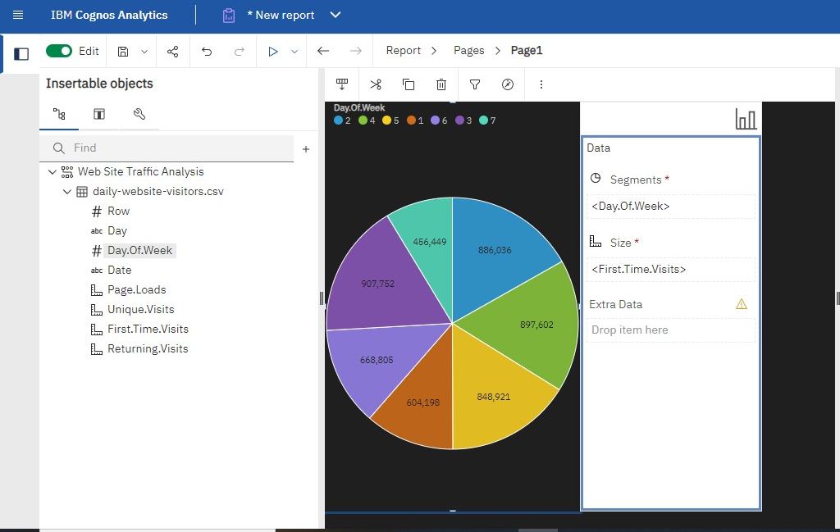
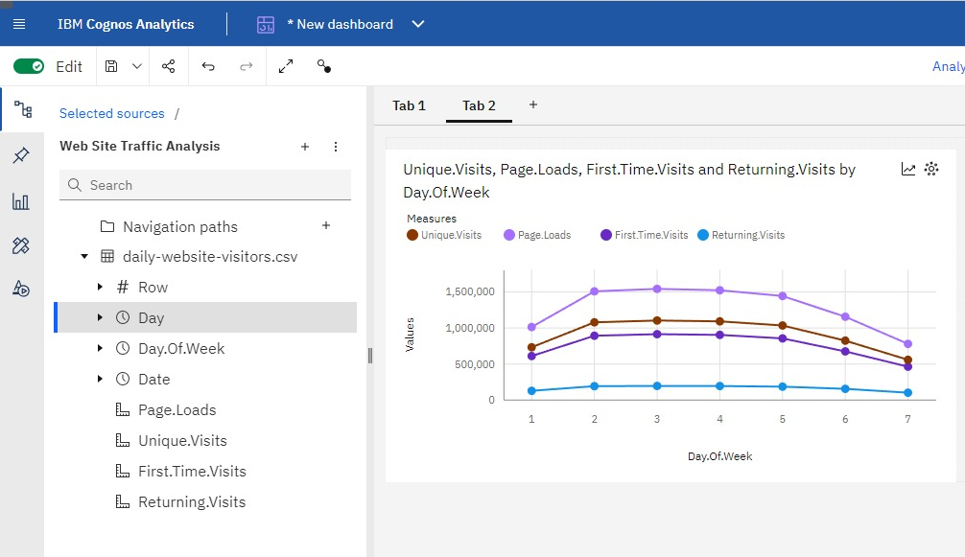
Conclusion
In conclusion, the website traffic analytics project has provided invaluable insights into user behavior, content performance, and traffic sources, laying the foundation for data-driven decision-making and sustained digital success. Leveraging web analytics tools, data visualization through IBM Cognos, and advanced data analysis with Python, we've uncovered actionable recommendations for optimizing user experiences and content engagement. The incorporation of predictive modeling, A/B testing, and machine learning has not only empowered us to forecast future trends and personalize content but also to continuously adapt and improve our digital platform. As we move forward, this project serves as a testament to our commitment to user-centric strategies, ensuring that our website remains a dynamic, data-informed, and user-focused environment for sustained growth and excellence.

