**Final Assignment: Business Plan**

**Business Plan**

This assignment asks teams to develop a business plan that offers a strategic solution to a gap you have identified in the area of women, technology and society. The audience for this Business Plan includes me, and a team of “angel investors” who have a (hypothetical for now :) $500,000 to invest in the startup of a promising social responsibility venture.

The goal is to identify an area of need, design a solution that meets that need involving a new technology, web service, mobile or device app, game, or adaptation of existing technologies such as social media or content management tools. Then you will consider what is necessary to actually produce the solution and get it started as an entrepreneurial effort.

This will be presented to class in a ~12-minute presentation.

**Required Components:**

**Objectives**

* Restate goals of assignment, and how the objectives of your project meet goals.

**Company Summary**

* *Imagine an identity for your team – Independent consulting firm? Freelance consultants? Tech entrepreneurs? Well-established corporation? Inventors? Open source software community?*
  + **Indie game developers/company**
* *Describe your team as an entity and the products/services you generally offer. Who is your typical client base? What is the name of it? Brand?*
  + **We aim to develop games for all ages, especially inspiring female programmers**
  + **Dionysus**
  + **Encourage all children and adults in a fun and educational way.**

**Mission Statement**

* *Write a 1 – 2 paragraph mission statement for your entity (company, etc.). This would be a marketing piece that could be featured on your company website for instance.*

**Statement of the Problem (Market Need)**

* *Describe the gender and technology gap you see as a “problem” and “Market Need.” Note, this does not have to be a business related problem, it can relate to a sociological issue.*
  + **PROBLEM: There is an absence of women in statistics for STEM fields especially for programming**
  + **MARKET NEED: not enough products and educational institutions that promote gender equality in the IT field** 
    - * **Also, not enough games with wide appeal w/ “relatable” female protag for young boys & girls alike**
* *Use data from your past assignments (and any new data as necessary) to provide evidence for the problems you have identified. For instance:*
  + Portrayals of women in media/tech; involvement of women in various technology activities including social media; role of women in world-wide economic development efforts; women as technology professionals
  + Demographics; limitations in technology access / skills; technology affordances (e.g., wifi); and other cultural capital affordances necessary for the audience/customers.
  + (FYI, this is also known as “Market Segmentation”)

**Statement of the Solution**

* *What is your proposed solution to helping mitigate the problems you have identified?*
  + **Has a female protagonist which would portray women in a positive way**
  + **Game is geared toward both genders instead of other games that favor one gender**
  + **Promotes women to get interested in programming (inclusion) by seeing a strong female character**
  + **Making an impression on young children on gender equality, especially in the STEM field**
* *How is the product/service tailored for its target audience? How does it meet the needs of this community?*
  + **Children look for a role model to play as**
  + **The game promotes education through fun activities (concept of flow)**
* *What is the Value Proposition for this product/service, in terms of benefits to individuals, as well as business opportunities for your group (company, etc.)*
  + *Benefits to citizens*
    - **They learn to program (kinda)**
    - **Exposes people to fields uncommon in standard educational institutions**
    - **Promotes inclusion of women as equals in male-dominated areas**
  + *Business opportunities*
    - **A genuinely good educational game (most are bad and not fun) - problem-solving, not rote memorization**
    - **More diversity/more candidates within the field**
      * **More interest in the field**
* *Prototype? Demo?*
  + **Storyboards**
* *What is your distribution strategy? (e.g., what kind of business marketing / community outreach is needed to ensure awareness and adoption of your product/service?)*
  + **Online - Website, Steam, Amazon**
* *How will you determine/measure its success?* 
  + **Number of downloads**
  + **Reviews**
  + **Collaboration with CODECADEMY**

**Competitive Edge**

* *Talk about roles and your company’s strategic positioning and offering. Why is your group best suited to providing this solution?*
  + **The other game only uses BASIC ← the ingame language is called Sprak which is inspired by BASIC**
  + **Sell for cheap**
    - **We offer more languages**
  + **FEMALE PROTAGONIST**
  + **Available in other platforms**
  + **else heart.break() ← inspiration**

**Budget**

* ROUGHLY how will you use the $500,000 in startup?
* Use Excel to develop this.

**Strategy and Implementation Summary Conclusion**

* 1-page summary and conclusion, starting with “In summary, our solution will…”

NOTE: Use graphics, flow charts, tables, and visuals whenever possible to convey your ideas. Be visual in your solutions development. These can be used for both the background data, AND, the proposed solution. For instance, maybe you have a multi-tiered distribution plan that could be expressed well using concept blocks and arrows. I encourage you to be creative in expressing your ideas.

Deliverables:

1 print out of all groups components (presentation, budget, write up, etc)

1 Works Cited (mostly associated with competitive edge and budget)

1 2-4 page write up for EACH team member covering the headings in RED

**Team 3**

Zyd T.

Jonathan C.

Gabriella T.

Lee C.

Liam L.

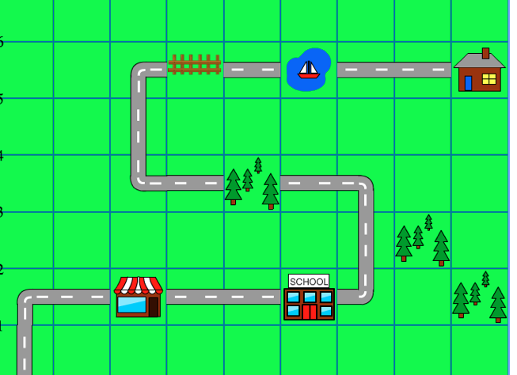

1. Stop by shop to pick up supplies.
2. Stop by the school because the troll has hacked into the grading system and failed all of the students and report cards come out today. A friend is there to help you.
3. Trees have fallen in your path and you must maneuver through them.
4. You must figure out a way to hop over the fence, a friend will give you a boost.
5. You must assemble a canoe and swim across the lake to trolls house.
6. Figure out how to open trolls door.
7. Outmaneuver troll to get to his computer and shut down his system.



Protagonist Troll



Guy friend Girl friend

Example obstacle:

