**3600 user pairs for possible use for power-domain NOMA at 2.485 GHz**

* Motivation behind this test:

Theoretically, NOMA is a technique suitable for simultaneous transmissions for a group of users with

very different channel strengths. If all the users have similar channel strengths, NOMA is not a good

technique candidate. Coarsely speaking, as the channel strength difference increases, the benefit of NOMA becomes more significant. From this viewpoint, the channel strength difference (i.e., $Δq=\frac{{\left\|h_{s}\right\|}^{2}}{{\left\|h_{w}\right\|}^{2}}$) should be set as large as possible. On the other hand, in real wireless networks, the value of $Δq$ cannot be set to too large. This is because the real wireless receivers have limited detection sensitivity. Now the question is: What is the average channel gain difference in a real-world wireless environment like indoor office building?

* Floor plan

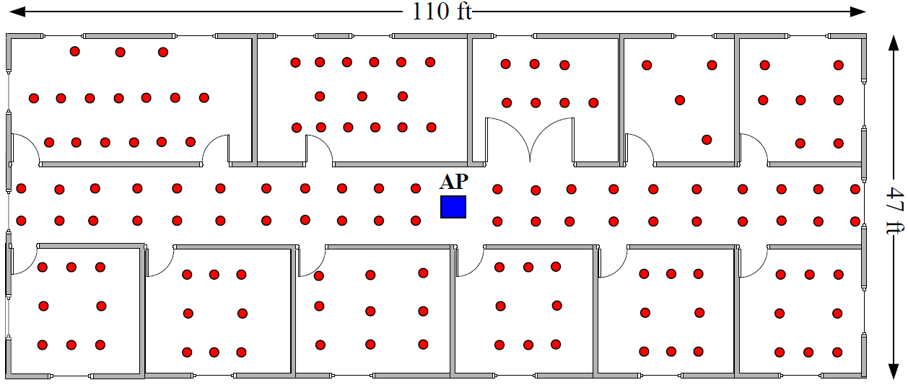

Figure 1- Floor plan of 120 different locations for the STA

The AP is placed at the blue spot in the middle of floor plan. A station is deployed on the 120 different locations (red circles). The transmit power of the AP is set to 20 dBm, and the CSI is measured at frequency of 2:485 GHz. The measured channels are sorted in increasing order and divided into two clusters of weak and strong channels. Each cluster has 60 channels and, thus, there are 3600 user pairs (one strong channel and one weak channel) for possible NOMA transmission. Recall that $Δq$ is the strength difference of a user pair’s channels in decibel.

* Result

Fig. 2 shows the cumulative distribution function (CDF) of the measured $Δq$, and Fig. 3 presents its probability density function (PDF). The median, mode, and average of _q are 8:5 dB, 8:1 dB, and 9:3 dB, respectively. The median, mode, and average of $Δq$ are 8:5 dB, 8:1 dB, and 9:3 dB, respectively.

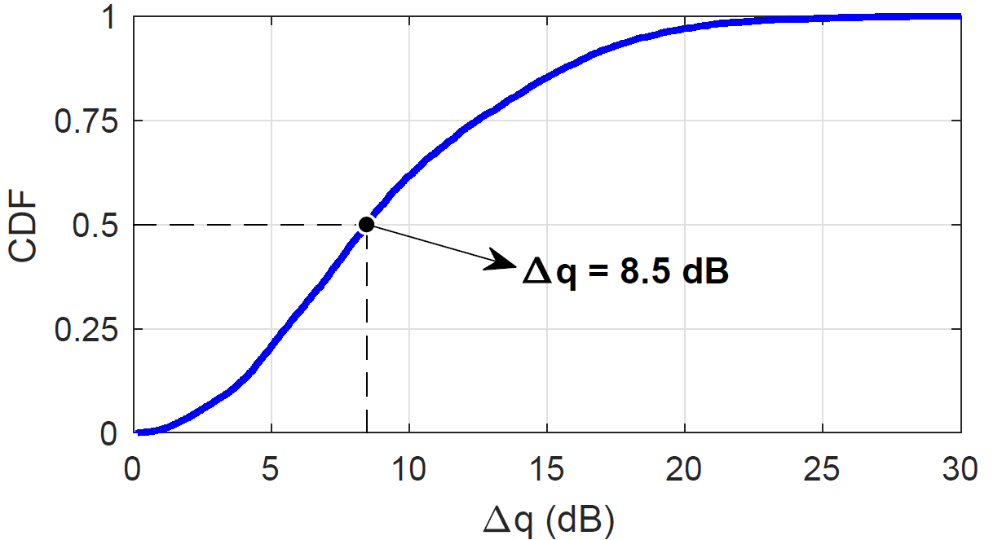

Figure 2- Cumulative distribution function (CDF) of the measured $Δq.$

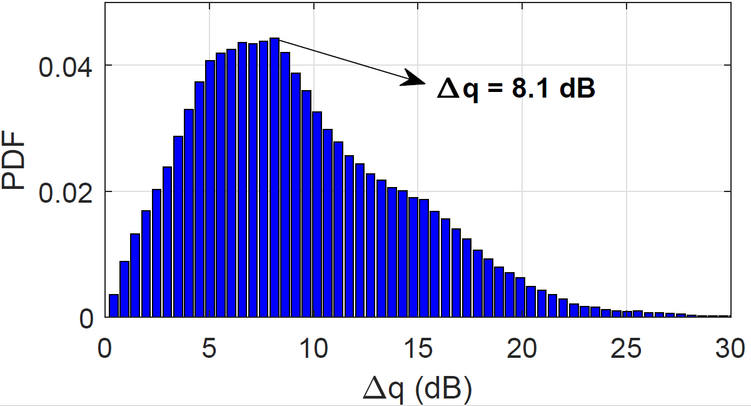

Figure 3- Probability density function (PDF) of the measured $Δq.$