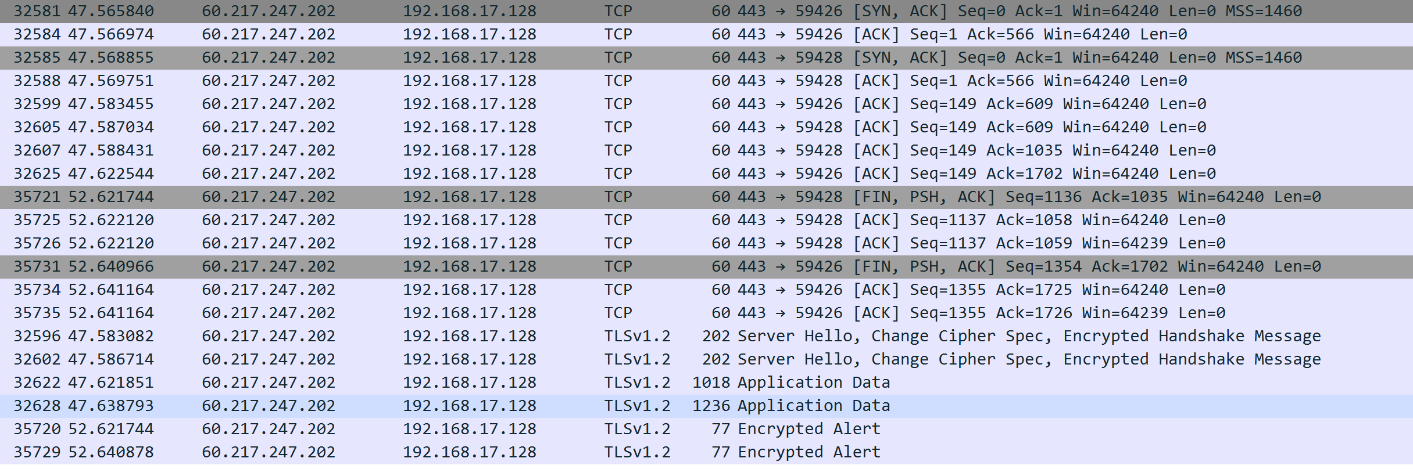

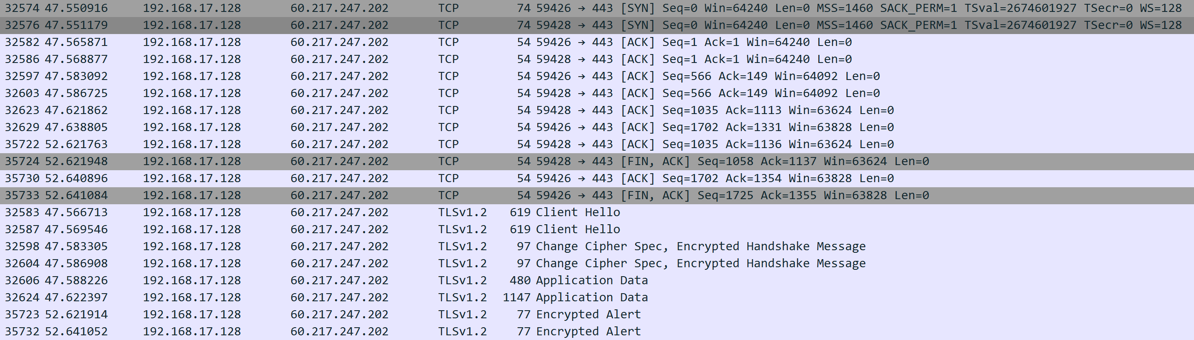



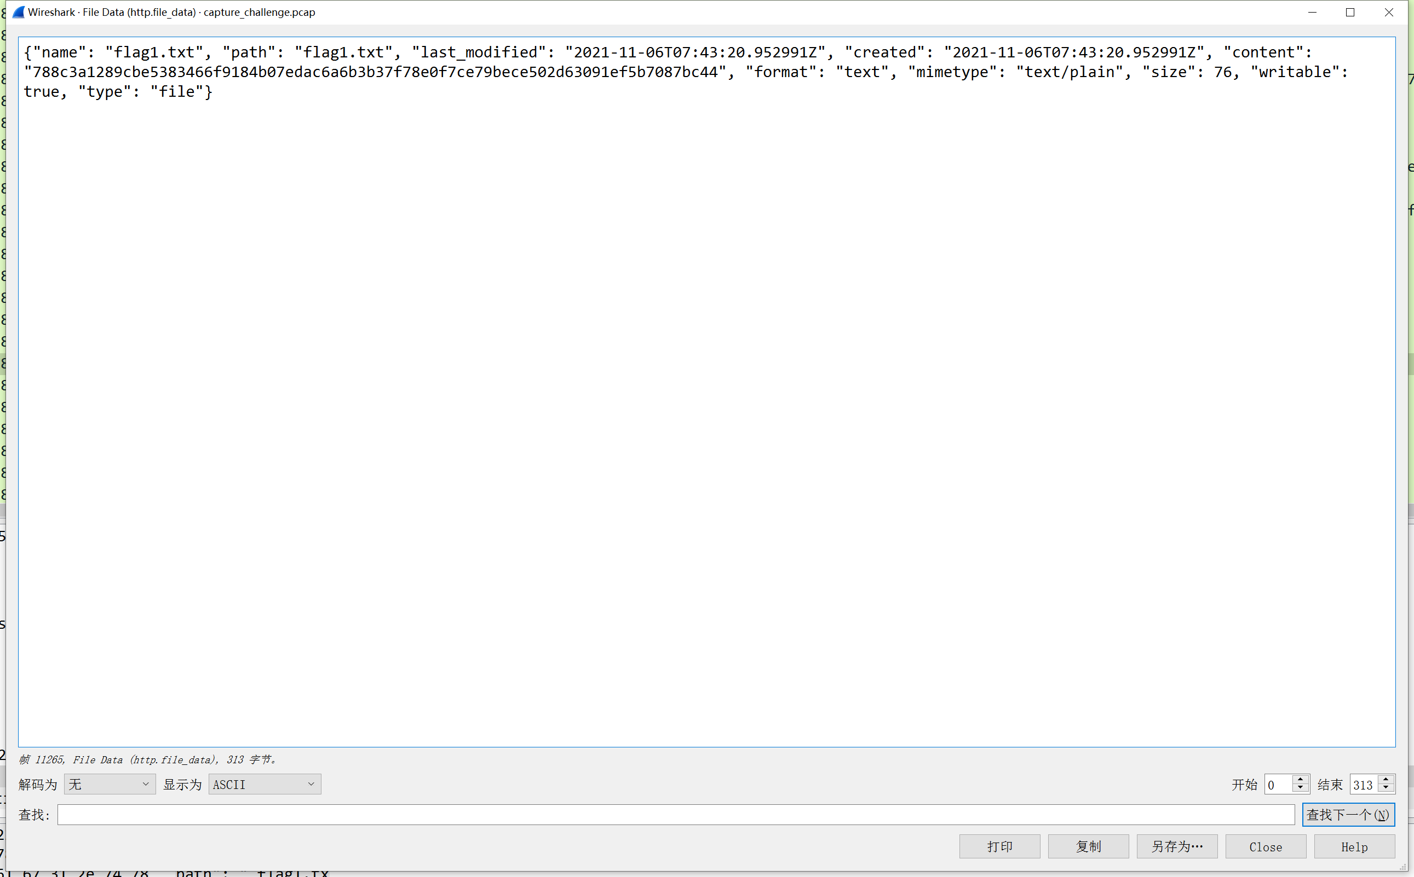

788c3a1289cbe5383466f9184b07edac6a6b3b37f78e0f7ce79bece502d63091ef5b7087bc44

flag{9d9a9d92dcb1363c26a0c29fda2edfb6}