530微积分A2-模拟期末考试

姓名____________ 证件类型____________ 证件号____________ 考试日期____________ 成绩____________

本次模拟考试是为6月8日的期末正式考试做准备，同学们根据操作文档说明熟悉流程，本次模拟题不批改，熟悉操作后，可在半小时后交卷离开考场。

试题

满分: 100分 答题限时: 不限时

全卷10道题，每题10分，需要完整过程 （共10题 共100分）

1.（10分）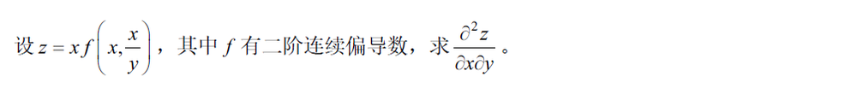

考生作答: ____________________________________________________________________________________________________

______________________________________________________________________________________________________________

______________________________________________________________________________________________________________

参考答案: 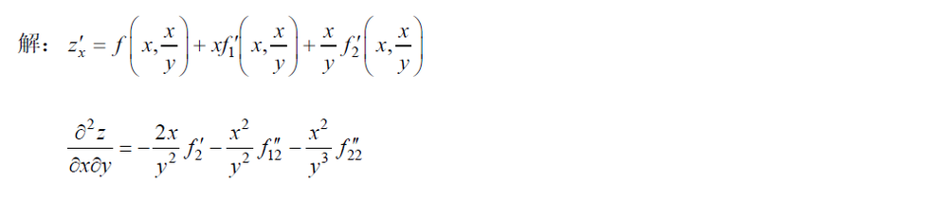

试题解析:

2.（10分）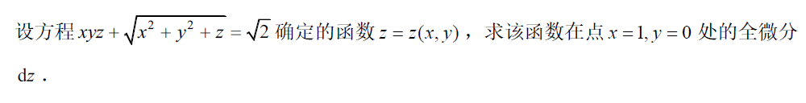

考生作答: ____________________________________________________________________________________________________

______________________________________________________________________________________________________________

______________________________________________________________________________________________________________

参考答案: 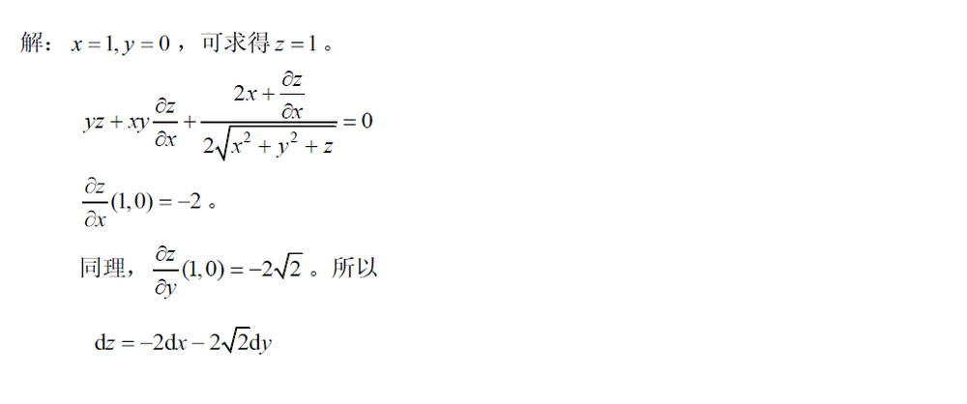

试题解析:

3.（10分）

考生作答: ____________________________________________________________________________________________________

______________________________________________________________________________________________________________

______________________________________________________________________________________________________________

参考答案: 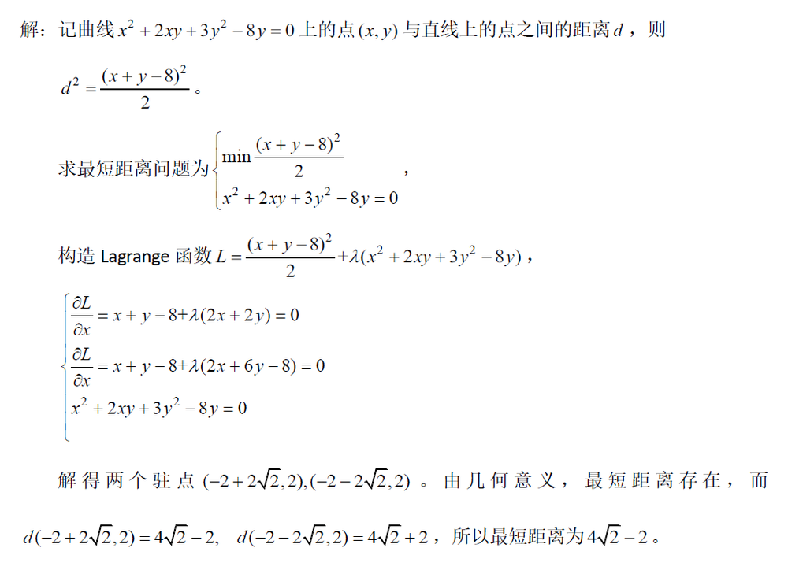

试题解析:

4.（10分）

考生作答: ____________________________________________________________________________________________________

______________________________________________________________________________________________________________

______________________________________________________________________________________________________________

参考答案: 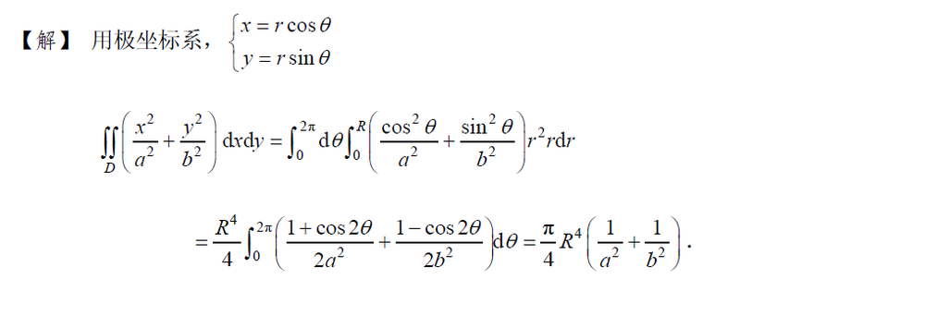

试题解析:

5.（10分）

考生作答: ____________________________________________________________________________________________________

______________________________________________________________________________________________________________

______________________________________________________________________________________________________________

参考答案: 

试题解析:

6.（10分）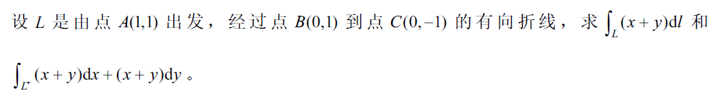

考生作答: ____________________________________________________________________________________________________

______________________________________________________________________________________________________________

______________________________________________________________________________________________________________

参考答案: 

试题解析:

7.（10分）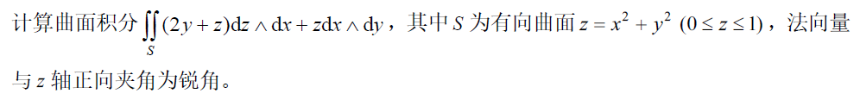

考生作答: ____________________________________________________________________________________________________

______________________________________________________________________________________________________________

______________________________________________________________________________________________________________

参考答案: 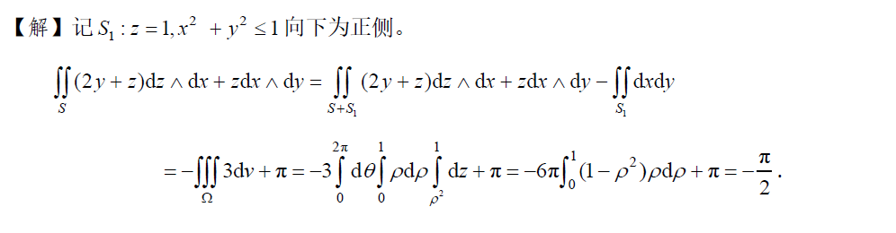

试题解析:

8.（10分）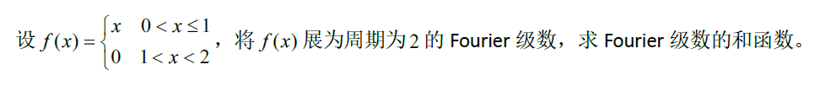

考生作答: ____________________________________________________________________________________________________

______________________________________________________________________________________________________________

______________________________________________________________________________________________________________

参考答案: 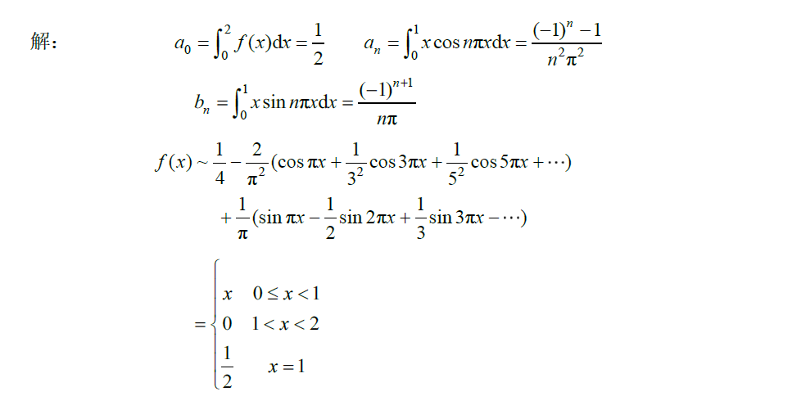

试题解析:

9.（10分）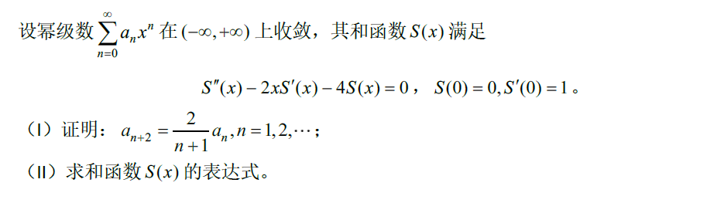

考生作答: ____________________________________________________________________________________________________

______________________________________________________________________________________________________________

______________________________________________________________________________________________________________

参考答案: 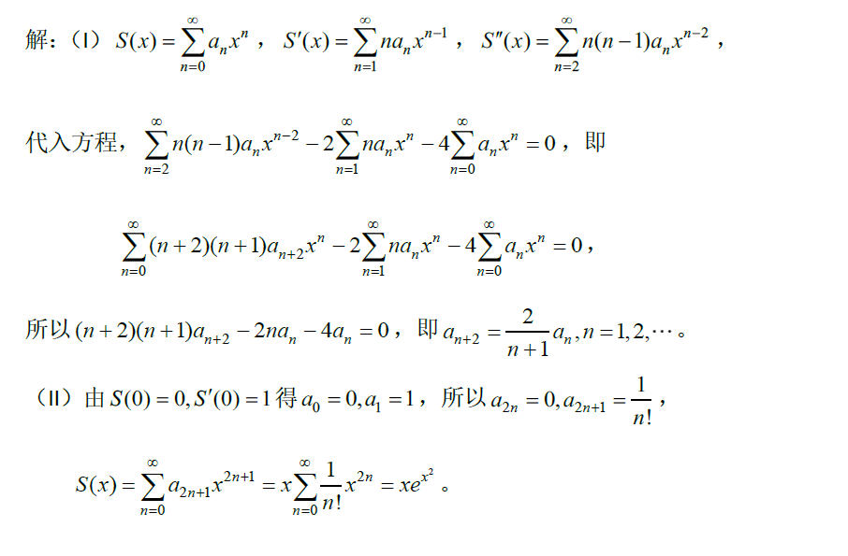

试题解析:

10.（10分）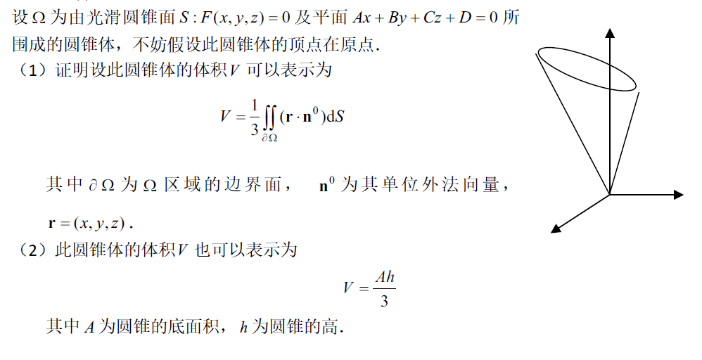

考生作答: ____________________________________________________________________________________________________

______________________________________________________________________________________________________________

______________________________________________________________________________________________________________

参考答案: 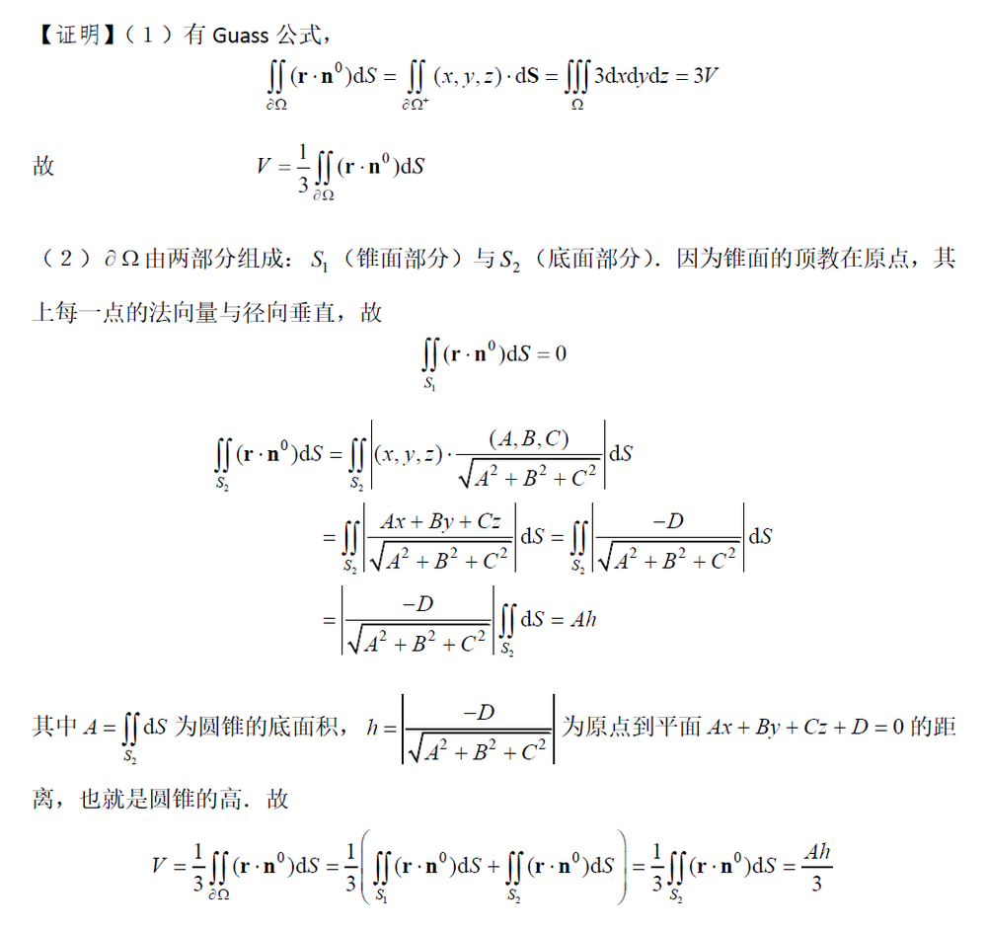

试题解析: