**Computer Networks Sample Questions - Solution**

__D_ 1. The time that a router spends in routing table lookup, is part of which type of delay?

1. Propagation delay
2. Queueing delay
3. Transmission delay
4. Processing delay

__C__2. Which protocol has both an infrastructure mode and an ad hoc mode?

1. SMTP
2. BGP
3. WiFi
4. DNS

__C__ 3. Which protocol helps disseminate AS-level reachability information within an AS?

1. RIP
2. OSPF
3. i-BGP
4. e-BGP

__A__ 4. Which of the following does NOT happen within a router?

1. Fast retransmit
2. Output port queueing
3. Head-of-line blocking
4. Longest prefix matching

__B__ 5. The exchange of RTS and CTS messages in WiFi is introduced to address which problem?

1. Head-of-line blocking
2. Hidden terminal problem
3. Exposed terminal problem
4. Count-to-infinity problem

__B__ 6. A NAT gateway changes the following fields of a packet going from the internal (local area) network to the external (wide area) network:

1. Source IP address
2. Source IP address and source port number
3. Destination IP address
4. Destination IP address and destination port number

__B__ 7. Which pair of protocols adopt Internet Checksum for error detection?

1. Pop3 and SMTP
2. TCP and UDP
3. IPv4 and IPv6
4. Ethernet and WiFi

__D__ 8. Who invented the Ethernet and won the 2022 Turing Award?

1. Zongpeng Li
2. Vint Cerf
3. Jim Kurose
4. Bob Metcalfe

__B__ 9. In slotted Aloha, each type of slot (Success, Empty, Collision) has length 1. We now introduce collision detection, such that a Collision slot has length 0.2 instead of 1. What is the efficiency of this “slotted Aloha with CD” protocol?

1. Below 40%
2. Between 40% and 50%
3. Between 50% and 60%
4. Above 60%

__D__ 10. Which of the following is NOT directly related to SDN?

1. Openflow
2. OpenDaylight
3. ONOS
4. CDMA

11. The multimedia streaming protocol DASH is based on UDP.

Pick one by circling: TRUE **FALSE**

12. Selective-repeat ARQ is always more efficient than Go-back-N ARQ.

Pick one by circling: TRUE **FALSE**

13. Openflow adopts an “match + action” approach, for performing generalized forwarding.

Pick one by circling: **TRUE** FALSE

14. Ethernet’s MAC protocol is unslotted CSMA/CA with binary backoff.

Pick one by circling: TRUE **FALSE**

15. Wireless signal attenuates as it propagates in the air, and signal strength is inversely proportional to distance of travel.

Pick one by circling: TRUE **FALSE**

16. Link-layer switches decrement the TTL field in the IP header.

Pick one by circling: TRUE **FALSE**

17. TCP implements flow control, while UDP does not.

Pick one by circling: **TRUE** FALSE

18. Token Ring is an example of the “taking-turns” MAC protocol.

Pick one by circling: **TRUE** FALSE

19. A shortest path tree computed by link-state routing is a minimum spanning tree.

Pick one by circling: TRUE **FALSE**

20. During the slow start phase of TCP congestion control, *cwd* increases exponentially as a function of RTT.

Pick one by circling: **TRUE** FALSE

21. Draw a line to connect each protocol with the layer that it belongs to.

Openflow

Application layer

Transport layer

Network layer

Data link layer

ICMPv6

BitTorrent

TCP

Pop3

ARP

Bluetooth

22. Name three differences between traditional Internet routing and the SDN approach to routing.

1. Distributed vs logically centralized
2. Dest IP based forwarding vs source routing
3. Single path vs multiple possible paths

23. **Reliable data transfer: forward error correction (FEC) and ARQ**

FEC: For each group of p data packets (of equal size), the source generates q parity packets, such that any p out of these (p+q) packets can be used to recover the original p packets. The source then transmits original data packets and parity packets to the receiver across the network.

1. Name an advantage of FEC over ARQ.

When number of packets lost during network transmission, in the group of p+q packets, is below q, no retransmission is required. More suitable for delay sensitive applications.

1. Name an advantage of ARQ over FEC.

ARQ avoid parity packet computation and packet recovery computation.

ARQ avoids extra bandwidth consumption incurred by the q parity packets.

FEC requires packet loss rate prediction, ARQ does not.

1. Assume that someone attempts to combine FEC with Go-back-N ARQ, so that the input to the ARQ sender includes both original data packets and parity packets. What changes to the ARQ mechanism would you suggest him/her to consider?

ARQ sender: when up to q timers in packet in the group of p+q packets expire, do not retransmit, only decrease cwd. Upon expiration of (q+1)st packet in group, retransmit.

24. Assume that in CRC checksum computation, the data packet is 110010, the 4-bit generator is 1101. (i) What is the 3-bit CRC checksum? (ii) Construct a different 6-bit binary sequence, with the same 3-bit CRC checksum.

Answer: the 3-bit CRC checksum is 100.

Another sequence can be : 000110, 101000, 100101,001011, 111111

25. The following diagram illustrates AIMD congestion control between two network connections who share a bottleneck link. These two connections have the same RTT. Now, assume that **the RTT of connection 1 equals 50% of the RTT of connection 2**, draw a new AIMD diagram starting from the same initial point A.

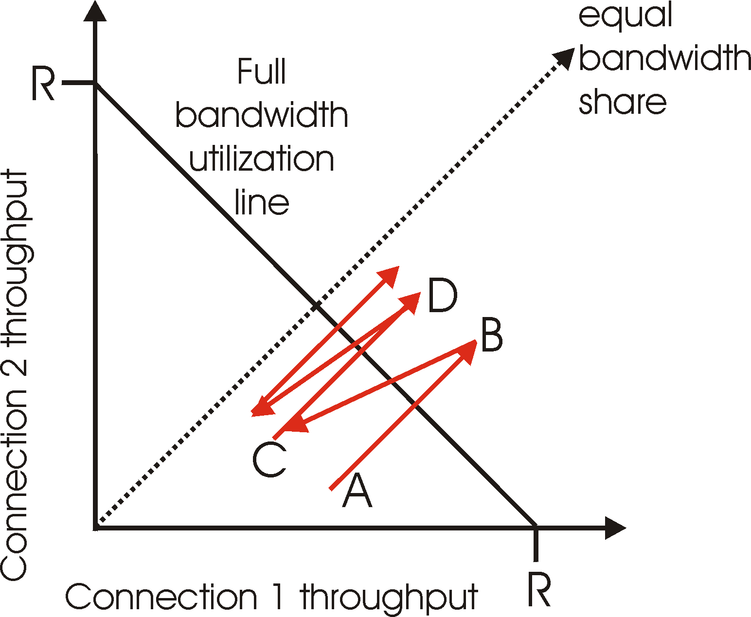

Answer: the new line zigzags in AIMD fashion and converges to the line of x=4y.

* During the AI phases, cwd1 grows twice as fast as cwd2.
* Upon convergence, cwd1 = 2*cwd2.
* Further considering that RTT1 = 0.5*RTT2,
* we have throughput 1 = 4* throughput 2.

26. Answer the following questions about MPLS.

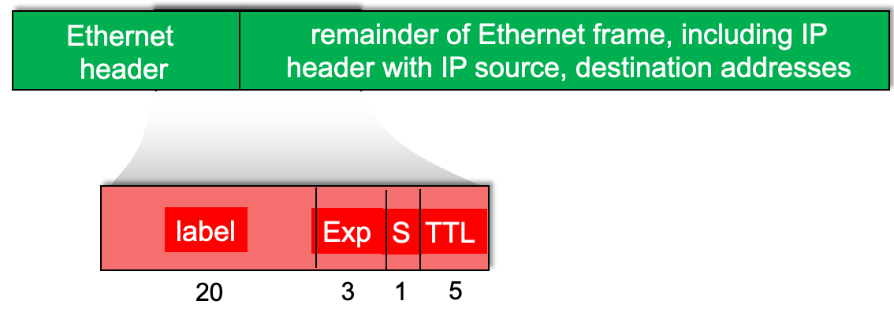

(0) (**bonus**, 3 points) The figure above has an error. What is the error?

The length of TTL is 8.

(1) Which of the four fields (label, Exp, S, TTL) is used to indicate priority of a data packet?

Exp

(2) In the figure below, when an MPLS packet with destination A arrives at router R4, will it be forwarded to R2 or R3?

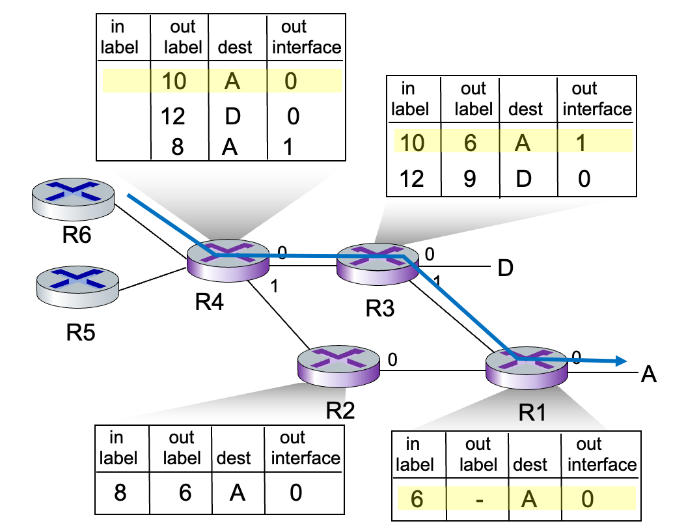

Depends on flow, 10 – R3, 8 – R2.

(3) Name a potential benefit of fixed-length label switching, as compared with longest-prefix matching in IP forwarding.

Faster