|  |  |  |  |  |  |
| --- | --- | --- | --- | --- | --- |
| C:\Users\ufozgg\AppData\Roaming\Tencent\Users\657228726\QQ\WinTemp\RichOle\56U78`T%N~G@O7B$FVE6V9I.png | C:\Users\ufozgg\AppData\Roaming\Tencent\Users\657228726\QQ\WinTemp\RichOle\Z8{E]$0N{CSTTT4T4M36V`V.png | C:\Users\ufozgg\AppData\Roaming\Tencent\Users\657228726\QQ\WinTemp\RichOle\(H_0LHY1[%$W)N{0{@`R5[1.png | | C:\Users\ufozgg\AppData\Roaming\Tencent\Users\657228726\QQ\WinTemp\RichOle\E919Q`(OMUVFU%GMZ~ZT%L9.png | C:\Users\ufozgg\AppData\Roaming\Tencent\Users\657228726\QQ\WinTemp\RichOle\%S}4STXBKXG0}02OEO3TL]C.png |
| C:\Users\ufozgg\AppData\Roaming\Tencent\Users\657228726\QQ\WinTemp\RichOle\2]%EF9`6QBQMUKYG0NT[C1P.png | C:\Users\ufozgg\AppData\Roaming\Tencent\Users\657228726\QQ\WinTemp\RichOle\)_@NR4YWLY@OUT[(HSJT`0D.png | C:\Users\ufozgg\AppData\Roaming\Tencent\Users\657228726\QQ\WinTemp\RichOle\{8`8HWIM~J7X@TH$Z3JJVOF.png | | C:\Users\ufozgg\AppData\Roaming\Tencent\Users\657228726\QQ\WinTemp\RichOle\~HWF}~TKJNTQV%W$B}F[FCK.png |  |
|  |  |  | |  |  |
|  |  |  | |  |  |
| C:\Users\ufozgg\AppData\Roaming\Tencent\Users\657228726\QQ\WinTemp\RichOle\GO5EL~LLM)T[{[~~J8PIJ(U.png | C:\Users\ufozgg\AppData\Roaming\Tencent\Users\657228726\QQ\WinTemp\RichOle\W26ES~KDFMT9I475]K~LI6R.png | C:\Users\ufozgg\AppData\Roaming\Tencent\Users\657228726\QQ\WinTemp\RichOle\W~60X)Y5}V$T)S]4@QA)RMR.png | | | 共源增益最大化：增加（增加）。增加增加受限于 |
| C:\Users\ufozgg\AppData\Roaming\Tencent\Users\657228726\QQ\WinTemp\RichOle\AJ]PH_GKYKGRF`S{U_H]`7U.png | C:\Users\ufozgg\AppData\Roaming\Tencent\Users\657228726\QQ\WinTemp\RichOle\E)2{``R{615Y~}G%[``]KIC.png | 二极管 | C:\Users\ufozgg\AppData\Roaming\Tencent\Users\657228726\QQ\WinTemp\RichOle\CG5)T7~U@X0WV]D23TT9N(X.png共模抑制 | | C:\Users\ufozgg\AppData\Roaming\Tencent\Users\657228726\QQ\WinTemp\RichOle\RM()LN6CHF~LBRZUQQ`S]0K.png =C:\Users\ufozgg\AppData\Roaming\Tencent\Users\657228726\QQ\WinTemp\RichOle\2[HCA5OXB~_MD@L[$]0D~IM.png |
| C:\Users\ufozgg\AppData\Roaming\Tencent\Users\657228726\QQ\WinTemp\RichOle\EMZ6}{0}`M_F@UESN4[V3RH.png |
|  |
|  |  |  | | 差模： | 共模：半边分析 |
|  |  |  | | ， |  |

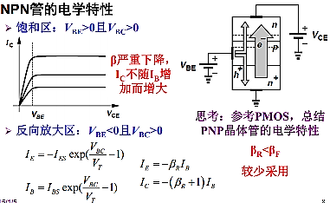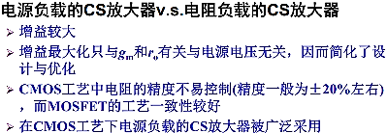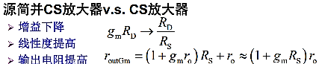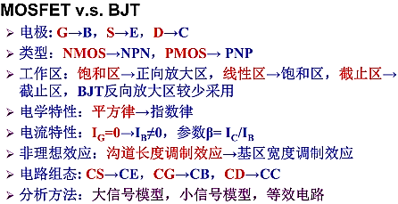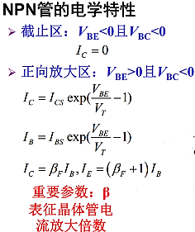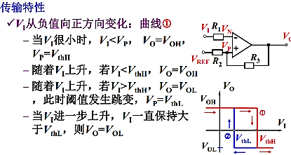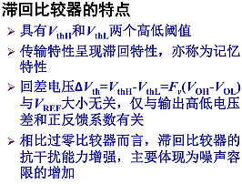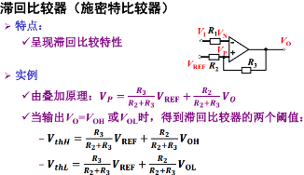C:\Users\ufozgg\AppData\Roaming\Tencent\Users\657228726\QQ\WinTemp\RichOle\X1UWN[A4%@D@DX%S}4HD@{W.png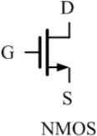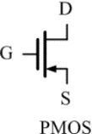

|  |  |  |
| --- | --- | --- |
| C:\Users\ufozgg\AppData\Roaming\Tencent\Users\657228726\QQ\WinTemp\RichOle\CH}A4HZNTK5M$(@0CF)LQ}W.png | C:\Users\ufozgg\AppData\Roaming\Tencent\Users\657228726\QQ\WinTemp\RichOle\28SD7I@L%`RD14}TNYR[9)0.png | C:\Users\ufozgg\AppData\Roaming\Tencent\Users\657228726\QQ\WinTemp\RichOle\7@LLA{K@%W_DX04WZH@G2TA.png |
|  |  |  |

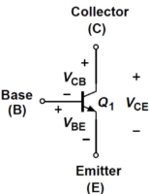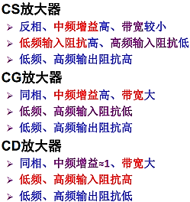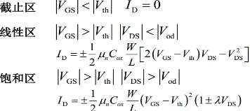

|  |  |
| --- | --- |
| C:\Users\ufozgg\AppData\Roaming\Tencent\Users\657228726\QQ\WinTemp\RichOle\0OBV8TVWF}7E%7@}GRPG)3W.png | C:\Users\ufozgg\AppData\Roaming\Tencent\Users\657228726\QQ\WinTemp\RichOle\22_X`TFTE~E3F~%I$Y`}SQ1.png |
|  |  |

图示

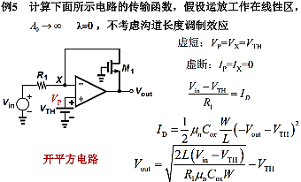C:\Users\ufozgg\AppData\Roaming\Tencent\Users\657228726\QQ\WinTemp\RichOle\OP%5N(UGZTV)3LSQ`DH8%$V.png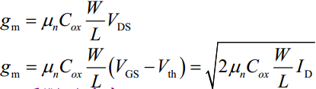

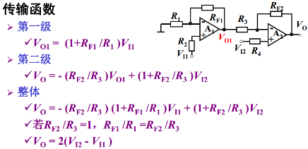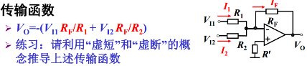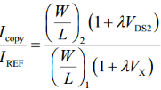电流镜：

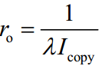

C:\Users\ufozgg\AppData\Roaming\Tencent\Users\657228726\QQ\WinTemp\RichOle\Y9FAV3[3X8)0T{X8R~@HEND.png