|  |
| --- |
| SOUTHERN CROSS UNIVERSITY |

**ASSIGNMENT COVER SHEET**

For use with online submission of assignments

Please complete all of the following details and then make this sheet the **first page of each file of your assignment – do not send it as a separate document.**

Your assignments must be submitted as either **Word documents, text documents with .rtf extension or as .pdf documents**. If you wish tosubmit in any other file format please discuss this with your lecturer well before theassignment submission date.

|  |  |
| --- | --- |
| Student Name: | **Pinder Kaur** |
| Student ID No.: | **23500813** |
| Unit Name: | **Web Development** |
| Unit Code: | **ISY10209** |
| Tutor’s name: | **Atie Asadikia** |
| Assignment No.: | **3** |
| Assignment Title: | **Three Column Layout** |
| Due date: | **22/05/2020** |
| Date submitted: | **22/05/2020** |

Declaration:

*I have read and understand the Rules Relating to Awards (*[*Rule 3 Section 18 – Academic Misconduct Including Plagiarism*](http://policies.scu.edu.au/view.current.php?id=00140#s18)*) as contained in the SCU Policy Library. I understand the penalties that apply for plagiarism and agree to be bound by these rules. The work I am submitting electronically is entirely my own work.*

|  |  |
| --- | --- |
| Signed:  (please type your name) | Pinder Kaur |
| Date: |  |

22/05/2020

# 1.CONCEPT MAP

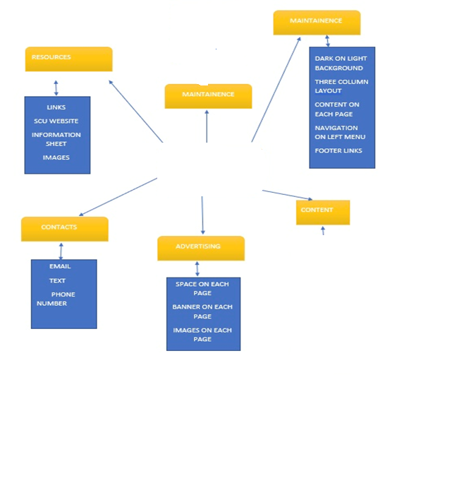

Index

Sports

Resume

Web skills

Photography

Hobbies

Pinder’s Portfolio

# 2. CSS Design

CSS layout plan for Home page

LOGO

HEADER

FOOTER

CONTENT

IMAGES

IMAGES

NAVIGATION

ABOUT

## 3. CSS TEXT PLAN

|  |  |
| --- | --- |
| CSS Tag | Value |
| Body | background-image:url(../images/background.jpg);  min-width:800px;  width:100%;  height:100%;  background-size:cover;  background-attachment:fixed;  background-repeat:no-repeat; |
| #header img | float: left;  width:100px;  height: 65px;  margin-left:35px; |
| #webName | font-size:4em;  text-align:center;  overflow:auto;  background-color:grey; |
| .monospace | font-family: "Lucida Console", Courier, monospace; |
| #navigation a | text-decoration:none;  color:black;  font-size:1.5em;  font-weight:bold; |
| #navigation li:hover | color:white; |
| navigation li a:hover | width:15%;  color:white;  text-decoration:none; |
| #navigation | width:15%;  float:left;  position:absolute;  left:0%;  top:20%;  margin-top:7%;  margin-right:1%;  text-align:center; |
| #navigation li | padding:5%;  border:2px double black;  background-color:grey; |
| #navigation ul | list-style-type:none;  font-weight: bold; |
| #logo | margin-left:50px; |
| #center | font-size: 1.5em;  text-align: justify; |
| #middle | height:1000px;  width:50px;  min-width:700px;  margin-left:250px;  margin-right:0px;  margin-top:20px;  margin-bottom: 0px;  font-size:1em;  text-align: justify |
| #right | width:20%;  height:200px;  margin-right:5px;    margin-bottom:100%;  margin-top:5%;  float:right;  font-size: 1.5em;  font-weight: bold ; |
| p.a | font-style: normal;  color: black;  text-align:justify;  font-size:1.5em; |
| p.b | font-style: normal;  color: black;  text-align:justify;  font-size:1.5em; |
| h2 | font-size:2em;  text-align:center;  background-color: grey; |
| h3 | font-size:2em;  text-align:center;  background-color: grey; |
| h4 | font-size:2em;  text-align:center;  background-color: grey; |
| h5 | font-size:2em;  text-align:center;  background-color: grey; |
| #education | color: black;  padding-bottom: 20px;  text-align:justify;  font-size: 1.5em;  font-weight: normal; |
| #resume | height:1000px;  width:50px;  min-width:700px;  margin-left:250px;  margin-right:0px;  margin-top:20px;  margin-bottom: 0px;  font-size:1em; |
| #study | font-size: 1.5em;  text-align: center; |
| #web skills | text-align:center;  padding: 50px;  font-size:1.5em; |
| P1 | font-size: 1.5em;  text-align: justify; |
| P2 | font-size: 1.5em;  text-align: justify; |
| P3 | font-size: 1.5em;  text-align: justify; |
| P4 | font-size: 1.5em;  text-align: justify; |
| P5 | font-size: 1.5em;  text-align: justify; |
| table,th,tdtable,th,td | margin-left:90px;  margin-top:65px;  width:50px;  height:50px;  border:2px solid black;  :middle;  font-size:1.2em; |
| Caption | font-size:2em;  background-color:grey;  border:2px solid black;  font-weight:bold;  color:black; |
| .textbox | padding-right:10%;  margin-top: 10px;  margin-right: 10px;  float: middle; |
| .text | padding-left:10px;  text-align: right;  margin-top: 10px;  float: left;  display:block;  font-weight: bold; |
| #labels label | text-align: right;  font-weight: bold;  border: 2px solid black; |
| #labels | border: 2px solid black;  font-size:1em;  text-align:left;} |
| #comment | border: 3px solid black;  padding: 10px;} |
| .radio{ | font-size: 70%; |
| #Music | border: 3px solid black;  font-size:1.5em; |
| #music | font-size:1.5em;  text-align: justify; |
| #Content | font-weight:bold;  font-size:1.2em;  text-align:center; |
| #issues | font-style:normal;  font-size:1.5em;  text-align: justify; |
| #goals | font-style:normal;  font-size:1.5em;  text-align: justify; |
| #introduction | border:4px solid black;  padding:5px; |
| #photography | border:2px solid black;  padding: 5px; |
| #image | padding: 10px;  float:center;  margin-left: 40px; |
| #mail | border-radius:50%;  width:100px;  position:absolute;  left:380px; |
| #mail:hover | border-radius:50%;  width:109px;  height:90px;  position:absolute;  left:380px; |
| #call | border-radius:50%;  width:100px;  position:absolute;  left:840px; |
| #call:hover | border-radius:50%;  width:109px;  height:90px;  position:absolute;  left:840px; |
| #footer | text-align:center;    background-color:grey;  padding-top:10px;  padding-bottom:10px;  color:black;  margin-top:800px;  font-size:1.25em; |

# 4. Navigation Map

5. STRUCTURE CHART (PHYSICAL)

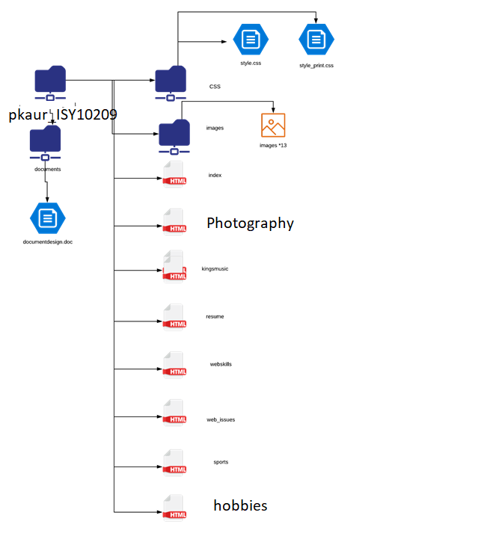

# 6. Storyboard

# Storyboard for Homepage index.html

|  |  |  |  |
| --- | --- | --- | --- |
| Title: index.html | | Screen ID: 4.0 | Date: 22-05-2020 |
| Web Page Diagram: | | | |
| Footer  image  image  header  Navigation Bar  Education  Pinder Introduction  logo | | | |
| Graphics: There are number of graphics used in this web page from which some are the Pinder own images, and some are CSS background images. | | | |
| Text: In this web Page there is an information about Pinder’s life about their aim of the life and her likes and dislikes. | | | |
| Multimedia: There are no audio and video available on this web page | | | |
| Notes: To begin with there is a header in which the name of the web page. After that there is a logo in the header section and their underneath there is three column Layout websites. In the left column there is a navigation bar which consist of Photography, resume, sports, web skills. By clicking on them individual can directly go to that page. In the middle column there is an information about Pinder’s life and aim of her life even her likes and dislikes. Moreover, there is also one column at the right which consist of some images such as photography images. At last there is a footer section that contain links. | | | |
| Description: | Home page | | |
| Content: | Pinder’s Portfolio | | |
| Interactions: | Navigations links such as resume page, sports page, Photography page, web skills etc. Moreover, there is a link of Southern Cross University. | | |
| Media Creation: | No | | |
| Navigation: | Home, Photography, sports, Language skills ,web skills, resume | | |

# Storyboard for page resume.html

|  |  |  |  |
| --- | --- | --- | --- |
| Title: resume.html | | Screen ID: 4.1 | Date: 22-05-2020 |
| Web Page Diagram: | | | |
| images  images  Footer  Hobbies  Personal Details  Skills  Experience  Navigation Bar  Logo  Header | | | |
| Graphics: There are number of graphics used in this web page from which some are the Pinder own images, and some are CSS background images | | | |
| Text: A resume based on the Pinder’s skills , hobbies and interest, experience and contact details . | | | |
| Multimedia: There are no audio and video available on this web page | | | |
| Notes: To begin with there is a header in which the name of the web page. After that there is a logo in the header section and their underneath there is three column Layout websites. In the left column there is a navigation bar which consist of travelling, resume, sports, web skills. By clicking on them individual can directly go to that page. In the middle column there is an information about Pinder’s resume such as herhobbies and interest, experience. Moreover, there is also one column at the right which consist of three images. At last there is a footer section that contain links | | | |
| Description: | Resume | | |
| Content: | Resume of Pinder | | |
| Interactions: | Navigations bar such as resume page, sports page, photography page, web skills etc. Moreover, there is a link of Southern Cross University. | | |
| Media Creation: | No | | |
| Navigation: | Home, photography, sports, Hobbies, web skills, resume | | |

# Storyboard of page web_skills.html

|  |  |  |  |
| --- | --- | --- | --- |
| Title: web_skill.html | | Screen ID: 4.4 | Date: 22-05-2020 |
| Web Page Diagram: | | | |
| images  images  Footer  Web issue link  Brief description about web skills  King music link  Navigation Bar  Logo  Header | | | |
| Graphics: There are number of graphics used in this web page from which some are the images that own Pinder, and some are CSS background images | | | |
| Text: A brief description about web skills of Pinder | | | |
| Multimedia: There are no audio and video available on this web page | | | |
| Notes: To begin with there is a header in which the name of the web page. After that there is a logo in the header section and their underneath there is three column Layout websites. In the left column there is a navigation bar which consist of hobbies, resume, sports, web skills. By clicking on them individual can directly go to that page. In the middle column there is a brief description about web skills and there are two links such as king music for sign up the music form and link to direct go to the page of web issue. Moreover, there is also one column at the right which consist of three images. At last there is a footer section that contain links | | | |
| Description: | Web skills | | |
| Content: | Web skills of Pinder, some about web issue and king music and their links. | | |
| Interactions: | Navigations bar such as resume page, sports page, travelling page, web skills etc. Moreover, there is a link of Southern Cross University. | | |
| Media Creation: | No | | |
| Navigation: | Home, Photography, sports, Language skills , web skills, resume | | |

# Storyboard for hobbies .html

|  |  |  |  |
| --- | --- | --- | --- |
| Title: hobbies.html | | Screen ID: 4.3 | Date: 22-05-2020 |
| Web Page Diagram: | | | |
| images  images  Footer  Image of different sport  Explaining about Hobbies  Types of sports  Navigation Bar  Logo  Header | | | |
| Graphics: There are number of graphics used in this web page from which some are the Pinder own images, and some are CSS background images | | | |
| Text: A brief description about different sports skills of Pinder | | | |
| Multimedia: There are no audio and video available on this web page | | | |
| Notes: To begin with there is a header in which the name of the web page. After that there is a logo in the header section and their underneath there is three column Layout websites. In the left column there is a navigation bar which consist of Language skills , resume, sports, web skills. By clicking on them individual can directly go to that page. In the middle column there is a brief description about sports and different kinds of sports. Moreover, there is also one column at the right which consist of three images. At last there is a footer section that contain links | | | |
| Description: | Hobbies | | |
| Content: | Sports skill of Pinder , and brief description about its types | | |

# Storyboard for photography.html

|  |  |  |  |
| --- | --- | --- | --- |
| Title: photography.html | | Screen ID: 4.2 | Date: 22-05-2020 |
| Web Page Diagram: | | | |
| images  images  Footer  Image of different Photographs Clicked by pinder  Photography interest  Brief explanation of Types of Photography  Navigation Bar  Logo  Header | | | |
| Graphics: There are number of graphics used in this web page from which some are the Pinder own images, and some are CSS background images | | | |
| Text: A brief description about different Photography interest of Pinder | | | |
| Multimedia: There are no audio and video available on this web page | | | |
| Notes: To begin with there is a header in which the name of the web page. After that there is a logo in the header section and their underneath there is three column Layout websites. In the left column there is a navigation bar which consist of travelling, resume, sports, web skills. By clicking on them individual can directly go to that page. In the middle column there is a brief description about Pinder’s Photography interest and different kinds of photography. Moreover, there is also one column at the right which consist of three images. At last there is a footer section that contain links | | | |
| Description: | Photography skill | | |
| Content: | Photography interest of Pinder , and brief description about its types | | |
| Interactions: | Navigations bar such as resume page, sports page, language skill page, web skills etc. Moreover, there is a link of Southern Cross University. | | |
| Media Creation: | No | | |
| Navigation: | Home, language skills , sports, Hobbies , web skills, resume | | |

# Storyboard for page language_skills.html

|  |  |  |  |
| --- | --- | --- | --- |
| Title: language_skill.html | | Screen ID: 4.5 | Date: 22-05-2020 |
| Web Page Diagram: | | | |
| images  images  Footer  Different types of Language Pinder knows  Language skills of Pinder  Brief explanation of Types of languages  Navigation Bar  Logo  Header | | | |
| Graphics: There are number of graphics used in this web page from which some are the pinder own images, and some are CSS background images | | | |
| Text: A brief description about language skills of pinder. | | | |
| Multimedia: There are no audio and video available on this web page | | | |
| Notes: To begin with there is a header in which the name of the web page. After that there is a logo in the header section and their underneath there is three column Layout websites. In the left column there is a navigation bar which consist of travelling, resume, sports, web skills. By clicking on them individual can directly go to that page. In the middle column there is a brief description about languages that pinder can speak and different kinds of travelling. Moreover, there is also one column at the right which consist of three images. At last there is a footer section that contain links | | | |
| Description: | Language skill | | |
| Content: | Language skills of Pinder and different languages | | |
| Interactions: | Navigations bar such as resume page, sports page, hobbies page , web skills etc. Moreover, there is a link of Southern Cross University. | | |
| Media Creation: | No | | |
| Navigation: | Home, Photography, sports, hobbies, web skills, resume | | |

# Storyboard for page kings_music.html

|  |  |  |  |
| --- | --- | --- | --- |
| Title: king_music.html | | Screen ID: 4.7 | Date: 22-05-2020 |
| Web Page Diagram: | | | |
| Sign Up Form  Header | | | |
| Graphics: There are number of graphics used in this web page from which some are the Pinder own images, and some are CSS background images | | | |
| Text: Sign Up for King music | | | |
| Multimedia: There are no audio and video available on this web page | | | |
| Notes: To begin with there is a header in which the name of the web page. After that there is a logo in the header section and their underneath there is three column Layout websites. In the left column there is a navigation bar which consist of Photography, resume, sports, web skills. By clicking on them individual can directly go to that page. In the middle column there is a sign-up form for King Music. Moreover, At last there is a footer section that contain links. There is different background image. | | | |
| Description: | King music form | | |
| Content: | Sign up form of king music | | |
| Interactions: | Navigations bar such as resume page, sports page, photography page, web skills etc. Moreover, there is a link of Southern Cross University. | | |
| Media Creation: | No | | |
| Navigation: | Home, Photography, sports, Hobbies , web skills, resume | | |

# Storyboard for page web_issues .html

|  |  |  |  |
| --- | --- | --- | --- |
| Title: web_issues.html | | Screen ID: 4.6 | Date: 22-05-2020 |
| Web Page Diagram: | | | |
| references  Web issues  images  images  Footer  Navigation Bar  Logo  Header | | | |
| Graphics: There are number of graphics used in this web page from which some are the Pinder own images, and some are CSS background images | | | |
| Text: Brief description about web issues in the Pinder’s website and some refrences | | | |
| Multimedia: There are no audio and video available on this web page | | | |
| Notes: To begin with there is a header in which the name of the web page. After that there is a logo in the header section and their underneath there is three column Layout websites. In the left column there is a navigation bar which consist of photography, resume, sports, web skills. By clicking on them individual can directly go to that page. In the middle column there is an information of web issue of Pinder’s website and below there are references. Moreover, there is also one column at the right which consist of three mages. At last there is a footer section that contain links | | | |
| Description: | Web issues | | |
| Content: | Web issues in Pinder webpage | | |
| Interactions: | Navigations bar such as resume page, sports page, photography page, web skills etc. Moreover, there is a link of Southern Cross University. | | |
| Media Creation: | No | | |
| Navigation: | Home, photography, sports, hobbies, web skills, resume | | |

# 7. Testing plan

Testing procedure for this Website is as follows.

• **Validation of Files**

1. All HTML5 pages will be validated using W3C Markup Validation Service
2. All CSS files will be validated using W3C CSS Validation Service

• Test “Look and Feel” of display on several browser sizes

1. 1024 X 768 pixels
2. 1280 X 1024 pixels
3. 1440 x 900 pixels
4. 1280 x 854 pixels
5. 1600 x 1024 pixels.

• Test “Look and Feel” of site on different browsers

1. Internet Explorer 8 (Windows XP)
2. Internet Explorer 9 (Windows 7)
3. Firefox 9.0.1 (Mozilla)
4. Chrome (Google)
5. Safari OS X (Apple)
6. Opera version 11.60 (Opera Software ASA)

• **Test all hyperlinks on site**

1. All internal links (site navigation)
2. All external hyperlinks.

**• Test proper functioning of all media on site**

1. Images:
   1. All images links has been tested all are correct and working
   2. All images have been checked for being free to use and share for copyright usage.
   3. Jpg and png type of images use in this website.

. **• Test proper functioning of all JavaScript**

1. Form JavaScript